### **Lab 4 - Bi-Phase-L BER with Optimal Threshold**

**ECE 4513**

**Leonardo Aviles**

[**tue51778@temple.edu**](mailto:tue51778@temple.edu)

**March 8,2017**

**Abstract:**

The performance of a digital system with additive white Gaussian noise (AWGN) can be studied by the measurement of the bit error rate or the BER. Bi phase or sometimes called Manchester or split phase RZ line code is used for this lab. Bi-phase L is an asymmetrical baseband signal. The binary rectangular asymmetrical PAM NRZ system with BER analysis is in MS figure 2.37.

**Introduction:**

In this lab we are tasked to assess the BER performance of a Bi-phase-L baseband signal with an optimum receiver and a threshold. We are assigned a random amplitude and a single bit time ranging from 50uSec to 500usec in steps of 50 usec. A appropriate simulation step time Ts must be chosen, this step time will be and the parameters of the Data Rate blocks,correlation reference pulse,Integrate and Dump,threshold value and delay between the transmitted and received bits must be chosen as well. Obtaining a 0 BER with no AWGN is crucial for this lab, will will allow the performance errors to be caused by the delays and timing parameters which will make improving the BER easier.

The task of this lab was to first run Simulink model Fig237 with the standard model parameters. Next a single correlator receiver is configured with a reference source that is developed as φ2 ^ (t). The signal is plotted over several bit times to verify its performance. Next the threshold is computed for equally likely binary data (P1=P2) and set as a constant using the Summer and Sign blocks. Next the power of the bi-phase-L transmitted signal is found assuming equal binary data and compute the SNR in dB the standard range of inf,10,8,6,4,2, and 0 db by first determining Eb then setting the AWGN channel appropriately. In this lab the Eb/No ratio is used for the noise instead of the variation.

Our simulation is ran and compared to the theoretical probability of bit error. A table with the BER is created and compared to the MS Table 2.9 for binary rectangular asymmetrical,PAM NRZ binary data.

**Discussion:**

The first step was to run the simulation file called Fig237 with the standard model parameters. For this step it was found that there was a BER of 0 with a Eb/No ration of 40. This means that the input signal was much larger than the noise inputted to the signal. For this diagram the threshold was -625 which was added to the integrate and dump.

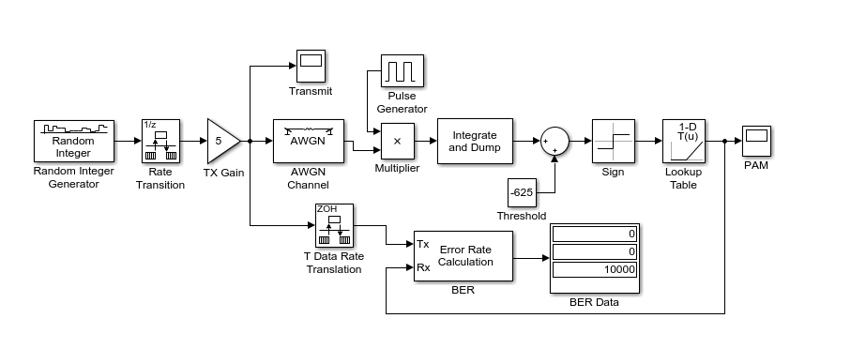

**Figure 1: Shows the diagram of figure 237 with a BER of zero.**

The next step was to configure the single correlator receiver for this the figure below was the diagram created. In this signal the input was decided to be the initial input before entering AWGN channel from figure 1 and the second input would be a pulse generator with an amplitude of 12 a period of 250e-6,pulse width of 30% and a phase delay of 125e-6. The output of this signal is shown in figure 2.

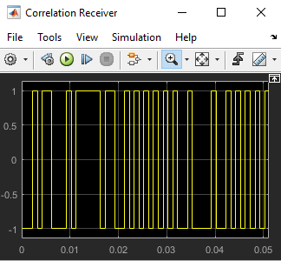

**Figure 2: Shows the output of the correlation receiver without a threshold.**

The next step was to compute a threshold for our signal. For this instance the data is equally likely which meant P1=P2 and in term the equation used would be shown below.



**Equation 1: Equation used to compute the threshold.**

For this instance the second term will drop out since Ln(1) = 0. The constant is then added to the integrate and dump and feed into the sign block. For this step I was unable to find S11^ and S12^ necessary for finding the threshold. For this step the threshold was kept the same from the original diagram. Next the power of the bi-phase-L transmitted using SNR in dB us calculated from the standard range of 10,8,6,4,2, and 0 dB. The Ed/No was changed to each of these values and the BER was recorded. The theoretical value for the Perror is found using the equation 2 and the Q function chart from blackboard.

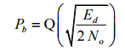

**Equation 2: Equation used to calculate the Perror**

The values of the theoretical and simulation errors are shown in figure 3 below.

|  |  |  |  |  |
| --- | --- | --- | --- | --- |
| ED/No dB | ED/No (Power) | BER | Q(a) | P(b) |
| inf |  | 0 |  | 0 |
| 10 | 10 | 0.27735 | 2.236067977 | 0.0129 |
| 8 | 6.30957 | 0.3192 | 1.776171444 | 0.0375 |
| 6 | 3.98107 | 0.34985 | 1.410863211 | 0.0793 |
| 4 | 2.51189 | 0.380225 | 1.12068952 | 0.1314 |
| 2 | 1.58489 | 0.4043 | 0.8901937991 | 0.1867 |
| 0 | 1 | 0.4242 | 0.7071067812 | 0.2389 |

Figure 3: The table above shows the data found in the lab.

Figure 3 shows the Q(a) values found by using equation 2 this is the value of (Ed/N0*2)^.5. Using the Q table the values are found and recorded in the column labeled P(b). Next the BER from simulation is found and recorded in the column BER. One large discrepancy is the values found between simulation and theoretical. The simulation values are much larger the the calculated values but one similarity is the BER values increase as the ED/No decreases.

**Conclusions:**

For this lab the goal was to find the BER of a Bi-Phase-L signal. When running the diagram without the noise the function gave a error rate of zero, though this BER changed dramatically once the Ed/No ratio decreased to smaller numbers such as 2. One observation was that in both the theoretical and simulation the BER would increase as the Ed/No became smaller. A area of error and of great discrepancy is the values of the theoretical and simulation. The BER values for simulation we very large for BER with the smallest value being .28, this value is not acceptable for a bit error rate and would not be a good system. A cause for this error could have come from the choosing of the threshold which was left the same since I was unable to find a proper threshold or the signal that was multiplied by the noise added signal which in my case was a pulse generator.

**Appendix:**

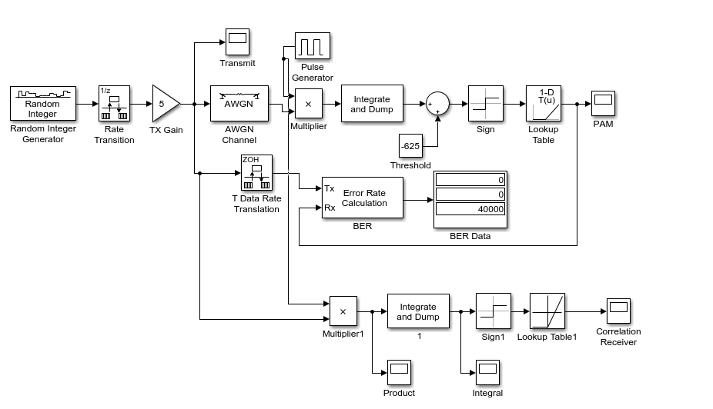

**Appendix Figure 1: Shows the diagram created for the lab. With a threshold of -625 and a AWGN Ed/No value of 40. This resulted in a BER data of zero.**