**[Non-uniform mutation (NUM) [32]](Artigos_Otimização/2007 - a new mutation operator for real codeded genetic algorithms.pdf)**

- Um dos operadores de mutação mais utilizados em real coded GAs

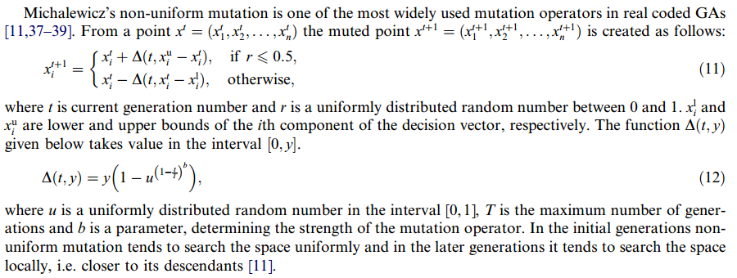

Parâmetro livre: b

**[Makinen, Periaux and Toivanen mutation (MPTM)](Artigos_Otimização/2007 - a new mutation operator for real codeded genetic algorithms.pdf)**

A mutação de Makinen, Periaux e Toivanen [22] é um operador de mutação relativamente novo e tem sido aplicada para resolver problemas de otimização de forma multidisciplinar, bem como um grande conjunto de problemas de otimização restrita [40].

Makinen, Periaux and Toivanen mutation (MPTM) [27] has been proved to solve constrained and multidisciplinary shape optimization problems.

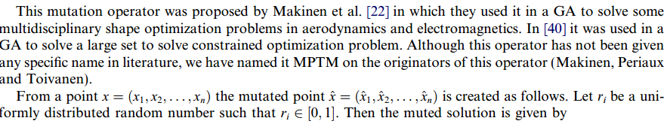

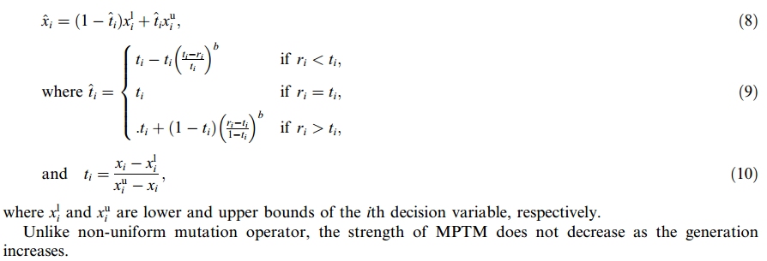

**[Power mutation (PM) [25]](Artigos_Otimização/2007 - a new mutation operator for real codeded genetic algorithms.pdf)**

- is based on power distribution.

- The strength of PM is regulated by its index: small index value produces small diversity.

- The strength of mutation is governed by the index of the mutation (p). For small values of p less perturbance in the solution is expected and for large values of p more diversity is achieved.

- The probability of producing a mutated solution y on left (right) side of x_ is proportional to distance of x_ from xl(xu) and the muted solution is always feasible

**- PM performs better than MPTM and Non-Uniform Mutation (NUM) when all three mutators were combined with Laplace Crossover (LX).**

-

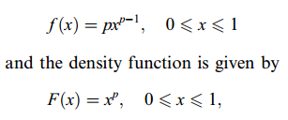

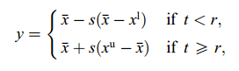

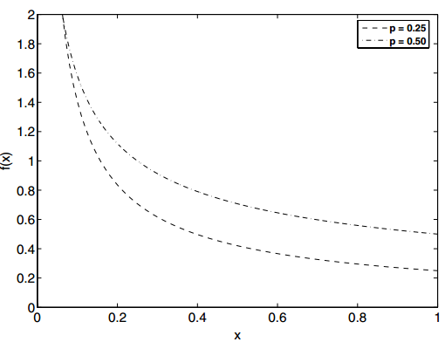

**[Polynomial mutation (PLM) [26]](Artigos_Otimização/2014 - analysing mutation schemes for real-parameter genetic algorithms.pdf)**

- one of the most efficient and widely used mutation schemes for an RCGA

- one of the most widely used operator as it has been applied in single and multi-objective optimization problems [28], [29].

- Não precisa de penalidade

- nm pertence a [20, 100]



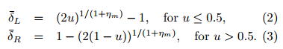

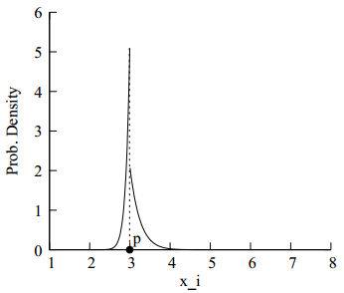

**Random mutation [15]** **Michalewicz [11]**

- common mutation operator

- based on Gaussian distribution whereby the user specifies a range of uniform random value to replace the value of the chosen gene.

**- Uniform:** a gene is replaced with a random value between its lower and upper bound.

**-** **Non-uniform:** the step size decreases as the generations increase. Uniform search in the initial space and very little at the later stage.

Let xi be within the range [ai,bi], then we assign U(ai,bi) to xi.

U(ai,bi) denotes a uniform random number from within the range [ai,bi].

**[Gaussian Mutation in RealParameter GAs](Artigos_Otimização/2014 - analysing mutation schemes for real-parameter genetic algorithms.pdf)**

A mutação gaussiana faz uso da função de erro de Gauss. É muito mais eficiente na convergência do que os algoritmos mencionados anteriormente. Selecionamos um gene aleatório, digamos xi, que pertence ao intervalo [ai, bi]. Deixe a mutação ser x’i. Cada variável tem um operador de força de mutação (σi). Usamos σ = σi / (bi-ai) como um parâmetro não dimensionalizado fixo para todas as n variáveis;

No operador de mutação gaussiana, são necessários dois parâmetros: a média (geralmente definida como zero) e o desvio padrão da distribuição gaussiana. O desvio padrão da distribuição gaussiana dita a força da mutação. Uma mutação gaussiana com tamanho de etapa de mutação auto-adaptativa [31] e uma mutação gaussiana auto-adaptativa com adaptação baseada em feedback do tamanho da população é proposta em [32]

Let xi ∈ [ai, bi] be a real variable. Then the truncated Gaussian mutation operator changes xi to a neighboring value using the following probability distribution

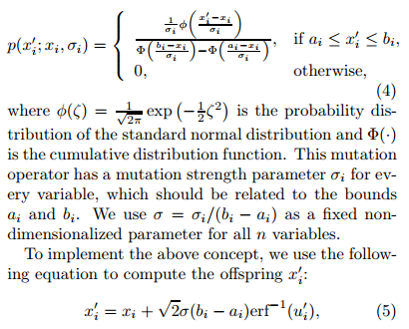

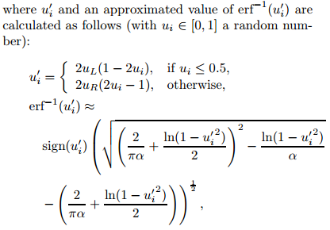

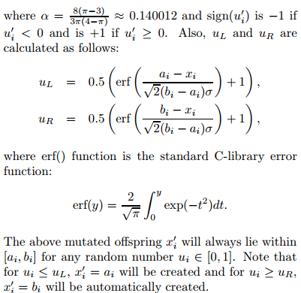

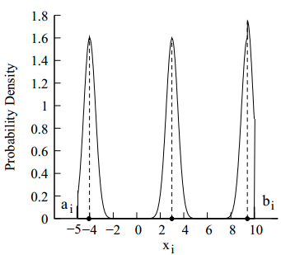

**[Rosenbrock mal](https://www.researchgate.net/publication/323868315_A_Direction-Based_Exponential_Mutation_Operator_for_Real-Coded_Genetic_Algorithm)**

**[Mutation Schemes](Artigos_Otimização/2014 - analysing mutation schemes for real-parameter genetic algorithms.pdf)**

**Adaptive mutation [35] operator**

- uses the simulation of gradient or counter-gradient direction in its searching strategies. It relies on the frequency of the best chromosomes’s genes and it possesses an adaptive feature. On the contrary, adaptive directed mutation (ADM) [36] incorporates the strategies of local directional search and the adaptive random search to avoid the concentration of each chromosome caused by a crossover operator. This strategy can also prevent an unsystematic search of the system due to random mutation.

**Mirror mutation and binary bit-flipping mutation [13], [14]**

- are alike in that the mirror mutator replaces a gene with its mirror value at the middle point of the boundary interval for the gene, whereas in bit-string representation GA, bit-flip mutation remains unchanged. Order based GAs and grouping GAs are instances of GA minus the bit-flip mutation.

**Mutation based on directed variation techniques [16]**

- make use of the feedback information from the current population to make changes to certain individuals. The direction of mutation based on co-evolutionary technique [17] is determined by a solution vector.

**Directed mutation [18]**

- is based on gradient or extrapolation. The directed mutation deterministically finds a new point in the population using the information applied in the previous generations. Directed mutation based on momentum [19] is a standard Gaussian mutation, which is used to speed up the gradient descent training of neural networks. The existing momentum functions as a mutator for each component of an individual.

**Covariance matrix adaptation evolution strategy (CMAES) [20]**

- was recommended by experts as an outstanding parametric optimization algorithm. Muhlenbein’s mutation (MM) [21] generates offspring with alleles and logarithmic mutation (LM) [22] alters a randomly chosen allele. (CMAES) [37] was recommended by experts as an outstanding parametric optimization algorithm. Muhlenbein’s mutation (MM) [38] generates offspring with alleles and logarithmic mutation (LM) [39] alters a randomly chosen allele.