**Budget Program Manual**

**Android Studio**

This chapter describes how to install Android SDK and Android Studio. You don't have to install Android Studio, but it's better. The project can be built without Android Studio, using Gradle and Android SDK. Gradle is a build system used for building final APK file.

1. Install [Java JDK] (http://www.oracle.com/technetwork/java/javase/downloads/index.html)
2. Install [Android SDK](https://developer.android.com/sdk/index.html)
3. Run Android SDK Manager and [download necessary SDK packages] (https://developer.android.com/sdk/installing/adding-packages.html), make sure that you have installed Android SDK Tools, Android SDK Platform-tools, Android SDK Build-tools, Android Support Repository, Android Support Library and Google Play services
4. Install [Android Studio](https://developer.android.com/sdk/index.html)
5. Now you should be able to open/edit the Android project and build APK
6. You can also install [Genymotion](http://www.genymotion.com/) - fast Android emulator

**Project structure**

Project has the following structure (dngikutinirectories are marked by square braces):

* [doc] -documentation
* [gradle]
* [gradle]/[wrapper]- Gradle Wrapper
* [Apps]-main module
* [Apps] - main module
* [Apps]/[libs] - contains 3rd party libraries (not used)
* [Apps]/[src] - contains source code
* [Apps]/[src]/[main]
* [Apps]/[src]/[main]/[assets] - asset files (prepopulated database, images)
* [Apps]/[src]/[main]/[java] - java sources
* [Apps]/[src]/[main]/[res] - xml resources, drawables
* [Apps]/[src]/[main]/AndroidManifest.xml - manifest file
* [Apps]/build.gradle - main build script
* .gitignore - Gitignore file
* build.gradle - parent build script
* gradle.properties - build script properties
* gradlew - Gradle Wrapper (Unix)
* gradlew.bat - Gradle Wrapper (Windows)
* README.md - readme file
* settings.gradle - build settings containing list of modules

Java Packages:

* com.example.williem.hciss.AddActivity contains activity
* com.example.williem.hciss.CalenderFragment – contains Calender class
* com.example.williem.hciss.DatabaseHelper -contains database Sqlite class
* com.example.williem.hciss.EditActivity- contain EditText Activity class
* com.example.williem.hciss.ExpenseFragment -contains fragment class
* com.example.williem.hciss.MainActivity -contains application class and main config class
* com.example.williem.hciss.ToDoCursorAdapter - contains Cursor for To Do Adapter

**Configuration**

This chapter describes how to configure the project to be ready for publishing. All these steps are very important!

**Customization**

This chapter describes some optional customizations of the app.

**Custom colors and icons**

You can customize colors in \app\src\main\res\color.xml

[1]

<?xml version="1.0" encoding="utf-8"?>

<resources>

<color name="primary">#FFFF00</color>

<color name="primary_dark">#502020</color>

<color name="text_primary">#FF00ff00</color>

<color name="text_secondary">#FFff0000</color>

<color name="window_background">#000000</color>

<color name="nav_color">#505050</color>

</resources>

**Custom Banner logo in drawer menu**

There is a ... texture shown in the drawer menu. You can easily change this texture replacing ... file in .. directory.

**Building & publishing**

You don't need to install Gradle on your system, because there is a [Gradle Wrapper] (http://www.gradle.org/docs/current/userguide/gradle_wrapper.html). The wrapper is a batch script on Windows, and a shell script for other operating systems. When you start a Gradle build via the wrapper, Gradle will be automatically downloaded and used to run the build.

1. Open the project in Android Studio
2. Open configuration file _/apps/src/main/java/com/Example/hciss /MainActivity.java_ and set constants as required (see below for more info)
3. Open main build script _/apps/build.gradle_ and set constants as required (see below for more info)
4. Run `gradlew assemble` in console
5. APK should be available in _/mobile/build/outputs/apk_ directory

**Limitation consideration**

* Only Using Sqlite for Database and SQL connection.

First we use Xampp as our Database Connection for our Android Studio but we found that, we Cannot Connect The Database server

Solve: [2]Using SqLite for Database for SQL connection by add the table

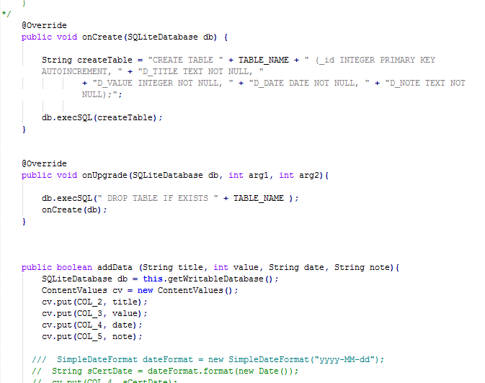

We Create the Table using Create Table() Function if the Sqlite object is called and We can add the data using AddData() function

**Prototype consideration**

We make it from the beginning not using other people code.

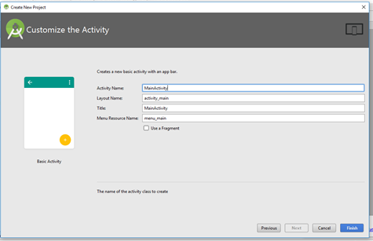

And now our Prototype in Android Phone:

* Home:



* Add New:

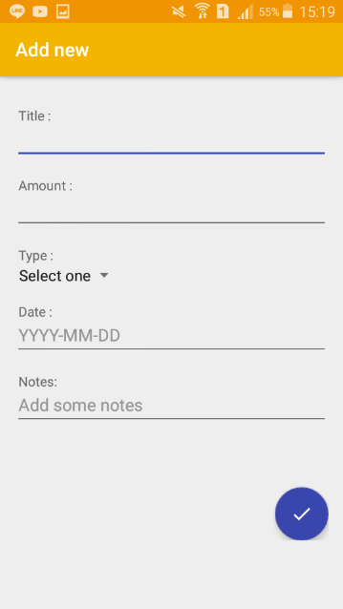

* Transaction Report:

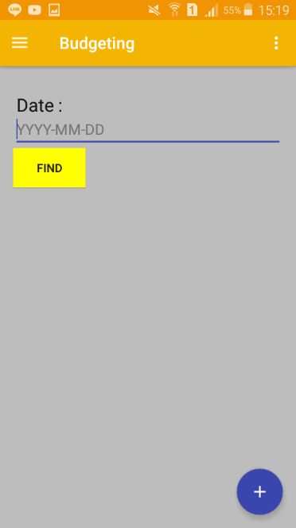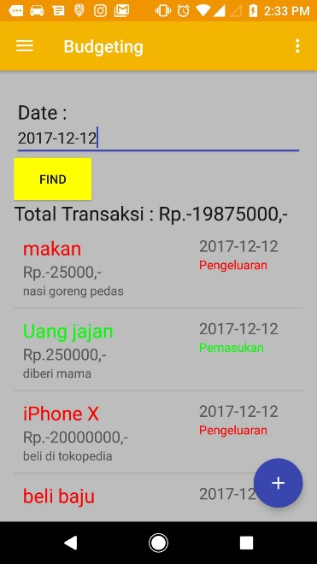

* Today’s Transaction:

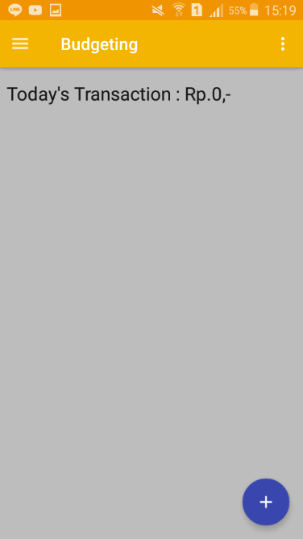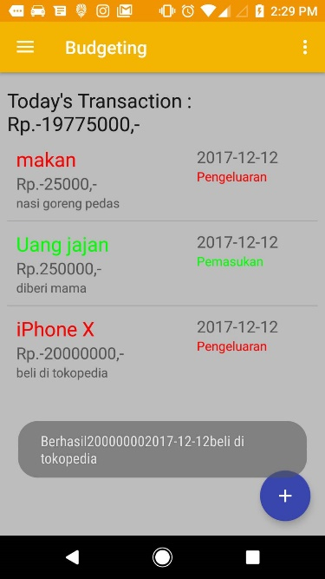

* Transaction History:

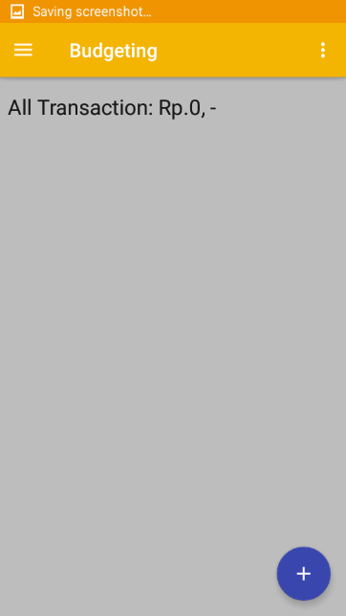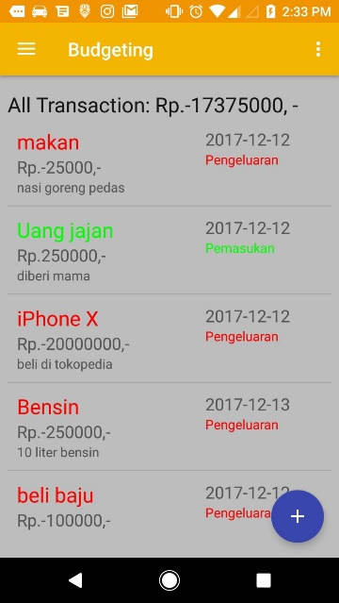

**Referensi**

[1] “Android-er: Customize color for your app, for Material Theme, using Android Studio.” [Online]. Available: http://android-er.blogspot.co.id/2015/09/customize-color-for-your-app-for.html. [Accessed: 03-Dec-2017].

[2] “Android SQLite Database Tutorial using Android Studio | MobileSiri.” [Online]. Available: http://mobilesiri.com/android-sqlite-database-tutorial-using-android-studio/. [Accessed: 03-Dec-2017].