<Budget>

**<USER Manual>**

Purpose of the document

The purpose of this document is to describe the

Application Budget to the user

**Table of Contents**

**PURPOSE OF THE DOCUMENT...............................................................................................1**

1. **GENERAL DESCRIPTION...................................................................................................................3**
   1. Brief description..................................................................................................................................3
   2. Project Players.....................................................................................................................................3
   3. Support................................................................................................................................................3
   4. Address...............................................................................................................................................3
   5. Authentication.....................................................................................................................................3
   6. System Requirement...........................................................................................................................3
2. **STRUCTURE OF THE APPLICATION...............................................................................................4**
   1. Layout.................................................................................................................................................4
   2. Menus.................................................................................................................................................4
   3. Icons....................................................................................................................................................4
   4. Functionalities.....................................................................................................................................5
      1. Functionalities Presented .....................................................................................................5
      2. Functionalities not Presented ...............................................................................................6
3. **Functionalities 1:Budgeting.....................................................................................................................7**
4. **Functionalities 2:......................................................................................................................................7**
5. **REFERENCES.........................................................................................................................................8**

# General Description

## Brief description

In a Brief, Budgeting Created to manage finance or budgeting that allows users to access and have a simple design that has new innovations such as having some features of expense / income, calendar and graph.

## Project players

Budget is developed by Informatics student at Universitas Pelita Harapan for Human Computer Interaction project.

-Williem Citralin, 00000014292 as a Database Management, Design.

-Leonardo Bunjamin, 00000014225 Main Feature, Documentation.

-Rickhen Hermawan 00000012311 as a Database Management(PIC), input Bill with Camera.

-Octa Wijaya-0000001939 as a Main Feature, Documentation

## Support

You can contact us through [budgetuph@gmail.com](mailto:budgetuph@gmail.com) for support.

## Address

Budget does not require internet connection to be accessed

## Authentication

Budget does not require authentication in order to be used.

## System Requirement

Minimum System Requirement for Budget to run:

1. Android OS: LOLLIPOP(API 21)

# Structure of the Application

## Layout

In general, the layout for main activity Budgeting is given below:

-Navigation drawer: when clicked, it will show Today’s Transaction, Transaction Report, Transaction History.

-Top Bar: shows the title of apps, contains navigation drawer and options menu.

-Options menu: when clicked, options will pop out help file,settings.

-Main Content: all the content for apps will be shown here.

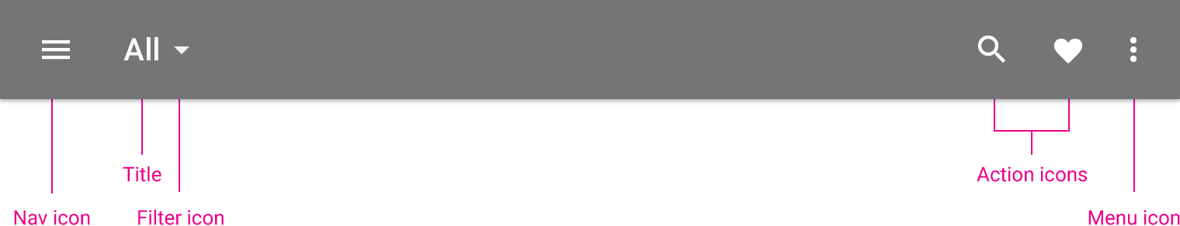

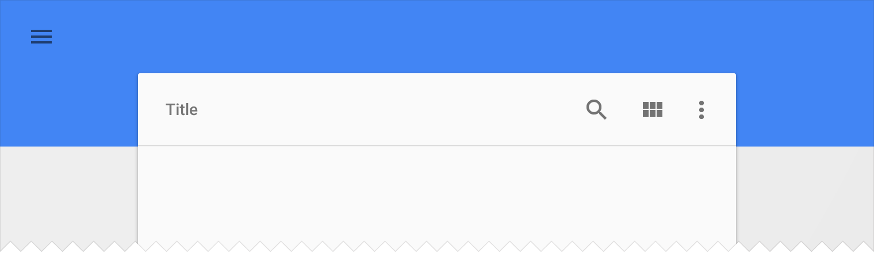

The app bar, formerly known as the action bar in Android, is a special kind of toolbar that’s used for branding, navigation, search, and actions.

The nav icon at the left side of the app bar can be:

A control to open a navigation drawer

An up arrow for navigating upward through your app’s hierarchy

Omitted entirely if no navigation is required from this screen

The title in the app bar reflects the current page. It can be an app title, page title, or a page filter.

Icons on the right side of the app bar are app-related actions. The menu icon opens the overflow menu, which contains secondary actions and menu items like help, settings, and feedback.

## Menus

Navigation Drawer:

1. Today’s Transaction
2. Transaction Report
3. Transaction History

Options Menu:

1. Help: show help for user in using the app
2. Settings : show options and help

## Icons

|  |  |  |
| --- | --- | --- |
| Icon | | Function |
|  | | App icon |
|  | | Checklist icon, when finished filling |
|  | | Add new icon, make new expense/income |
|  | | Other icon, help file and settings |
|  | | Transaction History icon |
|  | | Today’s Transaction icon |
|  | Transaction Report icon | |
|  | Find icon/button, for search or finding transaction by date | |

## Functionalities

2.4.1. Functionalities Presented

The functionalities that will be described in this manual are:

1. Add New
2. Today’s Transaction
3. Transaction Report
4. Transaction History
5. Edit

2.4.2. Functionalities not Presented

All the main functionalities of the app will be describe in this manual

# Functionalities 1 : Add new

This function enable user to make new expense or income, will contain :

1. Tittle
2. Amount
3. Type
4. Date
5. Notes

## SCREENSHOOT

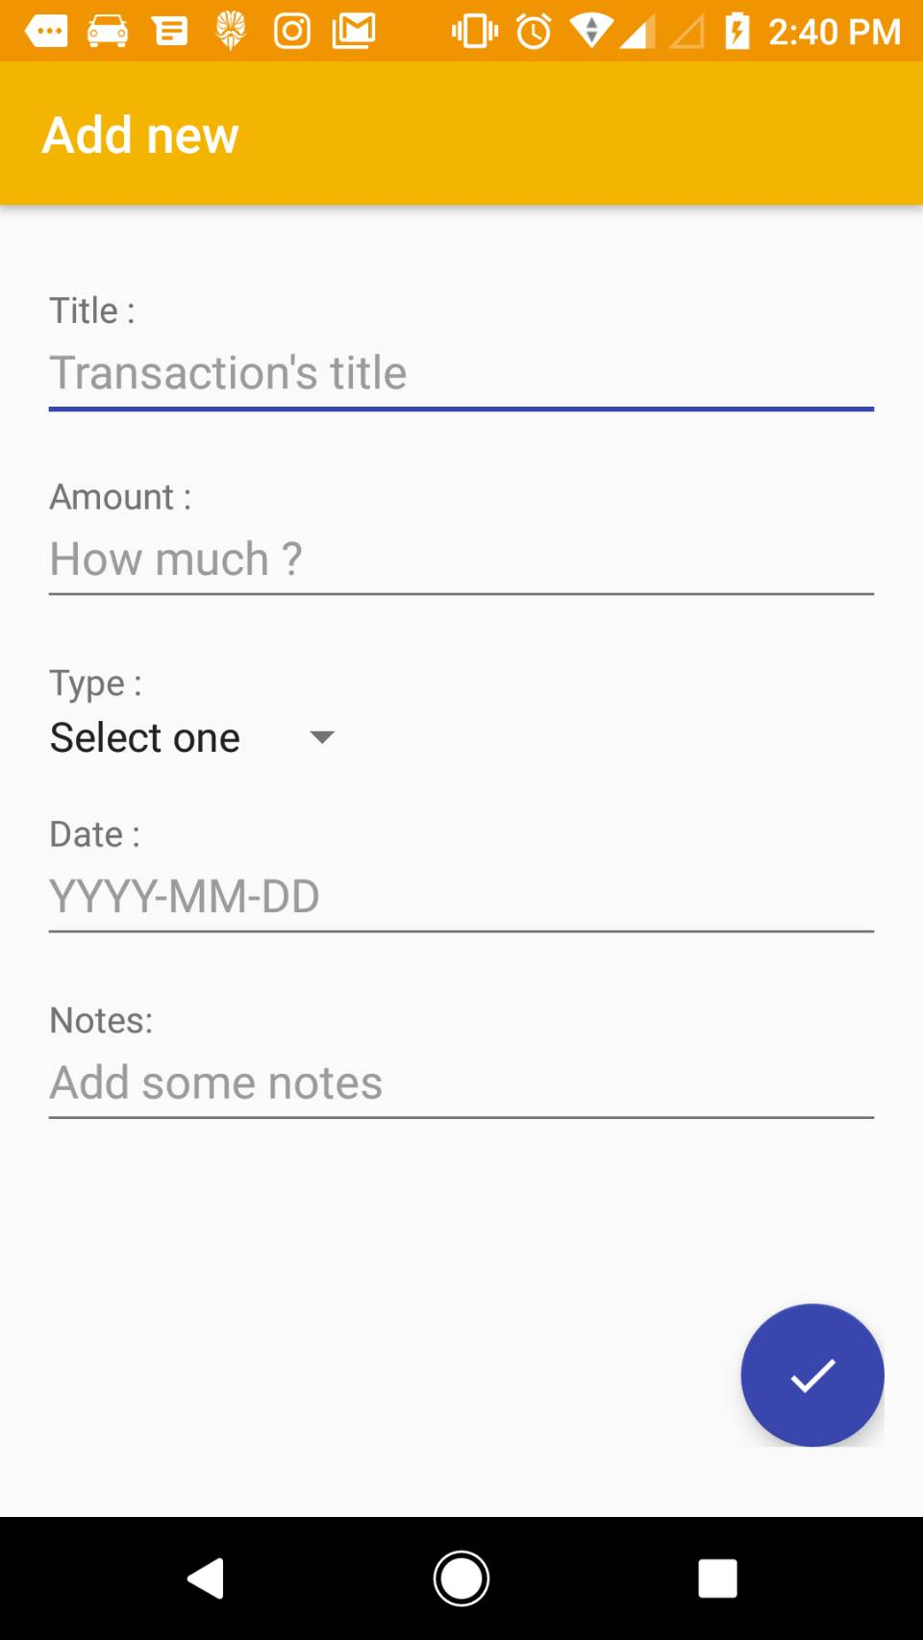

## DESCRIPTIONS OF FIELDS, CONTENT

Screenshot 3.1 shows all the functionalities of Add New. The description for each component are:

1. Tittle: Transaction’s Tittle
2. Amount : fill in some money
3. Type : type of expenses incurred
4. Date, DD/MM/YY : the time required for income or expenditure
5. Some Notes : additional note of interest

## DESCRIPTION OF ACTIONS

Actions possible in this screen are user able to fill new expense/income with some supporting components that need to be filled.

## SEQUENCE OF SCREENS

Add new will be shown when user selected expense/income menu.

# Functionalities 2 : Today’s Transaction

This function enables user to view Today’s Transaction and add transaction. The information will contain :

1. Type
2. Amount
3. Note
4. Date
5. Income/expenditure

## SCREENSHOOT

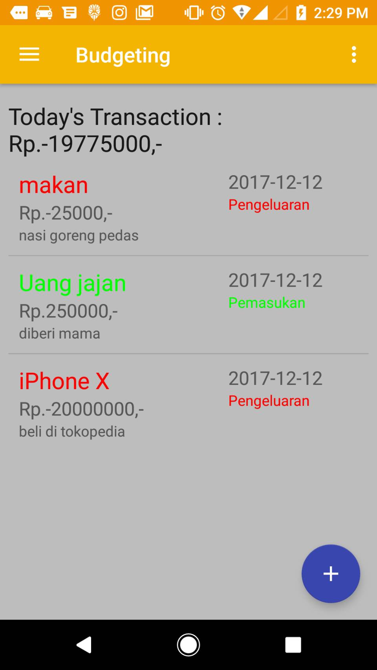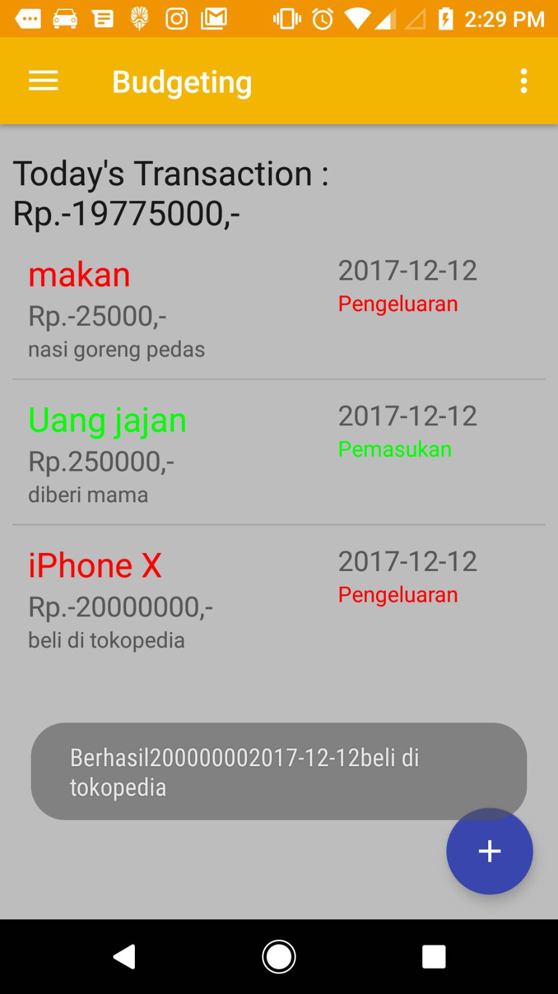

5.2 DESCRIPTION OF FIELDS, CONTENT

User can click add new icon to make transaction and user can show today’s transaction.

5.3 DESCRIPTIONS OF ACTIONS

When Today’s Transaction click, will show the interface and actions possible in this screen are user able to view today’s transactions.

5.4 SEQUENCE OF SCREENS

add new transaction and show transaction’s today when user selected a menu Transaction’s Today

# Functionalities 3 : Transaction Report

This function enables user to find for transaction. The search will return results based on date.

5.1 SCREENSHOOT

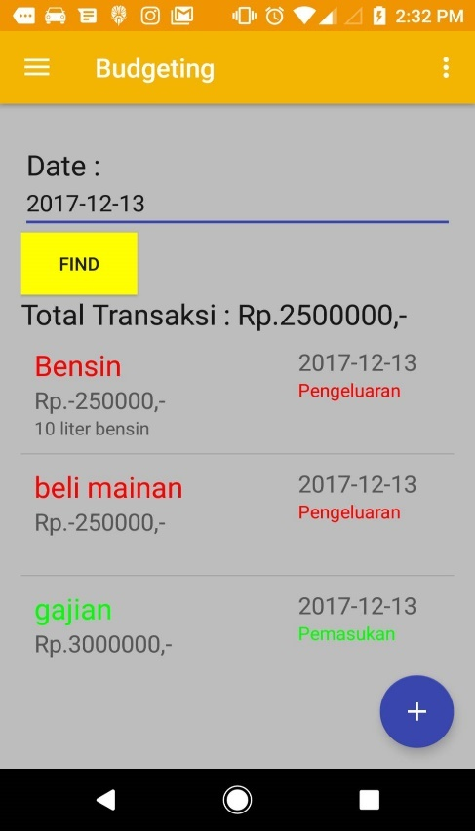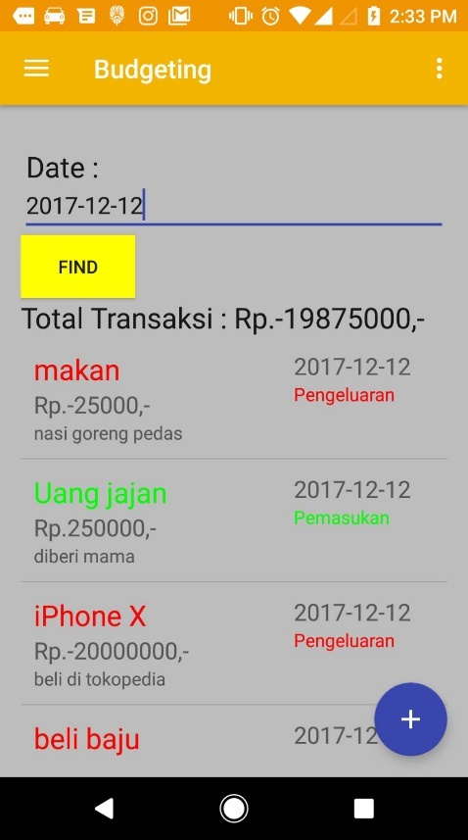

5.2 DESCRIPTIONS OF FIELDS, CONTENT

The return results will show transaction by date on search query. All transaction that contain search query will be shown in the screen. Example in screenshoot show that user find for the date : 2017-12-12 and when user pressed find button, the result is given.

5.3 DESCRIPTIONS OF ACTIONS

Actions available are search for transaction history, and click the transaction report.

5.4 SEQUENCE OF SCREENS

User view history transaction, then user can submit a add new transaction and filled it.

# Functionalities 4 : Transaction History

This function enables user show transaction history from last transaction and show total of money

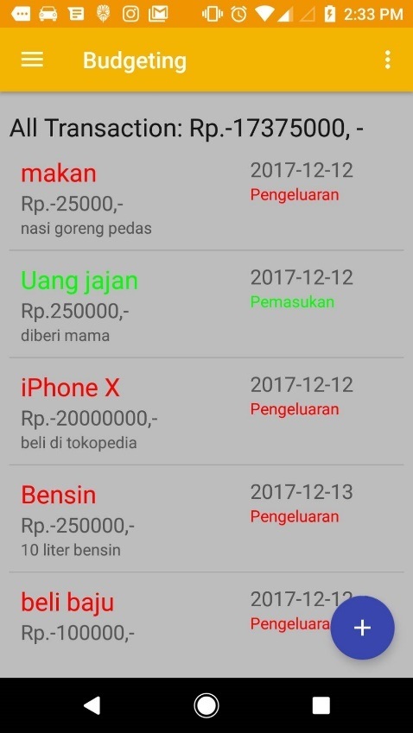6.1 SCREENSHOOT

6.2 DESCRIPTIONS OF FIELDS, CONTENT

Transaction History are list of transaction after submit at add new. This feature allows the user to view the last transaction that has been made and can be known various information such as amount, type, note, date and title.

6.3 DESCRIPTIONS OF ACTIONS

The action will start when the user has filled out the add new and the top view is the most recent transaction created by the user.

6.4 SEQUENCE OF SCREENS

User view history of transaction, then user after has filled the add new, and will appear the last transaction.

# Functionalities 5 : Edit

This function enable user to edit information about the transaction, will contain :

1. Add New
2. Today’s Transaction
3. Transaction Report
4. Transaction History
5. Edit

7.1 SCREENSHOOT

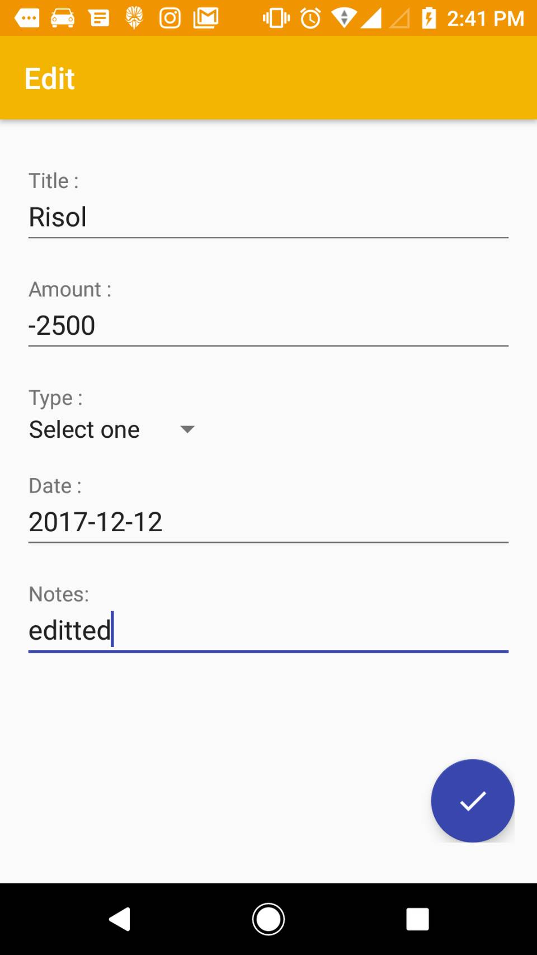

## DESCRIPTIONS OF FIELDS, CONTENT

Screenshot 7.1 shows all the functionalities of edit. Different from add new, edit only change if user want to change transaction information.

1. Tittle: Transaction’s Tittle
2. Amount : fill in some money
3. Type : type of expenses incurred
4. Date, DD/MM/YY : the time required for income or expenditure
5. Some Notes : additional note of interest

## DESCRIPTION OF ACTIONS

Action after user creates an income / expense transaction, information can be changed if user click edit button. edit can be done to change all the information contained in the data

## SEQUENCE OF SCREENS

Edit will be shown when user selected edit and user can edit information about the transaction.

# References

<https://material.io/guidelines/material-design/introduction.html>

[https://material.io/guidelines/layout/structure.html#](https://material.io/guidelines/layout/structure.html)

[https://material.io/guidelines/usability/accessibility.html#](https://material.io/guidelines/usability/accessibility.html)