ALS SVM Model Report

# Feature Set

pis_score, ls2slct, ls3-mpss, ls4-lcs, ls5-uss, ls6-dc, ls1-totalEnglish, ls1-totalFilipino, flt-overall-score

# Target Variable

Ready_Status (1 = Ready, 0 = Not Ready)

# Readiness Logic

If Level is JHS/SHS and FLT Overall Score is ≥ 75%, mark as Ready (1). Otherwise, Not Ready (0).

# Class Distribution

Not Ready: 968 learners

Ready: 1065 learners

# Original Class Distribution

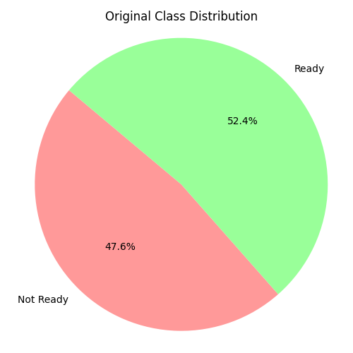

# Model Used

Support Vector Machine (SVM) with RBF kernel

# Model Performance

Accuracy: 98.77%

Confusion Matrix:  
[[181 0]  
 [ 5 221]]

Classification Report:  
 precision recall f1-score support  
  
 0 0.97 1.00 0.99 181  
 1 1.00 0.98 0.99 226  
  
 accuracy 0.99 407  
 macro avg 0.99 0.99 0.99 407  
weighted avg 0.99 0.99 0.99 407

# Cross-Validation (5-Fold)

Mean Accuracy: 99.02%

Standard Deviation: 0.0162

# Confusion Matrix

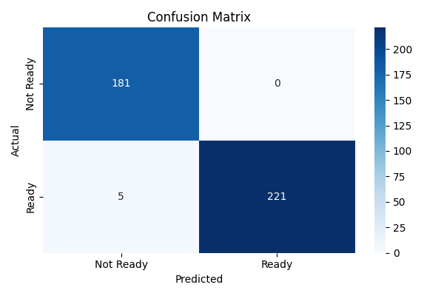

# ROC Curve

The ROC curve shows the trade-off between sensitivity and specificity.

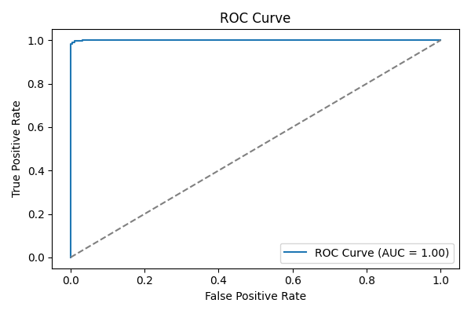

# Ready vs Not Ready Learners

