Name：Wei** Company: Xiaomi Department: Business Operations
RCA Process
Q1. What is the process of a cloud incident root cause analysis in the real world?
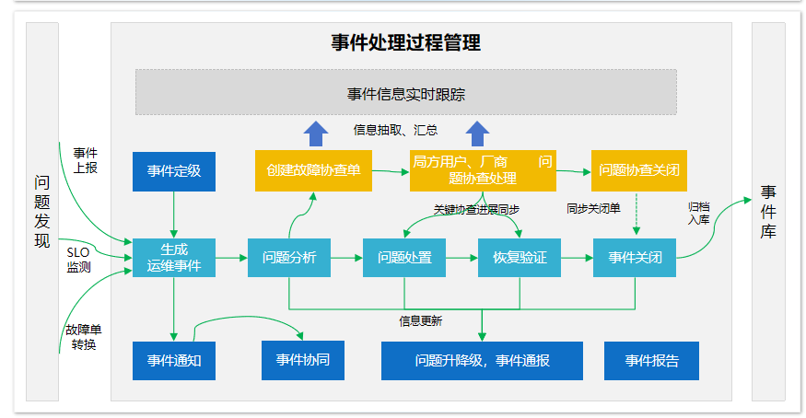

Roles In RCA
Q2. In your previous operations experience, aside from operations engineer, what other roles were typically involved?
Business Specialist
System Architect

Q3. In what ways did each of the previously identified roles participate in different steps of the RCA process?
Business Specialist: Works on understanding and prioritizing the incident's impact on business processes, aiding in setting investigation priorities.
System Architect: Evaluates the system’s structural design to detect any weaknesses or misconfigurations that could lead to the issue.

Human feedback in RCA
Q4. In your experience, how can human feedback be effectively integrated into the AI-based RCA process?
To effectively integrate human feedback, AI-based RCA should be designed with checkpoints for human intervention, where experienced engineers verify and adjust AI-generated hypotheses. Rather than relying solely on AI outputs, these checkpoints allow humans to validate, refine, or completely redirect findings based on firsthand knowledge and practical experience.

For example, after the AI suggests a root cause, engineers can quickly cross-check against known issues or add context the AI might lack, such as recent configuration changes. This back-and-forth, with AI providing data-driven insights and humans applying domain expertise, creates a dynamic process where AI doesn’t just generate reports but genuinely collaborates, learning from each human interaction to improve over time.

