Questions:

Should ‘**5**’ be considered as the neighbor of **Target** polygon?

The two polygons only attach at 1 point, in Generate Spatial Weight Matrix, I would not get ‘5’ as my neighbor if applied ‘CONTIGUITY_EGHES_ONLY’, but in Polygon Neighbors (in Analysis Tools), ‘5’ is considered as the attached neighbor of Target polygon.

Except that, the results are as expected (still need to further inspection to make sure all the cases), GSWM provided more than 4 neighbors if the attached polygons were less than 4; both in PCS and GCS.

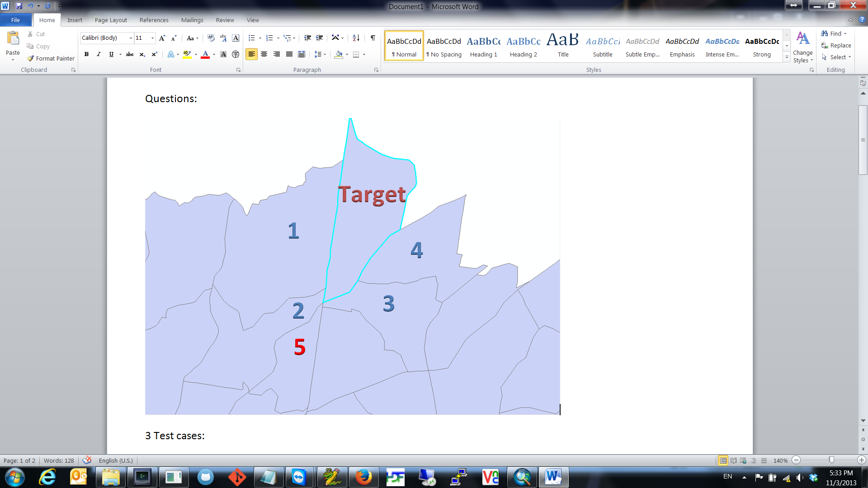

Test details are in the below:

Test data:

3 Test cases:

1. PCS polygons: polygon.shp (254 features)
2. GCS polygons: tracts.shp (218 features)
3. Larger PCS polygons: UScounties.shp (3978 features)

Test Scenario:

1. Used updated Weight.py script running Generate Spatial Weight Matrix, applied ‘CONTIGUITY_EGHES_ONLY’, and set Number of Neighbors as ‘4’, as below

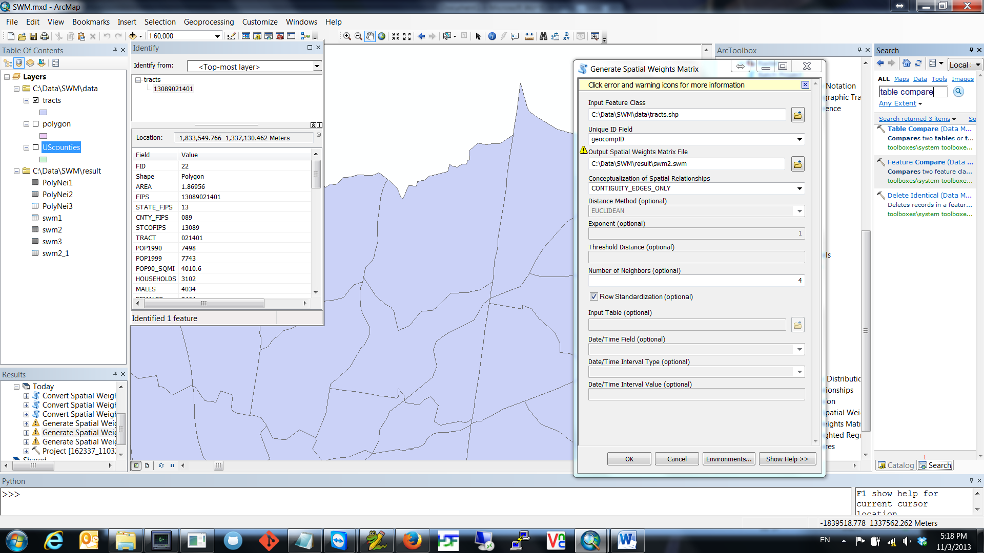

1. Use toolbox-> Analysis Tools -> Proximity -> Polygon Neighbors, as reference.
2. If the polygon has more than 4 attached neighbors, the result of Polygon Neighbors and GSWM should be identical
3. If the attached neighbors are less than 4, GSWM should also provide 4 neighbor polygons

(ex: polygon2 has 2 attached neighbors, Polygon Neighbors shows 2 neighbors, but GSWM should have 4 neighbors, 2 as the Polygon Neighbors and 2 from k nearest neighbor)

1. Use Table Compare tool to compare two tables (GSWM vs. Polygon Neighbor)
2. GSWM should always have equal or more neighbors than Polygon Neighbor
3. GSWM should always have at least 4 neighbors