After-Sales Dashboard Guild
The dashboard reads Firebase data prepared from C4C and SAP related scripts. Refresh every 9am.

Dealer Name Mapping

Raw name / alias |  | Dashboard dealer name
Regent RV - Frankston; Snowy River Frankston; 3141 / 3140 / 3151 / 204678 / 211197 | → | Frankston
Regent RV - Traralgon; 3123 / 204672 | → | Traralgon
Regent RV - Perth; St James; 3121 / 204645 | → | ST James
Leisure Lion - Newcastle / New Castle; Morisset; | → | Heatherbrae
QCCC - Gympie; Leisure Lion Pty Ltd - Gympie; 3137 | → | Gympie
Leisure Lion - Bundaberg; 3138 | → | Bundaberg
Green RV - Forest Glen; GREEN RV PTY LTD | → | Forest Glen
Green RV - Slacks Creek | → | Slacks Creek
All other names | → | Use own name
Critical Mapping
A ticket is Critical when its mapped first-level status is Critical. Current critical codes:
Input status code | Mapping result | Dashboard meaning
Main status codes  Z1 Z2 Z3 Z4 Z5 Z6 ZM ZR ZV | Critical | Included in Critical totals and Enter Critical
Other critical codes  Y6 YA YC | Critical | Included in Critical totals and Enter Critical
Z1 only | New Claim | New Claim is smaller than Enter Critical
Z1 New Claim,
Z2 Claim Assessment,
Z3 Awaiting Booking,
Z4/Z5/Z6 Requires Authorization,
ZM Management Query,
ZR Evidence Requested,
ZV Quote Validation,
Y6 Supplier Warranty Claim,
YA Awaiting Parts, and YC Suspended Claim.
Page 1 - Team Dashboard
- How to use Total Tickets card:
if no date range is selected, it shows total tickets. If a date range is selected, it shows total ticket change in that period.

- Entered Critical is wider than New Claim. It means tickets entering any Critical status, not only Z1 New Claim.

- Color direction: blue = entered critical, green = exited critical, orange = current critical stock.

- What 2-week benchmark means: tickets cleared within 14 days after entering critical.

- What Estimated clear time means: current critical backlog divided by recent net clear speed.

- Employee Color direction: Red bar = critical removed. Blue bar = current critical tickets.

- Employee Chart- Why red line can be higher than blue: Some exited employees tickets are handled by active employees.

Page 2 - Dealer Workbench
- Critical Tickets page shows the ticket list and critical status change log for the selected dealer.
- Parts Delivery page shows undelivered materials grouped by material and description.
- KPI 1: Current Awaiting Parts shows unique sales orders still waiting for parts. Prefer awaitingTicketRows(currentTickets).length; it deduplicates by sales order and keeps only ticketStatus == YA or text awaiting parts.
- KPI 2: Open Parts (Not Issued) counts material rows with material, not rejected, no rejection reason, and no first issue date. Prefer materialStats.openCount; otherwise use latest.kpi.openNotIssuedParts, then latest.kpi.openSoItems.
- Parts Selected table uses Period / Sales Order Selected. With current tickets, use buildUniqueSeriesFromTickets to count unique SOs by week, month, or year; otherwise use flow.newSoItems.
- Awaiting Parts and Parts Selected are unique SO counts; Issued, Open, Ageing, and Cost are material row counts.
- Risk Level Rules
Risk Level | Condition
Low | Current critical is under 30
Low | Dealer is nearly clean
High | Estimated clear time is over 90 days and critical change is over 15
Medium | Estimated clear time is over 45 days or critical change is over 20
Low | All other cases
Page 3 - Repairs
- Repair data comes from C4C.
- If role 43 is missing, use repairer name + state.
- Repair counts are material row-level, not ticket-level.
Analysis - Model Series
- Compare model series by repair rate first: Repairs / Units Sold. This shows which model series is most failure-prone.
- Check chassis repeat rate / average repairs per van to see whether the same unit keeps coming back. It can point to chronic faults, poor fix quality, or repeated claims on the same vehicle.
- Compare warranty cost by model, and also cost per unit sold, to see which series is draining the most budget.
- Use top failure components to find parts that keep failing, so you can separate one-off issues from repeat component problems.
- Split failure timing into 0-30, 30-90, 90-180, and 180+ days to tell build issues from supplier-life issues or normal wear.

Warranty Flow Overview
The diagram below summarizes the ticket, parts, and repair paths.
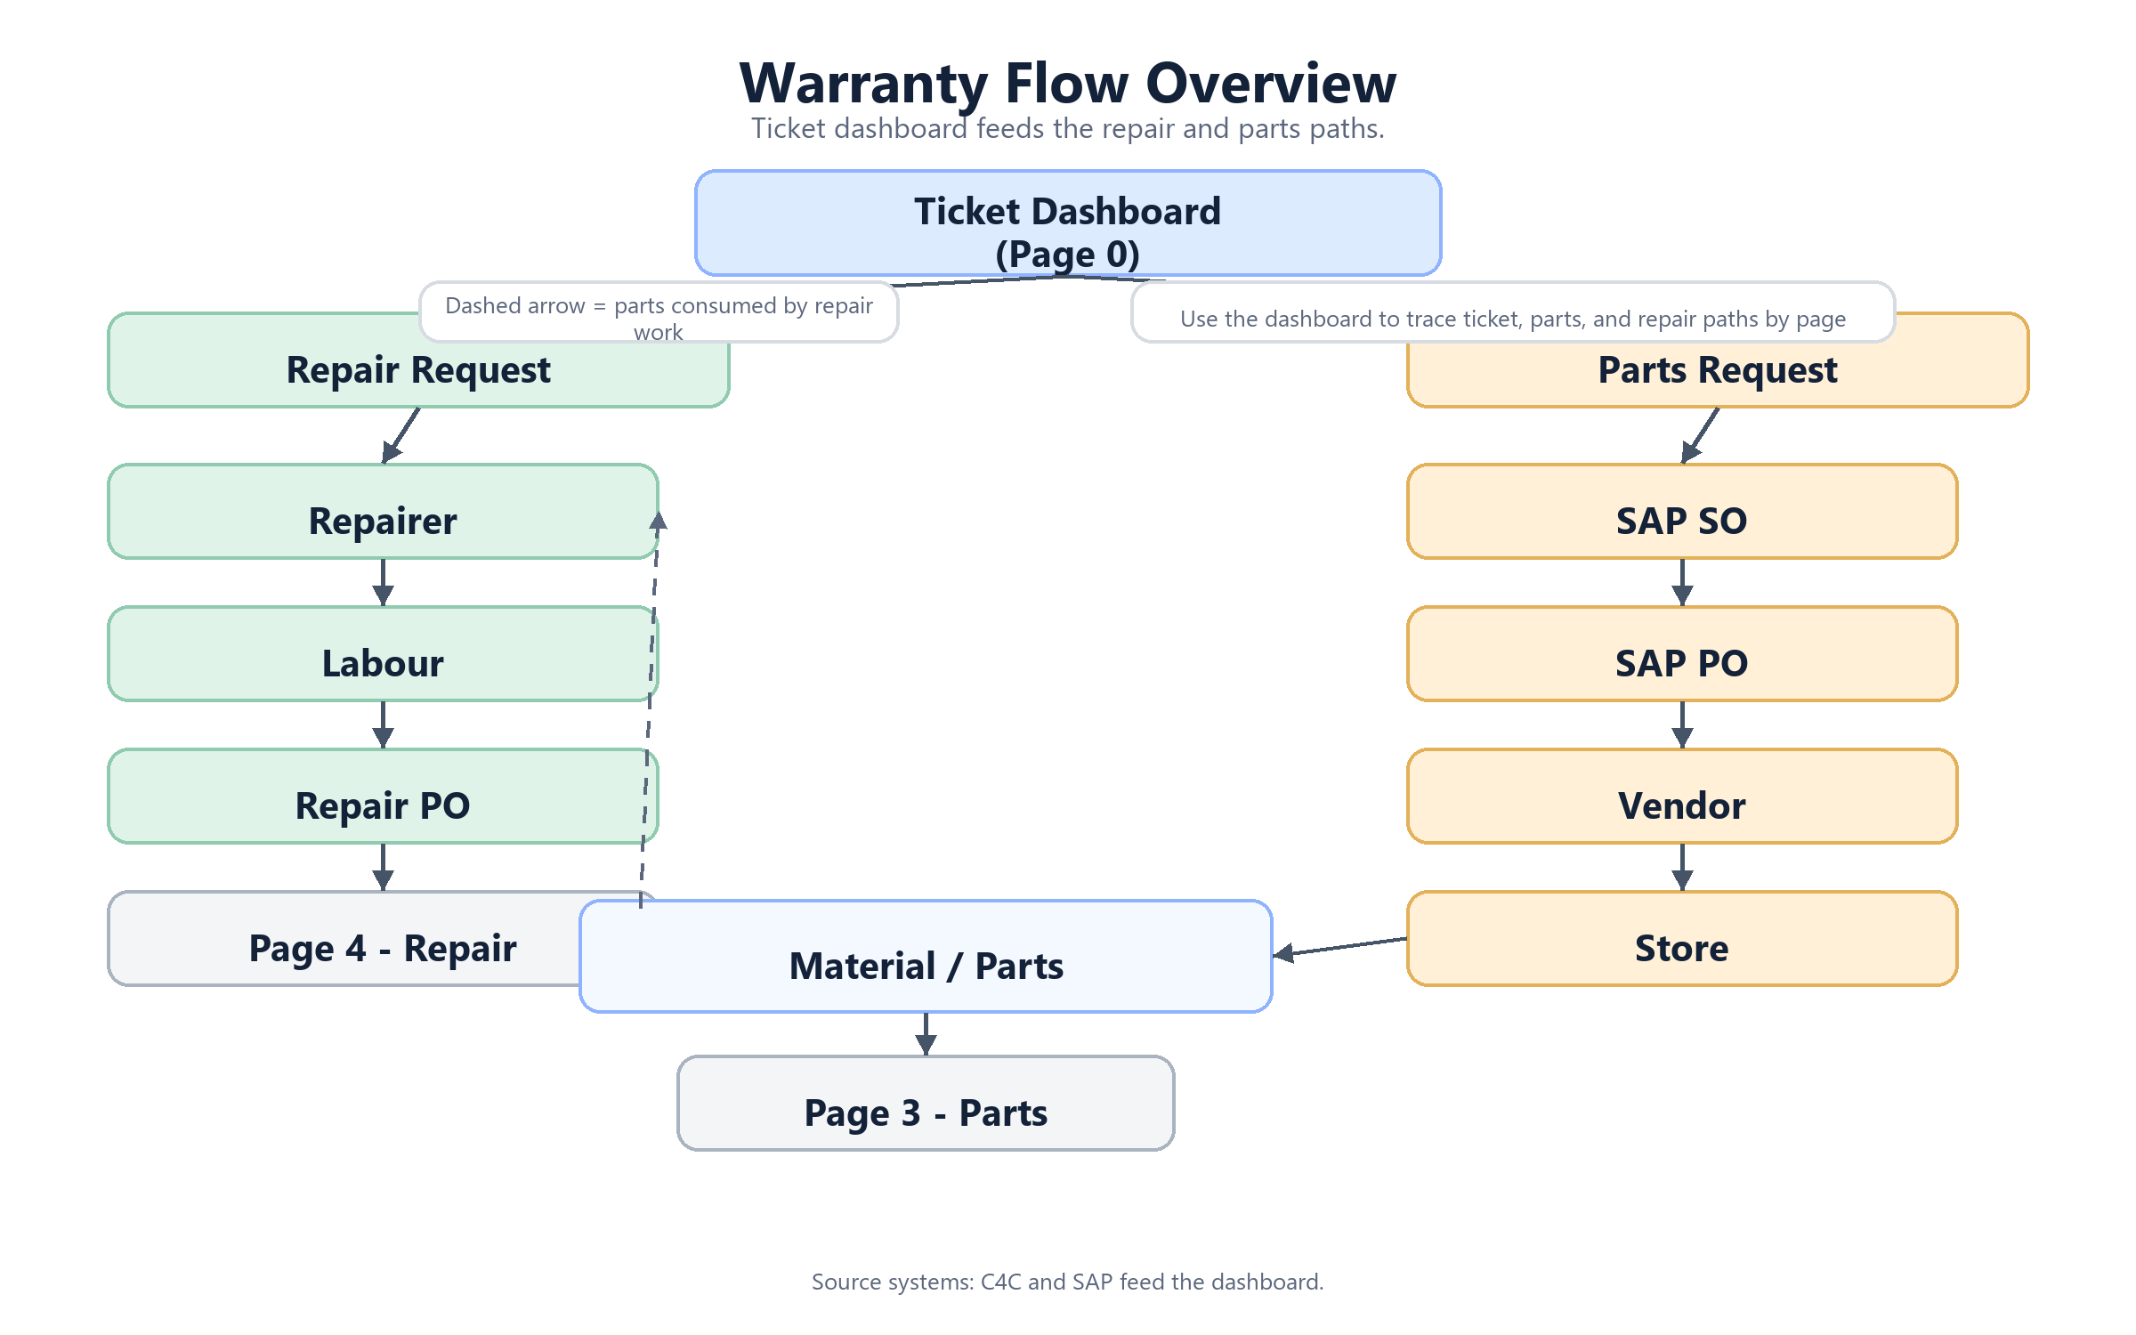
Flow chart based on the hand sketch.

