



Shivam Vinod Chaudhari
MC25B39












Date:

CERTIFICATE

This is to certify that Mr.Shivam Vinod Chaudhari has successfully completed the Practical Journal of “Python Programming” as a partial fulfilment of his/her Master of Computer Applications (MCA) Semester -I under the curriculum of Dnyaan Prasad Global University, Pune for the academic year 2025-26.

Mr. Amit Shrivastava Dr. Shikha Dubey
Course Incharge Program Head, MCA Head,Computer Application

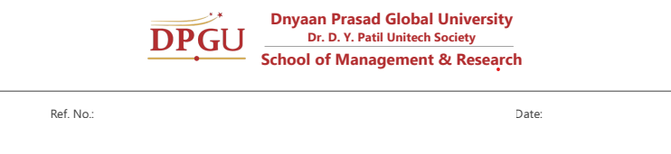

NO | PRACTICAL NAME | SIGN
1 | Demonstrate the installation of Python and Django.
2 | Develop and run your first Django application.
3 | Demonstrate the creation of simple models in Django.
4 | Perform basic ORM (Object Relational Mapping) operations on Django models.
5 | Establish and implement relationships between Django models.
6 | Implement Function-Based Views (FBVs) to handle web requests.
7 | Design dynamic web pages using Templates and manage Static Files.
8 | Implement Class-Based Views (CBVs) to simplify view logic.
9 | Create and handle Django Forms for user data input.
10 | Implement User Authentication, including login, logout, and registration functionality.
11 | Implement Authorization with defined User Roles and Permissions.
12 | Develop RESTful APIs using Django REST Framework.
13 | Implement CRUD (Create, Read, Update, Delete) operations using DRF.
14 | Implement API Authentication using Token or Session-based mechanisms.

1.Demonstrate the installation of Python and Django.

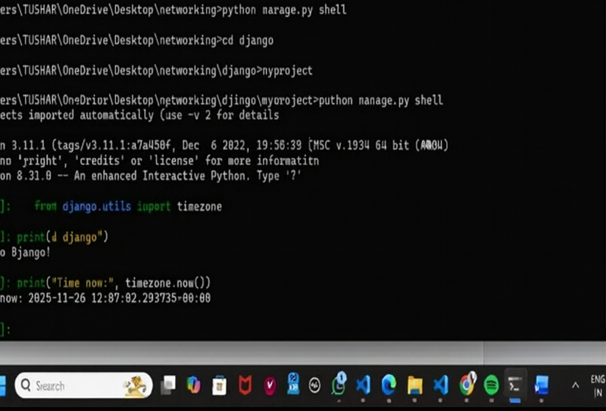

2. Develop and run your first Django application.

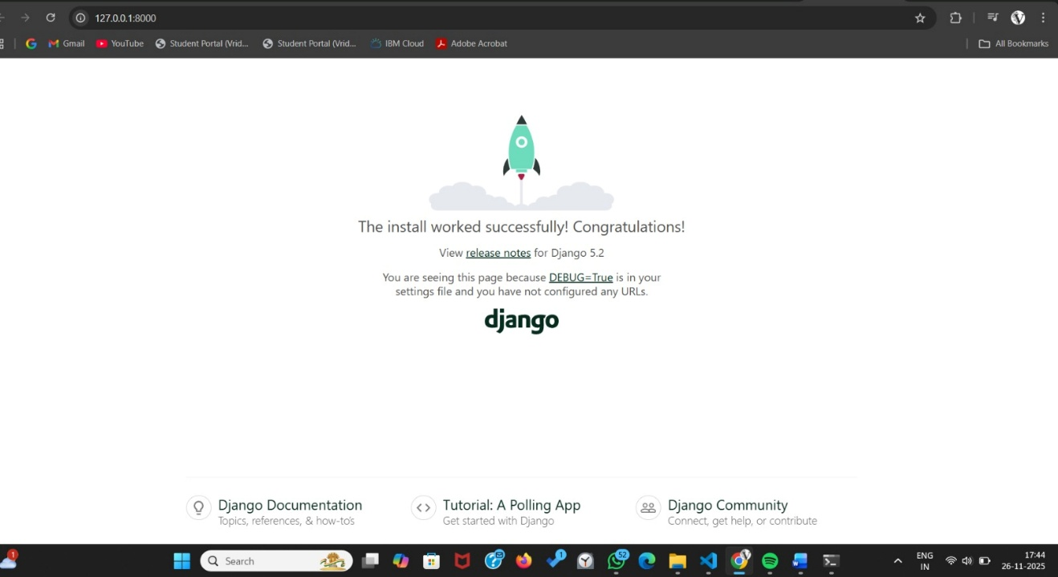

3.Demonstrate the creation of simple models in Django.

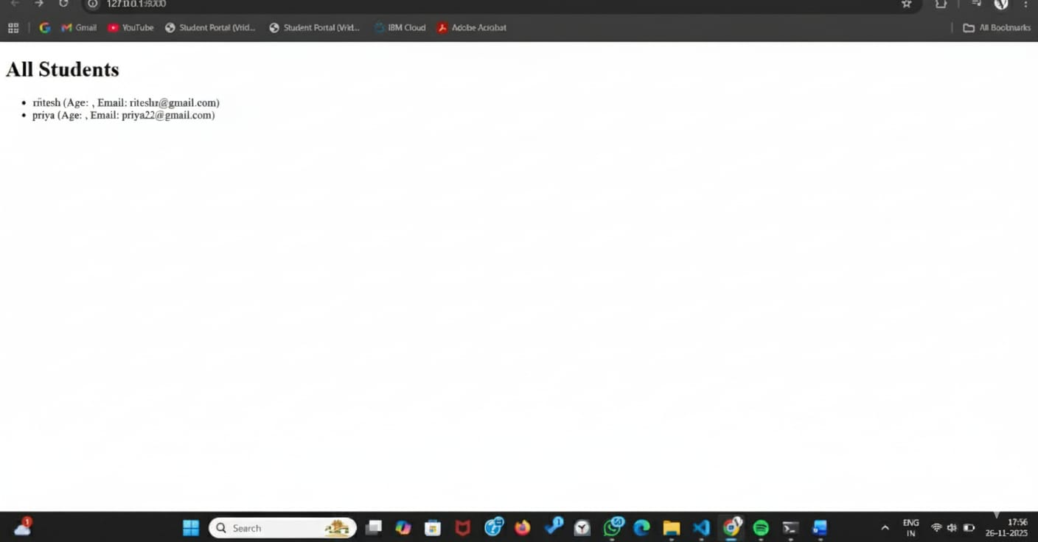

4. Perform basic ORM (Object Relational Mapping) operations on Django models.

5.Establish and implement relationships between Django models.

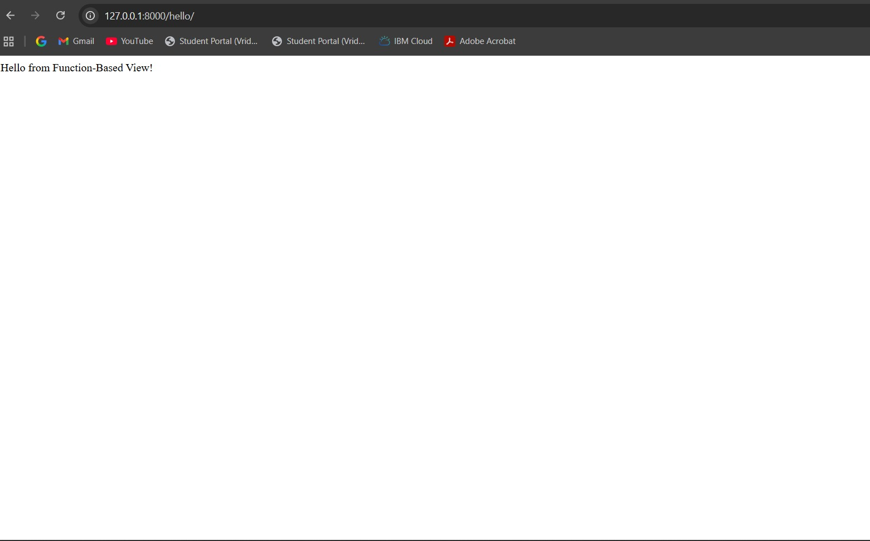

6.Implement Function-Based Views (FBVs) to handle web requests.

7. Design dynamic web pages using Templates and manage Static Files.

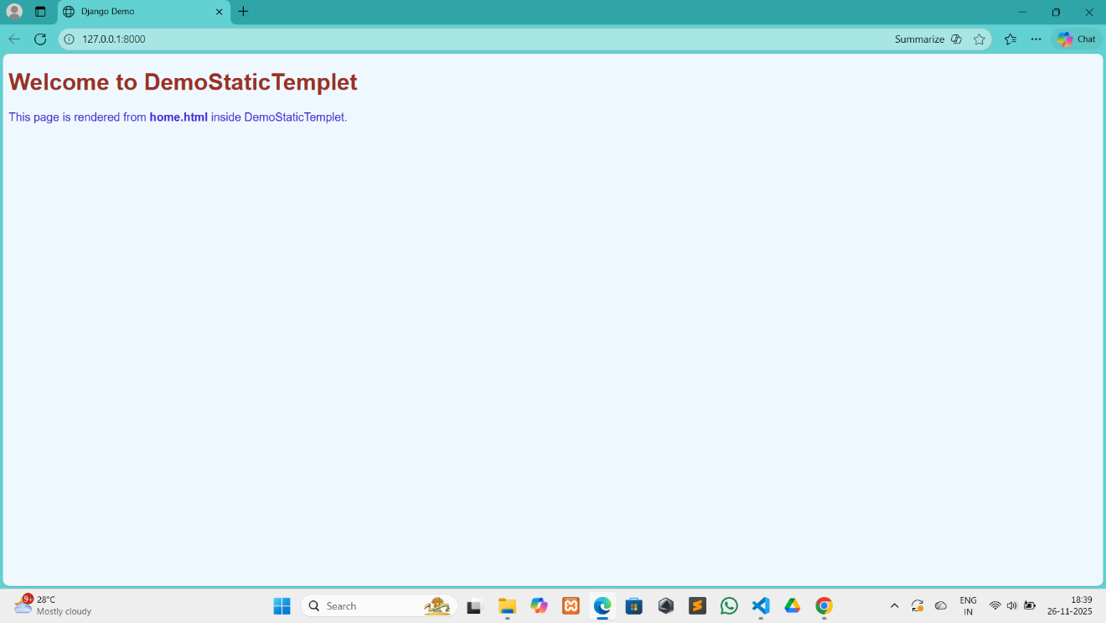

8.Implement Class-Based Views (CBVs) to simplify view logic.

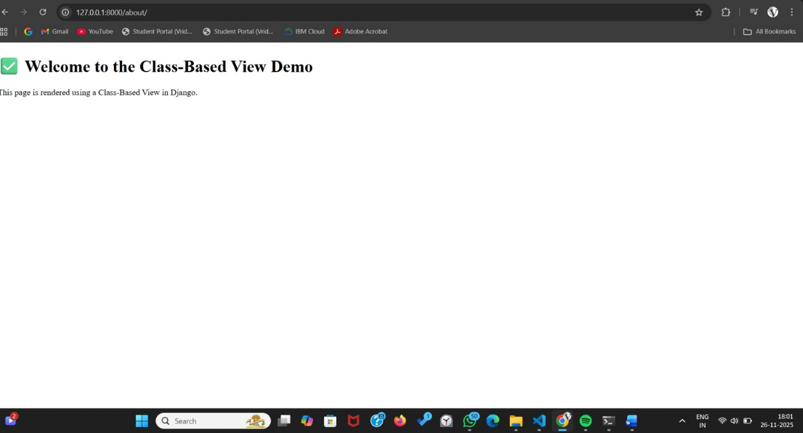

9. Create and handle Django Forms for user data input

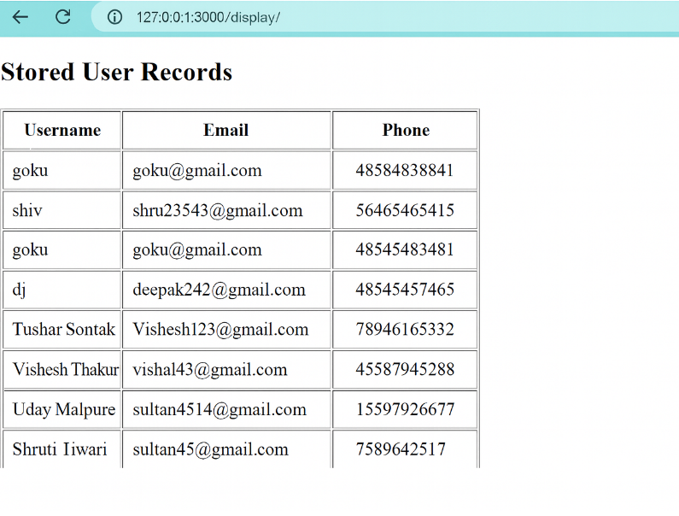
10. Implement User Authentication, including login, logout, and registration functionality.

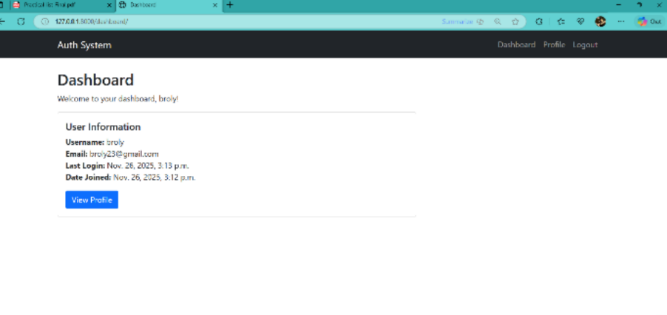

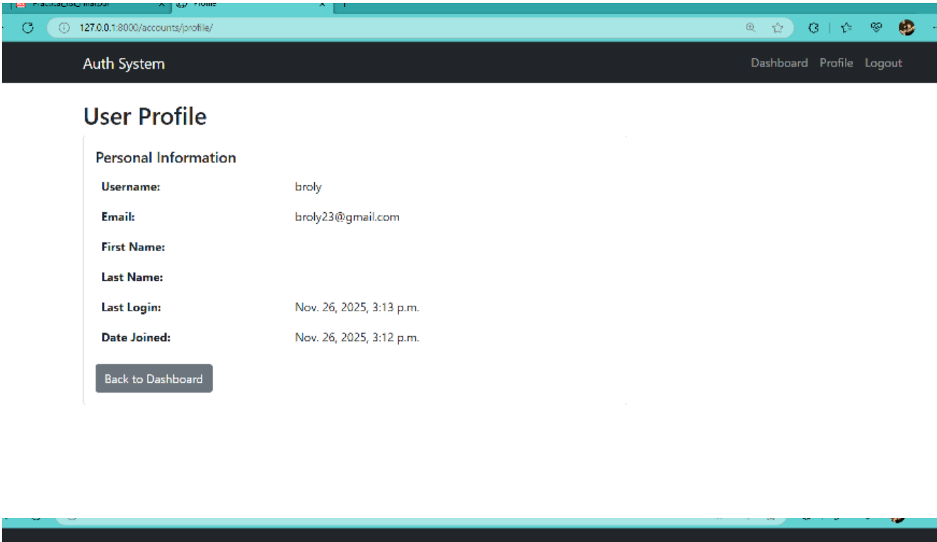

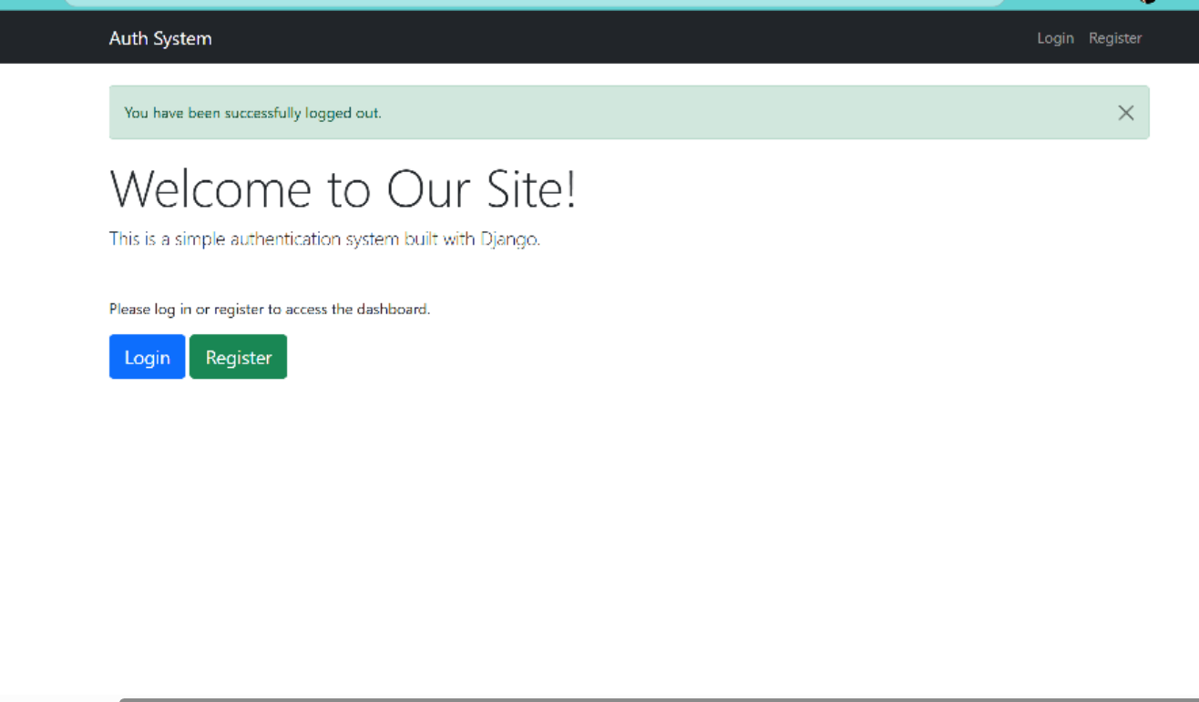

11. Implement Authorization with defined User Roles and Permissions.

1.models.py :
from django.db import models from django.contrib.auth.models import User from django.db.models.signals import post_save from django.dispatch import receiver
class UserProfile(models.Model):
ROLE_CHOICES = [
('super_admin', 'Super Administrator'),
('admin', 'Administrator'),
('manager', 'Manager'),
('editor', 'Editor'),
('user', 'Regular User'),
('viewer', 'Viewer'),
]

user = models.OneToOneField(User, on_delete=models.CASCADE)
role = models.CharField(max_length=20, choices=ROLE_CHOICES, default='user')
phone = models.CharField(max_length=20, blank=True)
department = models.CharField(max_length=100, blank=True)
created_at = models.DateTimeField(auto_now_add=True) updated_at = models.DateTimeField(auto_now=True)
def __str__(self):
return f"{self.user.username} - {self.role}"

@property
def is_super_admin(self):
return self.role == 'super_admin'

@property
def is_admin(self):
return self.role in ['super_admin', 'admin']

@property
def is_manager(self):
return self.role in ['super_admin', 'admin', 'manager']

@property
def is_editor(self):
return self.role in ['super_admin', 'admin', 'manager', 'editor']

@property
def is_viewer(self):
return self.role in ['super_admin', 'admin', 'manager', 'editor', 'viewer']
@receiver(post_save, sender=User) def create_user_profile(sender, instance, created, **kwargs):
if created:
UserProfile.objects.create(user=instance)
@receiver(post_save, sender=User) def save_user_profile(sender, instance, **kwargs):
if hasattr(instance, 'userprofile'):
instance.userprofile.save()
2. forms.py :
from django import forms
from django.contrib.auth.forms import UserCreationForm, AuthenticationForm from django.contrib.auth.models import User from .models import UserProfile
class CustomUserCreationForm(UserCreationForm):
email = forms.EmailField(required=True, widget=forms.EmailInput(attrs={'class': 'form-control'}))
first_name = forms.CharField(max_length=30, required=True, widget=forms.TextInput(attrs={'class': 'form-control'}))
last_name = forms.CharField(max_length=30, required=True, widget=forms.TextInput(attrs={'class': 'form-control'}))

class Meta:
model = User
fields = ('username', 'email', 'first_name', 'last_name', 'password1', 'password2')
widgets = {
'username': forms.TextInput(attrs={'class': 'form-control'}),
}
def __init__(self, *args, **kwargs):
super().__init__(*args, **kwargs)
self.fields['password1'].widget.attrs.update({'class': 'form-control'})
self.fields['password2'].widget.attrs.update({'class': 'form-control'})
def save(self, commit=True):
user = super().save(commit=False)
user.email = self.cleaned_data['email']
user.first_name = self.cleaned_data['first_name']
user.last_name = self.cleaned_data['last_name'] if commit:
user.save() return user
class UserProfileForm(forms.ModelForm):
class Meta:
model = UserProfile
fields = ('role', 'phone', 'department')
widgets = {
'role': forms.Select(attrs={'class': 'form-control'}),
'phone': forms.TextInput(attrs={'class': 'form-control'}),
'department': forms.TextInput(attrs={'class': 'form-control'}),
}
class UserUpdateForm(forms.ModelForm):
email = forms.EmailField(widget=forms.EmailInput(attrs={'class': 'formcontrol'}))
class Meta:
model = User
fields = ['username', 'email', 'first_name', 'last_name']
widgets = {
'username': forms.TextInput(attrs={'class': 'form-control'}),
'first_name': forms.TextInput(attrs={'class': 'form-control'}),
'last_name': forms.TextInput(attrs={'class': 'form-control'}),
}
class RoleAssignmentForm(forms.ModelForm):
class Meta:
model = UserProfile
fields = ['role']
widgets = {
'role': forms.Select(attrs={'class': 'form-control'}),

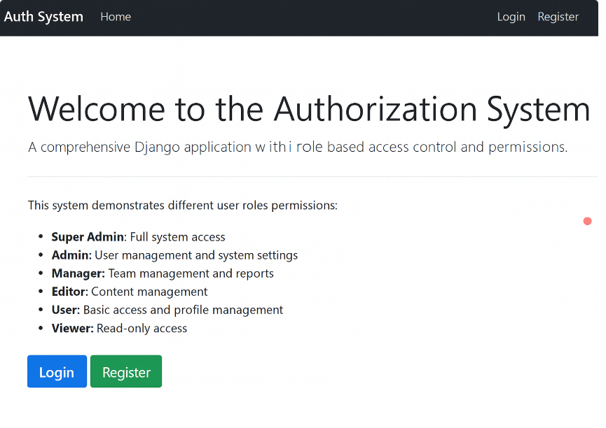

12.Develop RESTful APIs using Django REST Framework

13. Implement CRUD (Create, Read, Update, Delete) operations using DRF.

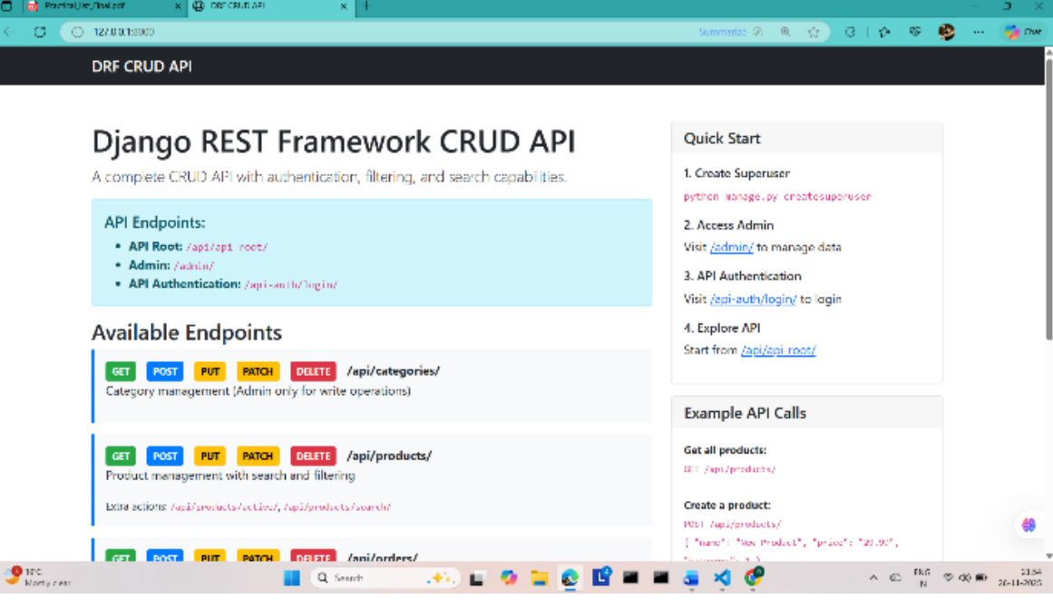

14. Implement API Authentication using Token or Session-based mechanisms.

