Colors

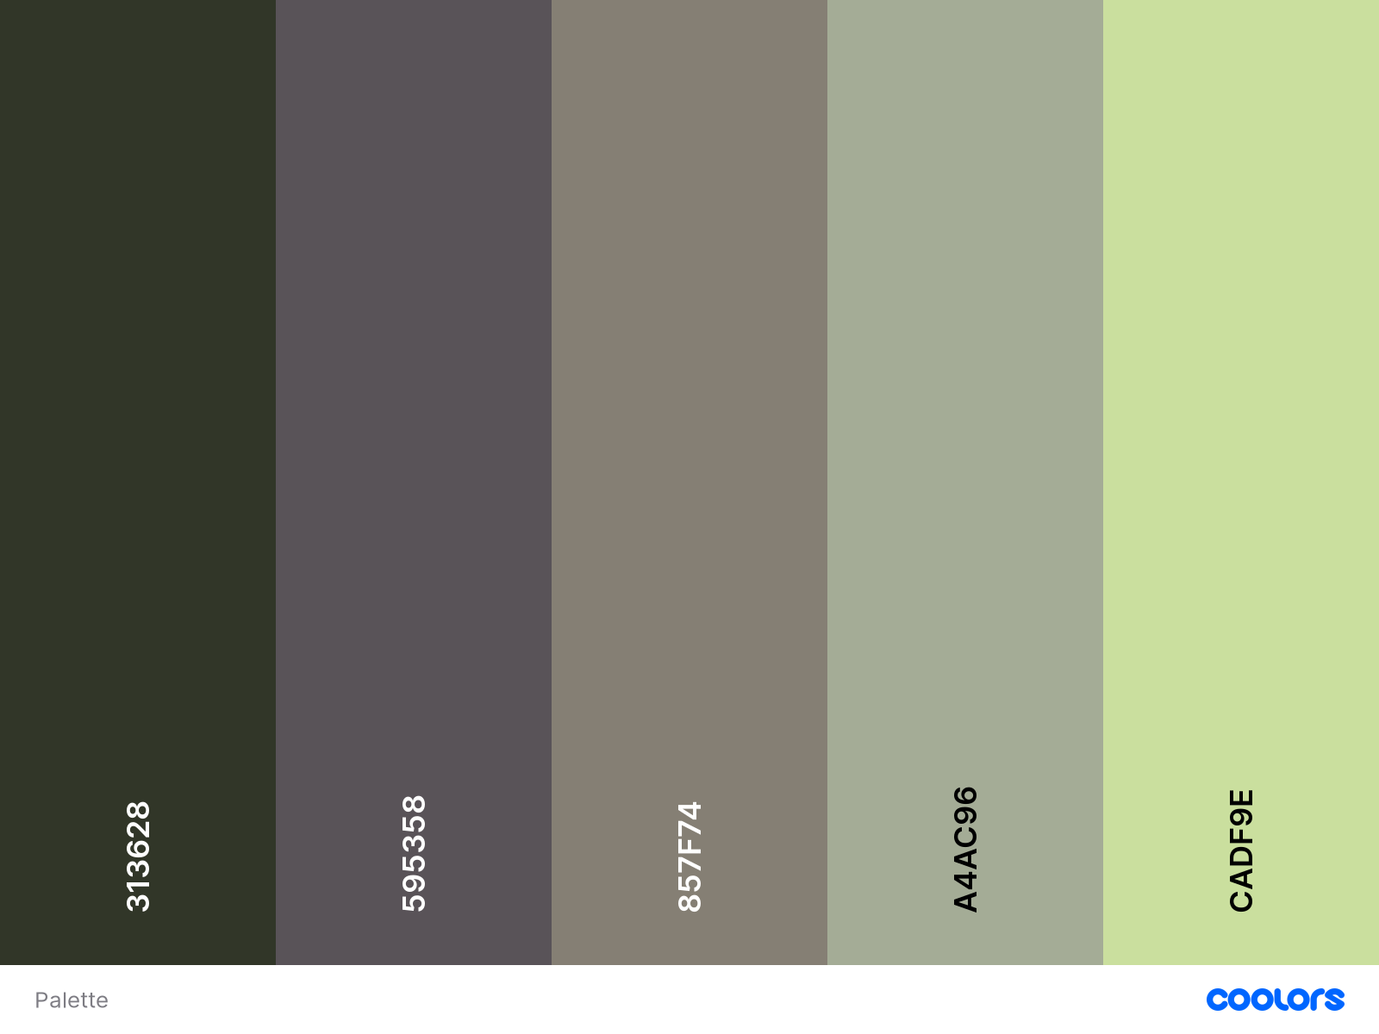

## Typography

## Arial Rounded MT Bold

Hello