TP07 — CI/CD con GitHub Actions
El entregable pide un pipeline que hace build, test y deploy automático al hacer push, conectado al repo de Docker del TP06 (anterior).

Cómo funciona un pipeline CI/CD
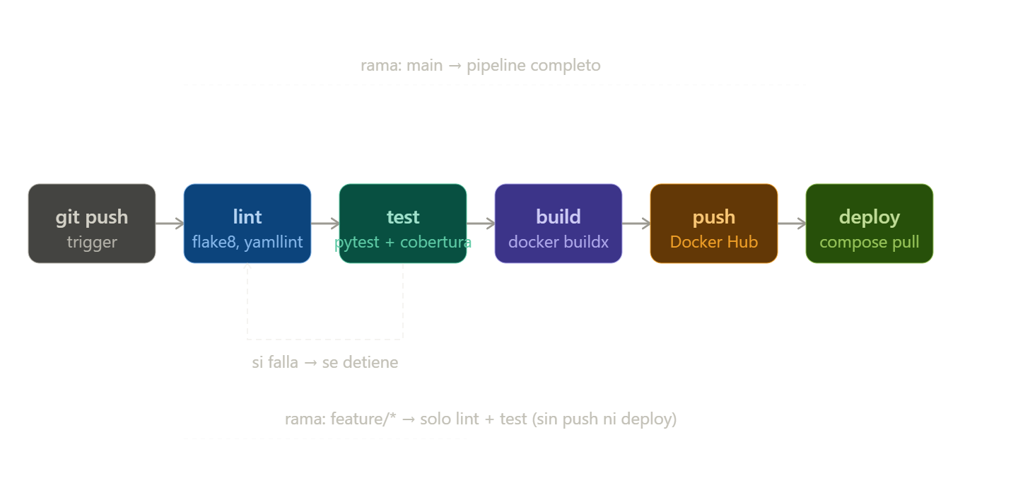

Paso 1 — Preparar el proyecto
Vamos a trabajar sobre el repo del TP06 agregándole el pipeline.
cd ~/devops-TP06

# Crear la estructura de GitHub Actions
mkdir -p .github/workflows

# Agregar tests al backend
mkdir -p backend/tests

Paso 2 — Agregar tests al backend
Los tests son necesarios para que el pipeline tenga algo que verificar. Sin tests, el stage "test" no existe.
cat > backend/tests/test_app.py << 'EOF'
import pytest
import json
import sys, os
sys.path.insert(0, os.path.join(os.path.dirname(__file__), '..'))

# Mock de psycopg2 para no necesitar Postgres en los tests unitarios
from unittest.mock import patch, MagicMock

@pytest.fixture
def client():
with patch('app.get_conn') as mock_conn:
mock_cursor = MagicMock()
mock_conn.return_value.cursor.return_value = mock_cursor
mock_cursor.fetchall.return_value = [
(1, "Nota test", "Contenido test", "2026-05-13 00:00:00")
]
mock_cursor.fetchone.return_value = (1,)
import app as flask_app
flask_app.app.config['TESTING'] = True
with flask_app.app.test_client() as client:
yield client

def test_health(client):
with patch('app.get_conn') as mock_conn:
mock_conn.return_value # simula conexión exitosa
r = client.get('/health')
assert r.status_code == 200
data = json.loads(r.data)
assert 'status' in data

def test_get_notes(client):
r = client.get('/api/notes')
assert r.status_code == 200
data = json.loads(r.data)
assert isinstance(data, list)

def test_create_note(client):
r = client.post(
'/api/notes',
data=json.dumps({'title': 'Test', 'content': 'Contenido'}),
content_type='application/json'
)
assert r.status_code == 201

def test_create_note_sin_titulo(client):
r = client.post(
'/api/notes',
data=json.dumps({'content': 'Sin título'}),
content_type='application/json'
)
# Debe fallar con 400 o 500 si no hay título
assert r.status_code in [400, 500]

def test_delete_note(client):
r = client.delete('/api/notes/1')
assert r.status_code == 200
EOF

# Dependencias de test
cat >> backend/requirements.txt << 'EOF'
pytest==7.4.0
pytest-cov==4.1.0
flake8==7.0.0
EOF

Paso 3 — El workflow principal: CI/CD completo
cat > .github/workflows/cicd.yml << 'EOF'
# ============================================
# cicd.yml — Pipeline completo CI/CD
# TP0 7 — Plan DevOps
# ============================================

name: CI/CD Pipeline

# ── Triggers ──────────────────────────────────────────────
on:
push:
branches:
- main # pipeline completo
- develop # solo CI (sin deploy)
- 'feature/**' # solo lint + test
pull_request:
branches:
- main
- develop

# ── Variables globales ────────────────────────────────────
env:
DOCKER_IMAGE: ${{ secrets.DOCKERHUB_USERNAME }}/devops-portfolio
PYTHON_VERSION: "3.12"

# ── Jobs ──────────────────────────────────────────────────
jobs:

# ── Job 1: Lint ────────────────────────────────────────
lint:
name: Lint
runs-on: ubuntu-latest
steps:
- name: Checkout código
uses: actions/checkout@v4

- name: Setup Python
uses: actions/setup-python@v5
with:
python-version: ${{ env.PYTHON_VERSION }}
cache: 'pip'

- name: Instalar dependencias de lint
run: pip install flake8 yamllint

- name: Lint Python (flake8)
run: |
flake8 backend/ \
--max-line-length=100 \
--exclude=backend/tests/ \
--count --statistics

- name: Lint YAML (yamllint)
run: |
yamllint -d "{extends: default, rules: {line-length: {max: 120}}}" \
docker-compose.yml \
.github/workflows/

# ── Job 2: Test ────────────────────────────────────────
test:
name: Test
runs-on: ubuntu-latest
needs: lint # solo corre si lint pasa

steps:
- name: Checkout código
uses: actions/checkout@v4

- name: Setup Python
uses: actions/setup-python@v5
with:
python-version: ${{ env.PYTHON_VERSION }}
cache: 'pip'

- name: Instalar dependencias
run: pip install -r backend/requirements.txt

- name: Correr tests con cobertura
run: |
cd backend
pytest tests/ \
--cov=. \
--cov-report=term-missing \
--cov-report=xml \
-v

- name: Subir reporte de cobertura
uses: actions/upload-artifact@v4
with:
name: coverage-report
path: backend/coverage.xml
retention-days: 7

# ── Job 3: Build y Push ────────────────────────────────
# Solo en main y develop (no en feature/*)
build-push:
name: Build y Push imagen
runs-on: ubuntu-latest
needs: test
if: github.ref == 'refs/heads/main' || github.ref == 'refs/heads/develop'

outputs:
image-tag: ${{ steps.meta.outputs.tags }}
image-digest: ${{ steps.build.outputs.digest }}

steps:
- name: Checkout código
uses: actions/checkout@v4

# Genera tags automáticos: latest, sha-abc123, v1.0 si hay tag
- name: Docker metadata
id: meta
uses: docker/metadata-action@v5
with:
images: ${{ env.DOCKER_IMAGE }}
tags: |
type=ref,event=branch
type=sha,prefix=sha-,format=short
type=raw,value=latest,enable=${{ github.ref == 'refs/heads/main' }}

- name: Login a Docker Hub
uses: docker/login-action@v3
with:
username: ${{ secrets.DOCKERHUB_USERNAME }}
password: ${{ secrets.DOCKERHUB_TOKEN }}

# buildx permite builds multi-plataforma (linux/amd64 + linux/arm64)
- name: Setup Docker Buildx
uses: docker/setup-buildx-action@v3

- name: Build y Push
id: build
uses: docker/build-push-action@v5
with:
context: ./backend
target: final
push: true
tags: ${{ steps.meta.outputs.tags }}
labels: ${{ steps.meta.outputs.labels }}
# Cache entre runs para builds más rápidos
cache-from: type=gha
cache-to: type=gha,mode=max

- name: Resumen del build
run: |
echo "### Imagen publicada" >> $GITHUB_STEP_SUMMARY
echo "Tags: ${{ steps.meta.outputs.tags }}" >> $GITHUB_STEP_SUMMARY
echo "Digest: ${{ steps.build.outputs.digest }}" >> $GITHUB_STEP_SUMMARY

# ── Job 4: Deploy ──────────────────────────────────────
# Solo en main (nunca en develop ni feature)
deploy:
name: Deploy
runs-on: ubuntu-latest
needs: build-push
if: github.ref == 'refs/heads/main'
environment: production # requiere aprobación manual si se configura

steps:
- name: Checkout código
uses: actions/checkout@v4

- name: Deploy via SSH
uses: appleboy/ssh-action@v1
with:
host: ${{ secrets.DEPLOY_HOST }}
username: ${{ secrets.DEPLOY_USER }}
key: ${{ secrets.DEPLOY_SSH_KEY }}
script: |
cd /opt/devops-portfolio
docker compose pull
docker compose up -d --remove-orphans
docker image prune -f
echo "Deploy completado: $(date)"

- name: Healthcheck post-deploy
run: |
sleep 10
STATUS=$(curl -s -o /dev/null -w "%{http_code}" \
--max-time 10 \
"http://${{ secrets.DEPLOY_HOST }}/health" || echo "000")
if [ "$STATUS" = "200" ]; then
echo "Deploy exitoso — HTTP $STATUS"
else
echo "Deploy falló — HTTP $STATUS"
exit 1
fi
EOF

Paso 4 — Workflow separado solo para PRs
cat > .github/workflows/pr-check.yml << 'EOF'
# ============================================
# pr-check.yml — Checks rápidos en Pull Requests
# ============================================

name: PR Check

on:
pull_request:
branches: [main, develop]

jobs:
validate:
name: Validar PR
runs-on: ubuntu-latest

steps:
- uses: actions/checkout@v4

- name: Setup Python
uses: actions/setup-python@v5
with:
python-version: "3.12"
cache: 'pip'

- name: Instalar dependencias
run: pip install -r backend/requirements.txt

- name: Tests
run: cd backend && pytest tests/ -v

- name: Verificar docker-compose sintaxis
run: docker compose config --quiet

- name: Comentar resultado en el PR
if: always()
uses: actions/github-script@v7
with:
script: |
const status = '${{ job.status }}' === 'success' ? 'OK' : 'ERR';
github.rest.issues.createComment({
issue_number: context.issue.number,
owner: context.repo.owner,
repo: context.repo.repo,
body: `${status} **PR Check** — ${{ job.status }}\nCommit: \`${{ github.sha }}\``
});
EOF

Paso 5 — Configurar los Secrets en GitHub
Los secrets son variables cifradas que el pipeline lee sin exponerlas en el código. Vas a Settings → Secrets and variables → Actions → New repository secret:
DOCKERHUB_USERNAME → tu usuario de Docker Hub
DOCKERHUB_TOKEN → token de Docker Hub (no tu contraseña)
DEPLOY_HOST → IP o dominio del servidor de deploy
DEPLOY_USER → usuario SSH del servidor
DEPLOY_SSH_KEY → clave privada SSH (contenido del archivo id_rsa)
Para generar el token de Docker Hub: hub.docker.com → Account Settings → Security → New Access Token.
Para testear sin un servidor real, podés comentar el job deploy y solo verificar hasta build-push.

Paso 6 — Simular el pipeline localmente con act
act te permite correr GitHub Actions en tu máquina antes de hacer push, ahorrando muchos ciclos de prueba y error.
# Instalar act
curl https://raw.githubusercontent.com/nektos/act/master/install.sh | sudo bash

# Crear archivo de secrets locales (nunca lo commiteés)
cat > .secrets << 'EOF'
DOCKERHUB_USERNAME=tu-usuario
DOCKERHUB_TOKEN=tu-token
EOF

# Simular el push a main
act push --secret-file .secrets

# Simular solo el job de test
act push --secret-file .secrets --job test

# Listar todos los workflows disponibles
act --list

Paso 7 — Badge de estado en el README
cat > README.md << 'EOF'
# DevOps Portfolio — TP0 7: CI/CD

![CI/CD Pipeline](https://github.com/TU_USUARIO/devops-TP06/actions/workflows/cicd.yml/badge.svg)

App de notas con pipeline CI/CD completo usando GitHub Actions.

## Pipeline

| Stage | Trigger | Qué hace |
|- --|- --|-- -|
| lint | todo push | flake8 en Python, yamllint en YAML |
| test | después de lint | pytest con reporte de cobertura |
| build-push | main y develop | docker buildx, push a Docker Hub |
| deploy | solo main | SSH al servidor, compose pull + up |

## 4 Secrets requeridos

- DOCKERHUB_USERNAME,
- DOCKERHUB_TOKEN DEPLOY_HOST,
- DEPLOY_USER,
- DEPLOY_SSH_KEY

## Correr tests localmente

Ejecutar en bash
cd backend
pip install -r requirements.txt
pytest tests/ -v --cov=. --cov-report=term-missing

Estructura del pipeline
feature/* → lint → test
develop → lint → test → build → push
main → lint → test → build → push → deploy
EOF

---

## Subir a GitHub

Ejecutar en bash
cd ~/devops-TP06

git add .github/ backend/tests/ README.md
git commit -m "TP07: pipeline CI/CD con GitHub Actions

- cicd.yml: lint → test → build/push → deploy
- pr-check.yml: validación rápida en PRs con comentario automático
- tests unitarios con mocks para correr sin Postgres
- badges de estado en README
- cobertura de código subida como artifact"
git push origin main
Después del push, entrás a github.com/TU_USUARIO/devops-TP06/actions y ves el pipeline corriendo en tiempo real.

El concepto central de esta TP07 es la diferencia entre CI (Continuous Integration) y CD (Continuous Delivery/Deploy). CI es automático siempre: cada push corre lint y tests sin importar la rama, y si fallan el pipeline se detiene antes de llegar a producción. CD es selectivo: solo main hace deploy, y opcionalmente con aprobación manual mediante environments. El cache-from: type=gha en el build es lo que hace que el segundo build tarde 30 segundos en vez de 3 minutos: GitHub cachea las capas de Docker entre runs.

