**Key Figure - DSAI Student Project – “Intelligent AOM” Leo Forster & Jonas Henker**

Project Donor: Prof Dr. Jürgen Eschner & team (Experimental Physics - Quantum Photonics)

**Key figure:** The key figure shows the two discrete frequency spectra, with the first being the input of the arbitrary wave generator (**AWG**) & the second showing the spectrum of the laser after passing through the acoustic-optical modulator (**AOM**), measured by two photodetectors in combination with a beam splitter, so called heterodyne measurement. The third shows a potential, desired AOM output spectrum, for which the model should predict the required AWG input spectrum. 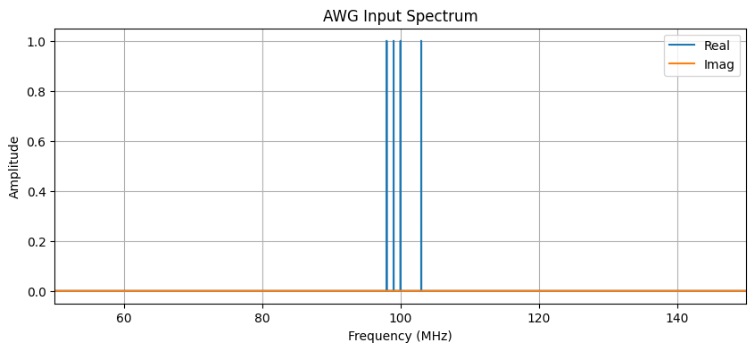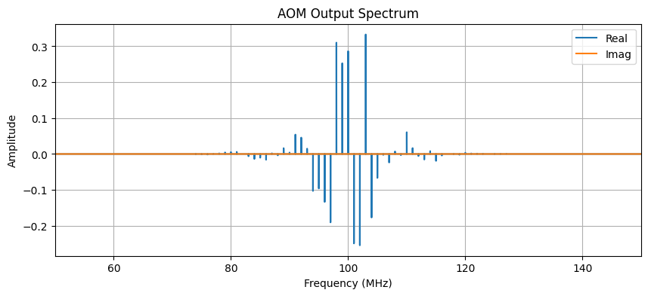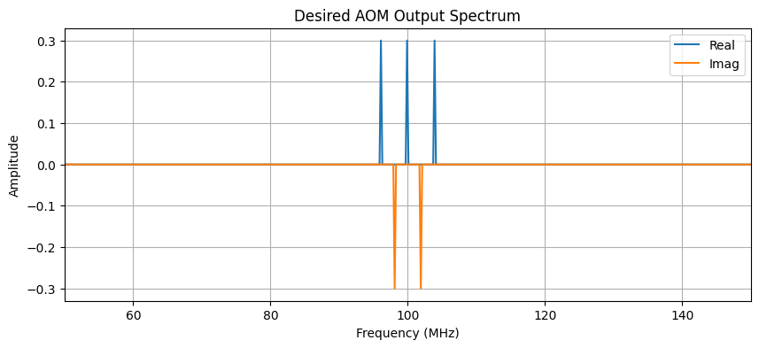

**Objective of this figure:** The objective of this figure is to show, how a machine learning model can be used to obtain a simple frequency configuration (*AWG Input Spectrum*), producing a desired output spectrum*,* given a rather complex, discrete laser spectrum (*Desired AOM Output Spectrum*)*.*  
The *AWG Input Spectrum* and *AOM Output Spectrum* show the non-linear relationship between the input and the output, and how even a simple AWG Input configuration can produce a complex output.

**Unit of observation:** Discrete frequency spectrum f’ of AOM for given, constant input frequency f of the laser and a non-linear interference v (unknown, learned by model). Given by the Fast-Fourier-Transform (**FFT**), this discrete spectrum contains real as well as imaginary components.

**Unit of measurement:** MHz

**Time window of observation:** Continuous real-time monitoring during experiment runtime.

**Overall description of this figure:** The figure shows the expected output of the machine learning model on a given input. In the learning phase, the model will get a *AOM Output Spectrum* as input and calculate the required *AWG Input Spectrum*, which will further be used to configure the AWG accordingly. When deployed, the input for the model will look more like the *Desired AOM Output Spectrum.*  
The AWG then modulates the laser, which has a constant frequency, via the AOM. After this, the laser should have the desired complex spectrum, which was given as input of the model.  
Here, a complex model is needed, since the input-output relation is typically non-linear.   
Once trained, the model operates in a closed-loop system, continuously receiving photodetector input and adjusting the RF signal to the AOM through an arbitrary waveform generator (AWG).

**Y-Axis:** Amplitude (-1 to 1 for all)

**X-Axis:** MHz (50 to 150 for all, although the AWG input will only utilize frequencies between 95 and 105 MHz)

**Legend:**   
“Real” - real components of FFT-Frequency bins (blue)  
“Imag” - imaginary components of FFT-Frequency bins (orange)

**Data processing required:**

1. Meta parameter selection: frequency-range for in- and output, number of frequency-bins, amplitude-range, carrier-frequency (constant frequency of laser)
2. Selection of AOM-model: We will simulate the AOM modulation with different, nonlinear AOM simulations. Thus, we need to preselect, different, viable AOM-models.
3. Sourcing of training data: We source the training data, by simulating different AWG-frequency-configurations on the AOM-models. Here we can already work with higher frequency-resolutions, so that a later re-simulation is not needed.
4. Frequency-domain transformation: We transform the continuous, time-based signals via the Fast-Fourier transform into discrete frequency spectra and vice versa.
5. Model architecture selection: We select the model architecture, which performs the best over all the different AOM-simulations, so that it will adapt the best to the real experiment-data when deployed.