**Motorcycle Classification with Convolutional Neural Networks**

# Summary

It always starts the same way. The forum post is always accompanied by a photo of some random motorcycle. What bike is this? Experts and novices alike scramble to find the make, model and year of the motorcycle pictured. Wouldn’t it be nice to easily classify a motorcycle from an image? This project seeks to do just that.

Using the power of pre-trained convolutional neural networks, we can customize the models to classify the year, make and model of motorcycle images. What kind of performance can we expect? Is it even possible? Motorcycles can be very similar between various models and years. We will find that we can routinely achieve around 70% top-3 accuracy with a relatively small data set. We will also find that to increase accuracy, we would likely need to greatly increase the size of the data set collected in this project. Along the way, we will look at methods to collect and process data, while building a suitable model for classification.

In the end, we will find that model tuning, data transformation, and data augmentation have, at best, incremental benefits on the model. In fact, the best time I spent on this project involved performance tuning Pytorch itself to achieve faster modeling times.

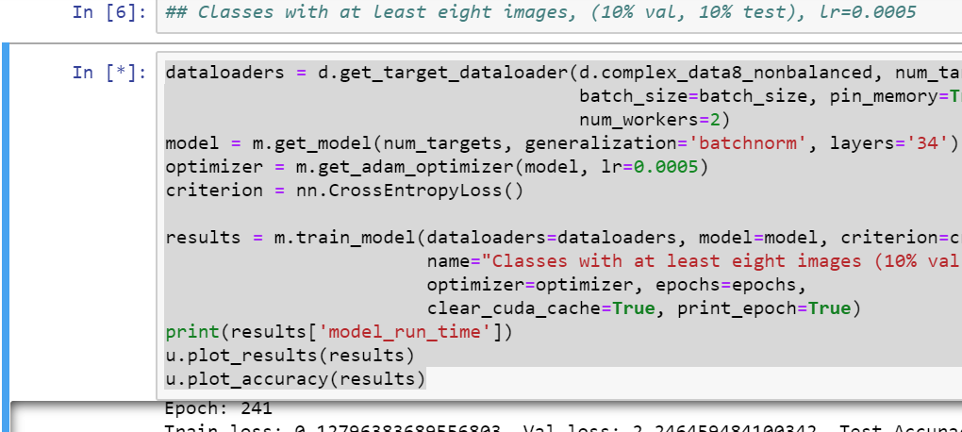

# Data

## Obtaining Data

## Pre-processing

## EDA

# Data Tuning

## Transforms

## Balance

# Modeling

## Model Selection

### Resnet-34

### Batchnorm vs. Dropout

## Model tuning

### Learning rate

### Batch Size

# Further Research

# Conclusion