**Instructions for using CIRCUIT ON App:**

1. Using your computer, **navigate** to the home page
2. **Sign in** using your credentials

 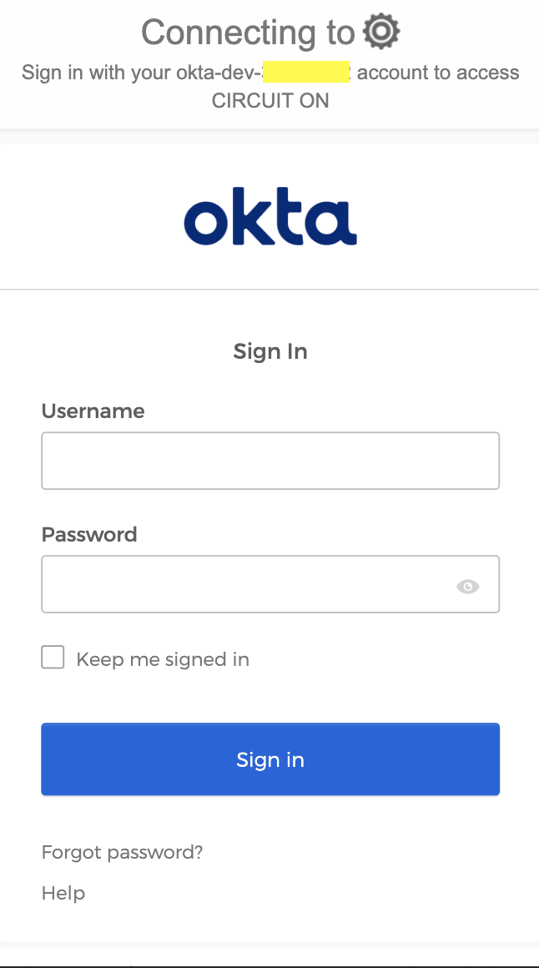 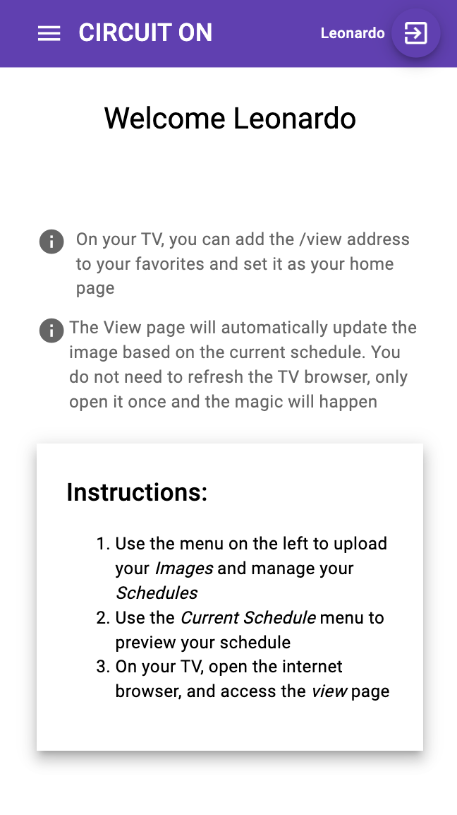

1. Use the menu on the left, click on **Manage Images**, and “**Add Item**”

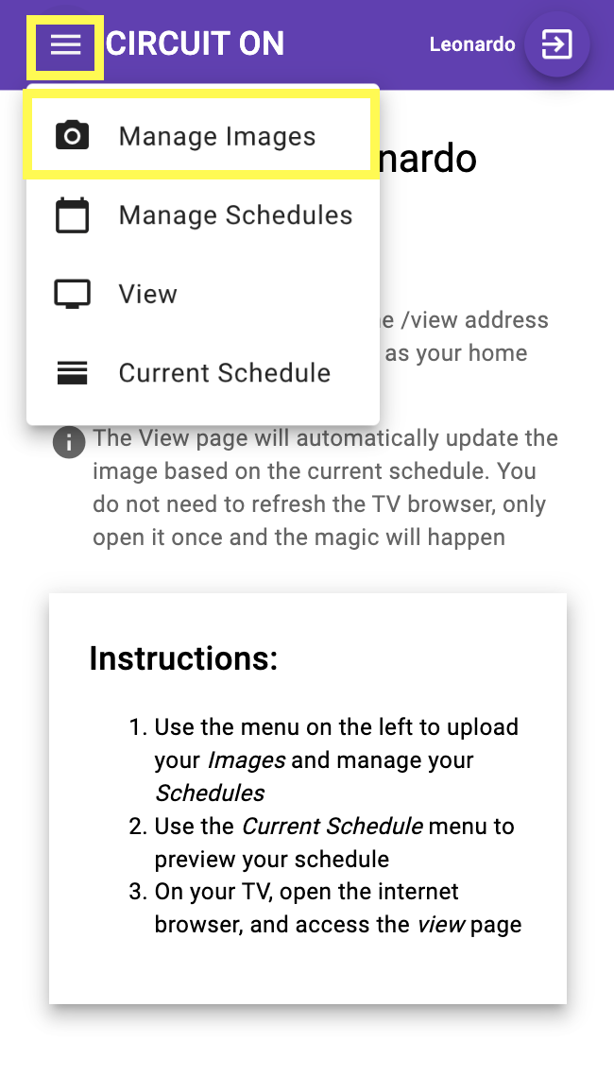 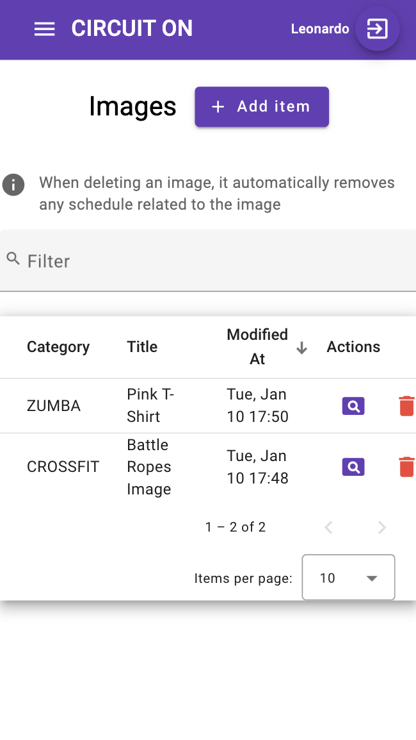 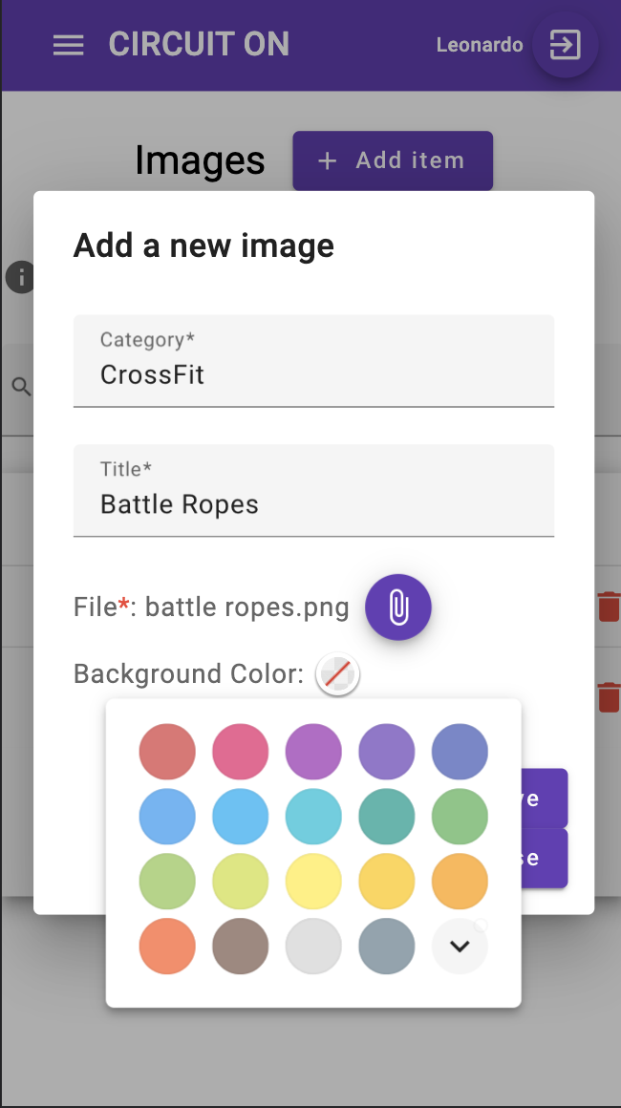

* 1. Select a **category**
  2. Enter a **title**. The title should describe your picture to help you to identify it in the future. E.g.: *Mobility: 16 min + Teams of 2 WOD AMRAP 17 min*
  3. Click on the select file **purple button** to select your **file**
     1. The file type must be one of the following: PNG, JPG, or JPEG, and the file must have a maximum size of 2MB
  4. The **background color is an optional field.** It is useful when you have a square image and you wanna set a color to fill the borders on both sides because the image is not in the format to cover the screen
  5. Click on **Save**, or the “Save and Close” button
  6. You should receive a **success message on the top**

1. Use the menu on the left, click on **Manage Schedules**, and “**Add Item**”

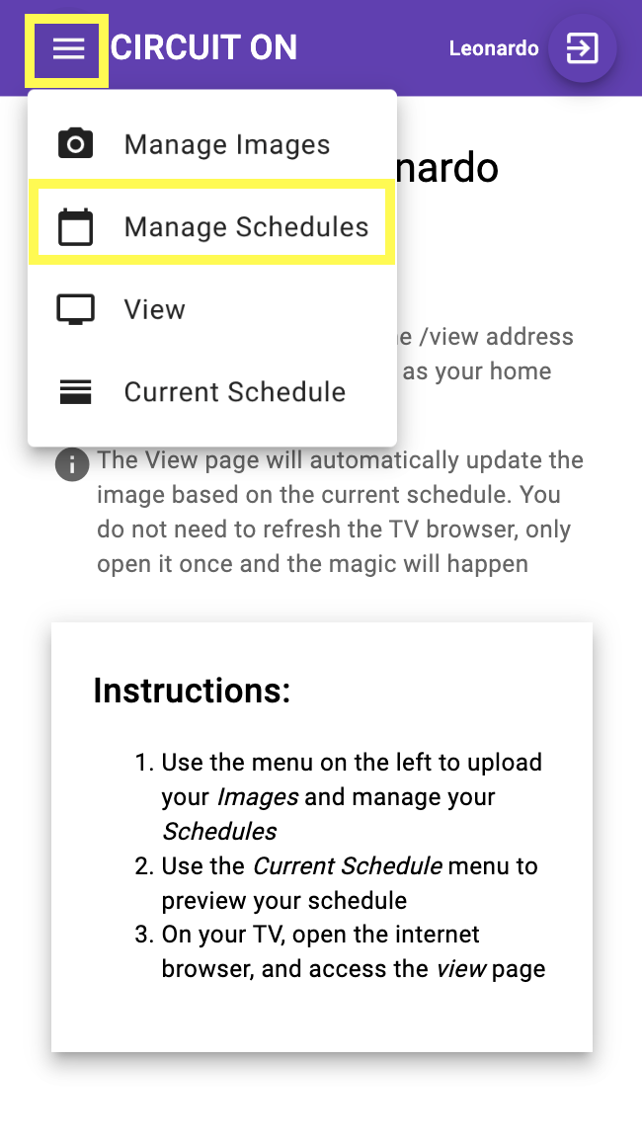 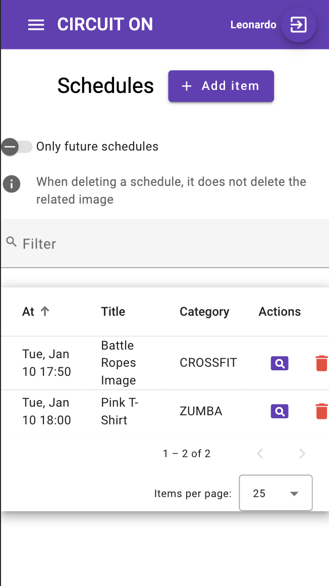 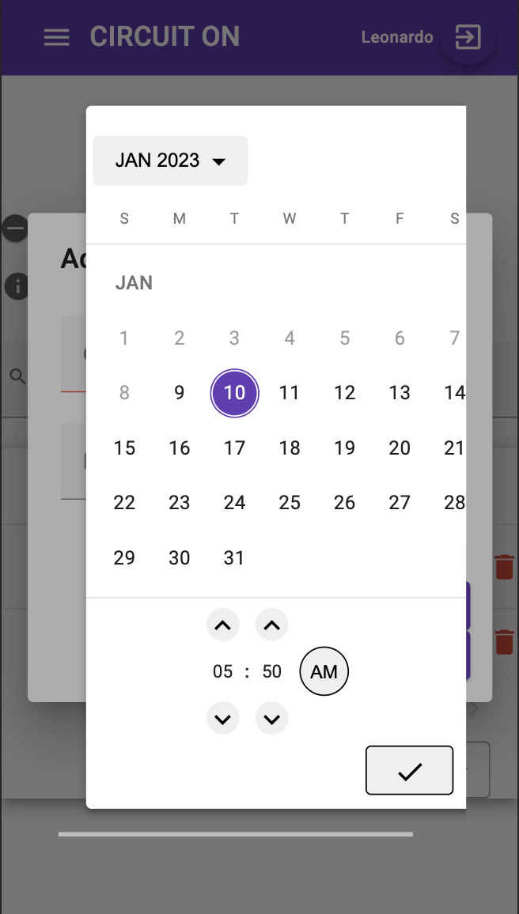

* 1. Click on the **calendar icon on the right side** to select a date and time
  2. Select an **image from the list**
  3. Click on **Save**, or the “Save and Close” button
  4. You should receive a **success message on the top**

1. Use the menu on the left, and click on **Current Schedule** to **review** it

Feel free to delete unnecessary schedules. Removing a schedule does not delete the related image. However, deleting an image automatically removes the schedules related to that image. You can keep the images saved on the system for reuse in the future for new schedules.

1. Use the button on the top right to **logout**

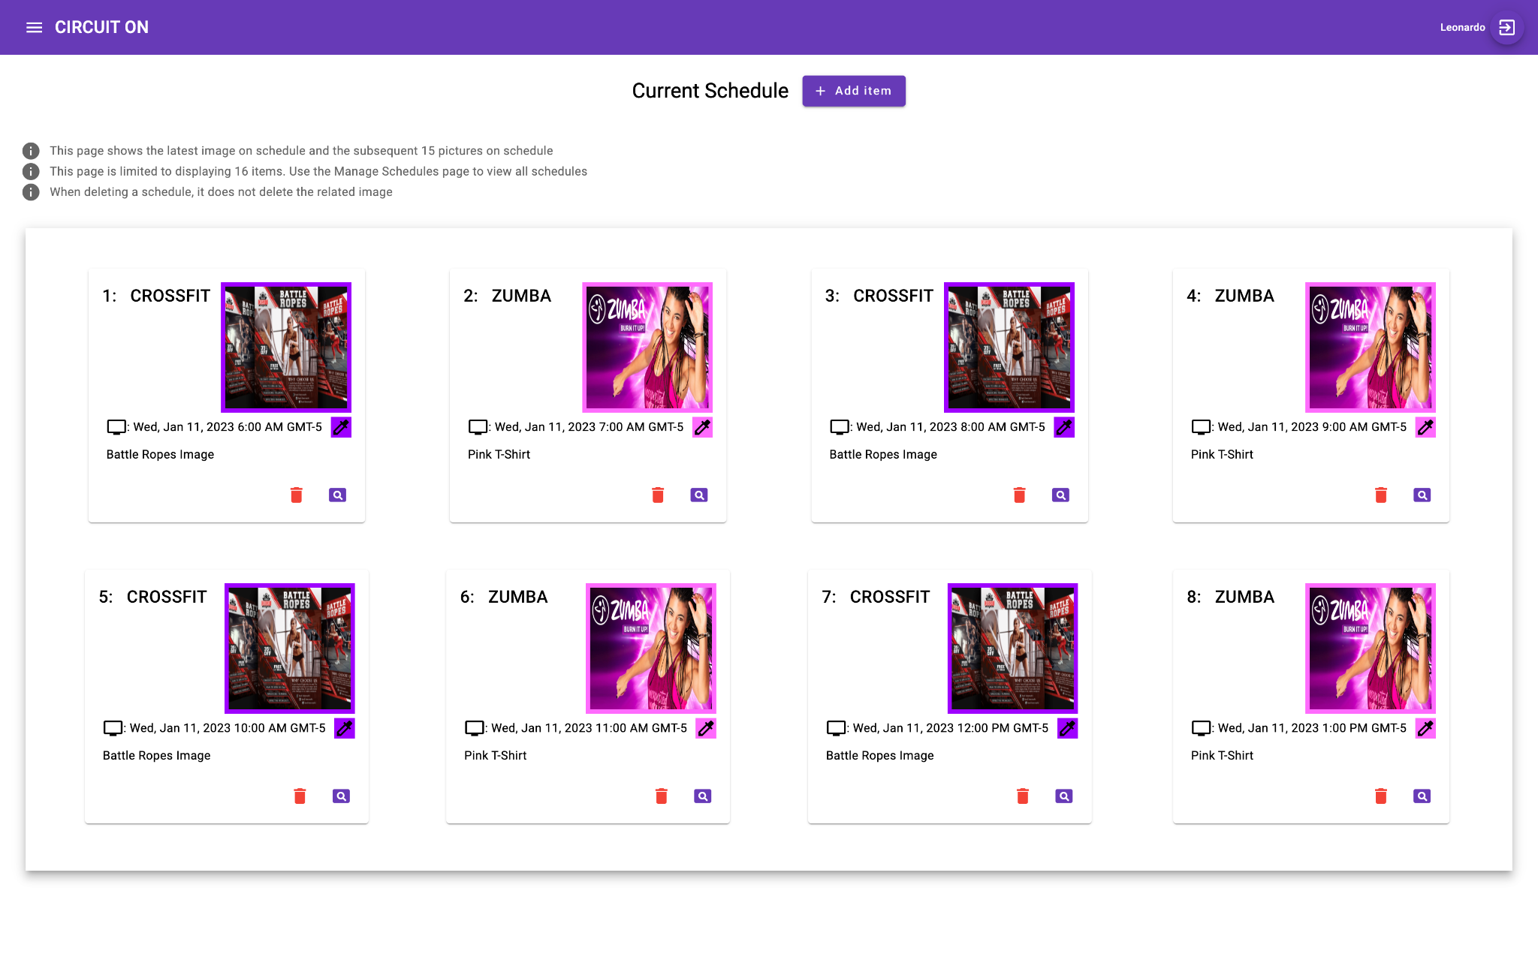

1. Open the **/view** page on the **TV Internet Browser.** Set it as the home page in the browser for quick access