EXPLORATORY DATA ANALYSIS
French Day-Ahead Power Market | 2018–2024
EDHEC MSc Data Analysis & AI — Master’s Thesis

1. Introduction
This report summarises the exploratory data analysis (EDA) conducted on the French day-ahead electricity market. The dataset covers hourly observations from January 2018 to December 2024 (61,344 hours), combining four sources:
- ENTSO-E Transparency Platform: day-ahead prices, load forecast, generation by fuel type
- ERA5 (Copernicus / ECMWF): hourly 2m temperature, 10m wind speed, solar radiation, precipitation
- Derived features: Heating Degree Days (HDD), wind power proxy, Weather Stress Index (WSI)

2. Price Dynamics

2.1 Descriptive Statistics
The table below summarises the distribution of French day-ahead prices over the full sample period.

Statistic | Value
Mean | 94.50 €/MWh
Median | 57.88 €/MWh
Std. Deviation | 104.34 €/MWh
Minimum | −134.94 €/MWh
Maximum | 2,987.78 €/MWh
Negative-price hours | ~2.1% of observations
Hours above 200 €/MWh | ~8.4% of observations

The large gap between mean (94.50) and median (57.88) reflects strong positive skewness driven by crisis episodes in 2021–2022 (gas supply shock, post-COVID demand rebound, nuclear maintenance wave). Negative prices occur mainly during low-demand weekends with high solar and wind output.

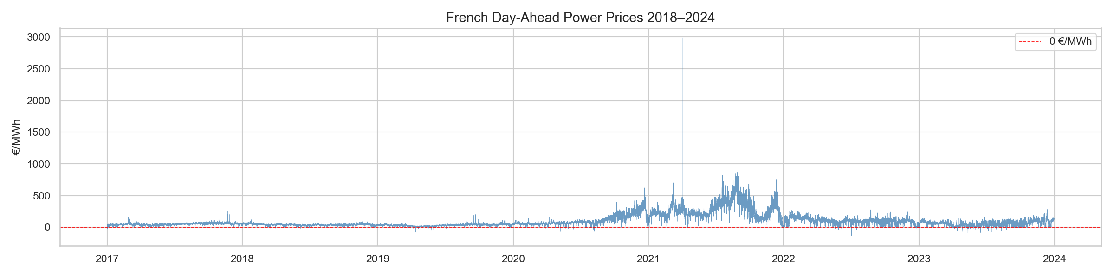
Figure 1 — French day-ahead prices 2018–2024 (hourly). The 2021–2022 energy crisis is clearly visible.

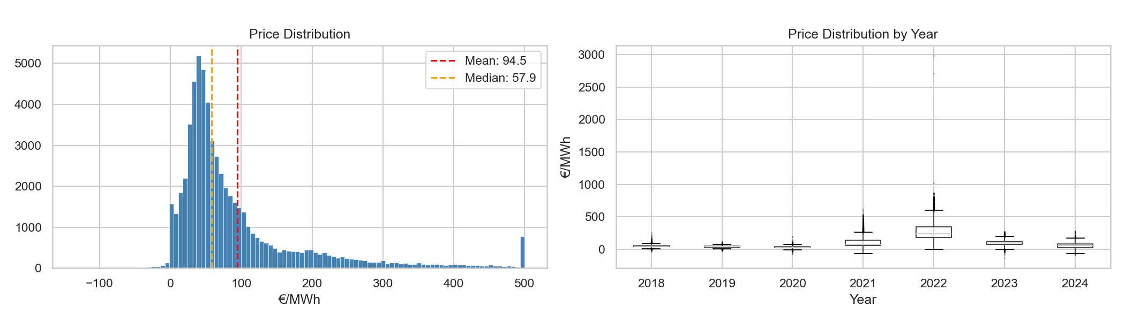
Figure 2 — Price distribution (left) and annual boxplots (right). The 2022 outliers compress the scale.

2.2 Seasonality
Prices exhibit strong intra-day, intra-week, and seasonal patterns. The heatmap (Figure 4) is particularly informative: morning peaks (7–9h) and evening peaks (18–20h) are consistent year-round, while winter months show structurally higher prices due to heating demand.

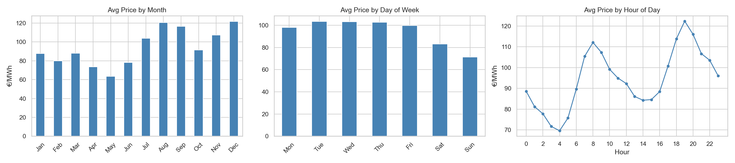
Figure 3 — Average price by month, day of week, and hour of day.

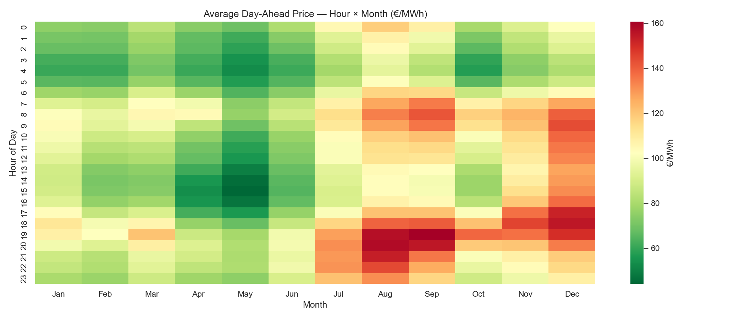
Figure 4 — Heatmap of average price by hour × month. Dark red = high price, green = low price.

2.3 Nuclear Generation
France is structurally dependent on nuclear power (~70% of production). The 2022 crisis was amplified by an unprecedented nuclear maintenance wave that reduced availability to historical lows, pushing prices to extreme levels.

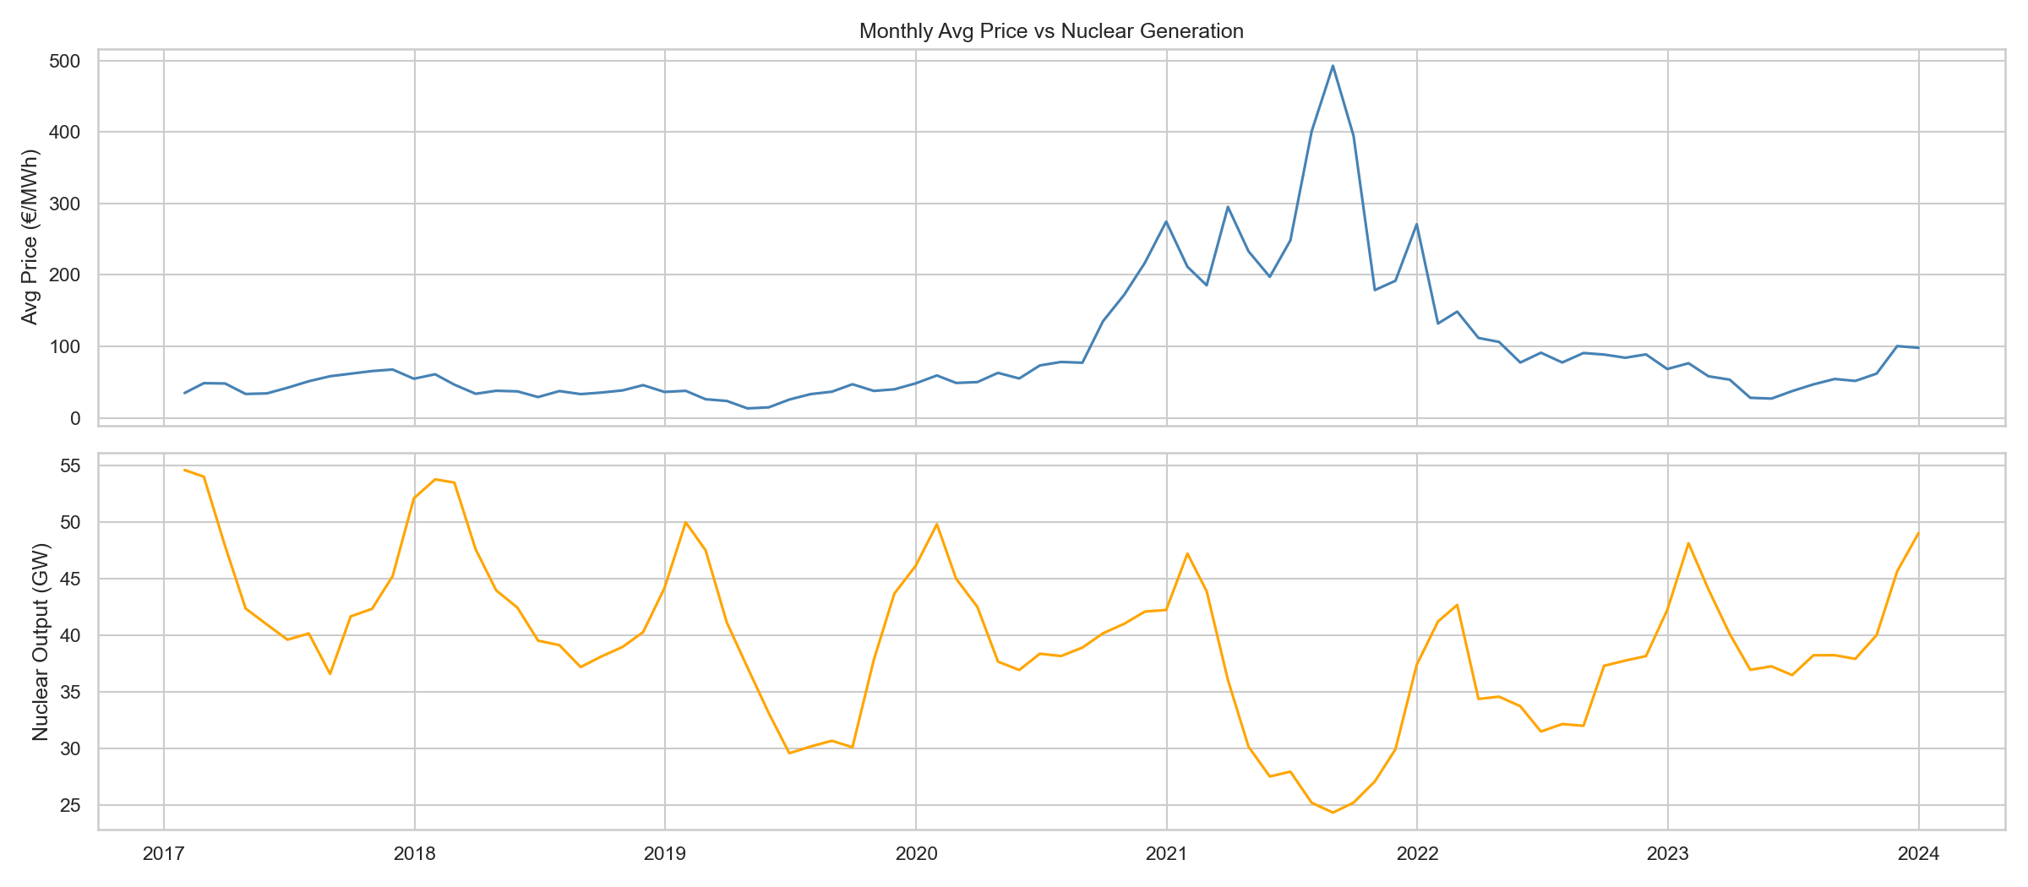
Figure 5 — Monthly average price (blue) vs. nuclear output (GW, orange). The inverse relationship is clear in 2022.

3. Weather Variables & Impact on Prices

3.1 Overview
ERA5 reanalysis data provides hourly weather observations spatially averaged over mainland France. Figure 6 shows the monthly evolution of the four weather variables used in the model.

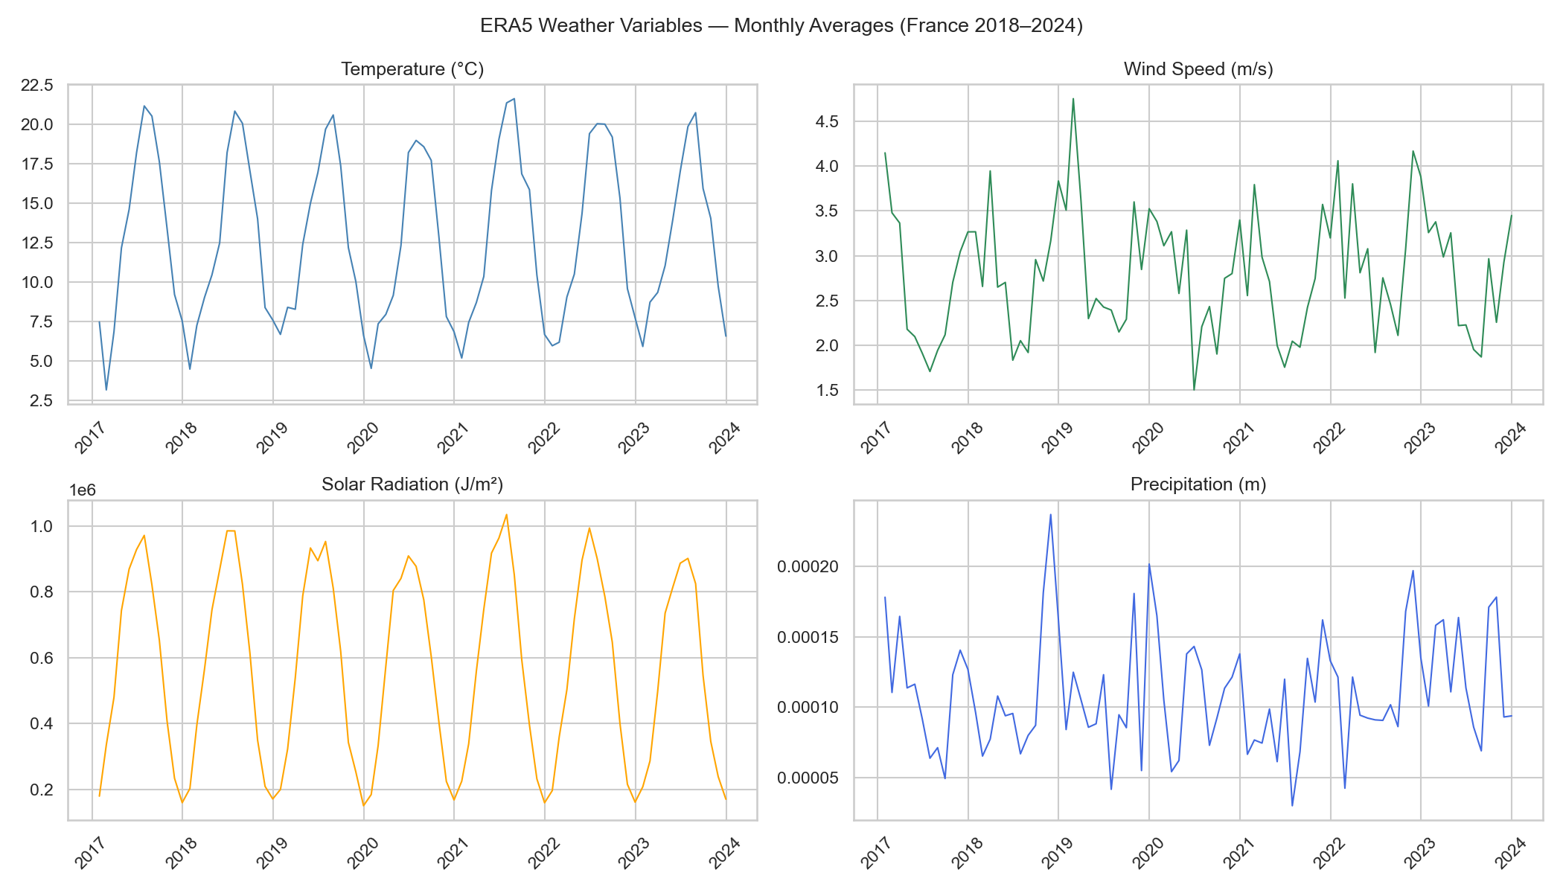
Figure 6 — Monthly averages of ERA5 weather variables for France (2018–2024).

3.2 Temperature & Heating Demand
Cold temperatures drive up electricity demand through electric heating, a dominant effect in France. The U-shaped relationship in Figure 7 confirms this: both very cold and moderately warm periods see higher prices (cooling demand in summer), with the lowest prices in mild spring/autumn months.

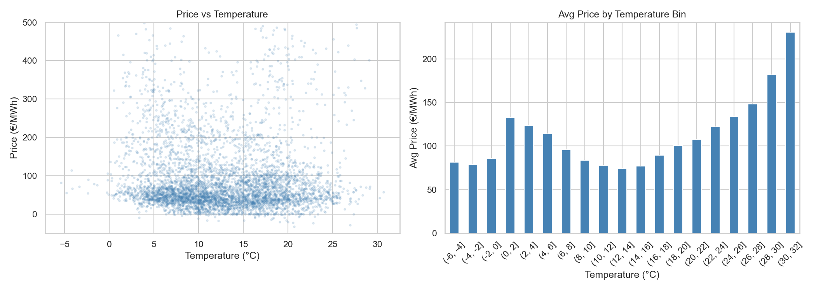
Figure 7 — Scatter and binned average price by temperature. U-shaped pattern reflects dual heating/cooling demand.

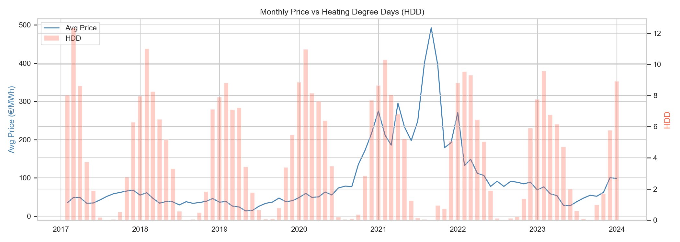
Figure 8 — Monthly price vs. Heating Degree Days (HDD). High HDD periods (winter) correlate with higher prices.

3.3 Wind Speed & Renewable Generation
Wind generation in France (primarily onshore) can displace gas-fired peakers and lower prices significantly. Low-wind periods combined with cold temperatures create the most extreme price spikes.

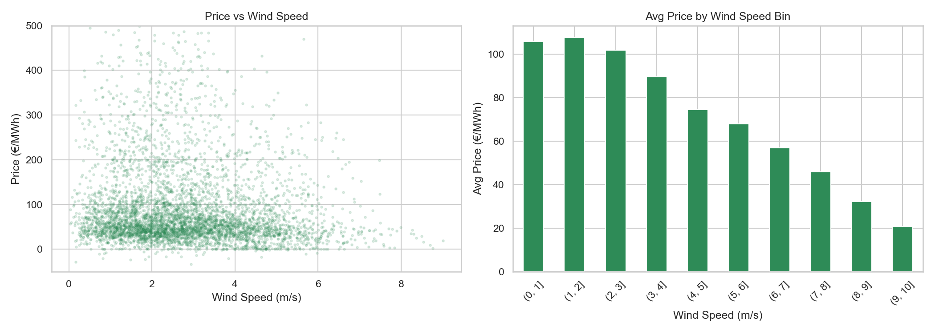
Figure 9 — Price vs. wind speed. Higher wind speed is associated with lower prices (merit-order effect).

3.4 Weather Stress Index
The Weather Stress Index (WSI) is a composite variable defined as HDD divided by wind speed. It captures simultaneous high-demand and low-renewable-supply conditions — the configuration most likely to produce extreme price spikes. The correlation between WSI and price is 0.42 (Pearson), the highest of all individual weather features.

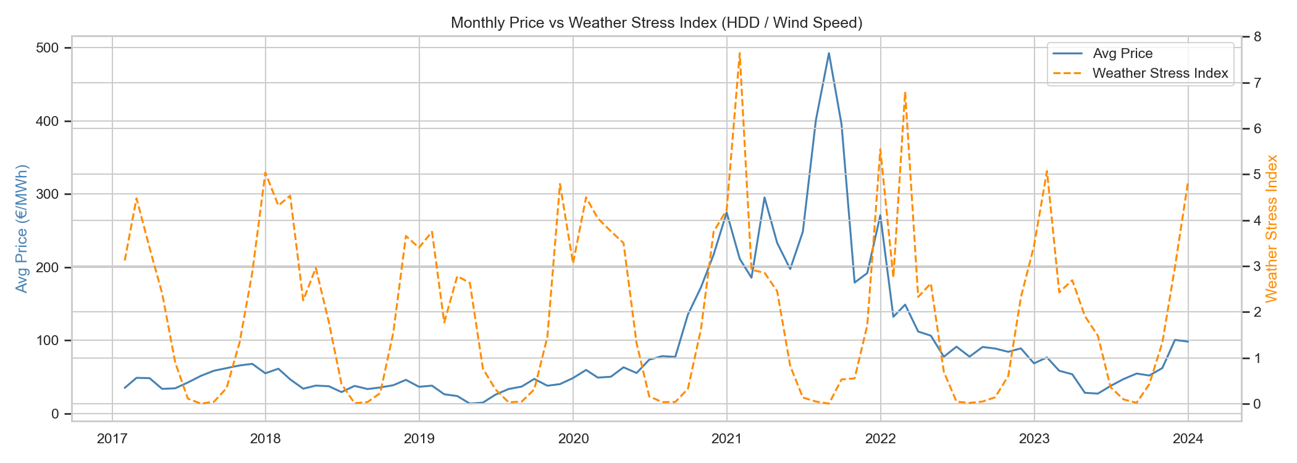
Figure 10 — Monthly WSI (orange dashed) vs. price (blue). Strong co-movement, particularly in winter 2021–2022.

3.5 Correlation Structure
The correlation matrix below confirms the expected relationships: nuclear output is negatively correlated with price, wind is negatively correlated, load positively correlated, and the WSI positively correlated.

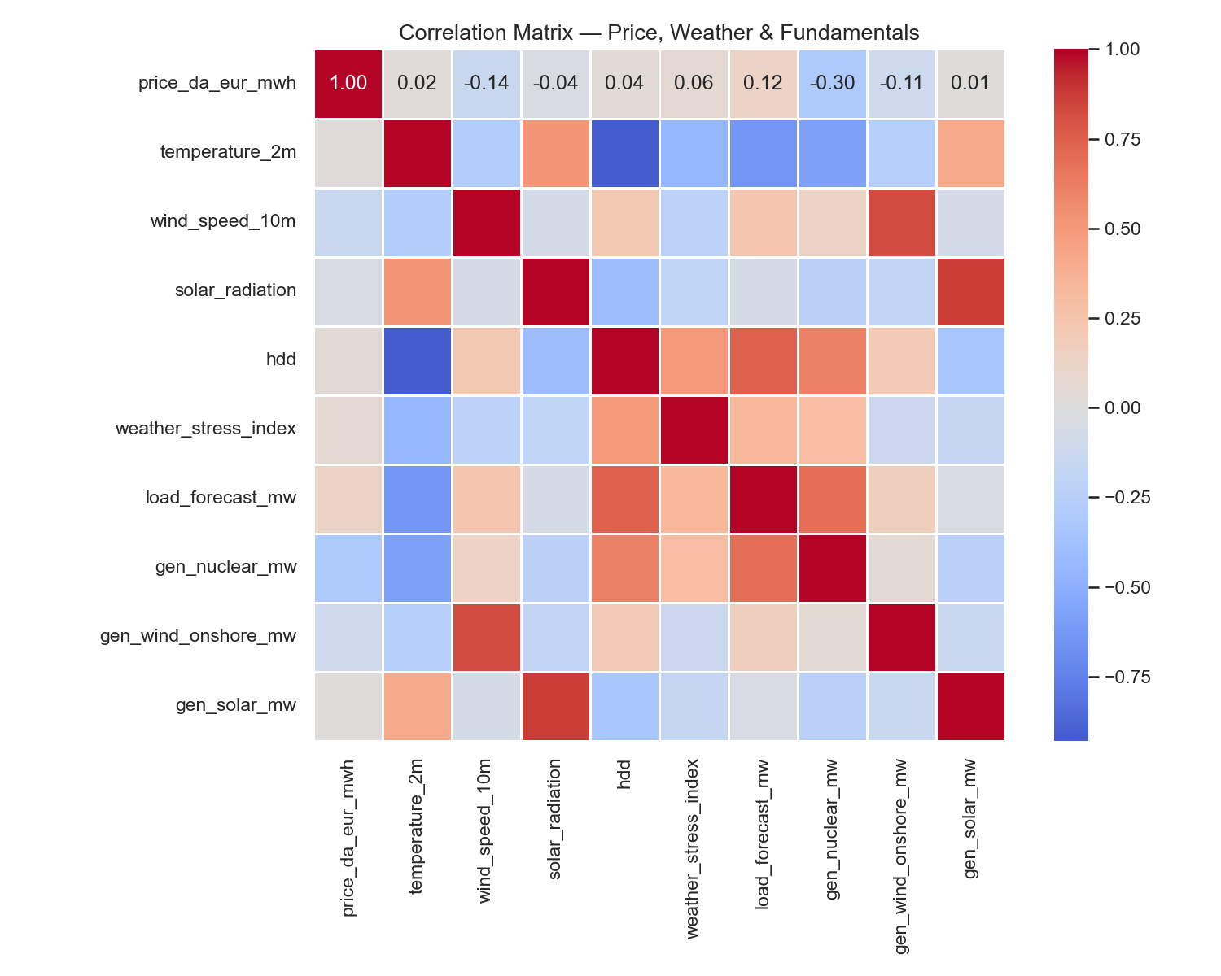
Figure 11 — Correlation matrix across price, weather, and fundamental variables.

4. Key Findings & Modelling Implications
- Strong seasonality at hourly, daily, and monthly levels — calendar features (hour, day-of-week, month) are essential inputs.
- Price lags (T−24h, T−48h, T−168h) capture auto-regressive structure and regime persistence.
- Nuclear availability is the dominant French market fundamental — it should be treated as a primary feature.
- The Weather Stress Index (WSI = HDD / wind speed) has higher correlation with price than raw temperature or wind alone — justifying its inclusion as an engineered feature.
- Extreme price events (>200 €/MWh) cluster in 2021–2022; robust models should be evaluated with and without this crisis period.

Leo Camberleng — EDHEC MSc Data Analysis & AI — May 2026

