OpenPGP - Encryption process (Using GPG* software)
*Please note that HSBC will not support GPG software and this document is only for internal reference only.

The key exchange process
- Generate the bank public key in SVM
- The bank public key for GPG must be in PGP format.

- Generate your private key
- Gen your private key in GPG by using ”gpg --gen-key”
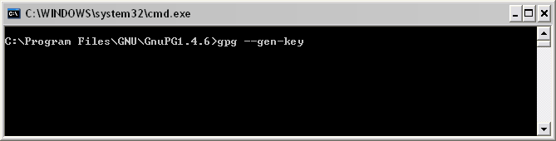

- Select the key type, key size and how long the key should be valid, then enter “y” to confirm.
(To upload a file to HSBCnet, the key type must be RSA, the key length must be 4096, and there must have an expired date.)
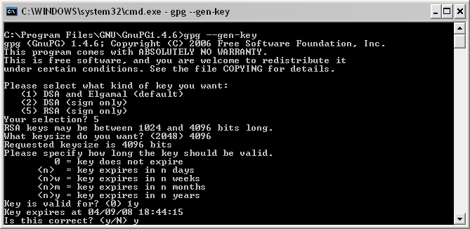

- Enter the key information and then set the passphrase to generate the key.
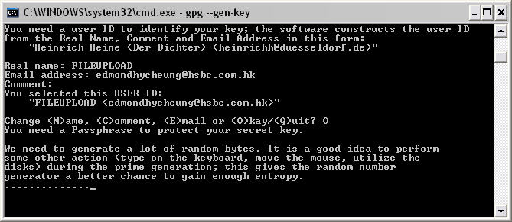

- Import the bank public key
- To import the bank public key to GPG, first put the bank public key to the directory of GPG.
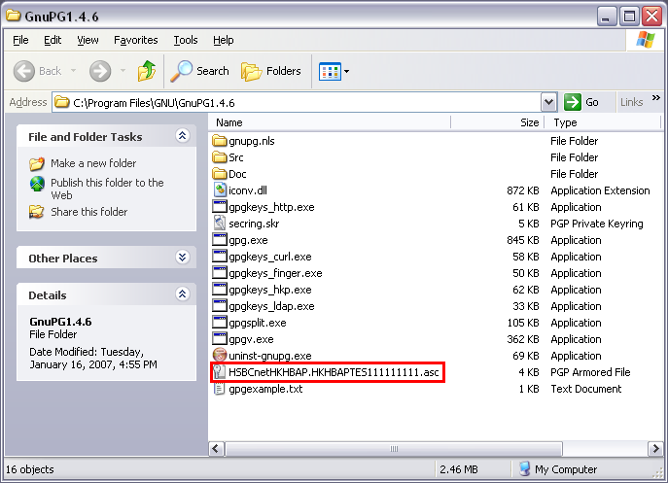

- And then import the key to GPG by using the command “gpg --import [Key file name]”
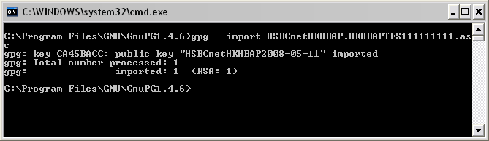

- Sign the bank key
- To sign the bank public key, use the command “gpg --sign-key [bank key ID]”, and then enter the passphrase of your private key.
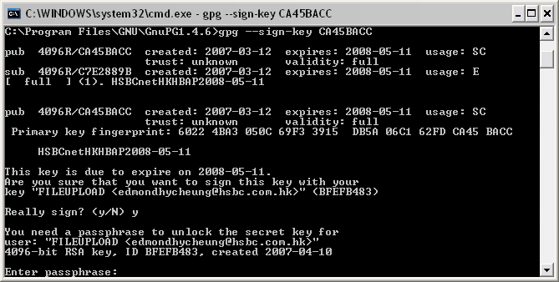

- Export your private key
- To export your private key, use the command “gpg --export –armor [Key ID] > [Key file name]”
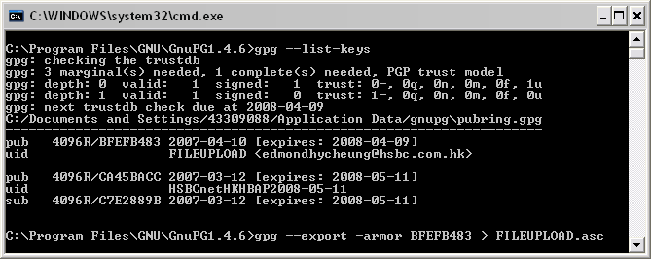

- After finishing export the key, the key file will appear in the directory of GPG.
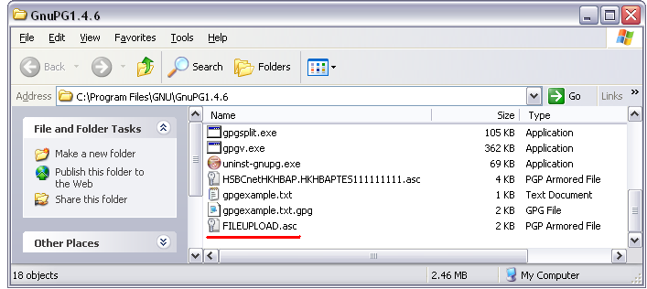

- Upload the key file to SVM
- The private must be in PGP format when uploading it to SVM.

Encrypt a text file

- Put the text file into the directory of GPG
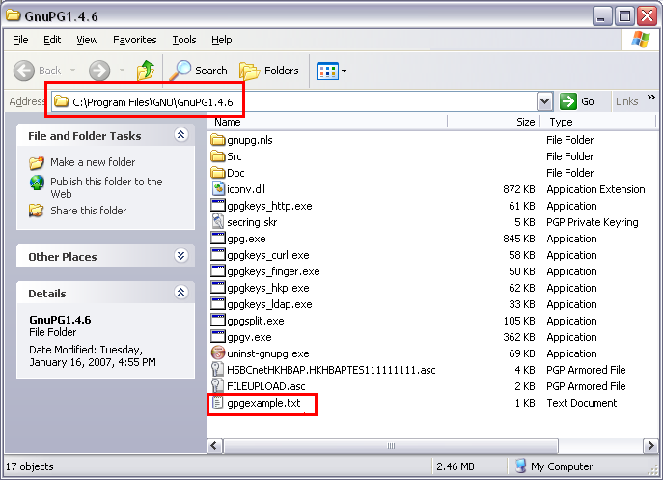

- Find out which key could be used for encryption by using the command “gpg --list-keys”.
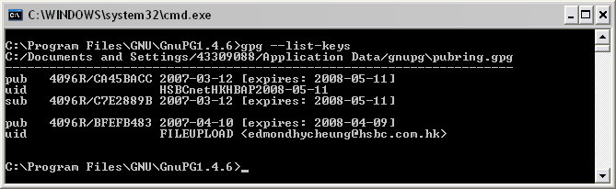

- Use the command “gpg –e –s –r [Bank key ID] [File Name]” to encrypt the test file.
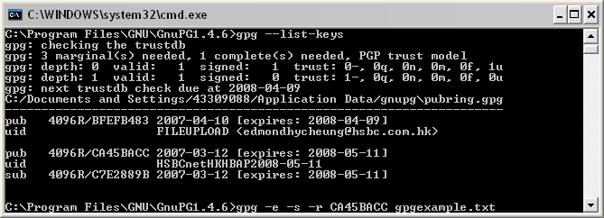

- Enter the passphrase of your key
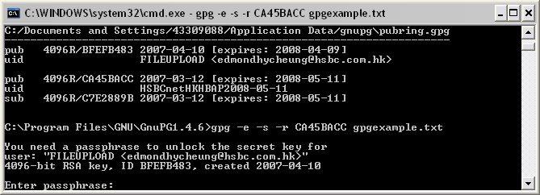

- When the encryption finish, a new file with .gpg appears in the directory of GPG. It is the GPG encrypted file.
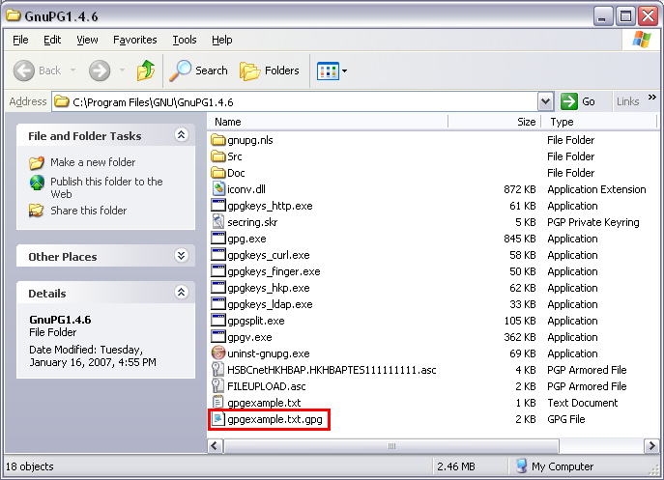

GPG autorun

Method 1: save the password of the signature key in a text file

- save the password into a text file
- use the parameter:
--passphrase-file [the text file which contains the password]
--batch
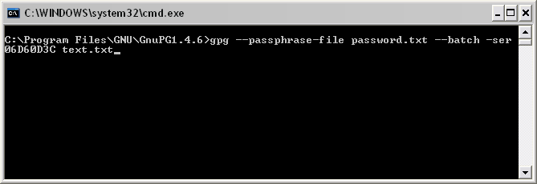
gpg --passphrase-file password.txt --batch -ser 06D60D3C text.txt
(password.txt is the text file which contains the password)

The password file:
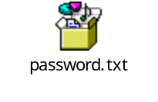

Method 2: remove the password from the key

- Use the command: --edit-key [Signature key ID]

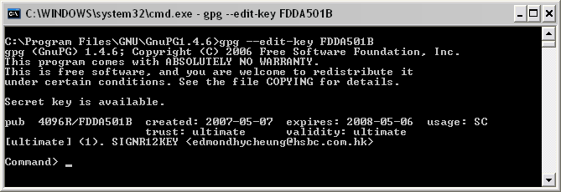

gpg --edit-key FDDA501B
(FDDA501B is the signature key ID)

- Enter the command: passwd

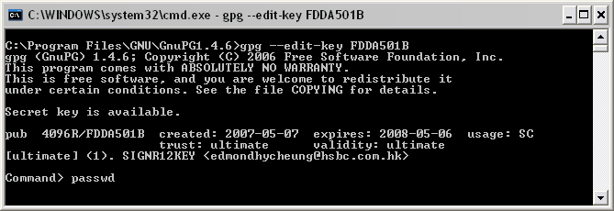

- Enter the passphrase to unprotect the key

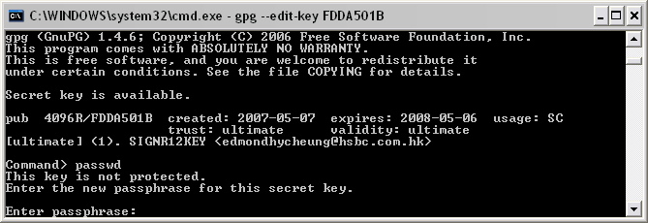

- Enter the new password, for using auto mode in GPG, do not enter any password, just pass enter
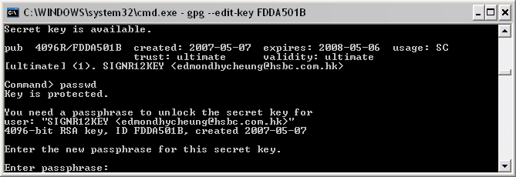

- Enter “y” to confirm
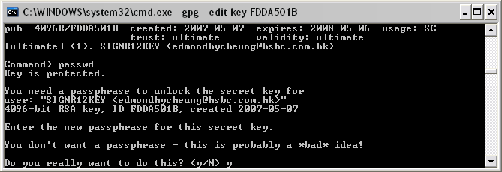

- Then you will be in the command screen, input “quit” to exit
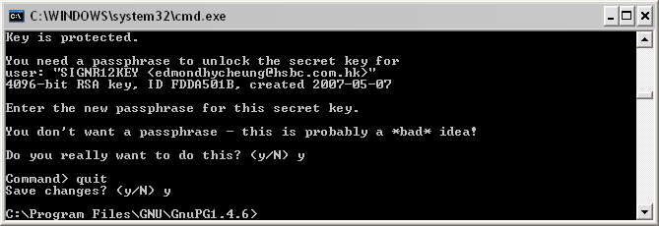
Reference

PGP (Pretty Good Privacy) is a computer program which provides cryptographic privacy and authentication. It's designed for store files and messages.

OpenPGP refers to the open standard that public adapted base on the PGP methodology. [From http://en.wikipedia.org/wiki/PGP]

GPG (also known as GnuPG) is a Free Software developed to support OpenPGP standard. It is a command line tool that allow user to encrypt and sign data. The latest version is 1.4.7. refers to the open standard that public adapted base on the PGP methodology. [From http://www.gnupg.org]

GPG Command quick reference
Key generation
gpg --gen-key
To upload an encrypted file to HSBC, it is needed to select RSA for the key type and 4096 for the key size when generating the key. Also enter how long the key should be valid as HSBCnet does not accept any key without expired date. Then enter the name, E-mail address, the comment of the key and the passphrase of the key.

Import key
gpg --import [key file name]
The key file must be in .asc format

Sign key
gpg --sign-key [Signee ID]

Export key
gpg --export –armor [Key ID] > [Key file name.asc]
The key file should be in .asc format
armor → ASCII output

Encryption
gpg –e –s –r [Key ID] [File Name]
e → Encrypt data
s → Encrypt a file with signature
r → recipient name

Delete key
gpg --delete-key [Key ID]
A secret key cannot be deleted by this method.

Delete a secret key (2 procedures to delete a secret key)
1. gpg --delete-secret-key [Key ID]
2. gpg --delete-key [Key ID]

List Keys
gpg --list-keys

Help
gpg --help

Appendix

1. Your customer failed on decryption because the original Bank key (exchanged with customer) was generated on "PGP" mode.

Customer's pubkey marked with different mode will be handled by different Encryption Servers (PGP or Axway - for OpenPGP).
That is, PGP for "PGP" mode and Axway for "OpenPGP" mode.

Since this customer's Pubkey was imported and tagged with "OpenPGP" mode, the system attempted to look for the Bank key on the OpenPGP server for validation, but failed.

2. The system is not allowed to change the key's mode or delete it after import. Moreover, the system has uniqueness checking on the key. That's why you have to exchange the key with the customer and import a new unique pubkey and tag it with "PGP", since you use the Bank's PGP pubkey.

Actually, another way of workaround for you is to send the Bank's "OpenPGP" pubkey to customer to avoid them from generating a new key.

According to product said, technically speaking, both PGP server or Axway server are OpenPGP compliant and can both be used to support customer with 3rd party OpenPGP compliant software, as long as the bank key's mode match with the mode you set for the customer's pubkey.

However, for better management, after commercialisation, Channel will suggest customer to use OpenPGP mode for software other than PGP.

3. Currently, only GPG is tested as the OpenPGP compliant software to work with HSBC's OpenPGP server. Other than that, Product recommend customer to perform a test with us to prove its full compliance before rollout.

