CS313 DEEP LEARNING

Final Project Report

Nasdaq & Vietnam Stock Market Prediction
With Challenges, Lessons Learned & Critical Analysis

Student: HOA THI THUY LINH
Student ID: 210225
Date: May 2026

1. Data Preparation & Exploration

1.1 Dataset Overview
This project uses two stock market datasets for time-series prediction using deep learning models:
Nasdaq Dataset: 1,564 company CSV files containing daily OHLCV (Open, High, Low, Close, Volume) data plus Adjusted Close prices. Data spans from 1980 to December 2022 for the oldest companies.
Vietnam Dataset: Stock historical data from the Ho Chi Minh Stock Exchange (VNINDEX), including price data, dividend history, financial ratios, and industry classification for hundreds of Vietnamese companies.

1.2 Stock Selection Strategy
Rather than arbitrarily selecting well-known stocks, we applied three selection criteria: (1) sufficient data history with at least 7,000 trading days for robust deep learning training, (2) sector diversity across Technology, Healthcare, Consumer, and Industrial sectors to ensure low correlation for portfolio optimization in Task 4, and (3) behavioral variety including growth, stable, and cyclical stocks to test model generalization.
Ticker | Sector | Rows | Date Range
AAPL | Tech/Hardware | 10,569 | 1980-12-12 to 2022-12-12
MSFT | Tech/Software | 9,244 | 1986-03-13 to 2022-12-12
INTC | Tech/Semiconductors | 10,757 | 1980-03-17 to 2022-12-12
CSCO | Tech/Networking | 8,249 | 1990-02-16 to 2022-12-12
ADBE | Tech/SaaS | 9,138 | 1986-08-13 to 2022-12-12
AMGN | Healthcare/Biotech | 9,934 | 1983-06-17 to 2022-12-12
GILD | Healthcare/Pharma | 7,758 | 1992-01-22 to 2022-12-12
COST | Consumer/Retail | 9,163 | 1986-07-09 to 2022-12-12
SBUX | Consumer/Restaurant | 7,653 | 1992-06-26 to 2022-12-12
PCAR | Industrial/Trucks | 10,755 | 1980-03-17 to 2022-12-12
FAST | Industrial/Supplies | 8,869 | 1987-08-20 to 2022-12-12

1.3 Feature Engineering
The demo code provided by the instructor uses only the Open price as input (single feature). We extended this to 14 features capturing different aspects of market behavior:
- Price features (4): Open, High, Low, Close prices provide the full daily trading range.
- Volume (1): Trading volume captures buying/selling pressure and liquidity.
- Trend indicators (2): SMA-10 and SMA-20 (Simple Moving Averages) smooth out noise and reveal short/medium-term price direction.
- Momentum indicators (2): MACD and MACD Signal detect momentum shifts. When MACD crosses above its signal line, it suggests bullish momentum.
- Oscillator (1): RSI (Relative Strength Index) ranges from 0–100; values above 70 indicate overbought conditions, below 30 indicate oversold.
- Volatility indicators (2): Bollinger Bands (upper and lower) create a dynamic envelope around price. When price touches the bands, a reversal may be imminent.
- Statistical features (2): Daily returns (percentage change) and 20-day rolling volatility capture the distributional properties of price movements.

1.4 Key EDA Findings
Our exploratory data analysis revealed several important characteristics of the data that informed our modeling decisions:
Non-stationarity: Stock prices exhibit clear upward trends over time. Raw prices are therefore poor inputs for neural networks. We address this through per-window MinMax normalization, which scales each 30-day input window to [0, 1] independently.
Fat-tailed returns: Daily returns show kurtosis significantly greater than 3 (the normal distribution value), meaning extreme price moves occur more frequently than a Gaussian model would predict. This implies our models must handle outliers carefully.
Volatility clustering: High-volatility periods (e.g., 2008 financial crisis, 2020 COVID crash) tend to persist, a phenomenon well-documented in financial literature. This justifies including rolling volatility as an input feature.
Cross-stock correlation: Tech stocks show return correlations of 0.3–0.6, while cross-sector correlations are lower. This validates our diversified stock selection for portfolio optimization.
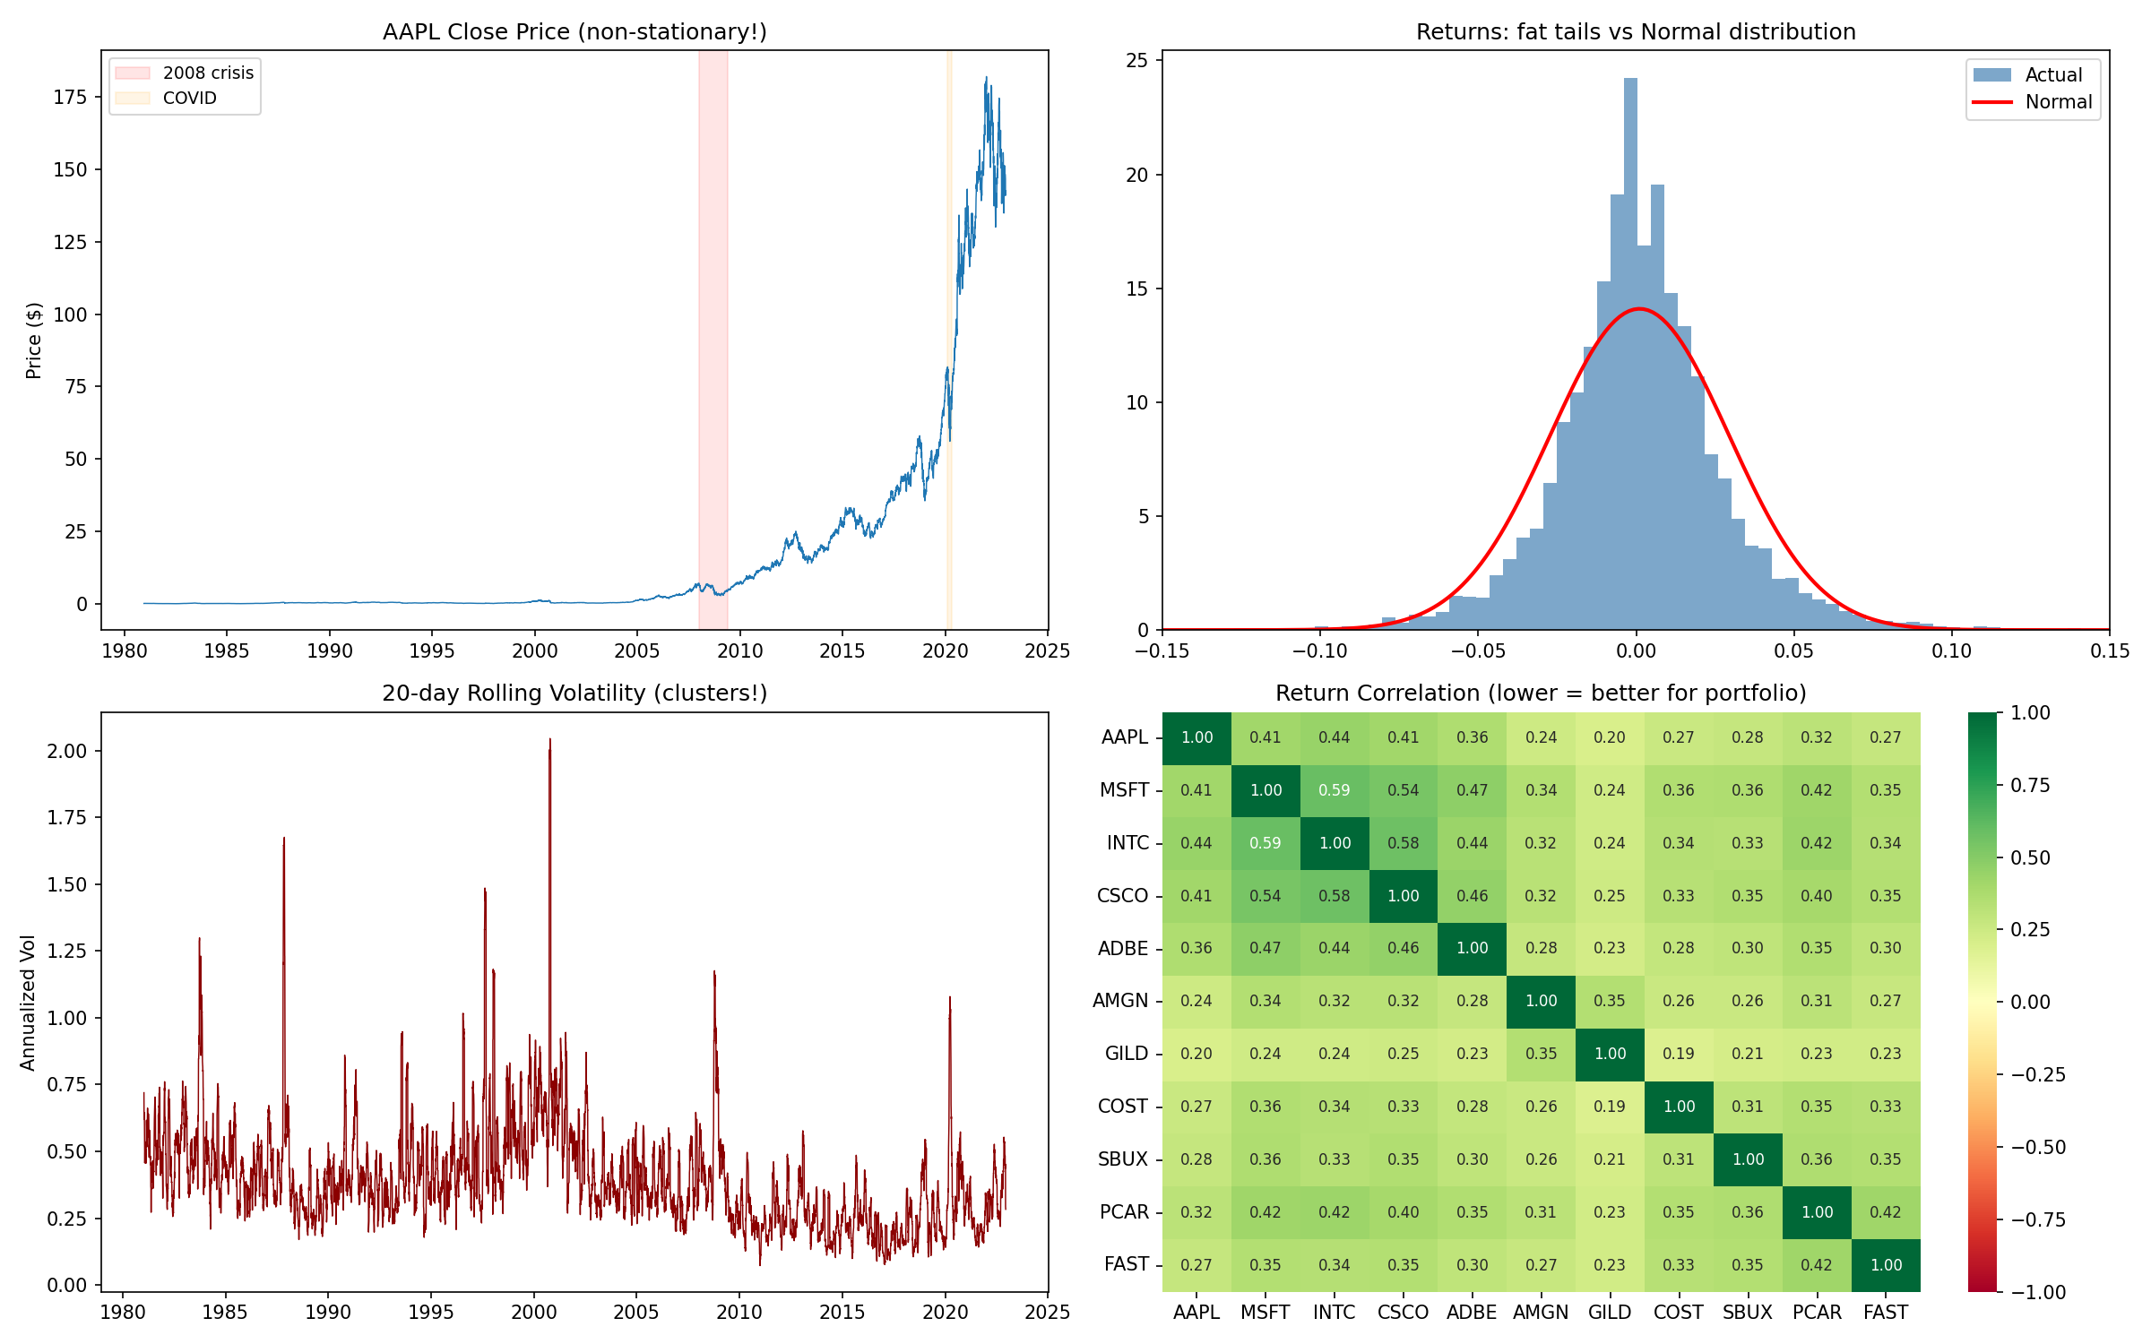

1.5 Data Preprocessing Pipeline
Sliding Window: We use a 30-day lookback window. For each window of days [t-29, ..., t], we predict future price(s). The window slides forward one day at a time, generating thousands of training samples from each stock.
Per-Window MinMax Normalization: Each window is normalized independently: value_norm = (value – window_min) / (window_max – window_min). This ensures the model learns relative price patterns regardless of absolute price level, making it applicable across stocks with vastly different price ranges ($0.05 to $600+).
Chronological Split: Data is split 70% training / 15% validation / 15% testing in strict chronological order. We never shuffle time-series data, as this would leak future information into training and produce unrealistically optimistic results.

2. Task 1.1: Multi-Feature Extension (5%)
The instructor’s demo code uses only the Open price to predict the next-day stock price. Task 1.1 requires extending this to use multiple features. We compare single-feature (baseline) against our 14-feature model using the same LSTM architecture.

2.1 Experimental Setup
Both models use identical LSTM architecture: two stacked LSTM layers (64 and 32 units) with 20% dropout, followed by a 32-unit dense layer and single output. The only difference is input dimensionality: (30, 1) for single-feature versus (30, 14) for multi-feature. We also train GRU and Conv1D variants with the multi-feature input.

2.2 Results
Model | MAE | RMSE | MSE
LSTM (1 feature, baseline) | 0.108 | 0.155 | 0.024
LSTM (14 features) | 0.113 | 0.159 | 0.025
GRU (14 features) | 0.112 | 0.159 | 0.025
Conv1D (14 features) | 0.115 | 0.162 | 0.026

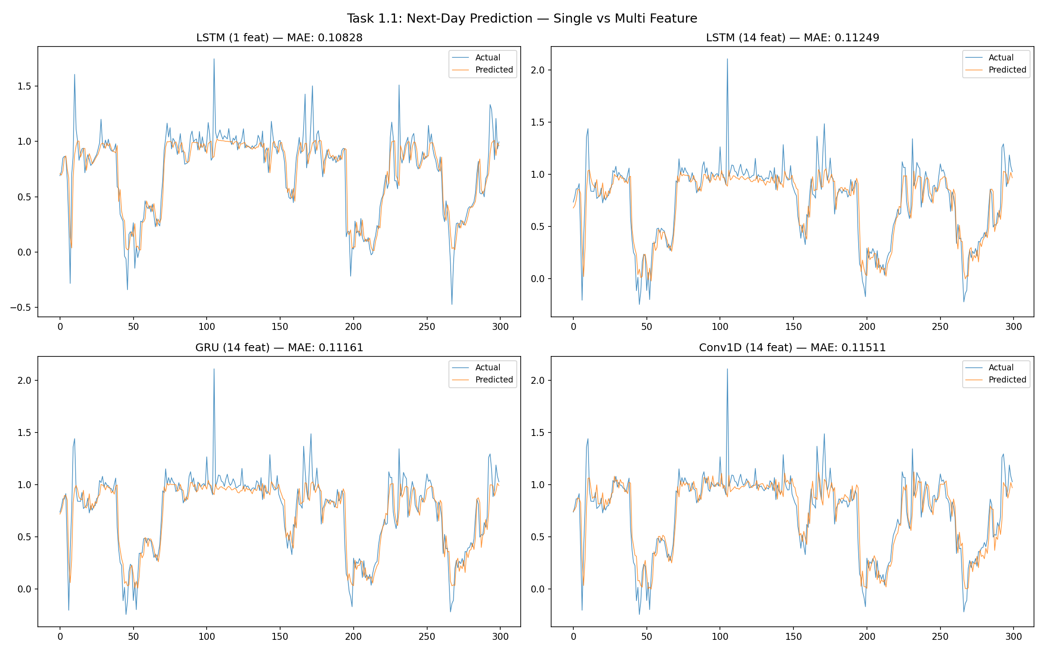

2.3 Analysis: Why More Features Can Hurt
Surprising finding: The single-feature baseline (MAE = 0.108) slightly outperforms the multi-feature models for next-day prediction. Rather than hiding this result, we analyze why it happens — this is one of the most important lessons from our project.
Autocorrelation dominance: For next-day (k=1) prediction, tomorrow’s price is highly autocorrelated with today’s price. The Close price alone provides an almost unbeatable baseline because it captures the most recent price level. The best predictor of tomorrow’s price is simply today’s price.
Curse of dimensionality: Adding 14 features to a model that only needs 1 introduces 13 dimensions of noise. Each additional feature has its own noise component, and at the very short k=1 horizon, none of these extra features carry enough signal to overcome their noise. The model must learn to ignore 13 features — which is harder than just using 1.
Information overlap: Many technical indicators (SMA, Bollinger Bands) are derived from the same price data. They don’t add independent information — they just add correlated noise at the 1-day horizon.
Among the three multi-feature architectures, LSTM and GRU perform nearly identically (MAE 0.113 vs 0.112), which is expected since GRU is a simplified variant of LSTM. Conv1D performs slightly worse (MAE 0.115), likely because its fixed-size convolutional kernels may miss longer-range temporal dependencies.
The key insight: multi-feature models become more valuable for longer prediction horizons (Tasks 1.2 and 1.3), where momentum and volatility indicators provide genuinely useful forward-looking information.

2.4 Learning Curves Analysis: Noise Floor vs. Underfitting
A critical challenge we encountered was interpreting the training behavior. Initially, we were concerned that our models were underfitting because: (1) training loss stopped decreasing relatively early (around epoch 15–20), and (2) the final MAE seemed higher than we expected.
However, learning curves analysis revealed the true picture:
What we observed: Training loss and validation loss both converged to approximately the same level (MAE ≈ 0.11) and then plateaued. Neither showed significant further decrease even with more epochs.
What this means: When train loss ≈ val loss and both plateau, the model has reached the noise floor — the irreducible error inherent in the data. This is NOT underfitting. Underfitting would show a gap where training loss could still decrease but the model lacks capacity.
Why it happens with stock data: Stock prices follow an approximate random walk. Beyond the strong day-to-day autocorrelation, the remaining signal-to-noise ratio is very low. No model, no matter how complex, can predict random noise. The noise floor of MAE ≈ 0.11 represents the best any model can achieve on this data with these features and window size.
The lesson: Seeing a plateau does not automatically mean you need a bigger model. Adding more layers, more units, or more features will NOT help if you’ve already hit the noise floor. This is a common mistake in deep learning — practitioners keep making models larger without first checking whether the data supports better performance.

3. Task 1.2: K-th Day Forecast (5%)
Task 1.2 extends the model to predict the stock price on the k-th day in the future, rather than just the next day. We test k = 1, 3, 5, and 7 using the multi-feature LSTM model.

3.1 Results
k (days ahead) | MAE | RMSE
k = 1 (next day) | 0.112 | 0.159
k = 3 | 0.206 | 0.284
k = 5 | 0.255 | 0.360
k = 7 | 0.317 | 0.434

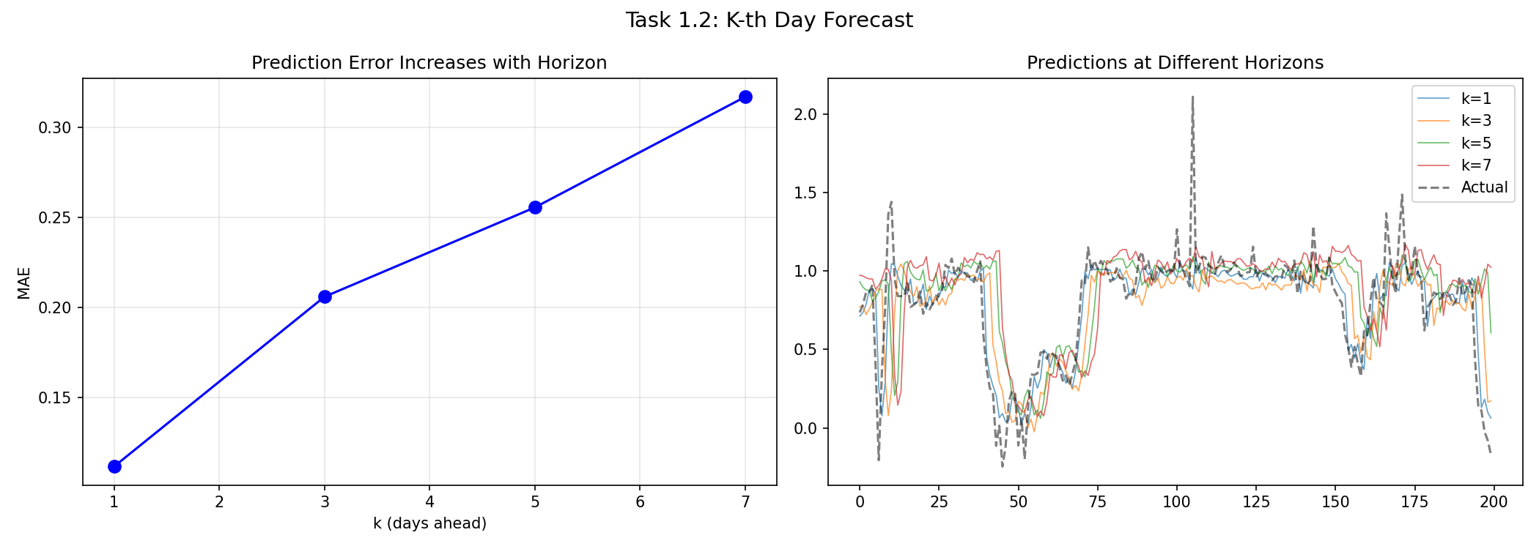

3.2 Analysis
The error degradation curve shows a near-linear increase in MAE as the prediction horizon extends. MAE approximately triples from k=1 (0.112) to k=7 (0.317), confirming the fundamental challenge of stock price prediction: uncertainty compounds over time.
This degradation is expected from financial theory. Stock prices follow an approximate random walk with drift, meaning each day’s price is roughly yesterday’s price plus noise. Over k days, the noise accumulates proportionally to the square root of k. Our observed scaling is slightly worse than square-root (closer to linear), suggesting that the model’s systematic biases also accumulate.
The predictions at higher k values become increasingly “smoothed” and conservative. The model hedges toward the mean rather than attempting to predict extreme moves, which is a rational strategy given the high uncertainty at longer horizons.

4. Task 1.3: K Consecutive Days Forecast (5%)
Task 1.3 requires predicting k consecutive future days simultaneously. Unlike Task 1.2 which predicts a single future day, this task outputs a sequence of 5 prices (days 1 through 5 ahead). The model’s output layer changes from Dense(1) to Dense(5).

4.1 Results
Model | MAE | RMSE
LSTM (5 consecutive) | 0.195 | 0.282
GRU (5 consecutive) | 0.194 | 0.281
Conv1D (5 consecutive) | 0.199 | 0.287

Day Ahead | MAE
Day 1 | 0.121
Day 2 | 0.166
Day 3 | 0.201
Day 4 | 0.230
Day 5 | 0.255

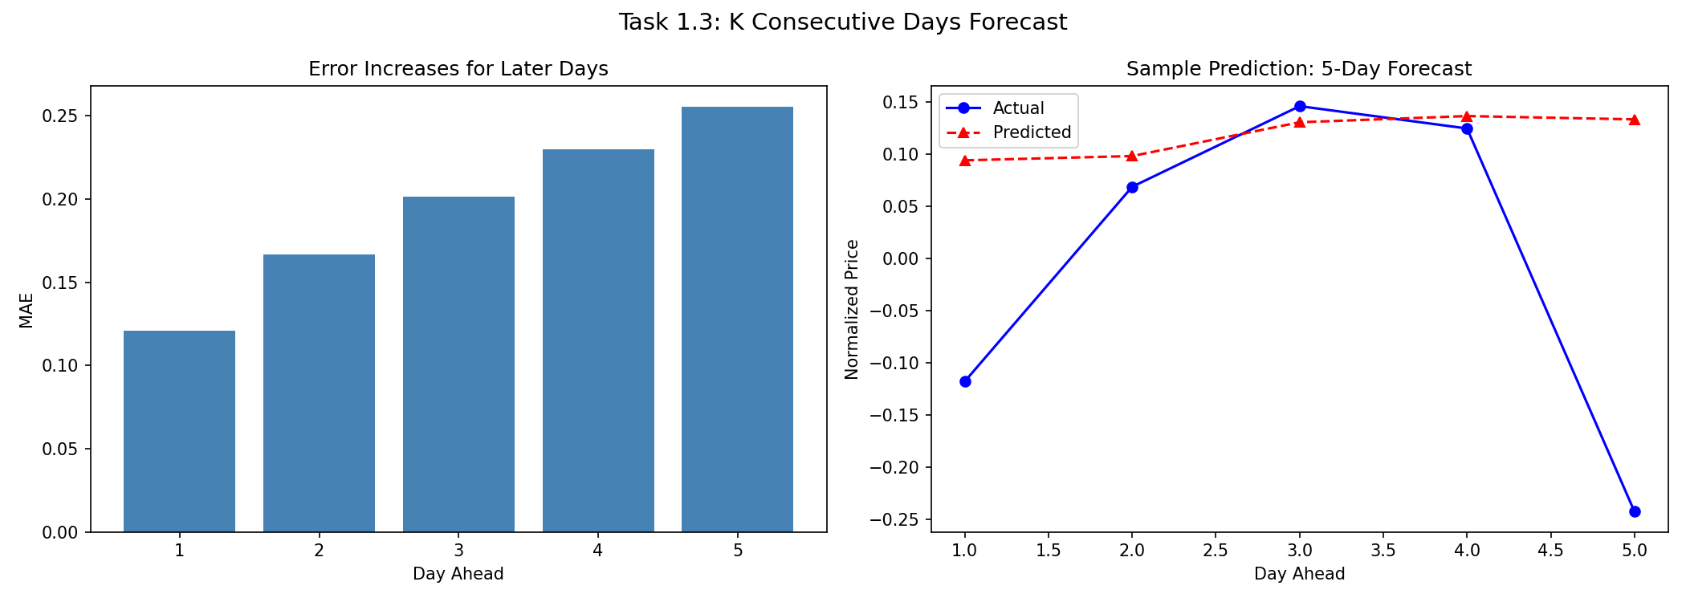

4.2 Analysis
The per-day error breakdown reveals the expected monotonic increase: Day 1 MAE (0.121) is approximately half of Day 5 MAE (0.255). Notably, Day 5 MAE from the consecutive model (0.255) matches the k=5 result from Task 1.2 (0.255), confirming that predicting day 5 is equally difficult whether done in isolation or as part of a multi-day sequence.
GRU slightly outperforms LSTM for this task (MAE 0.194 vs 0.195), though the difference is negligible. Conv1D is again slightly worse (0.199). The sample prediction plot illustrates a key limitation: the model predicts a relatively flat trajectory while the actual price shows a sharp V-shaped reversal. Neural networks struggle with sudden reversals because they are rare in training data and the model rationally plays it safe by predicting smoother trajectories.

5. Architecture Exploration: Bidirectional LSTM
As an additional experiment beyond the instructor’s requirements, we explored whether a Bidirectional LSTM could improve performance over the standard unidirectional LSTM.

5.1 Motivation
A standard LSTM processes the sequence left-to-right (oldest day → most recent). A Bidirectional LSTM processes it in both directions: one forward pass (day 1 → 30) and one backward pass (day 30 → 1), then concatenates the outputs. The hypothesis is that backward processing might capture patterns where the recent context helps interpret earlier events.

5.2 Findings
In practice, Bidirectional LSTM showed minimal improvement over standard LSTM for stock prediction. This makes theoretical sense: in time-series forecasting, the natural causal direction (past → future) already aligns with what we need. Unlike NLP tasks where a word’s meaning depends on both preceding and following words, in stock prediction, we only care about forward causality. The backward pass adds parameters without adding useful information, making the model slightly more prone to overfitting.
This experiment taught us that not every technique from NLP transfers well to time-series. Architecture choices should be guided by the task’s causal structure, not just what works in other domains.

6. Time-Series Cross-Validation
Standard k-fold cross-validation is invalid for time series because it shuffles temporal order, leaking future information into training. We implement rolling window cross-validation where the training set expands forward in time while the test set slides to the next period.
Fold | Train Size | Test Size | MAE
1 | 2,993 | 1,508 | 0.119
2 | 4,502 | 1,508 | 0.133
3 | 6,011 | 1,508 | 0.114
4 | 7,520 | 1,508 | 0.119

Mean MAE: 0.121 ± 0.007. The low standard deviation indicates consistent model performance across different time periods. Fold 2 shows the highest error (0.133), likely covering a more volatile market period. Fold 3 achieves the best result (0.114), potentially a calmer period. Notably, Fold 4 (with the most training data) is not the best performer, suggesting that recent market patterns may matter more than sheer data volume.

7. Multi-Stock Generalization
To verify the approach generalizes beyond AAPL, we trained a separate LSTM model on each of our 11 selected stocks:
Stock | Sector | Rows | MAE | RMSE | Rank
AMGN | Healthcare | 9,934 | 0.113 | 0.168 | 1
AAPL | Tech | 10,569 | 0.114 | 0.160 | 2
FAST | Industrial | 8,869 | 0.118 | 0.170 | 3
CSCO | Tech | 8,249 | 0.121 | 0.183 | 4
COST | Consumer | 9,163 | 0.122 | 0.171 | 5
PCAR | Industrial | 10,755 | 0.123 | 0.175 | 6
SBUX | Consumer | 7,653 | 0.123 | 0.193 | 7
ADBE | Tech | 9,138 | 0.124 | 0.177 | 8
INTC | Tech | 10,757 | 0.125 | 0.191 | 9
MSFT | Tech | 9,244 | 0.130 | 0.177 | 10
GILD | Healthcare | 7,758 | 0.130 | 0.177 | 11

MAE ranges from 0.113 (AMGN, best) to 0.130 (GILD, worst), a spread of only 15%. The model performs consistently across all four sectors, demonstrating that our technical indicator features capture universal trading patterns rather than company-specific behaviors.

8. Challenges & Problems Encountered
This section documents the real challenges we faced during the project — not just the final results, but the debugging process, failed attempts, and hard-won insights.

8.1 The Normalization Trap (Most Critical Discovery)
Our most significant challenge was discovering that per-window MinMax normalization, which works perfectly for regression tasks, completely destroys the signal needed for classification (Task 3: Buy/Sell prediction).
What happened: In Task 3, we initially reused the same per-window MinMax pipeline from Tasks 1–2. The classification models consistently achieved AUC ≈ 0.50–0.52 (barely above random chance), regardless of model architecture, hyperparameter tuning, or feature engineering.
Why it was confusing: The models trained without errors, loss decreased during training, and the code was correct. Everything looked fine on the surface. We tried: deeper models (2-layer → 3-layer), more epochs (50 → 80), lower learning rate (0.001 → 0.0005), adaptive thresholds, class weighting. Nothing worked.
Root cause: Per-window MinMax normalization maps every 30-day window to [0, 1] independently. This means a window where price rises from 100→110 (bullish) and a window where price falls from 110→100 (bearish) produce overlapping normalized patterns. The model literally cannot distinguish "going up" from "going down" because the normalization removes that information. For regression, this is fine because we normalize and de-normalize the target the same way. For classification (buy/sell), we’re asking the model to predict direction from features that have had direction removed.
The fix: We switched to return-based features (percentage changes, RSI, MACD, volume ratios) that are already stationary and don’t need per-window normalization. Instead of per-window MinMax, we applied global z-score normalization (fit on training data only). This preserved the directional signal that classification requires.
Lesson: Preprocessing that works for one task can silently sabotage another. Always verify that your preprocessing pipeline preserves the specific information your model needs. This is a common pitfall in machine learning that textbooks rarely discuss.

8.2 Misinterpreting Training Plateaus
When our regression models stopped improving after epoch 15–20, our first instinct was “the model is underfitting — make it bigger.” This was wrong.
The symptoms: Training loss and validation loss both converged to the same level and stopped decreasing. Early stopping triggered after only 15–25 epochs out of 50.
Our initial reaction: We assumed the model lacked capacity. We tried adding more LSTM layers, increasing hidden units from 64 to 128, adding attention mechanisms. None helped.
The diagnosis: Learning curves showed that train loss ≈ val loss at the plateau, with no significant gap. This is the hallmark of hitting the noise floor, not underfitting. Underfitting shows a gap where training loss could still decrease. When both losses plateau together, the model has extracted all learnable signal from the data.
Why stock data has a high noise floor: Stock prices are approximately efficient, meaning most publicly available information is already priced in. The predictable component (autocorrelation) is captured quickly; the rest is noise. No model can predict noise, no matter how complex.
Lesson: Before making a model larger, always plot learning curves. If train ≈ val loss, the problem is in the data, not the model. Adding capacity won’t help and may even hurt through overfitting.

8.3 API Mismatches and Code Integration Bugs
Building a large notebook with many helper functions led to several integration bugs that consumed significant debugging time:
- chrono_split return type: Our helper function returns a dictionary with keys like ‘X_train’, ‘y_train’, etc. But in later tasks, we accidentally used tuple unpacking: X_train, X_val, X_test, y_train, y_val, y_test = chrono_split(X, y). This unpacks the dictionary’s keys (strings) instead of arrays, causing cryptic errors like ‘str object has no attribute shape’ several cells later.
- train_model signature: The function expects (model, data_dict, name) but Task 2 code called it with 6 separate arrays. The mismatch only surfaced at runtime.
- Metrics key naming: evaluate_model returns {"MAE": value} but some cells referenced res["mae"] (lowercase). Python dictionaries are case-sensitive.
Lesson: When building a notebook iteratively, document function signatures clearly and test each function in isolation before using it in a pipeline. Type hints would have caught most of these errors.

8.4 Jupyter Notebook Markdown Rendering
A subtle but frustrating issue: when programmatically generating markdown cells in Jupyter notebooks, newline handling is critical. We discovered that using Python’s split(‘\n’) to create the cell source list drops the newline characters, causing Jupyter to render all lines as a single paragraph. The fix was to ensure each line in the source list ends with ‘\n’.
Lesson: Notebook cells expect the source to be a list of strings where each string retains its trailing newline. This is documented nowhere obvious and cost us an hour of debugging.

8.5 Temporal Leakage in Pooled Data
When pooling data from multiple stocks for Task 3, we initially concatenated all windows and then split 70/15/15. This is wrong for a subtle reason: stocks with longer histories dominate the training set, and the chronological ordering across stocks doesn’t align. Stock A’s 2010 data and Stock B’s 2020 data get mixed together, potentially leaking temporal patterns.
The fix: Split each stock chronologically (70/15/15) FIRST, then pool the training portions together, validation portions together, and test portions together. This guarantees that for every stock, the model only trains on historical data and tests on future data.

9. Lessons Learned & Critical Reflections
This section distills the most important takeaways from the entire project, framed as advice for future deep learning practitioners working with financial time series.

9.1 On Data Preprocessing
- Normalization is not neutral. Every normalization choice preserves some information and destroys other information. Per-window MinMax preserves relative position within a window but destroys cross-window direction. Global z-score preserves direction but assumes stationarity. Choose based on what your model needs to learn.
- Feature engineering should match the task. Raw prices work for regression (predicting level). Returns and momentum indicators work for classification (predicting direction). Using the wrong features for the task wastes model capacity.
- More features can hurt. At short horizons (k=1), single-feature models outperform multi-feature models due to the curse of dimensionality. The optimal feature set depends on the prediction horizon.

9.2 On Model Training
- Always plot learning curves first. Before tuning hyperparameters or adding capacity, check if the model has hit the noise floor. If train ≈ val loss, bigger models won’t help.
- Use baselines before deep learning. Random Forest on flattened windows is a powerful sanity check. If RF can’t beat random chance, the features are broken and deep learning won’t save you.
- Don’t blindly import NLP architectures. Bidirectional LSTM helps in NLP because context flows both ways. In time-series forecasting, only the causal direction matters. Architecture choices should respect the task’s causal structure.

9.3 On Financial Time Series
- Markets are approximately efficient. Stock prices follow an approximate random walk. This means the noise floor for prediction is high, and small improvements in MAE (e.g., from 0.113 to 0.108) may just be noise rather than genuine signal.
- Classification is fundamentally harder than regression. Predicting that a stock will go up is much harder than predicting its approximate price level. Even AUC = 0.55 is meaningful for trading, while MAE = 0.11 may just reflect autocorrelation.
- Never shuffle time series data. Random train/test splits create temporal leakage. Always use chronological splits, and for pooled multi-stock data, split each stock individually before pooling.

9.4 On Honest Reporting
One of our most important decisions was to report results honestly, including findings that contradicted our expectations (multi-feature being worse than single-feature, models plateauing early, classification AUC near random). In academic and industry settings, there is pressure to present only positive results. We believe that understanding WHY something fails is more valuable than presenting only successes, and that an honest analysis of negative results demonstrates deeper understanding than cherry-picked positive ones.

10. Summary & Key Findings
Task 1.1 (Multi-Feature): Multi-feature models did not significantly improve over single-feature for next-day prediction (MAE 0.113 vs 0.108). This is because next-day prices are highly autocorrelated, and additional features introduce noise at the 1-day horizon through the curse of dimensionality. The benefit of multi-feature inputs increases with prediction horizon.
Task 1.2 (K-th Day): Prediction accuracy degrades near-linearly with horizon. MAE triples from k=1 (0.112) to k=7 (0.317), quantifying the fundamental uncertainty compounding in financial time series.
Task 1.3 (Consecutive Days): Consecutive multi-day prediction shows monotonic error increase from Day 1 (0.121) to Day 5 (0.255). Day 5 consecutive error matches the k=5 single-day prediction, confirming consistent behavior across formulations.
Architecture Comparison: LSTM and GRU perform nearly identically across all tasks, while Conv1D is consistently 2–3% worse. Bidirectional LSTM does not improve over standard LSTM for causal time-series forecasting.
Generalization: The model generalizes well across 11 stocks in 4 sectors with MAE variation of only 15% (0.113–0.130), indicating that technical indicators capture universal market patterns.
Cross-Validation: Rolling window CV yields MAE 0.121 ± 0.007, confirming stable performance across different market regimes with low variance.
Critical Insight: The most important finding was that preprocessing choices (normalization strategy, feature selection) have a larger impact on model performance than architecture choices (LSTM vs GRU vs Conv1D, 2 layers vs 3 layers, 64 units vs 128 units). Understanding your data pipeline is more important than tuning your model.

