2D Pose searching and analysis in art


Bruno Wicht, supervised by Leonardo Impett

Bachelor Project, IRVL Laboratory, EPFL, Spring 2017

Abstract

A lot of art historian are interested in the characters poses in artworks. But they have difficulties in working with big dataset of paintings and searching for specific poses among this dataset. Finding and analyzing similarities of poses in different paintings belonging to this dataset can be very painful due to the big size of the dataset. With this project, we are trying to make their life becoming easier. We are trying to reach this goal by creating an interractive program which give them the possibility to look for a specific pose in the whole dataset of paintings and help them to quickly get informations about the outputed paintings.

- Introduction

Since a long time ago, a lot of people are interested in all sort of art and are studying art history for a better understanding of the past. For all these art historians, even the smallest details in artwork count. We can assume that poses of the represented humans on pieces of art are one of the most important thing they are looking at. Therefore there are a some questions they can ask themselves about thoses poses: “What type of pose is typical of the 16th century in Italy ?”, “In what type of painting this position is more frequent ?”, “Where and when this pose has been represented for the first time ? And where it has been reused ?”. We can distinguish two types of art studying: the one called “close reading” and the other called “distant reading”. Art historian that are doing “close reading” are studying each smallest detail on a piece of art on only a few ones during their whole career. On the other way, art historian who are practicing “distant reading” are looking at a dataset of hundreds of artworks. This is the second category of art historian which interests us for this project; people who are studying no more than 20 paintings can easily have a look at every painting in a small ammount of time and remember of what which one consists, but people who are studying a dataset of thousands of paintings at once cannot have a look on each painting in a small ammount of time and remember easily which detail was on which painting. At this point, they might be interrested to have a computer program replacing them for this painful job in only a few seconds.

- Previous Work

Human action recognition [1]

Texas University researchers have developped a tool to regognize human actions on images. They have trained and tested their program on videos.
This project is a motivator for pose estimation because once we have recognized a pose on an image it could be interesting to determine what action is the represented person doing. And this could be really useful for art historians to be able to quickly find all the paintings in a dataset where there is someone praying for instance.

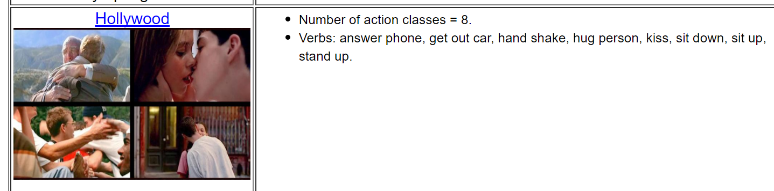Figure 1: Here we can see that their system has linked a bench of human actions with what is shown in the images left. We can see that those actions are not all correct but for example someone answering a phone call would be in the same position as on of the person in the image.
The Pintart Project [2]

This project has been realized at Lisbon University. They have asked an art historian to annotate (semantic information and character's contour or a set of points representing it) each painting of their dataset to get the main poses of each artwork, then they propose to use poses of the subjects and their relationship in the scene to retrieve similar images in their database. To do this, they combine the pose of each character and its contextual information that describe the image in which it appears. And then, given a query image they can compare its description with those in the database. Each image in the database get a rank according to its similarities with the query image and images with the higher rank are those which fit the better the query image. Therefore, the purpose of the Pintart Project is to help art historians to parse image databases. In Figure 2, we can observe that there are several paintings describing the same scene and on which there are almost exctly the same poses.
Figure 2: Pintart Project: Exemple of 3 different paintings describing the same scene

- Project Goals

The main goal is to develop a tool for searching and analyzing body poses in a dataset of paintings. This program is pipelined as follows : First we extract te data from the paintings, this means getting all the points and edges that forms a body on the painting. Then we design a query body we want to search for in the dataset. Thirdly we search for the nearest neighbors of the query body within all the bodies extracted in the first stage and retreive the painting they belong to. And finally we get information about the retrieved paintings looking at their metadata, and display these informations to the user.
It is also possible to create random hypothesis by searching for a random query body randomly picked in the set of bodies. This could help discovering some frequent poses that art historian haven't thought about.
This program has been designed and tested on a relatively small dataset of 21400 paintings which can be expanded to a lot more.

Data Extraction

The data to start the project with is a pickle file containing one tuple per painting in the dataset. Each tuple contains an URL link to the online painting's image, all the detected points of each bodies and the links between these points, and some informations about the artwork itself such as its author, its publication date, its genre and etc.
Everything that has been done before such as painting annotation (body points and limbs detection and metadata) was not part of the project.
The main work of this part is to transform a pickle tuple representing a painting into a list of bodies that are on this painting (As represented in Figure 1.). To transform this data we start from the links which are in fact a list of list of links where each list of links represents the links between the point each body has. So for each of these list of links, we have every link pointing to two points, we add those two points to the body we are constructing if there haven't already been added, and then we create a Limb containing the two points, and then make sure our just created Body point to its belonging body so that we can find metadata directly from the Body (as represented in Figure 2.). All the Bodies can be reprensented as a skeleton as in Figure 3.
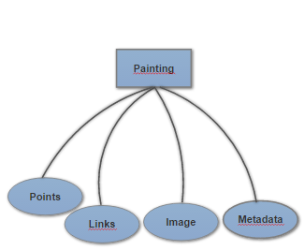Figure 1 : Received data structure: each tuple of data received is a painting containg point, links, a link to an image and some metadata
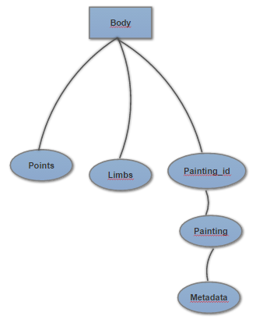Figure 2 : Transformed data structure: Each Body is formed by a list of points, some Limbs between these points, and a link to its belonging painting

Interactivity

Nearest Neighbors Research

Body and Metadata Correlation

Random Hypothesis Generation

Result Evaluation

Timing

Conclusion

Sources

[1]. https://www.cs.utexas.edu/~chaoyeh/web_action_data/dataset_list.html

[2]. Nuno Pinho da Silva, Manuel Marques, Gustavo Carneiro, João P. Costeira: Explaining scene composition using kinematic chains of humans: application to Portuguese tiles history. (2012)

Figure 3 : This is how a Body can be represented graphically

