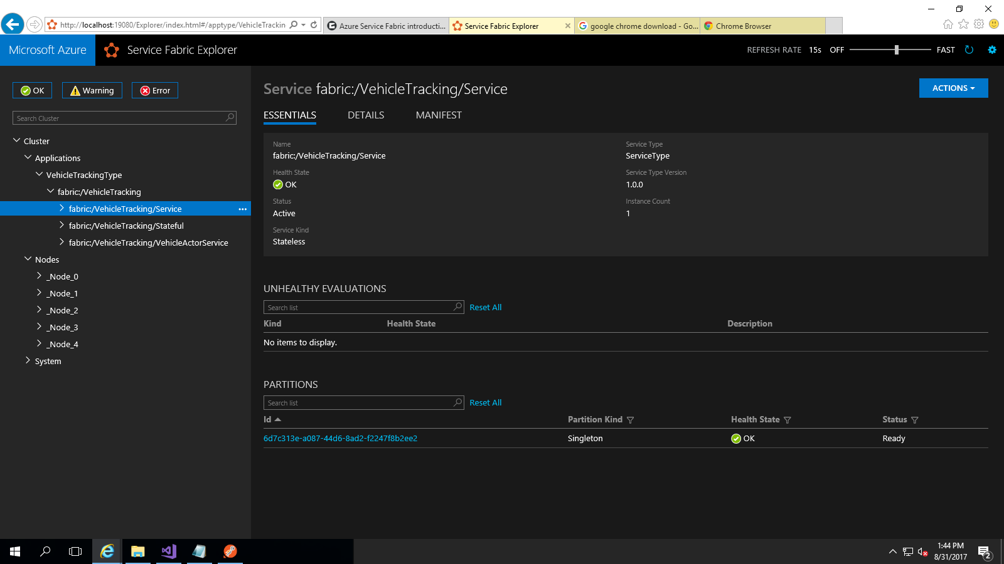

<http://localhost:8100/api/locations>

HTTP method: POST

Request JSON:

{ "VehicleId":"4C0E534D-3809-4826-B25B-CB3541C9A218", "Latitude":"12.08998", "Longitude":"55.677" }

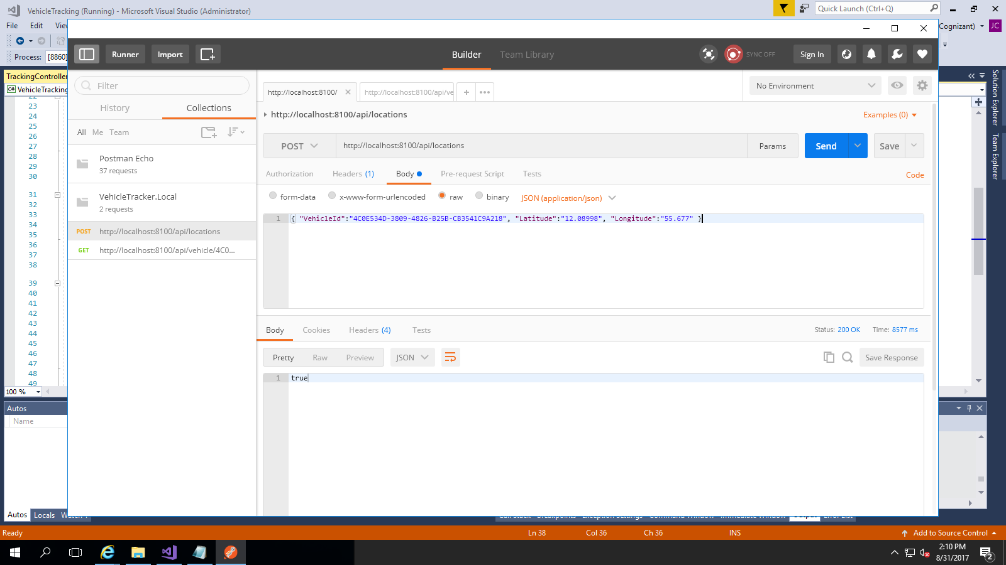

<http://localhost:8100/api/vehicle/4C0E534D-3809-4826-B25B-CB3541C9A218/lastlocation>

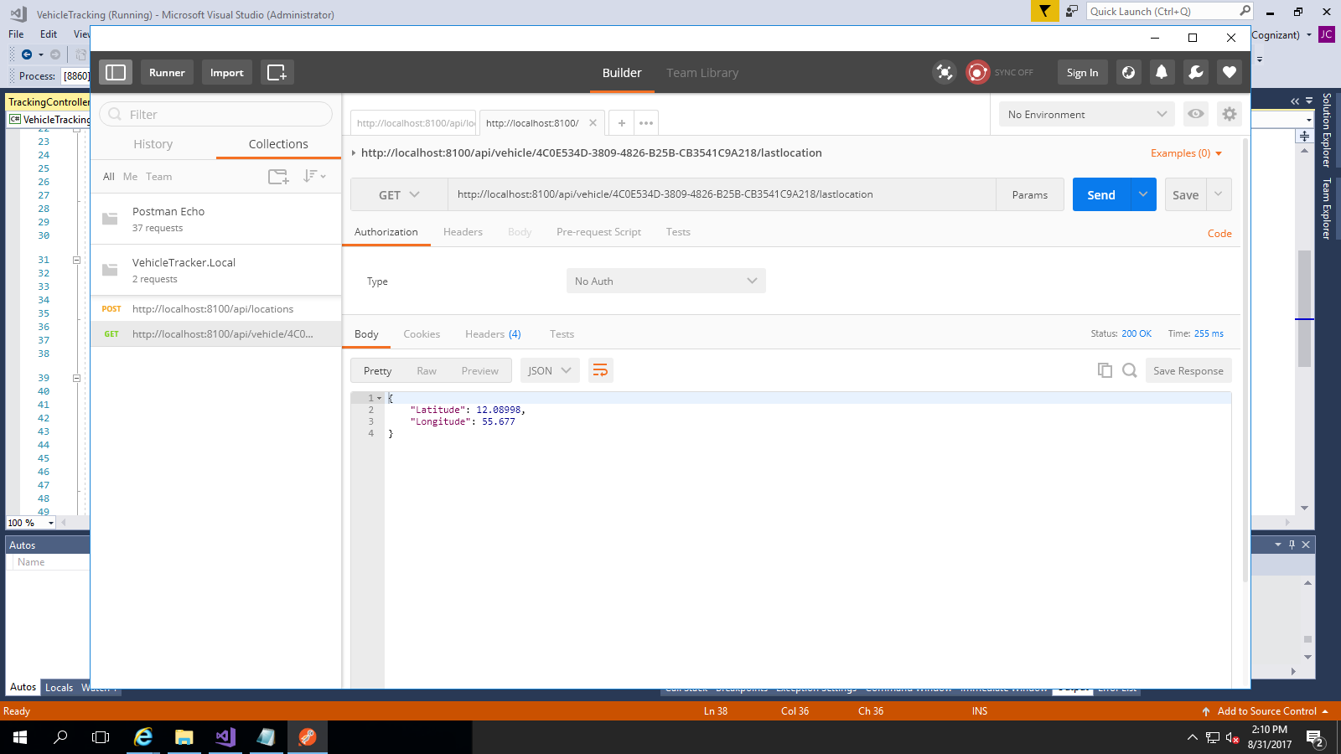

<http://localhost:8100/api/vehicle/4C0E534D-3809-4826-B25B-CB3541C9A218/lastlocation>

