Analysis of the Impact of Air Pollutants on Urban Air Quality: A Case Study in Medium-Sized Cities

Abstract
This study investigates the effects of air pollutants on air quality in medium-sized cities, using data collected over 12 months in three municipalities in southeastern Brazil. The concentrations of particulate matter (PM10 and PM2.5), sulfur dioxide (SO₂), nitrogen dioxide (NO₂), and tropospheric ozone (O₃) were analyzed. From this data, seasonal patterns, predominant emission sources, and correlations with meteorological variables were identified. The results indicate that urban transportation and industrial activities are the main contributors to air pollution, with winter months being the most critical for air quality.
Keywords: air pollution, particulate matter, nitrogen dioxide, medium-sized cities, air quality.

Main

1.1 Urbanization and Air Pollution
Urbanization leads to increased emissions of air pollutants due to higher energy consumption, vehicular traffic, and industrial activity. While megacities receive considerable attention in environmental studies, medium-sized cities often lack adequate monitoring and mitigation strategies. As their populations grow, so do the environmental and health risks associated with air pollution [1].

1.2 Key Pollutants of Concern
This study focuses on five major pollutants:
- PM10 and PM2.5: These fine particles can penetrate deeply into the lungs and bloodstream [2].
- NO₂ and SO₂: Byproducts of combustion processes, especially from vehicles and industrial sources [3].
- O₃ (Tropospheric ozone): A secondary pollutant formed through chemical reactions involving sunlight and nitrogen oxides.

1.3 Emission Sources and Urban Dynamics
Field observations and historical records confirm that vehicular emissions, industrial discharges, and biomass burning are the dominant sources of pollution in the studied cities [2]. Differences in economic activities (e.g., heavy industry vs. service sector) influence pollutant profiles, as does the urban layout and availability of green areas.

Figure 1: Annual Concentration of Major Pollutants in City A

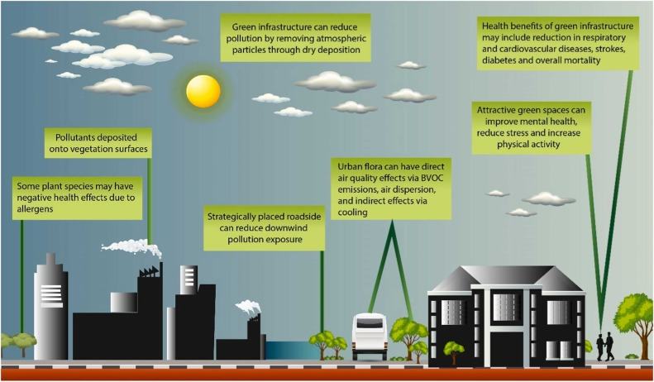
Figure 1 – Monthly and average annual concentration (μg/m³) of key pollutants in City A over the year 2024.

Discussion/Conclusions

2.1 Seasonal Trends and Health Implications
Pollutant levels were highest during the winter, when atmospheric conditions trap pollutants near the ground (a phenomenon known as thermal inversion) [4]. This leads to a spike in respiratory illnesses and hospitalizations, particularly among vulnerable populations such as children and the elderly.

2.2 Socioeconomic Impacts
Increased pollution correlates with decreased labor productivity, school absences, and higher public health costs [5]. Urban residents exposed to high levels of NO₂ and PM2.5 show increased cases of asthma, bronchitis, and cardiovascular disease [3].

2.3 Need for Public Policy
The results highlight the urgent need for integrated environmental policies. Suggested actions include:
- Expansion of green spaces and urban forests
- Electrification of public transport
- Implementation of emissions-based vehicle taxes
- Periodic emission testing for industries [1][2]
.

Table 1: Seasonal Variation in Pollutant Levels (μg/m³)

Pollutant | Summer | Autumn | Winter | Spring
PM2.5 | 24 | 30 | 47 | 29
PM10 | 35 | 40 | 60 | 38
NO2 | 22 | 28 | 52 | 26
O3 | 18 | 22 | 33 | 20

Table 1 – Seasonal variation in average pollutant concentrations across all studied cities.

Methods

3.1 Study Sites
The selected cities (referred to as City A, B, and C) are located in the southeastern region of Brazil. Each city has a population between 200,000 and 500,000 and distinct economic activities ranging from manufacturing to services [2].

3.2 Data Collection
Air quality data were obtained from government-run automatic monitoring stations. Data included:
- PM10 and PM2.5 (gravimetric and beta attenuation methods)
- SO₂ and NO₂ (UV fluorescence and chemiluminescence)
- O₃ (UV photometry)
Meteorological data were sourced from local meteorological institutes, providing temperature, humidity, wind direction/speed, and precipitation records [1].

3.3 Statistical Analysis
Statistical analyses were performed using R software. Tools included:
- Pearson correlation to evaluate relationships among variables.
- ANOVA to assess pollutant variation across seasons and cities.
- Multiple linear regression to model pollutant concentrations based on meteorological conditions and emission patterns.

References
- World Health Organization. Air quality guidelines for particulate matter, ozone, nitrogen dioxide and sulfur dioxide. Geneva: WHO; 2021.
- CETESB - Environmental Company of the State of São Paulo. Air quality report in the state of São Paulo 2023. São Paulo: CETESB; 2024.
- Braga, A. L. F. et al. Air pollution and health effects: an epidemiological approach. São Paulo: Hucitec Publishing, 2019.
- Saldiva, P. H. N.; Lombardi, C. Impacts of air pollution on health. USP Journal, no. 114, pp. 65–78, 2022.

