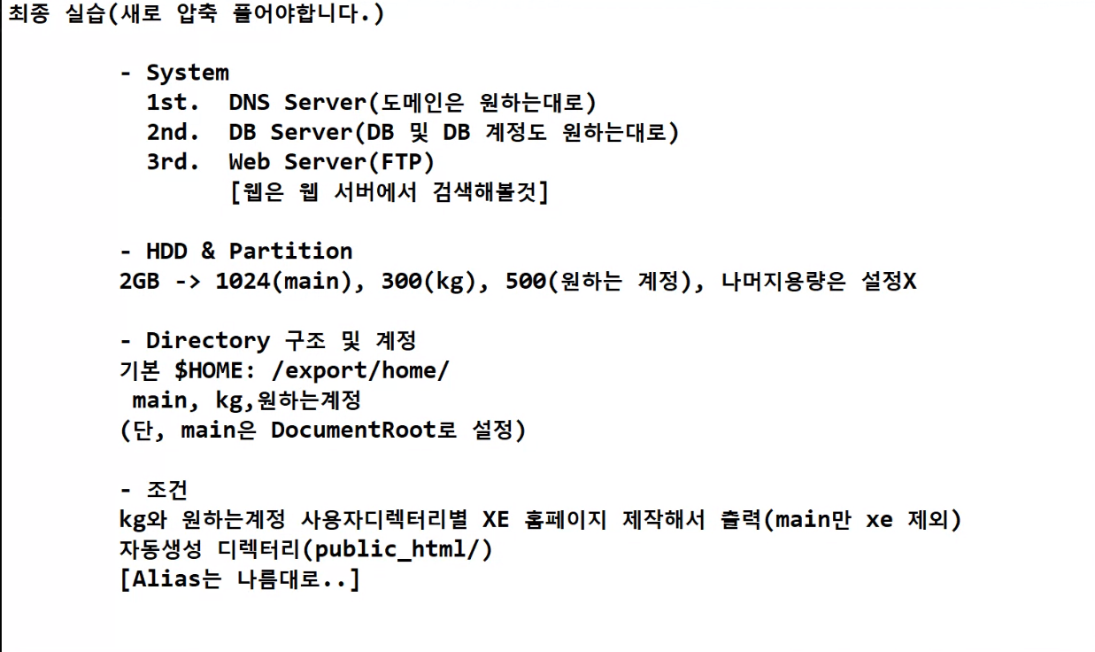

# cp -p /etc/samadal_yum /usr/bin/yum