Learning Focus:
Memo
(LQ Answering Flow, MC skills, your goals and resolutions…)
Specific Question Type
MC

Learning Focus:
Memo
(LQ Answering Flow, MC skills, your goals and resolutions…)
Specific Question Type
LQ

Chapter 10 _ Consumer Surplus & Producer Surplus, Profit Maximising & Output Determination
Type 1 (Change in CSPS)
Example Question 1 DSEPPMCQ14
The following diagram shows the demand and supply curves of good X in a perfectly competitive market.
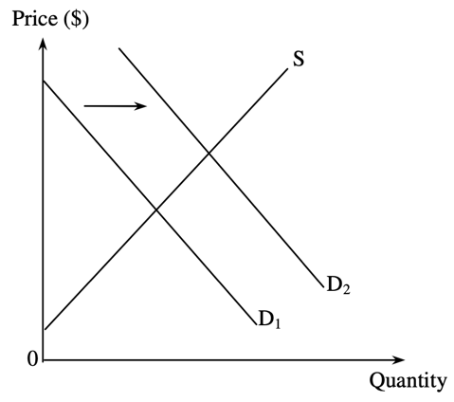
There is a shift in the demand curve for good X from D1 to D2. As a result,
A. firms enjoy more producer surplus. B. the marginal cost of producing the last unit decreases.
C. the supply of good X increases. D. consumers enjoy less consumer surplus.

下圖顯示在一個完全競爭市場內物品 X 的需求和供應曲線。
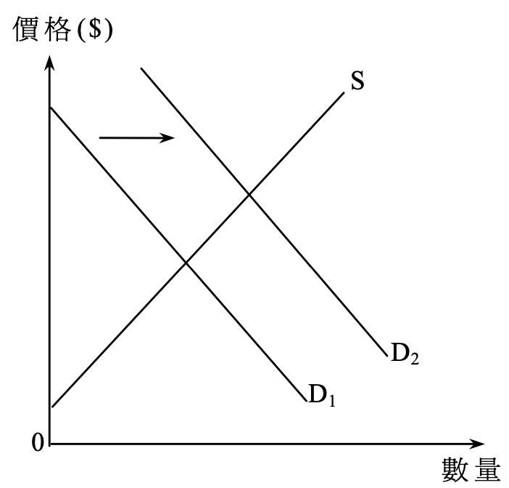
物品 X 的需求曲線由 D1移至 D2。結果，
A. 公司享有較多的生產者盈餘。 B. 生產最後一單位的邊際成本會下降。
C. 物品 X 的供應會增加。 D. 消費者享有較少的消費者盈餘。

Example Question 2 DSE2012MCQ14
On 10th 2011, the urban taxi fare for the first 2km was raised from $18 to $20. Which of the following statements about the urban taxi service are correct?
(1) The demand for tax service dropped
(2) The price of long-distance taxi trips relative to short-distance taxi trips dropped
(3) The consumer surplus for the taxi service dropped
A. (1) and (2) only B. (1) and (3) only C. (2) and (3) only D. (1), (2) and (3)

由於2011年7月10日開始，市區的士服務首兩公里的車費由18元增加至20元。下列哪些有關市區的士服務的陳述是正確的？
(1) 的士服務的需求下降。
(2) 相對短程的士服務，長程的士服務的價格下降。
(3) 的士服務的消費者盈餘下降。
A. 只有(1)、(2) B. 只有(1)、(3) C. 只有(2)、(3) D. (1)、(2) 及(3)

Example Question 3 DSE2015MCQ22
Refer to the following diagram.
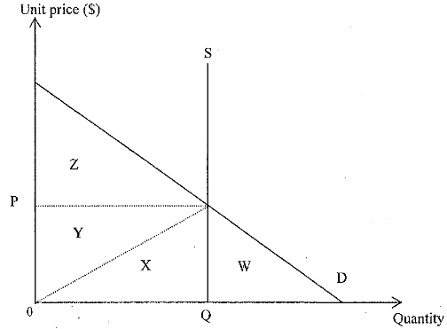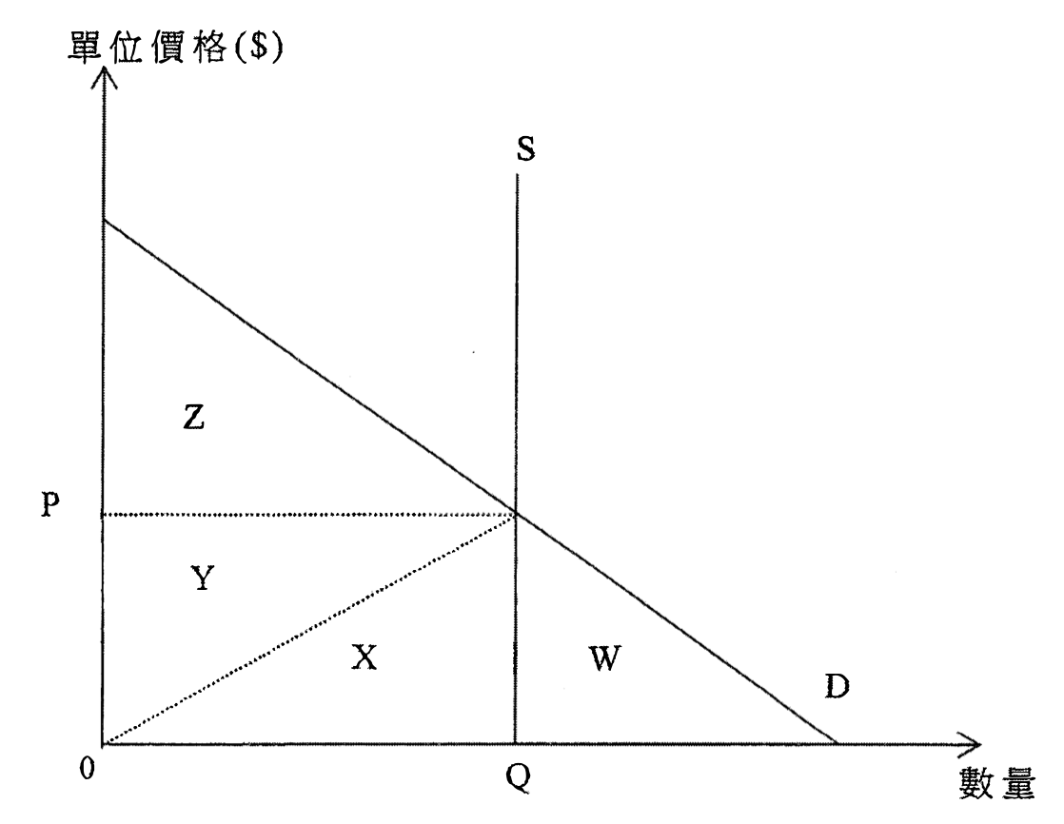
The maximum total social surplus is equal to ___________.
A. Area Z. B. Area(Y+Z) C. Area(W+X+Y) D. Area (X+Y+Z)

細閱下圖。最大的總社會盈餘等於___________。
A. 面積Z B. 面積(Y+Z) C. 面積(W+X+Y) D. 面積(X+Y+Z)

Type 2 (Profit Maximising and Output Determination)
Example Question 1 DSEPPMCQ12
The following table shows the total cost schedule of a price-taking firm which has a fixed cost equal to $20.
Quantity (units) | Total cost ($) | 數量（單位） | 總成本（$）
1  2  3  4  5 | 40  65  95  130  170 | 1  2  3  4  5 | 40  65  95  130  170
Suppose the market price is $35. At the profit-maximizing output level, the firm’s profit and total producer surplus are __________ and __________ respectively.
A. $10 ... $10 B. $10 ... $30 C. $30 ... $10 D. $30 ... $30

以下是一間受價公司的總成本表。該公司的固定成本等於$20。
假設市價是$35。在利潤極大化產出水平，該公司的利潤和總生產者盈餘分別是 __________ 和 __________。
A. $10 ... $10 B. $10 ... $30 C. $30 ... $10 D. $30 ... $30

Example Question 2 DSE2012MQ9
Refer to the following table showing the production costs of a price-taking firm.
Total output (units) | 2 | 3 | 4 | 5 | 6
Marginal cost ($) | 4 | 6 | 8 | 10 | 12
Average variable cost ($) | 3 | 4 | 5 | 6 | 7
Fixed cost ($) | 1 | 1 | 1 | 1 | 1
If the product price is $6,
A. The firm will produce 5 units of output to maximise its profit B. The maximum profit the firm can make is $5
C. The average variable cost is $5 when the firm maximises its profit D. The minimum total cost of the firm is $13

細閱下表有關某受價廠商的生產成本。
產出（單位） | 2 | 3 | 4 | 5 | 6
邊際成本（$） | 4 | 6 | 8 | 10 | 12
平均可變成本（$） | 3 | 4 | 5 | 6 | 7
固定成本（$） | 1 | 1 | 1 | 1 | 1
若產品價格為$6，
A. 該廠商會生產5單位的產出以爭取利潤極大化。 B. 該廠商可賺取的最高利潤是$5。
C. 當該廠商的利潤為最大化時，其平均可變成本是$5。 D. 該廠商的最少總成本是$13。

Example Question 3 DSE2013MQ3
The following table shows the cost-output relationship of a firm
Outputs (units) | 0 | 1 | 2 | 3 | 4 | 5
Total cost ($) | 10 | 28 | 42 | 52 | 60 | 72
Based on the above table, we can conclude that
A. The firm enjoys the benefits of economies of scale B. The firm’s optimal scale of production is 5 units of outputs
C. The average variable cost is increasing D. The total fixed cost is $10

下表顯示某廠商的成本與產出的關係。
產出（單位） | 0 | 1 | 2 | 3 | 4 | 5
總成本（$） | 10 | 28 | 42 | 52 | 60 | 72
根據上表，我們可得出結論如下：
A. 該廠商享有規模經濟。 B. 該廠商的最優生產規模是5單位的產出。
C. 平均可變成本正上升。 D. 總固定成本是$10。

Example Question 4 DSE2014MQ6
The following table shows the cost-output relationship of a price taker.
Output (unit) | Total cost ($)
1 | 20
2 | 45
3 | 75
4 | 110
5 | 150
Given that the profit maximizing output of the firm is 3 units. If the fixed cost increases by $5, the price of the good and the output will be _______ and _______ respectively.
A. $25 … 2 units B. $30 … 2 units C. $30 … 3 units D. $75 … 3 units

下表顯示某受價者的成本和產量的關係。
產量（單位） | 總成本（$）
1 | 20
2 | 45
3 | 75
4 | 110
5 | 150
已知該廠商的利潤極大化產量是3單位，若固定成本增加$5，該物品的價格和產量分別是_______和_______
A. $25 … 2 單位 B. $30 … 2 單位 C. $30 … 3 單位 D. $75 … 3 單位

***Example Question 5 DSE2015MQ5
The schedule below shows the marginal cost of a firm in a perfectly competitive market.
Output (units) | 3 | 4 | 5 | 6 | 7 | 8 | 9
Marginal cost ($) | 5 | 5.5 | 6 | 6.5 | 7 | 8 | 9.5
Suppose the rental of the machine hired, a fixed cost, increased by $2 while the marginal cost for each unit of the output is reduced by $0.5. As a result, the profit-maximising output of the firm _______ while the profit of the firm _________.
A. Increases … decreases B. Increases … may increase or decrease
C. Decreases … decrease D. Decreases … may increase or decrease

下表顯示在完全競爭市場內某廠商的邊際成本。
產量（單位） | 3 | 4 | 5 | 6 | 7 | 8 | 9
邊際成本（$） | 5 | 5.5 | 6 | 6.5 | 7 | 8 | 9.5
假設租用機器的租金（屬固定成本）上升了$2，而每單位產出的邊際成本減少了$0.5。該廠商利潤極大化的產量因此_________，而利潤_________。
A. 上升 … 下跌 B. 上升 … 可能上升或下跌
C. 下跌 … 下跌 D. 下跌 … 可能上升或下跌

Example Question 6 DSE2016MQ12
The following table shows the cost-output relationship of a price-taker.
Output (units) | Average cost ($) | 產出（單位） | 平均成本（$）
2 | 20 | 2 | 20
3 | 21 | 3 | 21
4 | 22 | 4 | 22
5 | 23 | 5 | 23
6 | 24 | 6 | 24
7 | 25 | 7 | 25
Suppose the market price is $25. What are the profit-maximising output and profit respectively?
A. 4 units and $0 B. 4 units and $12 C. 7 units and $0 D. 7 units and $12

下表顯示一受價者的成本與產出的關係。
假設市場價格是$25。利潤極大化的產出和利潤分別是多少？
A. 4 單位及 $0 B. 4 單位及 $12 C. 7 單位及 $0 D. 7 單位及 $12
Example Question 7 DSE2017MQ8
The following table shows the cost-output relationship of a price-taker.
Output (units) | Average cost ($) | 產出（單位） | 平均成本（$）
5 | 10 | 5 | 10
6 | 11 | 6 | 11
7 | 12 | 7 | 12
8 | 13 | 8 | 13
9 | 14 | 9 | 14
The market price is $20. Suppose the average cost has increased by $2 for every unit of output. The profit of the firm will ______.
A. Increase by $16 B. Increase by $14 C. Decrease by $16 D. Decrease by $14

下表顯示某受價者的成本與產出的關係。
市場價格是 $20。假設每單位產出的平均成本上升 $2。該廠商的利潤會_______。
A. 增加 $16 B. 增加 $14 C. 減少 $16 D. 減少 $14

Example Question 8 DSE2018MQ6
The following table shows the cost-output relationship of a profit-maximising firm. The firm has a fixed cost of $5.
Output (units) | 1 | 2 | 3 | 4 | 5 | 6
Average cost ($) | 7 | 6 | 7 | 8 | 9.6 | 12
Which of the following statements is correct?
A. The optimal scale of production is 2 units B. There exist diseconomies of scale after the third unit of output is produced
C. If the market price is $8, the output is 4 units D. If the market price is $9, the profit is $6.

下表顯示一家利潤極大化廠商其成本與產出的關係。該廠商的固定成本是 $5。
產出（單位） | 1 | 2 | 3 | 4 | 5 | 6
平均成本（$） | 7 | 6 | 7 | 8 | 9.6 | 12
下列哪項陳述是正確的？
A. 最優生產規模是2單位。 B. 在生產第三個單位的產出後，該廠商出現規模負經濟。
C. 若市價是$8，產出是 4單位。 D. 若市價是$9，利潤是$6。

***Example Question 9 DSE2019MQ4
If the fixed cost of a price-taking firm decreases by $200 and the marginal cost of each unit of output increases by $10, the profit-maximising output will _______ and the profit _______.
A. Increase … will decrease B. Increase … may increase or decrease
C. Decrease … will increase D. Decrease … may increase or decrease

如果某受價者廠商的固定成本下跌 $200而每單位邊際成本上升 $10，利潤極大化的產量會_______，而利潤_______。
A. 上升 … 會下跌 B. 上升 … 可能上升或下跌
C. 下跌 … 會下跌 D. 下跌 … 可能上升或下跌

Example Question 10 DSE2019MQ10
The following table shows the cost-output relationship of a price taking firm.
Total output (units) | Average cost ($) | 總產出（單位） | 平均成本（$）
3 | 10 | 3 | 10
4 | 15 | 4 | 15
5 | 20 | 5 | 20
6 | 25 | 6 | 25
7 | 30 | 7 | 30
If the profit-maximising output is 6 units, the market price will be ______.
A. $5 B. $25 C. $30 D. $50

下表顯示某受價者廠商成本與產出的關係。若利潤極大化的產量是6單位，市場價格會是______。
A. $5 B. $25 C. $30 D. $50

Example Question 11 DSE2020MQ9
Refer to the following table about the cost-output relationship of a profit-maximizing firm.
Quantity (units) | 1 | 2 | 3 | 4 | 5
Average cost ($) | 5 | 6 | 7 | 8 | 9
If the average cost of every unit of output decreases by $1 and the market price is $8.
A. the minimum cost of production is $18 B. the profit maximising output is 3 units.
C. the maximum profit is $10. D. the marginal cost of every unit of output will remain unchanged.

參考以下某利潤極大化廠商的成本與產出的關係表。
數量（單位） | 1 | 2 | 3 | 4 | 5
平均成本（$） | 5 | 6 | 7 | 8 | 9
如果每單位產出的平均成本下降 $1，市場價格為 $8。
A. 最低生產成本為$18。 B. 利潤極大化產量是3單位。
C. 極大化的利潤是$10。 D. 每單位產出的邊際成本會維持不變。

Example Question 12 DSE2021MQ12
The following table shows the cost-output relationship of a price-taking firm.
Quantity (units) | Average cost ($) | 產出（單位） | 平均成本（$）
1 | 5 | 1 | 5
2 | 4 | 2 | 4
3 | 4 | 3 | 4
4 | 4.5 | 4 | 4.5
5 | 6 | 5 | 6
Based on the above table, when the market price falls from $6 to $4, we can conclude that
A. the firm starts to enjoy economies of scale. B. the total cost of the firm will decrease from $30 to $12.
C. the profit of the firm will decrease by $6. D. the quantity supplied will decrease from 5 units to 3 units.

下表顯示某受價者廠商成本與產出的關係。根據上表，我們可以得出結論：當市場價格由 $6 下降至 $4，
A. 該廠商開始享有規模經濟。 B. 該廠商的總成本會由 $30 下降至 $12。
C. 該廠商的利潤會減少 $6。 D. 供應量會由 5 單位下降至 3 單位。

2014DSE LQ9b
Many countries have considered imposing ‘soft drink tax’ for health reasons. Suppose a country decides to impose a per unit tax on the sellers for every bottle of soft drink sold in the market. Using the same diagram, indicate the change in the consumer surplus after the tax is imposed.
許多國家以國民健康為理由考慮徵收「汽水稅」。假設某國決定對賣家在市場中售出的每瓶汽水徵收一項從量稅。利用供需圖，標示在開徵該稅項後消費者盈餘的改變。 (1)

_______________________________________________________________________________________
_______________________________________________________________________________________
_______________________________________________________________________________________
_______________________________________________________________________________________
_______________________________________________________________________________________
_______________________________________________________________________________________
_______________________________________________________________________________________
_______________________________________________________________________________________
_______________________________________________________________________________________
_______________________________________________________________________________________
_______________________________________________________________________________________
Marking Scheme:
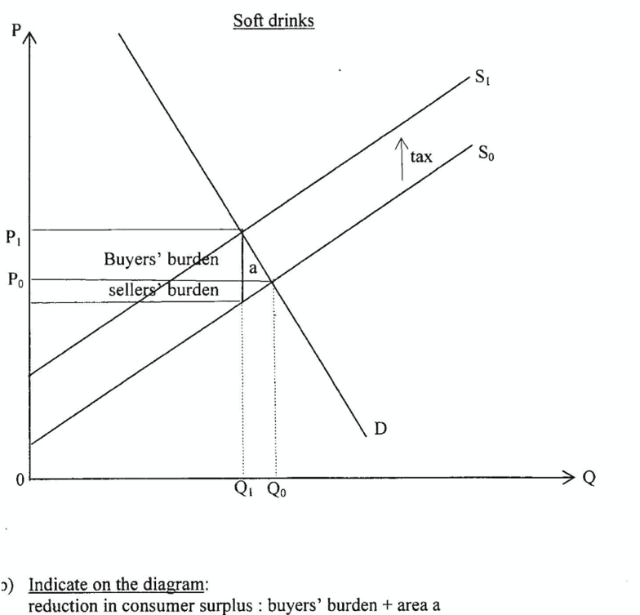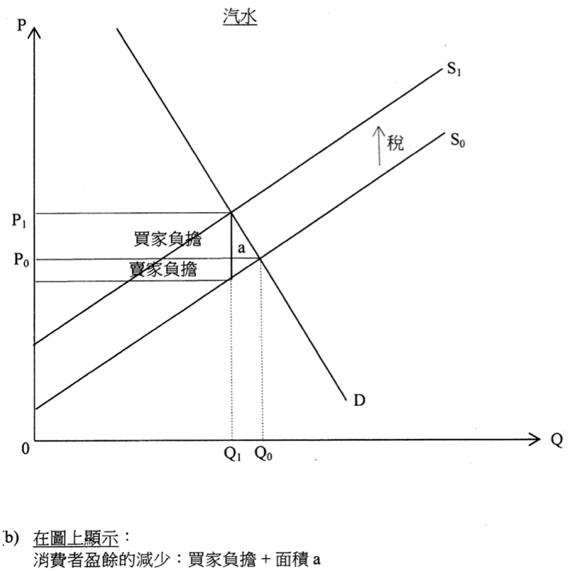

Candidates’ Performance:
Good. Many candidates indicated accurately the prices, quantities, and tax burdens before and after tax on a supply-demand diagram. There was a technical problem in graphical presentation, however, that candidates should be aware of -the shading or using different colours to represent the tax burdens and the change in consumer surplus were sometimes hardly visible on the markers' computer screens. Candidates are thus advised to label the (3 or 4) corners of the relevant areas for these objects. A few candidates wrongly assumed inelastic demand and ignored the role of the demand and supply elasticities.
良好。很多考生能在供需圖中準確標示稅前和稅後的價格和數量，及稅項負擔。但是考生需要注意一個繪圖表達的技術問題：在標示稅項負擔時的陰影或用不同顏色在閱卷員的螢幕上有時難以清楚看見。考生宜在有關的面積的三或四個角位作標示。一些考生錯誤地假設需求屬低彈性，忽略了需求和供應彈性的角色。

2014DSE LQ2b
Ah Wing runs a store selling mobile phone accessories in Mong Kok. Give ONE example of variable cost incurred in Ah Wing’s business. Explain your answer.
亞榮在旺角開設一家售賣手提電話配件的店舖。舉出在亞榮的業務中所涉及可變成本的一個例子。試加以解釋。 (2)
_______________________________________________________________________________________
_______________________________________________________________________________________
_______________________________________________________________________________________
_______________________________________________________________________________________
_______________________________________________________________________________________
_______________________________________________________________________________________
_______________________________________________________________________________________
_______________________________________________________________________________________
_______________________________________________________________________________________
_______________________________________________________________________________________
_______________________________________________________________________________________
_______________________________________________________________________________________
Marking Scheme:
Cost of buying the accessories, or wages of part-time workers (1)
As expenses on these items would vary (increase) with the output of Ah Wing’s shop. (1)

購買配件的成本/兼職員工的工資，
因為在這些項目的開支會隨着阿榮店舖的產出轉變（增加）而轉變（上升）

Candidates’ Performance:
Fair. Most candidates realized that they should not give examples of fixed cost in their answers. But many of them chose to provide examples of variable factors, such as electricity and part-time workers, instead of variable cost. Among those who were able to give a correct example, some did not explain how cost varies with output.
尚可。大部份考生知道他們不應舉出固定成本例子作答。但是很多考生選擇寫出可變要素的例子，例如電力和兼職員工，而不是可變成本。在能夠寫出正確例子的考生中，部份沒有解釋成本如何隨着產量上升。

Marking Scheme:
Type 1 (Marginal Benefit, Marginal Cost, Consumer Surplus and Producer Surplus)
1 | A | 2 | C | 3 | D | 4 | A | 5 | D | 6 | A | 7 | D | 8 | C | 9 | D
Type 2 (Profit Maximising and Output Determination)
1 | B | 2 | B | 3 | D | 4 | C | 5 | B | 6 | B | 7 | D | 8 | D | 9 | D | 10 | D
11 | B | 12 | C | 13 | D | 14 | C | 15 | A | 16 | A | 17 | A | 18 | C | 19 | D | 20 | B

