Learning Focus:
Memo
(LQ Answering Flow, MC skills, your goals and resolutions…)
Specific Question Type
MC

咩話？DSE Sample Paper, Practice Paper, 2012, 2013, 2014, 2015, 2016, 2017, 2018, 2019, 2020, 2021, 2022
MC全部拍晒解題片？係呀，有唔明即scan即睇！就係咁firm！


Learning Focus:
Memo
(LQ Answering Flow, MC skills, your goals and resolutions…)
Specific Question Type
LQ

咩話？DSE Sample Paper, Practice Paper, 2012, 2013, 2014, 2015, 2016, 2017, 2018, 2019, 2020, 2021, 2022
LQ全部拍晒解題片？係呀，有唔明即scan即睇！就係咁firm！


Chapter 22 _ Exchange rate & Balance of Payment
Type 1 (Linked Exchange Rate System in Hong Kong)
Example Question 1 CE1993MCQ33
Which of the following about the linked exchange rate in Hong Kong is correct?
A. It is determined by market forces
B. It has been change several times by the government
C. The linked rate system is used to stabilize the exchange rate of the Hong Kong dollar
D. It is an exchange rate between the Hong Kong dollar and a basket of foreign currencies

以下哪項關於香港聯繫匯率是正確的？
A. 它是由市場力量決定。 B. 它已被政府更改了幾次。
C. 採用聯繫匯率制度穩定港元匯率。 D. 這是港元與一籃子外幣之間的匯率。

Example Question 2 CE1996MCQ52
Hong Kong practices a linked exchange rate system. In the foreign exchange market the exchange rate of the Hong Kong dollar relative to the US dollar is ____________ and that relative to other currencies is ________.
A. fixed at US$1 = HK$7.8 … fixed B. fixed at US$1 = HK$7.8 … not fixed
C. not fixed … fixed D. not fixed … not fixed

香港實行聯繫匯率制度。在外匯市場上，港元兌美元的匯率是____________，兌於其他貨幣是________。
A. 固定在1美元 = HK$7.8 … 固定 B. 固定在1美元 = HK$7.8 … 不固定
C. 不固定 … 固定 D. 不固定 … 不固定

Example Question 3 CE1998MCQ49
Under the linked exchange rate system of Hong Kong, which of the following statements is true?
A. The exchange rate of the HK dollar relative to Renminbi is fixed.
B. The market exchange rate of the HK dollar relative to the US$ is fixed at US$1 = HK$7.8.
C. The competitiveness of Hong Kong exports decreases when the US dollar appreciates against other currencies.
D. Hong Kong will not have a balance of payments problem.

在香港的聯繫匯率制度下，以下哪項說法是正確的？
A. 港元兌人民幣的匯率是固定的。 B. 港元兌美元的市場匯率固定為1美元 = 7.8港元。
C. 當美元兌其他貨幣升值時，香港出口的競爭力下降。 D. 香港不會有國際收支平衡問題。

Example Question 4 CE2001MCQ46
Under the linked exchange rate system in Hong Kong,
A. the market exchange rate of the HK dollar relative to the US dollar is fixed.
B. the market exchange rates of the HK dollar relative to currencies other than the US dollar are fixed.
C. the HK dollar will depreciate against the Australian dollar if the US dollar appreciates against the Australian dollar.
D. the HK dollar will appreciate against the Japanese yen if the US dollar appreciates against the Japanese yen.

在香港的聯繫匯率制度下，
A. 港元兌美元的市場匯率是固定的。 B. 港元兌美元以外貨幣的市場匯率是固定的。
C. 如果美元兌澳元升值，港元兌澳元將貶值。 D. 如果美元兌日元升值，港元兌日元將升值。

Example Question 5 CE2006MCQ47
Under the linked exchange rate system in Hong Kong, which of the following statements is correct?
A. The exchange rate of the Hong Kong dollar (HKD) relatively to the US dollar (USD) is fixed at USD 1= HKD 7.8 on the foreign exchange market
B. If Mainland China has a visible trade surplus, Hong Kong will also have a visible trade surplus
C. When the USD depreciates against the Euro, the HKD will also depreciates against the Euro
D. All of the above

在香港的聯繫匯率制度下，以下哪項說法是正確的？
A. 在外匯市場，港元（HKD）兌美元（USD）的匯率固定在1美元 = 港幣7.8元
B. 如果中國大陸存在有形貿易順差，香港也會存在有形貿易順差。
C. 當美元兌歐元貶值時，港元兌歐元也會貶值。
D. 以上皆是。

Example Question 6 CE2009MCQ50
Under the linked exchange rate system of Hong Kong,
A. The exchange rate of the Hong Kong dollar with the US dollar in the foreign exchange market is fixed.
B. The Hong Kong government need not hold a large amount of foreign exchange reserves.
C. Hong Kong citizens can give the Hong Kong government Hong Kong dollars in exchange for US dollars at the linked rate.
D. The Hong Kong dollar banknotes are fully backed by foreign exchange reserves.

在香港的聯繫匯率制度下,
A. 港元與美元在外匯市場的匯率是固定的。 B. 香港政府不需要持有大量的外匯儲備。
C. 香港市民可以向香港政府以聯繫匯率提供港元以換取美元。 D. 港元完全由外匯儲備支持

Example Question 7 CE2011MCQ50
Under the linked exchange rate system in Hong Kong,
A. The market exchange rate of the Hong Kong dollar relative to the US dollar is fixed at US$1 = HK$7.8
B. The three note-issuing banks in Hong Kong have the obligation to the general public to exchange Hong Kong dollars for US dollars at the linked rate.
C. The Hong Kong dollar banknotes do not have to be fully backed by foreign exchange reserves.
D. The market exchange rate of the Hong Kong dollar relative to the Euro will move in the same direction as the market exchange rate of the US dollar relative to the Euro.

在香港的聯繫匯率制度下，
A. 港元兌美元的市場匯率定為1美元=7.8港元 B. 香港三家發鈔銀行對公眾有責任按聯繫匯率將港元兌換成美元。
C. 港元不必完全由外匯儲備支持。 D. 港元兌歐元的市場匯率將與美元兌歐元的市場匯率走向相同。

Example Question 8 DSE2013MCQ40
Which of the following statements about the linked exchange rate system of Hong Kong is correct?
(1) Hong Kong dollar banknotes are fully backed by Renminbi and the US dollar
(2) The Hong Kong Monetary Authority holds a considerable amount of foreign exchange reserves
(3) All note-issuing banks can exchange for US dollars at the linked exchange rate with the Hong Kong Monetary Authority
(4) The exchange rate of Hong Kong dollar to the US dollar in the foreign exchange market is fixed.
A. (1) and (2) only B. (1) and (4) only C. (2) and (3) only D. (2) and (4) only

下列哪項有關香港聯繫匯率制度的陳述是正確的?
(1) 港元完全由人民幣和美元支持。
(2) 香港金融管理局持有大量的外匯儲備。
(3) 所有發鈔銀行可按聯繫匯率與香港金融管理局兌換美元 。
(4) 港元兌美元在外匯巿場的匯率是固定的 。
A. 只有(1)、 (2) B. 只有(1)、(4) C. 只有(2)、(3) D. 只有(3)、(4)

Example Question 9 DSE2015MCQ42
Under the linked exchange rate system of Hong Kong, which of the following statements is correct?
A. The money supply (M1) of Hong Kong has to be fully backed by the US dollar.
B. The market exchange rate of HK dollar to the US dollar is fixed at 1 USD to 7.8 HKD by the Hong Kong Monetary Authority.
C. Hong Kong’s import volume will increase when US dollar appreciates against other currencies.
D. A current account deficit in the US will lead to a current account deficit in Hong Kong.

在香港的聯繫匯率制度下，以下哪項說法是正確的？
A. 香港的貨幣供應量M1必須完全由美元支持。 B. 香港金融管理局將港元兌美元的市場匯率定為1美元兌7.8港元。
C. 當美元兌其他貨幣升值時，香港的進口量將會增加。 D. 美國的經常帳戶赤字將導致香港的經常帳戶赤字。
Example Question 10 DSE2017MCQ45
Under the linked exchange rate system of Hong Kong, which of the following statements is correct?
A. The non-bank public can sell their Hong Kong dollars to the Hong Kong Monetary Authority in exchange for US dollars at any time
B. It enables the Hong Kong Monetary Authority to carry out an expansionary monetary policy to stimulate private investment
C. The market exchange rate of the US Dollar against the HK Dollar is fixed at US$1 = HK$7.8
D. There would be a downward pressure on the consumer price indices of Hong Kong when the Renminbi continuously depreciates against the US Dollar

在香港聯繫匯率制度之下，下列哪項陳述是正確的?
A. 非銀行公眾可以在任何時間將所持有的港幣賣給香港金融管理局以換取美元 。
B. 它讓香港金融管理局可以實施擴張性貨幣政策以刺激私人投資。
C. 美元兌港元的市場匯率是固定於1美元 = 7.8港元 。
D. 人民幣兌美元持續貶值，會對本港消費物價指數構成向下壓力。

Example Question 11 DSE2020MCQ45
Under the linked exchange rate system of Hong Kong, which of the following statements is correct?
A. The money supply M1 of Hong Kong has to be fully backed up by the US dollar.
B. Hong Kong's export volume will increase when the US dollar depreciates against other currencies.
C. The market exchange rate of the HK dollar relative to the US dollar is fixed.
D. Hong Kong citizens can sell 1 USD to the three note-issuing banks for 7.8 HKD

在香港的聯繫匯率制度下，以下哪項說法是正確的？
A. 香港的貨幣供應量M1必須完全由美元支持。
B. 當美元兌其他貨幣貶值時，香港的出口量將會增加。
C. 港元兌美元的市場匯率是固定的。
D. 香港市民可以向三家發鈔銀行以1美元兌7.8港元的匯率兌換美元。

Example Question 12
Under the linked exchange rate system of Hong Kong, which of the following statements is correct?
A. When the HK dollar appreciates against the British pounds, it follows that the US dollar will appreciate against the British pounds.
B. The market exchange rate of the HK dollar relative to the US dollar is fixed.
C. Cash held by non-bank public and authorized institutions is fully backed by US dollar.
D. As the US dollar continuously depreciates against the Renminbi, the competitiveness of Hong Kong’s exports to mainland China will decrease.

在香港的聯繫匯率制度下，以下哪項說法是正確的？
A. 當港元兌英鎊升值時，美元兌英鎊也會升值。
B. 港元對美元的市場匯率是固定的。
C. 非銀行公眾和授權機構持有的現金完全由美元支持。
D. 隨著美元兌人民幣持續貶值，香港對中國大陸出口的競爭力將會下降。

Example Question 13
Under the linked exchange rate system of Hong Kong, which of the following statements are INCORRECT?
(1) The monetary base of Hong Kong is fully backed by the US dollar.
(2) The exchange rate of Hong Kong dollar relative to the US dollar in the foreign exchange market is fixed.
(3) Hong Kong citizens can sell 1 USD to the HKMA for 7.8 HKD.
A. (1) and (2) only B. (1) and (3) only C. (2) and (3) only D. (1), (2) and (3)

在香港的聯繫匯率制度下，以下哪些陳述不正確？
（1）香港的貨幣基礎完全由美元支持。
（2）在外匯市場上，港元對美元的匯率是固定的。
（3）香港市民可以以7.8港元的價格向金管局出售1美元。
A. 只有（1）和（2） B. 只有（1）和（3） C. 只有（2）和（3） D. （1）、（2）和（3）

Example Question 14
Under the linked exchange rate system in Hong Kong, which of the following statements are correct?
(1) When the US dollar appreciates against Renminbi, it follows that Hong Kong may face a trade deficit.
(2) The fixed exchange rate of HK dollar to the US dollar is fixed at 1 USD to 7.8 HKD by the three note-issuing banks in Hong Kong.
(3) The three note-issuing banks in Hong Kong can exchange for US dollars at the linked exchange rate with the Hong Kong Monetary Authority
A. (1) and (2) only B. (1) and (3) only C. (2) and (3) only D. (1), (2) and (3)

在香港聯繫匯率制度下，以下哪項陳述是正確的？
（1）當美元兌人民幣升值時，香港可能面臨貿易逆差。
（2）香港三間發鈔銀行將美元兌港元的固定匯率定為1美元兌7.8港元。
（3）香港三間發鈔銀行可按與香港金融管理局的聯繫匯率兌換美元
A.只有（1）和（2） B. 只有（1）和（3） C. 只有（2）和（3） D.（1）、（2）和（3）

Type 1 (Linked Exchange Rate System in Hong Kong)

Type 2 (Exchange Rate affecting trade value and volume)
Example Question 1 CE1991MCQ51
The appreciation of the Japanese yen may cause
A. a decrease in the price of Japanese goods in Hong Kong. B. a decrease in the number of Hong Kong tourists visiting Japan.
C. an increase in the quantity of goods exported by Japan. D. a decrease in Japanese investment abroad.

日圓升值可能導致
A. 日本出口到香港商品價格下跌。 B. 訪日香港旅客人數減少。
C. 日本出口商品數量的增加。 D. 日本海外投資減少。

Example Question 2 CE1993MCQ55
Year | Exchange rates
1990  1991 | HK$576 = 10 000 Japanese yen  HK$622 = 10 000 Japanese yen
The above change in the exchange rate of the Hong Kong dollar against the Japanese yen would lead to
A. a slower growth rate imports from Japan B. a smaller volume of Hong Kong garments exported to Japan
C. less Japanese investments in Hong Kong’s real estates D. a trade surplus in Hong Kong against Japan

年份 | 匯率
1990  1991 | 港元 $576 = 10 000 日圓  港元 $622 = 10 000日圓
上述港元對日元匯率的變化將導致
A. 從日本進口的增長率放緩 B. 香港出口到日本的服裝數量較少
C. 日本對香港房地產的投資減少 D. 香港對日本貿易盈餘

Example Question 3 CE1994MCQ57
If the Hong Kong dollar depreciates against the Japanese yen,
A. Fewer Japanese tourists will be willing to come to Hong Kong. B. The price of imports from Japan will fall.
C. The competitive power of Hong Kong products in Japan will fall. D. Those who hold Japanese yen deposits will gain.

如果港元兌日圓貶值，
A. 願意來香港的日本遊客會越來越少。 B. 從日本進口的價格將下降。
C. 香港產品在日本的競爭力將下降。 D. 持有日圓存款的人將受益。

Example Question 4 CE1997MCQ54
When the HK dollar appreciates against the British pound,
A. the volume of the exports of Hong Kong to the US will increase.
B. the volume of the imports to Hong Kong from the UK will increase
C. the volume of the imports to Hong Kong from the US will increase
D. the capital inflow to Hong Kong from the UK will increase

當港元兌英鎊升值時，
A. 香港對美國的出口量將增加 B. 從英國進口到香港的量將增加
C. 從美國進口到香港的量將增加 D. 從英國流入香港的資金將增加

Example Question 5 CE1998MCQ48
What will be the effect on Hong Kong’s trade with Canada if the exchange rate changes from C$1 = HK$5.7 to C$1 = HK$5?
A. The volume of Hong Kong’s exports to Canada will increase.
B. The volume of Hong Kong’s imports from Canada will increase.
C. Hong Kong’s imports from Canada will be more expensive.
D. Hong Kong’s expenditure in Hong Kong dollars on imports from Canada will increase.

如果匯率由1加元 = 5.7港元改為1加元 = 5港元，對香港與加拿大的貿易有何影響？
A. 香港對加拿大的出口量將會增加。 B. 香港從加拿大的進口量將會增加。
C. 香港從加拿大進口的物品會更貴。 D. 香港從加拿大進口的港幣開支將會增加。

Example Question 6 CE2003MCQ47
What would result from the following change in the exchange rate between the HK dollar and the Japanese Yen?
15th February HK$6.4 = 100 yen
15th March in the same year HK$6.1 = 100 yen
(1) the volume of imported goods from Japan to Hong Kong would increase
(2) the number of Japanese tourists to Hong Kong would increase
(3) the prices of the exported goods from Hong Kong to Japan in terms of Japanese yen would increase.
A. (1) and (2) only B. (1) and (3) only C. (2) and (3) only D. (1), (2) and (3)

港元與日圓匯率的以下變化會產生什麼結果？
2月15日 HK$6.4 = 100日圓
同年3月15日 HK$6.1 = 100日圓
（1）日本對香港的進口物品量將增加
（2）訪港的日本遊客人數將增加
（3）香港對日本出口商品以日圓計價的價格將會上升。
A. 只有（1）和（2） B. 只有（1）和（3） C. 只有（2）和（3） D. （1）、（2） 和 （3）
Example Question 7 CE2005MCQ49
Year X | Exchange rates
January  May | US$1 = 120 Japanese yen  US$1 = 105 Japanese yen
Under the linked exchange rate system, the above change in the exchange rate between the US dollar and the Japanese yen will lead to
A. a decrease in the number of Hong Kong people visiting the US
B. an increase in the number of Hong Kong people visiting Japan
C. a decrease in the quantity of Japanese electrical appliances exported to Hong Kong
D. a decrease in the quantity of Hong Kong made fashions exported to Japan

年份 | 匯率
1月  5月 | 美元 $1 = 120 日圓  美元 $1 = 105 日圓
在聯繫匯率制度下，上述美元與日圓匯率的變化將導致
A. 訪美港人減少 B. 訪日港人數目增加
C. 日本出口到香港的電器數量減少 D. 出口到日本的港產時裝數量減少

Example Question 8 CE2008MCQ50
Date | Exchange rates
11/07/2007  14/11/2007 | US$1 = 122 Japanese yen  US$1 = 111 Japanese yen
Under the linked exchange rate system of Hong Kong, the above change in the exchange rate between the US dollar and the Japanese yen would lead to _________.
(1) an increase in the competitiveness of Hong Kong exports to Japan
(2) a decrease in the number of Hong Kong tourists to Japan
(3) a decrease in the total value of Hong Kong imported from Japan (in terms of HKD)
A. (1) and (2) only B. (1) and (3) only C. (2) and (3) only D. (1), (2) and (3)

日期 | 匯率
11/07/2007  14/11/2007 | 美元 $1 = 122 日圓  美元 $1 = 111 日圓
在香港的聯繫匯率制度下，上述美元與日圓匯率的變化將導致_________。
（1）提高香港對日出口的競爭力
（2）訪日香港旅客減少
（3）香港從日本進口的總值減少（以港元計）
A. 只有（1）和（2） B. 只有（1）和（3） C. 只有（2）和（3） D.（1）、（2 和（3）
Example Question 9 CE2009MCQ49
Date | Exchange rates
01/12/2007  01/12/2008 | US$1 = 930 KRW  US$1 = 1468 KRW
Under the linked exchange rate system of Hong Kong, the above change in the exchange rate of the South Korean Won (KRW) with the US dollar would lead to
A. More Korean tourists visiting Hong Kong B. More Hong Kong tourists visiting Korea.
C. Fewer US tourists visiting Hong Kong. D. Fewer US tourists visiting Korea.

日期 | 匯率
01/12/2007  01/12/2008 | 美元 $1 = 930韓元  美元 $1 = 1468韓元
在香港的聯繫匯率制度下，上述韓元（KRW）對美元的匯率變化將導致
A. 更多韓國遊客訪港 B. 更多訪韓香港遊客。
C. 訪港的美國遊客減少。 D. 訪韓的美國遊客減少。

Example Question 10 CE2010MCQ50
Under the linked exchange rate system, when the British pound depreciates against the US dollar, there would be
A. An increase in the quantity of Hong Kong electrical appliances exported to Britain.
B. A decrease in the quantity of British souvenirs bought by Hong Kong people.
C. An increase in the number of Hong Kong people visiting the US.
D. A decrease in the number of British people visiting Hong Kong.

在聯繫匯率制度下，當英鎊兌美元貶值時，會出現
A. 香港電器出口到英國的數量增加。 B. 港人購買的英國紀念品數量減少。
C. 訪美的香港人數目增加。 D. 訪港的英國人數目減少。

Example Question 11 CE2011MCQ49
Date | Exchange rates
26/06/2009  26/06/2010 | US$1 = £0.605  US$1 = £0.665
Under the linked exchange rate system of Hong Kong, the above change in exchange rate of the British Pound (£) with the US dollar would lead to _________.
A. An increase in the number of British tourists to Hong Kong.
B. An increase in the competitiveness of British exports in Hong Kong
C. A decrease in the total value of British imports from Hong Kong (in terms of the British Pound)
D. A decrease in the total value of British exports to Hong Kong (in terms of the Hong Kong dollar)
日期 | 匯率
26/06/2009  26/06/2010 | 美元 $1 = 英鎊 £0.605  美元 $1 = 英鎊 £0.665
在香港的聯繫匯率制度下，上述英鎊與美元的匯率變動將導致_________。
A. 到香港的英國遊客人數增加。 B. 英國出口在香港的競爭力提升
C. 英國從香港進口的總值下降（以英鎊計） D. 英國對香港出口總值（以港元計）下降

Example Question 12 DSESPMCQ40
Year X | Exchange rates
April  July | €1 = US$1.12  €1 = US$1.35
Under the linked exchange rate system, the above change in the exchange rate between the Euro and the US dollar will lead to
A. a decrease in the number of Europeans visiting Hong Kong.
B. a decrease in the number of Hong Kong people visiting the US.
C. an increase in the quantity of European cars exported to Hong Kong.
D. an increase in the quantity of Hong Kong garments exported to Europe.

年份 | 匯率
4月  7月 | €1 = US$1.12  €1 = US$1.35
在聯繫匯率制度下，上述歐元與美元匯率的變化將導致
A. 訪港的歐洲人減少。 B. 訪美的港人減少。
C. 出口到香港的歐洲汽車數量增加。 D. 香港成衣出口到歐洲的數量增加。

Example Question 13 DSE2013MCQ37
A country’s currency appreciates against its trading partners’ currencies. If the country’s demand for import is ________, the appreciation of its currency will lead to ________ in the total import value (in terms of domestic currency).
A. Unitarily elastic … a rise B. Inelastic … a rise C. Elastic … a fall D. Inelastic … a fall

一個國家的貨幣對其貿易夥伴的貨幣升值。如果該國的進口需求是________，其貨幣的升值將導致進口總值（以本國貨幣計）的________。
A. 單一彈性 … 上升 B. 無彈性 … 上升 C. 彈性 … 下降 D. 無彈性 … 下降

Example Question 14 DSE2014MCQ42
Suppose South Korean Won depreciates against the US Dollar. Under the linked exchange rate system of Hong Kong, which of the following would be results of the above exchange rate?
(1) The volume of imported goods from South Korea to Hong Kong would increase.
(2) The price of exported goods from Hong Kong to South Korea in term of HK dollar would increase.
(3) The number of tourists from South Korea to Hong Kong would decrease.
A. (1) and (2) only B. (1) and (3) only C. (2) and (3) only D. (1), (2) and (3)

假設南韓圜兌美元貶值。在香港聯繫滙率制度下，下列哪些會是上述滙率改變的結果?
(1) 從南韓進口至香港的物品數量會增加。
(2) 從香港出口至南韓的物品價格(以港元計算)會上升 。
(3) 到訪香港的南韓遊客人數會下跌 。
A.只有(1) , (2) B.只有(1)、(3) C.只有(2)、(3) D. (1)、(2)及(3)

Example Question 15 DSE2016MCQ44
Suppose the countries in a certain region are competitors of exporting goods to the U.S.. The currencies of the countries in the region except that of Country X depreciates against the US dollar. As a result, the volume of Country X’s exports to the U.S. will
A. decrease. B. increase. C. remain constant. D. be indeterminate.

假設某地區中的國家都是出口物品往美國的競爭對手。除了X國的貨幣外，在該地區中其他國家的貨幣兌美元均貶值· 結果，X國出口往美國的物品數量會
A. 下降。 B. 上升。 C. 維持不變。 D. 未能確定。

Example Question 16 DSE2016MCQ45
Date | Exchange rates
15/02/2015  15/08/2015 | US$1 = £0.8773  US$1 = £0.8965
Under the linked exchange rate system of Hong Kong, the above change in the exchange rate of Euro (€) to the US dollar would lead to _________.
A. an increase in the number of European tourists to Hong Kong
B. an increase in the total value (in terms of Hong Kong dollar) of European exports to Hong Kong
C. a decrease in the volume of Hong Kong exports to the U.S.
D. a decrease in the total value (in terms of Hong Kong dollar) of Hong Kong exports to Europe

日期 | 匯率
15/02/2015  15/02/2015 | 美元 $1 = 英鎊 £0.8773  美元 $1 = 英鎊 £0.8965
在香港聯繫匯率制度下， 上述歐元兌美元匯率的改變會引致
A. 到訪香港的歐洲遊客人數上升 B. 歐洲出口往香港的物品總值上升(以港元計算)
C. 香港出口往美國的物品數量下降 D. 香港出口往歐洲的物品總值下降(以港元計算)

Example Question 17 DSE2017MCQ44
The below change in the exchange rate between the US Dollar and the Renminbi would lead to
Date | Exchange rates
22/11/2015  22/11/2016 | US$1 = RMB¥6.39  US$1 = RMB¥6.89
A decrease in the number of Chinese tourists to the US
- A decrease in the competitiveness of US export to China
- An increase in the total value of US exports to China (in terms of the US Dollar)
A. (1) and (2) only B. (1) and (3) only C. (2) and (3) only D. (1), (2) and (3)

日期 | 匯率
22/11/2015  22/11/2016 | 美元 $1 = 人民幣 ¥6.39  美元 $1 = 人民幣 ¥6.89
以上美元兌人民幣匯率的改變會令
(1) 到訪美國的中國旅客人數減少 。
(2) 美國出口往中國的物品競爭力下降 。
(3) 美國出口往中國的物品總值上升(以美元計算)。
A 只有(1)、(2) B.只有(1)、(3) C.只有(2)、(3) D.(1)、 (2)及(3)

Example Question 18 DSE2018MCQ45
Mr Wong used $10000 Hong Kong Dollars (HKD) to buy Renminbi (RMB) at Day 1 and sold the sum at Day 2 to obtain HKD at the exchange rates shown in the table below.
Date | Exchange rates
Day 1  Day 2 | 1 HKD = 0.83 RMB  1 HKD = 0.77 RMB
Mr Wong _____ approximately in the above transactions
A. Lost HK$779 B. Lost HK$600 C. Gained HK$600 D. Gained HK$779

日期 | 匯率
第1日  第2日 | 港幣 $1 = 人民幣 ¥0.83  港幣 $1 = 人民幣 ¥0.77
黃先生以港幣10 000元在第一天購入人民幣，並在第二天出售該筆款項以獲取港幣，其兌換率如下表所示：
在以上的交易，黃先生大約______
A. 損失了港幣779元 B. 損失了港幣600元 C. 賺取了港幣600元 D. 賺取了港幣779元

Example Question 19 DSE2019MCQ45
Study the prices of iPhone X in Hong Kong in terms of Hong Kong dollar (HKD) and in the Mainland in terms of Renminbi (RMB).
Hong Kong | The Mainland
HKD 8588 | RMB 8316
Given the exchange rate of HKD 1 = RMB 0.875, which of the following statement is correct?
- Travellers tend to buy an iPhone X in the Mainland instead of Hong Kong
- RMB is under-valued as the price of an Iphone X in the Mainland is lower than that in Hong Kong
- If the transportation cost is HKD 950, buying an iPhone X in Hong Kong and re-selling it in the Mainland will no longer gain
- The potential gain from ‘buy low, sell high’ will disappear when the price of iPhone X in Hong Kong is higher than HKD 9504

細閲iPhoneX在香港的價格（以港元計算）與在內地的價格（以人民幣計算）。
香港 | 內地
港元 8588 | 人民幣 8316
已知匯率是1港元兌0.875人民幣，下列哪項陳述是正確的？
- 遊客傾向於在內地而非在香港購買iPhoneX。
- 人民幣的幣值被低估，因為iPhoneX在內地的價格比在香港的便宜。
- 若運費是950港元，在香港購買一部iPhoneX並在內地轉售便再不能獲利。
- 當本港iPhoneX的價格高於9504港元，「低價高賣」的潛在利益便會消失。

Example Question 20 DSE2020MCQ44
The following table shows the change in the exchange rate of Euro against the US dollar.
Date | Exchange rates
22/09/2018  22/08/2019 | 1 EUR = US$ 1.176  1 EUR = US$1.109
The above change in the exchange rate will lead to a decrease in
A. the number of European tourists visiting the US.
B. the volume of goods exported from Europe to the US.
C. the total value of US exports to Europe (in terms of Euro).
D. the total value of European exports to the US (in term of the US dollar).

下表顯示歐元兌美元的匯率轉變。
日期 | 匯率
22/09/2018  22/08/2019 | 歐元 €1 = 美元 $1.176  歐元 €1 = 美元 $1.109
上述匯率的轉變會引致 __________下降。
A. 到訪美國的歐洲遊客人數 B. 從歐洲出口至美國的物品數量
C. 從美國出口至歐洲的物品總值（以歐元計算） D. 從歐洲出口至美國的物品總值（以美元計算）

Example Question 21 DSE2021MCQ45
Study the following table.
Date | Exchange rates
03/12/2019  03/12/2020 | 1 HKD = RMB 0.902  1 HKD = RMB 0.923
On 3 December 2019, Mr Chan exchanged a total of MB 300 000 from Hong Kong dollar and deposited the sum to a bank as time deposits at an annual interest rate of 0.8%. Suppose he withdrew the sum on 3 December 2020 and exchanged it back to Hong Kong dollar. From the above transactions, Mr Chan
A. lost about HK$4967 B. lost about HK$7570 C. gained about HK$6300 D. gained about HK$8515

細閲下表。
日期 | 匯率
03/12/2019  03/12/2020 | 港幣1 =人民幣 0.902  港幣1 =人民幣 0.923
在2019年12月3日，陳先生用港幣兌換了300 000人民幣，並將該筆款項存入銀行作定期存款，年利率0.8%。假設他在2020年12月3日提取該筆款項，並且它兌回港幣。在上述的交易後，陳先生
A. 損失了約港幣$4967 B. 損失了約港幣$7570 C. 賺取了約港幣$6300 D. 賺取了約港幣$8515

Example Question 22
The depreciation of the Hong Kong dollar against Japanese Yen will cause
(1) an increase in the price of Hong Kong goods in Japan.
(2) a reduction in the number of Hong Kong tourist visiting Japan.
(3) an increase in the quantity of Hong Kong’s goods exported to Japan.
(4) an increase in the number of Japanese tourists visiting Hong Kong.
A. (1) and (3) only B. (2) and (4) only C. (1), (3) and (4) only D. (2), (3) and (4)

港元兌日元貶值將導致
(1) 香港商品在日本的價格上漲。
(2) 減少訪日香港遊客人數。
(3) 香港出口到日本的物品數量增加。
(4) 訪港的日本遊客人數增加。
A.只有（1）和（3） B. 只有（2）和（4） C. 只有（1）、（3）和（4） D.（2）、（3）和（4）

Example Question 23
Year | Exchange rate
2019 | 1 GBP = 10.0071 HKD
2020 | 1 GBP = 9.9564 HKD
The above change in the exchange rate of the Hong Kong dollar against the Great British pounds may lead to
(1) an increase in the competitiveness of Hong Kong exports in the UK.
(2) an increase in the competitiveness of British exports in Hong Kong.
(3) an increase in the value of British exports (in terms of HKD) in Hong Kong
(4) an increase in the value of British exports (in terms of GBP) in Hong Kong.
A. (1) and (3) only B. (2) and (4) only C. (1), (3) and (4) only D. (2), (3) and (4) only

年份 | 匯率
2019  2020 | 英鎊1 = 港幣 10.0071  英鎊1 = 港幣 9.9564
上述港元兌英鎊匯率變動可能導致
(1) 提高香港出口在英國的競爭力。
(2) 提高英國出口在香港的競爭力。
(3) 英國在香港的出口總值（以港元計）增加
(4) 英國在香港的出口總值（以英鎊計）增加。
A.只有（1）和（3） B.只有（2）和（4） C.只有（1）、（3）和（4） D.（2）、（3）和（4）

Example Question 24
Under the linked exchange rate system, if the Hong Kong dollar appreciates against the Japanese Yen,
(1) People who hold the US dollar will gain.
(2) People who hold the Hong Kong dollar will gain.
(3) The competitiveness of the Japanese exports in Hong Kong will increase.
(4) Hong Kong may face a trade deficit.
A. (1) and (2) only B. (2) and (3) only C. (1), (2) and (3) only D. (2), (3) and (4) only

在聯繫匯率制度下，如果港元兌日元升值，
(1) 持有美元的人會獲利。
(2) 持有港元的人會獲利。
(3) 日本出口在香港的競爭力將會上升。
(4) 香港可能面臨貿易逆差。
A.只有（1）和（2） B.只有（2）和（3） C.只有（1）、（2）和（3） D.只有（2）、（3）和（4）

Example Question 25
When the Great British pound appreciates against the Hong Kong dollar,
(1) the capital flow to Hong Kong from the UK will increase.
(2) the price of exports to the UK from Hong Kong will decrease (in terms of HKD).
(3) the price of exports to the UK from Hong Kong will decrease (in terms of the GBP).
(4) the value of exports to Hong Kong from the UK will decrease (in terms of GBP).
A. (2) and (4) only B. (3) and (4) only C. (1), (3) and (4) only D. (2), (3) and (4) only

當英鎊兌港元升值時，
(1) 從英國流向香港的資金將會增加。
(2) 香港出口到英國的價格將下降（以港元計）。
(3) 香港出口到英國的價格將下降（以英鎊計）。
(4) 英國對香港的出口值將會下降（以英鎊計）。
A. 只有（2）和（4） B. 只有（3）和（4） C. 只有（1）、（3）和（4） D.只有（2）、（3）和（4）

Example Question 26
Under the linked exchange rate system, when the US dollar appreciates the Great British pound,
(1) the value of exports (in terms of HKD) to Hong Kong from the UK will increase.
(2) the value of exports (in terms of GBP) to Hong Kong from the UK will increase.
(3) the number of Hong Kong tourists visiting the UK will increase.
(4) the capital flow to the UK from Hong Kong will increase.
A. (1) and (3) only B. (2) and (3) only C. (1), (3) and (4) only D. (2), (3) and (4) only

在聯繫匯率制度下，當美元對英鎊升值時，
(1) 由英國出口到香港的價值（以港元計）將會增加。
(2) 英國對香港的出口值（以英鎊計）將會增加。
(3) 訪英的香港旅客人數將會增加。
(4) 從香港流向英國的資金將會增加。
A. 只有（1）和（3） B. 只有（2）和（3） C. 只有（1）、（3）和（4） D. 只有（2）、（3）和（4）

Example Question 27
Study the following table, it is given that the percentage increase in exchange rate of GBP relative to HKD is 2.4%.
 | Exchange rate
29 December 2012 | 1 GBP = 12.5 HKD
29 December 2013 | 1 GBP = 12.8 HKD
On 29 December 2012, Mr. Chan exchanged a total of GBP 420 000 from Hong Kong dollar and deposited the sum to a bank as time deposits at an annual interest rate of 2.4%. Suppose he withdrew the sum on 29 December 2013 and exchanged it back to Hong Kong dollar. From the above transactions, Mr. Chan
A. lost about HK$786 B. lost HK$22080 C. gained HK$255024 D. neither gained nor lost

研究下表，可以得出英鎊兌港元匯率上升的百分比為2.4%。
 | 匯率
29/12/2012 | 英鎊1 = 港幣12.5
29/12/2013 | 英鎊1 = 港幣12.8
於2012年12月29日，陳先生以港幣兌換合共42萬英鎊，並以年利率2.4%的定期存款形式存入銀行。假設他在2013年12月29日提取款項並將其兌換回港元。從上述交易來看，陳先生
A. 虧損約港幣786元 B. 虧損約港幣22080元 C. 收益約港幣255024元 D. 既不得也不虧

Example Question 28
Study the following table, it is given that the percentage decrease in exchange rate of RMB relative to HKD is 5%.
 | Exchange rate
1 July 2018 | 1 RMB = 1.18 HKD
5 August 2019 | 1 RMB = 1.121 HKD
On 1 July 2018, Mr. Chan exchanged a total of RMB 180 000 from Hong Kong dollar and deposited the sum to a bank as time deposits at an annual interest rate of 5%. Suppose he withdrew the sum on 5 August 2019 and exchanged it back to Hong Kong dollar. From the above transactions, Mr. Chan
A. lost HK$531 B. lost HK$10620 C. gained about HK$16057 D. neither gained nor lost

研究下表，假設人民幣兌港元匯率下跌的百分比為5%。
 | 匯率
01/07/2018 | 人民幣1 = 港幣1.18
05/08/2019 | 人民幣1 = 港幣1.121
於2018年7月1日，陳先生以港幣兌換合共人民幣18萬元，並以年利率5%存入銀行定期存款。假設他在2019年8月5日提取了這筆款項並將其兌換回港元。從上述交易來看，陳先生
A. 虧損約港幣531元 B. 虧損約港幣10620元 C. 收益約港幣16057元。 D. 既不得也不虧

Example Question 29
Study the following table, it is given that the percentage increase in exchange rate of RMB relative to HKD is 2%.
 | Exchange rate
1 July 2018 | 1 GBP = 11.4 HKD
1 July 2019 | 1 GBP = 11.628 HKD
On 1 July 2018, Mr. Chan exchanged a total of GBP 350 000 from Hong Kong dollar and deposited the sum to a bank as time deposits at an annual interest rate of 2%. Suppose he withdrew the sum on 1 July 2019 and exchanged it back to Hong Kong dollar. From the above transactions, Mr. Chan
A. lost about HK$602 B. lost about HK$318684 C. gained HK$252196 D. neither gained nor lost

研究下表，假設人民幣兌港元匯率升幅為2%。
 | 匯率
01/07/2018 | 英鎊1 = 港幣11.14
01/07/2019 | 英鎊1 = 港幣11.628
於2018年7月1日，陳先生以港幣兌換合共35萬英鎊，並以年利率2%存入銀行。假設他在2019年7月1日提取了這筆款項並將其兌換回港元。從上述交易來看，陳先生
A. 虧損約港幣602元 B. 虧損約港幣318684元 C. 收益約港幣252196元 D. 既不得也不虧

Type 2 (Exchange Rate affecting trade value and volume)

Type 3 (Balance of Payment)
Example Question 1 CE1990MCQ36
Which of the following will have favorable effects on the current account of Hong Kong’s balance of payments?
(1) A Japanese tourist spends a day in the Ocean Park.
(2) An American bank sets up a representative office in Hong Kong.
(3) The Hong Kong government buys a computer system from the U.S.A.
(4) A Hong Kong resident receives dividends from his U.S. stocks.
A. (1) and (2) only B. (1) and (4) only C. (2) and (3) only D. (3) and (4) only

下列情況會對香港的國際收支平衡帳中的經常帳有利？
(1) 一日本遊客在海洋公園遊玩一天
(2) 一美資銀行在香港設立辦事處
(3) 香港政府從美國購入一電腦系統
(4) 一香港居民收取他的美國股息
A. 只有（1）和（2） B. 只有（1）和（4） C. 只有（2）和（3） D. 只有（3）和（4）

Example Question 2 CE1991MCQ49
The rental income earned from a property in Canada and remitted to Hong Kong by a Hong Kong citizen
A. is included in the GDP of Hong Kong. B. has a favorable effect on Hong Kong’s balance of visible trade.
C. has a favorable effect on Hong Kong’s balance of payment. .D. is taxable in Hong Kong.

香港市民從加拿大物業中賺取的租金收入在匯返香港後
A. 包括在香港的本地生產總值之內。 B. 對香港的有形貿易平衡有利。
C. 對香港的國際收支平衡帳有利。 D. 須在香港繳税。

Example Question 3 CE1991MCQ50
The following table shows the balance of payments of a country: $billion
下表顯示某國的國際收支帳目。
 | $billion十億元
Exports 總出口 | 30
Imports 總進口 | X
Capital inflow 資本流入 | 50
Capital outflow 資本流出 | 60
Foreign exchange and gold reserves decrease by $20 billion.
海外儲備下跌20十億元。
What is the value of X?
A. 10 B. 20 C. 30 D. 40

X為何值？
A. 10 B. 20 C. 30 D. 40

Example Question 4 CE1992MCQ60
Which of the following items would NOT be entered in the capital account of Hong Kong ‘s balance of payments?
A. A Hong Kong citizen buying a factory in Japan B. A Hong Kong citizen buying a computer made in the USA
C. A Hong Kong citizen buying securities in London’s stock market D. A Hong Kong citizen buying a house in the USA

以下哪一項並不包括在香港國際收支的資本及金融帳內?
A. 一香港市民在日本購買一間工廠。 B. 一香港市民購買一台美國製造的電腦。
C. 一香港市民在倫敦股票市場購買證券。 D. 一香港市民在美國購買一所房子。

Example Question 5 CE1993MCQ40
Referring to the following data of an economy in a certain year: $ million
參考某年某一經濟的以下數據： 百萬元
 | $million百萬元
Private consumption expenditure 私人消費支出 | 40
Government consumption expenditure 政府消費支出 | 10
Gross domestic fixed capital formation 本地固定資本形成總額 | 10
Change in stocks 存貨改變 | 1
Total exports of goods 總物品出口 | 80
Domestic exports 本地出口 | 70
Re-export 轉口 | 10
Imports of goods 物品進口 | 60
Exports of services 服務出口 | 20
Import of services 服務進口 | 30
Inflow of capital 資本流入 | 30
Outflow of capital 資本流出 | 15

The balance of payments of the economy in that year is
A. $10 million B. $15 million C. $20 million D. $25 million

該經濟當年的國際收支差額為:
A. 10 百萬元 B. 15 百萬元 C. 20 百萬元 D. 25 百萬元

Example Question 6 CE1993MCQ54
Which of the following will improve the capital account of Hong Kong ‘s balance of payments?
A. A Hong Kong businessman set up a computer firm in the USA
B. A British investor buys a commercial building in Hong Kong
C. A Hong Kong shipping company receives rental income for providing shipping services to a foreign merchant
D. A Hong Kong investor receives a dividend from an overseas investment.

以下哪一項會改善香港國際收支平衡帳中的資本及金融帳?
A. 一港商在美國設立一間電腦公司。
B. 一英國投資者在本港購入一幢商業大廈。
C. 一香港船運公司向一外商提供航運服務所賺取的租金收入。
D. 一本港投資者從海外投資所賺取的股息。

Example Question 7 CE1994MCQ55
Which of the following has a favorable effect on the current account on Hong Kong’s balance of payments?
A. A Macau citizen leaves Hong Kong by using the service provided by a Hong Kong hydrofoil company.
B. A businessman from Mainland China invests in the real estate market in Hong Kong.
C. A local bank pays interest to an overseas depositor.
D. A company in mainland china issues shares in Hong Kong.

下列哪一項對本港國際收支平衡帳中的經常帳有利?
A. 一位澳門市民使用本港汽墊船公司的服務離開香港。 B. 一位中國商人在本港地產市場投資。
C. 一間本地銀行支付利息予一位海外存款客戶。 D. 一間中國公司在本港發行股票。

Example Question 8 CE1994MCQ56
Mr. Chan, who is an imported worker in Hong Kong, remits his income to his family in China. Which of the following statements is correct?
A. Mr. Chan’s income is included in Hong Kong’s GNP.
B. The remittance has an unfavorable effect on Hong Kong’s balance of visible trade .
C. The remittance has a favorable effect on Hong Kong’s balance of invisible trade.
D. The remittance has favorable effect on China‘s balance of payments.

陳先生是本港一位輸入勞工，他將收入匯給在中國的家人。下列哪一項正確?
A. 陳先生的收入包括在本港國民生產總值內。 B. 該筆匯款對本港有形貿易差額不利。
C. 該筆匯款對本港無形貿易差額有利。 D. 該筆匯款對中國國際收支有利。

Example Question 9 CE1994MCQ54
Consider the following balance of payments account of an economy: $million
參考一個經濟的以下國際收支帳戶：百萬元
 | $million 百萬元
Export of good & services總出口 | 2800
Import of good & services總進口 | 3200
Capital inflows 資本流入 | Z
Capital outflows 資本流出 | 700
Increase in foreign exchange & gold reserves 海外儲備上升 | 40

Z is
A. 260 B. 340 C. 1060 D. 1140

Example Question 10 CE1996MCQ48
Which of the following will worsen the balance of payments but not the balance of trade of Hong Kong?
A. A Japanese pop singer cancelled his concerts in Hong Kong.
B. A charity organization in Hong Kong reduces its donations to Mainland China.
C. U.S. businessmen reduced their investment in Hong Kong.
D. Re-export from Hong Kong to mainland China decreased.

下列哪一事項不會使香港的貿易差額惡化，但卻會使它的國際收支差額惡化?
A. 一名日本流行歌手取消他在香港舉行的音樂會。 B. 香港某慈善機構減少對中國大陸的捐款。
C. 美國商人減少在香港投資。 D. 香港輸往中國大陸的轉口減少。

Example Question 11 CE1996MCQ50
Which of the following is favorable to the capital account of Hong Kong’s balance of payments?
A. An American firm buys some certificates of deposit issued by a bank in Hong Kong.
B. An American firm donates money to a charitable organization in Hong Kong.
C. A Hong Kong firm buys a hotel in Canada.
D. A Hong Kong firm receives interest and dividends from its investment in the U.S.A.

下列哪一事項對香港國際收支帳中的資本及金融帳有利?
A. 美國一廠商購買香港某銀行發行的存款証。 B. 美國一廠商捐款予香港某慈善機構。
C. 香港一廠商在加拿大購買一間酒店。 D. 香港一廠商從投資美國賺獲利息和股息。

Example Question 12 CE1997MCQ50 & 51
Answer the following questions by referring to the data below of an economy in a certain year: $ Billion
參考下列某年經濟體數據回答下列問題： 十億元
 | Billion十億元
Local export of goods本地物品出口 | 50
Re-export轉口 | 35
Import of goods物品進口 | 60
Export of services服務出口 | 25
Import of services服務進口 | 10
The balance of visible trade (in $ billion) is 有形貿易差額(以十億元計算)是
A. -15 B. 25 C. 30 D. 60

Example Question 13
The balance of payments (in $ billion) is 國際收支差額(以十億元計算)是
A. -40 B. -10 C. 10 D. 40快。
Example Question 14 CE1997MCQ52
Which of the following will produce a favorable effect on the balance of payments of Country A?
A. The citizens of Country A increase their investment abroad
B. The government of Country A abolishes the tariffs on imports
C. The citizens of Country A receive interest from the US government bonds they hold
D. The government of Country A pays for the service of a foreign consultant firm

下列哪一項會對甲國的國際收支差額有利?
A. 甲國國民增加在外國的投資。 B. 甲國政府取消徵收進口關稅。
C. 甲國國民從他們所持有的美國政府債券收取利息。 D. 甲國政府支付費用予外國顧問公司。

Example Question 15 CE1998MCQ46
Which of the following is an invisible export in Hong Kong’s balance of payments accounts?
A. A Japanese firm buys shares on the Hong Kong Stock Exchange.
B. A Hong Kong citizen buys tickets from Japanese airlines.
C. A Hong Kong citizen remits money to his son in Japan.
D. A Japanese tourist consults a local doctor in Hong Kong.

下列哪一項是香港國際收支平衡帳中的一項無形出口?
A. 一間日本公司在香港股市購買股票。 B. 一位香港市民購買日本的航空公司的機票。
C. 一位香港市民匯錢給他在日本的兒子。 D. 一位日本遊客在香港向一位本地醫生求診。

Example Question 16 CE1999MCQ53
Being a Hong Kong resident, Mr Wong earns a living in Hong Kong. He gets married to Mei-ling who lives in Mainland China. Which of the following events will NOT affect the balance of payments of Hong Kong?
A. He buys a wedding ring in Hong Kong and takes it to her by himself.
B. He remits a sum of money as the betrothal gifts through a bank to Mei-ling’s parents.
C. He pays for the honeymoon trip to Thailand.
D. He rents a residential apartment for her in Shenzhen.

王先生是一位香港居民。他在香港工作，賺取收入。他與在中國內地居住的美玲結為夫婦。下列哪一項對香港的國際收支並無影響?
A. 他在香港購買結婚戒指，親自送給美玲。
B. 他經銀行匯一筆款項給美玲的父母作為聘禮。
C. 他支付往泰國度蜜月的旅費。
D. 他在深圳租賃一個住宅單位給美玲居住。

Example Question 17 CE1999MCQ54
Which of the following is NOT included in the calculation of the balance of Hong Kong’s current account?
A. The investment of a U.S. company in a Hong Kong computer firm
B. Japanese cars sold in Hong Kong
C. A drama performance attended by the tourists in Hong Kong
D. The exports of China handled in the container port of Hong Kong

在計算香港的經常帳差額時，下列哪一項並不包括入計算之內?
A. 某美國公司對香港一間電腦公司的投資。 B. 在香港銷售的日本汽車。
C. 遊客在香港所觀看的一場戲劇表演。 D. 利用香港貨櫃港口設施所處理的中國出口物品。

Example Question 18 CE2000MCQ50
Suppose country A has a balance of payments deficit in Year 1. In Year 2, the changes in the balance of payments are as shown below:
假設A國在第1年出現國際收支赤字。第2年，國際收支變動如下：
 | Billion十億元
Export of goods 物品出口 | +28
Export of services 服務出口 | +7
Import of goods 物品進口 | +35
Import of services 服務進口 | +13
Capital inflows 資本流入 | +5
Capital outflows 資本流出 | +8
Based on the above information, we can conclude that
A. in Year 2, the visible trade deficit has increased. B. in Year 2, the visible trade deficit has decreased.
C. in Year 2, the balance of payments deficit has increased. D. in Year 2, the balance of payments deficit has decreased.

據以上資料，我們可得結論如下：
A. 有形貿易赤字在第2年上升了。 B. 有形貿易赤字在第2年下降了。
C. 國際收支赤宇在第2年上升了。 D. 國際收支赤字在第2年下降了。

Example Question 19 CE2000MCQ51
Which of the following should be included in the calculation of the balance of Hong Kong’s current account ?
A. A company in Hong Kong pays interests for loans from a bank in the U.K.
B. A Hong Kong resident purchases a new flat in Shenzhen.
C. A U.S. investor purchases 5000 units of the Tracker Fund of Hong Kong.
D. An author in Hong Kong sells the copyright for his new book to a publisher in Taiwan.

下列哪一項應包括入香港經常帳差額的計算之內？
A. 一家香港公司向英國某銀行借款所付的利息。 B. 一名香港居民在深圳購置一層新樓。
C. 一名美國投資者購買5000 個單位盈富基金。 D. 一名香港作家售賣他一本新書的版權予一名台灣出版商。

Example Question 20 CE2001MCQ41
Which of the following should be included in the calculation of the balance of Hong Kong’s current account?
A. A foreigner buys shares issued by a local property developer.
B. A foreigner receives rental income from his property in Hong Kong.
C. A company in Hong Kong donates medical equipment to a hospital in Mainland China.
D. A US manufacturer sets up a factory in Hong Kong.

在計算香港的經常帳差額時，應包括下列那一項？
A. 一位外國人購買本港某地產發展商發行的股票 B. 一位外國人收到他在香港出租物業的租金收入
C. 香港一間公司捐贈醫療儀器給中國內地一間醫院 D. 某美國製造商在香港設廠

***Example Question 21 CE2001MCQ45
 | $million百萬元
Current Account 經常帳 | 72000
Goods 物品 | -25000
Service 服務 | 81000
Factor income 海外要素收入 | 27000
Current transfers 經常轉移 | -11000
Capital and Financial Account 資本及金融帳 | -76000
Net errors and omissions淨錯誤和遺漏 | 4000
 | Total sum = 0 總和 = 0

According to the above data,
(1) the visible trade deficit is $25 000 million.
(2) the invisible trade surplus is $81 000 million.
(3) the balance of payments account is in balance.
A. (1) and (2) only B. (1) and (3) only C. (2) and (3) only D. (1), (2) and (3)

根據上表資料，
(l) 有形貿易赤字是 25 000 百萬元。
(2) 無形貿易盈餘是 81 000 百萬元。
(3) 該國際收支平衡表達致平衡。
A. 只有 (1），(2) B. 只有 (1)，(3) C. 只有 (2)，（3) D. (1)、(2)和(3)
Example Question 22 CE2002MCQ48
Which of the following should be included in the calculation of the balance of Hong Kong’s current account?
A. A Hong Kong resident buys a life insurance policy from an insurance company in the US.
B. A company in Hong Kong purchases the copyright of a film from a British film producer.
C. A Hong Kong resident purchases a house in the US.
D. A Hong Kong investor buys a number of shares of a listed company in the US.

以下哪一項應包括在香港經常帳的計算之中？
A. 香港居民向美國保險公司購買人壽保險。
B. 香港某公司向英國電影製片人購買電影版權。
C. 香港居民在美國購買房屋。
D. 香港投資者購買美國上市公司的股票。

Example Question 23 CE2004MCQ50
Mr Wong, a Mainland resident, comes to visit Hong Kong for a week. Which of the following should be included in Hong Kong’s current account?
A. the transport service he bought from a Mainland airline. B. the accommodation service he bought from a Hong Kong hotel
C. the residential flat in Tsim Sha Tsui he bought D. the Bank of Chain (H.K.) Ltd shares he bought

王先生是一位中國內地的居民，他前來香港旅遊一個星期。下列那一項應被包括在香港的經常帳內？
A. 他向內地一間航空公司購買的交通服務。 B. 他向本港一間酒店購買的住宿服務。
C. 他購買的一所位於尖沙咀的住宅。 D. 他購買的「中國銀行（香港）」股票。

Example Question 24 CE2007MCQ48
Refer to the data of an economy in a certain year: $ Billion
參考某年某經濟體數據：十億元
 | Billion十億元
Domestic export of goods本地物品出口 | 20
Re-export 轉口 | 25
Import of goods 物品進口 | 40
Export of services 服務出口 | 23
Import of services 服務進口 | 19
The visible trade balance is $___ billion.
A. -20 B. -5 C. 5 D. 9

參照下表某經濟某年的資料：有形貿易差額是___億元。
A. -20 B. -5 C. 5 D. 9
Example Question 25 CE2008MCQ46
Which of the following should be included in the calculation of the invisible imports of Hong Kong?
A. A Hong Kong citizen purchases shares in a state-owned enterprise of the Hong Kong stock market
B. A Hong Kong citizen buys some air tickets from a Mainland Chinese airline
C. A mainland student pays tuition fee for his studies at a university of Hong Kong
D. A mainland investor purchases a residential apartment in Hong Kong

下列哪項包括在香港無形進口的計算之內？
A. 一名香港市民在本港股票市場購買國企股票。 B. 一名香港市民購買中國內地航空公司的股票。
C. 一名內地學生支付在香港一所大學學習的學費。 D. 一名內地投資者在香港購買一間住宅。

Example Question 26 CE2008MCQ47
Refer to the data of an economy in a certain year: $ Billion
參考某年某經濟體數據：十億元
 | Billion十億元
Domestic export of goods本地物品出口 | 50
Re-export 轉口 | 35
Import of goods 物品進口 | 60
Export of services 服務出口 | 25
Import of services 服務進口 | 10

There is a / an __________ of $ __________ billion.
A. visible trade surplus … 25 B. visible trade deficit … 10
C. invisible trade surplus … 40 D. invisible trade deficit … 15

該經濟有 __________ 億元的 __________。
A. 25 … 有形貿易盈餘 B. 10 … 有形貿易赤字
C. 40 … 無形貿易盈餘 D. 15 … 無形貿易赤字

Example Question 27 CE2008MCQ48
Last year, a film crew came to Hong Kong to make a Batman movie. The shooting of the film in Hong Kong would
(1) improve the visible trade balance of Hong Kong
(2) improve the invisible trade balance of Hong Kong
(3) increase the GDP of Hong Kong
A. (1) and (2) only B. (1) and (3) only C. (2) and (3) only D. (1), (2) and (3)

去年某電影公司的拍攝組到香港拍攝一套蝙蝠俠的電影。在香港拍攝該電影
（1）改善香港的有形貿易差額。
（2）改善香港的無形貿易差額。
（3）增加香港的本地生產總值。
A. 只有（1）、（2） B.只有（1）、（3） C.只有（2）、（3） D.（1）、（2）、（3）

Example Question 28 CE2008MCQ49
A US engineer is working in Hong Kong. Which of the following amounts should be included in the calculation of the balance of Hong Kong’s current account?
A. the part of her salary earnings that she deposits with a bank in Hong Kong
B. the part of her salary earnings that she remits to her family in the US
C. the money she pays to buy shares in Chinese state-owned enterprise quoted on the Hong Kong Stock Exchange
D. the money she spends on buying clothes and toys in Hong Kong which are sent to her children in the US
一名美國工程師在香港工作。下列那筆款項應包括由香港經常帳差額的計算之中？
A. 她將薪金收入的一部份存入本港一家銀行。
B. 她將薪金收入的一部份匯給他在美國的家人。
C. 她支出的一筆款項用作購買香港股票市場上的一些國企股票。
D. 她支出的一筆款項用作購買香港一些衣物及玩具，並送了給他在美國的子女。

Example Question 29 CE2009MCQ47
Mary is a fashion merchandiser for a department store in Thailand. She came to Hong Kong and purchased $300 000 worth of garments from a Hong Kong garment manufacturer. These garments were shipped directly from the garment manufacturer to the department store. During her stay in Hong Kong, she also bought a personal computer worth $10 000 from an electrical appliances shop for her own personal use. The $300 000 worth of garments would be regarded as a / an _______ export of Hong Kong and the $10 000 computer would be regarded as a / an ________ export of Hong Kong.
A. Visible ... visible B. Visible...invisible C. invisible...visible D. invisible ... invisible
瑪莉是泰國某百貨公司的時裝採購員。她前來香港，從一家香港成衣製造商購買了價值$300 000的成衣。該批成衣直接由製造商運往該百貨公司。在瑪麗留港期間，她又從電器店購買了一台價值的$10 000個人電腦，作私人用途。該批價值$300 000的成衣被視為香港的一項 ________ 出口，而該台價值的$10 000的電腦被視為香港的一項 ________ 出口。
A. 有形 … 有形 B. 有形 … 無形 C. 無形 … 有形 D. 無形 … 無形
Example Question 30 CE2010MCQ48
Refer to the following trade figures of an economy in a certain year:
某經濟體某一年的貿易數據如下：
 | Billion
Total exports of goods物品總出口 | 140
Re-export 轉口 | 50
Export of services 服務出口 | 33
Import of goods 物品進口 | 72
Import of services 服務進口 | 20
The visible trade balance is $_______ billion.
有形貿易為_______十億元。
A. 68 B. 81 C. 118 D. 131

Example Question 31 CE2010MCQ49
Which of the following should be included in the calculation of the invisible imports of Hong Kong?
A. The money spent by a Hong Kong citizen to buy a ticket for a concert held in Macau
B. The money spent by a Malaysian tourist to purchase a ticket for the 2009 East Asian Game held in Hong Kong
C. The money spent by a Hong Kong citizen on donations to earthquake victims in Haiti
D. The money spent by a Hong Kong citizen to purchase an RMB sovereign bond of mainland China through a Hong Kong bank

香港無形進口的計算應包括下列哪一項？
A. 香港居民購買澳門演唱會門票的費用
B. 一名馬來西亞遊客購買2009年在香港舉行的東亞運動會門票的費用
C. 香港市民捐款給海地地震災民的善款
D. 香港居民透過香港銀行購買大陸人民幣主權債券的資金

Example Question 32 CE2011MCQ48
During her stay in Hong Kong, a tourist from Mainland China spent $400 on transportation and bought a digital worth $2 000 from a shop. The $400 transportation cost would be regarded as a/an ______ export of Hong Kong and the $2 000 digital camera would be regarded as a/an _______ export of Hong Kong.
A. Visible … visible B. Visible … invisible C. invisible … visible D. invisible … invisible

一名內地遊客在香港逗留期間，花費400元交通費，在商店購買了一部價值2000元的相機。400元的運輸費用將被視為香港的 ______ 出口，而 2 000元的相機將被視為香港的 _______ 出口。
A. 有形 … 有形 B. 有形 … 無形 C. 無形 … 有形 D. 無形 … 無形

Example Question 33 DSESPMCQ38
If a country is running a current account deficit,
A. it must also be running a trade deficit. B. its capital and financial account must be in surplus.
C. the foreign exchange reserves of the country must decrease. D. all of the above are correct.

若一國有經常帳赤字，
A. 該國必定有貿易赤字 B. 該國的資本及金融帳必定有盈餘。
C. 該國的外匯儲備必定會減少。 D. 以上均正確。

Example Question 34 DSE2012MCQ40
Which of the following is an invisible import in the current account of Hong Kong?
A. In Beijing, a Hong Kong tourist purchases tickets to visit a local museum.
B. A Mainland resident consults a doctor in a hospital in Hong Kong.
C. A Mainland billionaire donates money to a university in Hong Kong.
D. A Hong Kong manufacturer purchases raw materials from a Mainland firm.

下列哪項是香港經常帳中的無形進口?
A. 一名香港旅客在北京購買門票遊覽當地的博物館。 B. 一名內地居民在香港向醫院求診。
C. 一名內地億萬富翁捐款予香港一間大學。 D. 一家香港製造商向一家內地廠商購買原料。

Example Question 35 DSE2014MCQ43
Which of the following is included in the calculation of the balance of Hong Kong’s current account?
A. A mainland investor purchases a house in Hong Kong.
B. A Hong Kong investor buys shares issued by a mainland listed company.
C. A mainland resident buys an air ticket to Hong Kong from a mainland airline.
D. A Hong Kong resident buys a life insurance policy from a mainland insurance company

下列哪項包括在香港經常帳差額的計算之內?
A. 一位內地投資者在香港購買一間房屋。 B. 一位香港投資者購買一家內地上市公司發行的股票。
C. 一位內地居民從一家內地航空公司購買前往香港的機票。 D. 一位香港居民從一家內地保險公司購買人壽保險。

Example Question 36 DSE2015MCQ43
A lecturer from the US has been working in Hong Kong for 10 years. Which of the following would be included in the calculation of Hong Kong’s current account balance?
(1) The money he gives to his wife in Hong Kong
(2) The money he uses to buy shares listed in the US stock market
(3) The money he donates to a charity organization in Africa
(4) The money he spends on visiting his parents in the US
A. (1) and (2) only B. (1) and (4) only C. (2) and (3) only D. (3) and (4) only

一位來自美國的講師在香港已工作了10年。下列哪些括在香港經常帳差額計算之內？
(1) 他給予在香港的太太的款項
(2) 他用來購買在美國股市上市的股票的款項
(3) 他捐給非州慈善機構的款項
(4) 他到美國探望父母所花的款項
A. 只有（1）、（2） B. 只有（1）、（4） C. 只有（2）、（3） D. 只有（3）、（4）

Example Question 37 DSE2015MCQ44
The following table shows some information about the balance of payments of Country A. According to the above data, which of the following statements are correct?
下表顯示甲國有關國際收支平衡的一些資料。
Items | Million百萬元
Balance of goods 有形貿易平衡 | -1200
Balance of services 無形貿易平衡 | 700
Net factor income from abroad 淨海外要素收入流入 | 200
Net current transfer 淨經常轉移 | -100
Increase in reserve assets 儲備資產上升 | 180

(1) The current account deficit is $400 million.
(2) Country A’s GDP is smaller than its gross national product.
(3) The balance of payments surplus is $180 million.
A. (1) and (2) only B. (1) and (3) only C. (2) and (3) only D. (1), (2) and (3)

根據以上資料，下列哪些陳述是正確的？
(1) 經常帳的赤字是400百萬元。
(2) 甲國的本地生產總值小於其本地居民生產總值。
(3) 國際收支平衡的盈餘是180百萬元。
A. 只有（1），（2） B. 只有（1），（3） C. 只有（2），（3） D.（1），（2）及（3）
Example Question 38 DSE2016MCQ43
The following table shows the information about the balance of payments of a country:
下表顯示某國有關國際收支平衡的資料:
 | million百萬元
Visible trade有形貿易 | 20
Invisible trade 無形貿易 | X
Capital inflow 資本流入 | 70
Capital outflow 資本流出 | 50
Suppose the foreign exchange reserves of the country increase by $30 million. What is the value of X?
A. -70 B. -10 C. +10 D. +70

假設該國的外匯儲備上升了30百萬元， X的值是多少?
A.-70 B.-10 C.+10 D.+70

Example Question 39 DSE2017MCQ41
Which of the following transactions will be included in the calculation of the balance of payments of Hong Kong?
(1) A Mainland resident who owns an apartment in Hong Kong receives rental payment from his tenant
(2) A Japanese resident sells the shares of a Hong Kong firm to a Korean resident
(3) A Hong Kong resident buys an air ticket to London from a Hong Kong based airline
(4) An Indonesian who works in Hong Kong as a domestic helper remits money to her husband who lives in Indonesia.
A. (1) and (3) only B. (1) and (4) only C. (2) and (3) only D. (2) and (4) only

下列哪些交易會包括在香港國際收支平衡的計算內?
(I) 一位擁有香港住宅的內地居民向租客收取租金。
(2) 一位日本居民出售香港公司的股票予韓國居民。
(3) 一位香港居民向一家以香港為基地的航空公司購買機票前往倫敦。
(4) 一位在本港當家傭的印尼人匯款給住在印尼的丈夫。
A. 只有(1)、(3) B 只有(1)、(4) C. 只有(2)、(3) D. 只有(2)、(4)

***Example Question 40 DSE2018MCQ42
The diagram below shows some trade data of Country A in the second quarter last year.
下圖顯示甲國去年第二季的一些貿易數據。
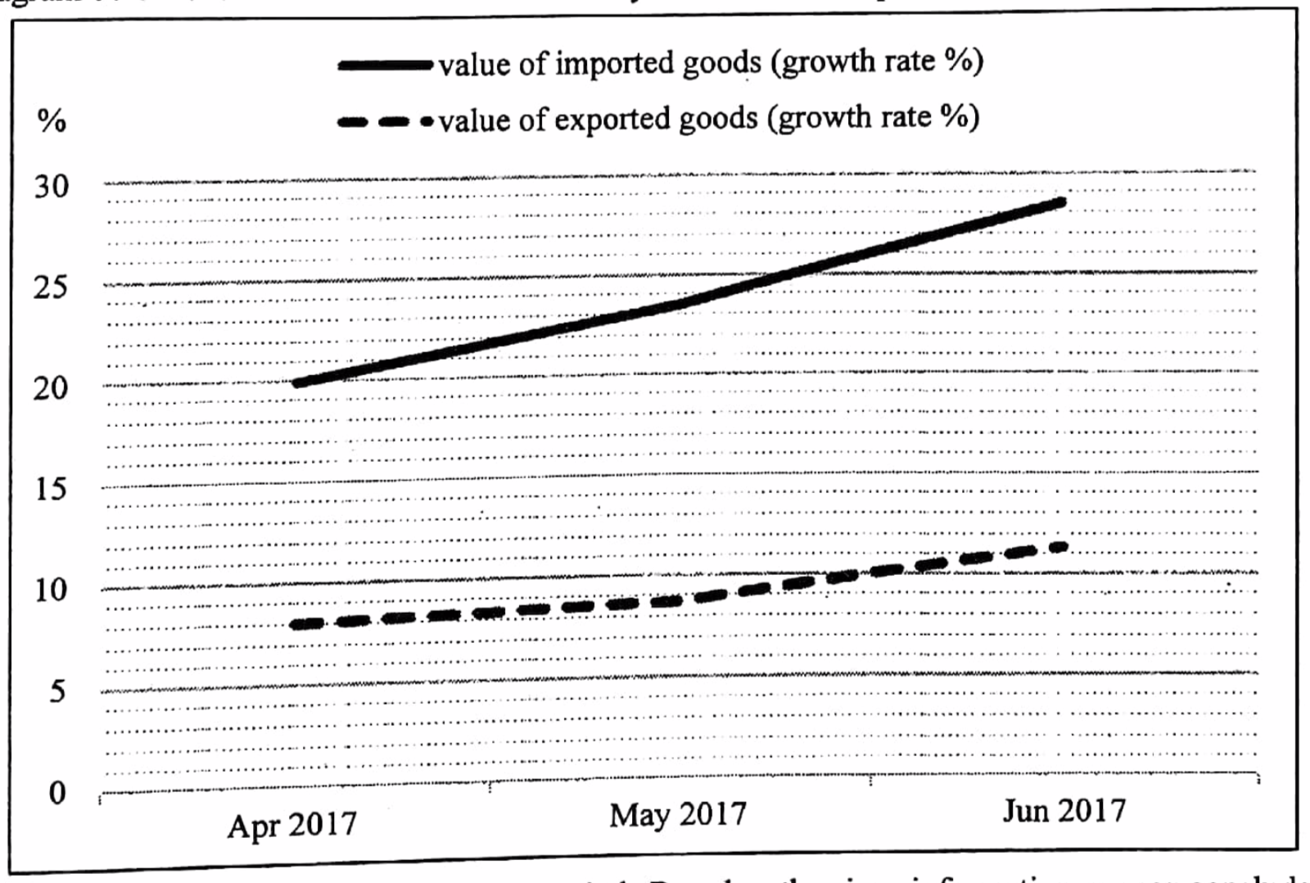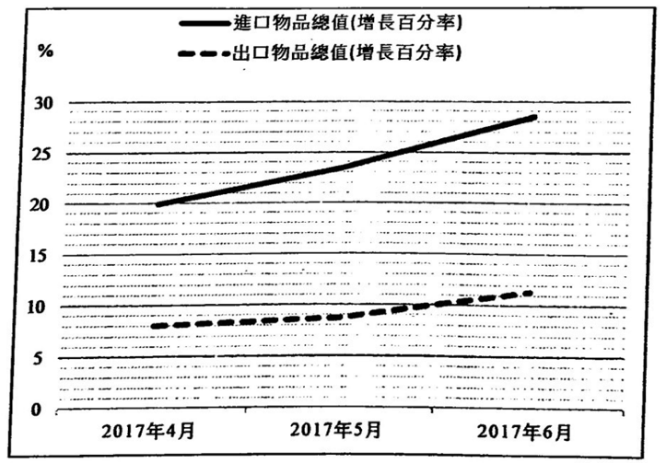
Country A reported a trade surplus during that period. Based on the given information, we can conclude that during the second quarter last year.
A. The trade balance was in deficit B. The volume of imported goods increased faster than that of exported goods
C. The visible trade surplus decreased D. The current account deficit increased

甲國在該期間錄得貿易盈餘，根據已有的資料，我們可以得出結論：去年第二季，
A. 貿易帳出現赤字。 B. 進口物品數量的增長比出口物品的快。
C. 有形貿易盈餘下跌。 D. 經常帳的赤字有所增加。

Example Question 41 DSE2018MCQ44
The Hong Kong Tourism Board organized the E-sports and Music Festival in summer 2017. Foreign E-sport players and K-pop superstars participated in the festival and they attracted locals and tourists from other parts of the world to attend the event. Organising the festival will lead to
(1) An increase in private consumption expenditure in Hong Kong
(2) An increase in export of services in Hong Kong
(3) A decrease in balance of payment deficit in Hong Kong
A. (1) and (2) only B. (1) and (3) only C. (2) and (3) only D. (1), (2) and (3)

香港旅遊發展局在2017年夏天籌辦電競音樂節。有外國電競選手和韓國流行巨星參與盛會，吸引了本地觀眾及來自世界各地的遊客到場。籌辦該節目會導致
(1) 香港的私人消費支出增加。
(2) 香港的服務出口增加。
(3) 香港的國際收支平衡逆差下降。
A. 只有(1),(2) B. 只有(1),(3) C. 只有(2),(3) D. (1),(2)及(3)

Example Question 42 DSE2019MCQ44
A Hong Kong billionaire travelled to Russia to watch matches in the World Cup. Which of the following would be included in the calculation of Hong Kong’s balance of payments?
(1) He bought a travel insurance for his Russia trip from a Hong Kong agency
(2) He bought a jersey of the Russia national team in Moscow as a souvenir
(3) He invested in a Russian football club and become the major owner.
A. (1) and (2) only B. (1) and (3) only C. (2) and (3) only D. (1), (2) and (3)

一名本港億萬富翁到俄羅斯旅遊，欣賞世界盃賽事。下列哪些會包括在本港國際收支平衡的計算之內？
(1) 他向一家本港代理為他的俄國之旅購買旅遊保險。
(2) 他在莫斯科購買一件俄羅斯國家隊球衣做紀念品。
(3) 他投資於俄羅斯一間球會，成為大股東。
A. 只有(1),(2) B. 只有(1),(3) C. 只有(2),(3) D. (1),(2)及(3)

Example Question 43 DSE2021MCQ42
Refer to the following statistical data about Hong Kong.
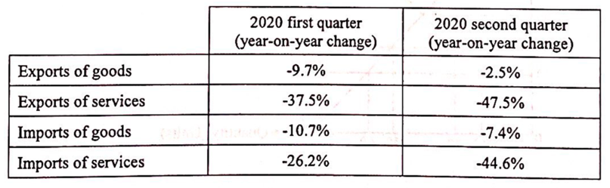
Based on the above information, we can conclude that
A. Hong Kong had an invisible trade deficit in 2020 second quarter.
B. Hong Kong's net exports in 2020 second quarter was lower than that in 2019 second quarter.
C. Hong Kong's exports of goods in 2020 second quarter was lower than that in 2020 first quarter.
D. Hong Kong's total imports of goods and services in 2020 second quarter was lower than that in 2019 second quarter.

參考以下有關香港的統計數據。
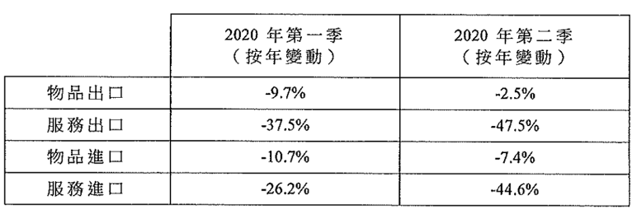
根據以上資料，我們可得出結論：
A. 香港2020年第二季無形貿易出現赤字。
B. 香港2020年第二季的淨出口較2019年第二季的為低。
C. 香港2020年第二季的物品出口較2020年第一季的為低。
D. 香港2020年第二代的物品和服務進口總值較2019年第二季的為低。
Type 3 (Balance of Payment)

2012DSE LQ8, 5b
(a) A country’s currency depreciates against its trading partners’ currencies. Will the depreciation necessarily lower the total import value of this country (in terms of domestic currency)? Explain with the aid of the diagram below.
相對於其貿易夥伴的貨幣，某國的貨幣貶值。這貶值會否必然降低該國的進口總值（以本國貨幣計算）？以下圖輔助，試加解釋。
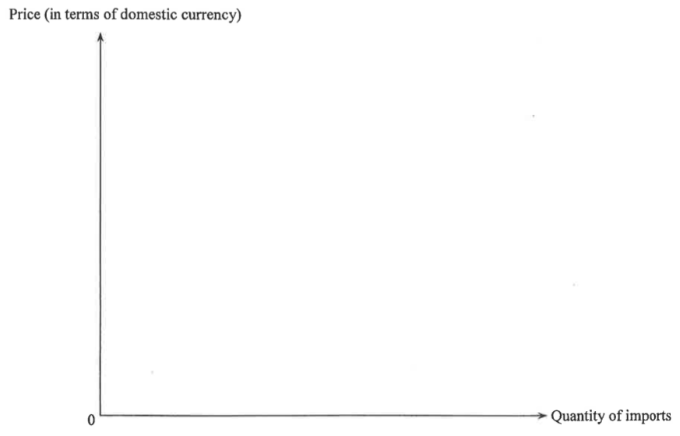
_______________________________________________________________________________________
_______________________________________________________________________________________
_______________________________________________________________________________________
_______________________________________________________________________________________
(b) Country A has imposed an effective price ceiling on Good X.
After the imposition of the price ceiling, many citizens in Country B travel to Country A to purchase Good X. Will the balance of invisible trade of Country A be affected? Explain. (3)
甲國對物品X實施一有效的價格上限。在實施該價格上限後，乙國很多市民前往甲國購買物品X。甲國的無形貿易差額會受影響嗎？試加解釋。
_______________________________________________________________________________________
_______________________________________________________________________________________
_______________________________________________________________________________________
_______________________________________________________________________________________
Marking Scheme:
(a) No, because (1)
If the demand for import is inelastic, the import value will not increase (1)
As the percentage increase in price will be greater than percentage decrease in quantity demanded (2)
否，因為
若進口物品屬低彈性，進口價值不會下降，原因是價格上升的百分比較需求量下降的百分比為高
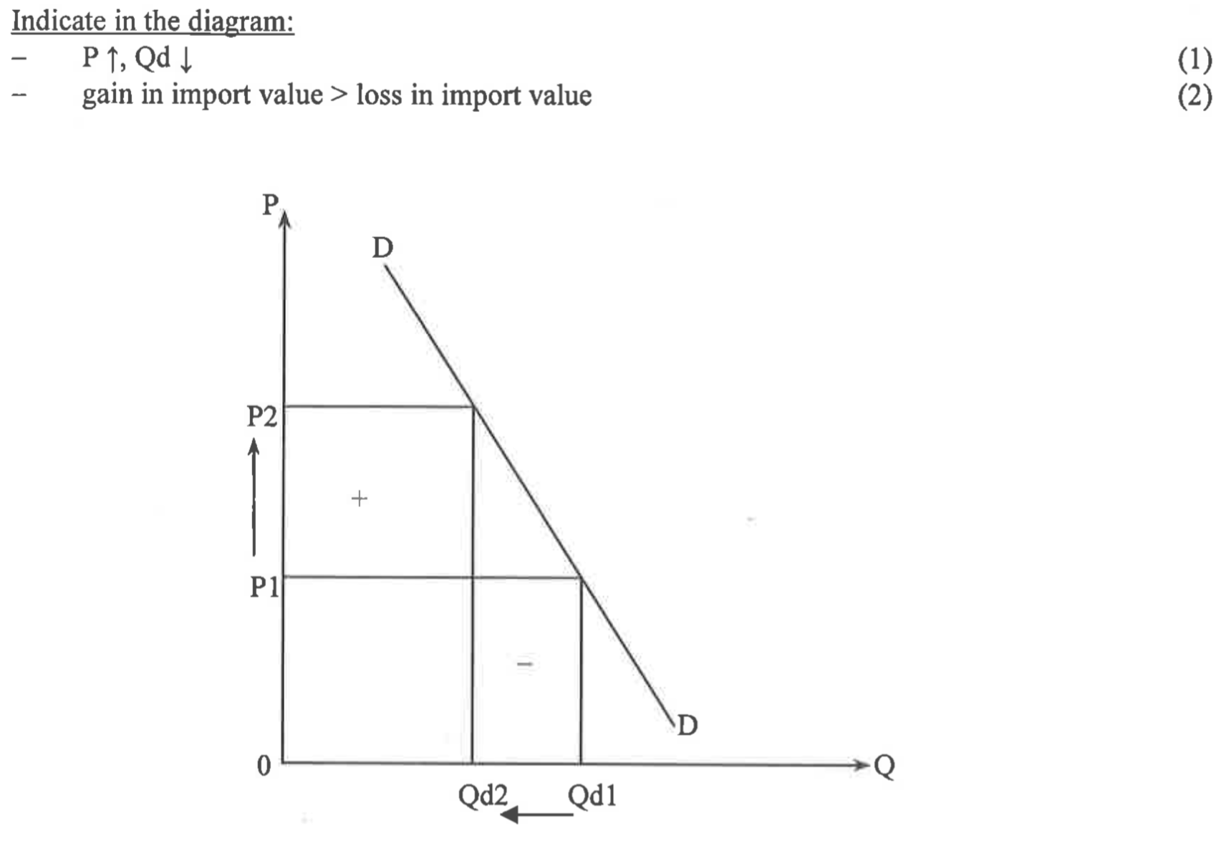
(b) Yes, because (1)
Transportation and other tourist-related expense, which are regarded as export of service, increase so the invisible trade account increases. (2)
是，因為交通和其他旅客有關開支會增加，這些開支被視為服務出口。故此無形貿易出口增加。

Candidates’ Performance:
(a) Poor. Most candidates made one of the following mistakes:
- failed to state their stance clearly;
- missed the key word 'necessarily'
- mistook depreciation for a drop in the price of imports;
- confused the decrease in price resulting from a movement along the demand curve with that from a reduction in demand.
(b) Satisfactory. Many candidates were able to identify tourist-related expenses as an export of services. Some used 'balance of invisible trade' and 'invisible trade' interchangeably, which resulted in confusing answers. Some mistook purchase of local goods by tourists for export of goods.

(a) 欠佳。大多數考生犯了以下錯誤之一：
- 未能明確表明自己的立場；
- 忽視了重要字眼“必然”
- 誤將貶值視為進口價格下降；
- 混淆了需求減低和沿著需求曲線移動造成的價格下降。
(b) 令人滿意。許多考生能夠將與旅遊相關的支出視為服務出口。有些人交替使用“無形貿易平衡”和“無形貿易”，以致其答案令人混淆。有些人誤以為遊客購買當地商品是物品出口。

2013DSE LQ6a, b
The table below shows the items of the balance of payments of Country A in a certain year:
 | Debt ($ million)  借方百萬元 | Credit ($ million)  貸方百萬元
Export of goods 物品出口 |  | 35
Import of goods 物品進口 | 50
Export of services 服務出口 |  | 47
Import of services 服務進口 | 27
Capital inflow 資金流入 |  | 70
Capital outflow 資金流出 | 85
Foreign exchange and reserves assets 外匯和儲備資產 |  | 10
Total 總額 | 162 | 162
(a) Calculate the current balance of Country A (1)
計算甲國的經常帳差額
(b) “Country A has a balance of payments surplus because there is an increase in foreign exchange reserves in that year.” Explain whether you agree with this statement. (3)
「甲國的國際收支出現盈餘，因為在該年外匯儲備增加了。」解釋你是否同意這項陳述。
_______________________________________________________________________________________
_______________________________________________________________________________________
_______________________________________________________________________________________
_______________________________________________________________________________________
_______________________________________________________________________________________

Marking Scheme:
(a) Balance of current account = 35 – 50 + 47 – 27 = $5 million (1)
(b) No, because the BOP balance is -$10 million, which implies a BOP deficit (3)
(a) 經常帳差額 = 35-50+47-27 = 5百萬元
(b) 否，因為國際收支平衡是 -10百萬元，這意味着國際收支出現赤字
Candidates’ Performance:
(a) Fair. The following are common mistakes:
- wrong inclusion of capital flows (whether inflows or outflows) in the calculation of current account balance;
- mixing up the BOP and current account balance;
- failure to specify the unit of measurement.
(b) Poor. The majority of candidates misinterpreted the $10 million credit in foreign exchange and reserve assets as an increase in reserves. They failed to demonstrate an understanding of the mechanism under which a BOP deficit causes an outflow of foreign reserves.

(a) 尚可。下列是考生常犯的錯誤：
- 誤將資本流動（不論是流人或流出）包括在往來帳差額的計算中。
- 混淆了國際收支平衡帳和往來帳差額的計算。
- 未能清楚寫出量度的單位。
(b) 欠佳。大部分的考生誤將外匯及儲備資產在貸方的$10百萬元當成儲備增加。他們未能顯示對國際收支赤字引致外匯流出的理解 。

2014DSE LQ11a
The following table shows the change in the exchange rate of the Hong Kong dollar against the Japanese Yen.
Date | Price of 1 unit of Hong Kong dollar
$1^{st}$August 2012 | 10.2 Yen
$1^{st}$August 2013 | 12.5 Yen
Japan exports automobiles to Hong Kong. Suppose the price of Japanese automobiles (in terms of Yen) does not change. With the aid of Figure 2, explain the above change in exchange rate would lead to an increase in the total export value (in terms of Yen) of Japanese automobiles to Hong Kong. (7 marks)
下表顯示港元兌日圓匯率的改變。
日本出口汽車至香港。假設日本汽車的價格（以日圓計算）沒有改變。以圖二輔助，解釋為什麼上述匯率的改變會導致出口至香港的日本汽車總值（以日圓計算）上升。
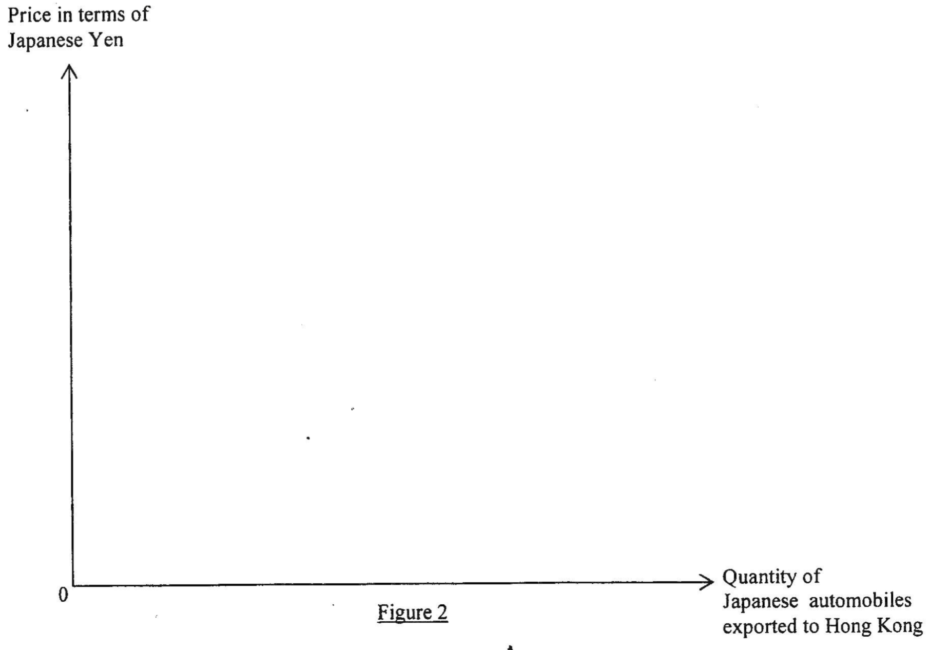
_______________________________________________________________________________________
_______________________________________________________________________________________
_______________________________________________________________________________________
_______________________________________________________________________________________
_______________________________________________________________________________________
Marking Scheme:
Japanese Yen depreciated against Hong Kong Dollar. (1)
As the price of Japanese automobiles does not change, the automobiles become cheaper in terms of HKD and Hong Kong importers will buy more Japanese automobiles. (1)
The demand for Japanese automobiles by HK people increases. (1)
Quantity transacted increases. (1)
Therefore, total export value of Japanese automobiles increases.
日圓兌港元貶值。
日本汽車的價格不變，該種汽車（以港元計算）變得較便宜，香港進口商會購買更多的日本汽車，
對日本出口汽車的需求上升，
交易量上升。
因此，日本出口汽車的總值上升了。
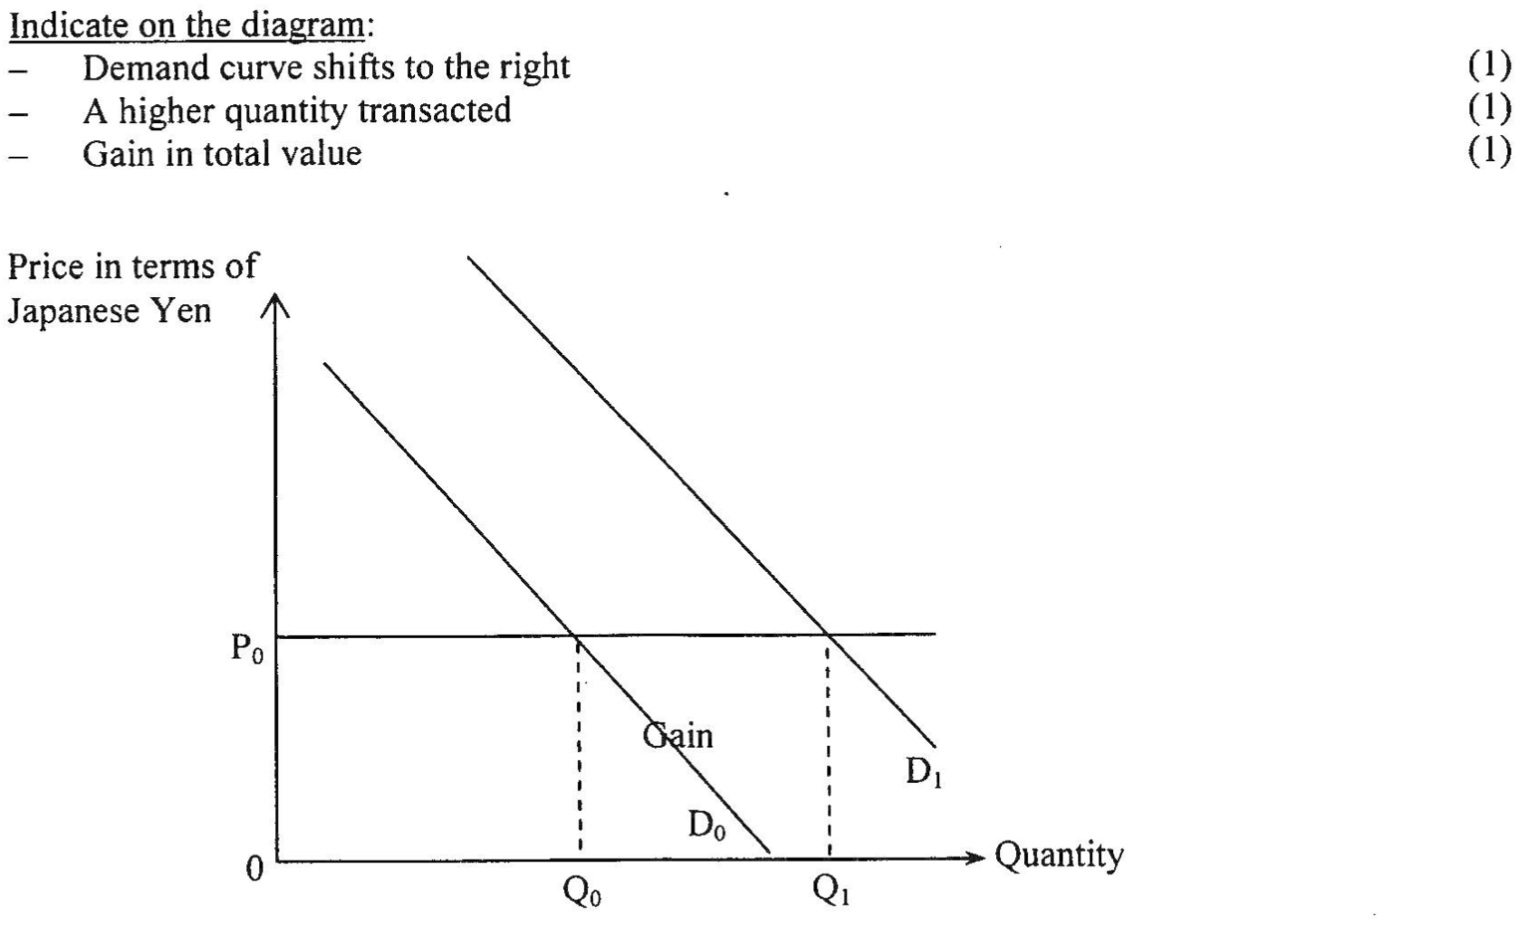

Candidates’ Performance:
Fair. Most candidates were able to point out that the demand for Japanese automobiles would increase as a result of the JPY-depreciation. But some candidates overlooked the condition that "the JPY-price of Japanese automobiles is constant" and wrongly drew a diagram that showed a rise in the JPY-price. Some other candidates mislabelled the Y-axis as "HKD-price of Japanese automobiles" and wrongly based their analysis on the price-elasticity of demand.

尚可。大部分考生能指出由於日圓貶值，日本汽車的需求會上升。但是部分考生忽略了「日本汽車的價格（以日圓計算） 是不變的 」這條件，故錯誤地繪畫了價格（以日圓計算）上升的圖。部分其他考生錯誤地將Y軸標示「日本汽車的價格（以港元計算）」，
故根據需求的價格彈性得出錯誤答案。

2015DSE LQ12a
Research shows that the “Individual Visit Scheme” of mainland tourists has brought economic benefits to Hong Kong. However, more and more Hong Kong residents have called on the government to reduce the number of mainland tourists to Hong Kong under the Scheme. How would the current account of Hong Kong be affected if the government limited the scale of the Scheme so that the number of tourists from the mainland would drop? Explain your answer. (2)
研究顯示內地旅客的「個人遊」計劃為香港帶來經濟利益。不過，越來越多香港居民要求政府減少透過該計劃到港的內地旅客人數。若政府限制該計劃的規模而令內地旅客訪港人數減少，香港的經常帳會如何受到影響？試加解釋。
_______________________________________________________________________________________
_______________________________________________________________________________________
_______________________________________________________________________________________
_______________________________________________________________________________________
_______________________________________________________________________________________
_______________________________________________________________________________________
_______________________________________________________________________________________
_______________________________________________________________________________________
_______________________________________________________________________________________
_______________________________________________________________________________________
_______________________________________________________________________________________
_______________________________________________________________________________________
Marking Scheme:
A drop in the export of services to mainland tourists (1)
Would reduce HK’s current account surplus (or enlarge its deficit) (1)
對內地旅客的服務出口下降
會令經常帳的盈餘下降（或赤字會上升）。
Candidates’ Performance:
Excellent. A minority of candidates mistakenly thought that, with fewer tourists coming to Hong Kong, the export of goods would fall.

優異。少數考生錯誤地認為來港遊客減少，貨物出口就會下降。

2016DSE LQ13bi
The airport corporation of Country H is a public corporation which hires different people to operate the airport. For example, there are security guards, technicians, engineers and financial managers.
Proposal A: | The government increases the income tax
Proposal B: | The airport corporation charges a lump-sum fee on every departing traveler
Discuss the effects of the two proposals on the current account in the balance of payments of Country H. (5)

H國的機場管理公司是一間公營公司，它聘請了不同職員營運機場，例如有保安員、技術員、工程師和財務經理。該機場管理公司計劃興建多一條跑道，當中有兩個為該跑道融資的提案。
提案A: | 政府提高薪俸稅
提案B: | 機場管理公司向每一位離境旅客徵收定額稅
討論這兩個提案對H國下列國際收支平衡中的經常帳的影響。
_______________________________________________________________________________________
_______________________________________________________________________________________
_______________________________________________________________________________________
_______________________________________________________________________________________
_______________________________________________________________________________________
_______________________________________________________________________________________
_______________________________________________________________________________________
_______________________________________________________________________________________
_______________________________________________________________________________________
_______________________________________________________________________________________
_______________________________________________________________________________________
_______________________________________________________________________________________
_______________________________________________________________________________________
_______________________________________________________________________________________
_______________________________________________________________________________________
_______________________________________________________________________________________
Marking Scheme:
Proposal A on current account:
An increase in income tax reduces the disposable income (1)
and result in a drop in consumption, AD and output levels
Import will drop, and (1)
current account will have more surplus/ less deficit. (1)

提案A對經常帳的影響：
增加薪俸稅令可用收入下降。
故此消費減少，總需求和產出水平下降。
進口會減少，
經常帳會有更多盈餘 / 赤字下降

Proposal B on current account:
A fee charged on departing travellers will result in an increase in the cost of using the airport to travel. (1)
Travelling industry will be adversely affected, reducing the number of both incoming and outgoing travellers. Both import and export of service will drop. (1)
And the effect of current account is uncertain. (1)

提案B對經常帳的影響：
對出境旅客收費會令人們使用機場成本上升。
對旅遊業會有負面影響，入境和出境的旅客人數均為下降。
服務的進口量出口量會下降。
對經常帳的影響未能確定。

Candidates’ Performance:
Fair. Most candidates attempted to identify the effects of the two proposals, but only some demonstrated their ability to apply economic concepts and theories correctly in this case. The following shows a list of mistakes for both parts that deserve attention:
- comparing the effects of building and not building the additional run way rather than the effects of the two proposals to finance the construction of the runway;
- mis-reading the question as meaning "how proposal A affects the current account" and "how proposal B affects the average flight distance",
- poor organization of answers, without a clear indication as to which of their arguments refers to which proposal.

For proposal A, the performance was fair. Most candidates simply stated that the increase in income tax would lower disposable income and consumption, while the stronger candidates were able to relate the fall in consumption to a fall in output as well as imports, and ultimately the current account.
For proposal B, many candidates did not realise that the expenditure/revenue of the tourist industry was counted as import/export of services and that the rise in the cost of using the airport would adversely affect both foreign visitors and local people flying to other countries.

Some candidates gave confusing answers without indicating whether they were talking about incoming or outgoing travellers.

尚可。大多數考生都試圖確定這兩個提案的影響，但只有一些考生證明了他們在這種情況下正確應用經濟概念和理論的能力。下面列出了這兩個部分值得注意的錯誤：
- 比較建造和不建造額外跑道的效果，而不是兩個為建造跑道提供資金的建議的效果；
- 將問題誤讀為“提案 A 如何影響經常帳”和“提案 B 如何影響平均飛行距離”，
- 答案組織不佳，沒有明確表明他們的哪些論點涉及哪個提案

對於提案 A，考生表現尚可。大多數考生只是簡單地表示，提高薪俸稅將降低可支配收入和消費，而能力較高的考生則能夠將消費下降與產出和進口下降以及最終經常賬的下降聯繫起來。
對於提案 B，不少考生並沒有意識到旅遊業的支出 / 收入被算作服務進出口，而機場使用成本上升會對飛往其他國家的外國旅客和本地人造成不利影響。

一些考生給出了令人困惑的答案，他們沒有表明談論的是入境旅客還是出境旅客。

2017DSE LQ12c
Before the British people voted against staying in the European Union (EU), i.e. Brexit, workers from the EU were free to work in Britain and vice versa. Brexit has shocked the economies in Europe and the following table shows some views on Brexit:
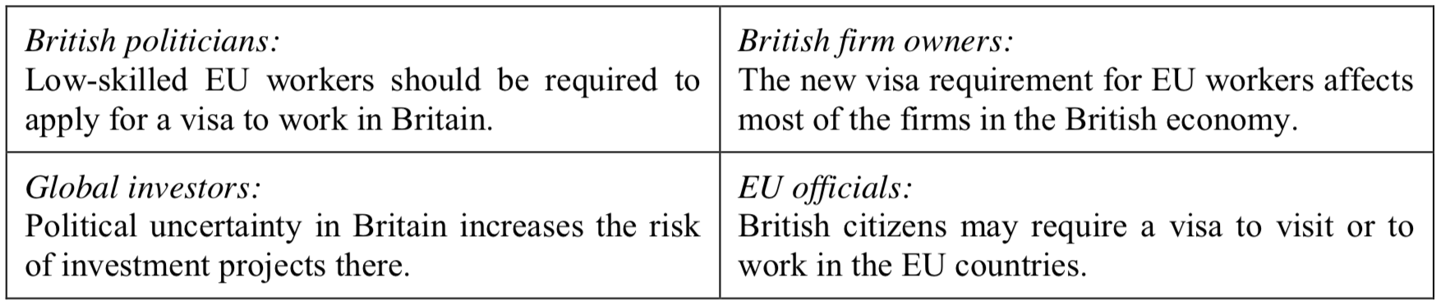
Referring to the view of the EU officials, which TWO components of current account in the balance of payments of Britain may be affected? Explain your answer. (4)

在英國人民投票反對留在歐盟。（即英國脫歐）之前，來自歐盟的工人可以自由在英國工作，反之亦然。英國脫歐引起歐洲經濟震盪，下表顯示是關於英國脫歐的一些看法 ：
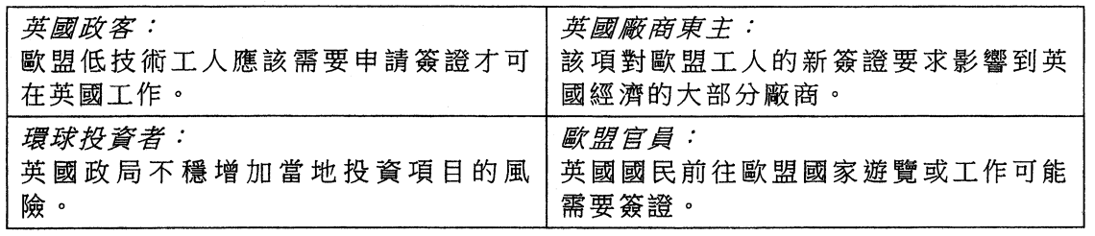
參考歐盟官員的看法，指出英國國際收支平衡的經常帳中，那兩個部份可能受影響。解釋你的答案。
______________________________________________________________________________________________________________________________________________________________________________________________________________________________________________________________________________________________________________________________________________________________________________________________________________________________________________________________________________________________________________________________________________________________________________________________________________________________________________________________________________________________________________________________________________________________________________________________________________________________________________________________________________________________________
Marking Scheme:
Components of current account:
Invisible trade: the increase in cost of travel will result in a fall in the number of visitors to EU and hence the import of service.
Factor income (primary income): fewer workers working in EU will result in a drop in wage payment to British workers.
Unilateral transfer (secondary income): fewer workers working in EU will result in a drop in workers’ remittance back to Britain. (@1)
經當帳的組成部分：
無形貿易：旅遊的成本增加令往歐盟的遊客減少，故此服務進口下跌。
要素收入（初級收入）：較少工人前往歐盟工作會令英國工人的薪資額下降。
單向轉移（次級收入）：較少工人前往歐盟工作會令工人匯款到英國的金額下降。

Candidates’ Performance:
Fair. As with similar questions in the past, some candidates did not have enough understanding of the components of the current account in the balance of payments and therefore failed to provide clear and accurate answers. Some candidates failed to start the analysis from the British standpoint, so the direction of invisible trade and factor income was not correct. Another common mistake is to treat labor services provided by British nationals to EU countries as tangible trade. Less capable candidates mistook transfer payments for "current transfers" and "intangible accounts" for "intangible trade accounts."

一般。和過往類似的題目一樣，部分考生對國際收支平衡中經常帳的組成部分了解不足，故未能提供清晰而準確的答案。一些考生未能用英國的立場開始分析，故無形貿易及要素收入的方向並不正確。另一常犯的錯誤是將英國國民給歐盟國家提供的勞工服務當成有形貿易。能力稍遜的考生誤將轉移支付當成「經常轉移 」，「無形帳」 當作 「無形貿易帳」 。

2018DSE LQ11, 12d
To develop nuclear weapons and increase the military power, Country Z has raises the proportion of government spending on national defence from 10% to 20%. All males aged from 20 – 25 are also required to join the military force for 2 years.
In response to the increasing military threat from Country Z, the United. Nations has passed a bill to embargo most of the good exporting from Country Z.

為了發展核武並增強軍力，Z國把投放在國防的政府開支份額由10% 提高至20%，而且所有20至25歲的男性都要被征召入軍隊兩年。
為此，聯合國通過一項決議，對Z國大部分的出口物品實施禁運，以應對Z國不斷增加的軍事威脅。
(a) Analyse the effects of the above situation on Country Z’s:
Balance of payment (3)
(a) 分述上述情況對Z國以下方面的影響：
國際收支平衡
___________________________________________________________________________________________________________________________________________________________________________________________________________________________________________________________________________________________________________________________________________________________________________________________________________________________________________________ (b) A reporter said, ‘The change in the exchange rate of the Renminbi to the US was a major factor contributing to the change
of the total tourism expenditure associated to inbound tourism. Based on Source 2 and 3, justify his statement. (6)
某記者指出：「人民幣兌美元匯率的改變是導致與入境旅遊相關的總消費改要的一項主要因素。」根據資料二及三，論證他的陳述 。
_________________________________________________________________________________________________________________________________________________________________________________________________________________________________________________________________________________________________________________________________________________________________________________________________________________________________________________________________________________________________________________________________________________________________________________________________________________________________Marking Scheme:
(a) BOP would be worsened. (1)
Export of goods would fall because of the embargo (1)
Export of service would also fall as fewer tourists would want to visit Country Z because of the threat of war. (1)
Foreign investors would withdraw their investments in Country Z, so capital may flow out of the country (1)
國際收支平衡：
國際收支平衡會變差。
因為禁運令物品出口下跌。
出口服務也會下降，由於戰爭威脅，較少遊客會到該國旅遊。
外國會撤走在乙國的投資，資本可能流出該國。

(b) During 2015-16, RMB depreciated against USD. Under HK’s linked exchange rate system, the value of HKD would follow that of USD, so RMB depreciated against HKD as well.
Depreciation of RMB implies that goods in HK became more expensive in terms of RMB. Therefore, fewer mainland tourists would come to HK, and those whose came would spend less in HK. As mainland visitors were the major source of tourists in HK, a significant drop in “total tourism expenditure associated to inbound tourism” would result. (6)
在2015-16年間，人民幣兌美元貶值。在聯繁滙率制度下，港元價值會跟隨美元，故此人民幣兌港元貶值。
人民幣貶值意味著香港物品的價格以人民幣計算會變得較貴，故此較少内地遊客會到港，而到港旅客也會花費較
少。由於内地遊容是本港旅客的主要來源，與人境旅遊相關的總消費下降幅度會很顯著。

Candidates’ Performance:
(a) Satisfactory. Most candidates were able to make use of appropriate tools to analyse the effects on Country Z. The following problems were identified:
- mistaking a worsening in the balance of payments (BOP) for BOP deficits;
- failing to indicate whether the embargo would reduce visible or invisible exports;
- failing to accurately use such BOP-related terms as capital inflow/outflow, and inflow/outflow of factor incomes.
(b) Satisfactory. Most candidates were able to identify the depreciation of RMB against USD and to make an inference regarding the corresponding depreciation of RMB again HKD under the linked exchange rate system. Common problems included:
- providing arguments to show that the reporter was wrong instead of justifying his statement;
- misinterpreting Source 3 as a depreciation of the USD;
- failing to state clearly whether the MB depreciated against the USD or HKD;
- failing to relate the depreciation of MB against HKD to the rise in prices of goods and services in Hong Kong (in terms of RMB) to the Mainland tourists.

(a) 令人滿意。大多數考生能夠利用適當的經濟來分析對 Z 國的影響。
- 將國際收支（BOP）惡化誤認為國際收支赤字；
- 未能表明禁運是否會減少有形或無形的出口；
- 未能準確使用資本流入 / 流出、要素收入流入 / 流出等國際收支相關術語。
(b) 令人滿意。大多數考生能夠識別人民幣兌美元的貶值情況，並推斷在聯繫匯率制度下人民幣兌港幣相應的貶值情況。常見問題包括：
- 提供論點證明記者的錯誤，而不是證明其言論合理；
- 將資料三誤解為美元貶值；
- 未能清楚說明人民幣兌美元或港幣是否貶值；
- 未能將人民幣兌港元貶值與向內地遊客提供的香港商品和服務價格（以人民幣計）的上漲聯繫起來。

2019DSE LQ11c
The Guangzhou-Shenzhen-Hong Kong Express Rail Link (High Speed Rail) was launched in September 2018. Suppose the fares of the High Speed Rail in terms of RMB are fixed. The fares of High Speed Rail tickets sold in Hong Kong, in terms of Hong Kong Dollars (HKD), will be adjusted according to the exchange rate of RMB against HKD. ‘A depreciation of RMB against the USD dollar (USD) will result in an increase in total revenue (in terms of HKD) od high Speed Rail tickets sold in Hong Kong.’ With the aid of Figure 2, Explain under what condition this statement will be correct. (8)

廣深港高速鐵路（高鐵）在2018年9月啟用。假設高鐵的票價以人民幣計算是固定的。在香港出售的高鐵車票價格（以港元計算）會跟隨人民幣兌港元的匯率而調整。「人民幣兌美元貶值會引致在香港出售的高鐵車票的總收入。（以港元計算）上升。」以圖2輔助，解釋在什麼條件下，這項上述會是正確。
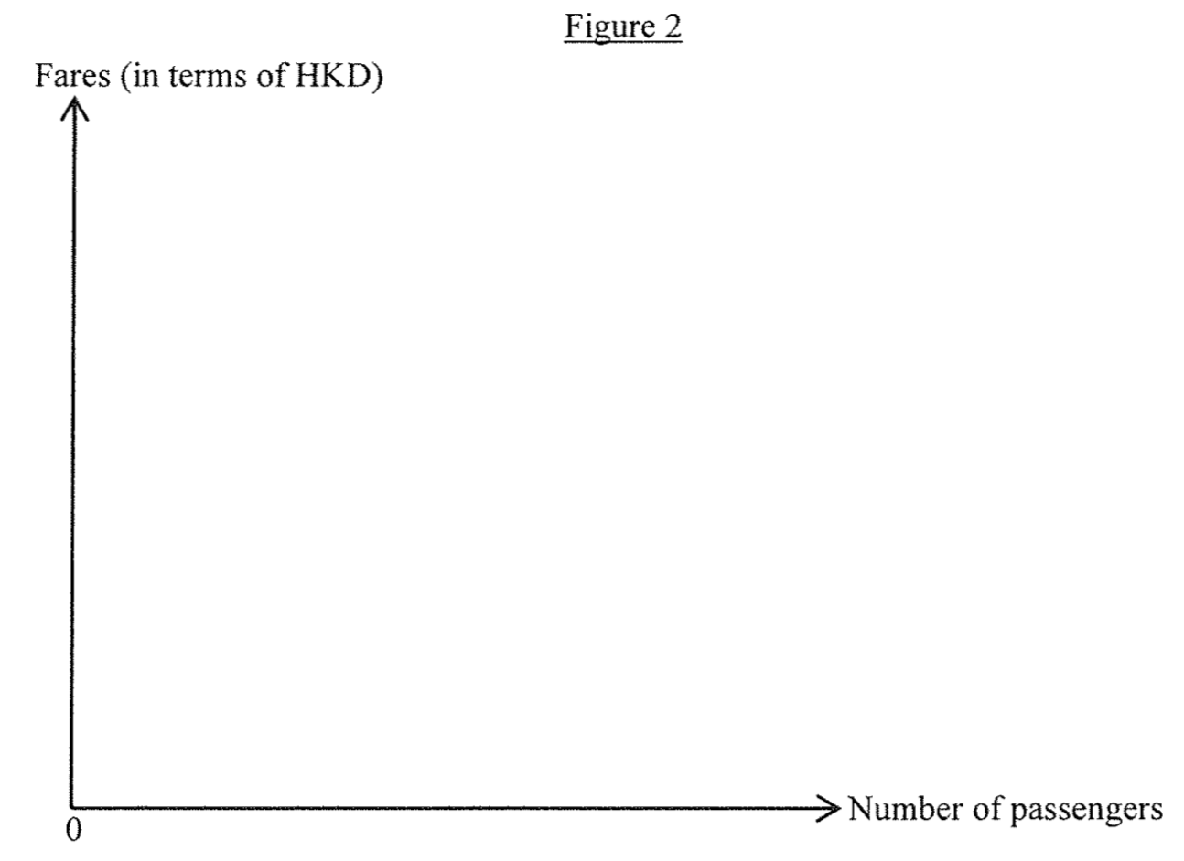
_________________________________________________________________________________________________________________________________________________________________________________________________________________________________________________________________________________________________________________________________________________________________________________________________________________________________________________________________________________________________________________________________________________________________________________________________________________________________

Marking Scheme:
Because of the linked exchange rate system, RM depreciates against HKD accordingly thus lowering fares in terms of HKD. If the demand is elastic, the percentage drop in price will be smaller than the percentage rise in quantity. Total ticket revenue will therefore increase. (6)
因為聯繫匯率制度，人民幣兌港元的匯率會隨之貶值。這會令到票價（以港元計算）下降。若需求屬高彈性，票價下降的百分比會低於乘客數量上升的百分比，總車票總收入因而上升。

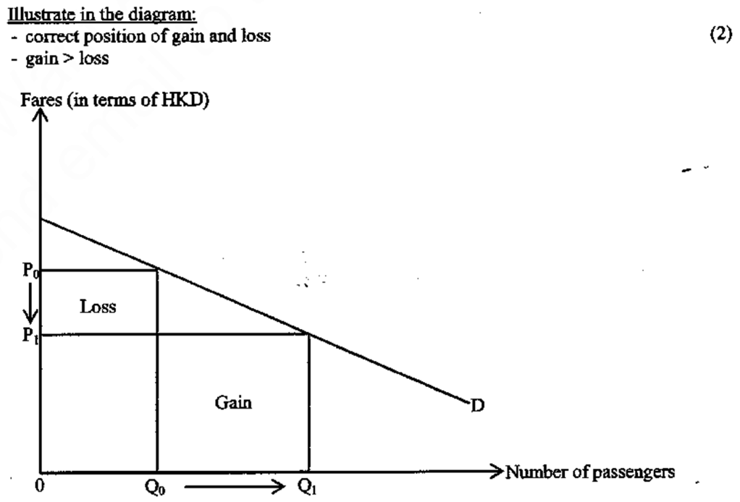

Candidates’ Performance:
Satisfactory. Good. Common problems include:
- failing to infer that MB would depreciate against HKD as it depreciates against USD;
- misconceiving that RMB would appreciate against HKD as it depreciates against USD;
- mis-thinking that there is an increase in train fare in terms of HKD;
- misconceiving that there would be an increase in demand (rather than quantity demanded) for tickets following the (HKD) price drop.

良好。常犯的錯誤包括：
- 未能由人民幣兌美元下跌推論出人民幣兌港元下跌
- 錯誤地由人民幣兌美元下跌推論出人民幣兌港元升值
- 誤以為以港幣計算車費有所增加
- 誤以為在以港幣計算的價格下降後需求會上升，(應是需求量上升)

2020DSE LQ10ai, aii
The following source shows the current account data of the US in 2017 and 2018.
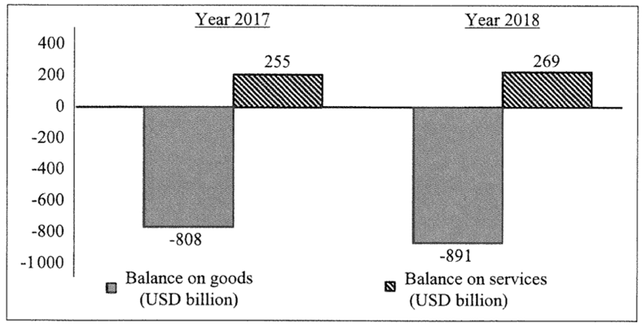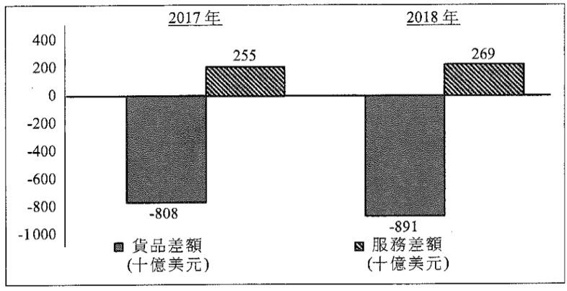
(a) (i) Describe the changes of current account data of the US in the above source. (2)
(ii) ‘Based on the above source, we can conclude that the current account deficit of the US in 2018 necessarily increased.’ Do you agree? Explain. (2)
(a) (i) 根據以上資料，描述美國經常帳數據的轉變。
(ii) 「根據以上資料，我們可以得出以下結論：美國2018年經常帳赤字必然增加。」你同意嗎？試加以解釋。
________________________________________________________________________________________________________________________________________________________________________________________________________________________________________________________________________________________________________________________________________________________________________________________________________________________________________________________________________________________________________________________________________________________________________________________________________________________________________________________________________________________________________________________

Marking Scheme:
(a) (i) Trade deficit increased while invisible trade surplus slightly increased. (2)
(ii) No. We also need the information of external factor income flow (i.e. net factor income from abroad) and current transfers. (2)
(i) 貿易赤字增加了，而無形貿易盈餘輕微增加。
(ii) 否。我們仍然需要海外要素收入（即海外要素收入淨值） 及經常轉移等資料數據已得出結論。

Candidates’ Performance:
(ai) Satisfactory. Common mistakes included
- missing the word ‘balance’ in their discussion of trade / current account balance
- mixing up the ‘balance of goods and services’ with balance of current account’.
(aii) Satisfactory. Most candidates were able to point out that there are other sub-accounts within the current account. One common mistake was the confusion between ‘current transfer’ and ‘transfer payment’.
(ai) 令人滿意。考生常犯的錯誤包括：
- 在討論貿易差額 / 經常帳差額時，漏寫差額一詞；
- 將商品及服務差額和經常帳差額混淆了。
(aii) 令人滿意。大部分考生能指出在經常帳中還有其他的子賬戶。一個常犯的錯誤是混淆了經常轉移和轉移支付。

DSE2021LQ5b
Mr Chan, a Hong Kong retired footballer, was employed as a consultant by a football club in the United Kingdom in January 2020. Seven months later, he quitted his position and returned to Hong Kong. If Mr Chan could chose to receive his salary in either British Pound (GBP) or US dollar (USD), which currency would you recommended him to choose? Explain your answer. (2)
陳先生是本港一名退役足球員。在2020年1月，他和一家英國球會聘請為顧問。七個月後，他辭職並返回香港。若陳先生可選擇以英鎊(GBP)或美金(USD)收取其薪金，你會建議她選擇哪種貨幣？解釋你的答案。
________________________________________________________________________________________________________________________________________________________________________________________________________________________________________________________________________________________________________________________________________________________________________________________________________________________________________________________________________________________________________________________________________________________________________________________________________________________________________________________________________________________________________________________
Marking Scheme:
USD, because the exchange rate of USD to HKD, thus the purchasing power of USD in Hong Kong, is more stable under the linked exchange rate. In other words, USD involves lower exchange-risk for Mr Chan. (2)
美元，因為美元兌香港因聯繫匯率的緣故會較穩定，故此在香港的購買力也較穩定。換句話說，陳先生選擇美元的外匯風險較低。

Candidates’ Performance:
Good. Many candidates managed to apply their knowledge about money and foreign exchange to justify their choices with proper economic reasons. A few candidates picked GBP based on the erroneous argument that, by such choice of currency denomination, Mr Chan would be able to earn more income when converted to HKD because GBP has a higher per-unit value than USD in terms of HKD. A minor few carelessly put down 1 HKD = 7.8 USD under the linked exchange rate.

良好。很多考生能運用有關貨幣和外匯的知識，並以確當的經濟理由論證其選擇。少數考生選擇英鎊的理由是錯誤的，他們以為選英鎊可以令陳先生的收入在兌換成港元後，能賺得更多，原因是1英鎊對港幣的價值較1美元為高。有很少數的考生不小心寫出在聯繫匯率下 1 HKD = 7.8USD 。

Marking Scheme:
Type 1 (Linked Exchange Rate System in Hong Kong)
1 | C | 2 | D | 3 | C | 4 | D | 5 | C | 6 | D | 7 | D | 8 | C | 9 | C | 10 | D
11 | B | 12 | C | 13 | C | 14 | B
Type 2 (Exchange Rate affecting trade value and volume)
1 | B | 2 | A | 3 | D | 4 | B | 5 | B | 6 | B | 7 | C | 8 | A | 9 | B | 10 | D
11 | B | 12 | D | 13 | D | 14 | B | 15 | A | 16 | D | 17 | A | 18 | D | 19 | C | 20 | A
21 | A | 22 | D | 23 | D | 24 | D | 25 | C | 26 | D | 27 | C | 28 | A | 29 | C
Type 3 (Balance of Payment)
1 | B | 2 | C | 3 | D | 4 | B | 5 | D | 6 | B | 7 | A | 8 | D | 9 | D | 10 | C
11 | A | 12 | B | 13 | D | 14 | C | 15 | D | 16 | A | 17 | A | 18 | C | 19 | A | 20 | B
21 | D | 22 | A | 23 | B | 24 | C | 25 | B | 26 | A | 27 | C | 28 | B | 29 | B | 30 | A
31 | A | 32 | D | 33 | B | 34 | A | 35 | D | 36 | D | 37 | D | 38 | B | 39 | B | 40 | /
41 | A | 42 | C | 43 | D | 44 | B | 45 | B | 46 | D | 47 | B | 48 | C | 49 | B | 50 | C
51 | A | 52 | D

