Learning Focus:
Memo
(LQ Answering Flow, MC skills, your goals and resolutions…)
Specific Question Type
MC

Learning Focus:
Memo
(LQ Answering Flow, MC skills, your goals and resolutions…)
Specific Question Type
LQ

Chapter 6 _ Factor of Production
Type 1 (Classification of factor of production)
Example Question 1 CE1990MCQ13
Which of the following is an example of ‘land’ in economics?
A. reservoirs B. factories C. rubber plantations D. mineral deposits

在經濟學上，下列哪一項為「土地」的例子？
A. 水庫 B. 工廠 C. 橡膠園 D. 礦床

Example Question 2 CE1991MCQ7
Which factor return has all of the following characteristics?
I. It can be negative.
II. It can be very large.
III It is not know before the sale of finished products.
A. rent B. wages C. interest D. profits

哪一項「要素收入」具有以下全部特性?
I. 它可以是負數。
II. 它可以是非常巨額。
III. 在最後製成品售出之前，不能知道它的數值。
A. 租金 B. 工資 C. 利息 D. 利潤

Example Question 3 CE1991MCQ10
Which of the following is an example of land in economics?
A. reclaimed land B. crude oil underground
C. gasoline stored underground D. Victoria Harbour following improvements

以下哪一項是經濟學上「土地」的一個例子?
A. 填海所得的土地 B. 地下的原油
C. 貯藏於地下的汽油 D. 經改良的維多利亞海港

Example Question 4 CE1992MCQ7
The war in the Middle East has led to fires in the oil wells in Kuwait.
Teams of firemen were risking their lives to put out the fires. Economists classify crude oil as______, oil pumps as _______, firemen as _______ and the owners of the oil wells as ______.
A. capital; capital; entreneurships; entreneurships B. capital; land; labour; labour
C. land; land; capital; entreneurships D. land; capital; labour; entreneurships

中東戰爭導致科威特油井大火。救火隊員冒生命危險去撲滅火災。經濟學者將原油歸類為____、抽油機為____、救火隊員為____、油井擁有者為____。
A. 資本; 資本; 企業家職能; 企業家職能 B. 資本; 土地; 勞力; 勞力
C. 土地; 土地; 資本; 企業家職能 D. 土地; 資本; 勞力; 企業家職能

Example Question 5 CE1992MCQ8
The main function of entreneurship is
A. to design new products B. to bear risks
C. to provide technical expertise D. to make routine business decisions

「企業家職能」的主要功能是
A. 設計新產品。 B. 承擔風險。
C. 提供技術專才。 D. 對日常經營事務作出決定。

Example Question 6 CE1993MCQ8
Which of the following belongs to the factor of production 'land'?
A. the reclaimed land in West Kowloon B. the fishing grounds in the South China Sea
C. the MacLehose Trail D. the killer whale in the Ocean Park

下列哪一項屬於「土地」這一生產因素?
A. 西九龍填海區 B. 南中國海漁場
C. 麥理浩徑 D. 海洋公園內的殺人鯨

Example Question 7 CE1994MCQ15
In economics, the covered playground of a government school is classified as _________ while the principal of the school is classified as a _________.
A. capital, entrepreneur B. capital, labour C. land, entrepreneur D. land, labour

在經濟學裏，政府官立中學的雨天操埸被歸類為____ ，而校長則被歸類為____。
A. 資本; 企業家職能 B. 資本; 勞工 C. 土地; 企業家職能 D. 土地; 勞工

Example Question 8 CE1994MCQ16
Capital differs from land in that, for example,
A. capital is produced from scarce resources but land is not. B. capital has a smaller supply elasticity.
C. the demand for capital is a derived demand but that of land is not. D. capital generates a higher return to its owners.

資本不同於土地，例如:
A. 資本是由稀少的資源製造的，而土地則非。 B. 資本的供應彈性較低。
C. 資本的需求屬衍生需求，而土地的則非。 D. 資本為它的擁有者提供較高的回報。

Example Question 9 CE1995MCQ18
The payment for the use of some well-known franchised names such as ‘McDonald’s’ and ‘7-Eleven’ can be regarded as
A. interest B. rent C. profit D. wage

使用某些著名特許經營店的名稱如「麥當勞」及「7-11」來營業須支付費用，這些費用被歸類為_____。
A. 利息。 B. 租金。 C. 利潤。 D. 工資。

Example Question 10 CE1995MCQ19
Which of the following about the return for entrepreneurship is true?
A. It can be determined before the commodity is sold. B. It can be positive or negative.
C. It does not vary with the business performance of the firm. D. It is higher than the return for labour.

下列哪一項關於企業家職能的報酬的描述是正確的？
A. 在商品售賣前已可決定它有多少。 B. 它可以是正值或負值。
C. 它不跟隨其廠商的營業狀況好壞而變動。 D. 它高於勞工的報酬。

Example Question 11 CE1996MCQ15
Which one of the following is an example of land?
A. Solar energy collected from sunlight by a power plant B. Rainwater collected in reservoirs
C. Land reclaimed from the sea D. Dew on farmland in the morning

下列哪一項是土地的一個例子?
A. 某能源廠從陽光收集到的太陽能 B. 在水塘收集到的雨水
C. 填海得來的土地 D. 早上農地上的露水

Example Question 12 CE1997MCQ13
Which of the following is classified as land in economics
A. live fisher sold in a seafood restaurant B. silver ore in a mine
C. the newly reclaimed land in Western Kowloon D. a piece of cultivated land

下列哪一項在經濟學上被歸類為土地？
A. 海鮮酒家出售的活魚 B. 礦藏裏的銀礦
C. 西九龍新填海區的土地 D. 一塊開墾了的土地

Example Question 13 CE1998MCQ12
Which of the following is classified as land in economics?
A. land reclaimed along the Victoria Harbour B. fish caught in the high seas
C. plants grown in the country parks D. crude oil newly discovered underground

在經濟學上，下列哪一項歸類為土地？
A. 沿維多利亞港填海獲得的土地。 B. 在公海裏捕獲的魚。
C. 郊野公園裏種植的植物。 D. 新發現的地下原油。

Example Question 14 CE1998MCQ16
Knowledge
A. is not capital because it does not have a physical form. B. is not capital because its ownership is not transferable.
C. is capital because it is desired by everybody. D. is capital because it can increase wealth in the future.

知識
A. 不是資本，因為它沒有一種形體。 B. 不是資本，因為它的擁有權不能轉讓。
C. 是資本，因為人人想擁它。 D. 是資本，因為它能增加將來的財富。

Example Question 15 CE1999MCQ11
Land is different from capital in that
A. land cannot be increased but capital can.
B. land is more demand inelastic than capital.
C. the use of land does not cost anything but the use of capital does.
D. land is less occupationally mobile than capital.

土地有異於資本，由於
A. 土地不能增加，而資本是可以增加的。 B. 土地的需求彈性較資本為低。
C. 使用土地沒有成本，而使用資本卻是有成本的。 D. 土地的職業流動性較資本為低。

Example Question 16 CE2000MCQ13
Which of the following is classified as capital?
A. the singing skill of a superstar B. the sunlight people enjoy on the beach
C. a strong current in the ocean D. an oasis in the desert

下列哪一項被歸類為資本？
A. 超級巨星的歌唱技巧 B. 人們在沙灘上享受的陽光
C. 海洋裏的洋流 D. 沙漠裏的綠洲

Example Question 17 CE2000MCQ14
‘Wild birds in the forests are classified as land in economics.’ This statement is
A. true, because they are free goods.
B. true, because they are natural resources.
C. false, because they can move while land is geographically immobile.
D. false, because their supply is not fixed.

「森林裏的野鳥在經濟學上被歸類為土地。」這句子是
A. 正確的，因為牠們是免費物品。
B. 正確的，因為牠們是天然資源。
C. 不正確的，因為牠們可以移動而土地沒有地域流動性
D. 不正確的，因為牠們的供應並非固定。

Example Question 18 CE2001MCQ9
Which of the following statements about land and capital is correct?
A. Land has no occupational mobility but capital does.
B. There is no cost of producing land but there is cost of producing capital.
C. Land is a free good but capital is an economic good.
D. Over time, the quantity of land is fixed but that of capital is not.

下列哪一項關於土地和資本的描述是正確的？
A. 土地沒有職業流動性，但資本是有的。
B. 製造土地沒有成本，但製造資本卻有成本。
C. 土地是免費物品，但資本卻是經濟物品。
D. 長遠而言，土地的數量是固定的，但資本的數量卻是可變的。

Example Question 19 CE2001MCQ11
Which of the following is classified as ‘capital’?
A. sunshine in California B. oil wells in Kuwait C. sand in the Sahara Desert D. fresh air in the Alps

下列哪一項被歸類為「資本」？
A. 加州的陽光 B. 科威特的油井 C. 撒哈拉沙漠的沙 D. 阿爾卑斯山上的空氣

Example Question 20 CE2001MCQ12
Dennis opened a convenience store and he has employed his friend, John, as a storekeeper. Dennis’ work is classified as _______ and John’s work is classified as _______.
A. secondary production ... labour B. tertiary production ... entrepreneurship
C. labour ... secondary production D. entrepreneurship ... tertiary production

丹尼開設一家便利店，並聘用他的朋友國強打理店務。丹尼的工作被歸類為______，而國強的工作被歸類為______。
A. 二級生産…… 勞力 B. 三級生産…… 企業家職能
C. 勞力…… 二級生産 D. 企業家職能…… 三級生産

Example Question 21 CE2002MCQ15
In economics, which of the following statements about capital is correct ?
A. The quantity of fixed capital cannot be changed in the short run.
B. Capital earns the highest rate of return among all factors of production.
C. Capital is produced to satisfy consumers’ wants directly.
D. The geographical mobility of capital is greater than that of land.

在經濟學上，下列哪一項關於資本的描述是正確的？
A. 在短期而言，固定資本的數量是不能改變的。 B. 在所有生產因素當中，資本的回報率最高。
C. 資本是製造出來以直接滿足消費者的欲望。 D. 資本的地域流動性較土地的為高。

Example Question 22 CE2003MCQ16
Which of the following statements about 'land' is correct?
A. The supply of land may be increased through human effort B. The supply of land may change over time
C. Land is a free good because it is part of nature D. Land is a scarce good because it cannot be produced

下列哪一項關於「土地」的描述是正確的？
A. 土地供應可透過人為增加。 B. 土地供應可能隨時間而改變。
C. 土地是免費物品，因為它是大自然的一部分。 D. 土地是稀少性物品，因為它是不能製造出來的。

Example Question 23 CE2004MCQ14
Michael Owen is a famous football player for Liverpool Football Club. In economics, he provides the service of ________ and he engages in ______________ production.
A. entrepreneurship ... secondary B. entrepreneurship ... tertiary
C. labour ... secondary D. labour ... tertiary

米高奧雲是利物浦足球會一位著名足球員。在經濟學上，他提供_____服務，他的工作屬於_____生產。
A. 企業家職能……二級 B. 企業家職能……三級
C. 勞力……二級 D. 勞力……三級

Example Question 24 CE2005MCQ15
Which of the following is classified as land in economics?
A. soil with chemical fertilizers added to it B. trees in a plantation area
C. underground coal reserves D. a piece of cultivated land

下列哪一項在經濟學上被歸類為土地？
A. 加了化學肥料的泥土。 B. 植林區裏的樹木。
C. 蘊藏於地下的煤礦。 D. 經開墾的土地。

Example Question 25 CE2006MCQ13
Mr Chan is the owner of a printing factory and he employs Mary as an accountant. The factory engages in _______ production and Mary provides the services of the factor _________.
A. secondary ... labour B. secondary ... entrepreneurship
C. tertiary ... labour D. tertiary ... entrepreneurship

陳先生擁有一家印刷廠，聘用瑪莉做會計。該工廠屬______生產而瑪利提供______這種生產要素的服務。
A. 二級⋯⋯勞力 B. 二級⋯⋯企業家職能
C. 三級⋯⋯勞力 D. 三級⋯…企業家職能

Example Question 26 CE2007MCQ16
Which of the following statements about land is correct?
A. Crude oil unextracted is land because it is fixed in supply
B. Ocean is land because it is geographical immobile
C. Rainfall on a piece of farmland is land because it is a gift of nature for production
D. Wood being cut in the tropical forests is land because it is used for production

下列哪一項對土地的描述是正確的？
A. 未開採的原油是土地，因爲它的供應是固定的。
B. 海洋是土地，因爲它沒有地域流動性。
C. 降在一片農地上的雨水是土地，因爲它是用作生產的天然資源。
D. 在熱帶森林裹砍下來的木頭是土地，因爲它有生產用途。

Example Question 27 CE2007MCQ17
Land is different from capital in that
A. the supply of land cannot be controlled, whereas that of capital can be
B. land is a free good but capital is an economic good
C. land has a lower occupational mobility than capital
D. land has a greater supply elasticity than capital

土地有別於資本是因爲
A. 土地的供應不能控制，而資本是可以的。
B. 土地是免費物品，但資本是經濟物品。
C. 土地的職業流動性較資本低。
D. 土地的供應彈性較資本高。

Example Question 28 CE2007MCQ18
In Economics, a taxi is classified as _______ and the income of the taxi owner from renting the taxi to a driver is classified as _______.
A. land ... rent B. capital ... interest C. land ... interest D. capital ... profit

在經濟學上，計程車被歸類爲______；而計程車車主將車子出租子司機的收入被歸類為______。
A. 土地……租金 B. 資本……利息 C. 土地……利息 D. 資本……利潤

Example Question 29 CE2008MCQ14
Which of the following are land in economics?
(1) the Chinese white dolphins living in the waters around Lantau Island
(2) the giant pandas living in Ocean Park Hong Kong
(3) migratory birds found in the Deep Bay
A. (1) and (2) only B. (1) and (3) only C. (2) and (3) only D. (1),(2) and (3)

下列哪項是經濟學上的土地？
(1) 在大嶼山一帶水域生活的中華白海豚
(2) 在香港海洋公園裹生活的大熊貓
(3) 在後海灣裏出現的候鳥
A. 只有 (1)，(2) B. 只有 (1)，(3) C. 只有 (2)，(3) D. (1)，(2)，(3)

Example Question 30 CE2009MCQ14
Some resort hotels in Japan provide natural hot springs for their customers. These resort hotels are engaged in _________ and these hot springs are classified as _________.
A. primary production ... producer goods B. tertiary production ... producer goods
C. secondary production ... consumer goods D. tertiary production ... consumer goods

在日本，一些度假酒店為顧客提供天然温泉。這些度假酒店參與______，而這些温泉被歸類為______。
A. 一級生產…… 生產者物品 B. 三級生産…… 生產者物品
C. 二級生產……消費者物品 D. 三級生產……消費者物品

Example Question 31 CE2009MCQ15
Which of the following belongs to the factor of production ‘land’?
A. Endangered species of Tibetan antelope found on the Tibetan Plateau
B. Flowers planted in Hong Kong Disneyland
C. Crocodiles living in Hong Kong Westland Park
D. Oxygen provided in the trains running across the Tibetan Plateau

下列哪項屬於生產要素「土地」？
A. 在青藏高原上發現的瀕危動物藏羚羊。 B. 在香港迪士尼樂園內種植的花朵。
C. 在香港濕地公園內生活的鱷魚。 D. 在青藏高原行駛的火車上供應的氧氣。

Example Question 32 CE2010MCQ17
Which of the following about ‘land’ and ‘capital’ is correct?
A. Both land and capital can be increased by human effort. B. Both land and capital are fixed factors of production.
C. Land is more elastic in supply than capital D. Land is less geographically mobile than capital.

下列哪項關於「土地」和「資本」的描述是正確的？
A. 兩者的數量皆可透過人爲地增加。 B. 兩者皆爲固定生產要素。
C. 土地的供應較資本更具彈性。 D. 土地較資本更缺乏地域流動性。

Example Question 33 CE2011MCQ16
In economics, a medical doctor in the public hospital provides the service of _________ and he engages in __________ production.
A. entrepreneurship ... secondary B. entrepreneurship...tertiary
C. labour...secondary D. labour ... tertiary

在經濟學上，公立醫院裹的醫生提供______的服務，而他涉及______生產。
A.企業家職能…… 二級 B. 企業家職能…… 三級
C. 勞力…… 二級 D. 勞力…… 三級

Example Question 34 CE2011MCQ17
Miss Chan rents a studio to record songs. In economics, the studio is classified as _______ and the rental income of the studio owner is classified as _________.
A. land ... rent B. land...profit C. capital...profit D. capital ... interest

陳小姐租用一間錄音室來錄製歌曲。在經濟學上，該錄音室被歸類爲______，而錄音室擁有人的租金收入被歸類爲______。
A. 土地 …… 租金 B. 土地 …… 利潤 C. 資本 …… 利潤 D. 資本 …… 利息

Example Question 35 DSE2016MCQ6
A school is a production unit which provides educational services. The following are people and objects that are usually found at a school:
(1) the school building
(2) teachers
(3) students
(4) private cars owned by teachers
(5) sanitisers in the toilets
Which of the above items are capital of the school?
A. (1) and (4) only B. (1) and (5) only C. (2) and (3) only D. (1), (4) and (5) only

學校是提供教育服務的生產單位。以下是一些在學校常見的人物和物件：
(1) 校舍
(2) 教師
(3) 學生
(4) 教師擁有的私家車
(5) 洗手間的洗手液
上述哪些是學校的資本？
A.只有 (1)、(4) B.只有 (1)、(5) C.只有 (2)、(3) D.只有 (1)、(4)、(5)

Example Question 36 DSE2019MCQ8
Which of the following are capital of a café?
(1) Coffee machines
(2) Coffee beans
(3) Video games consoles brought by its customers for party
(4) Comic books which can be borrowed by its customers free of charge
A. (1) and (2) only B. (1), (2) and (4) only C. (1), (3) and (4) only D. (2), (3) and (4) only

下列哪些是一家咖啡店的資本？
(1) 咖啡機
(2) 咖啡豆
(3) 顧客帶來開派對用的遊戲機
(4) 可供顧客免費借閱的漫查書
A.只有 (1)、(2) B.只有 (1)、(2)、(4) C. 只有 (1)、(3)、(4) D. 只有 (2)、(3)、(4)

Example Question 37 DSE2020MCQ6
Refer to the following dialogue.
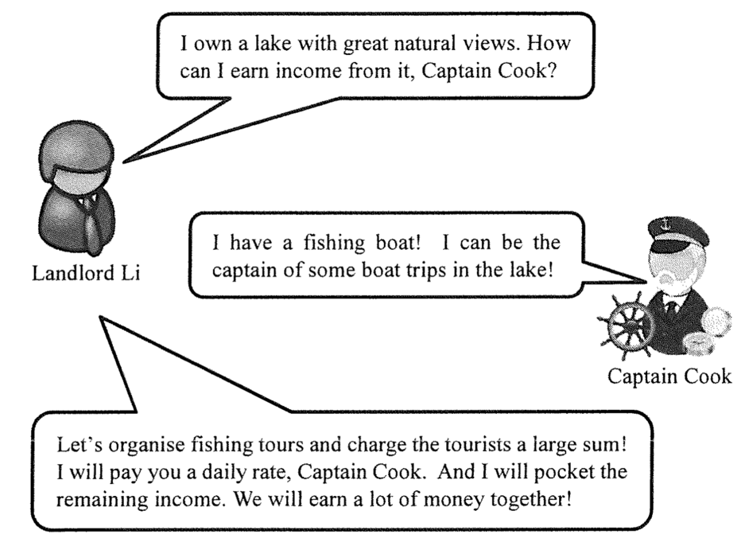
Given the return of land is rent, the return of labour is wage, the return of capital is interest while the return of entrepreneur is profit. The income earned by Captain Cook consists of ____ while the remaining income earned by Landlord Li consist of _____.
A. wage … … profit B. interest …… rent and profit
C. wage and interest …… rent D. wage and interest …… rent and profit

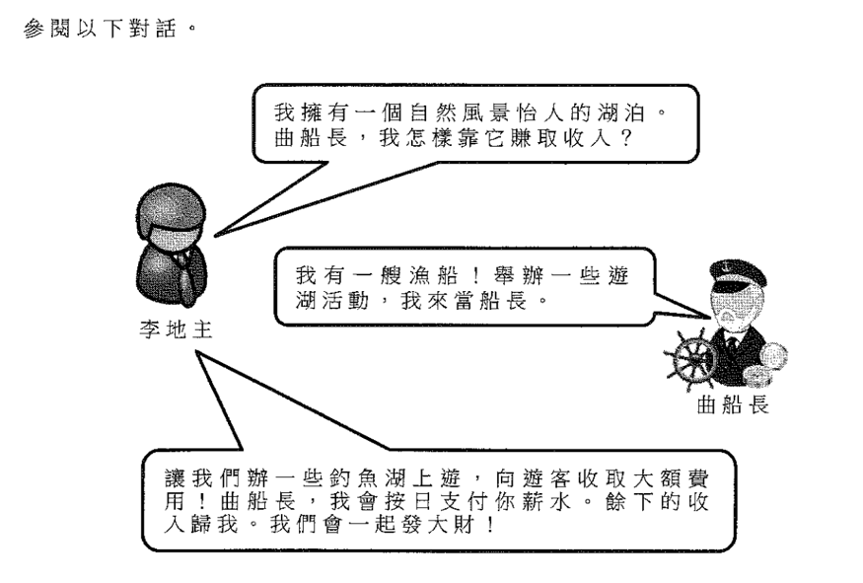
已知土地的回報是租金，勞工的回報是工資，資本的回報是利息，企業家的回報是利潤。曲船長的收入包含了______，而李地主所賺取的餘下收入包含了______。
A. 工資……利潤 B. 利息……租金及利潤
C. 工資及利息……租金 D. 工資及利息......租金及利潤

Type 1 (Classification of factor of production)

Type 2 (More about labour – Labour supply and labour productivity)
Example Question 1 CE1990MCQ20
Which of the following will increase the supply of labour?
(1) The legal minimum working age is raised.
(2) The government introduces an unemployment benefit scheme.
(3) Workers are willing to work for longer hours at the same wage rate.
(4) The retirement age is raised.
A. (1) and (2) only B. (1) and (4) only C. (2) and (3) only D. (3) and (4) only

下列哪些情況可使勞力的供應增加？
(1) 提高法定最低工作年齡
(2) 政府推出失業救濟計劃
(3) 在工資不變的情況下，工人願意工作更長時間
(4) 提高退休年齡
A. 只有 (1)、(2) B. 只有 (1)、(4) C. 只有 (2)、(3) D. 只有 (3)、(4)

Example Question 2 CE1991MCQ9
Which of the following will improve the average productivity of labour?
A. a larger population B. longer working-hours
C. more opportunities for tertiary education D. the emigration of skilled workers

以下哪一項會提高平均勞工生產力？
A. 人口增加 B. 延長工作時間
C. 有更多機會可接受專上教育 D. 高技能工人移民到外國去

Example Question 3 CE1991MCQ56
The supply of labour does NOT depend on
A. the size of the population. B. the composition of the population.
C. the legal minimum working age. D. the productivity of workers.

以下哪一項不會影響勞工的供應？
A. 人口數目 B. 人口組成
C. 法定最低工作年齡 D. 勞工生產力

Example Question 4 CE1992MCQ10
Which of the following can increase the productivity of factory workers?
(1) abandoning the price-rate system
(2) installing more machinery
(3) importing labour from Mainland China
(4) providing a better working environment
A. (1) and (2) only B. (1) and (3) only C. (2) and (4) only D. (3) and (4) only

以下哪項可提高工廠勞工的生產力？
(1) 放棄「計件」工資制度
(2) 裝設更多機器
(3) 從中國大陸輸入勞工
(4) 提供較佳的工作環境
A. 只有 (1)、(2) B. 只有 (1)、(3) C. 只有 (2)、(4) D. 只有 (3)、(4)

Example Question 5 CE1993MCQ6
Which of the following will improve the average productivity of labour in an economy?
(1) extending compulsory education to a high level
(2) raising the retirement age
(3) increasing the quantity of capital goods
(4) raising unemployment benefits
A. (1) and (3) only B. (1) and (4) only C. (2) and (3) only D. (2) and (4) only

下列哪一項能提高經濟中勞工的平均生產力?
(1) 提高強制教育至較高程度
(2) 提高退休年齡
(3) 增加資本物品的數量
(4) 增加失業救濟金
A. 只有 (1)、(3) B. 只有(1)、(4) C. 只有(2)、(3) D. 只有(2)、(4)

Example Question 6 CE1993MCQ19
The following table shows the output of dresses from a factory in 1991 and 1992.
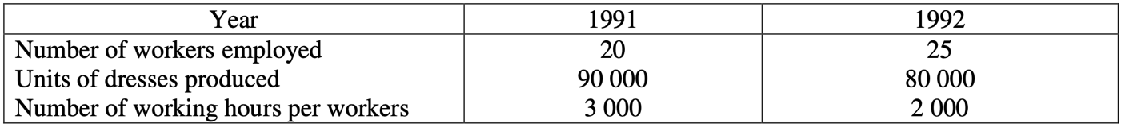
The factory employed a _______ quantity of labour in 1992 and the average labour productivity was ______ in that year.
A. larger; higher B. larger; lower C. smaller; higher D. smaller; lower

下表顯示一工廠在 1991 年和 1992 年生產衫裙的情況。
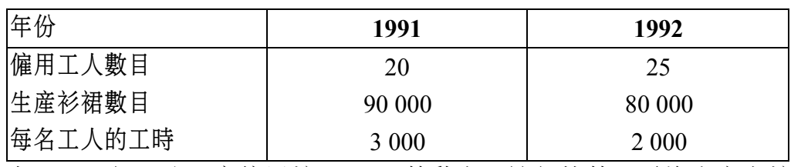
在 1992 年，這工廠僱用較_________勞工。該年的平均勞工生產力較__________。
A. 多；高 B. 多；低 C. 少；高 D. 少；低

Example Question 7 CE1994MCQ17
Which of the following factors would tend to increase the labor supply in Hong Kong?
(1) The government re-employs some retired civil servants.
(2) There are more public holidays each year.
(3) There is a greater proportion of males in the population.
(4) The educational level of workers becomes higher.
A. (1) and (3) only B. (1) and (4) only C. (2) and (3) only D. (2) and (4) only

以下哪種因素有可能使本港的勞力供應增加?
(1) 政府再聘用一些已退休的公務員
(2) 每年有更多公眾假期
(3) 男性佔較高的人口比例
(4) 工人的教育水平提高
A. 只有(1)、(3) B. 只有(1)、(4) C. 只有(2)、(3) D. 只有(2)、(4)

Example Question 8 CE1995MCQ16
Which of the following will increase the average productivity of labour?
(1) a larger labour force
(2) better education and training of workers
(3) better organization of production
(4) fewer public holidays
A. (1) and (2) only B. (1) and (4) only C. (2) and (3) only D. (3) and (4) only

下列哪些情況會增加勞工的平均生產力？
(1) 較大的勞動人口
(2) 工人的教育水平及訓練較佳
(3) 企業更好地組織生產
(4) 較少公眾假期
A. 只有 (1)及(2) B. 只有 (1)及(4) C. 只有 (2)及(3) D. 只有 (3)及(4)

Example Question 9 CE1996MCQ12
Which of the following will decrease the labor supply of a country?
A. fewer job vacancies B. more universities places for students
C. an increase in the retirement age of workers D. an increase in the number of immigrants

下列哪一項會使一國的勞力供應減少?
A. 職位空缺減少。 B. 大學提供更多學位以供學生就讀。
C. 勞工的退休年齡提高了。 D. 入口移民數目增加。

Example Question 10 CE1996MCQ13
Refer to the table below for Questions 32 and 33:
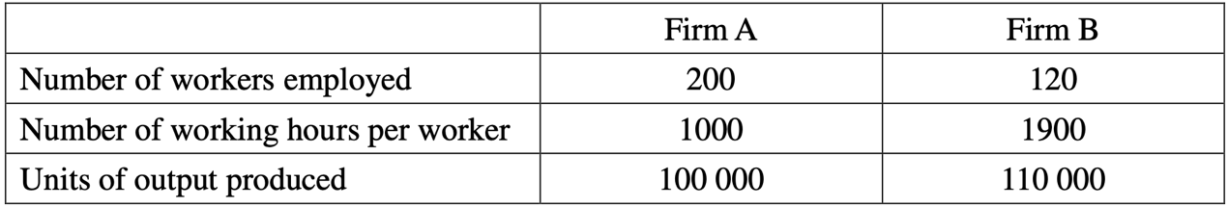
Which of the following comparisons is correct?
A. Workers in Firm B have a higher productivity. B. Firm B employs more labor services.
C. Firm B enjoys a greater economies of scale. D. Production in Firm B is more capital-intensive.

參閱下表,
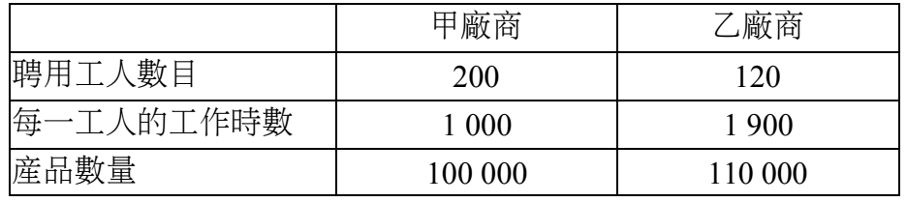
在下列各項比較中，哪一項是正確的？
A. 乙廠商工人的生產力較高。 B. 乙廠商聘用較多勞力。
C. 乙廠商享有較大規模經濟。 D. 乙廠商的生產較為資本密集。

Example Question 11 CE1996MCQ14
Which of the following is a possible reason for the difference in labor productivity of Firm A and Firm B?
A. Better training of workers in Firm A B. Better working environment in Firm B
C. A larger labor force in Firm A D. A higher wage rate in Firm B

下列哪一項是甲、乙廠商有不同的勞工生產力的可能原因?
A. 甲廠商工人有較佳訓練。 B. 乙廠商有較佳的工作環境。
C. 甲廠商有較多勞工。 D. 乙廠商的工資率較高。

Example Question 12 CE1998MCQ14
The average productivity of labour will increase if
(1) there is an increase in the number of machines.
(2) there is an increase in the size of the labour force.
(3) there is an improvement in the health conditions of workers
(4) workers work more hours per day.
A. (1) and (2) only B. (1) and (3) only C. (2) and (4) only D. (3) and (4) only

在下列哪些情況下，勞工的平均生產力會上升？
(1) 機器數目有所增加。
(2) 勞動人口數目有所增加。
(3) 勞工的健康狀況有所改善。
(4) 勞工每天工作時數有所增加。
A. 只有(1)、(2) B. 只有(1)、(3) C. 只有(2)、(4) D. 只有(3)、(4)

Example Question 13 CE1998MCQ15
Which of the following would increase the labour supply of Hong Kong?
A. The demand for imported workers increases.
B. All women are not allowed to work overtime.
C. More employers provided child care services to their employees.
D. More job vacancies are available.

下列哪一項會導致香港的勞力供應增加?
A. 對輸入勞工的需求增加。 B. 全部婦女不准超時工作。
C. 更多僱主提供幼兒托管服務予其僱員。 D. 有更多職位空缺。

Example Question 14 CE1999MCQ14
Which of the following would increase the labour supply of Hong Kong?
A. the provision of more day-time child-care services
B. a change in the payment system from piece rate to time rate
C. an increase in the number of public holidays in a year
D. a decrease in the number of people migrating to other countries

下列哪一項會增加香港的勞力供應？
A. 提供更多日間託管兒服務。 B. 付酬方式由「計件」改為「計時」。
C. 增加每年公眾假期的日數。 D. 移民往外國的人數下降。

Example Question 15 CE1999MCQ20
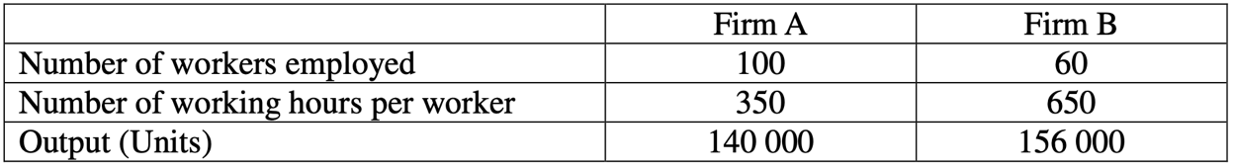
Which of the following concerning Firm A and Firm B is correct?
A. Firm B has a higher average labour productivity than Firm A.
B. Firm A has a higher average labour productivity than Firm B.
C. Firm A has a larger labour supply than Firm B.
D. Firm B has a larger labour supply than Firm A.

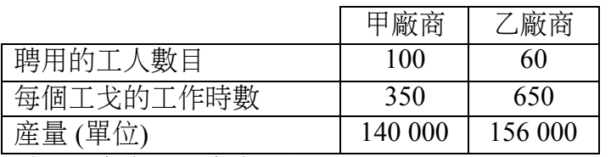
下列哪一項對於甲廠商和乙廠商的描述是正確的?
A. 乙廠商的平均勞動生產力較甲廠商高。
B. 甲廠商的平均勞動生產力較乙廠商高。
C. 甲廠商的勞力供應較乙廠商多。
D. 乙廠商的勞力供應較甲廠商多。

Example Question 16 CE2001MCQ13
Under which of the following situations would the labour supply in Hong Kong decrease?
A. All universities in Hong Kong admit fewer full time students.
B. More Hong Kong companies provide training courses to their staff during office hours.
C. Fewer Hong Kong people are allowed to emigrate to the US.
D. The Hong Kong government provides subsidies to private firms for installing high-tech equipment.

在下列哪一種倩況中，香港的勞力供應會減少？
A. 所有香港的大學都減少招收全日制學生。
B. 香港有更多公司在上班時問提供培訓課程予他們的員工。
C. 更少香港居民獲批准移民到美國。
D. 香港政府提供津貼予私人機構安裝高科技儀器。

Example Question 17 CE2001MCQ15
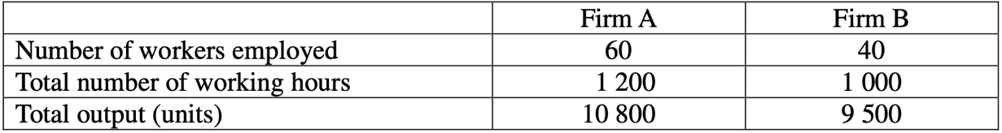
Which of the following is a possible reason for the difference in the labour productivity of Firm A and Firm B?
A. Firm B has a better working environment. B. Firm A has a higher degree of division of labour.
C. Firm A enjoys greater economies of scale. D. Firm B uses a more labour intensive method of production.

參閲下表：
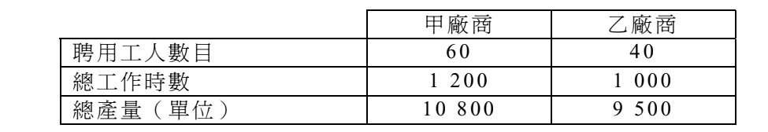
以下哪一項是甲、乙廠商有不同勞工生產力的一個可能原因？
A. 乙廠商的工作環境較佳。 B. 甲廠商的分工程度較高。
C. 甲廠商享有較大的規模經濟。 D. 乙廠商便用較爲勞力密集的生產方法。

Example Question 18 CE2002MCQ14
A higher average labour productivity means a higher
A. average output per worker. B. marginal product per man.
C. total output per worker. D. total product per unit of labour.

勞工的平均生產力較高，意指
A. 每工人的平均產出較高。 B. 每人的邊際產量較高。
C. 每工人的總產出較去年高。 D. 每單位勞力的總產量較高。

Example Question 19 CE2004MCQ16
The labour supply will increase if
A. more job vacancies are available.
B. more universities offer 4-year degree courses instead of 3-year degree courses.
C. the number of public holidays in a calendar year is reduced.
D. the retirement age is reduced.

在下列哪一種情況下，勞力供應會增加？
A. 有更多職位空缺。
B. 有更多大學提供四年大學學位課程，以代替三年大學學位課程。
C. 一年內的公眾假期減少。
D. 退休年齡下降。
Example Question 20 CE2005MCQ16
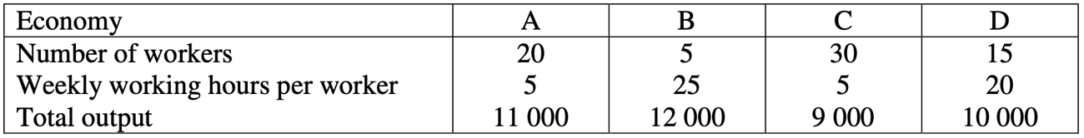
Which economy has the largest labour supply?
A. A B. B C. C D. D

參閲下表。
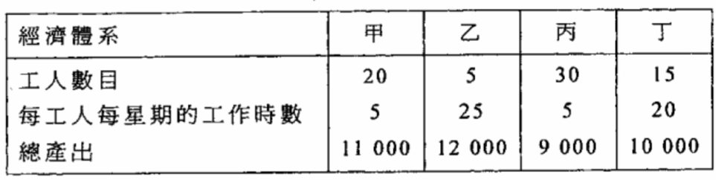
哪一經濟體系的勞力供應最高？
A. 甲 B. 乙 C. 丙 D. 丁

Example Question 21 CE2005MCQ17
Which of the following situations will increase the average labour productivity?
A. employing more workers B. extending the working hours
C. changing from time rates to piece rates D. reducing the degree of division of labour

下列哪項會提高勞工的平均生產力？
A. 僱用更多工人。 B. 延長工作時數。
C. 由計時工資轉為計件工資。 D. 減低分工的程度。

Example Question 22 CE2006MCQ14
Which of the following would raise the average labour productivity?
A. a larger working population B. fewer public holidays
C. a larger quantity of advanced equipment D. a lower degree of occupational mobility of labour

下列哪項會提高勞工的平均生產力？
A. 勞動人口增加。 B. 公眾假期減少。
C. 先進機械儀器增加。 D. 勞工的職業流動性減低。

Example Question 23 CE2007MCQ15
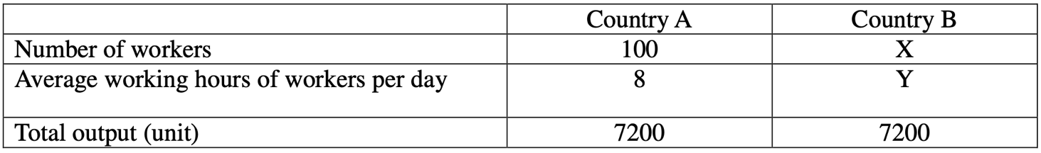
In the above table, if the labour productivity in Country B is higher, the possible value of X and Y would be ________ and ________ respectively
A. 140...6 B. 150...5 C. 200...4 D. 300...3

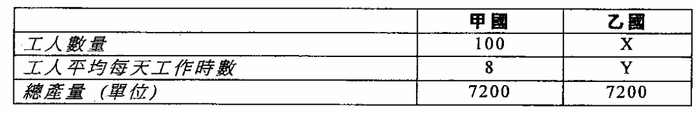
上表中，若乙國的勞工生產力較高，X和Y的值可能分別是_________和___________。
A. 140…… 6 B. 150……5 C. 200……4 D. 300……3

Example Question 24 CE2009MCQ16
If the government raises the legal retirement age,
A. The occupational mobility of workers will increase. B. The average labour productivity will increase.
C. The supply of labour will increase. D. More division of labour will be practised.

若政府提高法定退休年齡，
A. 工人的職業流動性會增加。 B. 勞工的平均生產力會增加。
C. 勞力供應會增加。 D. 廠商會實施更多分工。

Example Question 25 CE2009MCQ17
Which of the following is a possible reasons for increase in average labour productivity resulting from practising division of labour?
A. Fewer capital goods are required. B. The occupational mobility of workers is higher.
C. The total wage income of workers is higher. D. Time is saved from moving workers between different tasks.

下列哪項是因實施分工而導致平均勞工生產力上升的一個可能的原因？
A. 所需資本物品較少。 B. 工人的職業流動性較高。
C. 工人的總工資收入較高。 D. 節省了工人在不同工序之間轉換工作所需的時間。

Example Question 26 CE2010MCQ18
Which of the following will increase the average labour productivity?
(1) The number of promotion posts increases.
(2) The number of retired workers increases.
(3) Production become more capital-intensive.
A. (1) and (2) only B. (1) and (3) only C. (2) and (3) only D. (1), (2) and (3)

下列哪項會提升勞工的平均生產力
(1) 晉升職位的數目增加
(2) 退休工人的數目增加
(3) 生產方式變得更為資本密集
A. 只有(1)、(2) B. 只有 (1)、(3) C. 只有 (2)、(3) D. (1)、(2)、(3)

Example Question 27 CE2010MCQ20
Which of the following would decrease the labour supply of Hong Kong?
A. Better and more job opportunities in mainland China
B. The imposition of a minimum wage law for low-skilled workers in Hong Kong
C. A lower average salaries tax rate in Hong Kong
D. An increase in the retirement age in Hong Kong

下列那後會減少香港的勞工供應?
A. 中國內地有更多及更佳的就業機會
B. 香港實施低技術工人的最低工資
C. 香港薪俸稅的平均稅率下降
D. 提高香港人的退休年齡

Example Question 28 CE2011MCQ18
Which of the following will raise the average productivity of labour?
(1) Extending free education to tertiary level
(2) Raising the retirement age
(3) Expanding vocational training for workers
A. (1) and (2) only B. (1) and (3) only C. (2) and (3) only D. (1), (2) and (3)

下列哪項會提高勞工的平均生產力？
(1) 擴展免費教育至大專程度
(2) 提高退休年齡
(3) 提供更多職業訓練予勞工
A. 只有(1)、(2) B. 只有 (1)、(3) C. 只有 (2)、(3) D. (1)、(2)、(3)
Example Question 29 DSESPMCQ6
Which of the following would raise the average labour productivity?
A. an increase in the number of imported foreign specialists B. an increase in the average working hours
C. a ban on the use of environmentally harmful machines D. a cut in government subsidies for continuing education

下列哪項會提高勞工的平均生產力？
A. 輸入外地專才的數目增加 B. 平均工時增加
C. 禁止使用對環境有害的機械 D. 削減政府對持續進修的補貼

Example Question 30 DSE2012MCQ6
Which of the following policies will result in an increase in the labour force of Hong Kong?
A. Extension of free education from 9 years to 12 years
B. An increase in the minimum capital requirement of the Capital Investment Entrant Scheme
C. An increase in the immigration scheme quota for talented persons from the mainland
D. Introduction of maximum working hours

下列哪項政策會增加香港的勞動人口？
A. 免費教育由九年延長至十二年 B. 提高資本投資者入境計劃的最低資本要求
C. 增加內地優才入境計劃的限頟 D. 訂立最高工時

Example Question 31 DSE2014MCQ9
Which of the following will increase the labour supply of an economy?
A. More firms allow male employees to take paternity leave.
B. More companies offer free transport to employees working overtime.
C. Universities provide more full-time associate degree programmes for secondary school graduates.
D. The government adopts maximum working hours for the civil servants.

下列哪項會增加某經濟的勞力供應？
A. 更多廠商允許男性僱員請侍產假。
B. 更多公司爲加班的僱員提供免費交通。
C. 大學爲中學畢業生開辦更多全日制副學士學位課程 。
D. 政府對公務員實施最高工時。

Example Question 32 DSE2016MCQ8
The labour supply of a country will increase if
A. more training is provided for the existing labour force. B. the legal minimum working age is lowered from 16 to 15.
C. foreign direct investment increases. D. the government increases the salaries tax rate.

在下列哪種情況下，某國的勞力供應會增加？
A. 為現有的勞動人口提供更多訓練。 B. 法定最低的工作年齡由16歲降低至15歲。
C. 外國的直接投資增加。 D. 政府提高薪俸稅率。

Example Question 33 DSE2017MCQ11
The input-output relationship of a firm is as follows:
 | Year 1 | Year 2
Number of workers | 30 | 35
Number of working hours per day | 10 | 8
Quantity of output (units) | 3 000 | 2 900
Based on the above information, labour supply _______ and average labour productivity _______.
A. Rises …… rises B. Rises …… falls C. Falls …… rises D. Falls …… falls

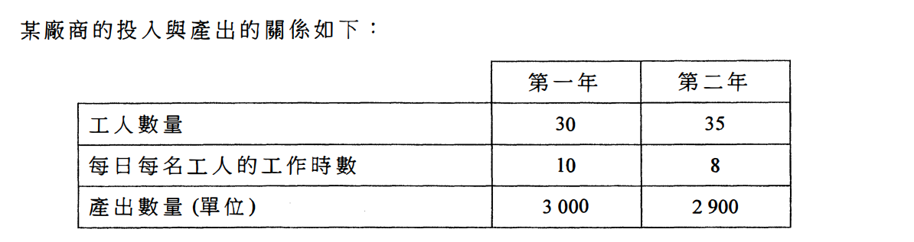
根據上述資料，勞力供應會__________而平均勞工生產力會__________。
A. 增加…… 增加 B. 增加…… 減少 C. 減少…… 增加。 D. 減少…… 減少

Example Question 34 DSE2018MCQ9
The labour supply in Hong Kong would increase if
A. More Hong Kong people migrated to foreign countries
B. More Hong Kong students studied in tertiary institutions
C. The government lowered the qualification requirements for the Quality Migrant Admission Scheme
D. All working fathers were allowed to take two extra days of paternity leave

若_________，香港的勞力供應會增加。
A. 更多香港人移民外國 B. 更多香港學生人讀大專院校
C. 政府降低「優才入境計劃」的資歷要求 D. 所有在職父親可多得兩天的侍產假
Example Question 35 DSE2019MCQ6
In the 2018-19 Budget, the Hong Kong Government raised the subsidy ceiling of the Continuing Education Fund from $10000 to $20000 per applicant to encourage members of the public to pursue further education. This policy will lead to a rise in _______ and _______ in the future.
A. Labour supply …… geographical mobility B. Labour supply …… occupational mobility
C. Labour productivity …… geographical mobility D. Labour productivity …… occupational mobility

在2018-19 年度財政預算案，香港政府將持續進修基金的資助上限由每位申請人$10000 提高至$20000，以鼓勵市民繼續進修。該政策會引致將來______和_______上升。
A. 勞力供應⋯⋯地域流動性 B. 勞力供應......職業流動性
C. 勞工生產力......地域流動性 D. 勞工生產力......職業流動性

Type 2 (More about labour – Labour supply and labour productivity)

Type 3 (More about labour – Wage payment)
Example Question 1 CE1991MCQ8
Private tuition is usually paid for by time rates because
A. the incentive to work is stronger. B. better examination results are guaranteed.
C. the tuition fee is less. D. The output is difficult to measure.

私人補習一般是依照「計時」方式支付工資的。這是因為
A. 這種計酬方法可以提高工作熱誠。 B. 這種計酬方法可以保證有更佳的考試成績。
C. 補習費用可以較低。 D. 這種工作的產出量難以量度。

Example Question 2 CE1994MCQ18
Instead of receiving only a fixed monthly salary, hotel waiters in Hong Kong generally earn a low basic monthly salary and receive tips from customers. To the hotel owners, which of the following in an advantage of the latter method of payment compared to the former method?
A. It is easier to calculate the output of the waiters. B. Fewer waiters are needed.
C. There is a better relationship among the waiters. D. The waiters provide better service.

香港的酒店侍應一般都不是只收取固定月薪，而是在低廉的基本工資上再加上客人給予的小費。對酒店東主來說，後者支酬方法較前者為優之處是
A. 更容易計算侍應的產出。 B. 所需侍應數目較少。
C. 各侍應之間的關係更好。 D. 侍應提供更佳服務。

Example Question 3 CE1995MCQ17
Secondary school teachers in Hong Kong are in general paid by time rates because
(1) the tasks of a teacher are not standardized.
(2) the output cannot be easily measured.
(3) there is a higher incentive to work.
A. (1) and (2) only B. (1) and (3) only C. (2) and (3) only D. (1), (2) and (3)

香港的中學教師一般都是以「計時」方式支付工資的，因為
(1) 教師擔當多種不同性質的工作。
(2) 教師的產出不易量度。
(3) 這可以提高工作的積極性。
A. 只有(1)、(2) B. 只有(1)、(3) C. 只有(2)、(3) D. (1)、(2)及(3)

Example Question 4 CE1996MCQ16
An employer has changed the method of payment to his employees and observed the following results:
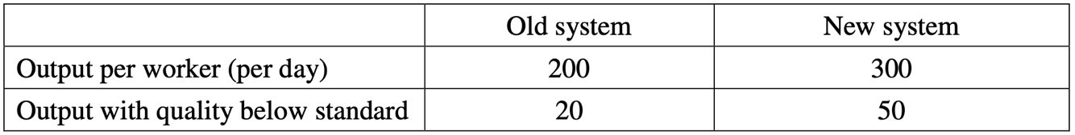
Most probably the old system is ____________ and the new system is ___________ .
A. time rate …… piece rate B. piece rate …… time rate
C. a profit sharing scheme …… time rate D. piece rate .......... A profit sharing scheme

某僱主改變了他對僱員的付款方法，觀察得下列結果：
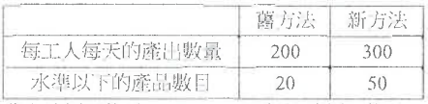
舊方法極可能是_____而新方法亦可能是_____.
A. 計時 … 計件 B. 計件 … 計時
C. 利潤分享計劃 … 計時 D. 計件 … 利潤分享計劃

Example Question 5 CE1998MCQ17
Private piano teachers are usually paid at an hourly rate instead of a piece rate. Which of the following statements are true?
(1) They tend to work longer hours.
(2) They are not encouraged to rush through more music pieces in a lesson.
(3) Their output is difficult to measure.
A. (1) and (2) only B. (1) and (3) only C. (2) and (3) only D. (1), (2) and (3)

私人鋼琴教師的酬勞一般都是「計時」而非「計件」。下列哪幾項是正確的？
(1) 他們傾向工作更長時間。
(2) 僱主不鼓勵他們每課倉猝地教授更多樂章。
(3) 他們的產出不易量度。
A. 只有(1)、(2) B. 只有(1)、(3) C. 只有(2)、(3) D. (1)、(2)、(3)

Example Question 6 CE1999MCQ51
Assume that the payment system of some civil servants is changed from time rate to piece rate. This change will NOT result in
A. an increase in their income. B. an improvement in the quality of their work.
C. an increase in the monitoring and supervision cost of their work. D. an increase in the quantity of work completed by them.

假設部分公務員的支薪方式由 「計時」改為「計件」。這種改變不會使
A. 他們的收入增加。 B. 他們的工作質素改善。
C. 監督他們工作的成本上升。 D. 他們完成的工作數量更多。

Example Question 7 CE2000MCQ15

A. The cost of measuring wage payment is higher in the XYZ Company.
B. The working incentive of mail assistants is higher in the XYZ Company.
C. The income of a mail assistant is higher in the ABC Company.
D. The cost of supervision is lower in the ABC Company.

參閲以下的招聘職員廣告：
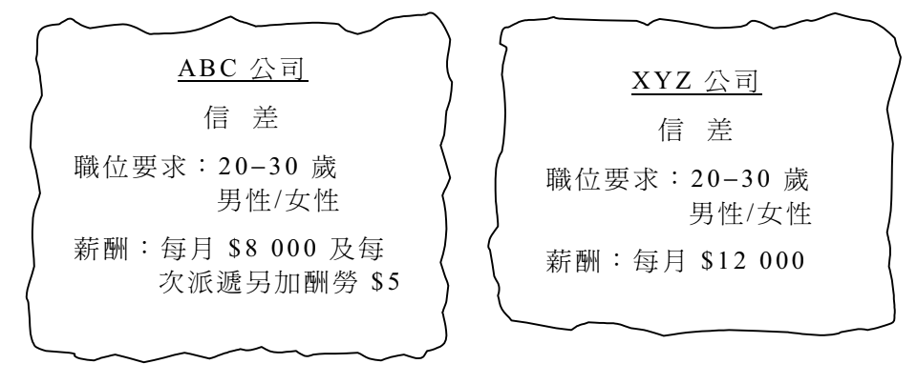
A. XYZ公司量度薪酬支出的成本較高
B. XYZ公司信差的工作熱誠較高
C. ABC公司信差的收入較高
D. ABC公司監察信差的成本較低

Example Question 8 CE2002MCQ16
Under the previous wage payment system, Mrs Chan found that her workers were lazy. Now, she has adopted another wage payment system under which the quantity as well as the quality of the output of her firm has been raised. This improvement could be due to the fact that the previous wage payment system was _______ and the present one is _________.
A. piece rate ... time rate B. piece rate ... profit-sharing C. time rate ... piece rate D. time rate ... profit-sharing

陳太發現她的員工在舊有的薪酬制度下是懶惰的。現在，她採用另一套薪酬制度，因而公司的產出無論量與質都有所改善。這可能是因為舊薪酬制度是________而新薪酬制度是_________。
A. 計件...... 計時 B. 計件......利潤分享 C. 計時...... 計件 D. 計時......利潤分享

Example Question 9 CE2003MCQ18
A factory owner has changed the method of payment to his workers and observes a higher labour productivity of his workers, but a lower quality of output. Most probably the old payment system is ________ and the new payment system is_________.
A. time rate; piece rate B. piece rate; time rate
C. profit share scheme; time rate D. piece rate; profit sharing scheme

某工廠東主發現在他改變支付員工薪酬的方式後，員工生產力提高，但產品質素下降。舊的薪酬方式最有可能是_______而新的薪酬方式最有可能是____________。
A. 計時 ...... 計件 B. 計件 ...... 計時
C. 利潤分享計劃 ...... 計時 D. 計件 ...... 利潤分享計劃

Example Question 10 CE2006MCQ16
Suppose the wage payment system of the salesmen employed in ABC Company changes as follows:
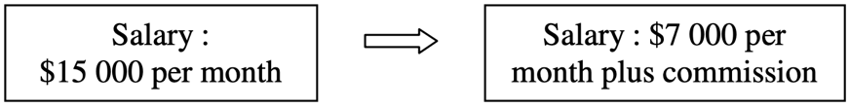
It results in:
A. a lower cost of calculating the wage payments B. a lower cost of monitoring the salesmen's performance
C. a lower income for salesmen D. a lower quality of services provided by the salesmen

假設 ABC 公司聘用的推銷員的工資制度改變如下:
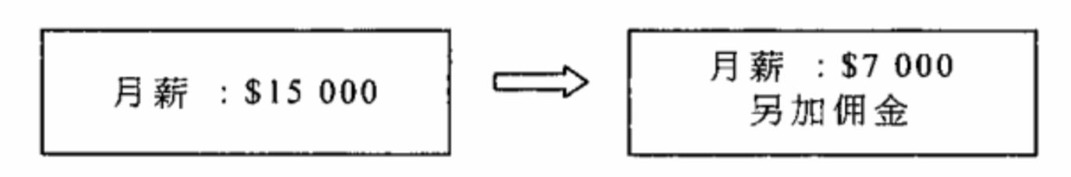
結果，
A. 計算工資的成本下降。 B. 監察推銷員工作表現的成本下降。
C. 推銷員的收入下降。 D. 推銷員的服務水平下降。

Example Question 11 CE2009MCQ18
Whose employer would have the highest cost in monitoring the performance of his work?
A. An office clerk who is paid with a fixed monthly salary B. A property agene who is paid through commission
C. A tourist guide who is paid with tips D. A movie star who shares the profit with his film producer

在下列人士中，誰的僱主要付出最高成本以監察其工作表現？
A. 一位辦公室文員，他收取固定月薪作為報酬。 B. 一位地產經紀，他收取佣金作為報酬。
C. 一位導遊，他收取小費作為報酬。 D. 一位明星，他與製片公司分享利潤作為報酬。

Example Question 12 DSEPPMCQ6
A worker is paid by the quantity he produced instead of receiving a monthly salary. Which of the following statements is INCORRECT?
A. The worker tends to produce more output. B. The quality of the output tends to be lower.
C. The cost of monitoring the worker regarding shirking will be lower. D. The income of the worker will increase.

某工人是以他所生產的產品數量計算工資而非領取月薪。下列哪項陳述是不正確的？
A. 該工人傾向提高其產量。 B. 產出的質素傾向較低。
C. 監察該工人偷懶的成本減低。 D. 該工人的收入會增加。

Example Question 13 DSE2012MCQ7
Some property agencies pay their employees a basic salary plus commission because
(1) It can increase the working incentive of the employees.
(2) It can transfer part of the business risk to the employees.
(3) The cost of calculating wages is lower.
A. (1) and (2) only B. (1) and (3) only C. (2) and (3) only D. (1), (2) and (3)

一些物業經紀行以基本薪金加佣金支付員工的薪金，因為
(1) 這可提高員工的工作意欲。
(2) 這可將部分經營風險轉嫁給員工。
(3) 計算工資的成本較低。
A. 只有(1)、(2) B. 只有(1)、(3) C. 只有(2)、(3) D. (1)、(2)及(3)

Example Question 14 DSE2012MCQ10
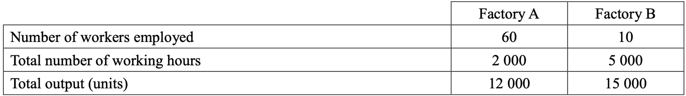
Which of the following is a possible reason for the difference between the labour productivity of Factory A and Factory B?
A. Factory B provides more training for its workers.
B. More machines are used in Factory B.
C. The working environment in Factory A is poorer.
D. Factory A pays its workers at piece rate while Factory B pays at time rate.

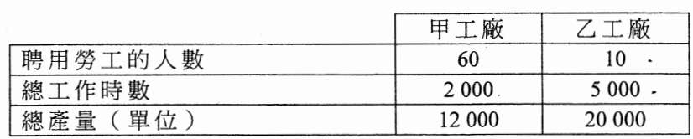
下列哪項是甲工廠和乙工廠勞工生產力有差別的可能原因？
A. 乙工廠提供較多員工訓練。
B. 乙工廠使用較多機器。
C. 甲工廠的工作環境較差。
D. 甲工廠採用計件工資而乙工廠採用計時工資。

Example Question 15 DSE2013MCQ7
Teachers in secondary schools are usually paid by time rate because
A. This can improve their working incentive. B. They prefer a stable income.
C. Most teachers are hardworking. D. It is costly to measure their outputs.

中學教師一般按工時支薪，因為
A. 這可改善他們的工作意欲。 B. 他們偏好穩定收入。
C. 大部分教師都是勤力的。 D. 量度他們產出的成本很高。

Example Question 16 DSE2015MCQ6
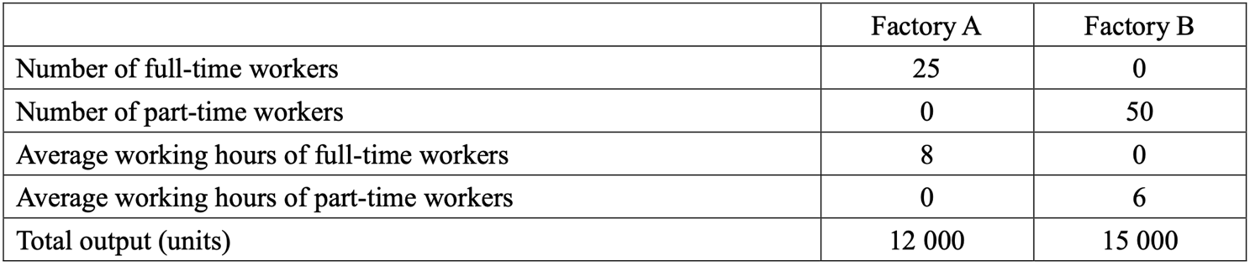
A. Factory A uses time rate while Factory B uses piece rate to pay its workers.
B. Factory A provides more training for its workers.
C. The part-time workers employed by Factory B are more skilled.
D. Factory B uses more capital goods.

細閱下表，
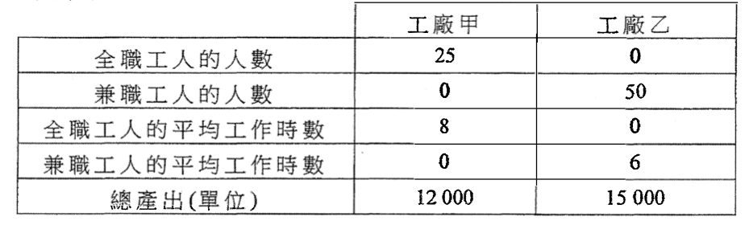
下列哪項是工廠甲和工廠乙在勞工生產力上有差異的一個可能原因？
A. 工廠甲以計時工資支付工資，工廠乙則以計件工資計算。
B. 工廠甲向工人提供更多的訓練。
C. 工廠乙聘請的兼職工人有較高技術。
D. 工廠乙運用較多資本物品。

Example Question 17 DSE2016MCQ10
Which of the following is most likely to be paid on a piece-rate basis?
A. a newspaper columnist B. a primary school teacher C. a fireman D. a bus driver

下列哪位最有可能以件工計酬？
A. 一位報章專欄作家 B. 一位小學教師 C. 一位消防員 D. 一位巴士司機

Example Question 18 DSE2021MCQ5
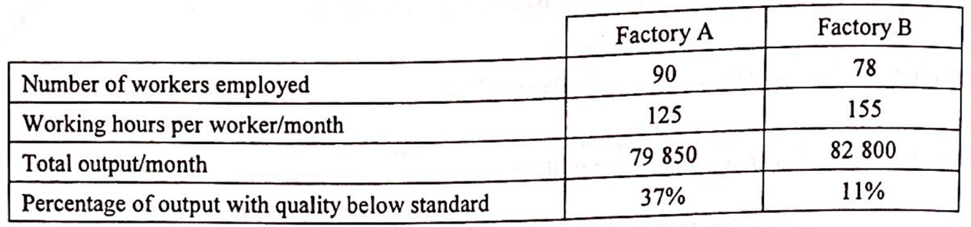
Refer to the above table. Which of the following can best explain the difference in quality of the outputs between Factory A and Factory B?
A. Factory A employs less labour service than Factory B
B. Factory A practises a higher degree of division of labour than Factory B
C. The degree for mechanisation of Factory A is higher than that of Factory B
D. Factory A uses piece rate while Factory B uses time rate

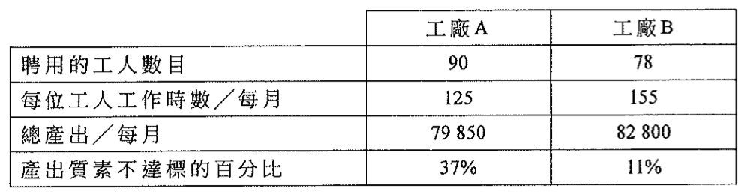
參閱上表，下列哪項最能解釋工廠A和工廠B產出質素的差別？
A. 與工廠B相比，工廠A聘請較少勞工服務。
B. 與工廠B相比，工廠A進行較高度的分工。
C. 與工廠B相比，工廠A機械化的程度較高。
D. 工廠A是以計件而工廠B 是以計時。

Type 3 (More about labour – Wage payment)

Type 4 (More about labour – Occupational mobility and Geographical mobility)
Example Question 1 CE1990MCQ9
The ban on the ivory trade in general harms the __________ craftsmen most because of their relatively ____________ mobility.
A. younger, low, occupational B. younger, high, geographical
C. older, low, occupational D. older, high, geographical

一般來說，禁售象牙對______的雕刻工人打擊最大，因為他們的_______流動性比較_________。
A. 較年青，職業，低 B. 較年青，地域，高
C. 較年長，職業，低 D. 較年長，地域，高

Example Question 2 CE1991MCQ6
Suppose the government provides housing subsidies to teachers serving in the same school for over 10 years. Such a measure will tend to _____ the occupational mobility and ______ the geographical mobility of these teachers.
A. increase, increase B. decrease, decrease C. increase, decrease D. decrease, increase

假設政府對於在同一所學校裏服務超過 10 年的教員提供房屋津貼。此舉會_______這批教員的職業流動性和________他們的地域流動性。
A. 增加，增加 B. 減少，減少 C. 增加，減少 D. 減少，增加

Example Question 3 CE1992MCQ9
Which of the following can increase the occupational mobility of labour?
A. the development of industries requiring high technology B. the setting up of more professional associations
C. the expansion of vocational training courses D. the extension of the Mass Transit Railway network

以下哪一項可增加勞工的職業流動性？
A. 發展高科技工業 B. 設立更多專業團體
C. 擴展職業訓練課程 D. 延伸地下鐵路網絡

Example Question 4 CE1993MCQ14
Lawyers generally have a low occupational mobility because
A. they enjoy social status B. they are not skillful in other professional
C. they have high occupational cost in changing jobs D. they are members of the Hong Kong Law Society

律師的職業流動性普遍為低，因為
A. 他們享有社會地位。 B. 他們在其他行業並無專長。
C. 他們轉職的機會成本高。 D. 他們是律師公會會員。

Example Question 5 CE1995MCQ21
Which of the following will raise the occupational mobility of labour?
(1) a higher degree of specialization of skills
(2) more information about job vacancies
(3) greater power of labour unions
(4) provision of retraining programmes
A. (1) and (2) only B. (1) and (3) only C. (2) and (4) only D. (3) and (4) only

下列哪些情況會提高勞工的職業流動性?
(1) 技術更專門化
(2) 有更多關於職位空缺的訊息
(3) 工會權力更大
(4) 提供再培訓計劃
A. 只有(1)及(2) B. 只有(1)及(3) C. 只有(2)及(4) D. 只有(3)及(4)

Example Question 6 CE1999MCQ16
Which of the following types of people is more occupationally mobile?
A. professors in economics in a university B. accountants C. salesmen D. company secretaries

下列哪一類人的職業流動性較高？
A. 大學裏的經濟學教授 B. 會計師 C. 售貨員 D. 公司秘書

Example Question 7 CE2001MCQ14
Suppose the government starts to recruit experienced Putonghua teachers from Mainland China. This would ________ the ________ mobility of experienced Putonghua teachers in Mainland China.
A. reduce ... occupational B. reduce ... geographical C. increase ... occupational D. increase ... geographical

假設政府開始從中國內地招聘有經驗的普通話教師來港任教。這會_________中國內地有經驗普通話教師的_________流動性。
A. 減少 ... 職業 B. 減少 ... 地域 C. 增加 ... 職業 D. 增加 ... 地域

Example Question 8 CE2004MCQ15
In order of attract more Mainland professionals to work in Hong Kong, some firms plan to provide a housing allowance for them. This would _______ the ___________ of these Mainland professionals.
A. reduce ... occupational mobility B. increase ... occupational mobility
C. reduce ... geographical mobility D. increase ... geographical mobility

爲了吸引更多內地專才來港工作，有些公司計劃向他們提供房屋津貼，此舉會_________這些內地專才的_________。
A. 減少... 職業流動性 B. 增加 ... 職業流動性
C. 減少... 地域流動性 D. 增加 ... 地域流動性

Example Question 9 CE2008MCQ15
In which of the following situations will the occupational mobility of labour increase?
A. improvement of the transportation network B. tightened restrictions on obtaining a professional license
C. provisions of more retraining programmes D. raising the legal retirement age

下列哪些情況會提高勞工的職業流動性？
A. 改善交通網絡 B. 收緊獲取執業牌照的規限
C. 提供更多再培訓計劃 D. 提高法定退休年齡

Example Question 10 DSE2012MCQ5
The occupational mobility of labour in an economy will increase when
A. The cross-border railway network is improved. B. Licenses are required for more types of job in the labour market.
C. Tax allowances are provided for continuing education. D. There is a greater degree of specialisation in production.

當 _________ ，該經濟中勞工的職業流動性會上升。
A. 跨境鐵路網有所改善 B. 勞力市場中有更多類型的工作需要牌照
C. 持續進修能獲免稅額 D. 生產更高度專門化

Example Question 11 DSE2014MCQ11
Which of the following would most likely increase the occupational mobility of labour in an economy?
A. The labour unions have stronger bargaining power for the welfare of their members.
B. The labour department provides tuition fee rebates for participants of retaining programmes.
C. The transport network is improved by the extension of highways.
D. The government stops granting funding for an online data system about job vacancies.

下列哪項最有可能增加某經濟中勞工的職業流動性？
A. 工會有更大的討價還價能力為其會員爭取福利。 B. 勞工處為再培訓計劃的參加者提供學費回贈。
C. 高速公路的擴展改善了交通網絡。 D. 政府停止為職位空缺網上資料系統提供資金。
Example Question 12 DSE2015MCQ4
The _________ mobility of labour will decrease if ______________.
A. geographical ... the government introduces “city-bike rental scheme” in all train stations.
B. geographical ... several big companies set up child care centres in their offices.
C. occupational ... the travelling subsidy scheme provided by government is reduced due to a budget
D. occupational ... Licences are required by the government for more professions

若___________，勞工的___________流動性會下降。
A. 政府在所有火車站推行「城市單車租賃計劃」 ...... 地域
B. 數家大公司在其辦公室設立幼兒託管中心 ...... 地域
C. 政府所提供的交通津貼因財政赤字而減少 ...... 職業
D. 政府在更多的行業規定從業員須具備執業牌照 ...... 職業

Example Question 13 DSE2016MCQ9
Which of the following is the most mobile in terms of occupational mobility?
A. a professional basketball player B. a licensed plumber
C. a graduate trainee in a law firm D. a clerk in an accounting firm

就職業流動性而言，下列哪項的流動性最高？
A. 一位職業籃球員 B. 一位持牌水喉匠
C. 一位律師行的大學畢業實習生 D. 一位會計師行的文員

Example Question 14 DSE2017MCQ7
Certain restaurants in China found that they can introduce robots to replace some workers in serving customers without reducing their output. This will
A. Increase the quantity supplied of restaurant workers B. Increase the labour productivity of those restaurants
C. Decrease the geographical mobility of restaurant workers D. Decrease the occupational mobility of restaurant workers

某些中國的餐廳發現能運用機械人代替部分工人接待顧客而不會令產出下降，這會
A. 增加餐廳工人的供應量。 B. 增加這些餐廳的勞工生產力。
C. 減低餐廳工人的地域流動性。 D. 減低餐廳工人的職業流動性。

Example Question 15 DSE2019MCQ6
In the 2018-19 Budget, the Hong Kong Government raised the subsidy ceiling of the Continuing Education Fund from $10000 to $20000 per applicant to encourage members of the public to pursue further education. This policy will lead to a rise in _______ and _______ in the future.
A. Labour supply …… geographical mobility B. Labour supply …… occupational mobility
C. Labour productivity …… geographical mobility D. Labour productivity …… occupational mobility

在2018-19年度財政預算案，香港政府將持續進修基金的資助上限由每位申請人$10000提高至$20000，以鼓勵市民繼續進修。該政策會引致將來_______和_______上升。
A. 勞力供應…..地域流動性 B. 勞力供應…..職業流動性
C. 勞工生產力…..地域流動性 D. 勞工生產力…..職業流動性

Type 4 (More about labour – Occupational mobility and Geographical mobility)

2013DSE LQ10bi, bii
There are cooks, waiters, managers and receptionists working in restaurants. The following is a job advertisement for a manager in a restaurant.
Manager
Working hours : 12:00 noon $-$ 10 : 00 p.m.
6 days a week
Salary : $15 000 per month + performance-related bonus
(a) From the viewpoint of the restaurant owner, explain ONE advantage of the above payment method over time rate. (2)
(b) From the viewpoint of the manager, explain ONE advantage of the above payment method over a profit-sharing scheme. (2)
以下是某餐廳招聘經理的廣告。
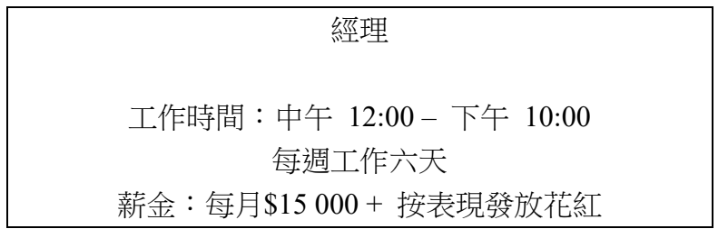
(a) 從餐廳東主的角度，解釋上述支薪方法相對時薪的一項優點。 (2)
(b) 從經理的角度，解釋上述支薪方法相對利潤分享計劃的一項優點。 (2)

_______________________________________________________________________________________
_______________________________________________________________________________________
_______________________________________________________________________________________
_______________________________________________________________________________________
_______________________________________________________________________________________
_______________________________________________________________________________________
_______________________________________________________________________________________
_______________________________________________________________________________________
_______________________________________________________________________________________
_______________________________________________________________________________________

Marking Scheme:
(a) - It improves the work incentive of the manager
- any other relevant point (2)

(b) - It gives a more stable income as the manager still receive a basic salary even if the
business is poor.
- any other relevant point (2)

(a) - 這會改善經理的工作意欲。
- 任何其他相關點 (2)

(b) - 這令收入較穩定，因為即使生意欠佳經理仍然獲發底薪。
- 任何其他相關點 (2)

2013DSE LQ11bi
The government has launched the “work Incentive Transport Subsidy Scheme”, with the following objectives:
- To relieve the burden of travelling expense commuting to and from work on the part of low-income households with employed members
- To promote sustained employment
Applicant must meet the monthly income and asset limits of the household (e.g. for a single person, the monthly income cannot exceed $7300 and the asset cannot exceed $72000) and work no less than 72 hours per month in order to apply for a subsidy of $600 per month. Discuss the effect of the scheme on labour mobility (3)

政府已推出「鼓勵就業交通津貼計劃」，目標如下:
(1) 減輕低收入住戶在職人士往返工作地點的交通費負擔
(2) 鼓勵持續就業
申請人必須符合住戶每月入息和資產限額 (以單身人士為例，每月入息不可超過$7 300，而資產不可超過$72 000) 及每月工作不少於 72 小時以申請每月$600的津貼。討論該計劃對勞力流動性的影響： (3)
_______________________________________________________________________________________
_______________________________________________________________________________________
_______________________________________________________________________________________
_______________________________________________________________________________________
_______________________________________________________________________________________
_______________________________________________________________________________________
_______________________________________________________________________________________
Marking Scheme:
It increases the geographical mobility as workers are more willing to travel to other districts for work. (3)
它令地域流動性上升，因為工人較願意到其他地區工作。 (3)
Candidates’ Performance:
Satisfactory. Although most candidates were able to provide a good analysis of the policy effects on labour mobility, some of
them failed to indicate clearly which kind of mobility – geographical or occupational – they were talking about. A few of
them mixed up the two kinds of mobility, so their answers and illustrations did not match each other.
滿意。大多數考生能指出部分低收入的住戶能因該計劃獲益。在闡述其答案時，部分能力較佳的考生能分辨「收入均等」和「機會均等」這兩個概念。但是一個常見的問題是考生過分著重貧窮人士的討論，未有指出該政策會如何影響富有人士。

2014DSE LQ2a
Ah Wing runs a store selling mobile phone accessories in Mong Kok. To what factor of production does Ah Wing belong?
Explain your answer. (2)
亞榮在旺角開設一家售賣手提電話配件的店舖。亞榮屬於那種生產要素？試加以解釋。 (2)
_______________________________________________________________________________________
_______________________________________________________________________________________
_______________________________________________________________________________________
_______________________________________________________________________________________
_______________________________________________________________________________________
_______________________________________________________________________________________
_______________________________________________________________________________________
_______________________________________________________________________________________
_______________________________________________________________________________________
_______________________________________________________________________________________
_______________________________________________________________________________________
_______________________________________________________________________________________
_______________________________________________________________________________________
_______________________________________________________________________________________

Marking Scheme:
Entrepreneurship (1)
As he bears business risk and makes business decisions. (1)
企業家職能， (1)
因為他承擔業務的風險並作出商業決定。 (1)

Candidates’ Performance:
Excellent. A minority of candidates erroneously thought that the question was about types of productions
優異。小部分考生誤以為該題與生產的種類有關。

2015DSE LQ10b, c
Suppose a football club in Hong Kong hired a famous football player from Brazil as the coach for a 2-month course for kids. He
received $8 million as his salary and returned to Brazil afterwards. However, the enrollment of the course was poor and the
revenue from the course was $3 million only.
(a) The following are contracts for two professional football players.
Contract A
Player A :
$10 000
PER WEEK
Contract B
Player B :
$8 000 per match +
$10 000 for each goal scored
Explain TWO advantages of Contract B over Contract A from the viewpoint of the employer. (4)
(b) Professional football players often retire in their mid-thirties. Although most of them have once been well-paid as footballers, some of them can only find low-paid jobs after retirement. Explain the above phenomenon in terms of labour mobility. (3)
下列是兩位職業足球員的合約。
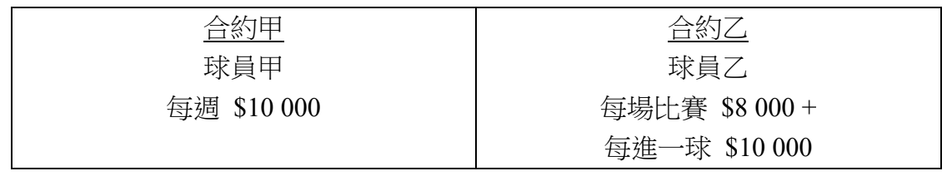
(a) 從僱主的角度，解釋合約乙較合約甲兩項優勝之處。 (4)
(b) 職業足球員通常在三十多歲退休。雖然他們大多在當球員時薪酬可觀，但有些在退休後只能找到低薪工作。以勞工流動性為依據，解釋上述現象。 (3)
_______________________________________________________________________________________
_______________________________________________________________________________________
_______________________________________________________________________________________
_______________________________________________________________________________________
_______________________________________________________________________________________
_______________________________________________________________________________________
_______________________________________________________________________________________
_______________________________________________________________________________________
_______________________________________________________________________________________
Marking Scheme:
(a) Advantage of Contract B over Contract A:
- The owner of the football team can share some business risks with player B as the former would make less payment to the latter when no match is played and/or no goal is scored
- The owner of the football team can have a lower cost of monitoring players’s performance as player would have a higher work incentive in training and in matches
- Any other relevant point (2)

(b) Professional football players have low occupational mobility, (2)
as their skill are very specific and not easily transferable to other jobs. (1)

(a) 合約乙較合約甲優勝之處:
- 足球隊的東主分擔部分商業風險予球員乙，因為當球員乙沒有比賽/沒有進球時，所需支付給球員乙的酬勞較低。
- 足球隊的東主降低檢查球員表現的成本，因為球員乙在訓練和比賽的工作意欲較高。
- 任何其他相關點 (2)
(b) 職業足球員的職業流動性低， (2)
因為他們的技術較專門，並不容易轉移到其他工作去。 (1)

Candidates’ Performance:
(a) Good. A few candidates did not analyse the problem from the perspective of the employer. Others only gave a term or a short phrase as answer without elaboration or application to the question.
(b) Good. A minority of candidates failed to indicate which kind of labour mobility (occupational or geographical) they were talking about.

(a) 良好。部分考生沒有從僱主的角度分析問題。另有考生只寫出一個術語或片語作答，並沒有加以說明或應用在題目的情況𥚃。
(b) 良好。小部分考生未能指出他們所討論的是哪類勞工流動性（職業或是地域）。

2016DSE LQ10b
Solar energy becomes an increasingly important energy source in the sunny western provinces, like Gansu and Xinjiang, in China.
The diagram below shows the market shares of Top 10 solar photovoltaic (PV) module manufacturers in 2012.
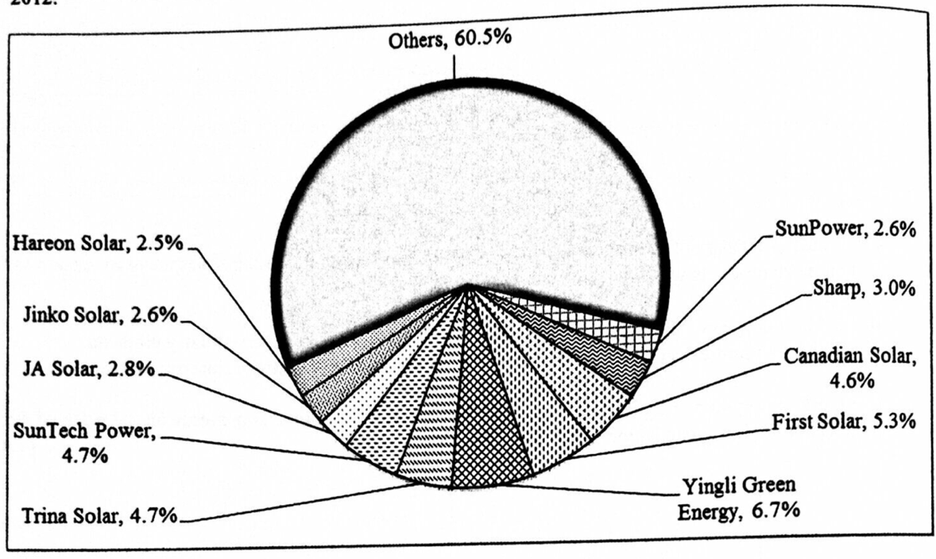
Explain to which type of factors of production the sunshine belongs in the production of solar energy. (2)
在中國西部省份，很多住宅樓宇的屋頂都安裝了太陽能電池板以進行太陽能發電。
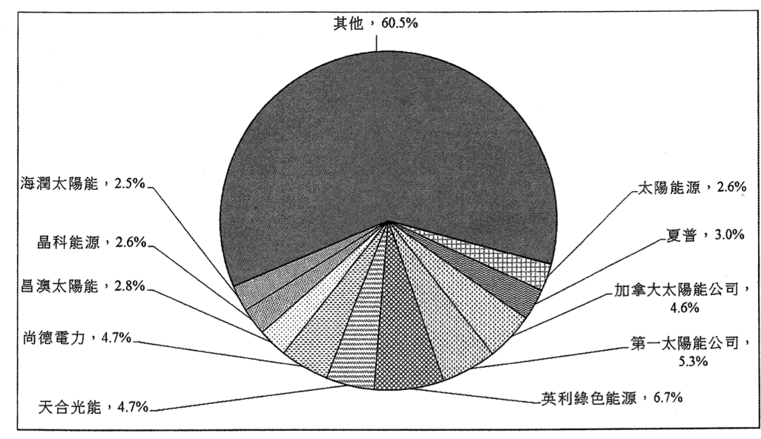
解釋陽光在生產太陽能時屬於哪種生產要素。 (2)
_______________________________________________________________________________________
_______________________________________________________________________________________
_______________________________________________________________________________________
Marking Scheme:
Land. (1)
It is because it as a natural resource which is a gift of nature. (1)
土地。 (1)
因為它是大自然賦予的一種天然資源。 (1)
Candidates’ Performance:
Good. A minority of candidates wrongly regarded sunlight as capital. Some mis-read the question and went on to explain the
type of factor inputs foo producing PV modules or to explain the type of production of the solar energy industry.
良好。少數考生誤將陽光當作資本。一些考生錯誤審題。解釋PV模組生產要素投入的種類，或解釋了太陽能行業的生產類別。

2017DSE LQ2ai, ii
Steven is a restaurant owner. He pays his waiters a monthly salary and allows them to keep the tips from customers. Compared to
time rate, explain why the above arrangement is preferred from the viewpoint of
(a) the employees.
(b) the employer. (4)
史提芬是某餐廳的東主。他以月薪支付其侍應的工資，並容許他們保留顧客給予的小費。以下列角度解釋，為什麼上述安排較以時計薪為佳？
(a) 僱員的角度
(b) 僱主的角度 (4)
_______________________________________________________________________________________
_______________________________________________________________________________________
_______________________________________________________________________________________
_______________________________________________________________________________________
_______________________________________________________________________________________
_______________________________________________________________________________________

2017DSE LQ12a
Before the British people voted against staying in the European Union (EU), i.e. Brexit, workers from the EU were free to work in Britain and vice versa. Brexit has shocked the economies in Europe and the following table shows some views on Brexit:
British politicians:  Low-skilled EU workers should be required to apply for a visa to work in Britain. | British firm owners:  The new visa requirement for EU workers affects most of the firms in the British economy.
Global investors:  Political uncertainty in Britain increases the risk of investment projects there. | EU officials:  British citizens may require a visa to visit or to work in the EU countries.
(c) Referring to the view of the British politicians, explain how labour mobility of the low-skilled workers from the EU would be affected. (3)
在英國人民投票反對留在歐盟（即英國脫歐）之前，來自歐盟的工人可以自由在英國工作，反之亦然。英國脫歐引起歐洲經濟震盪，下表顯示關於英國脫歐的一些看法：
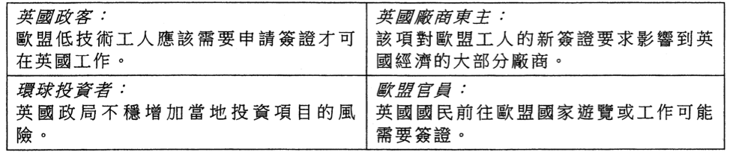
(c) 參考英國政客的看法，解釋來自歐盟的低技術工人的勞工流動性會如何受影響。 (3)
_______________________________________________________________________________________
_______________________________________________________________________________________
_______________________________________________________________________________________
_______________________________________________________________________________________
_______________________________________________________________________________________
_______________________________________________________________________________________
_______________________________________________________________________________________
_______________________________________________________________________________________
_______________________________________________________________________________________
_______________________________________________________________________________________
Marking Scheme:
(a) From the viewpoint of employee: (1)
possibility of getting higher income with more effort/better service (1)

(b) From the viewpoint of employer: (1)
lower monitoring cost for the performance of the waiters/higher work incentive for the waiters (1)

(c) The geographical mobility of the low-skilled workers from the EU would be lower. Because those workers from the EU are less likely to go to work in the UK. (3)

(a) 以僱員的角度： (1)
努力工作 / 提供更好服務，有可能獲取更高收入 (1)

(b) 以僱主的角度： (1)
監察侍應表現的成本下降及 / 或侍應努力工作和提供更好服務的意欲會較強。 (1)

(c) 來自歐盟的低技術工人的地域流動性會下降。因為簽證的要求令來自歐盟的工人到英國工作的成本上升。 (3)

Candidates’ Performance:
(a) Excellent. A few candidates confused the employer and employee perspectives.
(b) Good. Many candidates were able to explain how Brexit would reduce the geographical mobility of low-skilled workers from the EU. A small number of candidates missed the word "geographical", and some candidates failed to accurately write the direction of effect.
(a) 優異 。有少數考生混淆了僱主和僱員的角度。
(b) 良好。很多考生能解釋英國脫歐如何令來自歐盟的低技術工人之地域流動性下降。有小部分考生遺漏了「地域」一詞，亦有部分考生未能準確寫出影響的方向。

2018DSE LQ2b, 10a
(a) Last year, Peter operated a sole proprietorship. Recently he invited Paul and Mary to form a partnership to expand the business to other markets. Mary has invested in the firm but would not take part in its management. To what type of factor of production does Mary belong? Explain your answer. (2)
去年，彼得營運一家獨資經營的廠商。最近他邀請了保羅和瑪莉成立一家合夥公司，把業務拓展至其他市場。瑪莉投資於該廠商，但不會參與其管理。瑪莉屬哪類生產要素？解釋你的答案。 (2)
_______________________________________________________________________________________
_______________________________________________________________________________________
(b) Foreign domestic helpers are paid with a minimum wage at HK$4410 per month for a two-year contractual period in Hong Kong. Explain why foreign domestic helpers are paid by a monthly salary instead of a piece rate. (2)
香港的外籍家庭傭工在兩年合約期間獲支付每月港幣$4410的最低工資。解釋為什麼外籍家庭傭工是按月計薪，而非以件計薪。 (2)
_______________________________________________________________________________________
_______________________________________________________________________________________
Marking Scheme:
(a) Entrepreneurship,
as she bears business risk (2)
(b) The cost of measuring the output of the foreign domestic helpers is too high / the work of domestic helpers is not standardized. (2)
(a) 企業家職能
因為她承擔業務風險。 (2)
(b) 量度外籍家庭傭工產出的成本太高 / 家傭的工作並不標準化。 (2)
Candidates’ Performance:
(a) Satisfactory. Most candidates correctly identified Mary’s role as an entrepreneur. Some candidates wrongly treated Mary as capital because se provided (financial) capital to the company. A small number of candidates tried to provide a reason behind Mary’s role as an entrepreneur as she takes part in making business decisions. This, unfortunately, was contradictory to the information provided in the question.
(b) Excellent
(a) 令人滿意。大部分考生能正確指出屬於企業家職能角色。部分考生錯將瑪莉當作資本，源於她為公司提供（金融）資本。少數考生以瑪莉參與業務決策作為解釋她屬於企業家職能角色的原因，這與題目所提供的資料相矛盾。
(b) 優異。

2019DSE LQ9c, d, 11a
A beauty queen in Hong Kong, Miss Amy Au, is famous for demonstrating the use of cosmetic product with short videos on social media websites. She also sells Japanese cosmetic product on her website.
She plans to hire staff members to operate her website:
Personal assistant  Duties:  Arrange daily schedules and meetings  Salary:  $12 000 per month | Video designer  Duties:  Produce short videos to uploaded in social media  Salary:  $1 000 per video
(a) From the viewpoint of Miss Amy Au, suggest ONE advantage and ONE disadvantage of the payment method of the personal assistant (2)
(b) From the viewpoint of the employee, suggest ONE advantage and ONE disadvantage of the payment method of the video designer (2)
歐愛美小姐是香港選美冠軍。她以在社交媒體展示化妝品的使用示範短片而聞名。她也在自己的網站售賣日本化妝品。
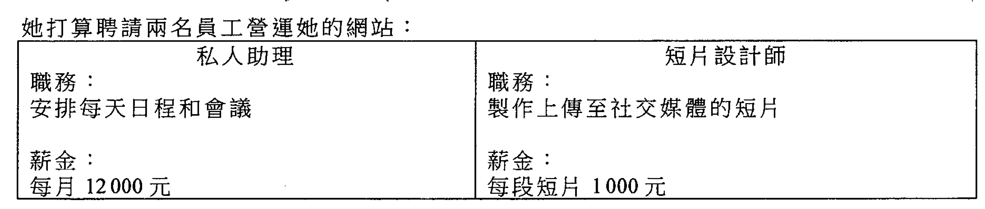
(a) 從歐愛美小姐的角度，舉出該私人助理的支薪方法的一個優點和一個缺點。 (2)
(b) 從僱員的角度，舉出該短片設計師的支薪方法的一個優點和一個缺點。 (2)
_______________________________________________________________________________________
_______________________________________________________________________________________
_______________________________________________________________________________________
_______________________________________________________________________________________
_______________________________________________________________________________________
_______________________________________________________________________________________
_______________________________________________________________________________________
_______________________________________________________________________________________
(c) The Guangzhou-Shenzhen-Hong Kong Express Rail Link (High Spreed Rail) was launched in September 2018. Explain the effect of the launch of High Speed Rail on labour mobility of Hong Kong. (3)
(c) 廣深港高速鐵路 (高鐵) 在2018年9月啟用。解釋高鐵啟用對本港勞工流動性的影響。 (3)
_______________________________________________________________________________________
_______________________________________________________________________________________
_______________________________________________________________________________________
_______________________________________________________________________________________
_______________________________________________________________________________________
_______________________________________________________________________________________
_______________________________________________________________________________________
_______________________________________________________________________________________
_______________________________________________________________________________________
_______________________________________________________________________________________

Marking Scheme:
(a) Advantage:
- Cost of measuring output of the employees can be saved
Disadvantage:
- Work incentive may not be high (1)
(b) Advantage:
- Higher output will yield higher income
Disadvantage:
- Income may be unstable (1)
(c) The launch of HSR will increase the geographical mobility of workers because the transportation network improves. (3)
(a) 優點：可節省計算員工產量的成本。
缺點：工作意欲未必很高。 (1)
(b) 優點：多勞多得。
缺點：收入或欠穩定。 (1)
(c) 高鐵開通會增加勞工的地域流動性，因為交通網絡改善了。 (3)
Candidates’ Performance:
(ab) Good. Overlooking the keywords ‘from the viewpoint of employer/employee’, a minority of candidates came up with inaccurate answers. In discussing the low cost of supervision under piece-rate contracts, candidates should make it clear whether they are referring to the cost of monitoring (the quality of) output or monitoring workers’ effort.
(c) Excellent
(ab) 良好。小部份考生因忽略了重要字句「從僱主 / 僱員的角度」，故其答案並不準確。在討論件工合約監察成本較低時，考生須清楚指出，他們是指監察產出（質素）的成本，還是監察勞工的付出。
(c) 優異。

Marking Scheme:
Type 1 (Classification of factor of production)
1 | D | 2 | D | 3 | B | 4 | D | 5 | B | 6 | B | 7 | B | 8 | A | 9 | A | 10 | C
11 | D | 12 | B | 13 | D | 14 | D | 15 | A | 16 | A | 17 | B | 18 | B | 19 | B | 20 | D
21 | D | 22 | B | 23 | D | 24 | C | 25 | A | 26 | C | 27 | A | 28 | B | 29 | B | 30 | B
31 | A | 32 | D | 33 | D | 34 | D | 35 | B | 36 | B | 37 | D | 38 | B | 39 | C | 40 | C
41 | A | 42 | B | 43 | A
Type 2 (More about labour – Labour supply and labour productivity)
1 | D | 2 | C | 3 | D | 4 | C | 5 | A | 6 | C | 7 | A | 8 | C | 9 | B | 10 | B
11 | A | 12 | B | 13 | C | 14 | A | 15 | D | 16 | B | 17 | A | 18 | A | 19 | C | 20 | D
21 | C | 22 | C | 23 | B | 24 | C | 25 | D | 26 | B | 27 | A | 28 | B | 29 | A | 30 | C
31 | B | 32 | B | 33 | C | 34 | C | 35 | D | 36 | C | 37 | A | 38 | D | 39 | B | 40 | B
41 | D | 42 | B
Type 3 (More about labour – Wage payment)
1 | D | 2 | D | 3 | A | 4 | A | 5 | D | 6 | B | 7 | D | 8 | D | 9 | A | 10 | B
11 | A | 12 | D | 13 | A | 14 | D | 15 | D | 16 | B | 17 | A | 18 | D | 19 | A | 20 | D
21 | B | 22 | B | 23 | C | 24 | A | 25 | D | 26 | C | 27 | A | 28 | C | 29 | A
Type 4 (More about labour - Occupational mobility and Geographical mobility)
1 | C | 2 | B | 3 | C | 4 | C | 5 | C | 6 | C | 7 | D | 8 | D | 9 | C | 10 | C
11 | B | 12 | D | 13 | D | 14 | B | 15 | D | 16 | D | 17 | B | 18 | A | 19 | B | 20 | B

