Learning Focus:
Memo
(LQ Answering Flow, MC skills, your goals and resolutions…)
Specific Question Type
MC

咩話？DSE Sample Paper, Practice Paper, 2012, 2013, 2014, 2015, 2016, 2017, 2018, 2019, 2020, 2021, 2022 MC全部拍晒解題片？係呀，有唔明即scan即睇！就係咁firm！


Learning Focus:
Memo
(LQ Answering Flow, MC skills, your goals and resolutions…)
Specific Question Type
LQ

咩話？DSE Sample Paper, Practice Paper, 2012, 2013, 2014, 2015, 2016, 2017, 2018, 2019, 2020, 2021, 2022 LQ全部拍晒解題片？係呀，有唔明即scan即睇！就係咁firm！


Chapter 13 _ National Income Accounting
Type 1 (Whether included in GDP or not)
Example Question 1 CE1990MCQ49
The following were received by Mr. A last year:
(1) wages of $10000
(2) public assistance of $1000
(3) $100 interest from his saving account
(4) a Mark Six prize of $8000
His contribution to the GDP last year was
A. $10000 B. $10100 C. $11100 D. $19100

下例是甲先生上年度所獲得的收入：
- 工資$10000
- 公共援助金$1000
- 儲畜戶口存款利息$100
- 六合彩奬金$8000
某甲去年對本地生產總值的貢獻為
A. $10000 B. $10100 C. $11100 D. $19100

Example Question 2 CE1991MCQ44
Which of the following is included when calculating Hong Kong’s gross domestic product (GDP) by the expenditure approach?
A. the compensation paid to Kowloon Walled City residents B. the expenditure incurred on buying a second-hand car
C. the revenue earned from toys sold to Americans D. the revenue received by the government from taxation

用「支出計算法」計算香港的本地生產總值時，以下哪一項會被包括在內？
A. 九龍城寨居民獲得的賠償 B. 購買二手車的支出
C. 售賣玩具給美國人賺取的收益 D. 政府稅收收益

Example Question 3 CE1992MCQ45
Which of the following amounts should be included in the measurement of GDP?
A. Mr Chan sells his house, built two yeas ago, for $2000000 B. Mr Chan buys shares worth $150000
C. Mr Chan wins a Mark Six prize of $100000 D. Mr Chan receives a monthly salary of $35000

以下哪一筆款項應被包括在本地生產總值的計算內？
A. 陳先生售出他的一所兩年前建成的房子獲得$2000000 B. 陳先生購入股票價值$150000
C. 陳先生買六合彩中奬獲得$1000000 D. 陳先生每月薪金$35000

***Example Question 4 CE1992MCQ58
The expenditure by the Hong Kong government on Vietnamese boat people _____ included in Hong Kong's GDP because _____.
A. should be; goods and services are produced in Hong Kong
B. should be; part of the expenditure will be paid back by the United Nations
C. should not be; goods and services are spent on foreign
D. should not be; Vietnamese boat people do not produce goods and services

香港政府為了越南船民而支付費用______被包括在香港的本地生產總值之內，因為______。
A. 應該；有貨物及服務在本港生產 B. 應該；部分支出會由聯合國償還
C. 不應；貨物及服務花費在外國人身上 D. 不應；越南船民並不生產貨物及服務

Example Question 5 CE1993MCQ35
Which of the following is included in the measurement of Hong Kong's GDP?
A. medical benefits of civil servants B. student travel subsidy
C. dividends gained from overseas investments D. money won from betting in a horse race

以下哪一項包括在香港的本地生產總值的計算之內？
A. 公務員的醫療福利 B. 學生交通津貼
C. 海外投資所賺獲的股息 D. 從賽馬博彩中贏取的奬金

Example Question 6 CE1994MCQ32
Which of the following items should be included in Hong Kong’s GDP for the current year?
A. An investor buys shares on the local stock exchange
B. A British citizen receives a salary for teaching English in a school in Hong Kong
C. A students sells some used textbooks to his friend
D. A manufacturer sells last year’s unsold stocks

下列哪一項應被包括在香港當年的本地生產總值內？
A. 一投資者在本港股票交易所購買股票 B. 一英國人在本港一所學校教授英語而收取的薪金
C. 一學生將一些舊教科書出售予他的朋友 D. 一製造商賣出去年的存貨

Example Question 7 CE1996MCQ27
Which of the following items is included in the calculation of Hong Kong’s GDP?
A. The government grant received by a university student
B. The salary received by a civil servant who is a foreigner working in Hong Kong
C. Interest to a loan paid by a firm in Hong Kong to a bank in Japan
D. Loans repayment made by the Hong Kong government to the Hong Kong Bank

下列哪一項被計算入香港本地生產總值之內？
A. 某大學生得到的政府津貼 B. 某外國人在香港任職公務員得到的薪金
C. 香港某廠商向日本某銀行借款所付出的利息 D. 香港政府向匯豐銀行償還的債款

Example Question 8 CE1997MCQ24
The following shows some assets of a farm.
Which should be included in the calculation of investment expenditure of the GDP of this year?
A. the expenditure on the ploughing of 10 acres of new farmland in spring this year
B. the value of 10 tones of wheat stocked up since last year
C. the settlements of a $10000 debt incurred as a result of repairing machines last year
D. recent expenditure on acquiring 10000 units of government bonds in order to earn an annual interest of $55000

下列顯示某農場部分資產。在計算香港本地生產總值時，哪一項應被包括在投資支出之內？
A. 今年春季開墾10畝耕地的開支
B. 由去年積存至今的10噸小麥的價值
C. 償還去年因維修機器而借入的$10000
D. 最近為取年息$55000而購入政府年初發行10000單位的債券所花費的一筆開支

Example Question 9 CE1997MCQ60
Which of the following items is NOT included in the calculation of GDP?
A. government spending of $300 million on the employee retraining programme
B. unemploymentbenefitsof$20millionpaidbythegovernment
C. commission paid by a successful job searcher to an employment agency for job referral services
D. salaries paid to the two extra posts created in the Labour Department to help job searchers

下列哪一項並不包括入本地生產總值的計算之內？
A. 政府花費在僱員再培訓計劃的3億元 B. 政府支付的 2千萬元失業救濟金
C. 一名成功求職者對替他介紹工作的職業介紹所支付的佣金 D. 勞工處為幫助求職者增加的兩名新官員的薪金

Example Question 10 CE1998MCQ26
Which of the following would be considered as part of the national income?
A. commissions received by salesmen selling second-hand cars
B. a gift cheque to a bride for an invitation to her wedding banquet
C. insurance compensation to injured workers
D. scholarships to students with good results in schools

下列哪一項被視為國民收入的一部分？
A. 經紀賣出二手車所賺獲的佣金 B. 被邀往婚宴送贈新娘的禮券
C. 受傷工人保險賠償金 D. 成績優秀學生的獎學金

Example Question 11 CE1998MCQ51
Transfer payments are not included in national income because
A. they are included in the gross national income but not the net national income
B. they are already included in the incomes of households
C. they are not returns for the production of goods and services
D. they are not taxed by the government

轉移支付不是計算入國民收入之內，因為
A. 它計算在國民總收入之中，卻不在國民收入淨值之內 B. 它已經計算在家庭收入之內
C. 它們不是生產貨物及服務的回報 D. 政府沒有對它徵稅

Example Question 12 CE1999MCQ31
Which of the following $1 million amounts is included in the calculation of Hong Kong’s GDP?
A. A famous singer holds a charity performance in Hong Kong and donates all the proceeds of $1 million to the floods victims in Mainland China
B. A father transfers $1 million worth of company shares to his daughter
C. A victim in a traffic accident receives a sum of $1 million from the government as compensation for injury
D. An investor earns a capital gain of $1 million from the sale of his flat

下列哪一項100萬元的款項應該算入香港本地生產總值之內？
A. 某著名歌星在香港舉辦一項慈善表演，將全部100萬元的收益捐贈予中國內地水災災民
B. 某父親將價值 100 萬元的公司股份轉名給他的女兒
C. 交通意外受害者從政府手中獲取 100 萬元的賠償
D. 投資者售樓賺得100 萬元的資本增值

Example Question 13 CE2000MCQ33
Which of the following is included in the calculation of the gross domestic product (GDP) of Hong Kong?
A. the estimated rental value of an owner-occupied property in Hong Kong
B. the low-interest government loans to university students in Hong Kong
C. the interest paid to foreign investors holding Exchange Fund bills
D. the increase in the price of the shares issued by a bank in Hong Kong

下列哪一項包括入香港本地生產總值的計算之內？
A. 香港某業主自住樓宇的估計租值 B. 政府借予香港的大學生的低息貸款
C. 支付予外國投資者所持有者外匯基金票據的利息 D. 香港某銀行所發行股票價格的資本增值

***Example Question 14 CE2001MCQ50
Which of the following should NOT be included in the calculation of Hong Kong’s GDP?
A. the loans made by a local bank to its customers B. the tips received by a bellboy in a local hotel
C. the 10% service surcharge collected by a local restaurant D. the income earned by a local hawker

下列哪一項不應被計算入香港的本地生產總值之內？
A. 本地一家銀行借予客戶的貸款 B. 本地一家酒店行李員所獲得的小帳
C. 本地一家酒樓所收取的加一服務費 D. 本地一家小販所賺取的收入

Example Question 15 CE2002MCQ49
Which of the following items should NOT be included in the calculation of Hong Kong’s GDP ?
A. Profit gained by a car agent from reselling second-hand cars
B. Compensation paid to a car owner for his loss in a traffic accident
C. Insurance premium for a car paid to a local insurance company
D. Income earned by a person from repairing cars

下列哪一項不應計算入香港的本地生產總值之內？
A. 一家汽車代理轉售二手車所獲賺取的利潤 B. 對一位交通意外蒙受損失的車主所作的賠償
C. 向一家本地保險公司繳付的汽車保險費 D. 某人從維修汽車所賺取的收入

Example Question 16 CE2004MCQ26
Which of the following should be included in the calculation of the GDP of Hong Kong?
A. the money received from the ‘We Care Education Fund’ by children who lost their parents to SARS
B. the money received by a local property agent for his service in the resale of flats
C. the money received by a local student from selling his used reference books to his schoolmates
D. the money received by a local limited company from issuing new bonds in the market

在計算香港本地生產總值時，下列哪一項應包括在內？
A. 因「沙士」喪失父母的兒童從「護幼基金」所獲得的款項 B. 本地某物業代理因提供樓宇轉售服務所獲得的款項
C. 本地某學生將自己用過的參考書賣給同學所獲得的款項 D. 本地某有限公司在市場發行新債券所獲得的款項

Example Question 17 CE2005MCQ26
Which of the following items is included in the calculations of the gross domestic product of Hong Kong?
A. the salary received by an American who works for a local television station as a reporter
B. the money received by a local student from selling his mobile phone to his classmate
C. the cash award won by a local citizen in a game show organized by a local television station
D. the insurance compensation received by a local construction worker for his injury

下列哪一項被計算入香港的本地生產總值之內？
A. 一個美國人在本港某電視台任職記者所收取的薪金 B. 一個本地學生將手提電話出售予他的同學所獲得的金錢
C. 一個香港市民在本地電視台遊戲節目中嬴取的獎金 D. 一個本地建築工人受傷後所獲得的保險賠償金

Example Question 18 CE2007MCQ27
Which of the following would be included in the GDP for 2005?
A. money deposited in a savings account during 2005 B. the purchase price of an antique in 2005
C. public assistance paid to individuals during 2005 D. the value of wheat produced but unsold in 2005

下列哪一項被包括入2005 年本地生產總值之內？
A. 在2005 年存入儲蓄戶口的金錢 B. 某古董在2005年的購入價
C. 在2005 年支付予個別人士的公共援助金 D. 在2005年生產但未售出的小麥價值

Example Question 19 CE2011MCQ29
Which of the following amounts of money should be included in Hong Kong’s GDP?
A. a Hong Kong resident’s Renminbi saving deposit in Hong Kong
B. The rental income earned by a Hong Kong resident from his property in Beijing
C. The donations of an overseas tourist in Hong Kong
D. The salary earned by a Japanese who is working for a local airline in Hong Kong

下列哪筆款項應包括入香港的本地生產總值之內？
A. 一位香港居民在本港的人民幣儲蓄存款 B. 一位香港居民在北京的物業所賺取的租金收入
C. 一位外國遊客在香港捐出的款項 D. 一位日本人在香港一家本地航空公司工作所賺取的薪金

Example Question 20 DSE2015MCQ24
Which of the following would be included in the calculation of Hong Kong’s GDP for 2014?
A. The old age allowance paid by the government in 2014
B. The market value of a flat built in 2013 but sold in 2014
C. The salary of a salesperson working in a shop selling second-hand handbags in 2014
D. The rental income from a property in Canada owned by a Hong Kong resident producing unit in 2014

下列哪項會包括在2014年香港本地生產總值的計算之內？
A. 2014年政府支付的長者生活津貼
B. 2013年建成但在2014年售出的樓宇的市場價值
C. 2014年一名在二手手袋店工作的售貨員的薪金
D. 2014年香港本地常駐生產單位所擁有的加拿大物業的租金收入

Example Question 21 DSE2018MCQ24
Which of the following are included in the calculation of the gross domestic product of Hong Kong?
(1) The estimated rental value of an owner-occupied property in Hong Kong
(2) The commission received by a real estate agent from selling second-hand property
(3) The scholarship received by a university student
A. (1) and (2) only B. (1) and (3) only C. (2) and (3) only D. (1), (2) and (3)

下列哪些會包括在本地生產總值的計算之內？
(1) 本港自住物業的估算租金價值
(2) 某地產經紀賣出二手物業所收取的佣金
(3) 某大學生收取的獎學金
A. 只有(1)、(2) B. 只有(1)、(3) C. 只有(2)、(3) D. 只有(1)、(2)、(3)

Type 2 (Circular Flow Model)
Example Question 1 CE1990MCQ35
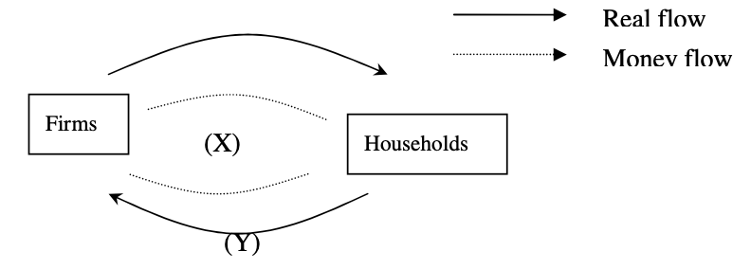
X and Y in the above circular flow of economic activities should be labeled respectively as
A. sales revenue, factor services. B. sales revenue, goods and services.
C. factor income, goods and services. D. factor income, factor services.

Example Question 2 CE1991MCQ47
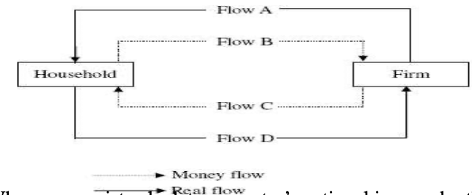
When economist calculate a country’s national income by the income approach, they measure _____ in the above chart.
A. Flow A B. Flow B C. Flow C D. Flow D

Example Question 3 CE1993MCQ37
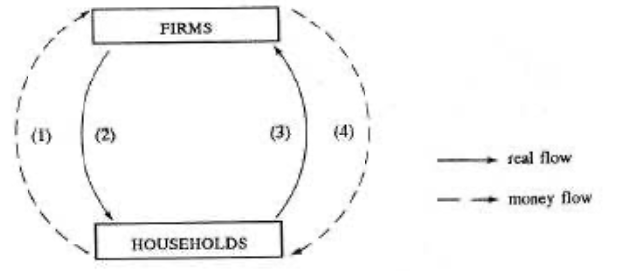
The diagram above shows the circular flow of economic activities. The economy’s expenditure and income are show in Flow _______ and Flow _______ respectively.
A. (1);(2) B. (1);(4) C. (2);(3) D. (3);(4)

Example Question 4 CE1994MCQ31
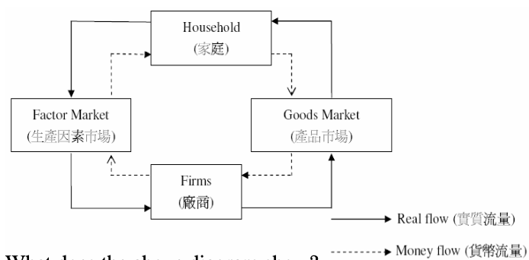
What does the above diagram show?
A. Economic activities take place in an open economy. B. There is government intervention in the economy.
C. National income equals national expenditure. D. Households conduct transactions in the goods market only.

Example Question 5 CE2002MCQ24
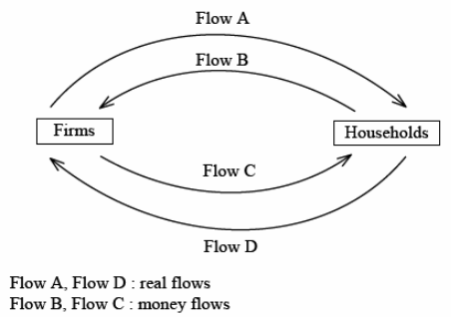
Refer to the above circular flows. Which of the following statements is correct?
A. Flows A and D are flows of households’ expenditure and firms’ payment to factor owners respectively.
B. All value-added totals contributed by the firms equal the market value of all final goods and services.
C. The market value of Flow B equals the market value of all final goods and services plus the market value of unsold goods.
D. The flow of final goods and services includes self-provided services.

Example Question 6 CE2003MCQ25
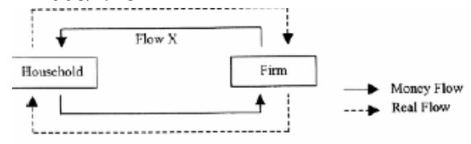
Which of the following is included in Flow X?
A. household expenditure on final goods and services B. factor income such as rent and wages
C. value of intermediate goods D. market value of all final goods and services.

Example Question 7 CE2009MCQ26
Refer to the following circular flow of Economy A:
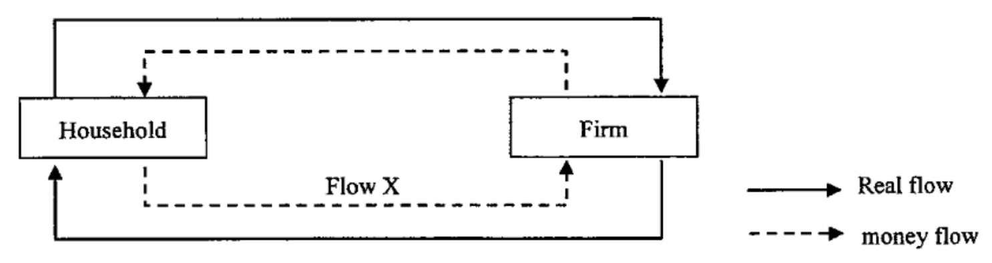
Flow X represents
A. the total expenditures on all final goods and services.
B. the total income earned by households from their factors services.
C. the total value of factor services provided by households to firms.
D. the total market value of all intermediate and final goods and services.

Type 3 (Expenditure Approach)
***Example Question 1
Answer the following questions by referring to the table below.
Items | $ billion
Private consumption expenditure | 220
Government consumption expenditure | X
Gross domestic fixed capital formation | 370
Net domestic fixed capital formation | Y
Changes in inventories | 80
Depreciation | 50
Net exports | 90
Indirect taxes | 40
Direct taxes | 60
Subsidies | 10
成分 | 百萬元
私人消費開支 | 220
政府消費開支 | X
本地固定資本形成總額 | 370
本地固定資本形成淨值 | Y
存貨增減 | 80
折舊 | 50
淨出口 | 90
間接稅 | 40
直接稅 | 60
津貼 | 10

What is the value of Y? Y 的值是多少？
A. 290 B. 310 C. 320 D. 420

***Example Question 2
If the GDP at factor cost is $1,090 billion, the value of X is. 如果按要素成本計算的GDP為10,900億元，則X的值為
A. 360 B. 380 C. 400 D. 420

***Example Question 3 CE1990MCQ33***
A Hong Kong citizen switches his flight from a local airline to Japan Airlines. What is the effect on Hong Kong‘s Gross Domestic Product (GDP)?
A. an increase in imports B.a decrease in exports C. a decrease in consumption D. an increase in investment

一名本港市民取消乘搭本港航空公司而轉成日本航空公司班機。此舉對香港本地生產總值有什麼影響？
A. 入口增加 B. 出口減少 C. 消費減少 D. 投資增加

Example Question 4 CE1993MCQ39
Answer the following question referring to the following data of an economy in a certain year:
Components | Million
Private consumption expenditure | 40
Government consumption expenditure | 10
Gross domestic fixed capital formation | 10
Change in stocks | 1
Total exports of goods | 80
Domestic exports | 70
Re-exports | 10
Imports of goods | 60
Export of services | 20
Imports of services | 30
Inflow of capital | 30
Outflow of capital | 15
成分 | 百萬元
私人消費開支 | 40
政府消費開支 | 10
本地固定資本形成總額 | 10
存貨增減 | 1
貨物出口總額 | 80
本地產品出口 | 70
轉口 | 10
貨物入口 | 60
服務出口 | 20
服務入口 | 30
流入的資金 | 30
流出的資金 | 15
The GDP of the economy in that year is
A. $61 million B. $70 million C. $71 million D. 81 million

該經濟當年的本地生產總值為
A. 61百萬元 B. 70 百萬元 C. 71 百萬元 D. 81 百萬元

成分 | 百萬元
私人消費開支 | 500
政府消費開支 | 100
本地固定資本形成淨值 | 250
存貨增減 | 30
貨物出口總額 | 800
貨物轉口 | 200
貨物進口 | 900
服務出口 | 300
服務進口 | 150
折舊 | 60
Example Question 5 CE2001MCQ28
The following table shows the gross domestic product (GDP) data of a country.
Components | Million
Private consumption expenditure | 500
Government consumption expenditure | 100
Net domestic fixed capital formation | 250
Change in inventories | 30
Total exports of goods | 800
Re-exports of goods | 200
Import of goods | 900
Exports of services | 300
Imports of services | 150
Depreciation | 60

The GDP at market price is 以市價計算的本地生產總值為
A. $900 million B. $930 million C. $990 million D. 1190 million
Example Question 6 CE2003MCQ26
成分 | 百萬元
私人消費支出 | 400
政府消費支出 | 100
本地固定資本形成總額 | 200
存貨減少 | 20
本地貨物出口 | 330
貨物轉口 | 170
貨物進口 | 550
服務出口 | 400
服務進口 | 350
折舊 | 60
The following table shows the GDP data of a country in a certain year:
Components | $ Million
Private consumption expenditure | 400
Government consumption expenditure | 100
Gross domestic fixed capital formation | 200
Reduction in inventories | 20
Domestic exports of goods | 330
Re-exports of goods | 170
Import of goods | 550
Exports of services | 400
Import of services | 350
Depreciation | 60
The GDP at market price is
A. $620 million B. $660 million C. $680 million D. 720 million

以市價計算的本地生產總值為
- 620 百萬元 B. 660 百萬元 C. 680 百萬元 D. 720 百萬元

成分 | 百萬元
本地生產總值 | 640
出口貨物淨值 | 200
折舊 | 50
間接商業稅 | 10
***Example Question 7 CE2004MCQ30
Components | $million
GDP | 640
Net exports of goods | 200
Depreciation | 50
Indirect Business Taxes | 10
Refer to the above GDP data of a country in a certain year. Its net domestic product (in $ million) is:
A. 440 B. 590 C. 630 D. 650

參照上表某國某年的本地生產總值資料，它的本地生產淨值（以百萬元為單位）是：
A. 440 B. 590 C. 630 D. 650

Example Question 8 CE2005MCQ27
The following table shows the statistical of an economy in a certain year.
Components | Million
Private consumption expenditure | 50 000
Government consumption expenditure | 8 000
Gross domestic fixed capital formation | 7 000
Decrease in inventory | 3 000
Total export | 30 000
Total import | 45 000
Indirect taxes | 50
Depreciation allowance | 4 200
成分 | 百萬元
私人消費支出 | 50 000
政府消費支出 | 8 000
本地固定資本形成總額 | 7 000
存貨減少 | 3 000
出口總值 | 30 000
進口總值 | 45 000
間接稅 | 50
折舊 | 4 200
The GDP at market price (in million dollars) is
A. 42 850 B. 47 000 C. 50 000 D.51 150

以市價計算的本地生產總值（以百萬元計算）為
A. 42 850 B. 47 000 C. 50 000 D. 51 150

Example Question 9 CE2008MCQ26
The following table shows the national income statistics of an economy:
Components | Million
Private consumption expenditure | 800
Government consumption expenditure | 250
Gross domestic fixed capital formation | 600
Decrease in inventories | 50
Total export of goods | 1 700
Total import of goods | 450
Export of services | 850
Import of services | 550
成分 | 百萬元
私人消費支出 | 800
政府消費支出 | 250
本地固定資本形成總額 | 600
存貨減少 | 50
貨物出口總額 | 1 700
貨物進口總額 | 450
服務出口 | 850
服務進口 | 550
The GDP at market price is $________ million.
A. 3100 B. 3150 C. 3200 D.3250

以市價計算的本地生產總值是_____百萬元。
A. 3100 B. 3150 C. 3200 D.3250

Example Question 10 CE2006MCQ28
The following table shows the statistical data of an economy.
Components | Million
Private consumption expenditure | 200
Government consumption expenditure | 150
Net domestic fixed capital formation | 300
Decrease in stock | 70
Subsidies | 120
Depreciation | 50
Net exports | 300
Net income from abroad | 80
Direct tax | 100
成分 | 百萬元
私人消費開支 | 200
政府消費開支 | 150
本地固定資本形成淨額 | 300
存貨減少 | 70
津貼 | 120
折舊 | 50
淨出口 | 300
海外收入淨值 | 80
直接稅 | 100
The GDP at factor cost (in $mn) is
A. 950 B. 970 C. 1050 D. 1190

以要素計算的本地生產總值是_____百萬元。
A. 950 B. 970 C. 1050 D. 1190

成分 | 百萬元
私人消費支出 | 600
本地固定資本形成淨額 | 250
存貨增加 | 70
政府消費支出 | 450
折舊 | 30
出口貨物及服務總值 | 500
進口貨物及服務總值 | 140
貨物轉口值 | 100
Example Question 11 CE2009MCQ28
The following table shows the statistical data on an economy.
Components | Million
Private consumption expenditure | 600
Net domestic fixed capital formation | 250
Increase in stock | 70
Government consumption expenditure | 450
Depreciation | 30
Total exports of goods and services | 500
Total imports of goods and services | 140
Re-exports of goods | 100
The GDP at market price is _______ million.
A. 1 690 B. 1 730 C. 1 760 D. 1 830

以市價計算的本地生產總值是_____百萬元。
A. 1 690 B. 1 730 C. 1 760 D. 1 830

Example Question 12 CE2010MCQ26, 27
本地生產總值項目 | 十億元
私人消費支出 | 100
本地固定資本形成總額 | 200
存貨變動 | -50
折舊 | 10
政府消費支出 | 150
轉移支付 | 20
間接稅 | 100
津貼 | 40
貨物及服務淨出口 | -15
Study the following table and answer questions below.
GDP items | Billion
Private consumption expenditure | 100
Gross domestic fixed capital formation | 200
Change in inventories | -50
Depreciation | 10
Government consumption expenditure | 150
Transfer payments | 20
Indirect taxes | 100
Subsidies | 40
Net exports of goods and services | -15
The GDP at market price is $_________ billion.
A. 375 B. 385 C. 395 D. 445
The GDP at factor cost is $_________ billion.
A. 315 B. 325 C. 375 D. 445

以市價計算的本地生產總值是_____十億元。
A. 375 B. 385 C. 395 D. 445
以要素成本計算的本地生產總值是_____十億元。
A. 315 B. 325 C. 375 D. 445

Example Question 13 CE2011MCQ27
Answer the following question by referring to the following statistical data on an economy.
Components | Million |  | 成分 | 百萬元
Private consumption expenditure | 600 |  | 私人消費支出 | 600
Gross domestic fixed capital formation | 300 |  | 本地固定資本形成總值 | 300
Decrease in stock | 40 |  | 存貨減少 | 40
Government consumption expenditure | 550 |  | 政府消費支出 | 550
Depreciation | 30 |  | 折舊 | 30
Total export of goods | 85 |  | 出口貨物總值 | 85
Total export of services | 115 |  | 出口服務總值 | 115
Total import of goods | 110 |  | 進口貨物總值 | 110
Total import of services | 50 |  | 進口服務總值 | 50
Re-export of goods | 15 |  | 貨物轉口值 | 15
The GDP at market price is $__________million. 以市價計算的本地生產總值是_____百萬元。
A. 1 420 B. 1 435 C. 1 450 D. 1 465
Example Question 14 DSEPPMCQ20
The following table shows the statistical data of an economy.
Components | Million |  | 本地生產總值成分 | 百萬元
Private consumption expenditure | 400 |  | 私人消費支出 | 400
Government consumption expenditure | 250 |  | 政府消費支出 | 250
Net domestic fixed capital formation | 300 |  | 本地固定資本形成淨額 | 300
Decrease in stock | 70 |  | 存貨下跌 | 70
Subsidies | 120 |  | 補貼 | 120
Capital consumption allowance | 50 |  | 資本消耗額 | 50
Net exports | 300 |  | 淨出口 | 300
Net income from abroad | 80 |  | 海外收入淨值 | 80
DFirect tax | 100 |  | 直接稅 | 100
The GDP at factor cost is $___________ million.
A. 1 250 B. 1 270 C. 1 350 D. 1 490

以要素成本計算的本地生產總值是_____百萬元。
A. 1 250 B. 1 270 C. 1 350 D. 1 490

***Example Question 15 DSE2012MCQ22
Refer to the following table.
Components | Million |  | 本地生產總值成分 | 百萬元
Private consumption expenditure | 200 |  | 私人消費支出 | 200
Net domestic fixed capital formation | 40 |  | 本地固定資本形成淨值 | 40
Increase in inventory | X |  | 存貨增加 | X
Government consumption expenditure | 24 |  | 政府消費支出 | 24
Net exports | 10 |  | 淨出口 | 10
Indirect taxes | 60 |  | 間接稅 | 60
Subsidies | 30 |  | 補貼 | 30
Depreciation | 40 |  | 折舊 | 40
Net factor income from abroad | 16 |  | 國外要素收益淨值 | 16
If the GDP at factor cost is $264 million, the value of X is _______.
A. -50 B. -20 C. 20 D. 50

若按要素成本計算的本地生產總值是264百萬元，X的值是______。
A. -50 B. -20 C. 20 D. 50

Example Question 16 DSE2013MCQ22
Consider the following Gross Domestic Product (GDP) data about an economy.

Components | Million |  | 成分 | 百萬元
GDP at market price | 200 |  | 以市價計算的本地生產總值 | 200
Private consumption expenditure | 120 |  | 私人消費支出 | 120
Gross domestic fixed capital formation | 40 |  | 本地固定資本形成總額 | 40
Changes in inventories | 10 |  | 存貨改變 | 10
Total export of goods | 80 |  | 物品出口總值 | 80
Domestic export of goods | 70 |  | 本地物品出口 | 70
Imports of goods | 60 |  | 物品進口 | 60
Exports of services | 20 |  | 服務出口 | 20
Import of services | 30 |  | 服務進口 | 30
Net income from abroad | 25 |  | 海外收入淨值 | 25
Depreciation | 35 |  | 折舊 | 35
Indirect business tax | 28 |  | 間接商業稅 | 28
Subsidies | 18 |  | 津貼 | 18
The government consumption expenditure for that year is $ _________ million.
A. 20 B. 30 C. 40 D. 50

該年的政府消費支出是_____百萬元。
A. 20 B. 30 C. 40 D. 50

Example Question 17 DSE2016MCQ23
Consider the following Gross Domestic Product (GDP) data about a country:
Components | Million |  | GDP組成部分 | 百萬元
Private consumption expenditure | 380 |  | 私人消費支出 | 380
Government consumption expenditure | 450 |  | 政府消費支出 | 450
Gross domestic fixed capital formation | 230 |  | 本地固定資本形成總額 | 230
Decrease in stock | 50 |  | 存貨減少 | 50
Subsidies | 30 |  | 補貼 | 30
Depreciation | 40 |  | 折舊 | 40
Total exports | 130 |  | 總出口 | 130
Total imports | 170 |  | 總進口 | 170
Direct taxes | 30 |  | 直接稅 | 30
The GDP at factor cost is $_______ million. 以要素成本計算的本地生產總值_____百萬元。
A. 960 B. 970 C. 1 000 D. 1 100
Example Question 18 DSE2018MCQ25
The following table shows the gross domestic product (GDP) data of an economy in a particular year:
GDP components | $ billion
Capital consumption allowance | 40
Net factor income from abroad | 36
Production subsidies | 14
Direct taxes | 5
Indirect taxes | 47
Which of the following statements about the economy are correct?
- The GDP is smaller than the gross national income (GNI)
- The GDP at market price is smaller than the GDP at factor cost
- Depreciation is positive in the economy
A. (1) and (2) only B. (1) and (3) only C. (2) and (3) only D. (1), (2) and (3)

下表顯示某經濟某一年本地生產總值的資料：
本地生產總值的組成 | 十億元
資本消耗額 | 40
外地要素收入淨額 | 36
生產補貼 | 14
直接稅 | 5
間接稅 | 47

下列哪些有關該經濟的陳述是正確的？
(1) 本地生產總值低於國民總收入
(2) 以市價計算的本地生產總值低於以要素成本計算的本地生產總值
(3) 該經濟折舊的數值大於零
A. 只有 (1)、(2) B. 只有 (1)、(3) C. 只有 (2)、(3) D. (1), (2) 及(3)

Type 4 (Production Approach / Value-added Approach)
Example Question 1 CE2000MCQ35
The following diagram shows a production chain involving the import of $100 worth of gasoline into Hong Kong:
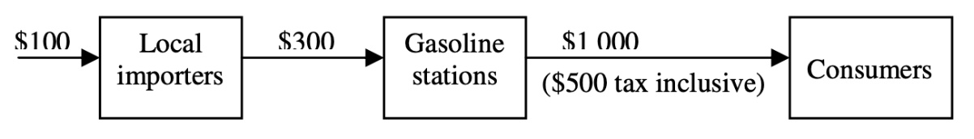
What is the contribution of the production chain to Hong Kong ‘s GDP at factor cost?
A. $400 B. $500 C. $900 D. $1000

下圖顯示一條生產鏈，開始時進口香港的汽油價值$100。
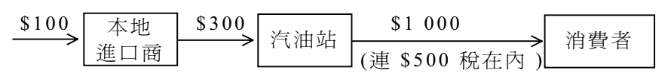
該生產鏈對以生產因素成本計算的香港本地生產總值的貢獻是
A. $400 B. $500 C. $900 D. $1000

Example Question 2 CE2003MCQ27
The following diagram shows the production of a garment factory in Economy A. The factory imports $20000 worth of raw materials.
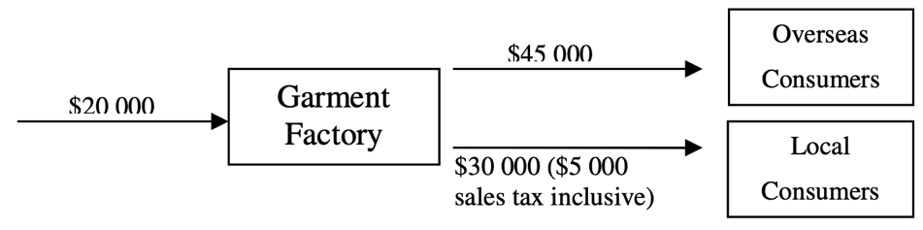
What is the contribution of the garment factory to Economy A's GDP at factor cost?
A. $10000 B. $50000 C. $55000 D. $75000

下圖顯示甲經濟中某製衣廠的生產。該廠進口價值$20000的原料。
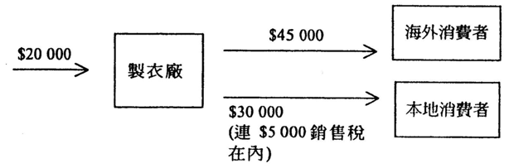
該製衣廠對甲經濟以要素成本計算的本地生產總值有何貢獻？
A. $10000 B. $50000 C. $55000 D. $75000

Example Question 3 CE2004MCQ27
The following diagram shows a production process of an economy.
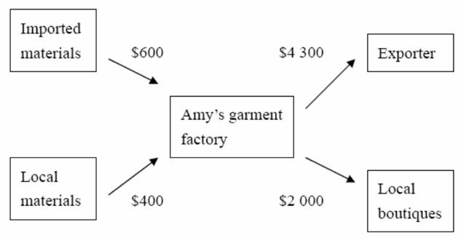
What is the contribution of Amy’s garment factory to the national income of the economy?
A. $1600 B. $3700 C. $5300 D. $5900

下表顯示某經濟的一個生產過程。
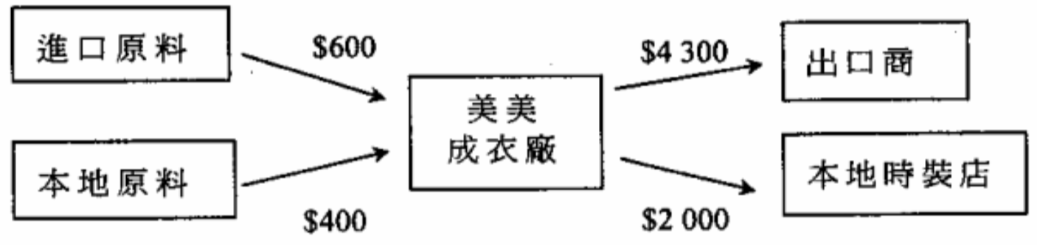
美美成衣廠對該經濟國民收入的貢獻是
A. $1600 B. $3700 C. $5300 D. $5900

Example Question 4 CE2005MCQ28
A production chain is shown below.
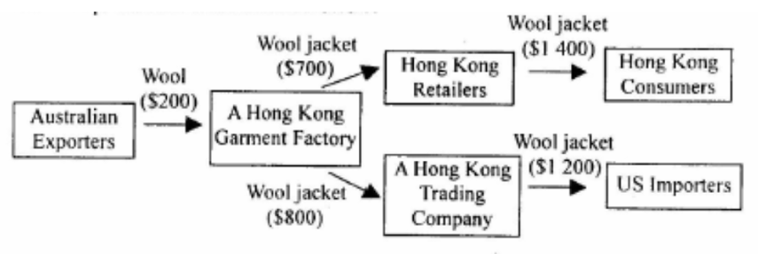
The contribution of the above chain to Hong Kong's GDP is
A. $1400 B. $1700 C. $2400 D. $2600

下圖顯示一條生產鏈。
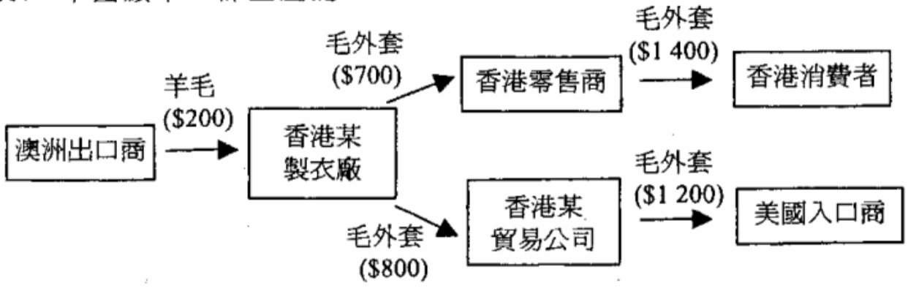
上述生產鏈對香港本地生產總值的貢獻是
A. $1400 B. $1700 C. $2400 D. $2600
Example Question 5 CE2007MCQ28
Answer the following questions by referring to the following production chain of watches in an economy. The local watch manufacturers import $10000 worth of raw materials.
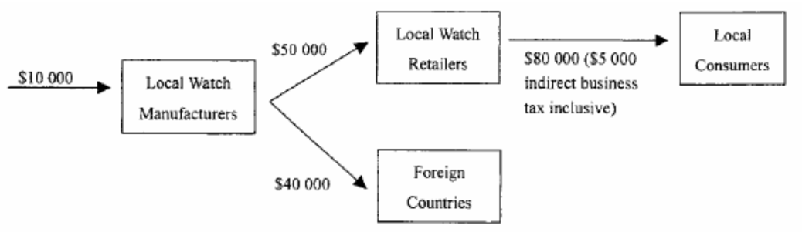
What is the contribution of the above producing chain to the economy's GDP at market prices?
A. $105 000 B. $110 000 C. $115 000 D. $120 000

Example Question 6 CE2007MCQ29
What is the contribution of the local watch retailers to the economy's GDP at factor cost?
A. $25 000 B. $30 000 C. $75 000 D. $80 000

參照下圖某經濟的鐘錶生產鏈回答第5及6題。該經濟的鐘錶製造商進口價值$10 000的原料。
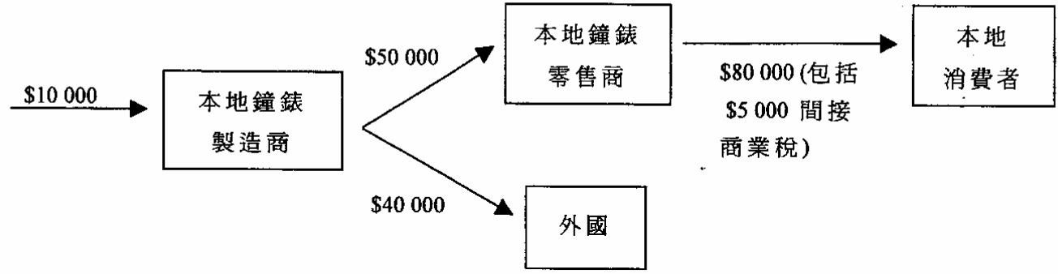
上述生產鏈對該經濟以市價計算的本地生產總值的貢獻是_____。
A. $105 000 B. $110 000 C. $115 000 D. $120 000

本地鐘錶零售商對該經濟以生產要素成本計算的本地生產總值的貢獻是_____。
A. $25 000 B. $30 000 C. $75 000 D. $80 000

Example Question 7 CE2009MCQ27
The following diagram shows a production chain of computers in an economy. It involves the import of $5 000 worth of raw materials.
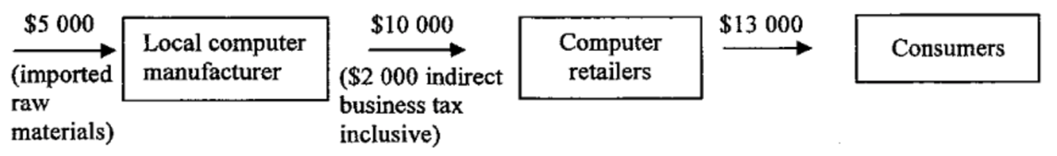
What is the contribution of the above production chain to the economy’s gross domestic product(GDP) at factor cost?
A. $6 000 B. $8 000 C. $10 000 D. $13 000

下表顯示某經濟中的電腦生產鏈，其中涉及價值$5000的原材料進口。
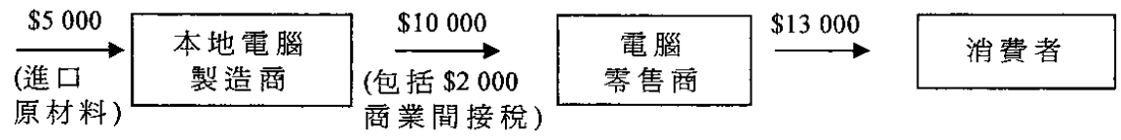
上述生產鏈對該經濟以要素成本計算的本地生產總值的貢獻是多少？
A. $6 000 B. $8 000 C. $10 000 D. $13 000

Example Question 8 CE2010MCQ28
The following diagram shows a production chain of computers in an economy. It involves the import of $6 000 worth of raw materials.
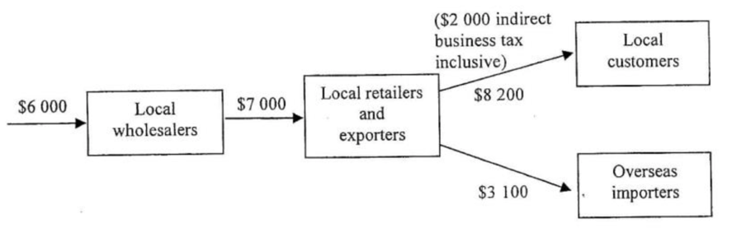
What is the contribution of the above production chain to the economy at factor cost?
A. $3 300 B. $5 300 C. $9 300 D. $11 300

下表顯示某經濟的電腦生產鏈。其中包括價值$6000的進口原料。
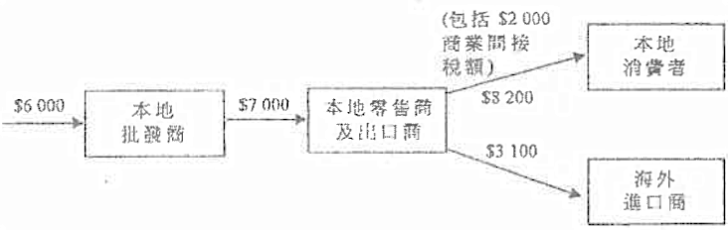
上述生產鏈對該經濟以要素計算的本地生產總值的貢獻是多少？
A. $3 300 B. $5 300 C. $9 300 D. $11 300

Example Question 9 CE2011MCQ26
The following diagram shows a production chain of garments in an economy. It also indicates the selling price of the output in different stages of the production. The imported raw materials are worth $6 000.
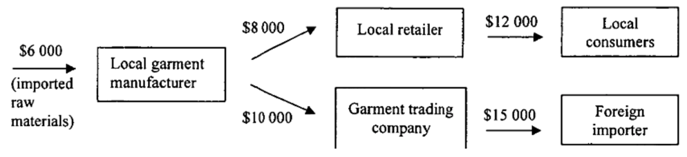
Suppose the garment trading company has received $1 000 export subsidy from the government. What is the contribution of the above production chain to the economy’s GDP at factor cost?
A. $20 000 B. $22 000 C. $26 000 D. $28 000

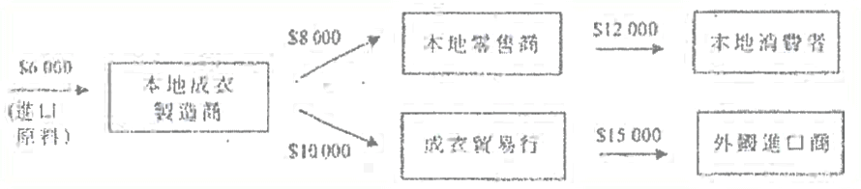
下圖顯示某經濟的一條成衣生產鏈及其在不同生產階段產出的售價。進口的原料價值$6000。

假設該成衣貿易行從政府收取了$1000出口津貼。上述生產鏈對該經濟以要素成本計算的本地生產總值的貢獻是多少？
A. $20 000 B. $22 000 C. $26 000 D. $28 000

Example Question 10 DSE2014MCQ24
The following diagram shows a production chain of a good in Economy X:
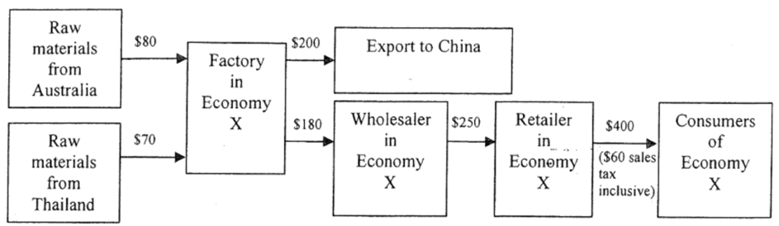
What is the contribution of the production chain to the Gross Domestic Product (GDP) at market price of Economy X?
A. $340 B. $390 C. $450 D. $600

下圖顯示在X經濟中某物品的生產鏈：
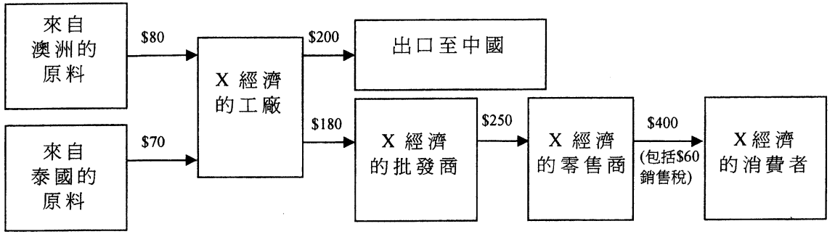
該生產鏈對X經濟以市價計算的本地生產總值的貢獻是多少？
A. $340 B. $390 C. $450 D. $600
***Example Question 11 DSE2017MCQ25
The following diagram shows a production chain of watches in an economy:
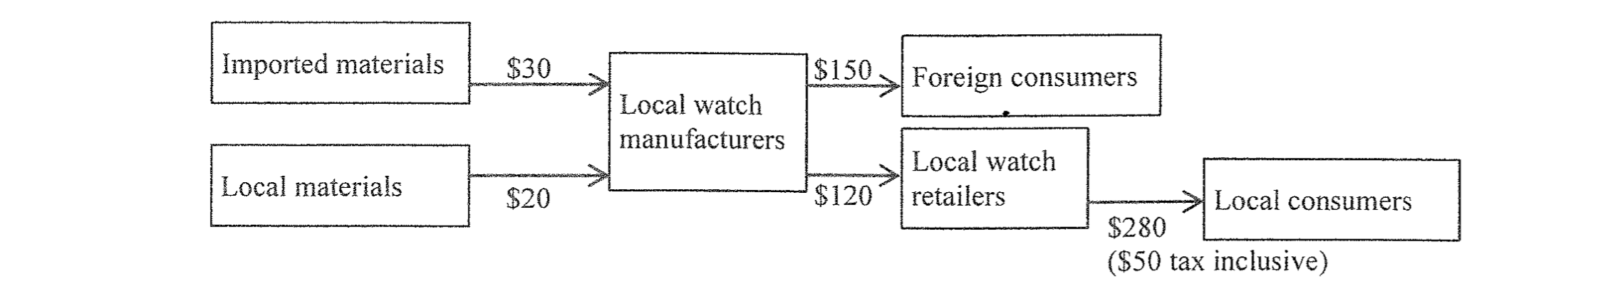
The contribution of the local watch manufacturers to the economy’s GDP at market price is _____.
A. $220 B. $240 C. $350 D. $400

下圖顯示某經濟中手錶的生產鏈。
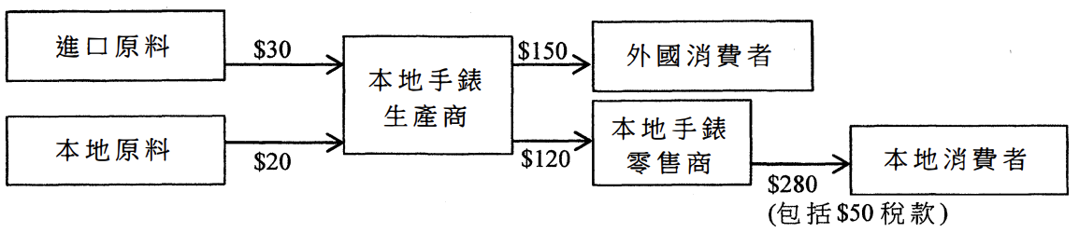
對該經濟以市價計算的本地生產總值而言，本地手錶生產商的貢獻是_____。
A. $220 B. $240 C. $350 D. $400

Example Question 12 DSE2019MCQ26
Refer to the following production chain in Country A and answer the question
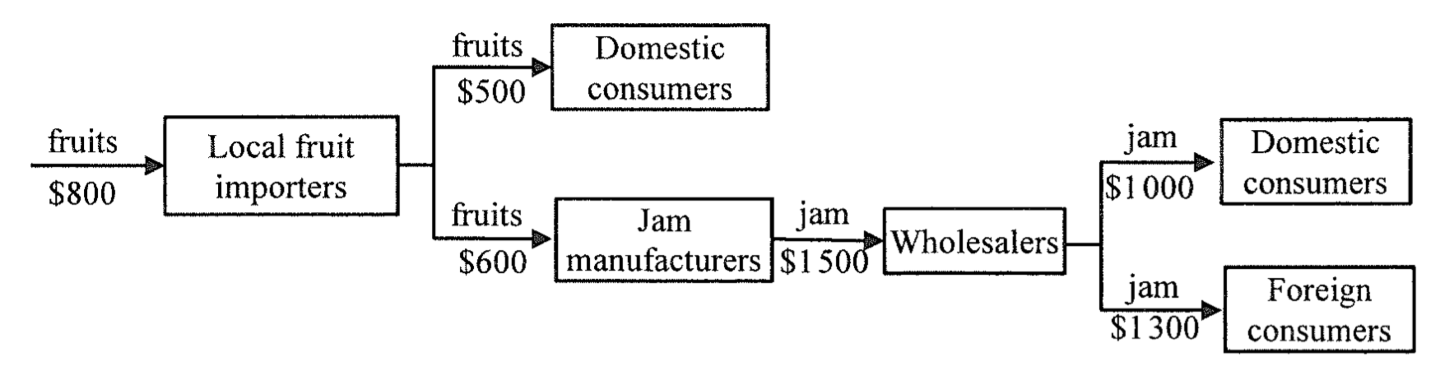
Suppose the above production chain has included a subsidy of $300 that is given to the jam manufacturers. What is the contribution of the above production chain to Country A’s GDP at factor cost?
A. $1700 B. $1800 C. $2000 D. $2300

参考以下在甲國的生產鏈，並回答問題。
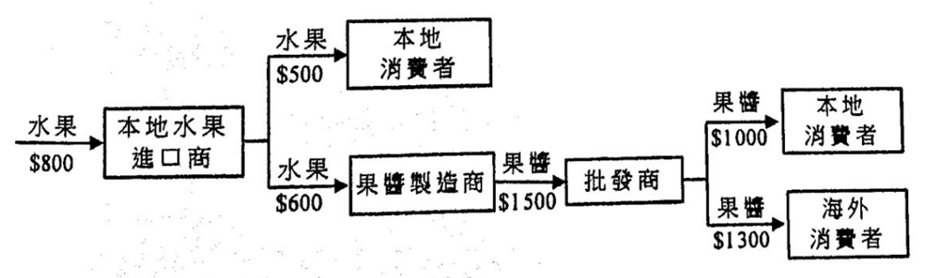
假設以上生產鏈包括了給予果醬製造商$300的補貼。以上生產鏈對甲國以要素成本計算的本地生產總值的貢獻是多少？
A. $1700 B. $1800 C. $2000 D. $2300

Example Question 13 2021DSEMCQ23
A production chain of Good X in an economy is shown below.
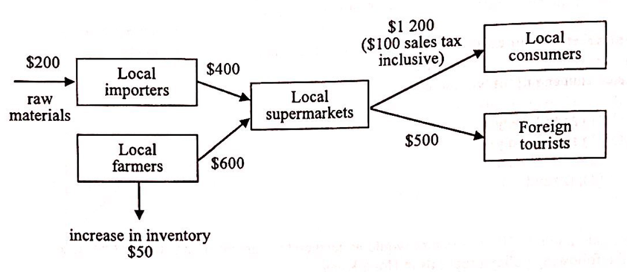
The contribution of the above production chain to the economy's gross domestic product at factor cost is________.
A. $1 400 B. $1 450 C. $1 500 D. $1 550

某經濟的物品X生產鏈顯示如下。
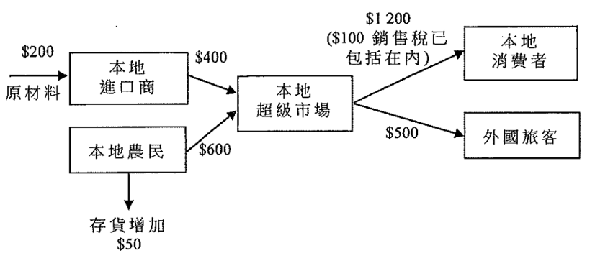
以上生產鏈對該經濟以要素成本計算的本地生產總值的貢獻是_________。
A. $1 400 B. $1 450 C. $1 500 D. $1 550

Type 5 (Gross National Product (GNI))
Example Question 1 CE1991MCQ43
Which of the following is included in a country’s gross national product?
A. the expenditure on newly-issued shares B. the salary paid to a foreign employee
C. the expenditure on public assistance D. the income of citizens earned abroad

以下哪一項包括在一個國家的國民生產總值之內？
A. 購買新發行股票的支出 B. 支付予外國僱員的薪金
C. 公共援助支出 D. 國民從外國賺取的收入

Example Question 2 CE1993MCQ44
If GNP is greater than GDP,
A. depreciation is greater than zero B. net income from aboard is greater than zero
C. transfer payments are greater than zero D. exports are greater than imports

若國民生產總值大於本地生產總值，則
A. 折舊大於零 B. 海外收入淨值大於零
C. 轉移支付大於零 D. 出口大於入口

Example Question 3 CE1995MCQ32
GDP will be greater than GNP when
A. the net export is negative B. the net export is positive
C. the net income from abroad is negative D. the net income from abroad is positive

在下列哪種情況下，本地生產總值會高於國民生產總值？
A. 出口淨值是負數 B. 出口淨值是正數
C. 海外收入淨值是負數 D. 海外收入淨值是正數

***Example Question 4 CE1997MCQ21 (cancelled)
To calculate Hong Kong's GNP from GDP, which of the following items should be taken into consideration in the calculation of external factor income flows?
(1) rental from overseas properties received by Hong Kong residents
(2) earnings from US stock and shares held by Hong Kong residents
(3) interest yields from Hong Kong Exchange Fund Notes received by residents in Japan
(4) fee paid by the MTR Corporation to UK experts for finding out the causes of a recent breakdown of MTR service
A. (1) and (2) only B. (3) and (4) only C. (1),(2) and (4) only D. all of the above

在香港用本地生產總值去計算國民生產總值時，「海外要素收入流量」的計算應考慮到下列哪幾項？
(1) 香港居民收取海外物業的租金
(2) 香港居民持有美國股票以得以賺獲的金錢
(3) 日本居民收取香港外匯基金債卷的派息
(4) 地鐵公司聘用英國專家，調查地鐵最近一次服務中斷的原因所付出的酬勞
A. 只有(1), (2) B. 只有(3), (4) C. 只有(1), (2), (4) D. 以上皆是

Example Question 5 CE1999MCQ26
Which of the following sources of income earned by local residents should be included in the calculation of net income from abroad’?
(1) export of goods
(2) export of services
(3) property investment in foreign countries
(4) stocks and shares investment in foreign countries
A. (1) and (2) only B. (1) and (3) only C. (2) and (3) only D. (3) and (4) only

在下列各種本地居民賺取收入的來源中，哪一項應包括在「海外收入淨值」的計算之內？
(1) 出口貨物
(2) 出口服務
(3) 投資海外產業
(4) 投資外國證券
A. 只有(1), (2) B. 只有(1), (3) C. 只有(2), (3) D. 只有(3), (4)

Example Question 6 CE1999MCQ29
Which of the following statements about GDP is correct?
A. GDP will be larger than GNP if the net export is positive
B. GDP does not include the income derived by local citizens from abroad
C. GDP does not consider the value of depreciation
D. Net income from abroad cannot be negative

下列哪一項關於本地生產總值的描述是正確的？
A. 若出口淨值是正數，本地生產總值便會超出國民生產總值 B. 本地生產總值並不包括本地市民從海外賺取的收入
C. 本地生產總值並不考慮折舊值 D. 海外收入淨值不可能是負數

Example Question 7 CE2002MCQ25
In order to calculate the gross national product of Hong Kong, which of the following items should be deducted from Hong Kong’s gross domestic product (GDP) figure?
A. the dividend received from shares in Hang Seng Bank by a Japanese person who lives in the U.S.
B. the rental income earned by a Hong Kong resident from his property in the U.S.
C. the salary earned by a native English teacher employed on a two- year contract in a secondary school in Hong Kong
D. the donations of a Hong Kong resident to mainland China

若要計算香港的本地居民生產總值(又稱國民生產總值)，下列哪一項須從香港的本地生產總值統計數字中扣減出來？
A. 一位居於美國的日本人從他購入的恆生銀行股票所獲派的股息
B. 一位香港居民在美國擁有物業所賺獲的租金收入
C. 一位由香港某中學以兩年期合約聘用的外籍英文教師所獲得的薪酬
D. 一位香港居民向中國內地捐出的款項

Example Question 8 CE2006MCQ26
Gross domestic product will be greater than gross national product when the amount of
A. net income from abroad is negative B. net income from abroad is positive
C. indirect taxes less subsides is positive D. net exports is negative

在下列哪種情況下，本地生產總值會大於國民生產總值？
A. 海外收入淨值是負數 B. 海外收入淨值是正數
C. 間接税減去津貼後是正數 D. 淨出口是負數

***Example Question 9 CE2006MCQ29
Which of the following items should be included in the calculation of Hong Kong’s net external factor income flow (i.e., net income from abroad)?
(1) the spending of a Japanese tourist in Hong Kong
(2) the revenue earned by a Hong Kong watch manufacturer from selling watches to Europe
(3) the rental income of a Hong Kong resident from property investment in the U.K.
(4) the interest received by a Hong Kong resident from his savings deposit in a bank in Switzerland
A. (1) and (2) only B. (1) and (3) only C. (2) and (4) only D. (3) and (4) only

下列哪項應被包括入香港的對外要素收益流量淨值(即海外收入淨值)的計算之內？
(1) 某日本遊客在香港的花費
(2) 香港某鐘錶生產商售賣鐘錶予歐洲市場所賺獲的收益
(3) 香港某居民在英國投資物業所賺獲的租金收入
(4) 香港某居民從瑞士某銀行的儲蓄存款賺獲的利息
A. 只有(1), (2) B. 只有(1), (3) C. 只有(2), (4) D. 只有(3), (4)

Example Question 10 CE2007MCQ26
Which of the following statements about GDP is correct?
A. GDP includes the value of imports
B. GDP is the total income of all the residents producing units
C. GDP is higher than gross national product if the net income from abroad is negative
D. GDP is the value of all goods and services transacted in the market

下列哪一項對本地生產總值的描述是正確的？
A. 本地生產總值包括進口價值
B. 本地生產總值是全部本地常住生產單位的總收入
C. 若海外收入淨值是負數，本地生產總值大過本地居民生產總值
D. 本地生產總值是在市場上成交的全部貨物及服務的價值

Example Question 11 CE2008MCQ27
Which of the following amounts should be added to the HKGDP in order to calculate the HKGNP?
A. the income earned by a Japanese singer who held two concerts in Hong Kong
B. the salary of a Hong Kong resident who works for the Hong Kong Office of an American bank
C. the rental income received by a Hong Kong resident from his residential apartment in Canada
D. an investment made by a Hong Kong resident in a garment factory in Thailand

香港本地生產總值須加上下列哪筆金額，方能計算香港本地居民生產總值？
A. 某日本歌手在香港舉行兩場演唱會所賺獲的收入
B. 某香港居民為一家美國銀行在本港的辦事處工作所賺取的薪酬
C. 某香港居民從他在加拿大的住宅所賺獲的租金收入
D. 某香港居民對泰國一家成衣廠投資的金額

Example Question 12 CE2009MCQ30
Suppose the GDP is greater than the gross national product. This implies that
A. The net factor income from abroad is positive. B. The net factor income from abroad is negative.
C. The net export is positive. D. The net export is negative.

假設本地生產總值大於本地居民生產總值，這意味著：
A. 海外要素收益淨值是正數 B. 海外要素收益淨值是負數
C. 出口淨值是正數 D. 出口淨值是負數

Example Question 13 CE2010MCQ30
Which of the following amounts should be deducted from the GDP of Hong Kong in order to calculate the gross national product of Hong Kong?
A. The rental income received by a mainland investor from his residential apartment in Hong Kong
B. The dividend received by a Hong Kong resident from his investment in the stock market in the US
C. The scholarship given by a Hong Kong tycoon to subsidize mainland students to study in Hong Kong
D. The salary of a Hong Kong resident working in a branch office of a British bank in Hong Kong

若果計算香港的本地居民生產總值，應將下列哪項從香港的本地生產總值中扣減出來？
A. 一位內地投資者從他在香港的住宅單位收取的租金
B. 一位香港居民從他在美國股市投資中收取的股息
C. 一位香港富豪大亨所設立用以津貼內地學生在香港求學的獎學金
D. 一位香港居民為一家英資銀行在香港的分行工作所收取的薪酬

Example Question 14 DSEPPMCQ21
If the value of the net external factor income flow (i.e. the net income from abroad) of an economy is negative, it implies that
A. the capital inflow to the economy is greater than the capital outflow from it.
B. the gross investment of the economy is smaller than the net investment.
C. the gross national product of the economy is less than the GDP.
D. the value of imports of the economy is greater than that of exports.

若某經濟的對外要素流量淨值(即海外收入淨值)為負數，這意味著該經濟的
A. 資本流入較資本流出為大 B. 總投資較淨投資為小
C. 國民生產總值較本地生產總值為小 D. 進口值較出口值為大

Example Question 15 DSE2013MCQ21
Which of the following item is NOT included in the calculation of Hong Kong’s net factor income from abroad for the current year?
A. the income received by a Japanese teacher who worked in a language school in Hong Kong for one year
B. rental income earned from real estate holdings in Canada owned by a Hong Kong resident
C. salary received by an Indian consultant who worked for the Hong Kong Airport Authority for three months
D. dividends earned from shares in Hong Kong held by a US resident

下列哪項並不包括在香港該年度的海外要素淨收入的計算之中？
A. 一位日本教師在香港某語文學校工作一年所得的收入 B. 一位香港居民在加拿大擁有地產物業所賺取的租金收入
C. 一位印度顧問為香港機場管理局工作三個月所得的薪金 D. 一位美國居民持有香港股票所賺取的股息

Example Question 16 DSE2019MCQ25
To calculate the gross national income of Hong Kong, which of the following should be added to the GDP of Hong Kong?
A. the income earned by a Japanese chef who has worked in a Hong Kong restaurant for two months
B. the rental received by a Hong Kong resident from leasing his house in Japan to a Japanese
C. the salary earned by a Hong Kong resident from working as a secretary at the Hong Kong branch office of an Australian company
D. the money from selling an apartment in Australia by a Hong Kong resident

要計算香港的本地居民總收入，我們須在香港的本地生產總值加上
A. 一位日本廚師在本港某餐廳工作兩個月所賺到的收入
B. 一位本港居民將他在日本的房屋出租予一位日本人所收到的租金
C. 一位本港居民在一家澳洲公司的本港分行任職秘書所賺到的薪金
D. 一位本港居民出售其在澳洲的物業所收取的款項

Type 6 (Real GDP, Nominal GDP, Per capita GDP)
Example Question 1 CE1991MCQ59
 | Growth rate of GDP in 1990
At current market prices | 15.2%
At constant (1980) market prices | 11.9%
 | 1990年本地生產總值的增長率
以當年市價計算 | 15.2%
以1980年固定市價計算 | 11.9%

The above data do NOT show an increase in the ______ in 1990.
A. general price level B. nominal GDP C. real GDP D. labour productivity

以上資料沒有顯示這經濟體系的_________在1990年上升
A. 一般物價水平 B. 名義本地生產總值 C. 實質本地生產總值 D. 勞工生產力

Example Question 2 CE1995MCQ34
If a country’s real GNP and price level both increase by 5%, this implies that
A. the standard of living will remain unchanged B. the nominal GNP will rise by 5%
C. the nominal GNP has a greater percentage increase than the real GNP D. the nominal GNP will remain constant

若一國的實質國民生產總值及物價水平皆上升5%，這意味著
A. 生活質素維持不變 B. 名義國民生產總值上升5%
C. 名義國民生產總值較實質國民生產總值有更高的百分比增長 D. 名義國民生產總值維持不變

Example Question 3 CE1997MCQ23
The following are data of Country X. 下列是X國的資料：
Year | 1992 | 1997
GDP | $500 billion | $700 billion
Price Index (1990 =100) | 120 | 135
年份 | 1992 | 1997
本地生產總值 | 5000億元 | 7000億元
物價指數（1990年=100） | 120 | 135
The growth rate of real GDP from 1992 to 1997 is:
A. 24.4% B. 28.6% C. 40.0% D. 57.5%

從1992年到1997年的實質本地生產總值增長率是
A. 24.4% B. 28.6% C. 40.0% D. 57.5%

Example Question 4 CE1998MCQ23
Suppose a closed economy produces food and clothing only. The outputs of Years 1 and 2 are as follows:
Year | Quantity of food (unit) | Unit price of food ($) | Quantity of clothing | Unit price of clothing
1 | 20 | 4 | 40 | 12
2 | 15 | 10 | 35 | 30
From Year 1 to Year 2, the real gross national product (real GNP) of this country has
A. worsened because the price level increases B. worsened because the output of both goods decreases
C. improved because the nominal GNP increases D. improved because the technology advances

設某封閉經濟體只生產衣服和食物，第1、2年生產量如下：
年份 | 食物數量(單位) | 食物單位價格($) | 衣服數量(單位) | 衣服單位價格($)
1 | 20 | 4 | 40 | 12
2 | 15 | 10 | 35 | 30
從第1年到第2年，該國的實質國民生產總值
A. 下降，因為物價水平上升 B. 下降，因為兩種物品的產出下降
C. 提升，因為名義國民生產總值上升 D. 提升，因為科技有進步

Example Question 6 CE1998MCQ29
Suppose a country experiences a 2% increase in the production volume of goods and services as well as a 3% rise in the general price level in a year. We can conclude that
(1) the real GNP will increase by 2%
(2) the nominal GNP will increase by 2%
(3) the nominal GNP will increase by 3%
(4) the nominal GNP will increase more than the real GNP by 1%
A. (1) only B. (2) only C. (1) and (2) only D. (1), (3) and (4) only

某國某年貨物及服務的生產量增加2%，而一般物價水平上升3%。可得結論如下：
(1) 該國實質國民生產總值上升2%
(2) 該國名義國民生產總值上升2%
(3) 該國名義國民生產總值上升3%
(4) 該國名義國民生產總值上升較實質國民生產總值多增加1%
A. 只有(1) B. 只有(2) C. 只有(1)、 (2) D. 只有(1)、 (3)、 (4)

Example Question 7 CE1999MCQ25
Suppose the nominal GNP and the price level increase by 10% and 5% respectively, but the population decreases by 10%. Then the per capita nominal GNP will _______ and the per capita real GNP will ______ .
A. increase ... increase B. decrease ... decrease
C. increase ... remain unchanged D. remain unchanged ... increase

假設名義國民生產總值與物價水平分別上升10%和5%，但人口下降10%。那麼，人均名義國民生產總值會_______而人均實質國民生產總值會_______。
A. 增加 ... 增加 B. 下降 ... 下降
C. 增加 ... 維持不變 D. 維持不變 ... 增加

Example Question 8 CE2000MCQ36
Year | GNP at current market price ($billion) | GNP deflator
1997 | 2100 | 105
1998 | 2800 | 125
Based on the above information, the growth rate of real gross national product (real GNP) between 1997 and 1998 is
A.12% B. 16.3% C. 33.3% D. There is insufficient information to find the answer.

年份 | 以當時市價計算的國民生產總值(10億元) | 國民生產總值平減指數
1997 | 2100 | 105
1998 | 2800 | 125
根據以上資料，從1997年到1998年間實質國民生產總值的增長率是
A. 12% B. 16.3% C. 33.3% D. 無足夠資料作答

***Example Question 9 CE2002MCQ30
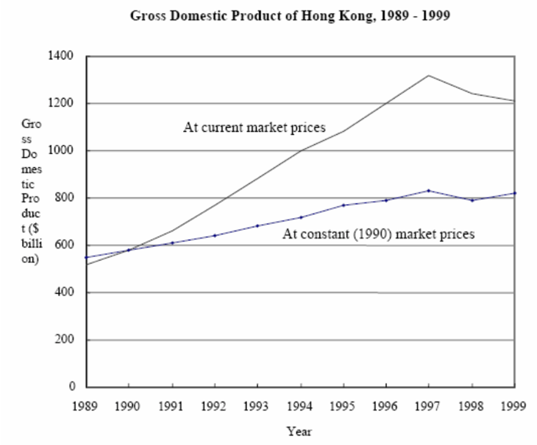
本地生產總值（以十億元為單位）
年份
按固定（1990年）市價計算
按當時市價計算
香港的本地生產總值 1989-1999
From 1991 to 1998, GDP at current market prices is always greater than GDP at constant (1990) market prices because
A. the inflation rate is increasing in this period.
B. the real output level is rising in this period.
C. the current price level is always higher than the price level of 1990.
D. the inflation rate is higher than the real output growth rate.

從1991年至1998年，按當時市價計算的本地生產總值都是大於固定(1990年)市價計算的本地生產總值，因為
A. 在此期間內，通脹率是上升的
B. 在此期間內，實質產出水平是上升的
C. 當時物價水平總是高於1990年的物價水平
D. 通脹率高於實質產出增長率

Example Question 10 CE2003MCQ29
If both of the nominal and real GDP of an economy are rising, the general price level of the economy
A. is rising B. is falling C. remain unchanged D. may be rising, falling or remain unchanged

若名義及實質本地生產總值皆上升，則一般物價水平
A. 正在上升 B. 正在下降 C. 維持不變 D. 可能上升，下降或維持不變

Example Question 11 CE2004MCQ34
Composite Consumer Price Index | -3.0%
GNP deflator | -2.7%
Nominal GDP | -0.6%
綜合消費物價指數 | -3.0%
本地生產總值平減物價指數 | -2.7%
名義本地生產總值 | -0.6%
According to the above data on an economy,
A. the real GDP has increased. B. the unemployment rate has increased.
C. the inflation rate has increased. D. the general living standard has decreased.

根據以上某經濟的資料，
A. 實質本地生產總值增加了 B. 失業率上升了
C. 通脹率上升了 D. 一般生活水平下降了

Example Question 12 CE2005MCQ29
年份 | 名義本地生產總值  (以百萬元計) | 物價指數
2003 | 75 000 | 90
2004 | 100 000 | 100
Study the following information about a country:
Year | Nominal GDP  (in million dollars) | Price index
2003 | 75 000 | 90
2004 | 100 000 | 100
As a compared to 2003, the _________ of this country was higher in 2004.
A. general living standard B. real GDP C. consumption expenditure D. average income

與2003年比較，該國在2004年的_______較高。
A. 一般生活水平 B. 實質本地生產總值 C. 消費支出 D.平均收入

Example Question 13 CE2007MCQ32
Year | Nominal GDP ($billion) | Population (million) | Consumer Price Index
1 | 3000 | 2 | 100
2 | 3500 | 2.5 | 110
According to the above information, from Year 1 to Year 2, the economy’s real GDP has ________ and the per capita nominal GDP has ________.
A. increased ... decreased B. increased ... increased C. decreased ... decreased D. decreased ... increased

年份 | 名義本地生產總值 (十億元) | 人口 (百萬人) | 消費物價指數
1 | 3000 | 2 | 100
2 | 3500 | 2.5 | 110
根據上表資料，由第1年到第2年，該經濟的實質本地生產總值_______而人均名義本地生產總值_______。
A. 增加了 … 減少了 B. 增加了 … 增加了 C. 減少了 … 減少了 D. 減少了 … 增加了
Example Question 14 CE2008MCQ32
The following table shows the change in GDP from Year 1 to Year 2. 本地生產總值從第1年到第2年有如下變動：
 | Change
GDP at current market prices | +5.1%
GDP at constant market prices | +8.1%
 | 變動
以當時市價計算的本地生產總值 | +5.1%
以固定市價計算的本地生產總值 | +8.1%
We can conclude from the above data that the real output _____ and the general price level _____ in that period
A. increased ... decreased B. increased ... increased C. decreased ... increased D. decreased ... decreased

根據以上資料，我們可以得結論如下：在該期間的實質產出_______而一般物價水平_______。
A. 增加了 … 下降了 B. 增加了 … 增加了 C. 下降了 … 增加了 D. 下降了 … 下降了

Example Question 15 CE2009MCQ29
Refer to the following statistical data (in $million) on an economy.
Year | GDP at current market price | GDP at constant (2000) market prices
2007 | 142 900 | 134 200
2008 | 144 800 | 132 300
Compared with 2007, the general price level has _____ and the real output of goods and services has _____ in 2008.
A. increased ... decreased B. increased ... increased C. decreased ... decreased D. decreased ... increased

參閱下表關於某經濟的統計資料（以百萬元為單位）。
年份 | 以當年市價計算的本地生產總值 | 以2000年固定市價計算的本地生產總值
2007 | 142 900 | 134 200
2008 | 144 800 | 132 300
與2007年比較，2008年的一般物價水平______了，而貨品及服務的實質產出______了。
A. 增加 … 減少 B. 增加 … 增加 C. 減少 … 減少 D. 減少 … 增加

Example Question 16 CE2011MCQ32
Refer to the following statistical data (in $million) on an economy.
Year | GDP at current market price | GDP at constant (2000) market prices
2009 | 163 000 | 150 000
2010 | 170 000 | 165 000
Compared with 2009, the general price level has ______ and the real output of goods and services has ______ in 2010.
A. decreased ... increased B. decreased ... decreased C. increased ... increased D. increased ... decreased

參閱以下關於某經濟的統計數字(以百萬元為單位)。
年份 | 以當時市價計算的本地生產總值 | 以2008年固定市價計算的本地生產總值
2009 | 163 000 | 150 000
2010 | 170 000 | 165 000
與2009年相比，2010年的一般物價水平______而貨物及服務的實質產出______。
A. 下降了 … 增加了 B. 下降了 … 減少了 C. 上升了 … 增加了 D. 上升了 … 減少了

Example Question 17 DSESPMCQ22
Consider the following information about an economy:
 | Growth rate (relative to previous year) (%)
 | Year 1 | Year 2
Nominal GDP | -3 | 0
Real GDP | 2 | 1
Population | 2 | -1
Which of the following about the economy is true?
A. The real output decreased in year 2. B. The per capita nominal GDP decreased in year 2.
C. The nominal GDP in the above two year is the same. D. The general price level decreased in year 1 but increased in year 2.

考慮以下某經濟的資料：
 | 增長率(相對去年)(%)
 | 第一年 | 第二年
名義本地生產總值 | -3 | 0
實質本地生產總值 | 2 | 1
人口 | 2 | -1
下列哪項有關該經濟的描述是正確的？
A. 實質產出於第二年減少 B. 人均名義本地生產總值於第二年減少
C. 以上兩年的名義本地生產總值是相同的 D. 一般物價水平於第一年下降，但於第二年上升

Example Question 18 DSEPPMCQ22
Over a given period, the GDP at current market prices of an economy increases by 15% and the rate of inflation decreases from 10% to 5%. Based on the above information, the real GDP __________ and the general price level __________.
A. increases ... rises B. increases ... falls C. decreases ... rises D. decreases ... falls

在一段時間內，某經濟以當時市價計算的本地生產總值增加15%，而通脹率則由10%減至5%。根據以上資料，實質本地生產總值_____，而一般物價水平________。
A. 增加 … 上升 B. 增加 … 下降 C. 減少 … 上升 D. 減少 … 下降

Example Question 19 DSE2014MCQ25
Year | Year-on-year percentage change in nominal GDP | Year-on-year percentage in nominal government spending | 年份 | 名義本地生產總值按年變動百分率 | 名義政府開支  按年變動百分率
2011 | 9.0 | 12.0 | 2011 | 9.0 | 12.0
2012 | 5.5 | 6.0 | 2012 | 5.5 | 6.0
Based on the about information, which of the following statements are correct?
(1) The size of the public sector in the economy increased in 2012.
(2) Both the nominal GDP and the nominal government spending dropped in 2012.
(3) A drop in both the real GDP and the real government spending was possible in 2012.
A. (1) and (2) only B. (1) and (3) only C. (2) and (3) only D. (1), (2) and (3)

根據以上資料，下列哪些陳述是正確的？
(1) 2012年該經濟公營部門的規模增大了
(2) 2012年名義本地生產總值和名義政府開支均下跌
(3) 2012年實質本地生產總值和實質政府開支均可能下跌
A. 只有(1)、(2) B. 只有(1)、(3) C. 只有(2)、(3) D. (1)、(2)及(3)

Example Question 20 DSE2014MCQ26
Suppose a closed economy produces food and clothing only. The output of Years 1 and 2 are as follows:
Year | Quantity of food (unit) | Unit price of food ($) | Quantity of clothing (unit) | Unit price of clothing
1 | 44 | 5 | 25 | 10
2 | 36 | 6 | 22 | 9
Which of the following statements about the economy are correct?
(1) The nominal GDP in year 1 is higher than that in year 2.
(2) The real GDP in year 1 is higher than that in year 2.
(3) The cost of living in year 1 is higher than that in year 2.
A. (1) and (2) only B. (1) and (3) only C. (2) and (3) only D. (1), (2) and (3)

假設某封閉經濟只生產食物及成衣。第一年和第二年的產量如下：
年 | 食物產量(單位) | 食物的單位價格($) | 成衣產量(單位) | 成衣的單位價格($)
1 | 44 | 5 | 25 | 10
2 | 36 | 6 | 22 | 9
下列哪些有關該經濟的陳述是正確的？
(1) 第一年的名義本地生產總值高於第二年的
(2) 第一年的實質本地生產總值高於第二年的
(3) 第一年的生活成本高於第二年的
A. 只有(1)、(2) B. 只有(1)、(3) C. 只有(2)、(3) D. (1)、(2)及(3)
Example Question 21 DSE2015MCQ25
Refer to the following table about an economy.
 | Growth rate (relative to previous year) (%)
 | Year 1 | Year 2
Nominal GDP | 4 | 0
General price level | 3 | 1
Population | -1 | 2
Which of the following statements about the economy is correct?
A. The per capital nominal GDP in year 2 is the same as that in year 1. B. The real output increased in year 2.
C. The general price level decreased in year 2. D. The per capita real GDP decreased in year 2.

參閱以下有關某經濟的表。
 | 增長率(相對於去年)(%)
 | 第1年 | 第2年
名義本地生產總值 | 4 | 0
一般物價水平 | 3 | 1
人口 | -1 | 2
下列哪項有關該經濟的陳述是正確的？
A. 第2年的人均名義本地生產總值和第1年的相同 B. 實質產出在第2年上升了
C. 一般物價水平在第2年下降了 D. 人均實質本地生產總值在第2年下降了

Example Question 22 DSE2017MCQ26
The following table shows some data of an economy.
 | Growth rate
 | 2015 | 2016
GDP | -3% | -2%
Price level | 1% | 0%
Population | 4% | 2%
Which of the following statements about the economy is correct?
A. Real GDP in 2016 decreases B. Per capita GDP in 2016 increases
C. The price level in 2016 decreases D. The growth rate of real GDP in 2016 is lower than that in 2015.

下表顯示某經濟的一些數據
 | 增長率
 | 2015 | 2016
本地生產總值 | -3% | -2%
價格水平 | 1% | 0%
人口 | 4% | 2%
下列哪項有關該經濟的陳述是正確的？
A. 2016年的實質本地生產總值下降 B. 2016年的人均本地生產總值上升
C. 2016年的價格水平下降 D. 2016年的實質本地生產總值增長率較2015年的為低

Example Question 23 DSE2019MCQ23
The following table shows the gross domestic product (GDP) data of an economy in a certain year.
Change in real GDP | -2.6%
Change in nominal GDP | -1.3%
Change in population size | -1.8%
According to the information above, we can conclude that in that year, the price level ____ and the per capita nominal GDP ____.
A. increased … increased B. decreased … decreased C. increased … decreased D. deceased … increased

下表顯示某經濟於某年度的本地生產總值資料：
實質本地生產總值的轉變 | -2.6%
名義本地生產總值的轉變 | -1.3%
人口的轉變 | -1.8%
根據以上資料，我們可以得出結論如下：在該年度，物價水平______，而人均名義本地生產總值______。
A. 上升了 … 增加了 B. 下降了 … 減少了 C. 上升了 … 減少了 D. 下降了 … 增加了

***Example Question 24 DSE2020MCQ26
The following diagram shows the gross domestic product (GDP) of Country A.
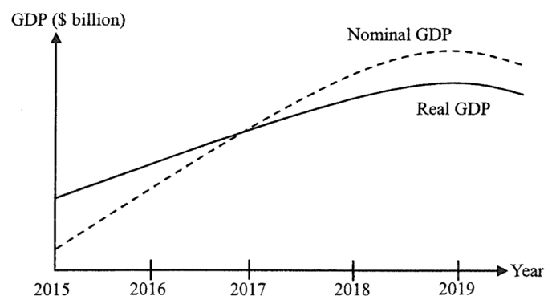
Which of the following statements about Country A is correct?
A. The price level increased between 2016 and 2018.
B. Deflation occurred before 2017.
C. The actual inflation rate was equal to the expected inflation rate in 2017.
D. The nominal GDP has been increasing since 2016.

下圖顯示甲國的本地生產總值(GDP)。
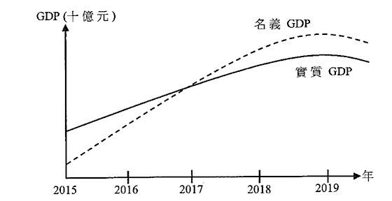
下列哪項有關甲國的陳述是正確的？
A. 2016至2018年間，價格水平上升 B. 2017年之前出現通縮
C. 2017年實質通脹率相等於預期通脹率 D. 自2016年起，名義本地生產總值一直上升

Example Question 25 DSE2021MCQ24
Refer to the gross domestic product (GDP) data of an economy.
 | Growth rate (relative to previous year)
Nominal GDP | 0
Real GDP | -1.2%
Per-capita nominal GDP | -3.5%

Compared to the previous year, the general price level has __________ and population has ________ in the economy in the current year.
A. increased ... increased B. increased ... decreased C. decreased ... increased D. decreased ... decreased

參閱某經濟的本地生產總值(GDP)數據
 | 增長率（相對於去年）
名義本地生產總值 | 0
實質本地生產總值 | -1.2%
人均名義本地生產總值 | -3.5%
與去年相比，本年度該經濟的一般物價水平_______，人口________。
A. 上升 … 上升 B. 上升 … 下降 C. 下降 … 上升 D. 下降 … 下降

Type 7 (Limitation of using National Income Statistics)
Example Question 1 CE1993MCQ41
The Gross National Product of a country may overstate the living standard of its people because the figure
(1) doses not reflect the improvement in the quality of the goods and services produced in the country
(2) doses not reflect the effect of a rise in the price level
(3) excludes the undesirable effects of production
(4) excludes the goods not transacted in the market
A. (1) and (2) only B. (1) and (4) only C. (2) and (3) only D. (3) and (4) only

一國家的名義本地生產總值可能高估了該國的人民生活水平。這是因為該數字
(1) 未能反映該國生產的物品及服務在品質方面的改善
(2) 未能反映物價上升的影響
(3) 不包括由生產帶來的不良影響
(4) 不包括沒有在市場交易的物品
A. 只有(1), (2) B. 只有(1), (3) C. 只有(2), (3) D. 只有(3), (4)

Example Question 2 CE1999MCQ30
Under which of the following circumstances will the per capita real GNP understate the living standard?
A. when the construction industry causes noise pollution B. when there is an increase in population due to immigration
C. when Mrs. Lam does the housework by herself instead of employing a servant D. when there is inflation

在下列哪一種情況中，人均實質國名生產總值所反映出來的生活水平較實際生活水平？
A. 建築業帶來噪音 B. 入口移民導致人口增加
C. 林太沒有聘用家庭傭工，她自己做家務 D. 通脹的出現

Example Question 3 CE2006MCQ50
GDP at constant market price would NOT be a good indicator to compare the living standard of two countries When the __________ of the two countries is different.
(1) population size
(2) income distribution
(3) inflation rate
A. (1) and (2) only B. (1) and (3) only C. (2) and (3) only D. (1), (2) and (3)

若兩國的___________並不相同，則以固定市價計算的本地生產總值不會是比較兩國生活水平的良好指標。
(1) 人口
(2) 收入分配
(3) 通脹率
A. 只有(1), (2) B. 只有(1), (3) C. 只有(2), (3) D. (1), (2), (3)
Example Question 4 CE2010MCQ29
The per capita real GDP of a country would overstate the living standard of its people because it
(1) does not reflect the improvement in the quality of goods and services produced.
(2) does not reflect the uneven distribution of income.
(3) does not reflect the undesirable effects of production.
(4) excludes the calculation of the goods and services not transacted in the market.
A. (1) and (2) only B. (1) and (4) only C. (2) and (3) only D. (3) and (4) only

因為一國的人均實質本地生產總值_________， 所以該國的國民生活水平會被高估了。
(1) 沒有反映該國所生產物品及服務在質素方面的改善
(2) 沒有反映不平均的收入分配
(3) 沒有反映生產的不良後果
(4) 沒有計算不在市場上交易的物品及服務
A. 只有(1), (2) B. 只有(1), (4) C. 只有(2), (3) D. 只有(3), (4)

Example Question 5 DSE2021MCQ26
The per-capita real GDP of a country would understate the general living standard because
A. it includes the value of non-consumption goods. B. it does not consider the size of population
C. it does not reflect the increasing crime rate in society. D. it does not include all non-marketed goods.

某國的人均實質本地生產總值會低估一般生活水平，因為
A. 它包括了非消費品的價值 B. 它沒有考慮人口的多寡
C. 它沒有反映社會中的罪案率上升 D. 它沒有包括全部非市場物品

2012DSE LQ10ai
In 2011, the Financial Secretary announced the “Scheme $6000” which provides $6000 to each Hong Kong permanent resident who is 18 years old or above. Mr. Chan is a retired person and received $6000 through the scheme in 2011. Should this item of payment by the government be included in the calculation of Gross Domestic Product of Hong Kong in 2011? Explain. (2)

財政司司長在2011年公布「$6000計畫」: 向每位十八歲或以上的香港永久居民派發$6000。陳先生是一名退休人士，在該計畫下於2011年獲得$6000，該筆政府支付的款項應否包括在2011年香港本地生產總值的計算之內？試加以解釋。 (2)
______________________________________________________________________________________________________________________________________________________________________________
_______________________________________________________________________________________
_______________________________________________________________________________________

Marking Scheme:
No, because (1)
There is no corresponding production. (1)

否，因為 (1)
沒有相應的生產。 (1)
Candidates’ Performance:
Excellent. A small number of candidates wrongly regarded transfer payments as part of government expenditure and thus included them in the calculation of GDP.

優異，小部分考生錯誤地將轉移支付當作政府支出的一部分，故將該項包括在本地生產總值的計算內。

2014DSE 11b
Suppose the sales revenue to the Japanese automobile exporters was 100 billion Japanese Yen in 2013. Give TWO reasons to explain why their contribution to Japan’s GDP would be less than 100 billion Japanese Yen in 2013. (4)

假設2013年日本汽車出口商的銷售收入是1000億日圓，舉出兩個理由解釋為什麼他們對2013年日本本地生產總值的貢獻會少於1000億日圓。 (4)
_______________________________________________________________________________________
_______________________________________________________________________________________
_______________________________________________________________________________________
_______________________________________________________________________________________
_______________________________________________________________________________________
_______________________________________________________________________________________
_______________________________________________________________________________________

Marking Scheme:
- Not all factor inputs used to produce Japanese cars originated from Japan. E.g. some of the parts or raw materials were imported.
- Some Japanese cars sold in 2013 were not produced in the same year. E.g. some of them came from the inventory.
[Mark the FIRST TWO reasons only.] (@2)

- 部分不是本地生產的，例如一些生產的原料是進口的。
- 部分不是當年生產的，例如一些物品是來自存貨。 (@2)
[只批閱首兩項]
Candidates’ Performance:
Good.
良好。

2015DSE LQ9d & 10ai,ii
(d) In July 2014, McDonald’s was accused of using expired meat as an ingredient for its food. Later, the related products were destroyed. Explain whether the value of these destroyed products would be included in the calculation of Hong Kong’s gross domestic product. (2)

(d) 在2014年7月，麥當勞被指責以過期肉類作為食材。其後，有關的產品被銷毀了。解釋這些已經銷毀產品的價值
是否會包括在香港本地生產總值的計算之中。 (2)
_______________________________________________________________________________________
_______________________________________________________________________________________
_______________________________________________________________________________________
(a) ***Suppose a football club in Hong Kong hired a famous football player from Brazil as the coach for a 2-month course for kids. He received $8 million as his salary and returned to Brazil afterwards. However, the enrolment of the course was poor and the revenue from the course was $3 million only. What is the effect of organising the above course on each of the following items? Explain.
(i) Hong Kong’s gross domestic product (GDP) (2)
(ii) Hong Kong’s gross national product (GNP) (3)

(a) 假設香港某球會聘請了一位巴西著名足球員擔任為期兩個月的兒童足球班教練，他收取了八百萬元的薪金，其後
返回巴西。不過，足球班的收生欠佳，學費收入只有三百萬元。舉辦上述足球班對下列各項有什麼影響？試加以解釋。
(i) 香港的本地生產總值 (GDP) (2)
(ii) 香港的本地居民生產總值 (GNP) (3)
_______________________________________________________________________________________
_______________________________________________________________________________________
_______________________________________________________________________________________
_______________________________________________________________________________________
_______________________________________________________________________________________
_______________________________________________________________________________________
_______________________________________________________________________________________

Marking Scheme:
(a) No, (1)
because it is not sold to the market and thus not counted in production /
because it is neither counted in consumption nor investment (1)
否 (1)
因為它沒有在市場出售，因此不計入生產 (生產面) /
因為它並不計算在消費或者投資內 (開支面) (1)

(a)(i) Hong Kong’s GDP would increase by 3 million. As the course is a current year production by a resident production unit, its value would be included in GDP. (2)
香港的本地生產總值會上升三百萬元，因為這課程是常住生產單位本年度的生產，該課程的價值會計入本地生產總值內。 (2)

(a)(ii) Hong Kong’s GNP would decrease by 5 million, as change in GNP = change in GDP (+ 3 million) + change in net income from abroad (- 8 million). As the Brazilian coach is NOT a HK resident, the 8 million he received would be counted as income outflow and enter as a negative item in HK’s national income account. (3)
香港的本地居民生產總值會下降5百萬元，因為GNP的轉變 = GDP的轉變 (+3百萬元) + 海外收入淨值NIFA的轉變 (-8百萬元)。因為該巴西球員不是本地居民，故該8百萬收入會計算成收入流出，在本港的國民收入計算內是須要扣減的。 (3)

Candidates’ Performance:
(a) Poor. Many candidates were under the misconception that the destroyed meat should be counted in GDP because it was bought by McDonald’s and should thus be included in its investment, or that it involves production and should thus be counted even if it is destroyed eventually. Those who were able to get their stand correct failed, however, to provide satisfactory explanations. Some regarded the expired meat as stock or non-final goods. Others stated that the values of these destroyed products were included in GDP when they were initially produced, so they should not be counted again or else they would be being counted twice.
欠佳，很多考生誤以為已經銷毀的肉類應該計入本地生產總值，因為它是麥當勞所購買，所以應包括在其投資中，或是它涉及了生產所以應該計算，儘管它最後被銷毀了。能寫出正確立場的考生中，很多也未能提出令人滿意的解釋。一些認為已過期肉類屬於存貨或非最終物品。另有考生指當那些已銷毀的產品原初生產時已計算在本地生產總值，所以不應重複計算。

(a)(i) Fair. Ost candidates were able to point out that GDP would increase as production activities were involved in this case. However, some missed such keywords as “current” or “resident producing unit” in their answers. A minority of candidates either confused “resident” with “resident producing unit” or thought that both the coach’s salary and the revenue from the course should be counted in GDP.
一般。大部分考生能指出本地生產總值會上升，因為這個案涉及生產活動。但是部分考生遺漏了關鍵詞如「現在」或者「常住生產單位」。有小部分考生混淆了「居民」和「常住生產單位」或是誤以為教練的薪金和課程的收入均須計入本地生產總值。

(a)(ii) Satisfactory. Many candidates were able to state the relation between GDP and GNP and to identify the coach’s income as factor income from abroad.
令人滿意，很多考生能指出本地生產總值和本地居民生產總值的關係，並知道教練的收入是海外要素收入流入。

2016DSE LQ11a
Medical service is one of the basic human needs.
Source A; a conversation outside a public clinic in Hong Kong
Son: Dad, I feel very ill.
Father: Oh no! There is a long queue waiting.
Son: Why don’t we go to a private doctor?
Father: The fee charged by the public clinics is only $45, much lower than that charged private doctors.
Refer to Source A. When a public clinic provides medical service for one patient, the resulting rise in gross domestic product will be $45. Do you agree? Explain. (3)

醫療服務是人類的其中一項基本需要。
資料甲：在本港某家公立診所外的一段對話
兒子: 爸爸，我很不舒服呀。
父親: 糟了！排隊等候的人很多。
兒子: 為什麼我們不去看私家醫生？
父親: 公立診所的收費只是45元，遠低於私家醫生的收費。
參考資料甲。當一家公立診所向一名病人提供醫療服務，本地生產總值會因而增加$45。你同意嗎？試加以解釋。 (3)
_______________________________________________________________________________________
_______________________________________________________________________________________
_______________________________________________________________________________________
_______________________________________________________________________________________
_______________________________________________________________________________________
_______________________________________________________________________________________
_______________________________________________________________________________________

Marking Scheme:
No, (1)
because public services are usually subsidized - i.e. provided at or below cost, which is in turn lower than market price. Their contribution to GDP, computed using market price, would thus higher than $45. /
because the public services which are not sold at the market price will be counted using factor cost in the GDP, which is higher than $45. (2)

否。 (1)
因為公營服務大多有補貼，即以成本或低於成本價提供，較市價為低。以市場價格計算，它們對本地生產總值的貢獻(或是市場價值) 會高於$45(診所收取的補貼後的價格)。/
因為沒有以市價出售的公營服務會以要素成本計算入本地生產總值裏，會高於$45。 (2)

Candidates’ Performance:
Poor. Many candidates misinterpreted the question as meaning “whether the $45 should be included in the calculation of GDP” – a frequently asked question in past papers. Some over-emphasised the imported raw materials (medicine) and reached the wrong conclusion of “less than $45”. Among those who got their stand correct, only some of them provided a good explanation.
欠佳。很多考生錯誤地將題目當成「該$45應否包括在GDP的計算之內」—— 一道在歷屆考試中經常考問的題目。部分考生過分著重於原料（藥物）的進口並得出一個錯誤的結論：「少於$45」。在能夠寫出正確立場的考生中，只有部分能提供適切的解釋。

2017DSE LQ13aii
To cope with the problem of a rapidly aging population in Hong Kong, the government has proposed a retirement protection scheme under which eligible elderly would receive $38 760 per year. Mr. Chan, a street sleeper, is eligible to receive $38 760 under this scheme. He would be able to afford the service of an elderly care centre and would spend $30 000 of the money to pay the yearly charges. If Mr. Chan moved to an elderly care centre, explain how the GDP of Hong Kong would be affected. (2)

為了應付香港人口的急速老化問題，政府建議一項退休保障計劃，計劃下合資格長者每年可以領取$38 760。陳先生是一位露宿者。在該計畫下，他合資格領取$38 760。他便能負擔安老院服務，並會花費其中的$30 000支付一年的院費。若陳先生入住安老院，解釋香港的本地生產總值會如何受影響。 (2)
_______________________________________________________________________________________
_______________________________________________________________________________________
_______________________________________________________________________________________
_______________________________________________________________________________________
_______________________________________________________________________________________
_______________________________________________________________________________________
_______________________________________________________________________________________

Marking Scheme:
GDP rises, (1)
as it is the consumption expenditure by Mr Chan spent on final goods and services. (1)

本地生產總值上升， (1)
因為安老院服務收費是陳先生花費在最終物品和服務上的消費支出。 (1)
Candidates’ Performance:
Good. Most candidates can point out that the gross domestic product (GDP) will rise. Some students mistakenly the $30 000 was treated as a transfer payment and it was concluded that "Hong Kong's GDP will not rise".
良好。大部分考生能指出本地生產總值GDP會上升。部分考生誤將$30 000當作轉移支付，得出「香港的本地生產總值不會上升」的結論。

2018DSE LQ12c
Tourism is one of the ‘pillar industries’ in Hong Kong. Data
Source 2 : statistical data about tourism in Hong Kong in 2016
 | 2016 | Compare with 2015 (%)
Mainland visitors | 42.8 million | -6.7%
Total visitors | 56.65 million | -4.5%
Total tourism expenditure associated to inbound tourism | HK$296.2 billion | -10.1%
With reference to Source 2, to which component of Hong Kong’s GDP does the ‘total tourism expenditure associated to inbound tourism’ belong? (1)

旅遊業是本港其中一項「支柱產業」。
資料二：2016年香港旅遊業的統計資料
 | 2016年 | 與2015年比較（%）
內地旅客 | 4,280萬 | -6.7%
旅客總數 | 5,665萬 | -4.5%
與入境旅遊相關的總消費 | HK$2,962億元 | -10.1%
參考資料二，「與入境旅客相關的總消費」屬於本港本地生產總值中的哪一個組成部分？ (1)
_______________________________________________________________________________________
_______________________________________________________________________________________
_______________________________________________________________________________________
_______________________________________________________________________________________

Marking Scheme:
Export of services / Net exports (1)

服務出口 / 淨出口 (1)
Candidates’ Performance:
Good. A minority of candidates mistook the inbound-tourist expenditure for private consumption expenditure.
良好。小部分考生誤將入境旅客的消費當作私人消費支出。

2020DSE LQ9d
Ocean Park and Hong Kong Disneyland are two large theme parks in Hong Kong. The first hotel in Ocean Park was launched in 2018 while the second hotel and the water park were scheduled to be opened before 2021. It is expected that such infrastructure development can attract more tourists to stay longer in Hong Kong. The contribution of the infrastructure development of Ocean Park to Hong Kong’s GDP in 2019 could be smaller than the total amount invested in the two hotels and the water park. Explain why the statement may be correct with TWO reasons. (4)

海洋公園和香港迪士尼樂園是香港兩大主題公園。海洋公園首家酒店已於2018年開業，而第二家酒店及水上樂園預計在2021年前開幕。人們預期這個基建發展能吸引更多旅客延長留港時間。海洋公園的基建發展對香港2019年本地生產總值的貢獻可能少於已在這兩家酒店及水上樂園的投資總金額。提出兩項理由，解釋為什麼這陳述可能正確。 (4)
_______________________________________________________________________________________
_______________________________________________________________________________________
_______________________________________________________________________________________
_______________________________________________________________________________________

Marking Scheme:
Not all factors inputs used to build the infrastructure originated from Hong Kong. For example, some raw materials were imported . (2)
Some of the output were not produced in the same year. For example, some has been already included as change in inventory / work in process in previous year. (2)

用於興建基礎設施的要素投入不是全部均源自香港。例如部分原材料是進口的。 (2)
部分的產出可能不是在2019年生產的。例如部分已經在以前年度計入在存貨改變 / 進行中的工程內。 (2)
Candidates’ Performance:
Fair. Many candidates were able to identify the source of discrepancy, but not everyone could provide a clear explanation. For instance, some candidates merely provided the terms ‘inventory’ or ‘import’ without mentioning that these goods are not produced in the current period or not produced by domestic firms.
一般。很多考生能指出該分別的原因，但並非全部可以提供清晰的解釋，例如他們只提出「存貨」或「進口」等術語，而沒有提到那些物品不是在當期生產 / 不是由本地廠商生產的。

DSE 2021 LQ5ai & ii
Mr Chan, a Hong Kong retired footballer, was employed as a consultant by a football club in the United Kingdom in January 2020. Seven months later, he quitted his position and returned to Hong Kong.
(a) Explain whether the salary received by Mr Chan from the football club in the United Kingdom would be included in the calculation of
(i) gross domestic product (GDP) in Hong Kong. (2)
(ii) gross national income (GNI) in Hong Kong. (3)
陳先生是本港一名退役足球員。在2020年1月，他獲一家英國球會聘請為顧問。七個月後，他辭職並返回香港。
(a) 解釋陳先生從英國球會收到的薪金會否包括在
(i) 香港的本地生產總值(GDP)的計算內。 (2)
(ii) 香港的本地居民總收入(GNI)的計算內。 (3)
_______________________________________________________________________________________
_______________________________________________________________________________________
_______________________________________________________________________________________
_______________________________________________________________________________________
_______________________________________________________________________________________
_______________________________________________________________________________________
_______________________________________________________________________________________
_______________________________________________________________________________________
_______________________________________________________________________________________

Marking Scheme:
(i) No, because the salary received by Mr Chan was derived from production by a non-resident producing unit (the UK football club) outside Hong Kong. (2)
否。因為陳先生所收取的薪金是來自一個非本地常住生產單位(該英國球會)的生產。

(ii) Yes. As Mr Chan is a Hong Kong resident, the salary he received would be counted as factor income from abroad. (3)
是。因為陳先生是香港居民，所收取的薪金會當作海外要素收入計算。

Candidates’ Performance:
i) Satisfactory. Most candidates stated correctly that Mr Chan's income from the UK would not be included in HK's GDP, but some of them failed to give a proper explanation. Some candidates mis-regarded Mr Chan (the employee) rather than the UK football club (the employer) as the non-resident producing unit (from HK's perspective)
令人滿意。大部分考生正確地指出陳先生在英國的收入不會包括在香港的GDP內，但部分考生未能提供確當的解釋。部分考生錯誤地指出陳先生(僱員)不屬香港的常住生產單位而非英國的球會(雇主)

ii) Satisfactory. Some candidates used the terms ‘people’ or ‘citizens’ instead of residents in their answers - which is not precise for the purpose of national income accounting. Other candidates mixed up the concepts of "resident' and 'resident producing unit'. Some failed to state clearly that Mr Chan's salary was an inflow of factor income from abroad.
令人滿意。部分考生在作答時所用的術語為「人民」或者「市民」而非居民，這在國民收入核算中並不準確。另有考生混淆了「居民」和「常住生產單位」這兩個概念。部分考生未能清楚指出陳先生的薪金屬於海外流入的要素收入。

Marking Scheme:
Type 1 (Whether included in GDP or not)
1 | B | 2 | C | 3 | D | 4 | A | 5 | A | 6 | B | 7 | B | 8 | A | 9 | B | 10 | A
11 | C | 12 | A | 13 | A | 14 | A | 15 | B | 16 | B | 17 | A | 18 | D | 19 | D | 20 | C
21 | A
Type 2 (Circular flow model)
1 | A | 2 | C | 3 | B | 4 | C | 5 | B | 6 | B | 7 | A | 8 |  | 9 |  | 10
Type 3 (Expenditure Approach)
1 | C | 2 | A | 3 | A | 4 | C | 5 | C | 6 | C | 7 | B | 8 | B | 9 | B | 10 | C
11 | C | 12 | B | 13 | C | 14 | C | 15 | B | 16 | A | 17 | C | 18 | B | 19 | B | 20 | A
21 | C | 22 | D | 23 | B | 24 | D | 25 | A | 26 | B | 27 | C | 28 | B | 29 | A | 30 | C
Type 4 (Production Approach / Value-added Approach)
1 | A | 2 | B | 3 | C | 4 | C | 5 | B | 6 | A | 7 | A | 8 | A | 9 | B | 10 | C
11 | A | 12 | D | 13 | B | 14 | C | 15 | B | 16 | D | 17 | A | 18 | C | 19 | A | 20 | C
21 | C | 22 | D
Type 5 (Gross national income GNI)
1 | D | 2 | B | 3 | C | 4 | D | 5 | D | 6 | B | 7 | A | 8 | A | 9 | D | 10 | C
11 | C | 12 | B | 13 | A | 14 | C | 15 | A | 16 | B | 17 | C | 18 | A | 19 | D | 20 | B
21 | C | 22 | A | 23 | D | 24 | B | 25 | D | 26 | C
Type 6 (Real GDP, Nominal GDP, Per-capita GDP)
1 | D | 2 | C | 3 | A | 4 | B | 5 | A | 6 | A | 7 | A | 8 | A | 9 | C | 10 | D
11 | A | 12 | B | 13 | A | 14 | A | 15 | A | 16 | A | 17 | C | 18 | A | 19 | B | 20 | A
21 | D | 22 | A | 23 | A | 24 | A | 25 | A | 26 | A | 27 | B | 28 | B | 29 | B | 30 | C
31 | A | 32 | D | 33 | B | 34 | A | 35 | C | 36 | A
Type 7 (Limitation of using National Income Statistics)
1 | C | 2 | C | 3 | A | 4 | C | 5 | D | 6 | D | 7 | A | 8 | B | 9 | D

