Learning Focus學習重點:
12.1 DSE Compulsory Part Syllabus  12.1 DSE必修部分大綱 | P.1
12.2 Definition List  12.2 定義列表 | P.3
12.3 The Role of Government: Equity & Income Inequality  12.3 政府的職責：公平與收入不平等 | P.5
12.4 Measuring Income Distribution  12.4衡量收入分佈 | P.7
12.5 Lorenz Curve  12.5洛倫茨曲線 | P.8
12.6 Gini Coefficient  12.6 堅尼系數 | P.10
12.7 Limitation of Measuring Income Inequality  12.7 衡量收入不平等的局限 | P.13
12.8 Source of Income Inequality  12.8收入不平等的根源 | P.14
12.9 Equalizing Income  12.9 收入均等化 | P.15
12.10 Equalizing Opportunity  12.10機會均等化 | P.15
12.11 Equalizing Income and Opportunity Demo  12.11 收入和機會均等化框架 | P.17
12.12 Multiple Choice Question Flow  12.12 選擇題框架 | P.20
12.13 Long Question Flow  12.13 長題目框架 | P.21

Chapter 12 _ Equity公平
DSE Compulsory Part
E | Topic | Key points | Elaboration of the curriculum contents | Fine-tunings
 | Efficiency, Equity and the Role of Government | Equity  - Efficiency and equity a market economy  - Measuring income inequity: Income distribution, Lorenz curve and Gini coefficient (N.B. Construction of the Lorenz curve and Gini coefficient NOT required)  - Sources of income inequality: human capital (e.g. skill differentials), discrimination and unequal ownership of capital, etc | • Students are expected to understand that  - The discussion of equity in Topic E is limited to income inequality,  - Resource allocation under perfectly competitive market situation is efficient,,  - resource allocation through market mechanism is inefficient under certain circumstances (e.g. the existence of divergence between private and social costs (benefits) may lead to inefficiency), and,  - even if resource allocation is efficient, there is an issue of income inequality.  • Students are NOT expected to explain  - the efficiency issue of public good even though they are expected to know the definition of public good, and  - in the Compulsory Part the efficiency implication of monopoly / price searching.  [NOTE: A philosophical exploration of the general concept of equity is NOT required.]  • Students are expected to  - understand the relationship between the size of Gini-coefficient and the shape of Lorenz curve,  - interpret the information delivered from the measuring tools: income distribution, Lorenz curve and Gini-coefficient, and  - analyse the issue of income inequality in Hong Kong.  • Students are NOT expected to grasp detailed analysis of the labour market such as deriving labour demand from marginal revenue product.
 |  | Policy concerns  - Equalizing income or equalizing opportunities  - Disincentive effects of taxes and transfers  - Tradeoff between equity and efficiency | • Students are expected to understand  - that equity is a broad concept and so the discussion of policy impact on equity in this part is LIMITED to two commonly considered ethical principles: equalizing income and equalizing opportunities, and  - the normative choice of these principles would affect policy choices.  • Students are expected to discuss, with reasoning provided, the effects on income inequality (both in terms of income and opportunities) and efficiency when a policy is given.  • Students are NOT expected to discuss THEORECTICALLY the possibility of trade-off between equity and efficiency.

Chapter 12 _ Equity公平
Definition List 定義列表

Chapter 12 _ Equity公平
12.3 The Role of Government: Equity & Income Inequality政府的職責：公平與收入不平等
- Efficiency  - Maximizing both Consumer Surplus & Producer Surplus  - Consumer Surplus =  - Producer Surplus =  - To maximize the producer surplus, we need | - 效率  - 最大化消費者盈餘和生產者盈餘  - 消費者盈餘 =  - 生產者盈餘 =  - 為了最大化生產者盈餘，我們需要
- Equity  - Fairness in society  - Fairness in income & opportunity  - Fairness is to ensure every people can enjoy the services / products  - If High income group, Middle income group and Low income group can all enjoy…  - The price cannot be set too high  - Then producer surplus… | - 公平  - 社會公平  - 收入和機會公平  - 公平是為了保證大家都能享受到服務 / 產品  - 如果高收入組別人士、中等收入組別人士和低收入組別人士都能享受……  - 定價便不能太高  - 然後生產者盈餘…

????? There is a tradeoff between Efficiency and Equity. ?????
????? 效率和公平之間存在取捨。?????

12.3 The Role of Government: Equity & Income Inequality Concept Corner:
1. In general, efficiency implies total social surplus is maximized. T / F
一般來說，效率意味著總社會盈餘最大化。
∵
2. In general, to maximize the consumer surplus, market price should be set as high as possible T / F
一般來說，要使消費者盈餘最大化，市場價格應該設置得盡可能高
∵
3. In general, to maximize the producer surplus, market price should be set as high as possible T / F
一般來說，要使生產者盈餘最大化，市場價格應設置得盡可能高
∵
4. Equity implies every person should not be deprived from resources because of their background. T / F
公平意味著每個人都不應該因為他們的背景而被剝奪資源。
∵
5. There is no tradeoff between efficiency and equity T / F
效率和公平之間沒有取捨
∵
6. Statement about fairness must be a normative statement T / F
關於公平的聲明必須是規範性陳述
∵
7. Equity can be divided to two aspects: Income and Opportunity T / F
公平可以分為兩個方向：收入和機會
∵
8. Setting a high price may maximize the producer surplus but harming the equity T / F
設定高價格可能會使生產者盈餘最大化，但有損公平
∵

ANS: TFTTF FTT
12.4 Measuring Income Distribution衡量收入分佈
Monthly Domestic Household Income  每月家庭收入(HK$) | Year 1  第一年 (%) | Year 2  第二年 (%)
<2000 | 3 | 3.9
2,000-3,999 | 3.7 | 5.3
4,000-5,999 | 4.1 | 5.5
6,000-7,999 | 5.7 | 6.6
8,000-9,999 | 7.4 | 6.6
10,000-14,999 | 17.5 | 15.2
15,000-19,999 | 14.5 | 12.5
20,000-24,999 | 11.4 | 10.2
25,000-29,999 | 7.9 | 7.3
>30000 | 24.9 | 26.9
Total | 100 | 100

- Trap 1  - % of low income group increase  - income gap MAY NOT widen | - 陷阱一  - 低收入組別人士的百分比增加  - 收入差距可能不會擴大
- Trap 2  - % of high income group increase  - income gap MAY NOT be narrowed | - 陷阱二  - 高收入組別人士的百分比增加  - 收入差距可能不會縮小

12.5 Lorenz Curve洛倫茨曲線
- Lorenz Curve洛倫茨曲線
Show the relationship between the cumulative percentage of income and the cumulative percentage of households
顯示收入累計百分比與家庭累計百分比之間的關係
Cumulative Percentage of Household  家庭累計百分比 | Cumulative Percentage of Income  累計收入百分比
 | Country A國家甲 | Country B國家乙 | Country C國家丙
1st Decile Group等分組 | 0.9% | 10% | 0%
2nd Decile Group等分組 | 2.1% | 20% | 0%
3rd Decile Group等分組 | 4.3% | 30% | 0%
4th Decile Group等分組 | 8.5% | 40% | 0%
5th Decile Group等分組 | 10% | 50% | 0%
6th Decile Group等分組 | 17.4% | 60% | 0%
7th Decile Group等分組 | 25.6% | 70% | 0%
8th Decile Group等分組 | 33.4% | 80% | 0%
9th Decile Group等分組 | 50% | 90% | 0%
All Decile Group  全等分組 | 100% | 100% | 100%
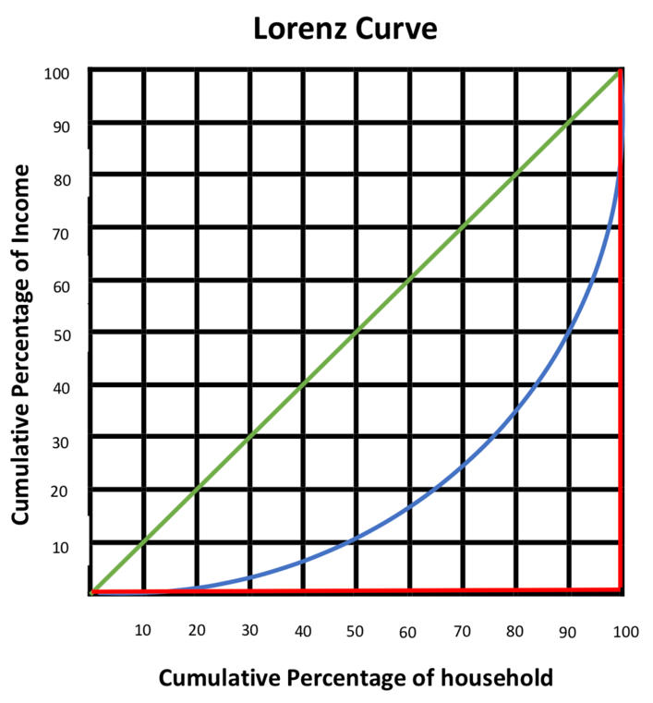
家庭累計百分比
累計收入百分比

12.5 Lorenz Curve洛倫茨曲線
Tips:
- Lorenz Cure洛倫茨曲線
Reminders:
- Trap 1
- From the graph, we are not able to know the actual amount of income people earn
- Cannot tell Country A’s people earn more than Country B’s people
- Trap 2
- From the graph, we can only know the income distribution
- Cannot tell the living standard of those countries
提示：
- 陷阱一
- 從圖中，我們無法知道人們的實際收入
- 分不清甲國人還是乙國人人掙得多
- 陷阱二
- 從圖中，我們只能知道收入分佈
- 分不清那些國家的生活水平

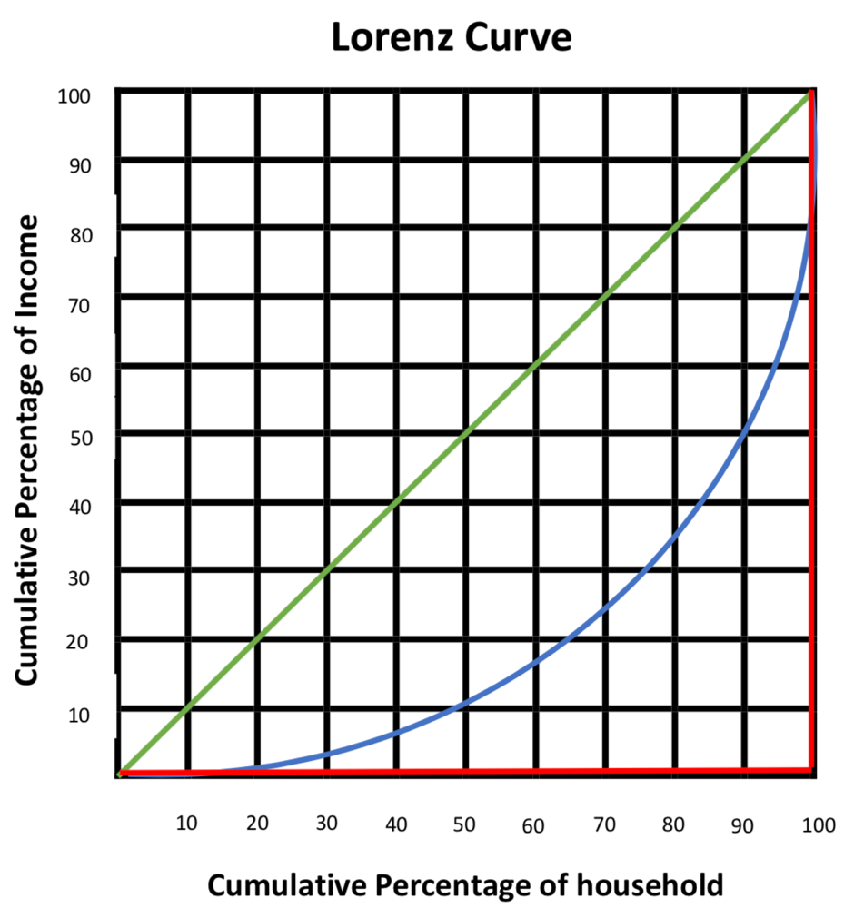
家庭累計百分比
累計收入百分比

- Income Equity  Country B > Country A > Country C | 1. 收入公平  .國家乙 > 國家甲 > 國家丙
- Country B Line of perfect income equality  Country C Line of perfect income inequality | - 國家乙 絕對平等線  國家丙 絕對不平等線
- If Lorenz curve is further away from the 45-degree line, it implies the income distribution of the economy is more unequal | - 如果洛倫茨曲線離45度線越遠，意味著經濟收入分佈越不平等
- X-axis % of households  Y-axis % of income | - X軸 家庭百分比  Y軸 收入百分比

12.5 Lorenz Curve Concept Corner:
1. In Lorenz Curve, Y-axis is showing the cumulative percentage of income T / F
在洛倫茨曲線中，Y 軸表示收入的累計百分比
∵
2. In Lorenz Curve, X-axis is showing the cumulative percentage of household T / F
在洛倫茨曲線中，X 軸表示家庭的累計百分比
∵
3. The 45-degree line is the perfect income inequality T / F
45 度線是完全收入不平等
∵
4. From the Lorenz Curve, we can see the change in actual income T / F
我們從洛倫茨曲線可以看出實際收入的變化
∵
5. From the Lorenz Curve, we can see the change in living standard T / F
從洛倫茨曲線可以看出生活水平的變化
∵
6. From the Lorenz Curve, we cannot see the change in cost of living T / F
從洛倫茨曲線看不到生活成本的變化
∵
7. The 90-degree line is the perfect income inequality T / F
90 度線是絕對不平等線
∵
8. If Lorenz curve is further away from the 90-degree line, it implies the income distribution of the economy is more unequal T / F
如果洛倫茨曲線離 90 度線越遠，意味著經濟的收入分佈越不平等
∵
9. If Lorenz curve is further away from the 45-degree line, it implies the income distribution of the economy is more unequal T / F
如果洛倫茨曲線遠離 45 度線，則意味著經濟的收入分佈更加不平等
∵
10. Post-tax-post-transfer implies the Lorenz Curve is calculated disposable income T / F
稅後轉移後意味著洛倫茨曲線計算可支配收入
∵

ANS: TTFFF TTFTT
12.6 Gini Coefficient堅尼系數
- Gini Coefficient堅尼系數/基尼系數
- Gini Coefficient is to measure the disparity between low-income group and high income group.  - Gini Coefficient is between 0 to 1,  - Country B: 0 (Absolute Income Equality)  - Country C: 1 (Complete Income Disparity)  - While 0 is the most even and 1 is the most uneven | - 堅尼系數的作用是用來衡量低收入組別人士和高收入組別人士之間的差距。  - 堅尼系數在0到1之間,  - B 國：0（絕對收入平等）  - C 國：1（完全收入差距）  - 所以0 是最平均的，1 是最不平均的
- Indicating Gini Coefficient  - 0.2 - 0.3 fairly equitable,  - 0.4 the international inequality threshold alert line,  - 0.4 - 0.5 fairly inequitable,  - Above 0.5 considerable disparity. | - 表示堅尼系數  - 0.2 - 0.3 相當公平，  - 0.4 國際不平等門檻警戒線，  - 0.4 - 0.5 相當不公平，  - 0.5以上差距較大。
- The Ratio of the area between the 45-degree line and the Lorenz curve to the total area below the  45-degree line (not above) | - 45度線與洛倫茨曲線之間的面積與曲線下方總面積之比  45度線（非上方）
- Impossible for Lorenz curve to be above the 45-degree line.  (Cumulative percentage of household income plotted starting from the household with the lowest cumulative income of the total household) | - 洛倫茨曲線不可能在45度線以上。  - (以累計收入佔總住戶最低的住戶為起點繪製的累計住戶收入百分比)
***  We do not know the actual amount of income and living standard when comparing the Gini Coefficient… | ***  我們在比較堅尼系數時並不知道實際的收入和生活水平…

12.6 Gini Coefficient Concept Corner:
1. In general, Gini Coefficient is between 0 to 1 T / F
一般來說，堅尼系數在0到1之間
∵
2. The change in Gini Coefficient implies change in actual income T / F
堅尼系數的變化意味著實際收入的變化
∵
3. Higher Gini Coefficient implies a worser income distribution T / F
較高的堅尼系數意味著較差的收入分佈
∵
4. Lower Gini Coefficient implies a worser income distribution T / F
較低的堅尼系數意味著較差的收入分佈
∵
5. 45-degree Lorenz Curve implies the Gini Coefficient is equal to 1 T / F
45 度洛倫茨曲線意味著堅尼系數等於 1
∵
6. 90-degree Lorenz Curve implies the Gini Coefficient is equal to 1 T / F
90 度洛倫茨曲線意味著堅尼系數等於 1
∵
7. When the ratio of the area between the 45-degree line and the Lorenz curve is divided by the total area below the 45-degree line ( ), the calculated value equals to Gini Coefficient. T / F
45度線與洛倫茨曲線之間的面積除以45度線以下的總面積( )，得出的比例數據等於堅尼系數
∵
8. It is impossible for Lorenz curve to be above the 45-degree line. T / F
洛倫茨曲線不可能在 45 度線以上。
∵
9. Living standard will be better if the Gini coefficient drops T / F
當堅尼系數下降，生活水平會更好。
∵
10. If Gini Coefficient is equal to 0, it implies absolute income equality T / F
如果堅尼系數等於0，意味著收入絕對平等
∵

ANS: TFTFF TTTFT
12.7 Limitation of Measuring Income Inequality衡量收入不平等的局限
- Limitation局限
- Different household sizes  - Households earning the same amount of income may have different household size | - 家庭規模不同  - 收入相同的家庭可能有不同的家庭人數
- Difficult to collect income data  - Some households may conceal income data  (E.g. people may hide part of their income sources) | - 難以採集收入數據  - 一些家庭可能會隱瞞收入數據  （例如，人們可能隱瞞部分的收入來源）
- Different definitions of income  - Some people may only count income from full-time job, some people may count income from transfer payment or from investment  (E.g. actual income and disposable income) | - 收入定義不同  - 有些人可能只計算全職工作的收入，有些人可能會計算來自轉移支付或來自投資的收入  - （例如實際收入和可支配收入）)
- Ignore Lifetime Income  - Some jobs start with low income and will increase over time  - (E.g. accountants, management trainees, bankers, etc…) | - 忽略終生收入  - 有些工作開始時收入很低，但會隨著時間的推移而增加  - （例如會計師、管理培訓生、銀行家等……）
- Ignore government policy  - Some countries may have a better government policy  (E.g. unemployment benefit, CSSA, transport allowance, etc…) | - 忽略政府政策  - 一些國家可能有更好的政府政策  - (例如失業金、綜援、交通津貼等…)

12.8 Sources of Income Inequality收入不平等的根源
- Different inborn abilities  - People with a higher IQ / better appearance are usually get a higher salary in the job market  - (E.g. Intelligence, appearance will affect income) | - 先天能力不同  - 智商更高 / 外貌更好的人通常在就業市場上獲得更高的收入  - （例如智力、外貌會影響收入）
- Different human capital / capital asset  - People with more human capital are tends to have a higher salary since they have more experience, better system.  - (E.g. Spend time and money to acquire better education higher income) | - 不同的人力資本 / 資本資產  - 擁有更多人力資本的人往往有更高的收入，因為他們有更多的經驗，更好的資本。  - （例如：花時間和金錢獲得更好的教育 更高的收入）
- Compensation differentials  - People who are willing to have a more dangerous jobs are tend to have a higher salary paid.  - (E.g. Leisure jobs usually lower income, Dangerous jobs usually higher income) | - 補償差異  - 願意從事更危險工作的人往往會獲得更高的收入。  - （例如，休閒工作 通常收入較低，危險工作 通常收入較高）
- Discrimination  - In different market / economies, there are many different kinds of discrimination, such as Asian usually get a lower paid than other foreigners in NBA.  - Some job markets may only hire females while some job markets may only hire males.  - (E.g. Sex discrimination / Racial discrimination) | - 歧視  - 在不同的市場 / 經濟體中，存在著多種不同的歧視，比如亞洲人在 NBA 中的收入通常低於其他外國人。  - 一些就業市場可能只僱用女性，而一些就業市場可能只僱用男性。  - （例如性別歧視 / 種族歧視）
- Geographical difference  - In USA, the average salary is higher than in Africa since their price level and living standard is not the same.  - (E.g. Demand and supply of the same type of worker are different in different region, China cheap labor) | - 地域差異  - 在美國，平均收入比非洲高，因為他們的物價水平和生活水平不一樣。  - （例如，同一類型工人的需求和供應在不同地區是不同的，中國 廉價勞動力）
12.9 Equalizing Income收入均等化
- Tax on the rich and transfer to the poor  - Tax: affect working incentive  - Transfer payment: discourage the unemployed to find jobs  - Inefficient | - 向富人徵稅並向窮人轉移  - 稅收：影響工作誘因  - 轉移支付：阻礙失業人士就業  - 低效率
- Minimum Wage Law  - Increase unemployment → inefficient  - There is often a trade-off between equity and efficiency  - (Average income tends to increase while Total income is uncertain)  - (Low-skill labor may become unemployed) | - 最低工資  - 失業率增加 →低 效率  - 公平與效率之間通常存在取捨  - （平均收入增加，而總收入不確定）  - （低技術勞動力可能會失業）
12.10 Equalizing Opportunity機會均等化
- Protection against discrimination  - Fair competition legislation  - Free education | - 防止歧視  - 公平競爭立法  - 免費教育
Tips:

12.9 Equalizing Income & 12.10 Equalizing Opportunity Concept Corner:
1. Equalizing income is opposing equalizing opportunity T / F
收入均等化與機會均等化是對立的
∵
2. A policy can only either improving income or improving opportunity T / F
一項政策只能提高收入或增加機會
∵
3. Improving opportunity implies increasing their future income earning ability T / F
機會均等化意味著增加他們未來的收入賺取能力
∵
4. A higher post-tax-post-transfer Gini Coefficient implies the government adopting a regressive tax system T / F
較高的除稅後及轉移支付後的堅尼系數意味著政府採用累退稅制
∵
5. Distributing a fixed amount of cash subsidies does not lead to a better income distribution T / F
分配固定數額的現金補貼並不能帶來更好的收入分佈
∵
6. Extending the free education helps equalizing better opportunity T / F
延長免費教育的時間有助於更好的機會均等化
∵

ANS: FFTFF T

Tips:

12.11 Equalizing Income and Opportunity Demo收入和機會均等化框架
Case 1: To extend the free education to 15 years  Equalizing Opportunities:  - Free education for longer years means that the poor are able to receive more education and improve their productivity and hence income-earning power in the future. | 案例一：免費教育延長至15年  機會均等化：  - 更長時間的免費教育意味著低收入組別人士能夠接受更多的教育並提高他們的生產力，從而提高他們未來提高收入的能力。
Case 2: To provide unemployment benefit  Equalizing Income:  - More welfare payments to the unemployed could help to reduce the income inequality between the employed (rich) and the unemployed (poor) | 案例二：提供失業救濟金  收入均等化：  - 向失業者提供更多福利可能有助於減少就業者（富人）和失業者（窮人）之間的收入不平等
Case 3: $6,000 Cash sharing  Equalizing Income:  - The $6,000 results in a higher percentage increase in the income of the poor  Equalizing Opportunities:  - It does not help equalizing opportunities. Relative to the rich, the poor do not get more resources to improve their productivity / increase future income | 案例 3：$6,000 現金分享  收入均等化：  - 6,000元導致窮人的收入增加百分比更高  機會均等化：  - 它無助於機會均等化。相對於富人，窮人沒有獲得更多資源來提高生產力 / 增加未來收入

12.11 Equalizing Income and Opportunity Demo收入和機會均等化框架
Case 4: Provide community-based primary care services, targeting the elderly, low-income individuals and patients with chronic diseases.  Equalizing Income:  - Basic medical service act like a transfer or subsidy-in-kind, enjoyed mainly by the low-income group; The high-income group may choose not to “queue up” for such medical benefits and turn to private medical services instead. | 案例 4：提供以社區為基礎的初級保健服務，針對老年人、低收入組別人士和慢性病患者。  收入均等化：  - 基本醫療服務作為轉移支付或實物補貼，主要由低收入組別人士享受；高收入組別人士可以選擇不“排隊”享受此類醫療福利，轉而尋求私人醫療服務。
Case 5: Raising the fee of the emergency car service  Equalizing Income:  - After the fee raise, the poor may no longer be able to afford the fee and thus be deprived of the opportunity to enjoy the medical services. Equity may be worsened as the poor cannot enjoy the transfer / subsidy while the rich can still use the service. | 案例五：提高急救車服務費  收入均等化：  - 加價後，窮人可能再也負擔不起費用，從而失去享受醫療服務的機會。公平性可能會惡化，因為窮人無法享受轉移 / 補貼，而富人仍然可以使用該服務。

12.11 Equalizing Income and Opportunity Demo收入和機會均等化框架
Case 6: Introduce a per-unit subsidy to the education services of private universities  Equalizing Opportunity:  - Subsidizing education is a measure to equalize opportunities, so the poor will not be deprived from university education because of their background. Education also improves their future income, thus reducing income inequality over generations. | 案例 6：按單位設立私立大學的教育服務補貼  機會均等化：  - 資助教育是一種機會均等化的措施，這樣窮人就不會因為出身而被剝奪接受大學教育的權利。教育還可以提高他們未來的收入，從而減少幾代人的收入不平等。
Case 7: A government introduces an allowance for low-income working families with the following objectives:  (1) Encourages members of low-income families to remain employed.  (2) Offers support for children from low-income families so as to promote upward mobility.  Equalizing Income:  - The allowance raises the cost of being unemployed. Therefore, more workers from low-income families will remain employed.  Equalizing Opportunity:  - An additional allowance will be provided for each child. Hence, children from low-income families may have more educational opportunities.  - The extra income may be spent on daily necessities rather than education. The children may not have more opportunities to move upwards. | 案例 7：政府為低收入工薪家庭提供津貼，  目標如下：  (1) 鼓勵低收入家庭成員繼續就業。  (2) 支援低收入家庭子女，促進向上流動  收入均等化：  - 津貼增加了失業的成本。因此，更多來自低收入家庭的工人將繼續就業。  機會均等化：  - 將為每個孩子提供額外津貼。因此，來自低收入家庭的孩子可能有更多的教育機會。  - 額外的收入可能會花在生活必需品上，而不是教育上。孩子們可能沒有更多的機會向上流社會移動。
12.12 Multiple Choice Question Flow選擇題框架
Type 1:

Type 2: Cross topic with Ch16 Fiscal Policy…

12.13 Long Question Flow長題目框架
Type 1: Limitation of Measuring the Income Inequality
類型 1：測量收入不平等的局限性
1. Show the Topic Sentence | 1. 顯示中心句
2. Further explanation | 2. 更深入的解釋
3. Provide examples if available | 3. 如有的話，提供例子
- Ignore Lifetime Income  - Some jobs start with low income and will increase over time  - (E.g. accountants, management  trainees, bankers, etc…) | - 忽略終生收入  - 有些工作開始時收入很低，但會隨著時間的推移而增加  - （例如會計師、管理人員、實習生、銀行家等……）
- Ignore government policy  - Some countries may have a better government policy (E.g. unemployment benefit, CSSA, transport allowance, etc…) | - 忽略政府政策  - 一些國家可能有更好的政府政策  - （例如失業救濟金、CSSA、交通津等……）

Type 2: Sources of Income Inequality
類型 2：收入不平等的根源
1. Show the Topic Sentence | 1. 顯示中心句
2. Further explanation | 2. 更深入的解釋
3. Provide examples if available | 3. 如有的話，提供例子
- Different inborn abilities / Different human capital / capital asset / Compensation differentials / Discrimination / Geographical different | - 不同的先天能力 / 不同的人力資本 / 資本資產 / 薪酬差異 / 歧視 / 地域差異

*Type 3: Equity
*類型 3：公平性
1. Show Income / Opportunity | 1. 顯示收入 / 機會
2. Explanation with key words | 2. 用關鍵字解釋
1. improve their productivity and hence income-earning power in the future ( )
提高他們的生產力，從而提高他們未來的創收能力

2. a higher percentage increase in the income of the poor, narrowing the IG ( )
窮人收入有更高百分比的增長，縮小了收入差距

3. will not be deprived from XXX because of their background ( )
不會因為他們的背景而被剝奪XXX

4) fixed transfer payment takes a larger proportion of income to LIG than HIG ( )
固定轉移支付對低收入者的收入佔比高於高收入者

NOTES

