Learning Focus:
Memo
(LQ Answering Flow, MC skills, your goals and resolutions…)
Specific Question Type
MC

咩話？DSE Sample Paper, Practice Paper, 2012, 2013, 2014, 2015, 2016, 2017, 2018, 2019, 2020, 2021, 2022
MC全部拍晒解題片？係呀，有唔明即scan即睇！就係咁firm！


Learning Focus:
Memo
(LQ Answering Flow, MC skills, your goals and resolutions…)
Specific Question Type
LQ

咩話？DSE Sample Paper, Practice Paper, 2012, 2013, 2014, 2015, 2016, 2017, 2018, 2019, 2020, 2021, 2022
LQ全部拍晒解題片？係呀，有唔明即scan即睇！就係咁firm！


Chapter 20 _ Monetary Policy
Type 1 (Monetary policy / Change in money cross topic with MDMS)
Example Question 1 DSEPPMCQ25
Which of the following can explain a leftward shift of the money demand curve?
A. a rise in the interest rate B. an increase in income of households
C. a more widespread use of Octopus cards D. an increase in the required reserve ratio

下列哪項能解釋貨幣需求曲線向左移?
A. 利率上升 B. 住戶收入增加
C. 人們更廣泛使用八達通卡 D. 法定儲備比率增加

Example Question 2 DSEPPMCQ26
The diagram below shows the money demand and money supply curves of an economy. The original equilibrium point is at E.
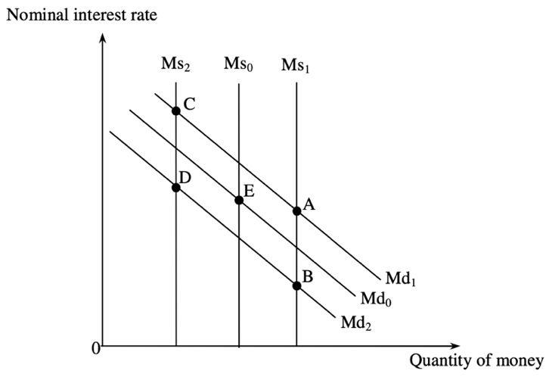
Suppose national income increases and the government carries out an open market purchase of bonds. The new equilibrium point will be at __________.
A. A B. B C. C D. D

下圖顯示某經濟的貨幣需求和貨幣供應曲線。起初的均衡點是 E。
假設國民收入增加而政府在公開市場購入債券。新的均衡點是 __________。
A. A B. B C. C D. D

Example Question 3 DSESPMCQ30
Which of the following may cause an increase in money supply?
(1) The central bank raises the discount rate
(2) The central bank lowers the required reserve ratio
(3) The central bank purchases government bonds from a commercial bank
A. (1) and (2) only B. (1) and (3) only C. (2) and (3) only D. (1), (2) and (3)

下列哪項會導致貨幣供應增加？
(1) 中央銀行提高貼現率
(2) 中央銀行降低法定儲備比率
(3) 中央銀行向一家商業銀行購買政府債券
A. 只有(1)、(2) B. 只有(1)、(3) C. 只有(2)、(3) D. (1)、(2)、(3)

Example Question 4 DSE2012MCQ30
Online shopping has become more popular, and hence people hold less cash for transaction purposes. Which of the following measures can be adopted by a central bank to reduce the effect of the above situation on the interest rate?
(1) An increase in discount rate
(2) An increase in required reserve ratio
(3) An open market purchase of government bonds
A. (1) and (2) only B. (1) and (3) only C. (2) and (3) only D. (1), (2) and (3)

網上購物日漸普及，人們因而持有較少現金作交易用途。中央銀行可採用下列哪些措施以減低上述情況對利率的影響？
(1) 提高貼現率
(2) 提高法定儲備比率
(3) 在公開市場購入政府債券
A. 只有(1)、(2) B. 只有(1)、(3) C. 只有(2)、(3) D. (1)、(2)、(3)

***Example Question 5 DSE2013MCQ28
An expansionary monetary policy is adopted in China when
(1) The Ministry of Finance provides cash subsidies to agricultural workers
(2) The People’s Bank of China reduces the required reserve ratio of all commercial banks.
(3) The Bank of China lowers its lending rate to small and medium-sized enterprises.
A. (1) only B. (2) only C. (3) only D. (1), (2) and (3)

在下列哪種情況下，中國正採取擴張性貨幣政策？
(1) 財務部向農民提供現金補貼
(2) 中國人民銀行調低所有商業銀行的法定儲備比率
(3) 中國銀行減低中小企業的借貸利率
A. 只有(1) B. 只有(2) C. 只有(3) D. (1)、(2)及(3)

Example Question 6 DSE2015MCQ32
The monetary base increases when
A. The commercial banks hold less excess reserves. B. The commercial banks buy government bonds from the public.
C. The central bank buys government bonds from the public. D. The central bank increases the discount rate.

當____, 貨幣基礎增加。
A. 商業銀行持有較少超額儲備 B. 商業銀行向大眾購買政府債券
C. 中央銀行向公眾購買政府債券 D. 中央銀行調高貼現率

Example Question 7 DSE2017MCQ32
The diagram below shows the money demand and supply curves of an economy. The original equilibrium point is at E.
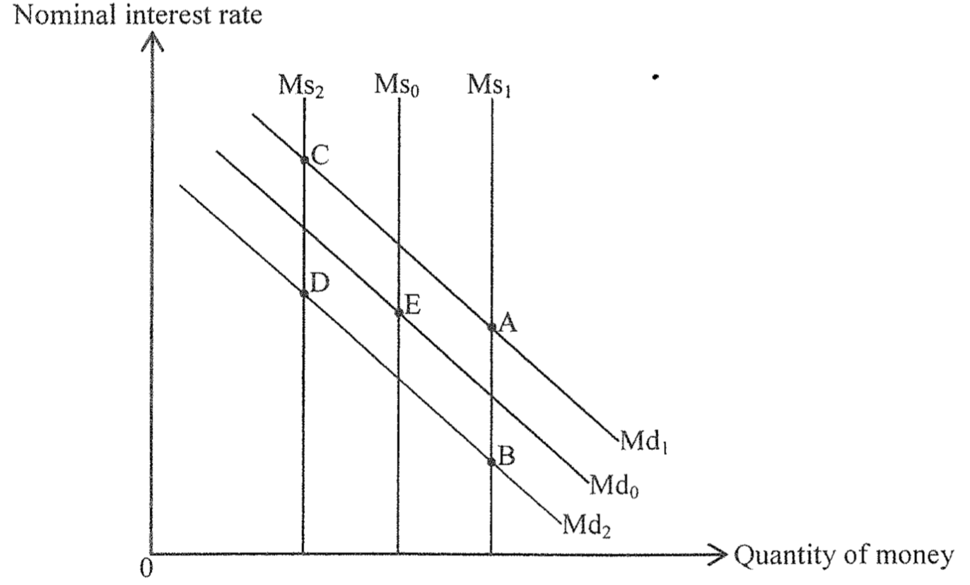
Suppose the risk of holding interest bearing assets (such as bonds) increases and the central bank reduces the discount rate. The new equilibrium point will be at _____.
A. A B. B C. C D. D

假設持有帶息資產(例如債券)的風險增加，而中央銀行下調其貼現率。新的均衡點會是____。
A. A B. B C. C D. D
Example Question 8 DSE2018MCQ30
Which of the following will lead to a reduction in monetary base?
A. The central bank increases the required reserve ratio B. The central bank purchases the government bonds from the public
C. The central bank raises the discount rate D. The commercial banks hold more excess reserve

下列哪項會令貨幣基礎下降？
A. 中央銀行增加法定儲備比率 B. 中央銀行從公眾購入政府債券
C. 中央銀行提高貼現率 D. 商業銀行持有更多超額儲備

Example Question 9 DSE2019MCQ33
The diagram below shows the money supply and money demand curves of an economy. The original equilibrium point is at E.

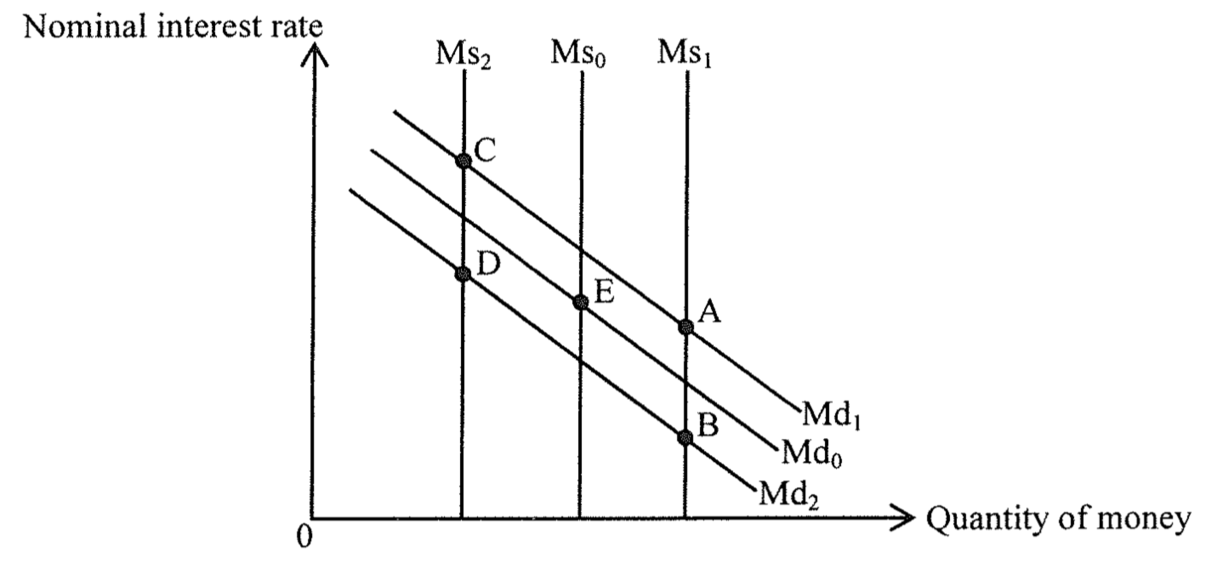

Suppose electronic payments become more common, and the central bank increase the legal reserve ratio of the commercial banks. The new equilibrium point will be at _____.
A. A B. B C. C D. D

下圖顯示某經濟的貨幣供應和貨幣需求曲線。原初的均衡點是E
假設電子支付越見普及，而中央銀行提高商業銀行的法定儲備比率。新的均衡點會是____。
A. A B. B C. C D. D

Example Question 10 DSE2020MCQ31
The following diagram indicates the money supply curve (M_{s}) and money demand curve (M_{d}) of a certain economy. Suppose the initial equilibrium point is at point E.

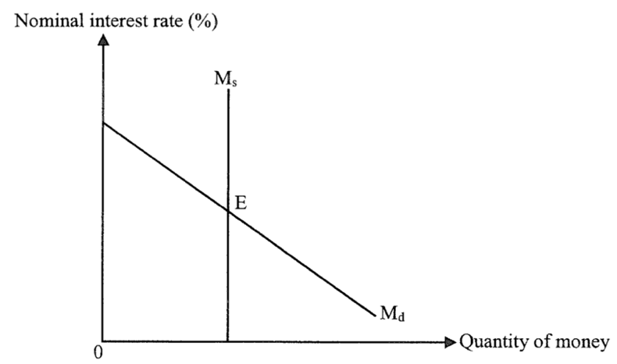

If the income of the public increases and the central bank sells government bonds to the public, the interest rate _________ and the quantity of money ________.
A. will increase …… will increase B. will increase …… may increase or decrease
C. may increase or decrease …… will decrease D. will increase …… will decrease

下面顯示某經濟的貨幣供應曲線（Ms）和貨幣需求曲線（Md）。假設原初均衡點是E。
若公眾的收入增加，而中央銀行向公眾發售政府債券，則利率____，貨幣數量____。
A. 會減少 …… 會增加 B. 會增加 …… 可能增加或減少
C. 可能增加或減少 …… 會減少 D. 會增加 …… 會減少

Example Question 11 DSE2021MCQ33
The diagram below shows the money demand and money supply curves of an economy. The original equilibrium point is at E.

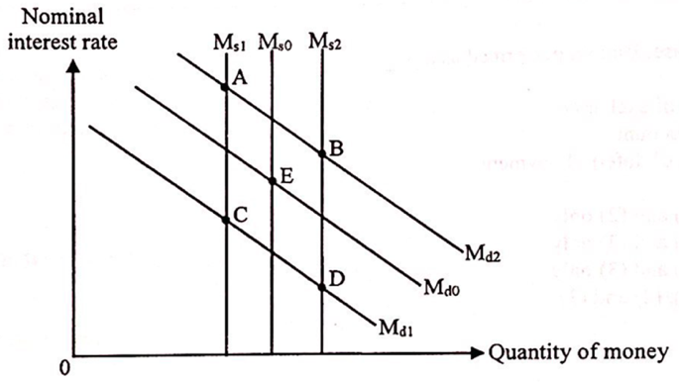

Suppose the stock market becomes more volatile. At the same time, the central bank decides to redeem government bonds from the public. The new equilibrium point will be at _______.
A. A B. B C. C D. D

下圖顯示某經濟的貨幣需求和貨幣供應曲線。原初均衡點是E。
假設股市日趨波動。同時，中央銀行決定向公眾贖回政府債券。新的均衡點會是____。
A. A B. B C. C D. D

Type 1 (Monetary policy / Change in money cross topic with MDMS)

Type 2 (Monetary policy / Change in money supply cross topic with ADAS & Fiscal Policy)

Example Question 1 DSESPMCQ33
In the long run, a change in money supply will NOT affect
A. the price level B. the real output C. the nominal demand for money D. all of the above

在長期而言，貨幣供應的轉變不會影響
A. 物價水平 B. 實質產出 C. 名義貨幣需求 D. 以上均正確

Example Question 2 DSESPMCQ35
During unemployment, an increase in money supply will NOT raise
A. the real national income. B. the nominal national income. C. the price level. D. the potential income.

當有失業時，貨幣供應增加不會使____增加/上升。
A. 實質國民收入 B. 名義國民收入 C. 物價水平 D. 潛在收入

Example Question 3 DSEPPMCQ32
Which of the following can help narrow a deflationary (output) gap?
A. an increase in the required reserve ratio B. a sale of bonds by the central bank in the market
C. an increase in government expenditure D. the abolishment of a tariff on imports

下列哪項有助收窄通縮（產出）缺口
A. 法定儲備比率增加 B. 中央銀行在市場售賣債券
C. 政府支出增加 D. 撤銷進口關稅

Example Question 4 DSEPPMCQ34
An increase in ______ may offset the effect of an expansionary monetary policy on national income.
(1) people’s desire to hold money as an asset
(2) people’s desire to save
(3) transfer payments
A. (1) and (2) only B. (1) and (3) only C. (2) and (3) only D. (1), (2) and (3)

_______有所增加可能會抵銷擴張性貨幣政策對國民收入造成的影響。
(1) 人們持有貨幣作為資產的意欲
(2) 人們的儲蓄意欲
(3) 轉移支付
A. 只有(1)、(2) B. 只有(1)、(3) C. 只有(2)、(3) D. (1)、(2)及(3)

Example Question 5 DSE2012MCQ36
Which of the following can offset the effect of a decrease in income tax rate on aggregate demand?
A. A decrease in the asset demand for money B. A decrease in the desire to import
C. An increase in the desire to invest D. An increase in the required reserve ratio

下列哪項能抵銷入息稅稅率下降對總需求的影響？
A. 資產性貨幣需求下降 B. 進口意欲下降
C. 投資意欲上升 D. 法定儲備比率上升
Example Question 6 DSE2013MCQ24
The diagram below shows the aggregate demand (AD) curve, the short run aggregate supply (SRAS) curve and the long run aggregate supply (LRAS) curve of an economy.
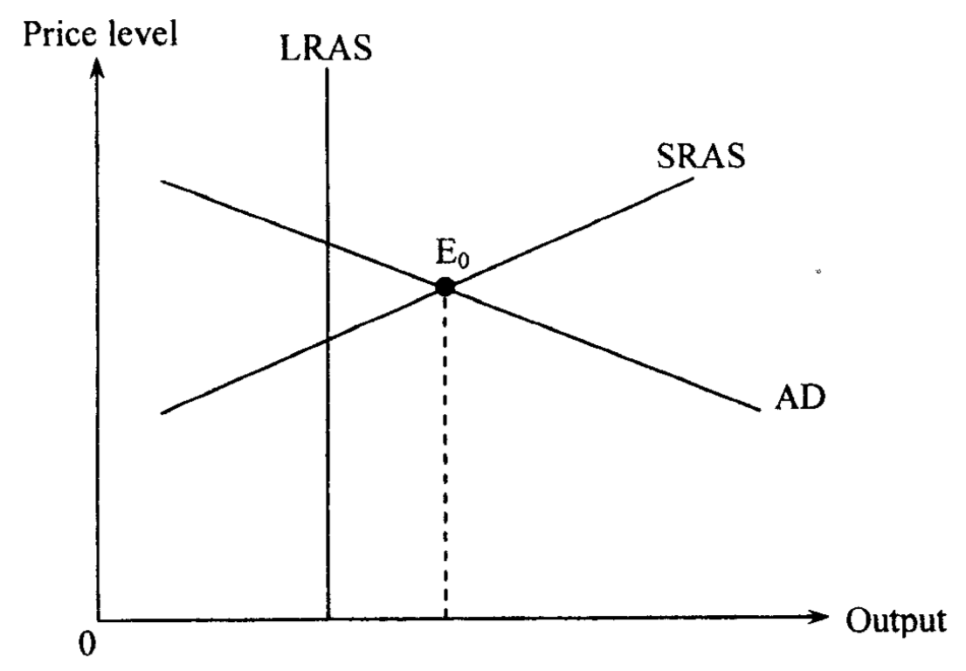
Suppose initially the economy operates at E₀. There is a/an _____ and _____ can help restore the long run equilibrium.
A. Inflationary (output) gap … a rise in transfer payments to the poor B. Inflationary (output) gap … a rise in the discount rate
C. Deflationary (output) gap … a rise in transfer payments to the poor D. Deflationary (output) gap … a rise in the discount rate

下圖顯示某經濟的總需求（AD）曲線、短期總供應（SRAS）曲線及長期總供應（LRAS）曲線。
假設原初該經濟在E₀ 運作，這出現了______而_____可幫助這經濟回復至長期均衡
A. 通脹（產出）差距 …… 增加對貧窮人士的轉移支付 B. 通脹（產出）差距 …… 增加貼現率
C. 通縮（產出）差距 …… 增加對貧窮人士的轉移支付 D. 通縮（產出）差距 …… 增加貼現率

Example Question 7 DSE2013MCQ31
Initially an economy operates at the full-employment equilibrium and the government expenditure equals its tax revenue. Which of the following will result in a coexistence of deflationary (output) gap and budget deficit?
A. A reduction in taxes B. A reduction in money supply
C. A reduction in government expenditure D. A reduction in desire to import

原初某經濟在全民充分就業均衡運作，而政府支出相等於其稅項收入。下列哪項會導致通縮（產出）差距和赤字預算同時出現
A. 減稅 B. 減少貨幣供應 C. 減少政府支出 D. 進口意欲下降
Example Question 8 DSE2014MCQ35
Which of the flowing policies can the government introduce to reduce the price and unemployment levels at the same time?
A. To raise the discount rate B. To raise the subsidies to small and medium-sized enterprises
C. To raise the salaries tax rate D. To raise the expenditure on social welfare

政府可以採取哪項政策同時調低物價和失業水平？
A. 提高貼現率 B. 增加對中小企的補貼
C. 提高薪俸稅率 D. 增加社會福利支出

Example Question 9 DSE2015MCQ26
Which of the following will result in a rightward shift of the aggregate demand curve of a country?
A. The central bank reduces the discount rate. B. The minimum wage rate is increased.
C. The general price level decreases. D. Its trading partner suffer from an economic recession.

下列哪項會導致某國的總需求線向右移？
A. 中央銀行調低貼現率 B. 提高最低工資
C. 一般物價水平下降 D. 其貿易夥伴遭逢經濟衰退

Example Question 10 DSE2015MCQ32
The monetary base increases when
A. The commercial banks hold less excess reserves. B. The commercial banks buy government bonds from the public.
C. The central bank buys government bonds from the public. D. The central bank increases the discount rate.

當____, 貨幣基礎增加
A. 商業銀行持有較少超額儲備 B. 商業銀行向公眾購買政府債券
C. 中央銀行向公眾購買政府債券 D. 中央銀行調高貼現率

Example Question 11 DSE2015MCQ38
Initially an economy operates at the long-run equilibrium. Which of the following will lead to a deflationary (output) gap in the economy?
A. The government increases the salaries tax rate.
B. The government reduces the profits tax rate.
C. The government invests in the construction of a cross-border express rail link.
D. The central bank reduces the required reserve ratio.

某經濟原初的運作處於它的長期均衡。下列哪項會令該經濟出現通縮（產出）差距？
A. 政府提高薪俸稅率 B. 政府減低利得稅率
C. 政府投資興建高鐵 D. 中央銀行降低法定儲備比率
Example Question 12 DSE2016MCQ26
The aggregate demand of a country will drop if
A. The price level of the country rises. B. The currency of its major trading partner appreciates.
C. The government spending on social welfare rises. D. The required reserve ratio rises.

在下列哪種情況下，某國的總需求會下降？
A. 該國的物價水平上升。 B. 該國主要貿易夥伴的貨幣升值。
C. 政府的社會福利開支上升。 D. 法定儲備比率上升。

Example Question 13 DSE2017MCQ37
Which of the following policies would most likely lead to a drop in aggregate output?
A. The government bought bonds from the public and raised the tax allowance at the same time
B. The government sold bonds to the public and reduced transfer payment to the poor at the same time
C. The government reduced required reserve ratio and raised the progressivity of income tax at the same time
D. The government increased the discount rate and lowered profits tax rate at the same time.

下列哪些政策最有可能會令總產出下降
A. 政府向公眾購入債券而同時提高免稅額 B. 政府向公眾出售債券而同時減少給予窮人的轉移支付
C. 政府調低法定儲備比率而同時調高入息稅的累進程度 D. 政府調高貼現率而同時調低利得稅稅率

Example Question 14 DSE2017MCQ38
To reduce fiscal deficits, the government may adopt either contractionary fiscal policy (increase taxes and/ or decrease fiscal spending) or expansionary monetary policy (e.g. finance the deficits by printing money).
Refer to a situation of an upward-sloping short run aggregate supply curve. Which of the following are the advantages of using expansionary monetary policy over contractionary fiscal policy to reduce fiscal deficits?
- The employment level will be higher
- The purchasing power of money will be higher
- The real output level will be higher
A. (1) and (2) only B. (1) and (3) only C. (2) and (3) only D. (1), (2) and (3)
為了減低財政赤字，政府可以採用緊縮性財政政策（例如加稅及/或減少財政開支）或是擴張性貨幣政策（例如發行鈔票為赤字融資。）
參考短期總供應曲線向右上斜的情況。與緊縮性財政政策相比，下列哪些是利用擴張性貨幣政策以減低財政赤字的優勝之處？
(1) 就業水平會較高
(2) 貨幣的購買力會較高
(3) 實質產出水平會較高
A. 只有(1)、(2) B. 只有(1)、(3) C. 只有(2)、(3) D. (1)、(2)及(3)

Example Question 15 DSE2018MCQ38
Suppose there is a reduction in the basic allowance of the salaries tax in an economy. Which of the following can offset its effect on aggregate demand?
A. People’s desire to save increases
B. The price level decreases.
C. The central bank carries out an open market sale of government bonds.
D. The required reserve ratio in the banking system decreases.

假設某經濟中薪俸稅的基本免稅額下降了。下列哪項可以抵銷其對總需求的影響。
A. 人們的儲蓄意欲增加 B. 物價水平下降
C. 中央銀行於公開市場購買債券 D. 銀行系統的法定儲蓄比率下降

Example Question 16 DSE2018MCQ39
Refer to the AS-AD diagram below.

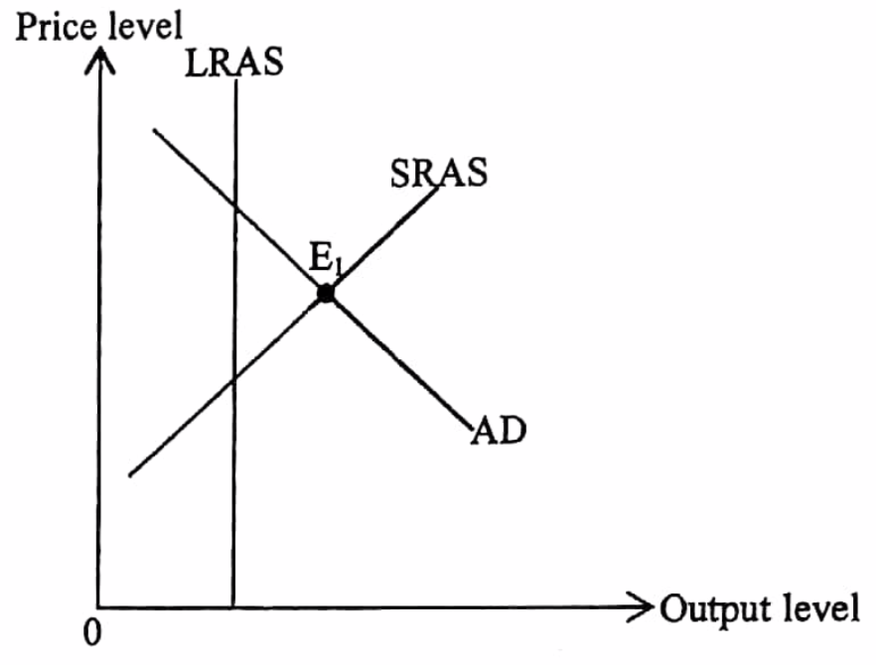
The economy operates at E1 initially. Which of the following can help the economy restore to the long run equilibrium?
- To reduce the subsidies to small enterprises
- To increase the required reserve ratio
- To reduce the discount rate
- To reduce property tax
A. (1) and (2) only B. (3) and (4) only C. (1), (2) and (3) only D (2), (3) and (4) only

參考一下的總供需圖
原初該經濟在E1 運作。下列哪些能幫助該經濟回復至長期均衡?
(1) 減少對小型企業的補貼
(2) 提高法定儲蓄比率
(3) 減低貼現率
(4) 減低物業稅
A. 只有(1)、(2) B. 只有(3)、(4) C. 只有(1)、(2)及(3) D. 只有(2)、(3)及(4)
Example Question 17 DSE2019MCQ38
The government carried out the following two policies:
Policy one : | Reduce the profits tax rate for corporations with profit less than two million dollars.
Policy two : | Inject fifty billion dollars to develop innovation and technology.
Which of the following AD-AS diagrams could most likely show the effect on aggregate output caused by the above two policies?
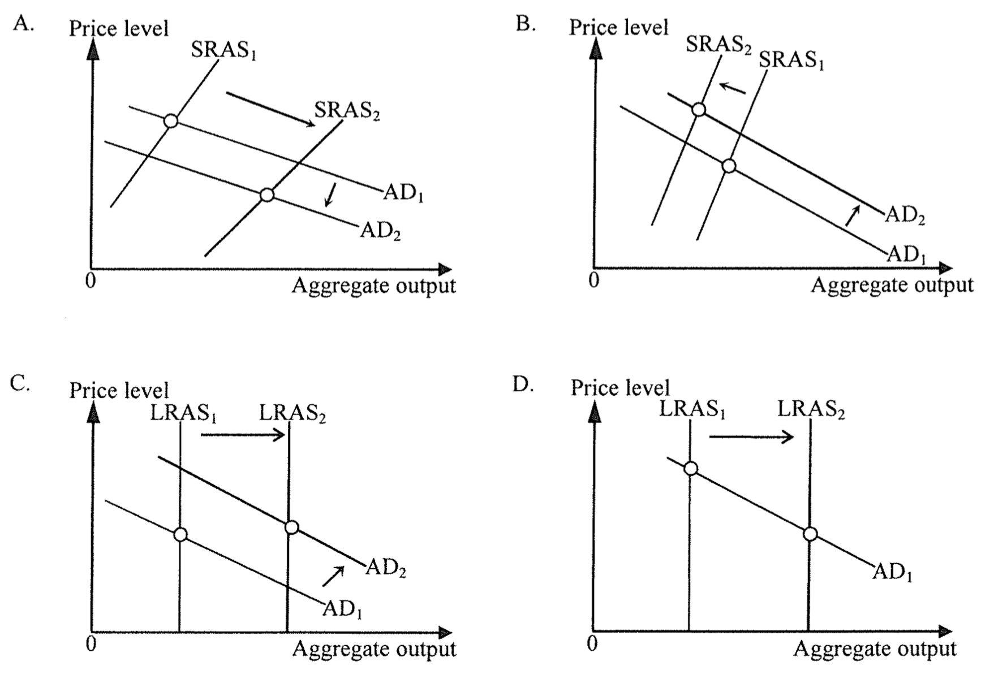

政府實施下列兩項政策
政策一： | 減低盈利低於二百萬的公司之利得稅稅率
政策二： | 投入五百億，發展創新科技
下列哪幅總供需圖最能顯示上述兩項政策對總產出的影響
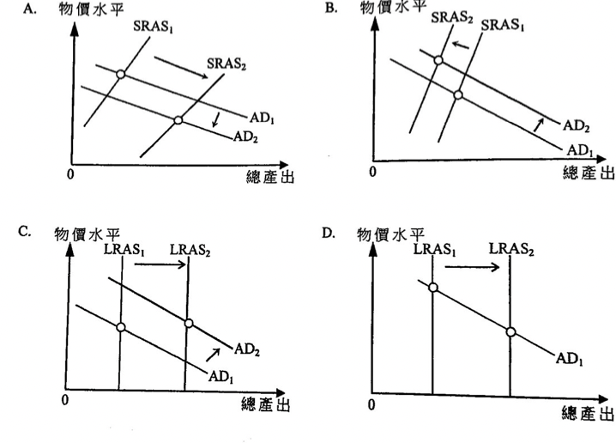
Example Question 18 DSE2019MCQ41
Study the following tale.
Policy I | Policy II | Policy III
- An open market purchase of government bonds  - A rise in the discount rate | - An open market purchase of government bonds  - A rise in the salaries tax allowance | - A rise in the salaries tax allowance  - A rise in the discount rate
Which of the following policies in the above table is / are expansionary?
A. Policy I only B. Policy II only C. Policy III only D. Policy I and Policy III only.

細閱下表。
政策I | 政策II | 政策III
- 在公開市場購入政府債券  - 提高貼現率 | - 在公開市場購入政府債券  - 增加薪俸稅免稅額 | - 增加薪俸稅免稅額  - 提高貼現率
上表哪項 / 些政策是擴張性的？
A. 只有政策I B. 只有政策II C. 只有政策III D. 只有政策I 及政策III

Type 2 (Monetary policy / Change in money supply cross topic with ADAS & Fiscal Policy)

Type 3 (Equation of Exchange EOE and Quantity Theory of Money QTM)
Example Question 1 DSESPMCQ32
The classical quantity theory of money
(1) predicts that changes in money supply may have no effect on the general price level.
(2) predicts that changes in nominal national income are positively related to changes in money supply.
(3) assumes that the velocity of circulation of money is constant.
A. (1) and (2) only B. (1) and (3) only C. (2) and (3) only D. (1), (2) and (3)

古典貨幣數量論
- 推斷貨幣供應的轉變可能不會影響一般物價水平。
(2) 推斷名義國民收入的轉變與貨幣供應的轉變是正比關係。
(3) 假設貨幣流動速度不變。
A. 只有(1)、(2) B. 只有(1)、(3) C. 只有(2)、(3) D. (1), (2)及(3)

Example Question 2 DSEPPMCQ33
Which of the following statements about the classical quantity theory of money is INCORRECT?
A. Both the velocity of circulation of money and the real output are assumed to be constant.
B. Any change in money supply will lead to the same proportional change in nominal output.
C. Deflation will occur when there is a continuous fall in money supply.
D. Any change in price level will lead to the same proportional change in money supply.

下列那項有關古典貨幣數量論的陳述是不正確的？
A. 貨幣流通速度和實質產出均假設為不變。
B. 任何貨幣供應的改變均會導致名義產出產生同等比例的改變。
C. 當貨幣供應不斷下降時，通縮便會出現。
D. 任何物價水平的改變會導致貨幣供應產生同等比例的改變。

Example Question 3 DSE2013MCQ32
The real output of an economy grows at a lower rate than the money supply. According to the quantity theory of money, we can conclude that
(1) The price level is increasing
(2) The unemployment rate is decreasing
(3) The velocity of circulation of money is decreasing
(4) The nominal output is increasing
A. (1) and (2) only B. (1) and (4) only C. (2) and (3) only D. (3) and (4) only

某經濟的實質產出有所增長，其增長率較貨幣供應的增長率為低。根據貨幣數量論，我們可得出結論如下:
(1) 物價水平正上升。
(2) 失業率正下降。
(3) 貨幣流通速率正下降。
(4) 名義產出正上升。
A. 只有(1)、(2) B. 只有(1)、(4) C. 只有(2)、(3) D. 只有(3)、(4)

Example Question 4 DSE2014MCQ37
Suppose the velocity of circulation of money remains constant. If a central bank reduces money supply by 10%,
A. The price level will decrease by 10% B. Real output will decrease by 10%
C. Nominal output may decrease by less than 10% D. Real output may decrease by less than 10%

假設貨幣流通率維持不變。若中央銀行減少貨幣供應10%，
A. 物價水平會下降10%。 B. 實質產出會下降10%。
C. 名義產出可能下跌少於10%。 D. 實質產出可能下跌少於10%。

Example Question 5 DSE2015MCQ33
The quantity theory of money implies that
A. An increase in money supply will lead to a rise in price level when real output is falling.
B. The economy is always at the full employment output level.
C. An increase in money supply will lead to a decrease in the velocity of circulation of money when real output is kept constant.
D. An increase in money supply will lead to a same-proportional increase in real output.

貨幣數量論意味着
A. 當實質產出正在下降，增加貨幣供應會令物價水平上升。
B. 該經濟一直處於全民就業產出水平。
C. 當實質產出維持不變，增加貨幣供應會令貨幣流通速率下降。
D. 增加貨幣供應會令實質產出有相同比例的提升。

Example Question 6 DSE2016MCQ34
According to the classical quantity theory of money, which of the following diagrams is correct when money supply is growing at a constant percentage each year?
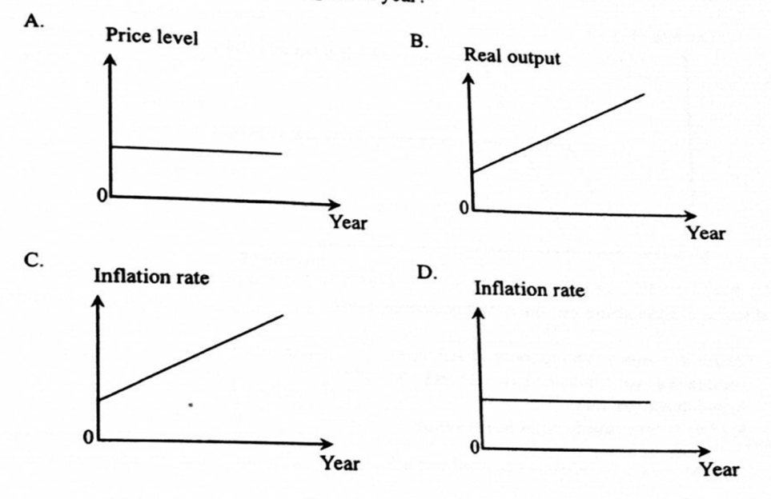
根據古典貨幣數量論，當每年的貨幣供應以一固定的百分率增長時，下列那幅圖是正確的？
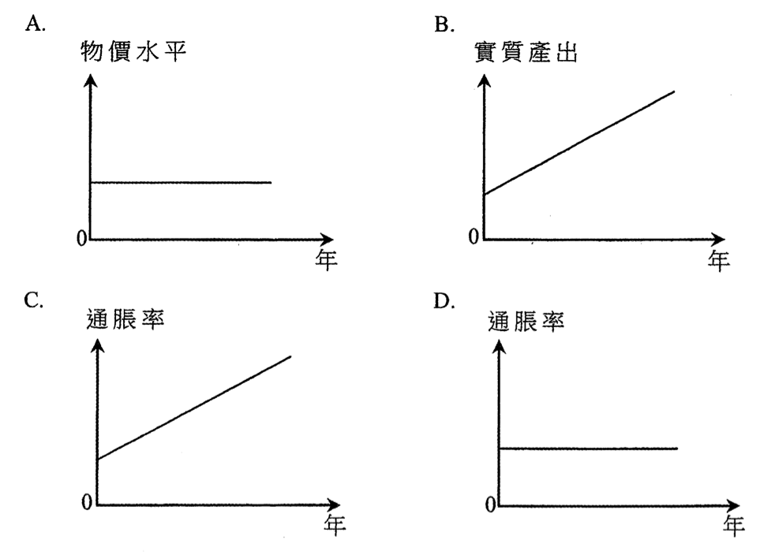
Example Question 7 DSE2017MCQ36
According to the quantity theory of money, if a central bank increases money supply,
A. The price level will increase B. Real output will remain constant
C. Nominal output will increase D. The unemployment rate will decrease

根據貨幣數量論，若中央銀行增加貨幣供應，
A. 物價水平會上升。 B. 實質產出會維持不變。
C. 名義產出會上升。 D. 失業率會下降。

Example Question 8 DSE2018MCQ37
Refer to the following diagram 參考下圖
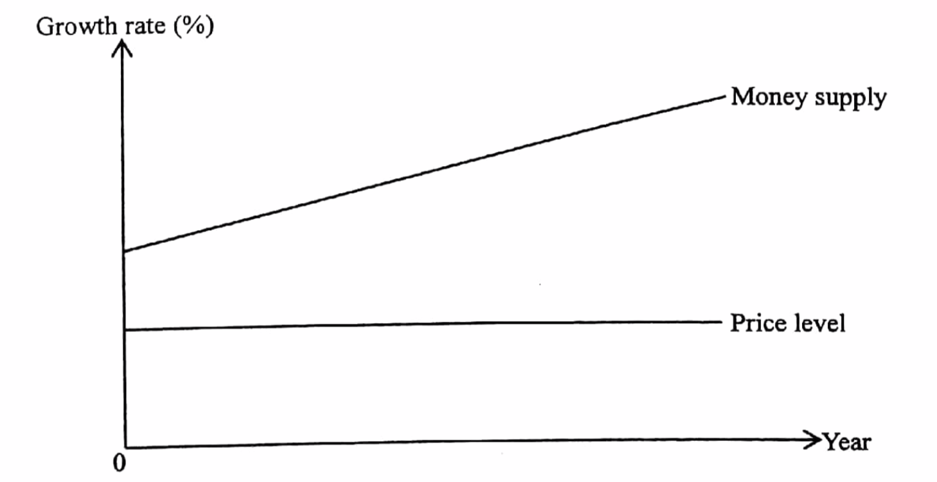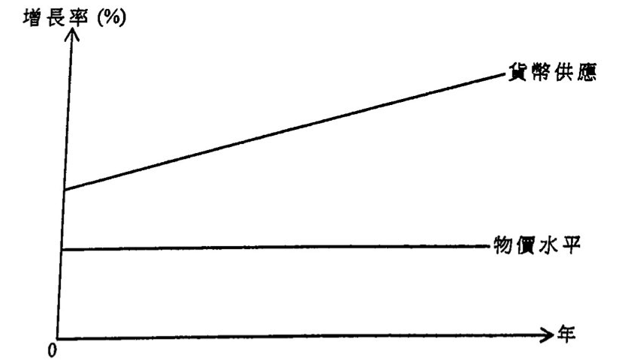
According to the quantity theory of money, which of the following statements is correct?
A. The inflation rate is zero B. The growth rate of real output is increasing
C. The growth rate of money supply is constant D. The growth rate of nominal income is constant

參考下圖
根據貨幣數量論，下列那項陳述是正確的？
A. 通脹率是零。 B. 實質產出的增長率正在增加。
C. 貨幣供應的增長率是固定的。 D. 名義收入的增長率是固定的。

Example Question 9 DSE2019MCQ35
Which of the following statements about quantity theory of money are correct?
(1) If money supply is growing too fast relative to the supply of goods in the economy, inflation will occur.
(2) If money supply increases, nominal output will increase by the same percentage
(3) If inflation rate is constant, real output will grow at the same percentage as money supply.
A. (1) and (2) only B. (1) and (3) only C. (2) and (3) only D. (1), (2) and (3)

下列那些有關貨幣數量論的陳述是正確的？
(1) 若某經濟的貨幣供應相對於物品供應增長得太快，通脹便會出現。
(2) 若貨幣供應增加，名義產出便會以相同的百分比增加。
(3) 若通脹率是固定的，實質產出和貨幣供應會以相同的百分比增長。
A. 只有(1)、(2) B. 只有(1)、(3) C.只有(2)、(3) D. (1), (2)及(3)

Example Question 10 DSE2021MCQ38
Study the following diagram.
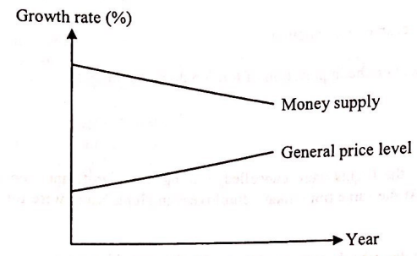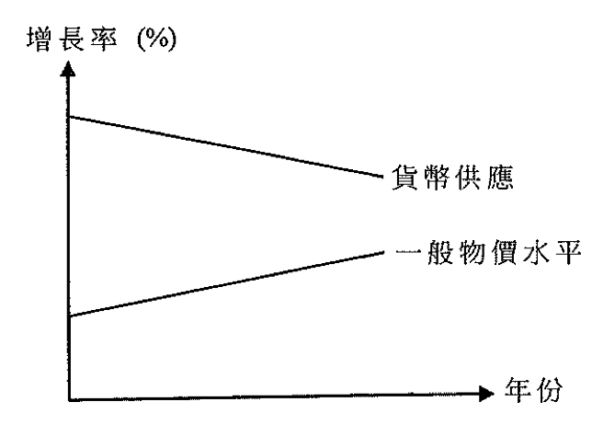
According to the quantity theory of money,
A. Real output is increasing B. Nominal output is decreasing
C. Money supply is decreasing D. The velocity of circulation of money is decreasing

細閱下圖。
根據貨幣數量論，下列那項陳述是正確的？
A. 實質產出正在上升 B. 名義產出正在下降。
C. 貨幣供應正在下降。 D. 貨幣流動速度正在下降。

Type 3 (Equation of Exchange EOE & Quantity Theory of Money QTM)

2012DSE LQ13a, b, c, d
The following table shows the balance sheet of the banking system of an economy.
Assets ($million) | Liabilities ($million)
Reserves 500  Loans 1 500 | Deposits 2 000
Suppose the public does not hold cash and there are $100 million reserves in the banking system.
(a) Find the required ratio. Show your working. (2)
(b) Find the maximum possible amount of deposits if the banks are fully loaned up. Show your working. (2)
(c) The central bank injects $200 million newly-printed banknotes into the banking system. If the banks lend out all of their excess reserves, what will the amount of money supply be in the economy? Show your working. (4)
(d) Based on the quantity theory of money, predict the effect of the monetary policy in (c) on the price level. State the assumption(s) needed to reach your conclusion. (4)
下表顯示某經濟銀行系統的資產負債表。
資產（百萬元） | 負債（百萬元）
儲備 500  貸款 1 500 | 存款 2 000
假設公眾不持有現金，而銀行系統內的超額儲備是100百萬元。
(a) 求法定儲備比率。列示你的計算。
(b) 若銀行可將派出款項全數借出，求最高可能存款額。列示你的計算。
(c) 中央銀行注入200百萬元新印的鈔票到銀行系統。若銀行將超額儲備悉數借出，該經濟的貨幣供應是多少，列示你的計算。
(d) 根據貨幣數量論，推斷(c)所述的貨幣政策對物價水平的影響。寫出要達致你的結論所需的假設。
_______________________________________________________________________________________
_______________________________________________________________________________________
_______________________________________________________________________________________
_______________________________________________________________________________________
_______________________________________________________________________________________
_______________________________________________________________________________________
_______________________________________________________________________________________
_______________________________________________________________________________________
_______________________________________________________________________________________
_______________________________________________________________________________________
_______________________________________________________________________________________
_______________________________________________________________________________________
Marking Scheme:
(a) Required reserve ratio = ($500 million - $100 million) / $2000 million (1)
= 20% (1)
(b) Maximum possible amount of deposit = $500 million x 1/0.2 (1)
= $2500 million (1)
(c) Deposit = $700 million x 1/0.2 = $3500 million (2)
Cash in public circulation = 0 (1)
Money supply = Deposit + Cash in public circulation
= $3500 million (1)
(d) QTM: MV = PY, where M = money stock, V = velocity of circulation of money, P = general price level and Y = real output, assuming V constant. (2)
An increase in M leads to an increase in P when Y increases by a smaller proportion
An increase in M leads to an increase in P by the same percentage when Y is constant (@2)

(a) 法定儲備比率 = (500百萬元-100百萬元)/ 2 000百萬元
= 20% . ..
(b) 最高可能的存款額 = 500百萬元x 1/0.2 .
= 2500百萬元 . . .
(c) 存款 = 700百萬元x 1 / 0.2 = 3500百萬元
公眾持有的現金 = 0
貨幣供應 = 存款 + 公眾持有的現金
= 3500百萬元
(d) - 貨幣數量論: MV = PY• 其中M = 貨幣供應丶V = 貨幣流通速率、P = 一般價格水平及Y = 實質產出，假設V
維持不變。
- 當Y上升的百分比較少， M的上升會導致P上升
或
- 當 Y 維持不變， M 的上升會導致 P 上升相同的百分比。
Candidates’ Performance:
(a) Excellent
(b) Good. The most common mistake was the careless missing of units. A minority of candidates failed to provide steps in their calculation. Some mistook the maximum possible amount of deposits for $(2000 million x 1/20%)
(c) Fair. Many candidates did not calculate the excess reserve before using the maximum credit-creation formula, resulting in a wrong calculation.
(d) Good. Most candidates were able to point out that an increase in money supply will lead to an increase in the price level, but failed to compare their percentage changes. Some put forth assumptions such as ‘no excess reserves’ and ‘no cash leakage’, which were irrelevant to the question. Some mistook the quantity theory of money for the MV = PY equation itself/

(a) 優異。
(b) 良好。最常見的錯誤是不小心地漏寫了單位。少部份考生未有寫出計算的步驟。部份考生把最高可能存款額當為（ 2000百萬元× 1 / 20%)。
(c) 尚可。很多考生在運用最大信貸創造的公式前沒有計算超額儲備，引致計算錯誤。
(d) 良好。大多數考生能指出貨幣的上升會令物價水平上升，但未能比較百分率的轉變。部份考生提出例如沒有超額儲備及沒有現金流失等假設，和題旨無關。部份考生將貨幣數量論等同於MV = PY公式本身。

2013DSE LQ12a, b, c
The following table shows the balance sheet of the banking system of an economy.
Assets ($million) | Liabilities ($million)
Reserves 400  Loans 1 600 | Deposits 2 000
The public holds $1000 million cash and all banks are fully loaned up.
(a) Calculate the monetary base and the money supply in the economy. Show your workings. (4)
(b) If the required reserve ratio is adjusted to 25%, calculate the new money supply in the economy. Show your workings. (2)
(c) With the aid of an aggregate-demand-aggregate supply diagram, explain the short run effects of an upward adjustment of the required reserve ratio on output and the price level of the economy. (8)
下表顯示某經濟內銀行系統的資產負債表。
資產（百萬元） | 負債（百萬元）
儲備 400  貸款 1 600 | 存款 2 000
公眾持有1000百萬元現金，而所有銀行將可貸款項全數借出。
(a) 計算該經濟的貨幣基礎和貨幣供應。寫出你的計算步驟。
(b) 若法定儲備比率調整至25%，計算該經濟新的貨幣供應。寫出你的計算步驟。
(c) 以一種供需圖輔助，解釋法定儲備比率向上調整對該經濟的產出和物價水平的短期影響。
______________________________________________________________________________________
_______________________________________________________________________________________
_______________________________________________________________________________________
_______________________________________________________________________________________
_______________________________________________________________________________________
_______________________________________________________________________________________
_______________________________________________________________________________________
_______________________________________________________________________________________
_______________________________________________________________________________________
_______________________________________________________________________________________
_______________________________________________________________________________________
Marking Scheme:
(a) Monetary base = $400 million + $1000 million = $1400 million (2)
Money Supply = $1000 million + $2000 million = $3000 million (2)
(b) New money supply
= $1000 million + $400 million x1/25% = $2600 million (2)
(c) An upward adjustment of required reserve ratio reduces the money supply, resulting in an increase in interest rate and a drop in investment expenditure. The aggregate demand will fall, and so will the price level and output level. (5)
Diagram:
- AD shifts to the left, Price level falls, Output level falls (3)

(a) 貨幣基礎 = 4 00 百萬元 + 1 000 百萬元 1400 百萬元
貨幣供應 = 1000 百萬元 + 2000 百萬元 = 3000 百萬元
(b) 新的貨幣供應=1 000 百萬元 +400 百萬元 x 1/25% = 2600 百萬元 .
(c) 文字解說：
法定儲備比率上調會減低貨幣供應，令利率上升，投資支出下降，總需求會下降，而物價水平和產出水平均會下降。
在圖中顯示 :
- AD 向左移 （1） 物價水平下降 （1） 產出水平下降 （1）
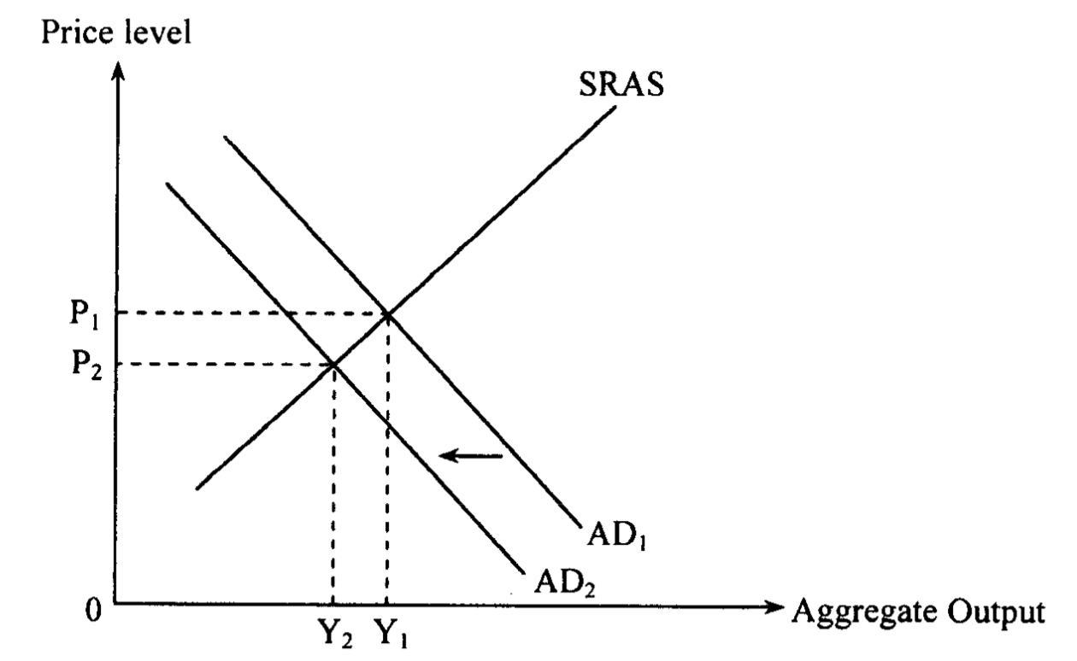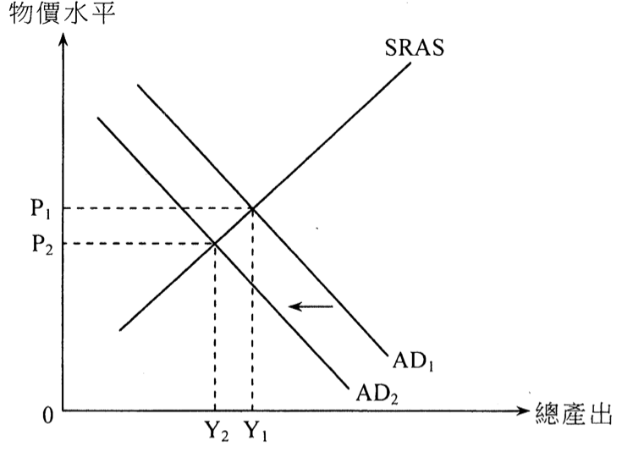

Candidates’ Performance:
(a) Good. A minority of candidates did not understand the concept of monetary base. Some expressed their answers in wrong units.
(b) Excellent. A few candidates carelessly stated their answers in terms of the change in money supply rather than the new level of money supply.
(c) Satisfactory. The majority of candidates were able to draw a well-labelled diagram and give a clear explanation about the effects of such a contractionary monetary policy. The following contains a list of common mistakes:
- mis-thinking that a change in money supply will affect disposable income directly;
- mis-representing a drop in money supply as a drop in short-run aggregate supply;
- mis-labelling the vertical axis of the AD-AS diagram as money or price instead of the price level;
- failure to provide a step-by-step analysis of how a change in money supply would affect AD (e.g., omitting the step that a rise in the interest rate will follow as a result of a reduction in money supply).

(a) 良好。小數考生不了解貨幣基礎的概念，有些考生以錯誤的單位作答。
(b) 優異。有些考生不小心地以貨幣供應的轉變作答案，而非新的貨幣供應水平。
(c) 滿意。大部分考生能劃出標示明確的圖，並清楚解釋這種收縮性貨幣政策所帶來的影響。
下列是常見的錯誤 :
- 誤以為貨幣供應會直接影響可支配收入。
- 誤將貨幣供應下降當成短期總供應下降。
- 誤將供需圖的縱軸標示貨幣或價格而非物價水平。
- 沒有按步分析貨幣供應如何影響總需求(例如:漏了貨幣供應下降會令利率上升的步驟)。

2014DSE LQ 7a, b
In an attempt to reduce its growing fiscal deficits, the US government has tried to increase tax on the one hand and decrease fiscal spending on the other. But many worry that such a policy would give rise to undesirable side effects.
(a) Explain TWO possible undesirable effects of the above fiscal policy on the US economy as a whole. (4)
(b) An alternative policy is to finance the fiscal deficits by printing money. Briefly discuss ONE advantage and ONE disadvantage of this alternative policy on the US economy as opposed to the above fiscal policy. (4)

美國政府嘗試一方面加稅，另一方面減低財政開支，以減低其不斷增加的財政赤字。但是很多人擔心這項政策會導致不良的副作用。
(a) 解釋上述財政政策對美國整體經濟可能引起的兩個不良效果。
(b) 另一替代政策是發行鈔票用以支付財政赤字。與上述財政政策相比，簡單討論這替代政策對美國經濟的一項好處和一項壞處。
_______________________________________________________________________________________
_______________________________________________________________________________________
_______________________________________________________________________________________
_______________________________________________________________________________________
_______________________________________________________________________________________
_______________________________________________________________________________________
_______________________________________________________________________________________
_______________________________________________________________________________________
_______________________________________________________________________________________
_______________________________________________________________________________________
_______________________________________________________________________________________
_______________________________________________________________________________________
_______________________________________________________________________________________
_______________________________________________________________________________________
_______________________________________________________________________________________
_______________________________________________________________________________________
Marking Scheme:
(a) Side effects of the contractionary fiscal policy:
- Negative output effect (fall in GDP) due to a reduction in government expenditure and thus aggregate demand
- Negative output effect (fall in GDP) due to a rise in sales / income tax, which would lower consumption / investment demand and thus aggregate demand
- Negative (disincentive) effect on labour supply and thus on employment (and output) as a result of higher income taxes (@2)

(b) Advantages:
- An increase in money supply would lower the interest rate and raise investment, leading to an increase in real output in the short run (given upward-sloping aggregate supply). Given idle resources in the economy, more labour (and / or capital) would be used to produce the bigger output, implying an increase in employment or decrease in unemployment. (Contractionary fiscal policy would not result in an increase in GDP and employment.) (2)
Disadvantages:
- In the long run (with vertical aggregate supply), an increase in money supply would not create any effect in output and employment. Ut if the fiscal policy deficits grow so fast that money supply has to be increased at a higher rate that of real output, high inflation would even arise. (Contractionary fiscal policy would not result in inflation.) (2)

(a) 收縮性財政政策的副作用：
- 對產出的負面影響（本地生產總值下降）：因為政府支出下降令總需求下降
- 對產出的負面影響（本地生產總值下降）：因為銷售稅/入息稅增加令消費/投資下降，總需求下降
- 對勞工的負面影響（抑制作用）並對就業（及產出）的負面影響：又增加入息稅所引致

(b) 優點：
- 增加貨幣供應會令利率下降，並增加投資，在短期零實質產出上升。已知該經濟有限知的資源，有更多的勞工（及/或資本）會用作生產更多產出。這令就業上升，失業下降（而收縮性財政政策不會導致產出和就業上升）。
缺點：
- 在長期（總供應曲線是垂直），增加貨幣供應不會影響產出和就業。但如果財政赤字增長太快，令貨幣供應增長率高於實際產生的增長率，高通脹會出現（而收縮性財政政策不會導致通脹上升）。

Candidates’ Performance:
(a) Satisfactory. Most candidates were able to explain the effects of contractionary fiscal policy using the AS-AD model. However, some candidates failed to provide a complete analysis; they simply rushed to the conclusion without elaborating on the process of changes in the macro variables.
(b) Fair. While many candidates were able to state correctly the advantage(s) and disadvantage(s) of the alternative policy, some important steps were omitted in their reasoning, such as how a change in the interest rate (induced by monetary expansion) would affect output and the price level.
(a) 令人滿意。大部份考生運用總供需解釋收縮性財政政策的效果。但是部份考生未能提供完整的分析，他們只匆忙寫出結論，而沒有寫出宏觀變量改變的過程。
(b) 尚可。很多考生能正確指出另一政策的優缺點，但是他們的推論欠缺了一些重要的步驟，例如利率的轉變（由擴張性貨幣政策引發）如何影響產出和物價水平。

2014DSE LQ12a, b, c
The Prime Minister of Japan, Shinzo Abe, adopted a series of policy measures in 2013 to expand the Japanese economy. One of the policy measures was stepping up the scale of the purchase of government bonds and other financial assets by the central bank.
(a) If the Japanese central bank purchases government bonds from Japanese commercial banks, explain
whether the monetary base of Japan would be affected. (3)
(b) Describe the process of deposit creation/contraction which may result from the purchase of government bonds by the central bank. Explain whether the process would further affect the monetary base of Japan. (5)
(c) What would be the short run effects of the above policy on the output and price levels of the Japanese economy? Explain your answer with the aid of an aggregate-demand-aggregate-supply diagram. (8)

2013年日本首相安倍晉三採取一系列政策以刺激日本經濟。其中一項政策是加大中央銀行購入政府債券和其他金融資產的規模。
(a) 若日本中央銀行向日本的商業銀行購入政府債券，解釋日本的貨幣基礎會否受影響。
(b) 描述中央銀行購入政府債券可能導致的存款創造 / 收縮過程。解釋這個過程會否進一步影響日本的貨幣基礎。
(c) 上述政策對日本經濟的產出和物價水平有什麼短期影響？以一總供需圖輔助，加以解釋。

_______________________________________________________________________________________
_______________________________________________________________________________________
_______________________________________________________________________________________
_______________________________________________________________________________________
_______________________________________________________________________________________
_______________________________________________________________________________________
_______________________________________________________________________________________
_______________________________________________________________________________________
_______________________________________________________________________________________
_______________________________________________________________________________________
_______________________________________________________________________________________
_______________________________________________________________________________________
_______________________________________________________________________________________
Marking Scheme:
(a) Monetary base = cash in public circulation + reserve held by commercial banks (1)
The monetary base increases because the commercial banks have more reserves. (2)

(b) Credit Creation process:
When the central bank purchases bonds from commercial banks, more cash is injected to the commercial banks as reserves and there would be excess reserves in the banking system. (1)
The banks would lend out the excess reserves. (1)
And the bank loans will be re-deposited into the banking system. (1)
The process will go on and on (until the actual reserves are equal to required reserves)
No. The monetary base will remain unchanged as the sum of cash in public circulation and reserves in the banking system will not be affected by the credit creation process. (2)

(c) The purchasing of government bonds increases money supply (1)
Resulting in a drop in the interest rate (1)
Investment / consumption expenditure increases (1)
And aggregate demand increases (1)
In the short run, the output and price levels increases. (1)
Diagram:
AD curve shifts to the right + Higher price level + Higher output (3)
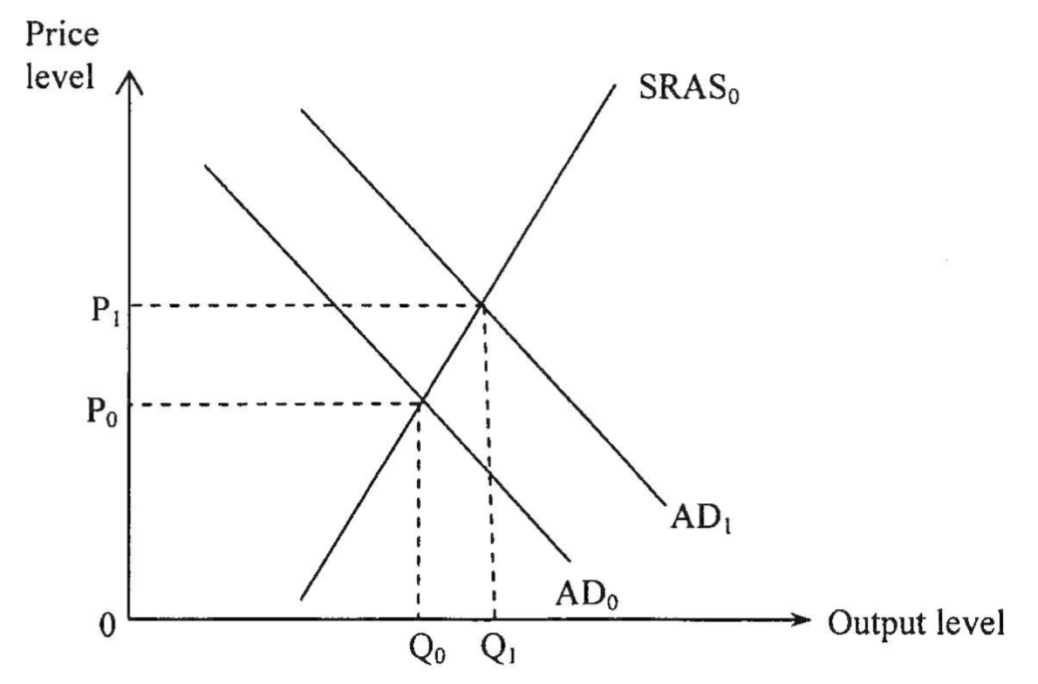

Marking Scheme:
(a) 貨幣基礎 = 在公眾流通的現金 + 商業銀行的儲備
貨幣基礎增加，因為商業銀行有更多儲備

(b) 信貸創造過程：
當中央銀行向商業銀行購入債券，更多的現金會注入商業銀行成為儲備，而銀行系統會有超額儲備。
銀行會借出其超額儲備。
銀行貸款會再存入銀行系統。
該過程會繼續（直到實際儲備等於法定儲備)。

否。貨幣基礎會維持不變，因為在公眾流通的現金和銀行系統内的儲備的總和不會受信貸創造的過程影響。

(c) 文字解說：
購入政府債券增加貨幣供應。
引致利率下跌。
投資 / 消費支出上升。 .
總需求上升。
在短期，產出和物價水平亦上升。

在圖中顯示：
- 總需求曲線向右移
- 物價水平上升
- 產出水平上升
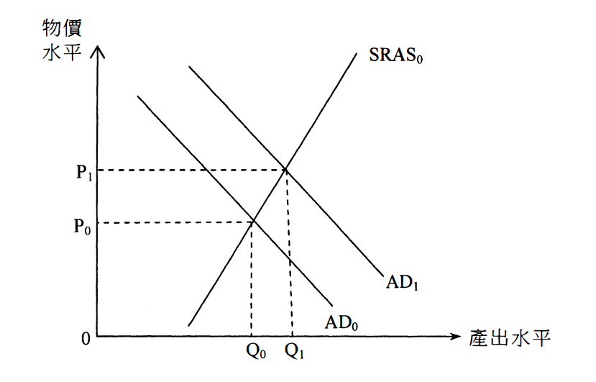

Candidates’ Performance:
(a) Good. However, a minority of candidates failed to show a good understanding of the concept of monetary base
(b) Satisfactory. The following contains a list of common mistakes:
- confusing the open market purchase with an open market sale;
- confusing the credit creation with a credit contraction; and
- confusing central-bank purchase of bonds from commercial banks with similar purchase from the general public.
(c) Good. The majority of candidates were able to draw a well-labelled diagram and to explain clearly the policy
effects. Some common mistakes included:
- a failure to realize the question is about short-run effects, thus wasting effort on irrelevant long-run analysis;
- mis-labelling the vertical axis of the AD-AS diagram as money or price (instead of the price level); and
- a failure to provide a step-by-step analysis of how a change in the money supply would affect AD (e.g., omitting the step that shows how a drop in the interest rate would follow from an increase in money supply)

(a) 良好。少數考生未能掌握貨幣基礎的概念。
(b) 令人滿意。下列是常犯的錯誤。
- 混淆了公開市場出售債券和公開市場買入債券。
- 混淆了信貸創造和信貸收縮。
- 混淆了中央銀行由商業銀行購買債券和由一般大眾購入。
(c) 良好。大多考生能畫出一幅表示清晰的圖，並清楚解釋證實的效果。常犯的錯誤包括：
- 不知道題目是關於短期分析，而浪費時間做長期分析。
- 誤將總供需圖的Y軸表示為貨幣或價格（而不是物價水平），
- 沒有按部就班分析貨幣供應的改變如何影響總需求。 （例如忽略寫出利率會隨着貨幣供應上升而下降）。

2017DSE LQ9b, c, d
Figures 1 and 2 show some macroeconomic data of the US. 圖一和圖二顯示美國的一些宏觀經濟數據。
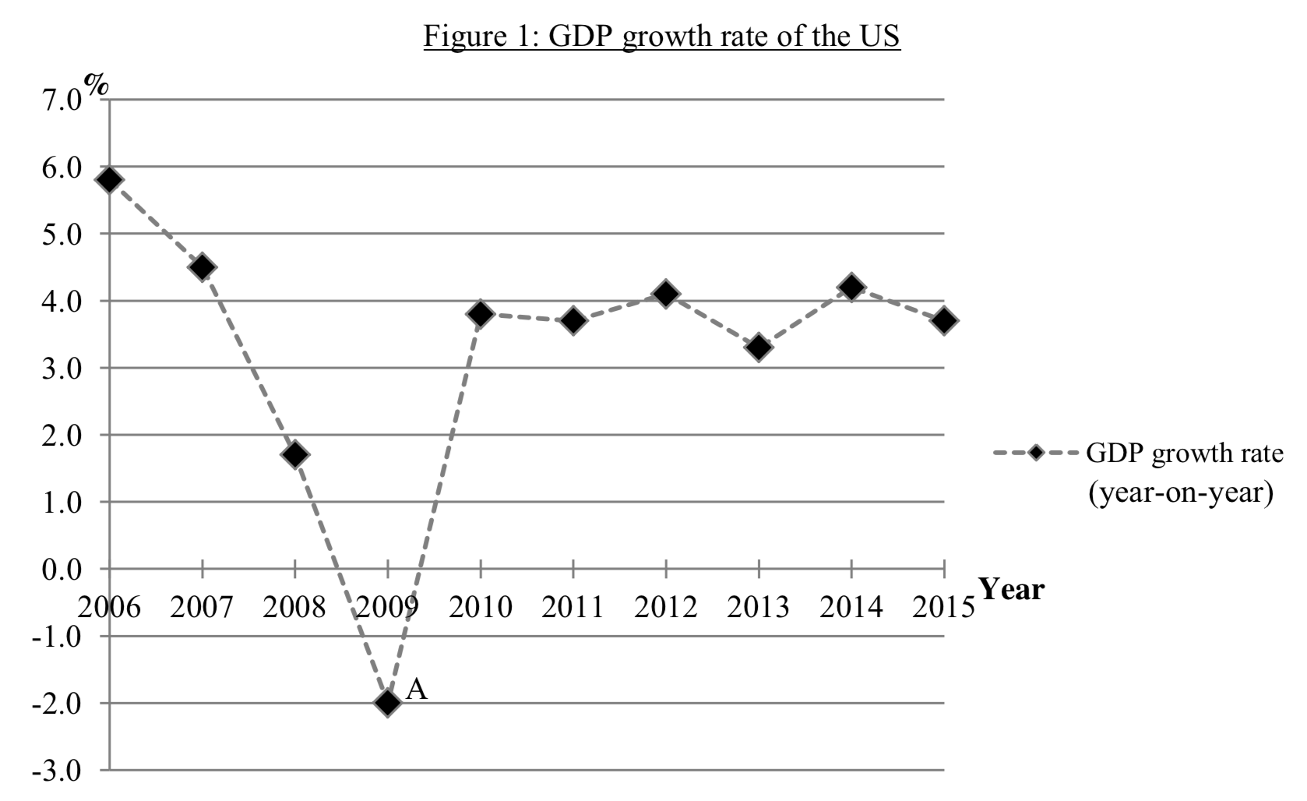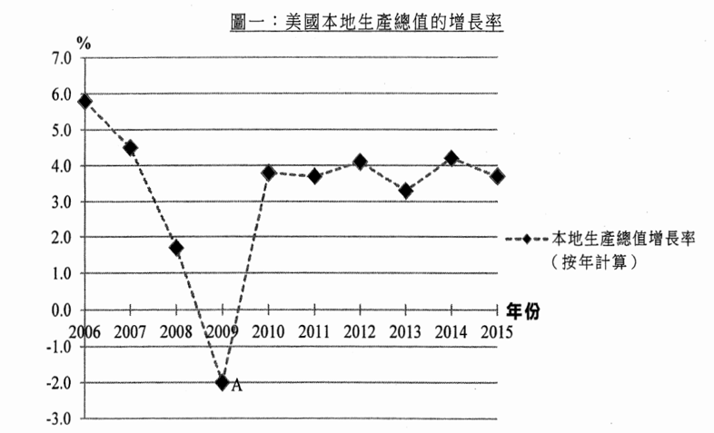
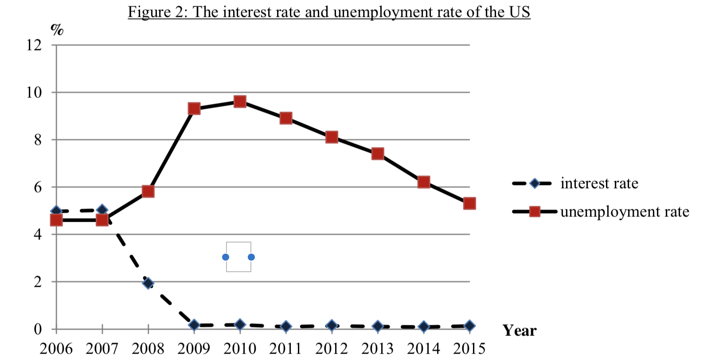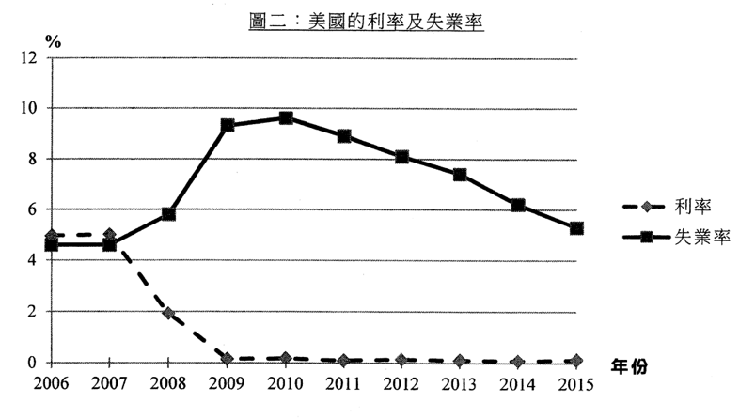
(a) How may a reduction in interest rate help the US economy in 2009? Without using a diagram, explain your answer in the light of aggregate supply and/or aggregate demand. (3)
(b) Discuss whether the data in Figures 1 and 2 are consistent with your answer in the above. (4)
(c) Suggest ONE policy that will help increase the aggregate output in the long run. Briefly explain your answer. (2)

(a) 利率下調可以如何幫助2009年美國的經濟？無需繪圖，根據總供應及 / 或總需求的概念，解釋你的答案。
(b) 討論圖一和圖二的數據是否和你在（b）部的答案相符。
(c) 舉出在長期而言有助增加總產出的一項政策。簡單解釋你的答案。
_______________________________________________________________________________________
_______________________________________________________________________________________
_______________________________________________________________________________________
_______________________________________________________________________________________
_______________________________________________________________________________________
_______________________________________________________________________________________
Marking Scheme:
(a) A reduction in interest rate results in a rise in investment/consumption. Aggregate demand increases and thus aggregate output increases. (3)
(b) Consistent. (1)
When interest rate dropped in 2009, GDP growth rate increased and unemployment rate dropped.
[Alternatively, it may be argued that the data is not consistent as the US cut the interest rate in 2008 but still in 2009 GDP had a negative growth and unemployment roared.] (3)
(c) Subsidizing research and development/ importation of labour / investment in infrastructures increases the LRAS/potential output/ production capacity of the economy as a whole.
[Mark the FIRST policy only.] (2)

(a) 減低利率會令投資及 / 或消費上升。總需求上升，總產出因而上升。
(b) 相符。
當利率在2009年下降， GDP的增長率上升而失業率下降。
［考生亦可論述該資料和(b)部的答案並不相符，因美國雖在2008年調低利息，但在2009年GDP仍然有負增長，失業人數仍然上升。］
(c) 補貼研究及發展 / 輸入勞工 / 投資基建可以在長期增加潛在產出 / 經濟整體的產能，故此令LRAS向右移。
［只批閱首項政策］
Candidates’ Performance:
(a) Good. Large investments probabilistically infer the impact on consumption and/or, on aggregate demand and aggregates. Small investments and the small investment interest rate SRAS increased, but there was no specific trend.
(b) General. Common mistakes candidates make when failing to answer are as follows:
- Confusing the instantaneous data shown in Figure 2.
- Misunderstanding the word "consistent".
- incorrectly quoted the data in Figure 2, for example: the answer cited pause and GDP instead of force and GDP force.
(c) Good. Policies that stimulate aggregate demand can help increase LRAS for most applicants.

(a) 良好。大部份考生能正確地推論減息對消費和 / 或投資，以及對總需求和產出的影響。少部份考生論證短期總供應上升，卻沒有具體論述。
(b) 一般。未能答對的考生的常犯錯誤如下：
- 混淆了圖二所顯示的兩組數據。
- 誤解「相符」一詞。
- 錯誤地引述圖二的數據，例如：答案引用了失業和本地生產總值，而不是失業率和本地生產總值增長率。
(c) 良好。大部份考生能提出增加產出的相關政策。少部份考生將刺激總需求的政策當作能幫助增加長期總供應。

2018DSE LQ7ai, ii, iii, b
The following is the balance sheet of a banking system
Assets ($ million) | Liabilities ($ million)
Reserves 500  Loans 1 500 | Deposits 2 000
Initially the banks held $100 million excess reserves and the public held $100 million cash. Suppose the central bank buys $40 million worth of government bonds from the public.
(a) Calculate the new monetary base. Show your workings. (2)
(b) State TWO assumptions under which the actual change in money supply would equal the maximum possible change in money supply (2)
(c) Calculate the maximum possible change in money supply. Show your workings. (4)
(d) Based on the quantity theory of money, predict the effect of an open market purchase of government bonds by the central bank on the price level. State the assumption(s) needed to reach your conclusion. (4)
以下是某銀行系統的資產負債表。
資產（百萬元） | 負債（百萬元）
儲備 500  貸款. 1 500 | 存款 2 000
原初銀行持有100百萬元超額儲備，而公眾持有100百萬元現金。假設中央銀行向公眾購買價值40百萬元的政府債
券。
(a) 計算新的貨幣基礎。列示你的計算。
(b) 在兩項假設下，貨幣供應的實際轉變會相等於貨幣供應的最大可能轉變，寫出這兩項假設。
(c) 計算貨幣供應的最大可能轉變。列示你的計算。
(d) 根據貨幣數量論，推斷中央銀行在公開市場購買政府債券對物價水平的影響。寫出要達至你的結論所需要的假設。
_______________________________________________________________________________________
_______________________________________________________________________________________
_______________________________________________________________________________________
_______________________________________________________________________________________
_______________________________________________________________________________________
_______________________________________________________________________________________
_______________________________________________________________________________________
Marking Scheme:
(a) New M₀ = $500 million + $100 million + $40 million = $640 million (2)
(b) Banks do not hold excess reserve /
There is sufficient demand for loans /
There is no cash leakage (@1)
(c) Old M_{s} = $2000 million + $100 million = $2100 million
RRR = ($500 million - $100 million) / $2000 million = 0.2
New M_{s} = $100 million + ($500 million + $40 million) / 0.2 = $2800 million
∴ M_{s} increases by $700 million (= 2800 million – 2100 million) (4)
(d) MV = PY, where M: money supply, V: velocity of circulation of money, P: price level, and Y: output
Assume V and Y constant. Then when M increases, P would increase by the same proportion.
OR
Assume V is constant. Then when the percentage increase in M is higher than that in Y, P would increase as well. (4)

(a) 新M0：500百萬元＋100百萬元＋40百萬元 = 640百萬元
(b) 銀行不持有超額儲備
公眾對貸款有足夠需求。
没有現金流失。
(c) 舊M = 2000 百萬元 + 100 百萬元 = 2100 百萬元
RRR =（500 百萬元 - 100百萬元）/ 2000 百萬元 = 0.2
新M, =100 百萬元 ＋（500 百萬元 + 40 百萬元) / 0.2 = 2800 百萬元
M增加 700 百萬元（= 2 800 百萬元 - 2100 百萬元）
(d) MV = PY，M：貨幣供應，V：貨幣流通速率，P：物價水平，Y：產出水平
假設 V和Y不變，當M上升，P會按比例上升 。
或
假設V不變，當M上升的百分比高於 Y的上升百分比，P會上升。

Candidates’ Performance:
(a) Good. A minority of candidates mistakenly thought that the central-bank purchase of government bonds from the public would reduce the amount of cash in circulation.
(b) Good.
(c) Fair. Many candidates were able to start by calculating the required reserve ratio, but unable to apply their knowledge of money and banking correctly to handle this somewhat unfamiliar case. The following is a list of mistakes and omissions evident in some candidates' work:
- failing to realise that the $40 million purchase of government bonds by the central bank should provide additional reserve for banks to carry out credit creation;
- mis-reading the question: some candidates merely calculated the maximum possible amount of (new) money supply, without finding the maximum possible change in money supply as required by the question
(d) Good. A small number of candidates did not state their assumptions when discussing the quantity theory of money (QTM), while some failed to indicate clearly the prediction of QTM regarding the change in the general price level.
(a) 良好。少數考生誤以為央行向公眾購買政府債券會令公眾所持的現金減少
(b) 良好。
(c) 一般。很多考生開始時能計算法定儲備率，但未能正確運用有關貨幣與銀行的知識處理這較陌生的題目。以下列出考生所犯的錯誤
- 未能了解央行購買40百萬元政府價券，可為銀行提供額外的儲備作信貸創造
- 錯解理解題目。考生只計算了(新)貨幣供應的最大可能金額，而沒有按題目的要求計算貨幣供應的最大可能改
變
(d) 良好。少數考生在討論貨幣數量論時沒有寫出其假設。部分考生未能清楚寫出貨幣數量論對一般物價水平的推斷

2019DSE LQ10c
To achieve the same effect on the deflationary (output) gap as in part (b), an economist suggested the government should lower the required reserve ratio of banks instead of implementing the above change in tax system. Discuss the suggestion by giving ONE argument FOR and ONE argument AGAINST it. (4)

為達至（b）部對通縮（產出）差距相同的影響，一位經濟學家建議政府應降低銀行的法定儲備比率而非實施上述的稅制改變。提出正反論點各一以討論該建議。
_______________________________________________________________________________________
_______________________________________________________________________________________
_______________________________________________________________________________________
_______________________________________________________________________________________
_______________________________________________________________________________________
_______________________________________________________________________________________
_______________________________________________________________________________________
_______________________________________________________________________________________
_______________________________________________________________________________________
_______________________________________________________________________________________
_______________________________________________________________________________________
_______________________________________________________________________________________
_______________________________________________________________________________________
_______________________________________________________________________________________
_______________________________________________________________________________________
_______________________________________________________________________________________
_______________________________________________________________________________________
_______________________________________________________________________________________
_______________________________________________________________________________________
_______________________________________________________________________________________
Marking Scheme:
For: Pros of the monetary policy OR Cons of the fiscal policy
- The monetary policy increases Y via investment which will help enhance present/future productivity (while the tax policy may not have such an effect)
- The tax policy may worsen the fiscal balance of the government (while the monetary policy will not have such an effect). (2)
Against: Pros of the fiscal policy OR Cons of the monetary policy
- The tax policy may narrow the income gap (while the monetary policy won’t have such an effect)
- Bank loans and money supply may not increase even if there is a fall in the required reserve ratio (while the tax policy will not be affected by the action of commercial banks). (2)

支持：該貨幣政策的優點或該財政政策的缺點
- 該貨幣政策透過投資令Y上升。這會幫助提升現在 / 將來的生產力（而該稅務政策沒有這效果）。
- 該稅務政策可能令政策財政平衡變差（而該貨幣政策沒有這後果）。
- 任何其他相關點

反對：該財政政策的優點或該貨幣政策的缺點
- 該稅務政策可能會縮窄收入差距（而該貨幣政策沒有這效果）。
- 即使法定儲備比率下降，銀行貸款和貨幣供應未必上升（而該稅務政策不會受商業銀行的行為所影響）。
- 任何其他相關點

Candidates’ Performance:
Fair.

Pros of the monetary policy:
Many candidates could point out that the decrease in RRR would increase money supply and lower the interest rate. Only some mentioned the possible increase in productivity (resulting from higher investment).

Cons of the fiscal policy:
Many candidates stated that the drop in tax rate might reduce tax revenue. Some could further infer that this would worsen the fiscal balance.

Cons of the monetary policy:
Some candidates raised the possibility that banks might not lend out the excess reserves, so as a reduction in RRR would not necessarily narrow the deflationary gap.

Pros of the monetary policy:
Most candidates merely stated that the drop in average tax rate could help narrow the income gap. But only some of them reached their conclusion by examining its effects on both the low-income and high-income groups.

一般。

貨幣政策的優點：
很多考生能指出法定儲備比率下降會令貨幣供應上升和利率下降。只有部份考生提到（由較高投資所引起的）生產力可能上升。

財政政策的缺點：
很多考生提到稅率下降，可能會令稅收下降。部份考生能推論到這會令財政平衡變差。

貨幣政策的缺點：
部份考生指出這種可能情況：銀行未必貸出超額儲備，故此法定儲備比率下降不一定收窄通縮差距。

財政政策的優點：
大部份考生只指出平均稅率下降能幫助收窄收入差距。但只有部份考生能分析對低收入和高收入人士的影響從而得出結論。

DSE2020LQ4c
Study the following information of an economy.
Year | Consumer price index (CPI)
2018 | 110
2019 | 117
‘The continuous open market purchase of government bonds by the central bank is the cause of inflation in the economy.’ Justify the statement with reference to the classical quantity theory of money. (4)

細閲以下有關某經濟的資料。
年份 | 消費者物價指數 (CPI)
2018 | 110
2019 | 117
「中央銀行在公開市場持續購入政府債券是該經濟出現通脹的成因。」參考古典貨幣數量論，論證陳述。
_______________________________________________________________________________________
_______________________________________________________________________________________
_______________________________________________________________________________________
_______________________________________________________________________________________
_______________________________________________________________________________________
_______________________________________________________________________________________
_______________________________________________________________________________________
_______________________________________________________________________________________
_______________________________________________________________________________________
_______________________________________________________________________________________
_______________________________________________________________________________________
_______________________________________________________________________________________
_______________________________________________________________________________________
_______________________________________________________________________________________
_______________________________________________________________________________________
Marking Scheme:
MV = PY, V and Y being constant. (2)
A continuous increase in M (caused by the open market purchase) will result in a continuous increase in general price level, i.e. inflation. (2)
MV = PY而M：貨幣供應；V：貨幣流通速率；P：物價水平及Y：產出水平。
假設V及Y維持不變。
M的持續增加（由公開市場購買債券引起）會令P持續上升，即通脹。

Candidates’ Performance:
Satisfactory. Most candidates wrote the correct quantity equation, but only a few got full marks. The following lists some of the mistakes found in their answers:
- Failing to define the variables M, V, P and Y;
- Failing to realise that Classical QTM assumes that V and Y are constant
- Failing to mention that inflation is a continuous and sustained increase in price level;
- Mis-thinking that open market purchase of government bonds would result in a fall in the money supply.

令人滿意。大部份考生寫出正確的貨幣數量的公式，但只有少部份考生取得滿分。以下列出一些考生答案中的錯誤：
- 沒有寫出變數M、V、P及Y的定義；
- 不知道古典貨幣數量論假設V和Y是不變；
- 沒提到通脹是指物價水平持續上升；
- 誤以為在公開市場購買政府債券會導致貨幣供應減少。

DSE2021LQ11c
Without using a diagram, explain how the central bank of Country F could use an open market operation to narrow the deflationary (output) gap. (4)

F國現有通縮（產出）差距。
毋須繪圖，解釋F國的中央銀行如何可以運用公開市場操作去收縮（產出）差距。
_______________________________________________________________________________________
_______________________________________________________________________________________
_______________________________________________________________________________________
_______________________________________________________________________________________
_______________________________________________________________________________________
_______________________________________________________________________________________
_______________________________________________________________________________________
_______________________________________________________________________________________
Marking Scheme:
The central bank could use open-market purchase (i.e. buy government bonds from the public) to increase money supply. Then, the interest rate would fall, thus inducing firms to invest more, implying an increase in aggregate demand. As a result, aggregate output (Y) would rise in the short run, but long-run output (Yf) would remain unchanged, so that the deflationary gap (= Y – Yf) would become narrower. (4)

中央銀行可以用公開市場購入債券（即向公眾購買政府債券）令貨幣供應增加。利率因而下降，這會誘發公司增加投資，總需求因而上升。在短期，總產出（Y）會上升，但長期總產出（Yf）不變，通縮（產出）差距（= Y - Yf）會收窄。
Candidates’ Performance:
Fair. Some candidates did not understand the meaning of open market operation and suggested other kinds of expansionary monetary policy instead. Some failed to state clearly how the drop in interest rate (due to open market purchase) would affect aggregate output via the various components of aggregate demand (e.g. investment, consumption). Lower performing candidates mistook the increase in money supply as a cash transfer and claimed that it would raise disposable income directly.

一般。部份考生不明白公開市場操作的意思，他們反而建議其他種類的擴張性貨幣政策。部份考生未能清楚指出利率下降。（由公開市場購入引致）如何透過總需求的各個組成部份（如消費、投資）影響總產出。表現較差的考生誤以為增加貨幣供應是現金轉移，會直接增加可支配收入。

Marking Scheme:
Type 1 (Monetary policy / Change in money cross topic with MDMS)
1 | C | 2 | C | 3 | C | 4 | A | 5 | B | 6 | C | 7 | A | 8 | C | 9 | D | 10 | D
11 | B | 12 | B | 13 | B | 14 | C | 15 | B | 16 | B | 17 | C | 18 | D | 19 | A | 20 | A
21 | C
Type 2 (Monetary policy / Change in money supply cross topic with ADAS & Fiscal Policy)
1 | B | 2 | D | 3 | C | 4 | A | 5 | D | 6 | B | 7 | B | 8 | B | 9 | A | 10 | C
11 | A | 12 | D | 13 | B | 14 | B | 15 | D | 16 | A | 17 | C | 18 | B | 19 | B | 20 | C
21 | D | 22 | B | 23 | C | 24 | D | 25 | B | 26 | D | 27 | D | 28 | B | 29 | A | 30 | D
31 | D | 32 | D | 33 | B | 34 | B
Type 3 (Equation of Exchange EOE and Quantity Theory of Money QTM)
1 | C | 2 | D | 3 | B | 4 | D | 5 | A | 6 | D | 7 | C | 8 | B | 9 | A | 10 | A
11 | D | 12 | C | 13 | C | 14 | D | 15 | C | 16 | D | 17 | D | 18 | D

