Learning Focus:
Memo
(LQ Answering Flow, MC skills, your goals and resolutions…)
Specific Question Type
MC

咩話？DSE Sample Paper, Practice Paper, 2012, 2013, 2014, 2015, 2016, 2017, 2018, 2019, 2020, 2021, 2022 MC全部拍晒解題片？係呀，有唔明即scan即睇！就係咁firm！
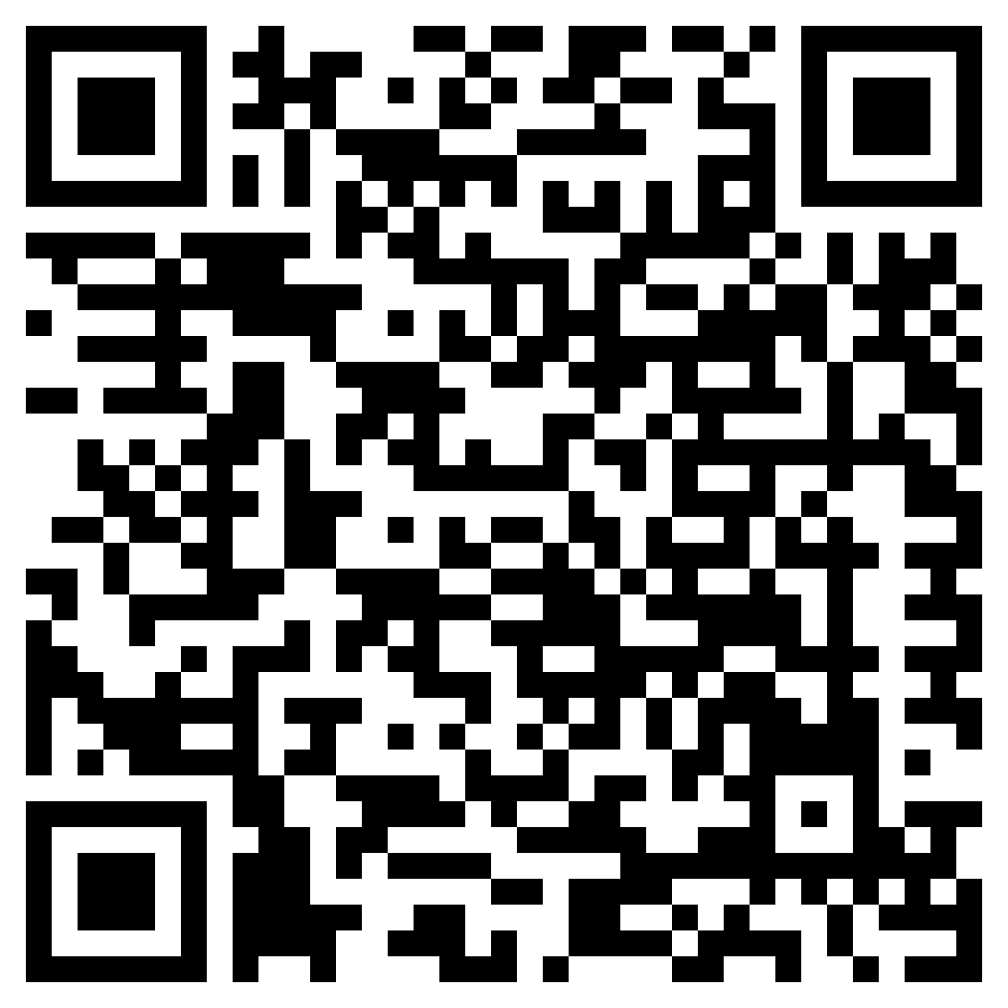

Learning Focus:
Memo
(LQ Answering Flow, MC skills, your goals and resolutions…)
Specific Question Type
LQ

咩話？DSE Sample Paper, Practice Paper, 2012, 2013, 2014, 2015, 2016, 2017, 2018, 2019, 2020, 2021, 2022 LQ全部拍晒解題片？係呀，有唔明即scan即睇！就係咁firm！
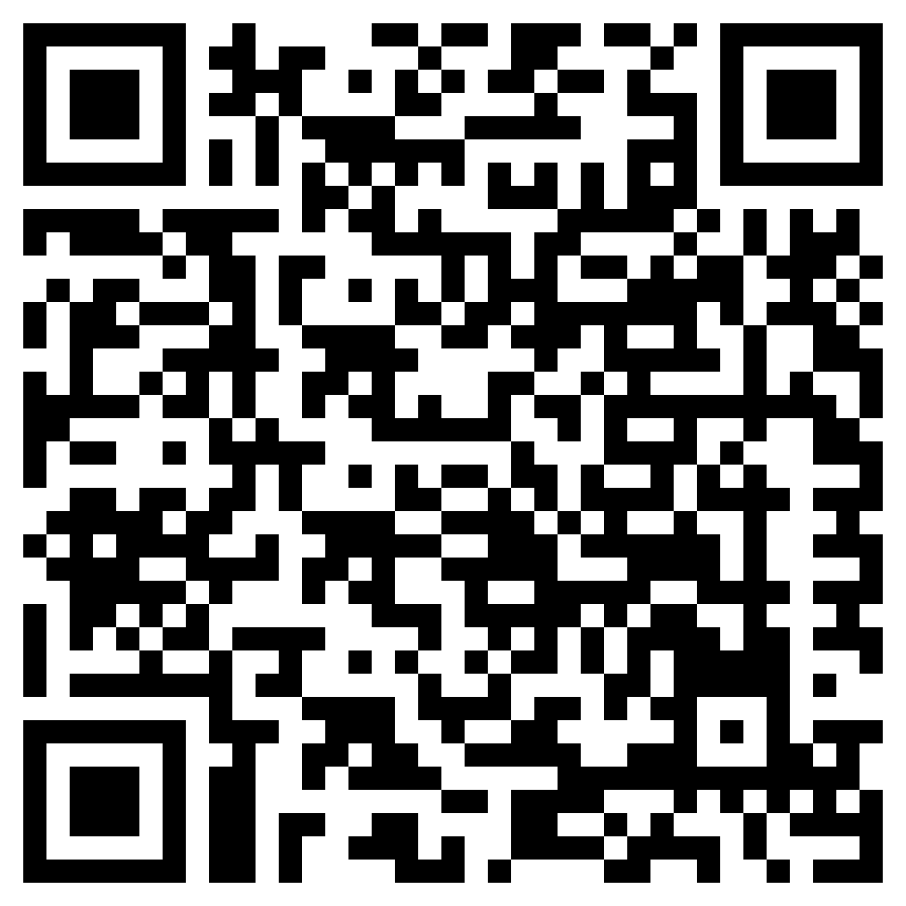

Chapter 17 _ Money & Banking
Type 1 (Barter Economy & Problem of Barter)
Example Question 1 CE1992MCQ59
Which of the following descriptions about barter is FALSE?
A. Barter means a direct exchange of goods and services
B. Barter is possible only when there is double coincidence of wants
C. Barter exists only in societies without a medium of exchange
D. Usually it is more difficult to practise barter in international trade than in domestic trade

以下哪一項關於「實物交易」的描述是錯誤的？
A. 實物交易指直接以物易物。 B. 只有雙向需求偶合存在才能出現實物交易。
C. 實物交易只存在於沒有交易媒介的社會裡。 D. 以實物交易方式進行國際貿易通常較進行本土貿易為困難。

Example Question 2 CE1995MCQ50
Exchange with the use of money differs from barter exchange in that the former
A. is controlled by the government, but the latter is not. B. has a price for each good, but the latter has not.
C. does not require the double coincidence of wants but the latter does. D. involves competition but the latter does not.

利用貨幣進行交易與以物易物不同之處在於前者
A. 被政府控制，但後者則不是。 B. 每一物品都有一價格，但後者則不是。
C. 不需要雙向需求偶合，但後者則需要。 D. 牽涉競爭，但後者則不會。

Example Question 3 CE2004MCQ35
When a barter economy changes to an economy that uses money in exchange,
(1) finding trading partners becomes easier.
(2) making transactions involving future settlement of debt becomes easier.
(3) agreeing upon prices takes a longer time.
A. (1) and (2) only B. (1) and (3) only C. (2) and (3) only D.(1), (2) and (3)

當「以物易物」的經濟轉變為「在交易中使用貨幣」的經濟，人們會
(1) 較容易尋獲交易對象。
(2) 較為容易達成在未來結帳的交易。
(3) 花費更多時間達致買賣雙方都同意的價格。
A. 只有(1)和(2) B. 只有(1)和(3) C. 只有(2)和(3) D. (1)、(2)、(3)

Example Question 4 CE2008MCQ34
An economy that changes from barter to using money in exchange would reduce
A. the need for specialization B. the need for exchange
C. the time for searching trading partners D. the frequency of making payments

一個經濟從以物易物轉變為以金錢來交易會減少
A. 專門化的需要。 B. 交易的需要。
C. 尋找交易夥伴的時間。 D. 支付的頻率。

Type 2 (Function of Money, Benefits of using Money, Properties of Money, Types of Money)
Example Question 1 CE1990MCQ29
To serve as a unit of account, money has to be
A. homogeneous B. portable C. scarce D. durable

作為記帳單位必須是
A. 同質。 B. 方便攜帶。 C. 稀少。 D. 耐用。

Example Question 2 CE1990MCQ41
The value of money is reflected by its
A. face value. B. intrinsic value C. purchasing power. D. owner’s subjective value.

下列哪一項反映貨幣的價值？
A. 它的面值 B. 它的內在價值 C. 它的購買力 D. 它的擁有者的主觀價值

Example Question 3 CE1991MCQ29
Which of the following can best serve as money in a desert?
A. shells B. sand C. water D. potatoes

以下哪一項是沙漠中最佳的貨幣？
A. 貝殼 B. 沙粒 C. 水 D. 馬鈴薯

Example Question 4 CE1992MCQ33
A time deposit fulfils the function of money as a
A. medium of exchange B. store of value
C. unit of account D. standard of deferred payments

定期存款有以下的貨幣功能：
A. 交易媒介 B. 價值儲藏
C. 記帳單位 D. 延期支付的標準

Example Question 5 CE1992MCQ57
The potato is NOT a good form of money mainly because it is
A. indivisible B. portable C. homogeneous D. perishable

馬鈴薯並非一種良好的的貨幣，主要因為它們是_______的
A. 不可分割 B. 可攜帶 C. 同質 D. 易於腐壞的

Example Question 6 CE1993MCQ31
Nowadays one can use a credit card or coins to make phone calls from public telephones. The telephone company accepts the use of credit cards for phone calls because
(1) a credit card is legal tender
(2) a credit card is a means of deferred payment
(3) credit card holders are more trustworthy people (4) the cost of handling coins can be reduced
A. (1) and (2) only B. (1) and (3) only C. (2) and (4) only D. (3) and (4) only

現時，我們可以用信用咭或硬幣來使用公眾電話。電話公司接受顧客以信用咭用以支付打電話的費用是因為
(1) 信用咭是法幣。
(2) 信用咭是延期支付的工具。
(3) 信用咭持有人是更值得信任的人。
(4) 此舉可減低處理硬幣的成本。
A. 只有(1)、(2) B. 只有(1)、(3) C. 只有(2)、(4) D. 只有(3)、(4)

Example Question 7 CE1993MCQ58
Money will NOT exist if
A. there is no banking system B. only credit cards are accepted for payment
C. there is only one man on earth D. trade is totally banned among countries

在以下哪一種情況中，貨幣不會存在？
A. 沒有銀行系統。 B. 只接受信用咭付款。
C. 地球上只有一個人。 D. 國與國之間完全禁絕交易。

Example Question 8 CE1994MCQ41
Banknotes are preferred to cheques as means of payment because the former are more
A. divisible B. generally acceptable C. portable D. scarce

作為支付工具，紙幣較支票為佳，因為前者
A. 更容易分拆為較細單位。 B. 更能普遍地被接受。 C. 更便於攜帶。 D. 更為稀有。

Example Question 9 CE1994MCQ38
Which of the following about money is correct?
A. It must have intrinsic value. B. It must be backed up by law to be the medium of exchange.
C. It must be convertible into some precious metal. D. It must be generally acceptable as the medium of exchange.

下列哪一項關於貨幣的描述是正確的？
A. 它必須具有內在價值。 B. 它必須由法律確定為交易媒介。
C. 它必須能兌換成某些貴重金屬。 D. 它必須被普遍接受為交易媒介。

Example Question 10 CE1995MCQ39
Banknotes is a better form of money than demand deposits because the former is more
A. generally acceptable B. divisible C. durable D. portable

作為貨幣，紙幣較往來戶口存款為佳，因為前者較
A. 能普遍地被接受。 B. 易分拆為較小的單位。 C. 耐用。 D. 便於攜帶。

Example Question 11 CE1996MCQ34
During war time, gold is a better form of money than paper money mainly because gold is more
A. durable B. portable C. generally acceptable D. homogeneous

在戰亂時期，黃金與紙幣相比，黃金是種較佳的貨幣，主因是黃金比較
A. 耐用。 B. 便於攜帶。 C. 能普遍地被接受。 D. 品質一致。

Example Question 12 CE1997MCQ32
99 gold is a better form of money than diamond because the former is more
(1) easily divisible
(2) scarce
(3) homogenous
A. (1) and (2) only B. (1) and (3) only C. (2) and (3) only D. (1), (2) and (3)

作為一種貨幣，九九金較鑽石為佳，因為前者
(1) 較易分拆為細單位。
(2) 數量較稀少。
(3) 品質較為一致。
A. 只有(1)和(2) B. 只有(1)和(3) C. 只有(2)和(3) D. (1)、(2)、(3)

Example Question 13 CE1998MCQ32
Cheques are preferred to banknotes and coins when used as a medium of exchange in large transactions because cheques are more
A. durable B. generally acceptable C. scarce D. portable

作為大額交易中的交易媒介，支票較紙幣及硬幣為佳，因為支票較為
A. 耐用。 B. 能普遍地被接受。 C. 稀少。 D. 便於攜帶。

Example Question 14 CE1999MCQ35
9999 Gold is better as a form of money than jade because the former is more
(1) generally acceptable.
(2) easily divisible.
(3) homogeneous.
A. (1) and (2) only B. (1) and (3) only C. (2) and (3) only D. (1), (2) and (3)

9999金與翡翠比較，前者會是一種較佳的貨幣形式，這是由於前者更為
(1) 被普遍接受。
(2) 容易分拆為較細單位。
(3) 品質一致。
A. 只有(1)和(2) B. 只有(1)和(3) C. 只有(2)和(3) D. (1)、(2)、(3)

***Example Question 15 CE2001MCQ48
In Hong Kong, drivers can buy tickets from tunnel companies for using tunnel services. These tickets are NOT a standard of deferred payment. In other words,
A. the purchasing power stored in the tickets can only be used for certain tunnel services.
B. most people in Hong Kong do not use the tickets for the tunnel services.
C. the value of most goods and services are not measured in terms of the tickets.
D. payment in the future in general is not denominated in the tickets.

在香港，駕駛人士可向隧道公司購買隧道券來使用隧道。這些隧道並非延期支付的標準。換句話說
A. 儲存在隧道券的購買力只可以在某些隧道使用。
B. 大部分香港人不使用隧道券。
C. 大部分貨品和服務的價值都不是用隧道券來量度的。
D. 未來的付款一般都不是以隧道券作為付款單位。

Example Question 16 CE2002MCQ34
Which of the following statements about money are correct?
(1) The purchasing power of money will remain unchanged in times of deflation.
(2) A wider use of electronic money will reduce the cash held by the public.
(3) Money helps people to accumulate their purchasing power.
A. (1) and (2) only B. (1) and (3) only C (2) and (3) only D. (1), (2) and (3)

下列哪幾項對貨幣的描述是正確的？
(1) 在通縮時，貨幣的購買力仍會下降。
(2) 當電子貨幣更普及時，市民持有的現金會減少。
(3) 貨幣有助於市民累積購買力。
A. 只有(1)和(2) B. 只有(1)和(3) C. 只有(2)和(3) D. (1)、(2)、(3)

Example Question 17 CE2003MCQ50
Fish are NOT good units of account mainly because they are not
A. durable B. scarce C. homogeneous D. portable

魚並非良好的記帳單位，主因是它並不
A. 耐用。 B. 稀少。 C. 同質。 D. 便於攜帶。

Example Question 18 CE2004MCQ36
A time deposit is better than a demand deposit in serving the __________ function of money because the former __________.
A. unit of account … has a common unit B. medium of exchange … is generally acceptable
C. store of value … bears interest income D. standard of deferred payments … is a liquid asset

定期存款比往來存款更能發揮貨幣的_______功能，因為前者_______
A. 記帳單位 … 有一個共同單位。 B. 價值儲藏 … 有利息收入
C. 交易媒介 … 為人普遍接受 D. 延期支付的標準 … 是一項流動資產

Example Question 19 CE2004MCQ35
Country A used gold as is currency. Suppose the scientists in the country have found a method to produce gold at nearly zero cost. As a result, the government has decided to give up using gold as its currency. This illustrates that good money has to be
A. portable B. divisible C. scarce D. durable

甲國原以黃金作為貨幣。假設該國的科學家找到一種方法，可以近乎零成本製造黃金，因此，該國的政府決定放棄以黃金作為貨幣。這說明貨幣必須是
A. 方便攜帶。 B. 可分割。 C. 稀少。 D. 耐用。

Example Question 20 CE2006MCQ33
Which of the following statements about money are correct?
(1) Under the electronic payment system, transactions are still settled with money
(2) Deflation reduces the purchasing power of money
(3) With the use of money in exchange, there is no need to have double coincidence of wants
A. (1) and (2) only B. (1) and (3) only C. (2) and (3) only D. (1), (2) and (3)

下列哪幾項對貨幣的描述是正確的？
(1) 在電子化付款系統裡，交易仍然是以貨幣來完成的。
(2) 通縮減低貨幣購買力。
(3) 在交易中使用貨幣，便不再需要雙向需求偶合了。
A. 只有(1)和(2) B. 只有(1)和(3) C. 只有(2)和(3) D. (1)、(2)、(3)

Example Question 21 CE2006MCQ34
9999 gold is a better form of money than grains of wheat because the former is more
(1) durable
(2) homogeneous
(3) easily divisible
A. (1) and (2) only B. (1) and (3) only C. (2) and (3) only D. (1), (2) and (3)

與麥粒相比，9999金是一種較佳的貨幣形式，因為後者更為
(1) 耐用。
(2) 品質一致。
(3) 容易拆細。
A. 只有(1)和(2) B. 只有(1)和(3) C. 只有(2)和(3) D. (1)、(2)、(3)

Example Question 22 CE2007MCQ35
During inflation, people are less willing to keep their wealth in the form of money. This is because at that time the function of money to serve as a ______ is weakened.
A. medium of exchange B. store of value C. unit of account D. means of payment

通脹期間，人們較不願意以持有現金的方式來儲存財富。這是因為在那時貨幣的_______功能減弱了。
A. 交易媒介 B. 價值儲藏 C. 記帳單位 D. 付款工具

Example Question 23 CE2007MCQ35
As a form of money, polymer notes are more ___ than paper notes.
A. homogenous B. durable C. divisible D. portable

作為一種貨幣，塑質鈔票較紙質鈔票更_____。
A. 同質 B. 耐用 C. 可分割 D. 容易攜帶

Example Question 24 CE2007MCQ35
A more popular use of electronic money can bring about the following advantages:
(1) a smaller amount of coins and notes to be handled
(2) a lower chance of receiving fake banknotes
(3) more interest earned by keeping the money in banks for a longer period of time
A. (1) and (2) only B. (1) and (3) only C. (2) and (3) only D. (1), (2) and (3)

電子貨幣更趨向普及可帶來哪些好處？
(1) 減少需要處理的硬幣和紙幣的數量
(2) 減少收到偽鈔的機會。
(3) 該筆金錢可存入銀行一段較長的時間以賺取更多利息。
A. 只有(1)和(2) B. 只有(1)和(3) C. 只有(2)和(3) D. (1)、(2)、(3)

Example Question 25 CE2009MCQ36
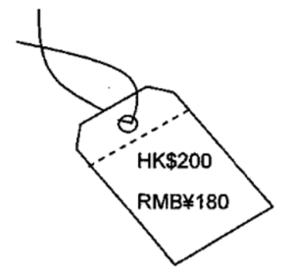
When the price of a good is quoted in Renminbi (RMB) on a price tag in some shops in Hong Kong, RMB is performing as
A. Legal tender. B. A store of value. C. A unit of account. D. A standard of deferred payment.

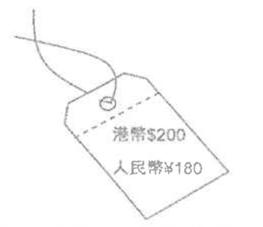
當香港部分商店將出售貨品的價格在價錢牌上以人民幣標示時，人民幣正在發揮_____的功能。
A. 法定貨幣 B. 價值儲藏 C. 記賬單位 D. 延期支付的標準
Example Question 26 CE2009MCQ36
Which of the following statements about money are correct?
(1) The use of money reduces the information cost of searching for trading partners.
(2) Money would not exist if there are no banks.
(3) Money still exists if all transactions are settled by electronic transfer or settled online.
A. (1) and (2) only B. (1) and (3) only C. (2) and (3) only D. (1), (2) and (3)

以下哪項對貨幣的描述是正確的？
(1) 貨幣的使用可降低尋找交易夥伴的訊息費用。
(2) 沒有銀行，貨幣便不會存在。
(3) 即使全部交易都使用電子轉賬或在互聯網上完成，貨幣仍會存在。
A. 只有(1)和(2) B. 只有(1)和(3) C. 只有(2)和(3) D. (1)、(2)、(3)

Example Question 27 CE2011MCQ36
Pure silver is a better form of money than diamonds in terms of _________.
A. Divisibility B. Portability C. Durability D. Scarcity

純銀與鑽石相比，以_________來衡量，純銀是一種較佳的貨幣形式。
A. 可分割性 B. 易攜性 C. 耐用性 D. 稀少性

Example Question 28 DSESPMCQ27
Which of the following statements about money is / are correct?
A. Deflation reduces the purchasing power of money.
B. Money does not exist in a cashless society where all transactions are settled through an electronic payment system.
C. With the use of money in exchange, exchange is possible even when trading parties do not have double coincidence of wants.
D. All of the above are correct.

下列哪幾項對貨幣的描述是正確的？
A. 通縮降低貨幣的購買力。
B. 在一個沒有現金的社會中，所有交易都透過電子繳費系統支付，貨幣在該社會並不存在。
C. 若交易中使用貨幣，縱使交易雙方沒有雙向需求偶合，交易仍是可能的。
D. 以上均正確。

Example Question 29 DSE2015MCQ35
Refer to the following news extract.
Yu’e Bao (餘額寶) is a new online investment fund introduced by Alibaba. Much of the popularity of Yu’e Bao has come from its ability to give customers the convenience of a demand deposit --- meaning they can withdraw their funds whenever they like --- but with returns well above what a bank could offer. It recently advertised an annualised return of 5.25%, but that level has on occasion risen to above 7% since the fund was set up. By contrast, banks offer 3.3% as interest for one-year fixed deposit and close to nothing no saving deposits.
Yu’e Bao is a better __________ as compared with bank deposits because _________.
A. Unit of account …… it provides a homogeneous means of payment.
B. Unit of account …… it can facilitate people’s buying and selling of goods and services.
C. Store of value …… it allows customers to have higher purchasing power in the future.
D. Store of value …… the customers can keep their unused funds in Yu’e Bao.

細閱以下的新聞撮要。
餘額寶是阿里巴巴新推出的網上投資基金。餘額寶受歡迎的主要原因是它可向客戶提供像活期存款般的方便，即他們可隨時提取其資金，但它的回報遠高於銀行可提供的利息。餘額寶近日宣傳指其每年回報為5.25%，但自該基金成立以來，回報水平有時高於7%。相對而言銀行一年定期存款的利率為3.3%，儲蓄存款則近乎沒有利息。
與銀行存款相比，餘額寶是較佳的__________，因為__________。
A. 記賬單位 …… 它提供同質的付款方法
B. 記賬單位 …… 它能促進人們買賣物品及服務
C. 價值儲藏 …… 它令顧客在將來有更高的購買力
D. 價值儲藏 …… 顧客可將他們未用的資金存在餘額寶

Example Question 30 DSE2016MCQ30
Refer to the following diagram.
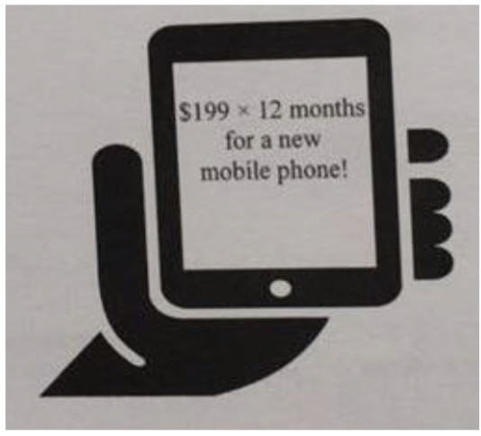
Ken read the above advertisement and bought a new mobile phone by instalments. In this payment, which of the following functions did money perform?
(1) store of value
(2) unit of account
(3) standard of deferred payment
A. (1) and (2) only B. (1) and (3) only C. (2) and (3) only D. (1), (2) and (3)

參閱下圖。
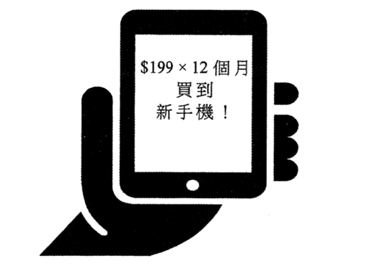
阿健看到以上廣告後，就以分期付款的方式購買了新手機，在這次付費中，貨幣發揮了以下哪些功能？
(1) 價值儲藏
(2) 記賬單位
(3) 延期支付的標準
A. 只有(1)和(2) B. 只有(1)和(3) C. 只有(2)和(3) D. (1)、(2)、(3)

Example Question 31 DSE2019MCQ30
Refer to the following hypothetical table
The currency of Country T, T-Dollar, has depreciated by 40 percent from the beginning of 2018 after the US announced a series of trade sanctions against Country T. As a result, some shops in Country T quoted prices in US Dollar instead of T-Dollar. Shops in black markets refused to accept T-Dollar. Some citizens bought foreign currencies to safeguard their assets.
Which of the following of money of the T-Dollar were weakened?
(1) Medium of exchange
(2) Unit of account
(3) Store of value
A. (1) and (2) only B. (1) and (3) only C. (2) and (3) only D. (1), (2) and (3)

參考以下的假設個案：
自2018年初美國公佈一系列針對T國的貿易制裁措施後，T國的貨幣「T元」貶值了40%。結果，T國的一些店鋪以美元而非T元訂價。黑市的店鋪拒絕接受T元。一些市民購買外幣以保障他們的資產。
T元的哪些貨幣功能被削弱了？
(1) 交易媒介
(2) 記賬單位
(3) 價值儲藏
A. 只有(1)和(2) B. 只有(1)和(3) C. 只有(2)和(3) D. (1)、(2)、(3)

Example Question 32 DSE2021MCQ30
Study the following news extract about Bitcoin.
In 2018, Kentucky Fried Chicken Canada launched ‘Bitcoin Bucket’. The company set up a Facebook live feed, displaying the number of bitcoins needed to pay for the meal as in the picture below. The ‘Bitcoin Bucket’ could only be purchased online and would be delivered to the buyers’ home later.
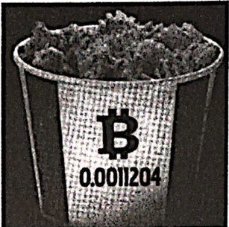
In the above case, Bitcoin performed as a _________.
(1) medium of change
(2) unit of account
(3) standard of deferred payment
A. (1) and (2) only B. (1) and (3) only C. (2) and (3) only D. (1), (2) and (3)

細閱以下有關比特幣(Bitcoin)的新聞撮要。
2018年，加拿大肯德基家鄉雞推出了「比特幣桶餐」。該公司開設了臉書直播，顯示購買該套餐所需的比特幣數量（如下圖所示）。該「比特幣桶餐」只能在網上購買，並會稍後外送至購買者家中。
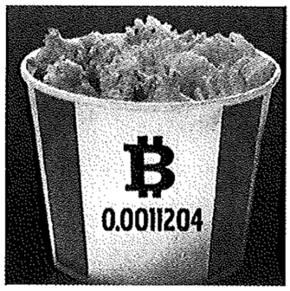
在以上個案中，比特幣用作
(1) 交易媒介
(2) 記賬單位
(3) 延期支付標準
A. 只有(1)和(2) B. 只有(1)和(3) C. 只有(2)和(3) D. (1)、(2)、(3)

Type 3 (Function of Central Bank / HKMA, Function of Commercial Bank)
Example Question 1 CE1995MCQ41
Which of the following are the central-bank functions performed by the HKMA?
(1) supervision of banking activities
(2) financing the budget deficit
(3) maintaining the stability of the exchange rate of the Hong Kong dollar
(4) cheque clearing
A. (1) and (3) only B. (1) and (4) only C. (2) and (3) only D. (2) and (4) only

下列哪些是由香港金融管理局所執行的中央銀行功能？
(1) 監察銀行業務
(2) 籌集資金以填補財政預算赤字
(3) 維持港元匯率的穩定
(4) 結算銀行支票
A. 只有(1)和(3) B. 只有(1)和(4) C. 只有(2)和(3) D. 只有(2)和(4)

Example Question 2 CE1996MCQ60
Which of the following is NOT a function of the Hong Kong Monetary Authority?
A. managing fiscal reserves for the government B. acting as a clearing house
C. supervising the banking system D. acting as the lender of last resort

下列哪一項並非香港金融管理局的功能？
A. 管理政府財政儲備 B. 作為票據交換中心
C. 監察銀行系統 D. 作為銀行最後的貸款者

Example Question 3 CE2000MCQ32
Which of the following about the central bank functions performed in Hong Kong is correct?
A. The Hong Kong Bank is responsible for the central clearance of the banking system.
B. The Exchange Fund acts as the government’s banker.
C. The Hong Kong Monetary Authority carries out monetary policies for the government.
D. The Hong Kong Association of Banks supervises banking activities.

下列哪一項關於中央銀行的功能如何在香港運作的描述是正確的？
A. 匯豐銀行負責為整個銀行系統作中央結算 B. 外匯基金扮演政府銀行的角色
C. 金融管理局替政府實施貨幣政策。 D. 香港銀行公會監察各銀行的活動

Example Question 4 CE2001MCQ49
Which of the following is NOT a function of the Hong Kong Monetary Authority?
A. to manage the foreign exchange reserves. B. to carry out monetary policy
C. to act as the lender of last resort D. to determine the best lending rate

下列哪一項並非香港金融管理局的功能？
A. 管理外匯儲備 B. 執行貨幣政策
C. 作為最後貸款者 D. 釐定最優利率

Example Question 5 CE2003MCQ37
Which of the following central bank functions are performed by the HKMA?
(1) managing the foreign exchange reserves
(2) determining the deposit interest rates of banks
(3) acting as the lender of last resort
A. (1) and (2) only B. (1) and (3) only C. (2) and (3) only D. (1), (2) and (3)

香港金融管理局發揮下列哪些中央銀行的功能？
(1) 管理外匯儲備
(2) 釐定銀行存款利率
(3) 作為最後貸款者
A. 只有(1)和(2) B. 只有(1)和(3) C. 只有(2)和(3) D. (1)、(2)、(3)

Example Question 6 CE2007MCQ37
Which of the following functions are performed by the Hong Kong Monetary Authority?
(1) maintaining the stability of the linked exchange rate
(2) supervising the liquidity position of the private banking institutions
(3) determining the market interest rate of Hong Kong
A. (1) and (2) only B. (1) and (3) only C. (2) and (3) only D. (1), (2) and (3)

下列哪項是香港金融管理局的功能？
(1) 維持聯繫匯率的穩定性
(2) 監管私營銀行機構的資產流動性
(3) 釐定香港的市場利率
A. 只有(1)和(2) B. 只有(1)和(3) C. 只有(2)和(3) D. (1)、(2)、(3)

Example Question 7 DSE2012MCQ29
Which of the following is NOT a function of the Hong Kong Monetary Authority?
A. Determining the inter-bank offered rate in Hong Kong B. Supervising the liquidity position of the private banking institutions
C. Managing and investing the Exchange Fund D. Maintaining the stability of the linked exchange rate

下列哪項不是香港金融管理局的功能？
A. 決定香港的銀行同業拆息 B. 監督私人銀行機構的流動性狀況
C. 管理及投資外匯基金 D. 維持聯繫匯率的穩定

Example Question 8 DSE2018MCQ33
Which of the following is NOT a function of the Hong Kong Monetary Authority?
A. to stabilise the mortgage rate B. to issue currency notes
C. to supervise the commercial banks D. to manage the Exchange Fund

下列哪項不是香港金融管理局的功能？
A. 穩定按揭利率 B. 發行鈔票
C. 監管商業銀行 D. 管理外匯基金

Example Question 9 DSE2019MCQ29
Which of the following is / are the function(s) of the Hong Kong Monetary Authority?
(1) Managing the Exchange Fund
(2) Supervising the implementation of fiscal policy
(3) Determining Hong Kong’s market interest rate
A. (1) only B. (2) only C. (3) only D. (1), (2) and (3)

下列哪項 / 些是香港金融管理局的功能？
(1) 管理外匯基金
(2) 監察財政政策的實施
(3) 決定香港的市場利率
A. 只有(1) B. 只有(2) C. 只有(3) D. (1)、(2)、(3)

Type 4 (3-Tier Banking System in Hong Kong)
Example Question 1 CE1993MCQ34
In Hong Kong a restricted licence bank faces more restrictions than a licensed bank with reference to
(1) the types of deposits it can accept
(2) the minimum deposits it can accept
(3) the maximum deposits interest rate it can offer
A. (1) and (2) only B. (1) and (3) only C. (2) and (3) only D. (1), (2) and (3)

在本港，一間有限制牌照銀行較一間持牌銀行在以下哪一方面更受限制？
(1) 可以接受的存款種類
(2) 可以接受最低的存款額
(3) 可以提供的最高存款利率
A. 只有(1)和(2) B. 只有(1)和(3) C. 只有(2)和(3) D. (1)、(2)、(3)

Example Question 2 CE1994MCQ39
Fanny plans to deposit HK$250 000 in a financial intermediary for three months. Which of the following institutions can accepts her deposit?
(1) licensed banks
(2) restricted licence banks
(3) deposit-taking companies
A. (1) and (2) only B. (1) and (3) only C. (2) and (3) only D. (1), (2) and (3)

芬妮計劃將HK$250 000 在財務機構中存放三個月。下列哪些機構可以接受她的存款？
(1) 持牌銀行
(2) 有限制牌照銀行
(3) 接受存款公司
A. 只有(1)和(2) B. 只有(1)和(3) C. 只有(2)和(3) D. (1)、(2)、(3)

Example Question 3 CE2000MCQ31
Mr. Cheung has $100 000 cash in hand. He needs the money two months later to use as partial payment for his new house. He may deposit the money into
(1) a licensed bank.
(2) a restricted licence bank.
(3) a deposit-taking company.
A. (1) only B. (1) and (2) only C. (1) and (3) only D. (2) and (3) only

張先生手頭有HK$100 000現金。他兩個月後需要該筆金錢支付他的新屋部分費用。他可將該筆金錢存放於：
(1) 一家持牌銀行內。
(2) 一家有限制牌照銀行內。
(3) 一家接受存款公司內。
A. 只有(1) B. 只有(1)和(2) C. 只有(1)和(3) D. 只有(2)和(3)

Example Question 4 CE2001MCQ27
John wants to deposit $80 000 for 4 months in Hong Kong. Which of the following financial institutions can accept his deposit?
A. a licensed bank B. a restricted licence bank C. a deposit taking company D. All of the above

偉強計劃將$80 000存放在香港四個月。下列哪一種財務機構可以接受他的存款？
A. 持牌銀行 B. 有限制牌照銀行 C. 接受存款公司 D. 以上各機構均可

Example Question 5 CE2002MCQ32
Which of the following financial institutions in Hong Kong can accept savings deposits?
A. licensed banks B. restricted licence banks C. deposit-taking companies D. all of the above.

下列哪一種香港的財務機構可以接受儲蓄存款？
A. 持牌銀行 B. 有限制牌照銀行 C. 接受存款公司 D. 以上各機構均可

Example Question 6 CE2003MCQ33
Sue wants to deposit $300 000 for 1 month. Which of the following institutions can accept her deposit?
(1) licensed banks
(2) restricted licence banks
(3) deposit-taking companies
A. (1) only B. (1) and (3) only C. (2) and (3) only D. (1), (2) and (3)

玉珊想將$300 000存款一個月，下列哪一些財務機構可以接受她的存款？
(1) 持牌銀行
(2) 有限制牌照銀行
(3) 接受存款公司
A. 只有(1) B. 只有(1)和(3) C. 只有(2)和(3) D. (1)、(2)、(3)

Example Question 7 CE2005MCQ36
Mr. Chan plans to deposit $500 000 for one month. Which of the following institutions can accept his deposit?
(1) licensed banks
(2) restricted licence banks
(3) deposit-taking companies
A. (1) and (2) only B. (1) and (3) only C. (2) and (3) only D. (1), (2) and (3)

陳先生計劃將$500 000存款一個月。下列哪些機構可接受他的存款？
(1) 持牌銀行
(2) 有限制牌照銀行
(3) 接受存款公司
A. 只有(1)和(2) B. 只有(1)和(3) C. 只有(2)和(3) D. (1)、(2)、(3)

Example Question 8 CE2007MCQ38
If an individual plans to deposit $200 000 in a financial institution in Hong Kong for three months, which of the following institutions can accept this deposit?
(1) licensed banks
(2) restricted licence banks
(3) deposit-taking companies
A. (1) and (2) only B. (1) and (3) only C. (2) and (3) only D. (1), (2) and (3)

某君計劃將$200 000港元存入本港一家金融機構中三個月。下列哪些機構可接受該項存款？
(1) 持牌銀行
(2) 有限制牌照銀行
(3) 接受存款公司
A. 只有(1)和(2) B. 只有(1)和(3) C. 只有(2)和(3) D. (1)、(2)、(3)

Example Question 9 CE2010MCQ38
David plans to deposit HK$400 000 in a Hong Kong financial institution for six months. Which of the following can accept his deposit?
(1) Licensed banks
(2) Restricted licence banks
(3) Deposit-taking companies
A. (1) and (2) only B. (1) and (3) only C. (2) and (3) only D. (1), (2) and (3)

大偉計劃在本港一家財務機構存入$400 000港元，為期六個月。下列哪些機構可接受他的存款？
(1) 持牌銀行
(2) 有限制牌照銀行
(3) 接受存款公司
A. 只有(1)和(2) B. 只有(1)和(3) C. 只有(2)和(3) D. (1)、(2)、(3)

Example Question 10 DSE2014MCQ31
Maggie plans to deposit $500 000 in an institution in Hong Kong for two months. Which of the following institutions can accept this deposit?
(1) Licensed banks
(2) Restricted licence banks
(3) Deposit-taking companies
A. (1) and (2) only B. (1) and (3) only C. (2) and (3) only D. (1), (2) and (3)

瑪姬計劃在香港的金融機構存入$500 000，為期兩個月。下列哪些機構可接受這筆存款？
(1) 持牌銀行
(2) 有限制牌照銀行
(3) 接受存款公司
A. 只有(1)和(2) B. 只有(1)和(3) C. 只有(2)和(3) D. (1)、(2)、(3)

Example Question 11 DSE2018MCQ31
Brain wants to deposit $80 000 for two months in an authorized institution in Hong Kong in the form of a negotiable certificate of deposit. Which of the following statements is correct?
A. As the term of maturity is longer than one month, a deposit-taking company can accept his deposit
B. As the term of maturity is shorter than three months, a restricted licence bank can accept his deposit
C. As the amount of deposit is less than $500000, a restricted licence bank cannot accept his deposit
D. As negotiable certificate of deposit are not available in a licensed bank, a licensed bank cannot accept his deposit.

拜仁想在香港的認可機構以可轉讓存款證的方式存入80 000元，為期兩個月。下列哪項陳述是正確的？
A. 由於存款期長於一個月，接受存款公司可以接納其存款。
B. 由於存款期短於三個月，有限制持牌銀行可以接納其存款。
C. 由於存款額少於500 000元，有限制持牌銀行不可以接納其存款。
D. 由於持牌銀行沒有發售可轉讓存款證，持牌銀行不可以接納其存款。

Example Question 12 DSE2021MCQ32
Jack wants to deposit $400 000 for 5 months. Which of the following financial institutions in Hong Kong can accept his deposit?
(1) a restricted licence bank
(2) a virtual bank which is classified as a licensed bank
(3) a deposit-taking company
A. (1) and (2) only B. (1) and (3) only C. (2) and (3) only D. (1), (2) and (3)

杰克想存款$400 000，為期五個月。下列哪些本港的金融機構可以接受他的存款？
(1) 一家有限制持牌銀行
(2) 一家被歸類為持牌銀行的虛擬銀行
(3) 一家接受存款公司
A. 只有(1)和(2) B. 只有(1)和(3) C. 只有(2)和(3) D. (1)、(2)、(3)

Type 5 (Liquidity)
Example Question 1 CE1995MCQ40
Arrange the following assets in terms of liquidity in descending order:
(1) ordinary shares
(2) real estate
(3) bank notes
(4) demand deposits
A. (1), (3), (4), (2) B. (3), (4), (1), (2) C. (3), (4), (2), (1) D. (4), (3), (2), (1)

將下列各項資產依流動性由高至低排列：
(1) 普通股股票
(2) 房地產
(3) 紙幣
(4) 往來戶口存款
A. (1), (3), (4), (2) B. (3), (4), (1), (2) C. (3), (4), (2), (1) D. (4), (3), (2), (1)

Example Question 2 CE1996MCQ38
Arrange the following bank assets in descending order of liquidity:
(1) loans and advances
(2) deposits with other banks
(3) real estates owned by the bank
A. (1), (2), (3) B. (1), (3), (2) C. (2), (1), (3) D. (3), (2), (1)

將下列銀行資產根據流動性由高至低加以排列：
(1) 借貸和墊款
(2) 在其他銀行的存款
(3) 銀行本身擁有的物業
A. (1), (2), (3) B. (1), (3), (2) C. (2), (1), (3) D. (3), (2), (1)

Example Question 3 CE1997MCQ39
Holders of a / an _________ has the least risk and the highest liquidity.
A. long-term corporate bond B. ordinary share C. preference share D. savings deposit

_______持有人所承受的風險最低，而資金流動性最高。
A. 公司長期債券 B. 普通股股票 C. 優先股股票 D. 儲蓄存款戶口

Example Question 4 CE1997MCQ39
Which of the following kinds of assets has the lowest liquidity?
A. cash in hand B. ordinary shares C. demand deposits D. savings deposits

下列哪一項資產的資金流動性最低？
A. 現金 B. 普通股股票 C. 往來存款 D. 儲蓄存款

Example Question 5 DSEPPMCQ29
An asset which can be readily converted into cash at short notice without making a loss is regarded as a _____________ asset.
A. portable B. durable C. divisible D. liquid

若某一資產可以在短時間內輕易地轉為現金，並且不會招致損失，那麼它可被視為一種 _________ 的資產。
A. 便攜 B. 耐用 C. 容易拆細 D. 流動

2012DSE LQ7
“9999 gold is preferred to cigarettes when used as money.” Give TWO reasons to explain this argument. (4)
「當用作貨幣時，9999金較香煙為佳。」提出兩項理由解釋這個論點。 (4)
_______________________________________________________________________________________
_______________________________________________________________________________________
_______________________________________________________________________________________
_______________________________________________________________________________________
_______________________________________________________________________________________
_______________________________________________________________________________________
_______________________________________________________________________________________
_______________________________________________________________________________________
_______________________________________________________________________________________
_______________________________________________________________________________________
_______________________________________________________________________________________
_______________________________________________________________________________________
_______________________________________________________________________________________
_______________________________________________________________________________________

Marking Scheme:
- Gold is more durable while cigarettes may lose their value during transaction  - Gold is more generally accepted as medium of exchange than cigarettes  - Gold is more homogeneous while cigarettes have different qualities  - 黃金較耐用，而香煙的價值可能在交易時減低。  - 黃金較香煙廣泛被接受作爲交易媒介。  - 黃金較同質而香煙的質素有所不同。 | (@2)  (@2)
Candidates’ Performance:
Fair. Some failed to elaborate on why gold is a good form of money by making reference to the functions of money.
尚可。部分考生未有參考貨幣的功能闡述為何黃金是一種良好的貨幣。
2017DSE LQ5
Due to political instability, the currency of a country depreciates sharply and becomes highly volatile. Which TWO functions of money may be weakened? Explain. (4)
由於政局不穩，某國的貨幣大幅貶值，並變得非常波動。這可能削弱了貨幣哪兩項功能？試加以解釋。 (4)
_______________________________________________________________________________________
_______________________________________________________________________________________
_______________________________________________________________________________________
_______________________________________________________________________________________
_______________________________________________________________________________________
_______________________________________________________________________________________
_______________________________________________________________________________________

Marking Scheme:
Functions of money:  - Store of value: As the value of the local currency drops in terms of foreign currency, its purchasing power drops in terms of the quantity of foreign goods and services bought.  - Standard of deferred payment: As the value of the currency becomes highly volatile, the cost of agreeing on the contracts of future payments of local currency increases.  - Medium of exchange: Some multinational firms may refuse to accept the currency if the value fluctuates too much.  貨幣的功能:  - 價值的儲藏: 由於本地貨幣的價值(以外幣計算)下跌，其購買力(以外國的物品和服務數量計算)會下降。  - 延期支付的標準: 由於貨幣的價值大幅波動，擬訂日後以本地貨幣支付的合約的成本會上升。  - 交易的媒介: 若貨幣價值波動太厲害，一些跨國的廠商可能拒收該國貨幣。 | (@2)  (@2)
Candidates’ Performance:
Good. Many candidates know that unstable and depreciating currencies weaken their functions as a store of value and a standard for deferred payment. A small number of candidates answered using "the function of price" or the characteristics of good money, which are irrelevant to the question's focus.
良好。很多考生知這不穩定和貶值的貨幣會削弱其儲藏價值 / 延遲支付的標準這些功能。小部分考生以「價格的功能」或良好貨幣的特徵作答，這些都無關題旨。

2018DSE LQ12b
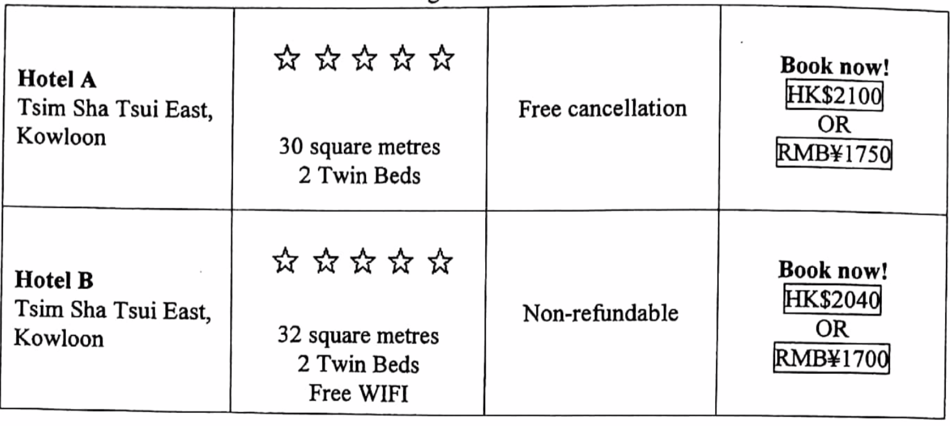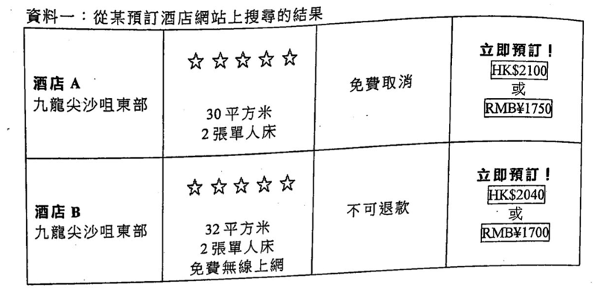
Tourism is one of the ‘pillar industries’ in Hong Kong. Which TWO functions of money does the Renminbi perform in Source 1? Explain. (4)
旅遊業是本港其中一項「支柱產業」。參考資料一，人民幣發揮哪兩項貨幣的功能？試加解釋。 (4)
_______________________________________________________________________________________
_______________________________________________________________________________________
_______________________________________________________________________________________
_______________________________________________________________________________________
_______________________________________________________________________________________
_______________________________________________________________________________________
_______________________________________________________________________________________

Marking Scheme:
- Unit of account: The price of the hotel accommodation service is expressed in terms of RMB.  - Medium of exchange: RMB serves as a medium to facilitate people’s buying and selling of services in the website  - 記帳單位：飯店住宿服務的價格以人民幣表示。  - 交易媒介：人民幣作為媒介，方便人們在網站上買賣服務 | (@2)  (@2)
Candidates’ Performance:
Good. Most candidates were able to identify the relevant functions of money performed by RMB in this context. However, only some of these candidates used the information provided to illustrate their answers. A small number of candidates might have misread the question and chose to discuss the functions of prices (rather than money) in their answers.
良好。小部分考生能寫出在這情況下人民幣所發揮有關的貨幣功能。但是只有部分考生運用所提供的資料解說他們的答案。少數考生可能誤解題目，作答時選擇討論價格（而非貨幣）的功能。
2020DSE LQ5b
Peter owes Mary $100 and he has no cash in his wallet. He suggests repaying Mary by a cash coupon (with a face value of $100) issued by a supermarket chain. Give TWO economic reasons to explain why Mary would refuse to accept the cash coupon as a repayment of Peter’s debt. (4)
彼德欠瑪莉$100，而他的錢包內並無現金。他向瑪莉提議用某連鎖超市發出的現金券（面值$100）還債。舉出兩個經濟理由解釋為什麼瑪莉會拒絕接受該現金券作為彼德的還債。 (4)
_______________________________________________________________________________________
_______________________________________________________________________________________
_______________________________________________________________________________________
_______________________________________________________________________________________
_______________________________________________________________________________________

Marking Scheme:
- Not generally accepted as the coupon can only be used in the supermarket chain but not other shops.  - Not divisible as the coupon is difficult to be broken down into smaller units to facilitate exchange.  - Not a good store of value as the supermarket chain may close down and the coupon become worthless.  - Not durable as banknotes because the coupon is not waterproof and may be easily damaged.  - Not a legal tender as other people may refuse to accept the coupon as payment.  - 並非普遍地被接受為交易媒介，因為現金券只能在該連鎖超市使用，其他店舖並不能使用。  - 並非可分割，因為現金券很難兌換成較細金額以幫助交易較便宜的物品。  - 並非良好價值儲藏，因為當該連鎖超市關店，現金券價值歸零。  - 不及紙幣耐用，因為該現金券並不防水，容易損壞。  - 不是法定貨幣，因為其他人可能拒絕接受現金券作支付之用。 | (@2)  (@2)
Candidates’ Performance:
Satisfactory. The majority of candidates were able to compare cash and the supermarket coupon from the perspective of ‘function of money’ or ‘features of good money’. A common problem was inaccuracy or imprecision in using such terminology as general acceptability, divisibility, durability medium of exchange, and store of value, resulting in vague or inconsistent answers.
令人滿意，大部分考生能從「貨幣的功能」或「良好貨幣的特徵」的角度比較現金和超市現金券。考生常見的毛病是未能準確地運用相關術語，例如普遍接受性、可分割、耐用、交易媒介及價值儲藏，以致答案含糊不清或前後不一。

2021DSE LQ5b, 7
(a) Mr Chan, a Hong Kong retired footballer, was employed as a consultant by a football club in the United Kingdom in January 2020. Seven months later, he quitted his position and returned to Hong Kong. If Mr Chan could chose to receive his salary in either British Pound (GBP) or US dollar (USD), which currency would you recommended him to choose? Explain your answer. (2)
(b) In a country, most of the prisoners in a correctional institution use cigarettes as a medium of exchange, but citizens in society refuse to settle payment by using cigarettes. Apart from not being generally acceptable, explain TWO reasons why cigarettes are NOT a good form of money in society. (4)
(a) 陳先生是本港一名退役足球員，在2020年1月，他獲一家英國球會聘請為顧問。七個月後，他辭職並返回香港。
若陳先生可選擇以英鎊(GBP)或美元(USD)收取其薪金，你會建議他選擇哪種貨幣？解釋你的答案。 (4)
(b) 在某國，懲教所大部分的囚犯都使用香煙作為交易媒介，但社會大眾拒絕用香煙結算支付。除了不獲社會普遍接
受外，以兩個理由解釋什麼香煙在社會中並不是一種良好的貨幣形式。 (4)
_______________________________________________________________________________________
_______________________________________________________________________________________
_______________________________________________________________________________________
_______________________________________________________________________________________
_______________________________________________________________________________________
_______________________________________________________________________________________
_______________________________________________________________________________________
_______________________________________________________________________________________
_______________________________________________________________________________________
_______________________________________________________________________________________
_______________________________________________________________________________________
_______________________________________________________________________________________
_______________________________________________________________________________________
_______________________________________________________________________________________
_______________________________________________________________________________________

Marking Scheme:
(a)  - USD, because the exchange rate of USD to HKD, thus the purchasing power of USD in Hong Kong, is more stable under the linked exchange rate. In other words, USD involves lower exchange-rate risk for Mr Chan.  Or  - GBP, because GBP is the legal tender in the UK, so he can use GBP directly to buy goods and services during his stay in the UK.  - 美元，因為美元兌港元因聯繫匯率的緣故會較穩定，故此在香港的購買力也較穩定。換句話說，陳先生選擇美元的外匯風險較低。  或  - 英鎊，因為英鎊在英國是法定貨幣，故此他在留英期間可以直接用英鎊購買物品和服務。 | (2)  (2)
(b)  - Not durable, as cigarettes can be easily damaged and cannot be stored for a long time.  - Not homogeneous, as cigarettes do not have uniform physical characteristics  - Not portable, as people need to carry a large quantity of cigarettes for high-value of transactions.  - Not divisible, as cigarettes if divided into smaller units would have a fall in total value.  - 香煙並不耐用，因為香煙容易損壞，不可長時間儲藏。  - 香煙並非同質，因為香煙物理特徵不一致。  - 香煙不方便攜帶，因為交易貴價貨品時，人們需要攜帶大量香煙。  - 香煙並非可分割，因為香煙的總值會因被分割而下降 | (@2)  (@2)
Candidates’ Performance:
(a)
Good. Many candidates managed to apply their knowledge about money and foreign exchange to justify their choices with proper economic reasons. A few candidates picked GBP based on the erroneous argument that, by such choice of currency denomination, Mr Chan would be able to earn more income when converted to HKD because GBP has a higher per-unit value than USD in terms of HKD. A minor few carelessly put down 1 HKD = 7.8 USD under the linked exchange rate.
(b)
Good. The following is a list of some common errors.
- Listening the functions of money (e.g. store of value) or a characteristics of good money (e.g. durable, homogeneous) without relating their answers to the case of cigarettes.
- Ignoring the ‘apart from’ clause of the question and mis-stating ‘not being generally acceptable’ as their answers.
- Not quite accurate elaboration on the ‘non-divisible’ property of cigarettes.
- Misunderstanding that cigarettes are not a good form of money because they are not scarce in the society.
(a)
良好。很多考生能運用有關貨幣和外匯的知識，並以確當的經濟理由論證其選擇。少數考生選擇英鎊的理由是錯誤的，他們以為選英鎊可以令陳先生的收入在兌換成港元後，能賺得更多，原因是一英鎊兑港幣的價值較美元為高。有很少數的考生不小心寫出在聯繫匯率下1HKD = 7.8USD。
(b)
良好。下列是一些常犯的錯誤：
- 只列出貨幣的功能（如價值儲藏——或良好貨幣的特徵（如耐用、同質）、卻沒有將答案和香煙這個案連繫起來。
- 忽略題目中「除了」這字眼，並錯誤以「不獲普遍接受」作為答案。
- 對香煙的「很難分割」屬性的解說欠準確。

Marking Scheme:
Type 1 (Barter Economy & Problem of Barter)
1 | C | 2 | C | 3 | A | 4 | C | 5 | D | 6 | C | 7 | A | 8 | B
Type 2 (Function of Money, Benefits of using Money, Properties of Money, Types of Money)
1 | A | 2 | C | 3 | A | 4 | B | 5 | D | 6 | C | 7 | C | 8 | B | 9 | D | 10 | A
11 | C | 12 | B | 13 | D | 14 | C | 15 | D | 16 | C | 17 | C | 18 | C | 19 | C | 20 | B
21 | A | 22 | B | 23 | B | 24 | D | 25 | C | 26 | B | 27 | A | 28 | C | 29 | C | 30 | C
31 | D | 32 | A | 33 | B | 34 | B | 35 | D | 36 | D | 37 | D | 38 | A | 39 | C | 40 | C
41 | C | 42 | D | 43 | D
Type 3 (Function of Central Bank / HKMA, Function of Commercial Bank)
1 | A | 2 | B | 3 | C | 4 | D | 5 | B | 6 | A | 7 | A | 8 | A | 9 | A | 10 | C
11 | D | 12 | B | 13 | A | 14 | A | 15 | A | 16 | A
Type 4 (3-Tier Banking System in Hong Kong)
1 | A | 2 | B | 3 | A | 4 | A | 5 | A | 6 | A | 7 | A | 8 | B | 9 | B | 10 | A
11 | C | 12 | C | 13 | A | 14 | B | 15 | B | 16 | A | 17 | C | 18 | C
Type 5 (Liquidity)
1 | B | 2 | C | 3 | D | 4 | B | 5 | D | 6 | B | 7 | C | 8 | D | 9 | B | 10 | D

