Learning Focus:
Memo
(LQ Answering Flow, MC skills, your goals and resolutions…)
Specific Question Type
MC

咩話？DSE Sample Paper, Practice Paper, 2012, 2013, 2014, 2015, 2016, 2017, 2018, 2019, 2020, 2021, 2022 MC全部拍晒解題片？係呀，有唔明即scan即睇！就係咁firm！


Learning Focus:
Memo
(LQ Answering Flow, MC skills, your goals and resolutions…)
Specific Question Type
LQ

咩話？DSE Sample Paper, Practice Paper, 2012, 2013, 2014, 2015, 2016, 2017, 2018, 2019, 2020, 2021, 2022 LQ全部拍晒解題片？係呀，有唔明即scan即睇！就係咁firm！


Chapter 3 _ Elasticity彈性
Type 1 (Table Format Questions - Calculation)
Example Question 1 CE2005MCQ12
The table below shows the relationship between the price of Good X and its total sales revenue.
Price ($) | 1 | 2 | 3
Total sales revenue ($) | 100 | 200 | 300
Within the above price range, the elasticity of demand of Good X is
A. equal to zero B. greater than zero and smaller than one C. equal to one D. greater than one

下表顯示某物品的價格與其總銷售收益之間的關係。
價格（$） | 1 | 2 | 3
總銷售收益（$） | 100 | 200 | 300
在上述價格範圍內，該物品的需求彈性
A. 等於零 B. 大於零及少於一 C. 等於一 D. 大於一

Example Question 2 CE2007MCQ9
The table below shows the relationship between the price of Good X and its sales revenue.
Price ($) | 10 | 20 | 30
Total sales revenue ($) | 1000 | 1500 | 2000
Within the above price range, the elasticity of demand for Good X is
A. equal to zero B. greater than zero and smaller than one C. equal to one D. greater than one

下表顯示物品X的價格與其總銷售收益之間的關係。
價格（$） | 10 | 20 | 30
總銷售收益（$） | 1000 | 1500 | 2000
在上述價格範圍內，物品X的需求彈性
A. 等於零 B. 大於零及少於一 C. 等於一 D. 大於一

Example Question 3 CE2011MCQ10
A seller found that when he raised the price of good X from $10 to $12, the daily total sales revenue of good X increased from $1 000 to $1 200. Based on the above information, within the above price range, the elasticity of demand of Good X is _______.
A. Zero B. Greater than zero but smaller than one C. Equal to one D. Greater than one

某賣家發現當他將物品X的價格由$10提高至$12，每日總銷售收益由$1000增加至$1200。根據以上資料，在該段價格範圍內，物品X的需求彈性是________。
A. 零 B. 大於零但少於一 C. 等於一 D. 大於一

Example Question 4 DSE2015MCQ11
The table below shows the relationship between the price of and the total expenditure on ice-cream.
Unit price ($) | 5 | 6 | 7 | 8
Total expenditure ($) | 25 | 30 | 35 | 40
From the above table, we can conclude that the elasticity of demand for ice-cream is _______ (without regard to its negative sign)
A. between zero and one B. equal to zero C. larger than one D. equal to one

下表顯示雪糕的價格和顧客對雪糕的總支出的關係。
單位價格($) | 5 | 6 | 7 | 8
總支出($) | 25 | 30 | 35 | 40
我們可從上表得出結論：雪糕的需求彈性是_____(不理會其負號)
A. 在零和一之間 B. 等於零 C. 大於一 D. 等於一

Example Question 5 DSE2020MCQ11
When the price of Australia’s red wine decreases from $70 to $50, the quantity demanded increases from 100 units to 122 units. What is the arc elasticity of demand for Australia’s red wine within the above price range?
A. 0.59 B. 0.77 C. 1.30 D. 1.68

當澳洲紅酒的價格由$70下降至$50，其需求量由100單位上升至122單位。在上述的價格範圍內，澳洲紅酒需求的弧彈性是多少？
A. 0.59 B. 0.77 C. 1.30 D. 1.68

Type 1 (Table Format Questions - Calculation)

Type 2 (Elasticity of Demand & Total revenue)
Example Question 1 CE1995MCQ7
價格
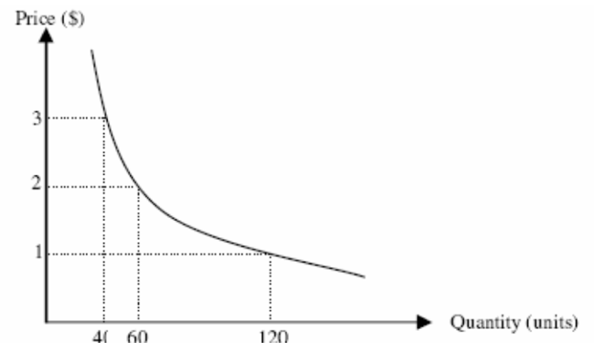
X貨品的需求
≈ç≈ç≈ç≈ç
The demand for good X
≈ç≈ç≈ç≈ç
數量（單位）
The demand for good X is
A. elastic B. unitary elastic C. perfectly elastic D. inelastic

X貨品的需求屬
A. 高彈性 B. 單一彈性 C. 完全彈性 D. 低彈性

Example Question 2 CE1998MCQ5
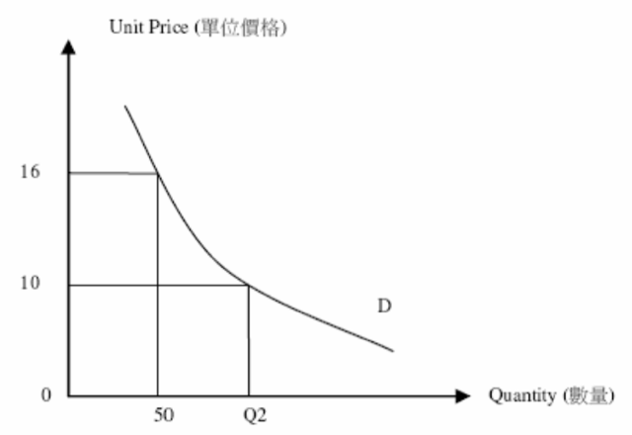
In the above diagram, if the demand is unitary elastic, Q₂ will be
A. 60 B.75 C.80 D.100

上圖中，若需求是單一彈性，Q₂便是
A. 60 B.75 C.80 D.100

Example Question 3 CE2001MCQ6
‘I love to take photos very much. Even though the price of film has increased by 30%, my spending on it will still be the same.’ Mary said. Mary’s demand for film is
A. perfectly inelastic. B. inelastic. C. elastic. D. unitarily elastic.

小欣說：「我很喜歡攝影。即使菲林的價格上升了30%，我在菲林上的開支仍會維持不變。」小欣對菲林的需求屬
A. 完全無彈性 B. 低彈性 C. 高彈性 D. 單一彈性

Example Question 4 CE2003MCQ7
Refer to the following straight line demand curve DD.
下圖的DD需求線是一條直線。
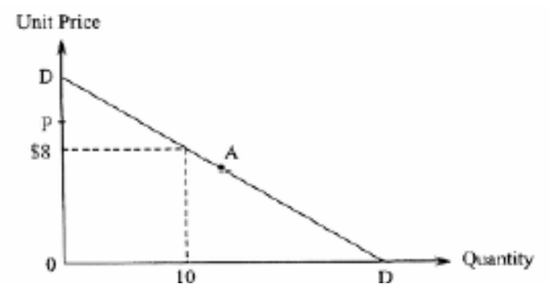
數量
≈ç≈ç≈ç≈ç
單位價格
≈ç≈ç≈ç≈ç
Point A is the mid point of the demand curve DD. If the unit price increases from $8 to P, the total revenue
A. will be greater than $80 B. will be equal to $80
C. will be smaller than $80 D. may be greater or smaller than $80

A點是需求線DD的中點。若單位價格由$8增加至P，總收益
A. 會大於$80 B. 會等於$80
C. 會少於$80 D. 可能大於，亦可能少於$80

Example Question 5 CE2003MCQ13
A marker researcher reports to the manager of a company, “Even if we cut prices to boost sale, the sales revenue will remain unchanged because of the elasticity of demand of our product?”
According to the market researcher, their product’s elasticity of demand is
A. perfectly inelastic B. inelastic C. elastic D. unitarily elastic

一名市場研究員向經理提交報告：「即使我們減價而刺激銷量，銷售收益仍會維持不變。這是由於我們產品的需求彈性所導致的。」根據他所言，他們產品的需求屬
A. 完全無彈性 B. 低彈性 C. 高彈性 D. 單一彈性

Example Question 6 CE2004MCQ9
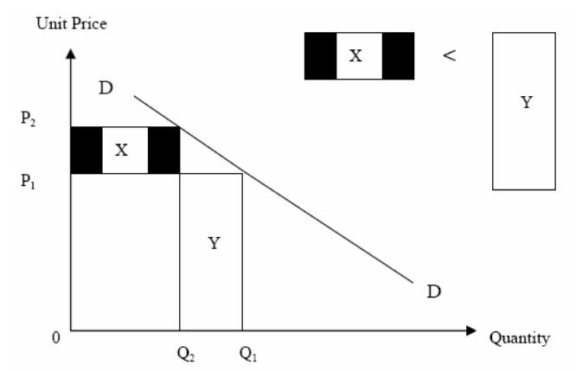
數量
≈ç≈ç≈ç≈ç
單位價格
≈ç≈ç≈ç≈ç
In the above diagram, DD is a demand curve. In the price range P₁ to P₂, the elasticity of demand
A. is less than 1. B. is equal to 1. C. is greater than 1.
D. may be less than or greater than 1, depending on the exact values of P₁, P₁, Q₁ and Q₂.

上圖中DD是一條需求曲線。在P₁至P₂的價格範圍內，需求彈性
A. 小於1 B. 等於1 C. 大於1
D. 可能小於或大於1， 視乎P₁、P₂、Q₁及Q₂的實際數值而定

Example Question 7 CE2009MCQ9
Mr Chan travels frequently between Hong Kong and Beijing on business trips. Last year, even though the price of air-tickets increased by 50%, Mr Chan’s total expenditure on these air-tickets remained unchanged. If Mr Chan’s demand for these air-tickets last year remained the same as the previous year, his demand for these air-tickets last year would have been
A. Perfectly inelastic. B. Inelastic. C. Unitarily elastic D. Elastic.

陳先生不時因公幹往返香港、北京兩地。在去年，即使飛機票價上升了50%，陳先生在飛機票上的總支出不變。假設陳先生去年對飛機票的需求和之前一年相同，他去年對飛機票的需求屬於
A. 完全無彈性 B. 低彈性 C. 單一彈性 D. 高彈性

Example Question 8 DSE2012MCQ11
Michelle is a jewelry lover and she says, “I will spend all my monthly salary on jewellery no matter what the price is.” From this we can conclude that her demand for jewellery is
A. elastic. B. inelastic. C. unitarily elastic. D. perfectly inelastic.

米雪是珠寶愛好者。她說：「我會將我全部的月薪花在珠寶上，不論它的價格如何。」由此我們可得出結論：她對珠寶的需求屬
A. 高彈性 B. 低彈性 C. 單一彈性 D. 完全無彈性

Example Question 9 DSE2017MCQ15
Refer to the following conversation between Mandy and Shirley
Mandy: I like coffee very much ! No matter how its price changes, I always buy the same amount of coffee every week!
Shirley: I like coffee very much too ! No matter how its price changes, I always spend the same amount of money on coffee every week!
Based on their conversation, Mandy’s demand for coffee is __________ and Shirley’s demand for coffee is __________.
A. Perfectly inelastic …… perfectly inelastic B. Perfectly inelastic …… unitarily elastic
C. Unitarily elastic …… perfectly inelastic D. Unitarily elastic …… unitarily elastic

參看文迪和莎莉的對話。
文迪： 我酷愛咖啡！不論其價格如何轉變，每週我總是購買相同數量的咖啡。
莎莉： 我也酷愛咖啡！不論其價格如何轉變，每週我總是花費相同金額購買咖啡。
根據他們的對話，文迪對咖啡的需求屬_________而莎莉對咖啡的需求屬_________
A. 完全無彈性 …… 完全無彈性 B. 完全無彈性 …… 單一彈性
C. 單一彈性 …… 完全無彈性 D. 單一彈性 …… 單一彈性

Type 2 (Elasticity of Demand & Total revenue)

Type 3 (Elasticity cross topic Demand & Supply)
Example Question 1 CE1993MCQ28
In a period of rainy whether, the price of umbrella increased by 10% while the quantity transacted increased by 15%. What is the price elasticity of demand/supply of umbrellas in the above situation?
A. The demand is elastic B. The demand is inelastic C. The supply is elastic D. The supply is inelastic

天雨期間，雨傘的價格上升10%，銷售量增加15%。在這種情況下，雨傘的價格需求彈性或價格供應彈性是怎樣的？
A. 需求屬高彈性 B. 需求屬低彈性 C. 供應屬高彈性 D. 供應屬低彈性

Example Question 2 CE2006MCQ9
Fearing an outbreak of bird flu, people tend to consume less live poultry but more canned food. As a result, the price of the canned food of a particular brand changed by 50% and its quantity transacted rose from 1000 cans to 1350 cans per month. We can conclude that within the above price range this canned food had
A. an elastic demand B. an inelastic demand C. an elastic supply D. an inelastic supply

因恐懼禽流感爆發，人們傾向減少食用活家禽而增加食用罐頭食品。因此，某牌子罐頭食品的價格改變了50%，交易量則由每月1000罐增加至每月1350罐。我們可得結論如下：在上述價格範圍內，該罐頭食品的
A. 需求屬高彈性 B. 需求屬低彈性 C. 供應屬高彈性 D. 供應屬低彈性

Example Question 3 CE2009MCQ10
Suppose with the more popular use of iPods (portable media players), the price of the traditional MP3 players has fallen by 40% and the quantity sold has change by 50%. This would indicate that within the price range, there was an __________ for the traditional MP3 player.
A. Elastic demand B. Inelastic demand C. Elastic supply D. Inelastic supply

假設由於人們更普及地使用iPod（一種可攜式媒體播放器），傳統MP3播放器的價格下跌了40%，其銷售量改變了50%。這顯示傳統MP3播放器在該價格範圍內的
A. 需求屬高彈性 B. 需求屬低彈性 C. 供應屬高彈性 D. 供應屬低彈性

Example Question 4 CE2011MCQ11
During the Easter holiday, the unstable political situation in Thailand caused the price of air tickets to Thailand to fall by 50% and the quantity sold to change by 70%. This suggests that during that period of time and within the price range, there was an _______ for/of air tickets to Thailand.
A. Elastic demand B. Inelastic demand C. Elastic supply D. Inelastic supply

在去年復活節假期期間，泰國的政局不穩導致飛往當地的機票價格下降了50%，而其售出數量改變了70%。這意味在該時期及上述價格範圍內，飛往泰國的機票的
A. 需求屬高彈性 B. 需求屬低彈性 C. 供應屬高彈性 D. 供應屬低彈性
Example Question 5 DSESPMCQ14
During winter, women tend to buy more hydrating facial cream. As a result, the price of bottled hydrating facial cream of a particular brand changed by 20% and its quantity transacted rose from 2 000 bottles to 2 800 bottles per month. We can conclude that within the above price range this bottled hydrating facial cream had
A. an elastic demand. B. an inelastic demand. C. an elastic supply. D. an inelastic supply.

在冬季，婦女傾向購買更多保濕面霜。結果，某品牌的瓶裝保濕面霜的價格轉變了20%，成交量則由每月2000瓶升至2800瓶。我們可得結論如下：在上述的價格範圍內，這瓶裝保濕面霜的
A. 需求屬高彈性 B. 需求屬低彈性 C. 供應屬高彈性 D. 供應屬低彈性

Example Question 6 DSEPPMCQ9
Suppose there is political unrest in the countries exporting crude oil. As a result, there is a 30% increase in the price of gasoline and a 15% change in the quantity transacted of gasoline. We can conclude that
A. the demand for gasoline is elastic. B. the demand for gasoline is inelastic.
C. the supply of gasoline is elastic. D. the supply of gasoline is inelastic.

假設原油出口國政局不穩。結果，汽油的價格增加30%，而汽油的交易量改變了15%。我們可以得出結論如下
A. 汽油的需求屬高彈性 B. 汽油的需求屬低彈性
C. 汽油的供應屬高彈性 D. 汽油的供應屬低彈性

Example Question 7 DSE2019MCQ11
Study the following news abstract.
A Dengue fever (登革熱) scare has hit Hong Kong after 19 people in the past week were confirmed to have contracted the virus locally. Dengue fever is transmitted to humans by Aedes albopictus (白紋伊蚊) ,a type of mosquito commonly found in Hong Kong.
Suppose the price and the quantity of mosquito repellents sold in Hong Kong changed by 5% and 120% respectively shortly after the release of the above news. This indicates that during that period and within the price range, there was an __________ the mosquito repellents in Hong Kong.
A. Elastic supply of B. Inelastic supply of C. Elastic demand for D. Inelastic demand for

細閱以下報章撮要：
登革熱恐慌襲港——上星期本港有19人確診在本地感染該病毒。登革熱是由白紋伊蚊傳播給人類，而白紋伊蚊是在本港常見的蚊子。
假設上述新聞發佈後，本港售賣的蚊怕水的價格和數量隨即分別轉變了5%和120%。這顯示了在該段時間和價格範圍內，本港蚊怕水的
A. 供應屬高彈性 B.供應屬低彈性 C. 需求屬高彈性 D. 需求屬低彈性

Example Question 8 DSE2021MCQ18
Refer to the following news.
In order to reduce pollution, the government imposes a production tax on all kinds of motor vehicles (except electric vehicles).
As a result, the price of gasoline changes by 22% and its quantity transacted changes by 35%. Which of the following statements is correct?
A. The demand for gasoline is elastic. B. The demand for gasoline is inelastic.
C. The supply for gasoline is elastic. D. The supply for gasoline is inelastic.

參考以下一則新聞。
為了減少污染，政府對所有種類的車輛徵收一項生產稅（電動車除外）。
結果，汽油的價格改變了22%及其交易量改變了35%，下列哪項陳述是正確的？
A. 汽油的需求屬高彈性 B. 汽油的需求屬低彈性
C. 汽油的供應屬高彈性 D. 汽油的供應屬低彈性

Type 3 (Elasticity cross topic Demand & Supply)

Type 4 (Factors Affecting Elasticity of Demand & Supply)
Example Question 1 CE1997MCQ9
The price elasticity of demand for the Hung Hom Cross-Harbor Tunnel service would decrease if
A. the tunnel fee is raised from $10 to $30
B. the Western Harbor Crossing is open
C. the Eastern Harbor Crossing is closed for maintenance work
D. a new hydrofoil services is produced between Tsuen Wan and Wan Chai

在下列哪一種情況下，經紅磡的海底隧道服務的需求價格彈性會降低？
A. 紅磡的海底隧道收費由$10提高至$30 B. 西區海底隧道通車
C. 東區海底隧道關閉做維修工作 D. 在荃灣和灣仔之間有渡海水翼船投入服務

Example Question 2 CE2003MCQ5
Which of the following would increase the elasticity of demand of the transport service of the MTR?
A. the cutting of bus lines running routes similar to those of the MTR
B. a decrease in MTR passenger fares
C. the opening of new lines of KCR running routes similar to those of the MTR
D. a decrease in the operating costs of the MTR

下列哪一項會增加地鐵運輸服務的需求彈性？
A. 削減與地鐵路線相近的巴士線 B. 地鐵減乘客票價
C. 九廣鐵路開設與地鐵路線相近的新路線 D. 地鐵的營運費用下降

Example Question 3 CE2010MCQ10
Suppose an increase in the demand for Good Y results in a 10% and 5% change in its price and quantity transacted respectively. Which of the following could explain the extent of the change in the price and the quantity transacted?
A. The good is a habit-forming good.
B. There are no close substitutes for the good.
C. Firms producing the good have excess capacity in production.
D. Firms producing the good have used factor inputs which are more specialized.

假設物品Y的需求增加導致它的價格及交易量分別改變了10%及5%。下列哪項可以解釋它的價格及交易量改變的幅度？
A. 該物品是習慣性使用的物品 B. 該物品沒有近似的代替品
C. 生產該物品的廠商有剩餘生產力 D. 生產該物品的廠商使用了更專門的生產要素

Example Question 4 DSE2014MCQ13
Which of the following would reduce the elasticity of demand for the transport service of the Airport Express?
A. There are more airport bus routes to different districts. B. Vans are not allowed to pick up passengers at the airport.
C. The fare of the Airport Express is raised. D. The maintenance cost of the Airport Express trains increases.

下列哪項會減低對機場快綫列車服務的需求彈性？
A. 有更多來往不同地區的機場巴士路線 B. 客貨車不准在機場接載乘客
C. 機場快綫列車服務的車費增加 D. 機場快綫列車的維修費用增加

Type 4 (Factors Affecting Elasticity of Demand & Supply)

Type 5 (Others)
Example Question 1 CE1992MCQ28
Suppose the demand for wheat is elastic. Which of the following will decrease if there is a poor harvest of wheat?
(1) the price of wheat
(2) the total expenditure on wheat
(3) the demand for wheat
(4) the quantity of wheat transacted
A. (1) and (2) only B. (1) and (3) only C. (2) and (4) only D. (3) and (4) only

設小麥的需求彈性高。若小麥失收，以下哪項會下跌或減少？
(1) 小麥價格
(2) 購買小麥總支出
(3) 對小麥的需求
(4) 小麥交易量
A. 只有(1)、(2) B. 只有(1)、(3) C. 只有(2)、(4) D. 只有(3)、(4)

Example Question 2 CE1996MCQ10
Research shows that changes in bus fares will not affect the number of passengers who travel before 9 am. But will affect the number of passengers who travel after 9 a.m. which changes by a greater percentage than the percentage change in bus fares? In order to obtain the largest revenue, the bus company should
A. raise the fares before and after 9am. B. not change the fares before 9am but reduce the fares after 9am.
C. raise the fates before 9am but reduce the fares after 9 am. D. not change the fares before 9am but raise the fares after 9am.

某研究指出，巴士票價的改變對上午九時前的乘客數量並無影響，但對上午九時後的乘客數量卻有影響：這些乘客數量的變動百分比大於票價變動的百分比。若要取得最大銷售收益，巴士公司應該怎樣做？
A. 無論在上午九時前或後都提高票價 B. 在上午九時前票價維持不變，但在上午九時後減價
C. 在上午九時前加價，但在上午九時後減價 D. 在上午九時前票價維持不變，但在上午九時後加價

Example Question 3 CE2010MCQ7
Most Hong Kong people use either town gas or electricity for cooking. Assume there is an increase in electricity charges. Consumers’ expenditure on electricity consumption _________ but their expenditure on town gas consumption ________.
A. will decrease ... will increase B. will increase ... may increase or decrease
C. may remain unchanged ... will decrease D. may increase or decrease ... will increase

多數香港人用煤氣或電力煮食。假設電費大幅增加，消費者的電費總支出 _____ 而煤氣費總支出則_____。
A. 會減少 … 會增加 B. 會減少 … 可能增加，亦可能減少
C. 可能維持不變 … 會減少 D. 可能增加，亦可能減少 … 會增加

Example Question 4 DSE2012MCQ12
Owing to continuous bad weather, the quantity transacted of local vegetables falls by 40% while the price rises by 13%. Which of the following statements are correct?
(1) The quantity demanded for local vegetables falls.
(2) The total expenditure on local vegetable rises.
(3) The demand for imported vegetable rises.
(4) The total expenditure on imported vegetables may rise or fall depending on the elasticity of demand.
A. (1) and (2) only B. (1) and (3) only C. (2) and (4) only D. (3) and (4) only

由於天氣持續惡劣，本地蔬菜的交易量下降了40%，而價格上升了13%。下列哪些陳述是正確的？
(1) 本地蔬菜的需求量下降。
(2) 本地蔬菜的總支出上升。
(3) 進口蔬菜的需求上升。
(4) 進口蔬菜的總支出可能上升或下降，按其需求彈性而定。
A. 只有(1)、(2) B. 只有(1)、(3) C. 只有(2)、(4) D. 只有(3)、(4)

Example Question 5 DSE2018MCQ17
The original price of Sausage McMuffin with Egg was $111 each. McDonald’s introduced the following discount in a limited time.
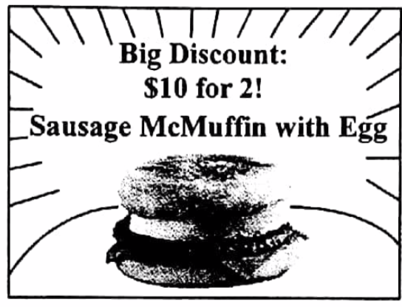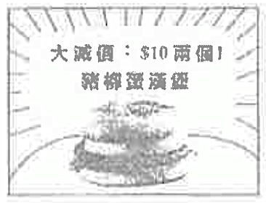
As a result, more people bought Sausage McMuffin with Egg during the promotion period. Which of the following statements about this statement is correct?
A. McDonald’s was not maximizing profit during the promotion period.
B. The demand for Sausage McMuffin with Egg would be higher during the promotion period.
C. The total expenditure of consumers on Sausage McMuffin with Egg would increase if the demand is elastic.
D. There would be a temporary shortage of the food ingredients for making Sausage McMuffin with Egg.

豬柳蛋漢堡的原價是每個$11。麥當勞推出上列的限時折扣。結果，更多人在優惠期間購買豬柳蛋漢堡。下列哪項有關這情況的陳述是正確的？
A. 在優惠期間麥當勞沒有爭取最高利潤。
B. 豬柳蛋漢堡的需求在優惠期間會上升。
C. 若需求屬高彈性，消費者對豬柳蛋漢堡的總支出會上升。
D. 製作豬柳蛋漢堡所需的食材會暫時出現短缺。
Example Question 6 DSE2019MCQ15
A new private hospital, Gleneagles Hong Kong Hospital (GHK), opened in Wong Chuk Hang in early 2017. GHK offered a 50% salary rise to attract experienced nurses from public hospitals.
Based on the above information, which of the following statements is correct after the opening of GHK?
A. The wage rate of experienced nurses in public hospitals would increase by more than 50% if the demand for nurse is elastic.
B. The supply of experienced nurses in public hospitals would decrease.
C. The elasticity of demand of public medical services would decrease.
D. The waiting time for public medical services would remain unchanged.

港怡醫院是一所新的私家醫院，於2017年初在黃竹坑開幕。港怡醫院以加薪50%來吸引公立醫院有經驗的護士轉職。
根據以上資料，在港怡醫院開幕後，下列哪項陳述是正確的？
A. 若護士的需求屬高彈性，公立醫院有經驗的護士的工資率會上升超過50%。
B. 公立醫院有經驗的護士的供應會減少。
C. 公共醫療服務的需求彈性會下降。
D. 公共醫療服務的輪候時間會維持不變。

Type 5 (Others)

2013DSE LQ9a
The following is an extract from a local newspaper article.
The MTR Corporation raised the railway fares by 5.4% in 2012 . This increase was based on the Fare Adjustment Mechanism set by the government . To respond to the discontent of the public over the fare increase , the Corporation introduced a concessionary measure “Ride 10 Get 1 Free” .
With the aid of a diagram, explain under what condition the total expenditure of passengers on the MTR will increase because of the rise in fare. (5)

以下是一篇本地報章報道的節錄。
港鐵公司在2012年提高鐵路票價5.4%。是次票價上調是根據政府所定的票價調整機制。為了回應公眾對票價上升的不滿，港鐵推出「搭十送一」優惠措施。
以一圖輔助，解釋在什麼情況下港鐵票價上升會引致乘客對鐵路服務的總支出上升。 (5)
_______________________________________________________________________________________
_______________________________________________________________________________________
_______________________________________________________________________________________
_______________________________________________________________________________________
_______________________________________________________________________________________
_______________________________________________________________________________________
_______________________________________________________________________________________
_______________________________________________________________________________________
_______________________________________________________________________________________
_______________________________________________________________________________________
_______________________________________________________________________________________
_______________________________________________________________________________________
_______________________________________________________________________________________
_______________________________________________________________________________________
_______________________________________________________________________________________
_______________________________________________________________________________________
Marking Scheme:
Verbal explanation:
If the demand for MTR service is inelastic, the percentage increase in fare will be higher than the percentage decrease in the number of trips, so the total expenditure will increase. (3)
Indicate on the diagram:
- correct position of gain and loss
- gain > loss

文字解說：
若對港鐵服務的需求屬低彈性，車費上升的百分比會高於乘搭人次下降的百分比，故此總支出會上升 (3)
在圖中顯示：
- 得益和損失的正確位置
- 得益 > 損失
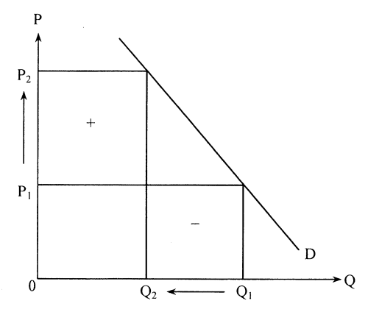

Candidates’ Performance:
Excellent. Most candidates could illustrate their answers with a well-labelled diagram.
優異。 大部份考生能利用清楚標示的圖加以說明。

2015DSE LQ11c
Tobacco duty is an indirect tax in Hong Kong. The Financial Secretary has increased the tobacco duty rate with the aim of discouraging smoking. An economist stated, “Other things being constant, the rise in the tobacco duty rate would not effectively reduce the quantity consumed of duty-paid cigarettes.” Justify his statement WITHOUT using a diagram. (4)

煙草稅是香港的一項間接稅。為了遏止吸煙，財政司司長增加了煙草稅稅率。一位經濟學家指出：「其他因素不變，增加煙草稅率不會有效地減少已完稅香煙的消費量。」毋需運用圖表，論證他的陳述。 (4)
_______________________________________________________________________________________
_______________________________________________________________________________________
_______________________________________________________________________________________
_______________________________________________________________________________________
_______________________________________________________________________________________
Marking Scheme:
Tobacco duty would increase the market price of duty-paid cigarettes and thus reduce its quantity demanded. (1)
If cigarette consumers are addicted, their demand for cigarettes would be inelastic, so the percentage decrease in quantity demanded would be smaller than the percentage increase in price. In this case, even a huge increase in tobacco duty may not be effective in reducing the consumption of cigarettes. (3)

煙草稅增加已完稅香煙的市場價格，故令其需求量下降。 (1)
若香煙消費者已吸煙成癮，他們對香煙的需求屬低彈性。因此需求量下降的百分比小於價格上升的百分比。在這情況下，即使煙草稅大幅上升，也未能有效減低香煙的消費。 (3)
Candidates’ Performance:
Fair. The following mistakes were common:
- neglecting the word “justify” and providing arguments against the statement;
- over-emphasising the opportunity for the smokers to turn to the black market for cigarettes, while ignoring that the question only concerns duty-paid cigarettes;
- mistaking “effectiveness” for “efficiency”
一般。常見的錯誤包括：
- 忽略了「論證」一詞，提出反對該陳述的論點。
- 過分強調吸煙人士可以向黑市購買香煙的機會，而忽略了這題目只跟已完稅香煙有關。
- 誤將「有效」當作「有效率」。

***2017DSE LQ10c
MTR Corporation Limited (stock code: 66) provides railway services in Hong Kong. Based on Table 1, can we conclude that ‘the increase in total revenue is a result of inelastic demand for the local services of MTR’? Explain your answer with the aid of a diagram. (7)
Table 1: Business information about the local services of MTR
Year | Fare Adjustment Rate | Total Passengers Boarding (in million) | Total Revenue (HK$ million)
2012 | +5.4% | 1431 | 14523
2013 | +2.7% | 1475 | 15166
2014 | +3.6% | 1548 | 16223

香港鐵路有限公司（股票編號：66）為本港提供鐵路服務。根據表一，我們可否得出「港鐵本地服務的總收入上升是由於其低彈性需求所致。」這結論？以圖輔助，解釋你的答案。 (7)
表一: 港鐵本地服務的業務資料
年份 | 車費調整率 | 總乘搭人次（百萬） | 總收入（港幣百萬元）
2012 | +5.4% | 1431 | 14523
2013 | +2.7% | 1475 | 15166
2014 | +3.6% | 1548 | 16223
_______________________________________________________________________________________
_______________________________________________________________________________________
_______________________________________________________________________________________
_______________________________________________________________________________________
_______________________________________________________________________________________
_______________________________________________________________________________________
_______________________________________________________________________________________
_______________________________________________________________________________________
_______________________________________________________________________________________
_______________________________________________________________________________________
_______________________________________________________________________________________
_______________________________________________________________________________________
Marking Scheme:
No.
Verbal elaboration:
– There was a rise in demand.
– Both the price and the quantity transacted increased.
– Total revenue increased.
Illustrate in the diagram:
D₁
D₀
Q₁
Q₀
0
P₀
P₁
P
Q
Increase in TR
– Demand curve shift to the right
– Higher Price and Quantity
– Higher Total Revenue
否。
總收入增加
≈ç≈ç≈ç≈ç
文字解說：
－ 需求上升。
－ 價格和交易量均上升。
－ 總收人上升。
在圖中顯示：
－ 需求曲線向右移
－ 價格和數量上升
－ 總收人增加

Candidates’ Performance:
Fair. Many candidates failed to perceive that both prices and quantity rose. They just recite the definition of low elasticity needs and try to pair the certainty with the data, ignoring the increase in total passengers boarding. Some candidates were able to interpret the data adequately and perceived a contradiction between rising prices and quantity and the inverse relationship between prices and quantities demanded in cases of inelastic demand. Candidates who do well can point to the reason for the increase in demand and illustrate the case with a clearly labelled diagram.

一般。很多考生未能察覺價格和交易量均上升。他們只背誦低彈性需求的定義，並嘗試將定義和資料配對，忽略了總乘客人數的增加。部分考生能充分解讀數據，並察覺價格和交易量上升與低彈性需求個案中價格和需求量的反向關係存在矛盾。表現出色的考生能指出需求上升這原因，並以標示清楚的圖說明本個案。

2018DSE LQ5a
During peak flu seasons, there is not enough medical staff in public hospitals in Hong Kong. An economist stated, ‘Even if the government sharply increases the wage rates of the medical staff, it is still difficult to relieve the problem,.’ Justify his statement using the concept of elasticity of supply / demand. (3)

流感高峰期間，香港公立醫院的醫護人員人手不足。某經濟學者指出：「即使政府大幅增加醫護人員的工資率，該問題仍然難以舒緩。」運用供應 / 需求彈性的概念，論證他的陳述。 (3)
_______________________________________________________________________________________
_______________________________________________________________________________________
_______________________________________________________________________________________
_______________________________________________________________________________________
_______________________________________________________________________________________
_______________________________________________________________________________________

Marking Scheme:
Supply of medical staff may be inelastic because they require special training and qualification. Even if the government raise their wage rates sharply, the percentage increase in the quantity supplied of medical staff would still be smaller than the percentage increase in their wage rates. (3)

醫護人員的供應可屬低彈性，因為醫護人員須有特別的培訓和資歴。即使政府大幅提高其工資率，醫護人員供應量上升的百分比仍然低於工資率上升的百分比。 (3)
Candidates’ Performance:
Fair. Common errors include:
- confusing the elasticity of supply with the elasticity of demand;
- comparing the percentage changes in price (wage rates) and in quantity demanded for medical staff to infer about the resulting change in total revenue (total cost of medical staff).
一般。考生常犯的錯誤如下：
- 混淆了需求彈性和供應彈性。
- 比較價格（工資率）和對醫護人員需求量的改變的百分比，從而推導對總收入（總醫療成本）的影響。

2021DSE LQ10c
Masks have become a daily necessity as it is compulsory for people to wear masks in many public areas. To stabilise the supply of surgical masks in Hong Kong, the Government has launched the ‘Local Mask Production Subsidy scheme’, which provides subsidy to local mask producers. With the aid of a diagram, explain under what condition the total expenditure of consumers on surgical masks will decrease because of the subsidy. (For simplicity, the subsidy is assumed to be a per unit one.) (7)

由於在很多公眾地方市民都要強制佩戴口罩，口罩成為生活必需品。為了穩定本港外科口罩的供應，政府推出「本地口罩生產資助計劃」，提供補貼予本地口罩生產商。以圖輔助，解釋在什麼情況下消費者對外科口罩的總支出會因為該補貼而下降。(為了簡化，假設該補貼屬從量。) (7)
_______________________________________________________________________________________
_______________________________________________________________________________________
_______________________________________________________________________________________
_______________________________________________________________________________________
_______________________________________________________________________________________
_______________________________________________________________________________________
_______________________________________________________________________________________
_______________________________________________________________________________________
_______________________________________________________________________________________
_______________________________________________________________________________________
_______________________________________________________________________________________
_______________________________________________________________________________________
_______________________________________________________________________________________
_______________________________________________________________________________________
_______________________________________________________________________________________
_______________________________________________________________________________________
_______________________________________________________________________________________
_______________________________________________________________________________________
Marking Scheme:
Verbal explanation:
The provision of subsidy would result in an increase in the supply of masks. If demand is inelastic, the percentage decrease un price would be bigger than the percentage increase in quantity, so that total expenditure on masks would drop. (4)
Illustrate in the diagram:
- downward shift of supply curve (3)
- correct positions of the increase in total expenditure (+) and the decrease in total expenditure (-)
- Area of (+) > Area of (-)

文字解說：
提供補貼引致口罩的供應增加。若需求屬低彈性，價格下降的百分比會大於數量上升的百分比，因而口罩的總支出會下降。 (4)
在圖中顯示：
- 供應曲線向下移動 (3)
- 總支出增加 (+) 和總支出減少 (-) 的正確位置
- 面積 (+) > 面積 (-)
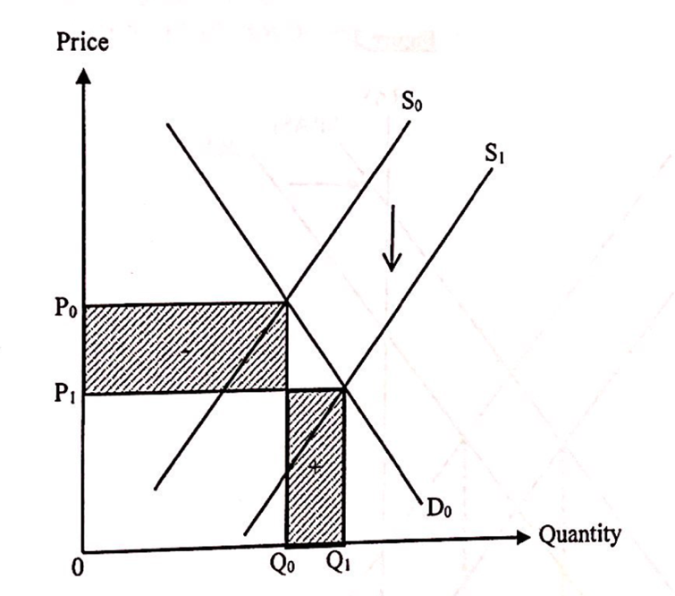
價格
≈ç≈ç≈ç≈ç
數量
≈ç≈ç≈ç≈ç

Candidates’ Performance:
Good. Many candidates were able to explain the case with a diagram. However, many of them made minor mistakes in their verbal explanations and/or diagrammatic illustrations. Common mistakes include:
- Wrongly stating that "demand being more inelastic than supply' is the condition for the reduction in total expenditure as a result of the subsidy.
- Wrongly comparing the changes of price and quantity, instead of comparing their percentage changes.
- Failing to label the demand curve and/or the supply curve.
- Failing to indicate that the fall in total expenditure due to the price decrease [Area (-)] and the rise in total expenditure due to the quantity increase [Area (+)], or failing to show in the diagram that Area (-) > Area (+).
- Mis-reading the question and discussing the shares of subsidy benefits or changes in the consumer surplus vs. the producer surplus (which is not required by the question).

良好。很多考生能以一幅圖解釋該個案。不過很多考生在文字解說及 / 或繪圖時犯下了小毛病。常犯毛病包括:
- 錯誤寫出「需求彈性較供應彈性為低」作為補貼導致總支出下降的條件。
- 錯誤比較價格和數量的改變，而非它們百分比的改變。
- 未有標示需求及 / 或供應曲線。
- 未有標示因價格下降令總支出減少 [面積(-)] 和因數量上升令總支出增加 [面積(+)]，或未有在圖中顯示面積(-) > 面積(+)。
- 未有清楚審題，討論補貼得益的分配或消費者盈餘和生產者盈餘的改變（這並非題目所要求）。

Marking Scheme:
Type 1 (Table Format Questions - Calculation)
1 | A | 2 | B | 3 | A | 4 | B | 5 | A
Type 2 (Elasticity of Demand & Total revenue)
1 | B | 2 | C | 3 | D | 4 | C | 5 | D | 6 | C | 7 | C | 8 | C | 9 | B
Type 3 (Elasticity cross topic Demand & Supply)
1 | C | 2 | D | 3 | C | 4 | C | 5 | C | 6 | B | 7 | A | 8 | C
Type 4 (Factors Affecting Elasticity of Demand & Supply)
1 | C | 2 | C | 3 | D | 4 | B | 5 | A | 6 | B | 7 | C | 8 | D
Type 5 (Others)
1 | C | 2 | C | 3 | D | 4 | B | 5 | C | 6 | B

