Learning Focus:
Memo
(LQ Answering Flow, MC skills, your goals and resolutions…)
Specific Question Type
MC

咩話？DSE Sample Paper, Practice Paper, 2012, 2013, 2014, 2015, 2016, 2017, 2018, 2019, 2020, 2021, 2022 MC全部拍晒解題片？係呀，有唔明即scan即睇！就係咁firm！


Learning Focus:
Memo
(LQ Answering Flow, MC skills, your goals and resolutions…)
Specific Question Type
LQ

咩話？DSE Sample Paper, Practice Paper, 2012, 2013, 2014, 2015, 2016, 2017, 2018, 2019, 2020, 2021, 2022 LQ全部拍晒解題片？係呀，有唔明即scan即睇！就係咁firm！


Chapter 11 _ Efficiency
Type 1 (Area showing CSPS)
Example Question 1 DSEPPMCQ15
The following diagram shows the demand and supply curves of good X in a perfectly competitive market.
下圖顯示在一個完全競爭市場內物品 X 的需求和供應曲線。
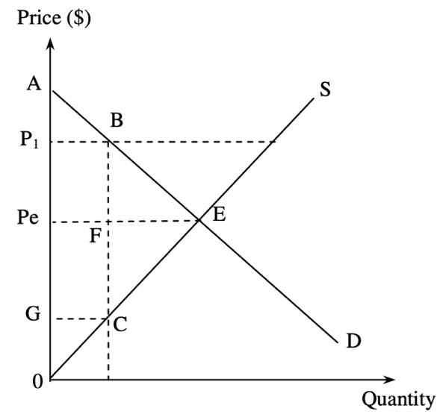
Suppose a price floor is set at P1. As a result,
A. the deadweight loss is equal to area BEF. B. the producer surplus is equal to area P1BC0.
C. the consumer surplus is equal to area AEPe. D. the total social surplus is equal to area P1BCG.

假設價格下限設在 P1。結果，
A. 效率損失等於面積 BEF。 B. 生產者盈餘等於面積 P1BC0。
C. 消費者盈餘等於面積 AEPe。 D. 總社會盈餘等於面積 P1BCG。

Example Question 2 DSEPPMCQ16
Which of the following are features of a perfectly competitive market?
(1) The marginal revenue of each firm equals the market price.
(2) The sellers and buyers have perfect market information.
(3) The marginal cost schedule of a firm is the same as its supply schedule.
A. (1) and (2) only B. (1) and (3) only C. (2) and (3) only D. (1), (2) and (3)

下列哪些是完全競爭市場的特徵？
(1) 每間公司的邊際收入等於市價。
(2) 賣家和買家掌握完全市場資訊。
(3) 一間公司的邊際成本表與它的供應表相同。
A. 只有 (1)、(2) B. 只有 (1)、(3) C. 只有 (2)、(3) D. (1)、(2) 及 (3)

Example Question 3 DSEPPMCQ17
Economic efficiency is attained when
(1) total benefits to consumers are maximized.
(2) all potential gains are fully captured.
(3) marginal social benefits are equal to marginal social costs.
A. (1) and (2) only B. (1) and (3) only C. (2) and (3) only D. (1), (2) and (3)

在下列哪些情況下，會達致效率？
(1) 消費者得到最大的總利益。
(2) 所有潛在得益可以完全獲取。
(3) 邊際社會利益等於邊際社會成本。
A. 只有 (1)、(2) B. 只有 (1)、 3) C. 只有 (2)、(3) D. (1)、(2) 及 (3)

Example Question 4 DSE2012MCQ14
On 10th July 2011, the urban taxi fare for the first 2 km was raised from $18 to $20. Which of the following statements about the urban taxi service are correct?
(1) The demand for taxi service dropped.
(2) The price of long-distance taxi trips relative to short-distance taxi trips dropped.
(3) The consumer surplus for the taxi service dropped.
A. (1) and (2) only B. (1) and (3) only C. (2) and (3) only D. (1), (2) and (3)

由 2011年7月10日開始，市區的士服務首兩公里的車費由 18元增加至 20元。下列哪些有關市區的士服務的陳述是正確的？
(1) 的士服務的需求下降。
(2) 相對短程的士服務，長程的士服務的價格下降 。
(3) 的士服務的消費者盈餘下降。
A. 只有(1)、(2) B. 只有(1)、(3) C. 只有(2)、(3) D. (1)、(2)及(3)

Example Question 5 DSE2012MCQ19
The increase of an effective quota on a good will result in
(1) An increase in the quantity transacted of the good.
(2) A further improvement in the quality of the good.
(3) A smaller deadweight loss.
A. (1) and (2) only B. (1) and (3) only C. (2) and (3) only D. (1), (2) and (3)

增加對某物品的有效配額會導致
(1) 該物品的交易量上升。
(2) 該物品的質素進一步提升。
(3) 效率損失較小。
A. 只有(1)、(2) B. 只有(1)、(3) C. 只有(2)、(3) D. (1)、(2)及(3)

***Example Question 6 DSE2013MCQ18
Suppose the market equilibrium output level is greater than the efficient output level.
A. Total social surplus will increase if output is reduced towards the efficient output level.
B. At the equilibrium output level, marginal benefit is greater than marginal cost.
C. The sum of consumer surplus and producer surplus is maximized as the market output level satisfies the equilibrium condition.
D. Government intervention is necessary to reduce output as there is over-production.

假設市場均衡產出水平高於效率產出水平。這意味着
A. 若減少產出令其更接近效率產出水平，總社會盈餘會上升。
B. 在均衡產出水平，邊際利益大於邊際成本。
C. 消費者盈餘和生產者盈餘的總和達到最大，因爲市場產出水平滿足均衡產出水平。
D. 因為出現生產過剩，政府有需要作出干預令產出水平下降。

Example Question 7 DSE2013MCQ19
Refer to the following demand-supply diagram of a good with the government setting a quota at Q1. Which of the following will be the result of a reduction in quota on the good?
參閱以下某物品的供需圖 ，政府為該物品設立配額Q1。下列哪項是減少該物品配額的結果？
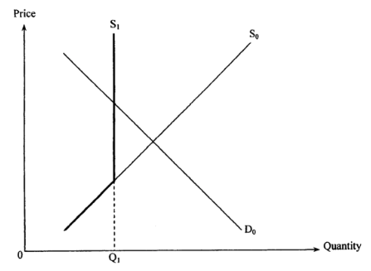
- The total expenditure on the good may increase or decrease.
- The consumer surplus will decrease.
- The total social surplus may increase or decrease.
A. (1) only B. (1) and (2) only C. (2) and (3) only D. (1), (2) and (3)

(1) 對該物品的總支出可能上升或下降。
(2) 消費者盈餘會下降。
(3) 總社會盈餘可能上升或下降。
A. 只有(I) B. 只有(1)、(2) C. 只有(2)、(3) D. (1)、(2)及(3)

Example Question 8 DSE2014MCQ15
Refer to the following supply-demand diagram for the Cross-Harbour Tunnel.
參考以下有關海底隧道的供需圖。
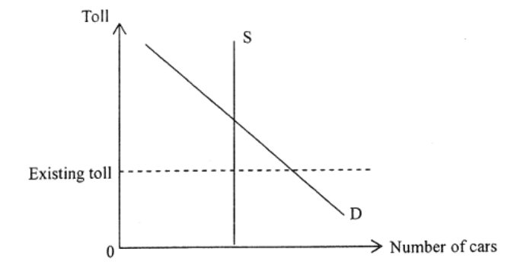
The government proposed to raise the toll for the Cross-Harbour Tunnel so as to lessen the traffic congestion during rush hours. Suppose the maximum vehicular volume of the tunnel is fixed. Which of the following statement are correct?
- The demand for the service of the Cross-Harbour Tunnel will decrease
- The total revenue of the Cross-Harbour Tunnel will increase
- The deadweight loss caused by traffic congestion will decrease
- The opportunity cost of the drivers using the tunnel will increase
A. (1) and (2) only B. (1) and (4) only C. (2) and (3) only D. (2) and (4) only

政府建議提高海底隧道的收費，以減低繁忙時段的交通擠塞情況。假設隧道最大行車量是固定的。下列哪些陳述是正確的？
- 對海底隧道服務的需求會減小。
- 海底隧道的總收入會上升。
- 由交通擠塞引起的效率損失會減小。
- 司機使用該隧道的機會成本會上升。
A. 只有 (1) , (3) B. 只有 (1) , (4) C. 只有 (2) , (3) D. 只有 (2) , (4)

Example Question 9 DSE2014MCQ21
Which of the following are results of the government lowering an effective price ceiling on a good?
(1) A reduction in the producer surplus
(2) An increase in excess demand
(3) An increase in the total sales revenue if the demand is elastic
A. (1) and (2) only B. (1) and (3) only C. (2) and (3) only D. (1), (2) and (3)

下列哪些是政府降低對某物品的有效價格上限的結果？
(1) 生產者盈餘下降。
(2) 超額需求上升。
(3) 若需求屬高彈性，總收入會上升。
A. 只有 (1) , (3) B. 只有 (1) , (4) C. 只有 (2) , (3) D. 只有 (2) , (4)

Example Question 10 DSE2014MCQ22
The imposition of a per-unit sales tax on cosmetics will
A. Reduce the total expenditure on cosmetics B. Reduce the total sales revenue (net-of-tax)
C. Increase the total social surplus in the cosmetics market. D. Increase the producer surplus in the cosmetics market.

政府對化妝品開徵從量銷售稅會
A. 引致對化妝品的總支出下降 B. 引致除稅後總銷售收益下降
C. 增加化妝品市場的總社會盈餘 D. 增加化妝品市場的生產者盈餘

Example Question 11 DSE2014MCQ23
Suppose the supply curves of cars and petrol are upward-sloping. quota on the production of cars,
A. the total social surplus in the car market will increase. B. the producer surplus in the car market will increase.
C. the total social surplus in the petrol market will decrease. D. the consumer surplus in the petrol market will increase.

假設汽車和汽油的供應曲線是向右上斜的。若政府對汽車的生產實施一有效的配額，
A. 汽車市場的總社會盈餘會上升 B. 汽車市場的生產者盈餘會下降
C. 汽油市場的總社會盈餘會下降 D. 汽油市場的消費者盈餘會上升

Example Question 12 DSE2015MCQ19
Refer to the following diagram.
細閱下圖。
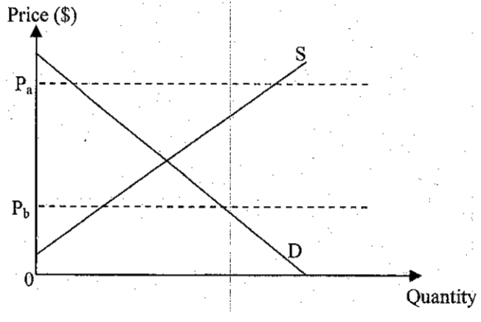
If the government lowers the price ceiling from P_{a} to P_{b},
A. The quantity transacted will increase. B. The deadweight loss will decrease.
C. The producer surplus will decrease. D. The consumer surplus will increase.

若政府將價格上限由Pa調低至Pb，
A. 交易量會上升 B. 效率損失會下降
C. 生產者盈餘會減小 D. 消費者盈餘會增加

Example Question 13 DSE2015MCQ22
Refer to the following diagram.
細閱下圖。
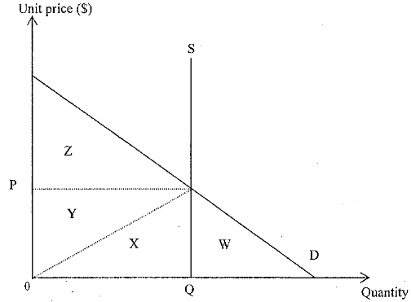
The maximum total social surplus is equal to ___________.
A. Area Z. B. Area (Y+Z) C. Area (W+X+Y) D. Area (X+Y+Z)

最大的總社會盈餘等於__________。
A. 面積Z B. 面積 (Y+Z) C. 面積 (W+X+Y) D. 面積 (X+Y+Z)

Example Question 14 DSE2016MCQ21
In which of the following situations is efficiency attained?
A. Total social benefit is equal to total social cost.
B. Producer surplus is equal to consumer surplus.
C. The difference between marginal social benefit and marginal social cost is zero.
D. The consumer surplus of all consumers in the market is maximised.

下列哪項情況會達至有效率？
A. 總社會利益等於總社會成本 B. 生產者盈餘等於消費者盈餘
C. 邊際社會利益和邊際社會成本的差額為零 D. 市場上全部消費者的消費者盈餘達至最高

Example Question 15 DSE2016MCQ22
The following diagram shows the supply and demand curves of Good X.
下列顯示物品X的供應和需求曲線。
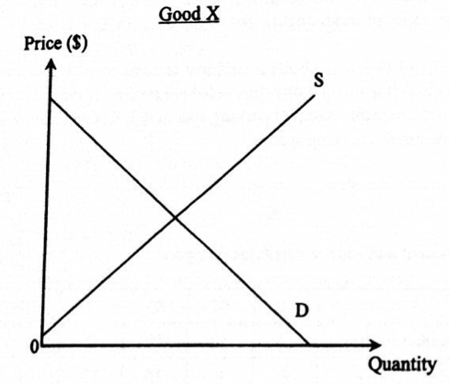
Good X and Good Y are in competitive supply. A rise in the demand for good Y will lead to _______ in the consumer surplus and ________ in the producer surplus in the market of Good X.
(Assume the supply and demand curves of Good X shift in a parallel manner.)
A. an increase ... ... an increase B. an increase ... ... a decrease
C. a decrease ... ... an increase D. a decrease ... ... a decrease

物品X 和 物品 Y 屬於競爭性供應。物品 Y的需求上升會令物品X市場的消費者盈餘_______，而生產者盈餘_____。
A. 增加……增加 B. 增加……減小
C. 減小……增加 D. 減小……減小

Example Question 16 DSE2017MCQ23
If the government raises the effective price floor on Good X and at the same time the price of its substitute increases, the consumer surplus in the market of Good X ________.
A. Will increase B. Will decrease C. Will remain unchanged D. May increase or decrease

若政府提高對物品X的有效價格下限，同時其替代品的價格上升了，在物品X巿場的消費者盈餘 ________。
A. 會增加 B. 會減少 C. 會維持不變 D. 可能增加或減少

Example Question 17 DSE2017MCQ24
Refer to the following supply-demand diagram of a good with quota set at Q₁ by the government.
參閱以下某物品的供需圖， 當中Q1為政府設下的配額。
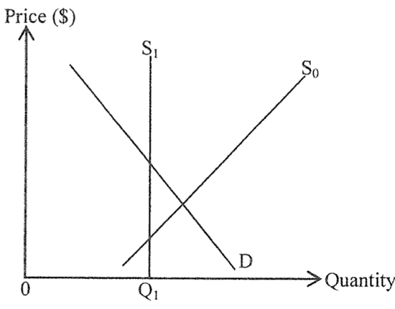
Which of the following will be the results of a reduction in quota on the good?
- The total expenditure on the good may increase
- The consumer surplus will decrease
- The total social surplus may increase
A. (1) and (2) only B. (1) and (3) only C. (2) and (3) only D. (1), (2) and (3)

下列哪些會是減少該物品配額的結果？
- 對該物品的總支出可能增加。
- 消費者盈餘會減少。
- 總社會盈餘可能增加 。
A. 只有(1)、(2) B. 只有(1)、(3) C. 只有(2)、(3) D. (1)、(2)及(3)

Example Question 18 DSE2018MCQ22
The following diagram shows the demand and supply curves of Good X.
下面顯示物品X的供需曲線。
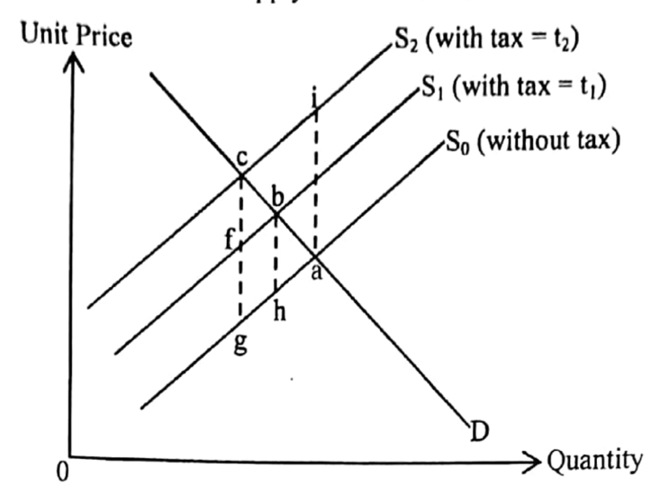
Suppose the government increases the tax on Good X from t₁ to t₂. Which of the following statements is correct?
A. The deadweight loss will increase by area bcgh B. The deadweight loss will decrease by area abh
C. The new deadweight loss is area bcf D. The new deadweight loss is area aci

假設政府對物品X的稅項由t1提高至t2。下列哪項陳述是正確的？
A. 效率損失會增加面積bcgh。 B. 效率損失會減小面積abh。
C. 新的效率損失是面積bcf。 D. 新的效率損失是面積aci。

Example Question 19 DSE2019MCQ21
Refer to the following supply-demand diagram of Good X.
參閱以下物品X的供需圖。
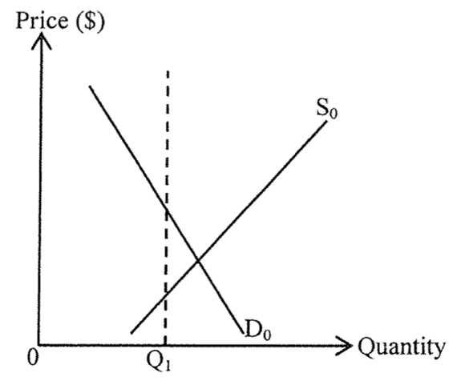
If the government sets a quota at Q1, then ________ decrease.
- Total social surplus
- Total expenditure in Good X
- Consumer surplus
- Producer surplus
A. (1) and (2) only B. (1) and (3) only C. (2) and (3) only D. (3) and (4) only

若政府把配額設定為Q1，_________會下降。
- 總社會盈餘
- 物品X的總支出
- 消費者盈餘
- 生產者盈餘
A. 只有 (1), (2) B. 只有 (1), (3) C. 只有 (2), (4) D. 只有 (3), (4)

**Example Question 20 DSE2019MCQ22
Suppose there is a bad harvest of flowers due to global warming. The marginal benefit of flowers will ________ and the total exchange value _______.
A. Decrease … will decrease B. Increase … will increase
C. Decrease … may decrease or increase D. Increase … may decrease or increase

假設全球暖化導致鮮花收成欠佳。鮮花的邊際利益會________，而總交易價值__________。
A. 減小…… 會減小 B. 增加…… 會增加
C. 減小…… 可能減小或增加 D. 增加…… 可能減小或增加

Example Question 21 DSE2020MCQ19
Study the following news extract.
In the last decade, the rent of residential units in Berlin was doubled due to continuous increase in demand. To deal with the problem, the Berlin government imposed a 'Rent Frozen Bill' under which the rent of residential units was not allowed to increase for at least 5 years
Suppose a similar bill is implemented in Hong Kong. Which of the following statements is correct?
A. The Gin coefficient will increase.
B. The property tax revenue of the government will increase.
C. There will be a deadweight loss if the demand for residential units keeps on increasing.
D. The property owners will have higher incentives to renovate their flats.

細閱下列的新聞撮要：
近十年來，由於需求持續上升，柏林住宅單位的租金已上升一倍。為了應付該問題，柏林政府實施「租金凍結法」，限制住宅單位的租金最小5年內不能增加。
假設香港推行類似的法例。下列哪項陳述是正確的？
A. 堅尼系數會上升 B. 政府的物業稅收入會上升
C. 若住宅單位的需求持續上升，效率損失會出現 D. 物業擁有人會有較高意欲裝修其單位。

Example Question 22 DSE2020MCQ20
Refer to the following supply-demand diagram for Good X
參閱以下物品X的供需圖。
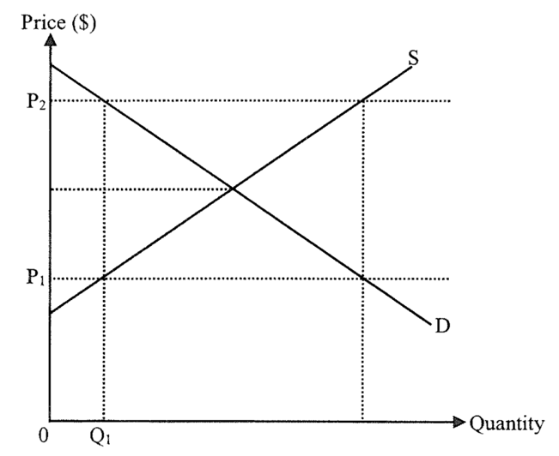
If the price floor of Good X changes from P1 to P2,
A. producer surplus will increase, B. quantity transacted of Good X will remain at QI.
C. deadweight loss will increase. D. excess demand of Good X will change to excess supply.

若物品X的價格下限由P1轉變至P2，
A. 生產者盈餘會上升 B. 物品X的交易量會維持在Q1
C. 效率損失會增加 D. 物品X的超額需求會轉變成超額供應
Example Question 23 DSE2021MCQ17
Refer to the following demand-supply diagram of Good Y.
參考以下物品Y的供需圖。
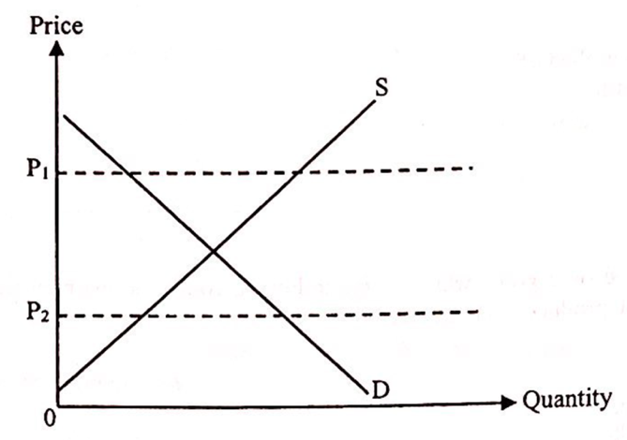
If the government lowers the price ceiling of Good Y from Pi to P2,
A. the producer surplus will decrease. B. the consumer surplus will increase.
C. the total social surplus will remain unchanged. D. the excess supply of Good Y will be eliminated.

若政府將物品Y的價格上限由P1下調至P2，
A. 生產者盈餘會下降 B. 消費者盈餘會上升
C. 總社會盈餘會維持不變 D. 物品Y的超額供應會消失

Example Question 24 DSE2021MCQ19
Since most schools deliver their lessons online, more students need to buy tablet computers. The marginal cost of the last unit of tablet computers will _____ and the producer surplus will _____ .
A. decrease … increase B. decrease … decrease C. increase … increase D. increase … decrease

由於大部分學校進行網上授課，更多學生需要購買平板電腦。最後一單位的平板電腦的邊際成本會_______，而生產者盈餘會________。
A. 下降……上升 B. 下降……下降 C. 上升……上升 D. 上升……下降

Example Question 25 DSE2021MCQ20
Initially a country imposes an effective quota on coffee bean production.
If now more people like to drink coffee, which of the following statements about coffee bean market are correct?
(1) The total expenditure will increase.
(2) The deadweight loss will increase.
(3) The consumer surplus will increase.
A. (1) and (2) only B. (1) and (3) only C. (2) and (3) only D. (1), (2) and (3) only

原初某國對咖啡豆實施有效配額。
若現在更多人愛喝咖啡，下列哪些有關咖啡豆市場的陳述是正確的？
- 總支出會上升
- 效率損失會上升
- 消費者盈餘會上升
- A. 只有(1)、(2) B. 只有(1)、(3) C. 只有(2)、(3) D. (1)、(2)及(3)

Type 1 (Area showing CSPS)

Type 2 (Externality)
Example Question 1 DSESPMCQ18
In which of the following situations will there be NO divergence between private and social costs / benefits?
A. A chemical factory upstream pollutes a river without considering the damage inflicted upon fish farmers downstream.
B. A diner smokes in a restaurant without considering the effects on people nearby.
C. A farmer raises some sheep which damage the crops of nearby farmland owned by the farmer.
D. A pianist plays the piano at home and receives no payment from his neighbour who enjoys the music.

在下列哪種情況下，私人與社會的成本/利益將不會出現分歧？
A. 一家位於上游的化工廠污染一條河流，而沒有考慮對下游漁民造成的損害。
B. 一名食客於酒樓吸煙而沒有考慮對附近的人的影響。
C. 一個農夫飼養的羊群破壞鄰近農地的農作物，而該農地是該農夫所擁有。
D. 一名鋼琴家在家彈奏鋼琴而沒有向享受這些音樂的鄰居收取任何款項。

Example Question 2 DSE2013MCQ20
A beekeeper keeps the bees for their honey. The bee-keeping benefits the farmers in the orchard nearby because the bees help pollinate the fruits in the orchard. Which of the following statements about this case is correct?
A. There will be a divergence between private and social benefits and the honey is over-produced.
B. The beekeeper should be subsidized by the government to improve economic efficiency.
C. If the value of honey is higher than the value of fruits, there is no need for the government to intervene to correct the
externality.
D. There will be no divergence between private and social benefits if the orchard nearby is owned by the beekeeper.

養蜜蜂者養蜂是爲了獲取蜂蜜。養蜜蜂對附近果園的居民有利，因為蜜蜂幫助果園的果樹傳播花粉。下列哪項有關上述個案的陳述是正確的？
A. 私人和社會利益分歧會出現，而蜂蜜會過度生產。
B. 養蜜蜂者應獲政府補貼以改善經濟效率。
C. 若蜂蜜的價值高於水果的價值，政府毋須介入改正界外效應。
D. 若附近果園屬該養蜜蜂者所擁有，私人和社會利益分歧不會出現。

Example Question 3 DSE2014MCQ18
Korean pop singers are becoming more popular in Hong Kong. To these singers, which of the following are their private benefits?
(1) The rise in royalties from the sales of their albums
(2) The rise in sales revenue of Korean-designed fashion
(3) The rise in the number of tourists visiting Korea
(4) The rise in revenue shared from their concerts held in Hong Kong
A. (1) and (3) only B. (1) and (4) only C. (2) and (3) only D. (2) and (4) only

韓國的流行歌手在香港越來越受歡迎。對這些歌手來說，下列哪些屬於他們的私人利益?
(1) 出售他們的唱片所得的版稅收入增加了。
(2) 韓國所設計的服裝其銷售收益增加了。
(3) 到訪韓國的遊客人數增加了。
(4) 他們在香港舉行演唱會所分成的收益增加了。
A. 只有 (1)、(3) B. 只有 (1)、(4) C. 只有 (2)、(3) D. 只有 (2)、(4)

Example Question 4 DSE2014MCQ19
Which of the following are ways to lessen the problem of divergence between private and social costs in Hong Kong?
(1) To collect a sewage charge
(2) To collect a university tuition fee
(3) To collect a charge on electricity
(4) To collect a levy on plastic bags
A. (1) and (3) only B. (1) and (4) only C. (2) and (3) only D. (2) and (4) only

在香港，下列哪些是減輕私人與社會成本分歧這個問題的方法?
(1) 收取排污費
(2) 收取大學學費
(3) 收取電費
(4) 對使用膠袋徵費
A. 只有 (1)、(3) B. 只有 (1)、(4) C. 只有 (2)、(3) D. 只有 (2)、(4)

Example Question 5 DSE2015MCQ17
Which of the following is an example of the divergence between private and social benefits?
A. A security guard watches live concerts when he is working in a concert hall.
B. A tourist enjoys the music performed by a singer on the street and he does not pay for that.
C. A resident living next to a karaoke lounge cannot fall asleep because of the noise.
D. After the removal of the airport, the market value of the residential flats in that region increases.

下列哪項是私人利益和社會利益分歧的一個例子？
A. 一名保安員在演奏廳當值時觀看到現場音樂會。
B. 一名遊客在欣賞街頭歌手的音樂表演而沒有付費。
C. 一名住客在卡拉 OK 酒廊左右的居民因噪音不能入睡。
D. 機場遷離後，該地區的住宅樓宇的市場價值上升。

Example Question 6 DSE2018MCQ23
Recently, unmanned aircraft systems have become very popular but using those aircrafts in urban areas has caused noise and safety concerns. The civil Aviation Department is considering regulating the manufacture, import and sale of unmanned aircraft systems.
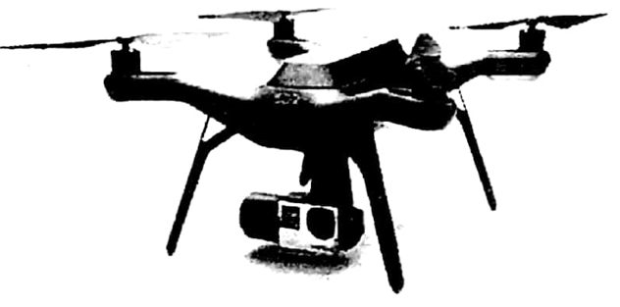
It is an example of divergence between private and social _______ and the _______ solution is being considered to reduce the divergence.
A. costs … market B. costs … government C. benefits … market D. benefits … government

近年，無人機飛行系統變得十分普及，但在市區使用這些飛行器引起人們對它在噪音和安全方面的關注。民航處正考慮對生產、進口和銷售無人飛行系統作出監管。
這是私人和社會_______分歧的一個例子，而_______的方法正被考慮用作減少該分歧。
A. 成本 … 市場 B. 成本 … 政府 C. 利益 … 市場 D. 利益 … 政府

Example Question 7 DSE2020MCQ21
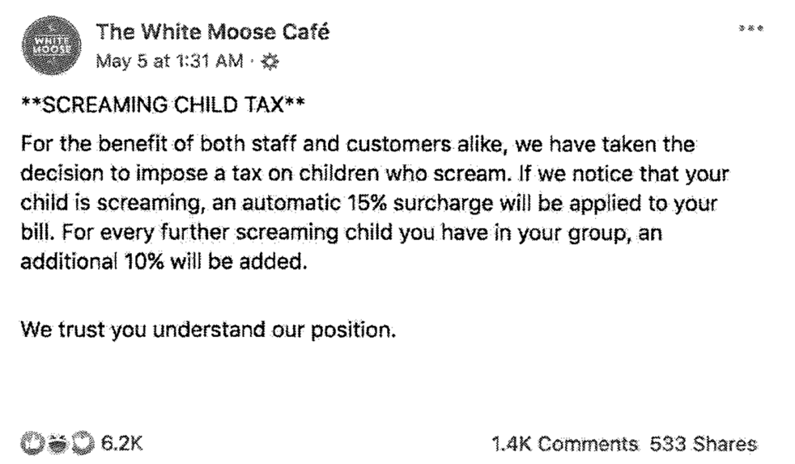
With reference to the above information, which of the following statements is correct?
A. Children screaming in the café results in negative externality and all cafés should introduce similar policy to restore efficiency.
B. The extra charge on screaming children increases the marginal private cost of the groups with screaming children.
C. The 'screaming child tax' is a government solution to the divergence between private and social costs.
D. The 'screaming child tax' is a kind of discrimination and should not be imposed.

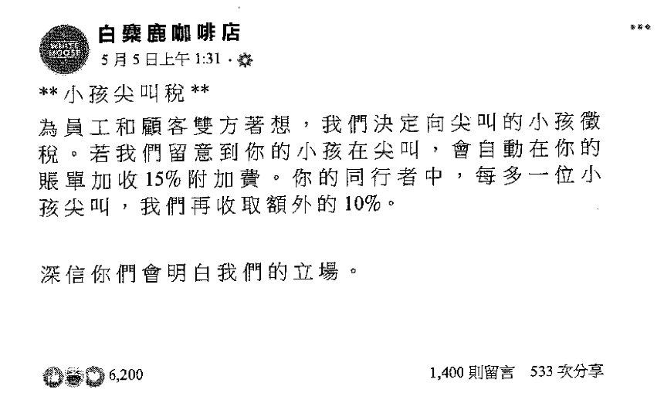
參考以上資料，下列哪項陳述是正確的？
A. 小孩在咖啡店尖叫引起負面界外影響，而所有咖啡店應該採取相似的政策以回復效率。
B. 對小孩尖叫的額外收費增加有尖叫小孩的人士的邊際私人成本。
C. 「小孩尖叫稅」是政府解決私人成本和社會成本分歧的一種方法。
D. 「小孩尖叫稅」是一種歧視，故此不應實施。

Type 2 (Externality)

Type 3 (Function of money)
Example Question 1 DSE2017MCQ12
A famous artist, Tsz-Wah, held a show. Many people complained that they could not buy a ticket. Ticket touts resold the tickets on the Internet and some buyers paid a higher price higher than HK$10000 for a ticket. The above case illustrates the ______ function of price because _______.
A. Rationing … the tickets are rationed to the highest-valued buyers
B. Rationing … demand will be reduced by a higher price
C. Allocative … more profits can be earned with a higher price
D. Allocative … more resources should be allocated to the producer to raise the supply

著名藝人子華舉辦了一場表演，很多人抱怨未能求得門票。門票黃牛黨在互聯網上轉售這些門票，有買家付出高於港幣$10 000購入一張門票。
上述個案說明了價格的 ______ 功能，因為 ______ 。
A. 配給…這些門票配給與最高價值的買家
B. 配給…價格越高需求便會下降
C. 分配…價格越高，利潤便會增加
D. 分配…更多資源應該分配予生產商以增加供應

Example Question 2 DSE2020MCQ13
In recent years, the rise in demand for private cars in China has attracted Volkswagen, a German car manufacturer, to set up car manufacturing factories in China. The above case illustrates the __________ function of price because __________.
A. rationing … …private cars are sold to the highest-valued users in China
B. rationing … ….fewer buyers are willing to buy private cars in Germany
C. allocative … … the supply of private cars falls in Germany
D. allocative … … more resources are allocated to the production of private cars in China

近年，中國對私家車的需求上升，這吸引了福士汽車（一家德國汽車製造商）在中國開設汽車製造工廠。
上述個案說明了價格的 __________ 功能，因為 __________ 。
A. 配給… …在中國，私家車賣給最高價值的用家
B. 配給… …在德國，較少買家願意購買私家車
C. 分配… …在德國，私家車的供應下降
D. 分配… …在中國，更多的資源投放在私家車的生產上

Type 3 (Function of money)

2012DSE LQ5c
Country A has imposed an effective price ceiling on Good X. Suppose the effective price ceiling is lowered. Will the change in price ceiling improve economic efficiency? Explain your answer with the aid of a diagram. (4)
甲國對物品 X 實施一有效的價格上限。假設該有效的價格上限被調低了。該價格上限的轉變會改善經濟效率嗎?以圖輔助，解釋你的答案。

_______________________________________________________________________________________
_______________________________________________________________________________________
______________________________________________________________________________________________________________________________________________________________________________
_______________________________________________________________________________________
_______________________________________________________________________________________
_______________________________________________________________________________________
_______________________________________________________________________________________
_______________________________________________________________________________________
_______________________________________________________________________________________
_______________________________________________________________________________________
_______________________________________________________________________________________
_______________________________________________________________________________________
_______________________________________________________________________________________
Marking Scheme:
Verbal Elaboration:
No, because (1)
There is greater deadweight loss. / total social surplus decreases. (1)
Indicate in the diagram:
- Lowering of the price ceiling
- Correct position of inrease in deadweight loss / loss in total social surplus
文字解說:
否，因為
會出現較大的效率損失 / 總社會盈餘下降。
在圖上顯示:
-價格上限下降
-效率損失上升 / 總社會盈餘減少的正確位置
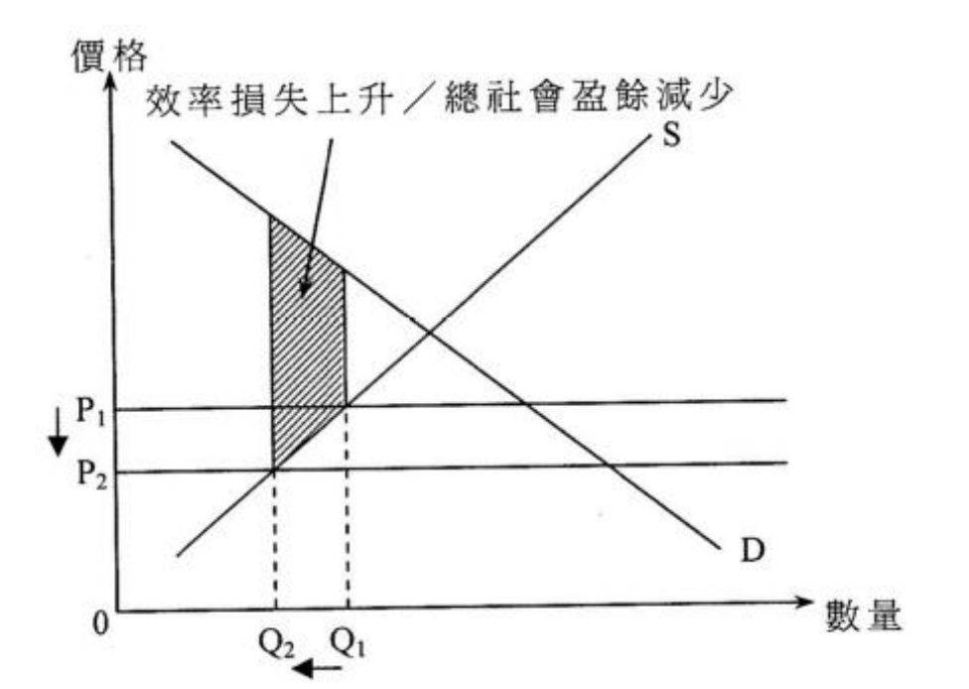

Candidates’ Performance:
Poor. Some candidates misinterpreted lowering the price ceiling as a relaxation of price control and the resulting increase in price, thus yielding an incorrect analysis. Among those who understood the gist of the question, some failed to correctly indicate the deadweight loss graphically.
欠佳。部份考生將降低價格上限誤當作放鬆價格管制而令價格上升，故作出不正確的分析。能正確理解題旨的考生中，部份未能在圖中畫出效率損失。

2014DSE LQ3
Figure 1 shows the market supply and demand curve of Good X. Suppose the government raises the price floor from P_{a} to P_{b}. (4)
圖一顯示物品 X 的市場供應和市場需求曲線。假設政府將價格下限由 Pa 提升至 Pb。
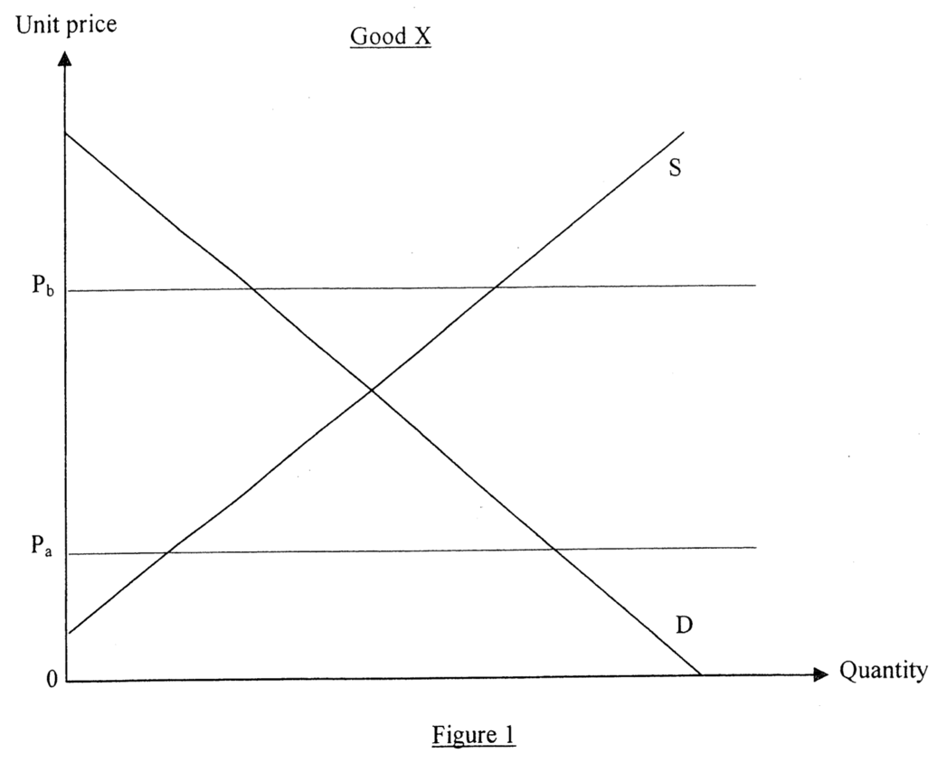
With the aid of Figure 1, explain whether the rise in the price floor could enhance economic efficiency. (6)
以圖一輔助, 解釋這樣提升價格下限能否改善經濟效率。
_______________________________________________________________________________________
_______________________________________________________________________________________
_______________________________________________________________________________________
_______________________________________________________________________________________
_______________________________________________________________________________________
_______________________________________________________________________________________
_______________________________________________________________________________________
_______________________________________________________________________________________
_______________________________________________________________________________________
Marking Scheme:
Verbal elaboration:
No, (1)
The inefficient price floor (P_{a}) becomes an effective price floor (P_{b}) (1)
At the new quantity (where the horizontal Pb-line intersects the demand curve D), (1)
Marginal benefit (maximum willingness-to-pay) is higher than marginal cost
And there exists a deadweight loss. (1)
Indicate on the diagram:
- Correct P₀ Q₀, Correct P₁ Q₁, Correct position of deadweight loss (DL) (3)
文字解說：
否。
該無效的價格下限 (P_{a}) 變成了有效的價格下限 (P_{b})
在新的產量（在水平的Pb線和需求曲線D相交的位置），邊際利益（人們願意支付的最大金額）高於邊際成本
而出現效率損失。
在圖中顯示：
- 正確的P₀ Q₀ 正確的P₁ Q₁ 效率損失（DL）的正確位置
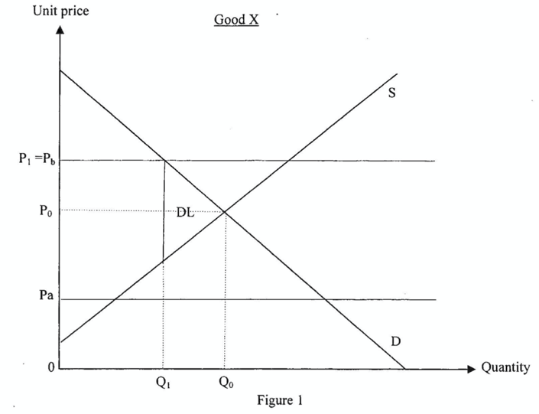
Candidates’ Performance:
Satisfactory. Most candidates showed adequate understanding of the concept of price floor, but provided incomplete analysis. Common mistakes included:
- not using the diagram to answer the question; - mistaking Pa for an effective price floor; and
- confusing the concepts of the two adjectives, "effective" and "efficient."
令人滿意。大部分考生展示出對「價格上限」這概念認識充分，但是分析欠完整，常犯的錯誤包括：
- 沒有運用供需圖作答。 - 錯誤地將Pa當作有效的價格下限。
- 混淆了下列兩個形容詞涉及的概念：「有效的」和「有效率的」。

2015DSE LQ3
An increase in an effective quota in the market of a good would lead to a reduction in deadweight loss. Do you agree? Explain your answer with the aid of a diagram. (6)
增加某物品在市場的有效配額會令效率損失減少。你同意嗎？以圖輔助，加以解釋。 (6)

_______________________________________________________________________________________
_______________________________________________________________________________________
_______________________________________________________________________________________
_______________________________________________________________________________________
_______________________________________________________________________________________
_______________________________________________________________________________________
_______________________________________________________________________________________
_______________________________________________________________________________________
_______________________________________________________________________________________
______________________________________________________________________________________________________________________________________________________________________________
_______________________________________________________________________________________
_______________________________________________________________________________________
_______________________________________________________________________________________
_______________________________________________________________________________________
_______________________________________________________________________________________
Marking Scheme:
Verbal elaboration:
Agree. (1)
The increase in effective quota would raise the supply and thus raise the quantity transacted and reduce the price. (1)
The gap between marginal benefit and marginal cost is reduced as the quantity produced is increased toward its efficient level.(1)
Indicate on the diagram:
- Rightward shift of the supply curve corresponding to an increase in quota
- A reduction in P and rise in Q
- Correct position of the reduction in deadweight loss (area wxyz) (3)
文字解說:
同意。
增加有效配額會增加供應並導致交易量上升和價格下跌。
邊際利益和邊際成本的差距會減少, 因為生產量增加,更貼近有效率水平。
在圖中顯示:
- 有效配額增加對應供應曲線向右移
- P 減少而 Q 上升
- 效率損失減少的正確位置 (面積 wxyz)
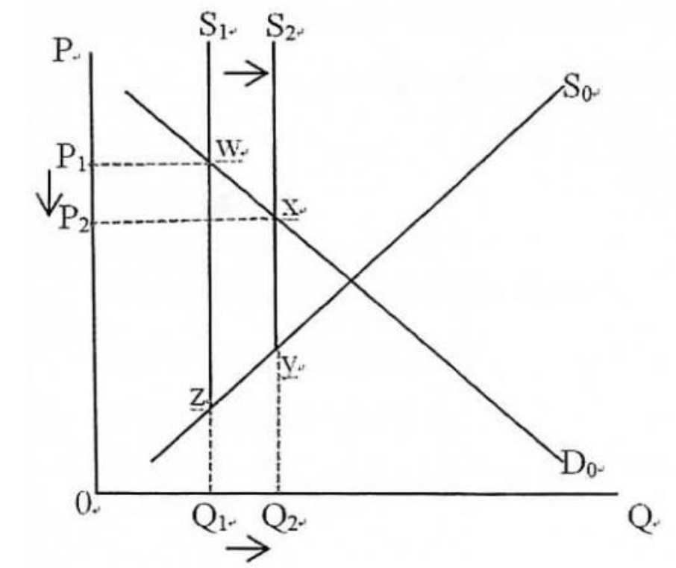
Candidates’ Performance:
Satisfactory. Many candidates were able to illustrate diagrammatically and explain verbally the reduction in deadweight loss when an effective quota is increased. However, some were unable to provide a proper explanation for the reduction in deadweight loss (i.e., narrowing the gap between marginal benefit and marginal cost, or reducing the level of under-production). A minority of candidates represented the change in quota mistakenly as a leftward shift in the supply curve and gave a wrong discussion accordingly.
令人滿意。很多考生能以圖說明並用文字解釋有效配額的增加，將使效率損失減低。不過，部份考生未能提供效率損失減低的正確解說（即縮窄邊際利益和邊際成本的差距，或令「生產不足」的程度減輕）。有小部份考生錯誤地把配額的改變以供應曲線向左移表示，其討論並不正確。

2015DSE LQ12d
Research shows that the “Individual Visit Scheme” of mainland tourists has brought economic benefits to Hong Kong. However, more and more Hong Kong residents have called on the government to reduce the number of mainland tourists to Hong Kong under the Scheme. Some residents complained that the large number of tourists overloaded the public transportation system, resulting in a large increase in travel time for all passengers. Explain, in terms of externality, why inefficiency may exist when the transportation system is overcrowded. (4)
研究顯示內地旅客的「個人遊」計劃為香港帶來經濟利益。不過，越來越多的香港居民要求政府減少透過該計劃到港的內地旅客人數。部分居民投訴大量旅客令公共交通系統不勝負荷，導致所有乘客的交通時間大幅增加。以界外影響為依據，解釋為什麼當交通系統過分擁擠時可能出現無效率。
_______________________________________________________________________________________
______________________________________________________________________________________________________________________________________________________________________________
_______________________________________________________________________________________
_______________________________________________________________________________________
Marking Scheme:
Negative externality / divergence between private and social costs (1)
When the public transportation system is overcrowded (i.e. at full capacity), any additional passenger using the system would increase the time cost for other passengers without having to compensate them for this extra cost is now higher than marginal social benefit, the number of passengers using the system would exceed its efficient level. (3)
負面界外影響 / 私人成本與社會成本分歧。
當公共交通工具過份擠迫(即達致飽和),任何額外的乘客都會令其他乘客的時間成本上升，卻沒有對這額外成本作出補償（意味著私人成本與社會成本分歧）。由於邊際社會成本大於邊際社會利益，在公共交通工具的乘客的數量高於有效率的水平。
Candidates’ Performance:
Satisfactory. The majority of candidates were able to state the negative external effects that would arise from overloading. However, only a few candidates were able to relate the increased travel time to the time cost and the higher marginal social cost. Many only stated the inefficiency condition as “MB not equal to MC,” without specifying that "MSC > MSB" in this particular case.
令人滿意。大部份考生能指出公共交通負荷過重造成的負面界外效應。但只有部份能將交通時間的增加和時間成本及邊際社會成本連繫起來。很多考生只寫出無效率的條件「邊際利益不等於邊際成本」，沒有清楚指明在這個案中「邊際社會成本 > 邊際社會利益」。

2016DSE LQ4
These years many customers like to take photos of the food they have in restaurants and share them on social media. However, some high-end restaurants do not allow their customers to take photos. Explain how the “photo-taking-and sharing” behavior of the customers may involve externality. (3)
近年來，很多顧客喜愛在餐廳拍攝他們享用的食物，並將照片在社交媒體分享，不過一些高級餐廳不准顧客拍照。解釋顧客「拍照並分享」這行為如何可能帶來界外影響。

______________________________________________________________________________________________________________________________________________________________________________
______________________________________________________________________________________________________________________________________________________________________________
_______________________________________________________________________________________
_______________________________________________________________________________________
_______________________________________________________________________________________
_______________________________________________________________________________________
_______________________________________________________________________________________
_______________________________________________________________________________________
Marking Scheme:
Taking photos may disturb other people in the restaurants/ sharing the photos in the social media may disclose the design of dishes which may have an undesirable effect on the revenue of the restaurants, while the photo-takers have not compensated for the action. There may be negative externality (external cost is involved) (3)
在餐廳拍照可能會騷擾他人/在社交媒體分享照片可能會透露了食品的設計。這可能對餐廳的收益/利潤有負面影響，但拍照者沒有對其影響作出（金錢或其他方面的）補償。這拍照並分享的行為可能造成負面界外效應。（涉及界外成本）
Candidates’ Performance:
Satisfactory. The following are common mistakes:
- Failure to state whether the externality was positive or negative
- giving confusing arguments without specifying who got the benefit and who needed to be compensated.
令人滿意。以下為常見的錯誤：
- 未能指出該界外影響屬正面或負面。
- 提出論點時卻沒有指明誰可獲益及誰要補償，論述欠明確。

2016DSE LQ11b, d
Medical service is one of the basic human needs.
Source A: a conversation outside a public clinic in Hong Kong
Son: Dad, I feel very ill.
Father: Oh no! There is a long queue waiting.
Son: Why don’t we go to a private doctor?
Father: The fee charged by public clinic is only $45, much lower than that charged by private doctors.
(a) With reference to Source A, explain with the aid of Figure 1 how the price set by public clinics may lead to economic inefficiency in the provision of public medical service. (Assume the supply curve in Figure 1 fully reflects the marginal social cost of public medical service.) (6)
Source B: an extract from the Hospital Authority webpage
The Hospital Authority is committed to providing community-based primary care services. Our target patients included the elderly, low-income individuals, and patients with chronic diseases.
(b) Many people argue that public clinics should raise the fee to reduce the waiting time. Evaluate this argument in terms of equity and economic efficiency. (4)

醫療服務是人類的其中一項基本需要。
資料甲：在本港某家公立診所外的一段對話
兒子：爸爸，我很不舒服啊。
父親：糟了！排隊等候的人很多。
兒子：為什麼我們不去看私家醫生？
父親：公立診所的收費只是$45 ，遠低於私家醫生的收費。
(a) 參考資料甲，並以圖一輔助，解釋公立診所釐訂的價格如何可能導致提供公立醫療服務時出現經濟沒有效率
（假設圖一中的供應曲線全數反映公共醫療服務的邊際社會成本。）
資料乙:摘錄自醫院管理局的網頁
醫院管理局致力提供以社區為本的基礎醫療服務，服務對象包括長者、低收入人士和長期病患者。
資料甲：在本港某家公立診所外的一段對話
(b) 很多人認為公立診所應該提高收費以減少輪候時間。以公平和經濟效率為依據,評價這種看法。
______________________________________________________________________________________________________________________________________________________________________________
_______________________________________________________________________________________
_______________________________________________________________________________________
_______________________________________________________________________________________
_______________________________________________________________________________________
_______________________________________________________________________________________
_______________________________________________________________________________________
_______________________________________________________________________________________
_______________________________________________________________________________________
_______________________________________________________________________________________
_______________________________________________________________________________________
_______________________________________________________________________________________
_______________________________________________________________________________________
_______________________________________________________________________________________
_______________________________________________________________________________________
_______________________________________________________________________________________
_______________________________________________________________________________________
_______________________________________________________________________________________
_______________________________________________________________________________________
_______________________________________________________________________________________
_______________________________________________________________________________________
_______________________________________________________________________________________
_______________________________________________________________________________________
_______________________________________________________________________________________
_______________________________________________________________________________________
_______________________________________________________________________________________
_______________________________________________________________________________________
Marking Scheme:
(a) Verbal elaboration
- Price is set at $45 which is below equilibrium
- Excess demand occurs
- There is a deadweight loss/ Marginal benefit > Marginal cost (@1 mark)
Illustrate in the diagram
- Price set below equilibrium
- Correct position of excess demand/shortage
- Correct position of deadweight loss (@1 mark)
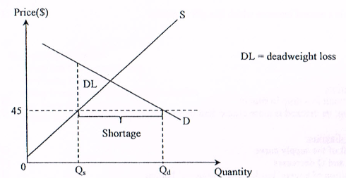
(b) Efficiency: the increase in price will result in a price closer to equilibrium price, (1)
reducing the gap between MB and MC or resulting in a smaller deadweight loss. (1)

Candidates’ Performance:
(a) Satisfactory. Most candidates managed to draw a well-labelled diagram for the case of excess demand, while many were able to indicate the position of deadweight loss. However, only a few of them were able to accurately state that the inefficiency was caused by MB>MC in this case. A minority of candidates represented their answer in a diagram of marginal social cost and marginal private cost, which was neither required under the existing curriculum and assessment framework nor applicable to this question.
(b) Good. Many candidates were able to demonstrate their understanding of the effects of the fee increase on efficiency and equity, and some could explain the efficiency-equity trade off in this case as well. The following shows a list of mistakes;
- thinking that they were only required to provide reasons to support the argument;
- mis-labelling their statement about efficiency under the heading of equity, or vice versa;
- failure to provide an explanation for their stand using economic terms.

文字解說:
- 價格訂在$45，低於均衡水平
- 交易量低於均衡數量/出現生產不足或短缺
- 邊際利益（MB）> 邊際成本（MC） (@1分)
在圖中顯示：
- 價格訂在均衡之下
- Qt的正確位置
- 效率損失的正確位置 (@1分)
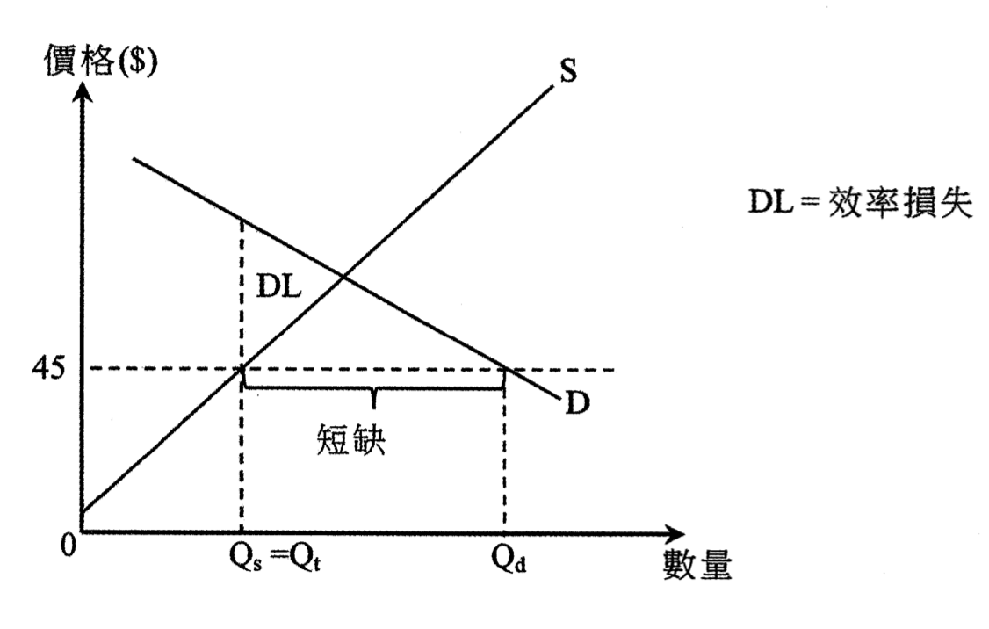
(b) 效率：加價會改善效率，因為價格會更接近均衡價格，縮減邊際利益和邊際成本之間的差距，令效率損失下降。

考生表現:
(a) 令人滿意。大部分考生能繪畫一幅有清楚標示的圖，以顯示超額需求的個案，而且很多考生能標示出效率損失的位置。不過，只有一些考生能準確地指出效率是由於邊際得益 > 邊際成本。有少數考生用一幅邊際社會成本和邊際私人成本的圖顯示他們的答案，這在現時的課程和評核架構裏並沒有要求，亦不適用於這題。
(b) 良好。很好考生能顯示他們了解費用增加對效率和公平的影響，部分考生能解釋個案中效率與公平之間是此消彼長的。以下列出一些考生的錯誤：
- 以為只須提供理由支持該論點。
- 誤將有關效率的陳述寫在公平的標題下，反之亦然。
- 未能以經濟術語解釋立場。

2017DSE LQ4
Pokémon Go is a popular game for which gamers need to move around different places with their smartphones to catch the cyber-pets. Its developer has placed hotspots in different areas where many gamers are attracted to gather. Some restaurants in remote areas found their business sharply increased as they are located near these hotspots.
(a) Based on the above information, explain, in terms of externality, how the placing of the hotspots may result in inefficiency. (3)
(b) How may such a problem of inefficiency be relieved by market? (2)
「 Pokémon Go」是一款熱門遊戲，玩家需攜帶智能手機前往不同的地點捕捉虛擬寵物。遊戲發展商在不同地區放置熱點，而這些熱點會吸引很多玩家聚集。一些在偏遠地區的餐廳發現生意急升，原因是它們位處這些熱點附近。
(a) 根據上述資料，以界外影響為依據，解釋放置熱點如何可能導致缺乏效率。
(b) 市場如何可以減輕這缺乏效率的問題？

_______________________________________________________________________________________
_______________________________________________________________________________________
_______________________________________________________________________________________
_______________________________________________________________________________________
_______________________________________________________________________________________
_______________________________________________________________________________________
_______________________________________________________________________________________
_______________________________________________________________________________________
_______________________________________________________________________________________
_______________________________________________________________________________________
_______________________________________________________________________________________
_______________________________________________________________________________________
_______________________________________________________________________________________
_______________________________________________________________________________________
_______________________________________________________________________________________
_______________________________________________________________________________________
Marking Scheme:
(a) Positive externality. Restaurants in remote area enjoy an increase in total revenue due to the game developer’s action without compensation to the game developer. So external benefit exists and marginal social benefit is greater than marginal social cost. The number of existing hotspots near the restaurants is lower than that required by the efficiency level. (3)
(b) The restaurants may pay the game developer to increase the hotspots nearby.
or
The game developer may charge the restaurants for placing more hotspots near them. (2)
(a) 正向界外影響。偏遠地區的餐廳因遊戲發展商所選熱點的位置利益，卻沒有補償發展商。故此出現了界外利益，
而邊際社會利益大於邊際社會成本。這些餐廳附近的現有熱點數目是低於效率水平。
(b) 餐廳可付款予遊戲發展商以增加其附近的熱點。
或
遊戲發展商可能向這些餐廳收費，以便在其附近放置更多熱點。

Candidates’ Performance:
(a) Satisfactory. Most candidates were able to point out that this involves a positive outside effect. However, many candidates mistakenly believe that this out-of-bounds benefit exists because gamers are not compensated (for electronic gaming keyboards). Some candidates mistakenly thought that this was the share of overproduction (lack of underproduction), while other candidates failed to exclude the concept of marginal social cost/benefit from their answers.
(b) General. (a) Some of the candidates who pointed out the positive impact on outsiders were able to point out that these restaurants need to be moderately compensated for the games, but some candidates thought that gamers should be paid. The share reviews how the government can intervene (for example: providing Syria to the game), which is implicitly related to this question.
(a) 令人滿意。大部份考生能指出這涉及正向界外效應。然而很多考生誤以為該界外利益存在是因為遊戲玩家沒有獲得補償（而非遊戲開發商）。部分考生誤以為這是超額生產的個案（而非生產不足），亦有其他考生未能運用邊際社會成本/得益的概念作答。
(b) 一般。大部份在 (a) 部指出正向界外影響的考生均能指出這些餐廳須對遊戲開發商支付部份補償，但部份考生誤以為應該付款給遊戲玩家。有小部份考生提及政府可如何干預（例如：提供補貼予遊戲開發商），這和本題題旨無關。

(b)

(a) 令人滿意。大部份考生能指出這涉及正向界外效應。然而很多考生誤以為該界外利益存在是因為遊戲玩家沒有獲得補償（而非遊戲開發商）。部分考生誤以為這是超額生產的個案（而非生產不足），亦有其他考生未能運用邊際社會成本/得益的概念作答。
(b) 一般。大部份在 (a) 部指出正向界外影響的考生均能指出這些餐廳須對遊戲開發商支付部份補償，但部份考生誤以為應該付款給遊戲玩家。有小部份考生提及政府可如何干預（例如：提供補貼予遊戲開發商），這和本題題旨無關。

2017DSE LQ11b
The government of Country X introduces a per-unit subsidy to the education services of private universities. ‘The subsidy causes inefficiency even though both students and universities benefit.’ Defend the statement by comparing the marginal cost and marginal benefit in Figure 3. (3)
X國政府向私立大學的教育服務提供一項從量補貼。「即使學生和大學均能得益，該補貼仍會導致缺乏效率。」透過在圖三中比較邊際成本和邊際利益，為以上陳述辯護。

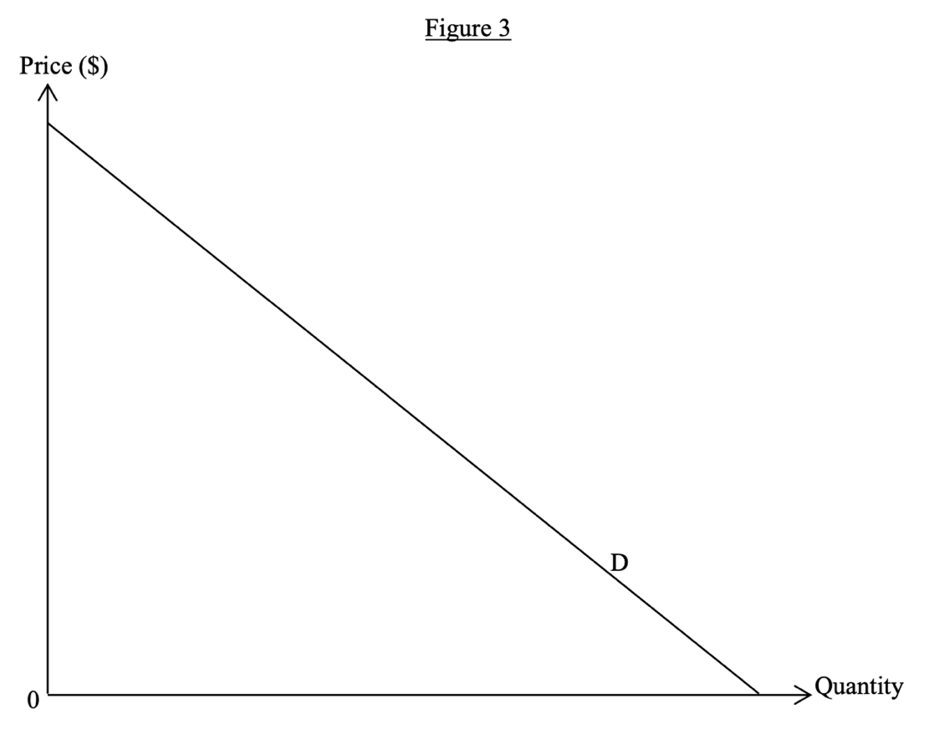
_______________________________________________________________________________________
_______________________________________________________________________________________
_______________________________________________________________________________________
_______________________________________________________________________________________
_______________________________________________________________________________________
_______________________________________________________________________________________
_______________________________________________________________________________________
_______________________________________________________________________________________
_______________________________________________________________________________________
Marking Scheme:
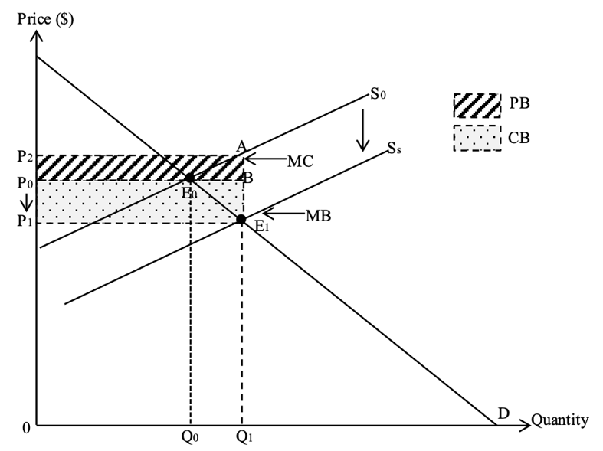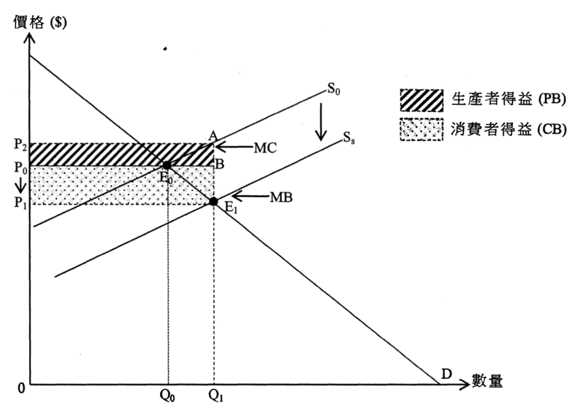

Verbal elaboration:
Marginal cost is larger than marginal benefit at Q1
Illustrate in the diagram:
- Correct position of marginal benefit
- Correct position of marginal cost

文字解說
在Q1，邊際成本(MC)高於邊際利益(MB)。
在圖中顧示：
- 邊際利益(MB)的正確位置
- 邊際成本(MC)的正確位置
Candidates’ Performance:
Satisfactory. Some candidates were able to clearly mark on the diagram or mention in the text explanation the equilibrium point after the subsidy, where the marginal cost is higher than the marginal benefit. Here are some things that are wrong:
- Thinking that the post-subsidy supply curve is the marginal cost curve, and mistakenly drawing the conclusion that "the post-subsidy equilibrium is efficient."
- Incorrectly marking the location of efficiency loss areas.
令人滿意。一些考生能清楚地在圖中標示或在文字解說中提到在補貼後的均衡點，邊際成本是高於邊際利益。以下是一些錯誤之處：
- 以為補貼後的供應曲線是邊際成本曲線，並錯誤地得出「補貼後均衡是有效率的」這結論。
- 錯誤地標示效率損失區域的位置。

2018DSE LQ10c
Foreign domestic helpers are paid with a minimum wage at HK$4410 per month for a two-year contractual period in Hong Kong. Suppose the minimum wage in the market of foreign domestic helpers in Hong Kong is effective. With the aid of figure 2, explain how it may result in economic inefficiency. (4)
香港的外籍家庭傭工在兩年合約期間獲支付每月港幣$4410的最低工資。假設香港外籍家庭傭工市場的最低工資是有效的。以圖二輔助，解釋這如何可能引致經濟缺乏效率。

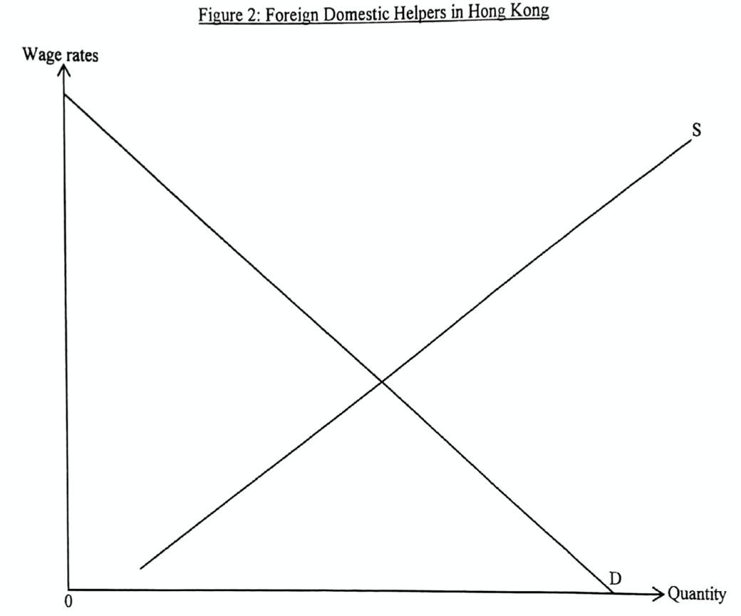
_______________________________________________________________________________________
_______________________________________________________________________________________
_______________________________________________________________________________________
_______________________________________________________________________________________
_______________________________________________________________________________________
_______________________________________________________________________________________
_______________________________________________________________________________________
_______________________________________________________________________________________
_______________________________________________________________________________________
Marking Scheme:
Verbal elaboration:
At Q1, marginal benefit is greater than marginal cost (1)
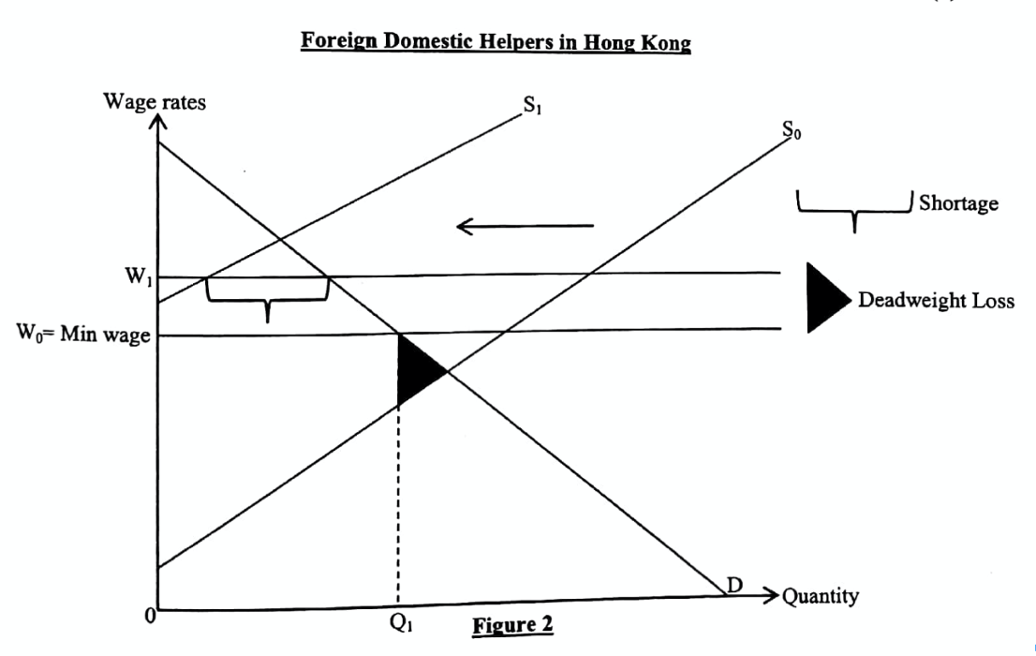

Candidates’ Performance:
Good. Many candidates correctly drew the minimum wage at a level higher than the market-clearing wage (i.e. above the intersection between the supply and demand curves) However, some diagrams were either incomplete - with missing labels (e.g. D, S, or W) – or inaccurate - failing to highlight the 'deadweight loss' area. In their verbal explanations, a few candidates were unable to state the inefficiency condition: marginal benefit > marginal cost.

文字解說：
在Q1，邊際利益高於邊際成本。 (1)

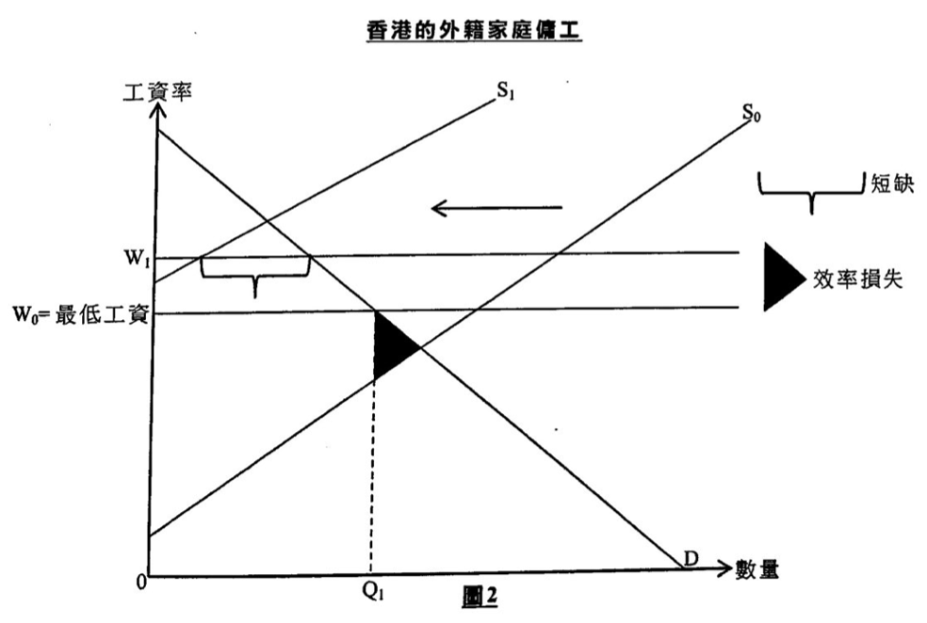

考生表現:
良好。很多考生正確地將最低工資水平繪畫在市場清銷工資之上方（即高於供需曲線交點）。但是，部份繪圖並不完整。（欠缺標示，如D、S或W ）或是不準確（未有標示效率損失的面積）。在以文字解說時，部份考生未能寫出缺乏效率的條件：邊際利益 > 邊際成本。(MB > MC)

2019DSE LQ4
Getting vaccinated is an effective way to prevent infection and protect oneself from flu viruses. Using the concept of externality, explain why the government provision of subsidy on Seasonal Influenza Vaccination may improve economic efficiency. (4)
接受疫苗注射是防止感染流感病毒及保護自己的一個有效方法。運用界外影響的概念，解釋為什麼政府對接種季節性流感疫苗提供補貼可能會改善經濟效率。
_______________________________________________________________________________________
_______________________________________________________________________________________
_______________________________________________________________________________________
_______________________________________________________________________________________
_______________________________________________________________________________________
Marking Scheme:
Getting vaccinated protects oneself as well as lowering the chance of others being infected by flu. Since the person receiving vaccination is not compensated by others (whose chances of being infected are reduced), there exists external benefit, with marginal social benefit exceeding marginal social cost. This implies that the number of people getting vaccinated is below the efficient level. Subsidy can increase the quantity of vaccination towards the efficient level and thus narrow the gap between marginal social benefit and marginal social cost.
注射疫苗保護自己之餘也會減低他人被流感傳染的機會。由於接受疫苗的人沒有向其他（被流感傳染的機會減少的）人士收取補償，故此出現界外利益，邊際社會利益高於邊際社會成本。這意味着接受疫苗注射的人數低於效率水平。補貼可以令疫苗注射人數增加至較接近效率水平，因而縮窄邊際社會利益和邊際社會成本的差距。
Candidates’ Performance:
Fair. Some candidates did not show a clear distinction between external benefits and external costs. Even among those who correctly pointed out that the vaccination gave rise to positive extremality, some misunderstood that the external benefits arose from the absence of government subsidy on the public's vaccination. Candidates were generally weak in explaining the efficiency improvement after subsidy. Instead of explaining how the provision of subsidy would increase the number of people getting vaccinated toward the efficient level, they simply argued that the subsidy would help prevent the spread of flu and therefore narrow the gap between marginal social benefit and marginal social cost. The weaker candidates gave reasons unrelated to externality in their answers - such as labour productivity, health, shortage in medical services, or even inflationary gap.
一般。部份考生沒有明確區分界外利益與界外成本。即使能正確指出注射疫苗會引致正面界外影響，當中有些考生誤以為界外利益是來自政府沒有對公眾注射疫苗提供補貼。考生解釋補貼後對效率的改善一般較弱。他們簡單地指出補貼會幫助防止流感的傳播，故此縮窄了邊際社會利益和邊際社會成本的差距，而未能解釋提供補貼如何增加注射疫苗的人數使其趨向效率成本。能力較弱的考生的答案和界外影響無關 ——例如勞工生產力、健康、醫療服務短缺，甚至是通脹差距。

2019DSE LQ11b
The Guangzhou-Shenzhen-Hong Kong Express Rail Link (high Speed Rail) was launched in September 2018. During non-holidays, there are a lot of empty seats on some trains of the High Speed Rail. With the aid of Figure 1, explain why the above situation may be inefficient. (4)
廣深港高速鐵路（高鐵）在2018年中月啟用。在非假日時段，部分高鐵列車有很多的空置座位。以圖1輔助，解釋為什麼上述情況可能缺乏效率。
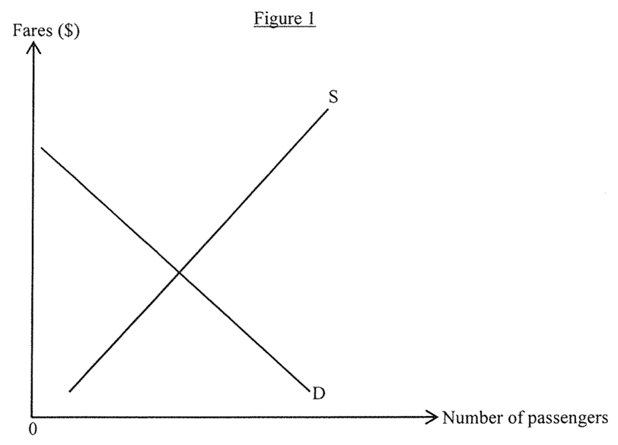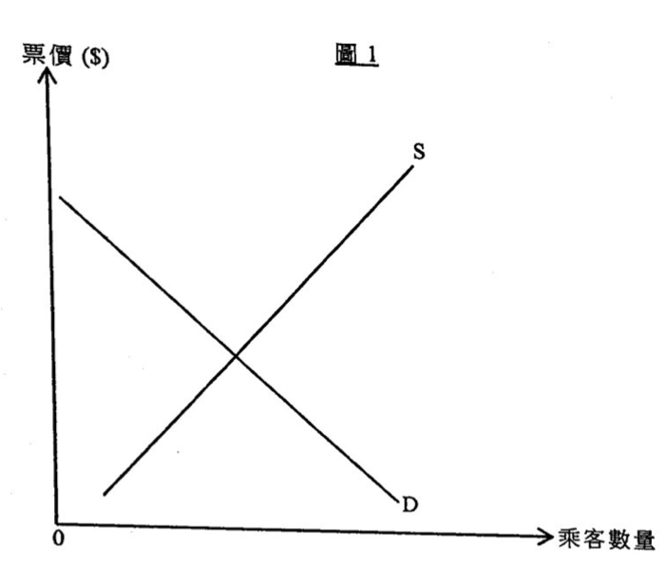
_______________________________________________________________________________________
_______________________________________________________________________________________
_______________________________________________________________________________________
_______________________________________________________________________________________
_______________________________________________________________________________________
_______________________________________________________________________________________
_______________________________________________________________________________________
_______________________________________________________________________________________
_______________________________________________________________________________________
_______________________________________________________________________________________
_______________________________________________________________________________________
_______________________________________________________________________________________

Marking Scheme:
Verbal elaboration:
Fares are set above the market-clearing (or equilibrium) level. So marginal benefit of train service is larger than marginal cost.(2)
Illustrate in the diagram
- Correct position of P and Q
- Correct position of deadweight loss (DL)
文字解說：
所訂票價高於市場清銷（或均衡）水平。故此鐵路服務的邊際利益高於邊際成本。 （2分）
在圖中顧示：
P 和 Q的正確位置
DL 效率損失的正確位置
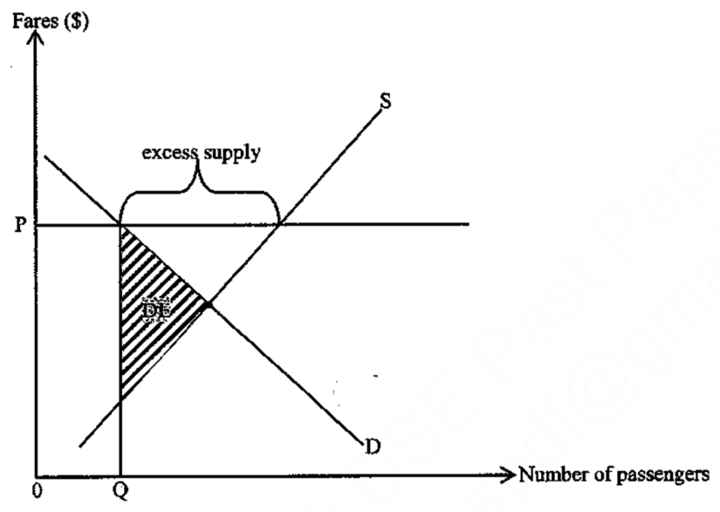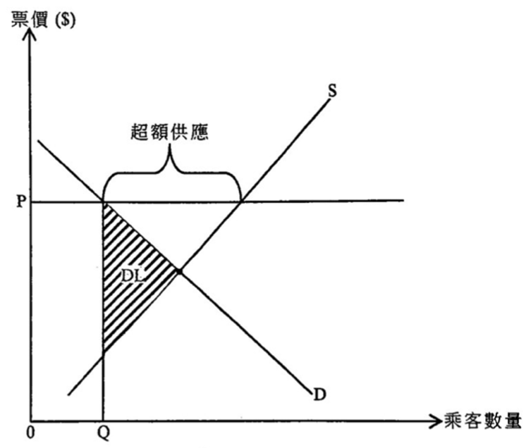

Candidates’ Performance:
Satisfactory. Some candidates failed to specify the condition for the existence of excess supply - i.e., price being set above its market-clearing (or equilibrium) level. Some mis-indicated the area of deadweight loss on the diagram. Others simply mentioned that marginal benefit (MB) was not equal to marginal cost (MC), without stating clearly that MB was greater than MC in this case.
令人滿意。部份考生未能清楚指出超額供應出現的條件 ——即價格訂於市場清銷（或均衡）水平之上。部份考生在圖上錯誤標示效率損失的面積。另有考生只提到邊際利益（MB）和邊際成本（MC）不同，未能清楚指出在這個案中MB大於MC。

DSE 2020 LQ10c
Economists argue that tariff may harm both the consumers and producers.
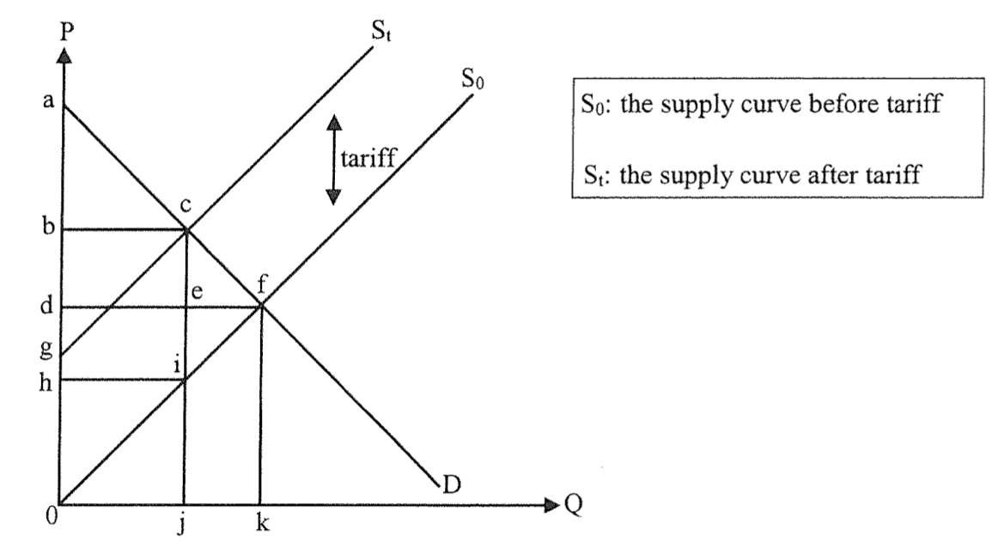
With reference to the above supply-demand diagram, complete the tale below. (3)
 | Before Tariff | After tariff
Consumers’ Surplus | Area adf
Producers’ surplus
經濟學家認為關稅可能損害消費者及生產者。
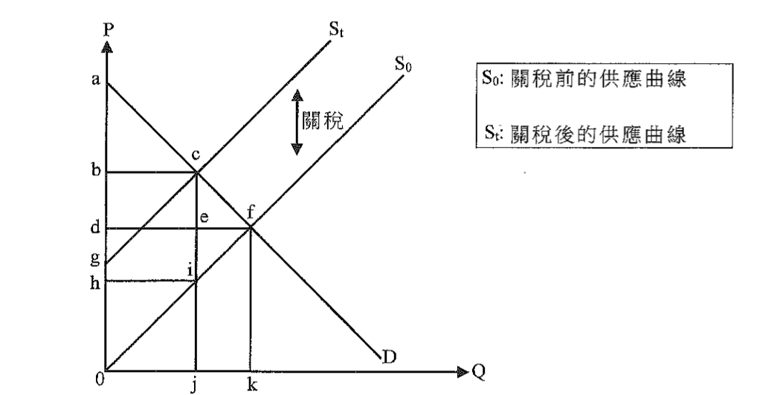
參考以上供需圖，完成下表。
 | 關稅前 | 關稅後
消費者盈餘 | 面積adf
生產者盈餘
Marking Scheme:
 | Before Tariff | After tariff
Consumers’ Surplus | - | Area abd
Producers’ surplus | Area df0 | Area hi0
 | 關稅前 | 關稅後
消費者盈餘 | - | 面積abc
生產者盈餘 | 面積df0 | 面積hi0

Candidates’ Performance:
Good. One common error was to wrongly include the tariff revenue in the after producers’ surplus and mis-labelling the latter area is bci0.
良好，一個常犯的錯誤是將bci0面積標未作扣除關稅後的生產者盈餘，即錯誤地將關稅收入包括在內。

DSE 2021 LQ10d
Wearing surgical mask can reduce the chance of contracting diseases for an individual and can prevent spreading diseases to others as well. In terms of externality, explain how the subsidy could improve economic efficiency. (4)
由於在很多公眾地方市民都要強制配戴口罩，口罩成為生活必需品。配戴外科口罩能減低個人染上疾病的機會，也能預防將疾病傳染給他人。以界外影響為依據，解釋該補貼如何可以改善經濟效率。
_______________________________________________________________________________________
_______________________________________________________________________________________
_______________________________________________________________________________________
_______________________________________________________________________________________
_______________________________________________________________________________________
_______________________________________________________________________________________
Marking Scheme:
Wearing mask protects oneself as well as lowering the chance of others being infected. Since the person wearing mask is not compensated by others (whose chances of being infected are reduced), there exists external benefit, with marginal social benefit exceeding marginal social cost. This implies that the number of people wearing mask is below the efficient level i.e. under-consumption of masks. Subsidy can increase the number of people wearing mask towards the efficient level (by lowering the marginal private cost), and thus narrow the gap between marginal social benefit and marginal social cost. (4)
配戴口罩保護自己亦減低其他人受感染的機會。由於配戴口罩的人沒有收到他人（受感染機會降低的人）的補償，這出現界外利益，邊際社會利益大於邊際社會成本。這意味着配戴口罩的人數低於效率水平，即口罩消費不足。補貼可以增加配戴口罩的人數。（透過減低邊際私人成本），使其較接近效率水平，因而縮窄邊際社會利益和邊際社會成本的差距。
Candidates’ Performance:
Satisfactory. In explaining the externality involved in mask-wearing, most candidates were able to make use of keywords such as “without compensation” or “without receiving payments” Some candidates confused the definition of positive externality with its corresponding inefficiency condition “MSC < MSB”. A few candidates tried to explain how subsidy could improve efficiency not from the perspective of the mask consumers (where consumption externality does prevail), but rather from that of the producers (where production externality does not exist).
令人滿意。在解釋戴口罩的界外影響時，大部份考生能運用關鍵字詞如「沒有補償」或「沒有收取金錢」。部份考生混淆了正向界外影響的定義和其相關的缺乏效率的條件「邊際社會成本 < 邊際社會得益」。少數考生嘗試解釋補貼如何可以改變效率時，不是從口罩消費者的角度（消費界外影響是存在的），卻是從口罩生產商的角度（生產界外影響並不存在）。

Marking Scheme:
Type 1 (Area showing CSPS)
1 | B | 2 | D | 3 | C | 4 | C | 5 | B | 6 | A | 7 | B | 8 | C | 9 | A | 10 | B
11 | C | 12 | C | 13 | D | 14 | C | 15 | D | 16 | A | 17 | A | 18 | A | 19 | B | 20 | D
21 | C | 22 | C | 23 | A | 24 | C | 25 | A | 26 | C | 27 | B | 28 | A | 29 | C | 30 | C
Type 2 (Externality)
1 | C | 2 | D | 3 | B | 4 | B | 5 | B | 6 | B | 7 | B | 8 | C | 9 | C | 10 | C
11 | B | 12 | A | 13 | A | 14 | D | 15 | B | 16 | B | 17 | C | 18 | C | 19 | D | 20 | C
Type 3 (Function of money)
1 | A | 2 | D | 3 | B | 4 | C | 5 | D | 6 | A | 7 | C | 8 | B

