Learning Focus:
Memo
(LQ Answering Flow, MC skills, your goals and resolutions…)
Specific Question Type
MC

咩話？DSE Sample Paper, Practice Paper, 2012, 2013, 2014, 2015, 2016, 2017, 2018, 2019, 2020, 2021, 2022
MC全部拍晒解題片？係呀，有唔明即scan即睇！就係咁firm！


Learning Focus:
Memo
(LQ Answering Flow, MC skills, your goals and resolutions…)
Specific Question Type
LQ

咩話？DSE Sample Paper, Practice Paper, 2012, 2013, 2014, 2015, 2016, 2017, 2018, 2019, 2020, 2021, 2022
LQ全部拍晒解題片？係呀，有唔明即scan即睇！就係咁firm！


Chapter 8 _ The growth of firm
Type 1 (The Objectives and Expansion of Firms)
Example Question 1 CE1990MCQ18
Which of the following is an example of lateral integration?
A. A flour mill combines with a bakery B. A jeans factory combines with a swimwear factory
C. A jewellery manufacturer combines with a noodle factory D. A furniture factory combines with a lumbering plant

下列哪一項為側向合併的例子？
A. 麵粉廠與西餅店合併 B. 牛仔褲廠與泳衣廠合併
C. 首飾廠與麵廠合併 D. 傢俬廠與木廠合併

Example Question 2 CE1991MCQ21
Cathay Pacific Airways Ltd. took over Hong Kong Dragon Airlines Ltd. This is an example of
A. horizontal integration. B. lateral integration.
C. forward vertical integration. D. backward vertical integration.

國泰航空有限公司收購了港龍航空公司。這是一個____的例子。
A. 橫向合併 B. 側向合併
C. 前向合併 D. 後向合併

Example Question 3 CE1993MCQ24
Which of the following is an example of lateral integration of a firm?
A. A telephone company combines with a telegraph company
B. A restaurant combines with a supermarket
C. A hospital sets up a school to student nurses
D. A furniture company combines with another furniture company

以下哪一項是「側向合併」的一個例子？
A. 一電話公司與一電報公司合併
B. 一酒店與一超級市場合併
C. 一醫院設立一學校以訓練護士學生
D. 一傢俬公司與另一傢俬公司合併

Example Question 4 CE1994MCQ27
A travel agent takes over a real estate firm. What kind of integration is this?
A. conglomerate integration B. lateral integration C. vertical integration D. horizontal integration

一旅行社收購一地產公司。這屬於哪種合併？
A. 集團合併 B. 側向合併 C. 縱向合併 D. 橫向合併

Example Question 5 CE1995MCQ27
A publisher takes over a bookstore. To the publisher, this is a ______ integration.
A. conglomerate B. forward C. backward D. lateral

一出版商收購一店，對該出版商而言，這是一種
A. 集團合併 B. 前向合併 C. 後向合併 D. 側向合併

Example Question 6 CE1998MCQ19
A famous singer expands his show business by producing stationery with his picture on it. This type of expansion is
A. horizontal B. forward C. backward D. conglomerate

某著名歌手擴充他的表演事業至生產印有他照片的文具。這屬於哪一類擴張？
A. 橫向 B. 前向 C. 後向 D. 集團

Example Question 7 CE2004MCQ24
A shirt-making factory has expanded its business follows:
To the shirt-making factory, the types of expansion shown by X and Y are _______expansion and _____ expansion respectively.
A. backward ... lateral B. lateral ... lateral C. backward ... backward D. lateral ... forward

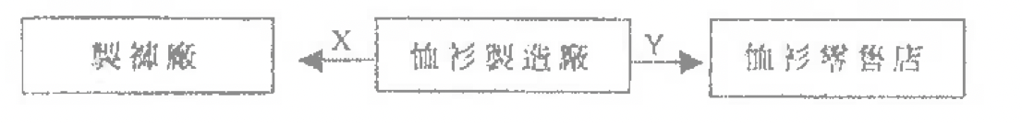
對該恤衫製造廠來說，X和Y的擴張類型分別是____擴張和____擴張？
A. 後向……側向 B. 側向……側向 C. 後向……前向 D. 側向……前向

Example Question 8 CE2005MCQ24
Which methods of integration can be used by firms to ensure the supply of raw materials?
A. backward integration. B. forward integration. C. conglomerate integration. D. horizontal vertical integration.

廠商可用哪種合併方式以保證其原料的供應
A. 後向合併 B. 前向合併 C. 集團合併 D. 橫向合併

Example Question 9 CE1993MCQ23
A movie-producing firm acquired a number of theatres to present its own films and films produced by other films. What are the advantages of this type of integration to the firm?
(1) The firm can enjoy economies of scale
(2) The firm can reduce the risks by diversifying its investment
(3) It is easier for the firm to obtain contracts with movie stars
A. (1) and (2) only B. (1) and (2) only C. (2) and (3) only D. (1),(2) and (3)

某電影製片公司收購了若干戲院來放映它本身及其他公司製作的電影。這種合併對該公司有何好處
(1) 可享有規模經濟
(2) 分散投資可降低風險
(3) 與電影明星傾談合約時更易成功
A. 只有(1)、(2) B. 只有(1)、(3) C. 只有(2)、(3) D. (1)、(2)、(3)

Example Question 10 CE1994MCQ28
In Hong Kong, when a commercial bank takes over another commercial bank,
A. it has greater influence on deposit rates. B. it is able to diversify risk in its business.
C. its market share is enlarged. D. it will suffer from diseconomies of scale.

在香港，當一商業銀行收購另一商業銀行，
A. 它對存款利率有更大的影響 B. 它可以分散生意上的風險
C. 它的市場佔有率有更高 D. 它會出現規模負經濟的問題

Example Question 11 CE1995MCQ28
Which of the following is the greatest benefit from conglomerate integration?
A. diversification of product B. economies of scale
C. ensuring the markets for its output D. larger market share

下列哪一項是集團結合的最大好處？
A. 產品多元化 B. 規模經濟
C. 保障產品有穩定的銷售市場 D. 更高的市場佔有率
Example Question 12 CE1997MCQ20
When a cake shop takes over a coffee shop, which of the following are correct?
(1) This can provide an outlet for its product
(2) The resources can be better utilized
(3) The risk of the business is reduced through diversification
(4) The profit will increase
A. (1), (2) and (3) only B. (1), (2) and (4) only C. (1), (3) and (4) only D. (2),(3) and (4) only

若一家餅店收購一家咖啡店，下列哪幾項是正確的
(1) 可以為產品提供穩定的銷售市場
(2) 資源可以運用得更好
(3) 生意風險可以透過分散投資而減少
(4) 利潤會增加
A. 只有(1)、(2)、(3) B. 只有(1)、(2)、(4) C. 只有(1)、(3)、(4) D. 只有(2)、(3)、(4)

Example Question 13 CE2000MCQ24
A mobile phone company joins hands with a commercial bank. A customer of the bank can handle matters concerning his accounts by using the mobile phones produced by the mobile phone company Which of the following is least likely a motive of the mobile phone company in this joint venture?
A. to ensure a steady supply of raw materials B. to benefit from more efficient use of resources
C. to benefit from economies of scale D. to promote goodwill

一家流動電話公司與一家商業銀行聯營一種生意。銀行的客戶可以利用該流動電話公司來處理銀行戶口事宜。以下哪一項最不可能是該流動電話公司參與該項聯營生意動機中的動機？
A. 保證原料有穩定的供應 B. 從更有效地運用資源中得益
C. 可從規模經濟中得益 D. 推廣商譽

Example Question 14 CE2001MCQ23
A bus company expands its business and starts to provide ferry services to the outlying islands. This enables the bus company to
A. diversify the risk of its business. B. diversify the markets for its product.
C. enjoy a larger market share. D. enjoy technical economies of scale.

一家巴士公司擴充業務，開始提供離島的渡輪服務。此舉可使該巴士公司
A. 分散風險 B. 的產品市場多元化
C. 享有更高的市場佔有率 D. 享有技術規模經濟

Example Question 15 CE2002MCQ22
Mrs. Chan, a large supplier of frozen beef, opens a chain of beef steak houses. To this supplier,
(1) the expansion is a vertical forward expansion.
(2) the risk of running a loss for her whole business will be lower.
(3) this can ensure a steady market outlet for her frozen beef.
A. (1) and (2) only B. (1) and (3) only C. (2) and (3) only D. (1), (2) and (3)

陳太是某大型凍牛肉供應商，開設了一家連鎖牛排店。對該供應商而言，
(1) 該生意擴張屬於前向擴張
(2) 全盤生意出現損失的風險會下降
(3) 這可保證她的凍牛肉有穩定的銷售市場
A. 只有(1)、(2) B. 只有(1)、(3) C. 只有(2)、(3) D. (1)、(2)、(3)

Refer to the following report to answer Question 16 and 17.
“Towngas Avenue is the largest customer service centre for Towngas. Towngas Avenue also sells tableware and glassware and operates an in-store café.

參考一下報告回答題16和17
「煤氣廊(Towngas Avenue)是煤氣公司最大的顧客服務中心。煤氣廊同時銷售餐具、玻璃器皿和在店內經營咖啡店」

Example Question 16 CE2003MCQ23
The extension of the business of Towngas to Towngas Avenue is an example of
A. horizontal expansion B. vertical backward expansion C. vertical forward expansion D. conglomerate expansion

將煤氣公司的生意擴展至經營名氣廊是一個什麼的例子？
A. 橫向擴張 B. 後向擴張 C. 前向擴張 D. 集團擴張

Example Question 17 CE2003MCQ24
To Towngas, the extension of the business of Towngas to Towngas Avenue has the advantage of
A. enjoying technical economies of scale B. ensuring a steady supply of raw materials
C. ensuring adequate market outlets D. diversifying production and separating risk

將煤氣公司的生意擴張至經營煤氣廊。對煤氣公司有以下哪一項的好處？
A. 享受技術規模經濟 B. 保證生產原料有穩定的供應
C. 促銷產品有穩定的銷售市場 D. 生產多元化，並將風險分散

Example Question 18 CE2006MCQ23
When an international airline company takes over a local airline company, the former has the advantage of
A. ensuring a steady supply of raw materials B. ensuring a better quality of its service
C. enjoying management economies of scale D. avoiding the existence of diseconomies of scale

當一家國際航空公司收購一家本地航空公司，前者可獲得以下的好處：
A. 保證可獲得穩定的原料供應。 B. 保證它有更高的服務質素。
C. 享有管理規模經濟。 D. 避免規模負經濟出現。

The MTR Corporation launched the Octopus Card. It is a smart card system facilitating transactions of small amounts. Answer questions 19 and 20 below:
地鐵公司引入了八達通卡，那是一種智能卡，支援小額交易。回答題19和20:
Example Question 19 CE2007MCQ23
To the MTR Corporation, this type of integration is __________
A. horizontal B. forward C. backward D. conglomerate

對於地鐵公司來說，這屬於哪一種擴張？
A. 橫向 B. 前向 C. 後向 D. 集團

Example Question 20 CE2007MCQ24
Such a type of integration has the advantage of
A. technical economies of scale B. increasing the market share of business
C. increasing the profit of the company D. diversifying the risk of business

該類型擴張具備下列哪一項優點？
A. 享有技術規模經濟 B. 增加所經營生意的市場佔有率
C. 增加公司利潤 D. 分散經營上的風險

A catering company owns many restaurants selling different Chinese foods. Recently, it has opened a new bakery. Which of the following descriptions in questions 21 and 22 concerning the expansion of the catering company are correct?
一家餐飲公司擁有很多餐廳售賣不同類型的中國菜。最近，它新開設了一家麵包店。回答21和22題
Example Question 21 CE2008MCQ22
The expansion is an example of
A. lateral expansion B. vertical forward expansion C. horizontal expansion D. conglomerate expansion

該餐飲公司的擴張是____的一個例子。
A. 側向擴張 B. 前向擴張 C. 橫向擴張 D. 集團擴張

Example Question 22 CE2008MCQ23
The expansion enables the catering company to
A. spread the business risk by diversifying the product B. have a greater influence on the market price
C. raise the productivity of its workers D. have a more steady supply of raw materials

該餐飲公司的擴張有助該公司
A. 產品多元化以分散營業風險 B. 對市場價格有更大的影響力
C. 提升其工人的生產力 D. 獲得更穩定的原料供應

Example Question 23 CE2009MCQ24
The integration of the MTR Corporation Limited (MTR) and the Kowloon-Canton Railway Corporation (KCR) is an example of _________ with the advantage of _________.
A. horizontal integration ... ensuring a steady supply of raw materials for production
B. vertical integration ... lowering the production cost
C. lateral integration ... economies of scale
D. conglomerate integration ... making more efficient use of resources

地鐵有限公司與九廣鐵路公司的合併是____的例子，有____的優點。
A. 橫向合併……保證生產原料供應穩定 B. 縱向合併……減低生產成本
C. 側向合併……規模經濟 D. 集團合併……資源運用更有效

Example Question 24 CE2010MCQ24
When a bakery takes over a flour producing factory, the former has the advantage of
A. ensuring a market outlet of its products. B. enlarging the market share.
C. ensuring a steady supply of raw materials. D. diversifying the market risk.

一家麵包店收購一家麵粉廠。此舉對前者的好處是
A. 可以保證它的產品有銷售渠道 B. 可以擴大它的市場佔有率
C. 可以保證它的生產原料有穩定的供應 D. 可以分散風險

Example Question 25 DSESPMCQ9
Suppose a Chinese computer manufacturer takes over a US computer manufacturer. Which of the following is NOT an advantage to the Chinese computer manufacturer in the above takeover?
A. turning a competitor into a partner B. diversifying risk of demand fluctuation
C. building up the goodwill of the company D. lowering the average cost of production

假設一家中國生產商收購一家美國電腦生產商。下列哪項並不是該中國電腦生產商在該收購中可獲得的好處？
A. 將競爭對手變成夥伴 B. 分散需求波動的風險
C. 為公司建立良好聲譽 D. 降低平均生產成本

Example Question 26 DSE2013MCQ8
A firm can ensure a steady supply of raw materials by engaging in _______ while it can increase its market share by engaging in _______.
A. backward integration ... horizontal integration B. backward integration ... lateral integration
C. forward integration ... horizontal integration D. forward integration ...lateral integration

某廠商可透過進行____確保原料供應穩定，而它可以透過進行____增加市場佔有率。
A. 後向合併……橫向合併 B. 後向合併……側向合併
C. 前向合併……橫向合併 D. 前向合併……側向合併

Example Question 27 DSE2015MCQ8
759 Store, a local retailer of imported snacks, expands its business to sell cosmetics and skincare products. Which of the following is LEAST likely motive behind the expansion?
A. To reduce competition B. To enjoy economies of scale
C. To expand its brand name to other products D. To spread risk by business diversification

759阿信屋是本地一家售賣進口零食的零售商。它將業務擴展至售賣化妝品和護膚產品。下列哪項最不可能是該擴張背後的動機。
A. 減少競爭 B. 享有規模經濟
C. 將其品牌推廣至其他產品 D. 以業務多元化分散風險

Example Question 28 DSE2016MCQ11
Hong Kong Television Network Limited (HKTV) has launched an online shopping platform “HKTV Mall”. This expansion
(1) helps spread business risk.
(2) ensures a higher profit for the company.
(3) extends its brand name to other markets.
A. (1) and (2) only B. (1) and (3) only C. (2) and (3) only D. (1), (2) and (3)

香港電視網絡有限公司(HKTV)推出一個網上購物平台「HKTV Mall」。這擴張
(1) 有助分散業務風險。
(2) 確保公司有更高的利潤。
(3) 將其品牌拓展至其他市場。
A. 只有(1)、(2) B. 只有(1)、(3) C. 只有(2)、(3) D. (1)、(2)、(3)

Example Question 29 DSE2017MCQ9
Giordano International Limited is a retailer of casual wear. It has launched the Giordano Ladies, which provides luxury clothes and suits for ladies. It is an example of _______ expansion.
A. Horizontal B. Vertical C. Lateral D. Conglomerate

佐丹奴國際有限公司是一間便服零售商。它開設了佐丹奴女裝Giordano Ladies，提供高級女士服裝和套裝。這是____擴張的一個例子。
A. 橫向 B. 縱向 C. 側向 D. 集團

Example Question 30 DSE2018MCQ8
Toridoll Holdings Corporation, a leading company in the restaurant industry in Japan, acquired a Hong Kong noodle chain Tam Chai Yunnan Noodles. Which of the following is the LEAST likely motive behind the integration?
A. To secure the supply of factor inputs B. To spread risk through product diversification
C. To enjoy economies of scale D. To expand its business to other markets

日本餐飲龍頭企業「東利多控股」收購了本地麵食連鎖店譚仔雲南米線。下列哪項最不可能是該擴張背後的動機
A. 確保要素投入的供應 B. 藉產品多元化分散風險
C. 享有規模經濟 D. 將業務擴展至其他市場

Example Question 31 DSE2019MCQ9
A Hong Kong travel company offers package tours to Japan. It invested in building a hotel, which provides accommodation services to its tour members visiting Japan. Which of the following is most likely the motive behind the expansion?
A. To increase the market share B. To secure the supply of factor inputs
C. To secure a market outlet of its services D. To reduce competition

一家香港旅行社經營日本旅行團業務。它投資興建一家酒店，為其日本旅行團的團友提供住宿服務。下列哪項最有可能是背後的動機？
A. 增加市場佔有率 B. 確保要素投入的供應
C. 保證其服務有銷售渠道 D. 減少競爭

Example Question 32 DSE2020MCQ18
ABC Diamond Cutting Factories expand its business as follows:
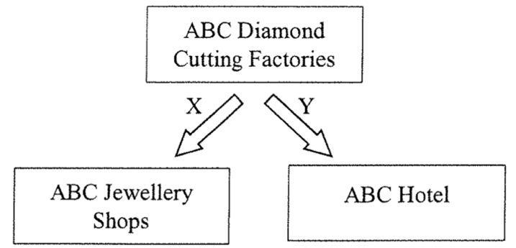
To ABC Diamond Cutting Factories, the types of expansion shown by X and Y are
expansion respectively.
A. backward … … conglomerate B. backward … … lateral
C. forward … … conglomerate D. forward … … lateral

ABC鑽石切割工廠的業務擴張如下：
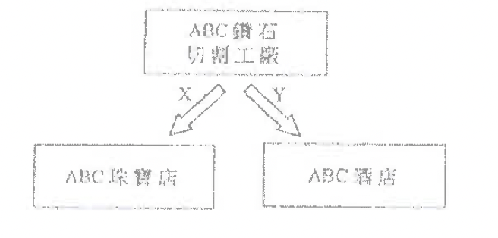
對ABC鑽石切割工廠來說，X和Y所示的擴張類型分別是____擴張和____擴張
A. 後向……集團 B. 後向……側向
C. 前向……集團 D. 前向……側向

Example Question 33 2021DSEMCQ8
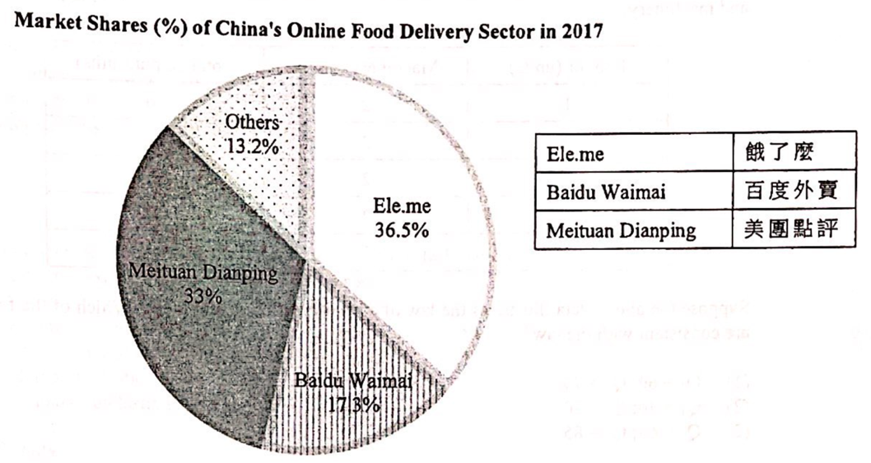
Ele.me acquired Baidu Waimai in 2017. Which of the following could be motive(s) behind the acquisition?
(1) to enjoy economies of scale
(2) to spread risk by business diversification
(3) to have a greater influence on the market price
A. (1) only B. (1) and (2) only C. (1) and (3) only D. (2) and (3) only
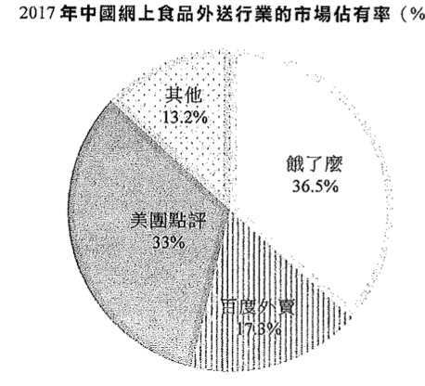
2017年「餓了麼」收購了「百度外賣」。下列哪項 / 些可能是這收購背後的動機
(1) 可享有規模經濟
(2) 使業務多元化以分散風險
(3) 可對市場價格有更大影響力
A. 只有(1) B. 只有(1)、(2) C. 只有(1)、(3) D. 只有(2)、(3)

Type 2 (Market structure)
Example Question 1 CE1993MCQ30
In economies , which of the following statements about ‘market’ is correct ?
A. All buyers and sellers must meet at a physical location for transactions to take place
B. Under monopolistic competition, the entry of firm is restricted
C. Firms in an oligopolistic market compete in price only
D. A perfectly competitive firm cannot influence the market price by itself

在經濟學上，下列哪一項有關「市場」的描述是正確的？
A. 所有買家和賣家都必需在一個地方會面才能進行交易。
B. 在壟斷性競爭下，廠商的加入受到限制。
C. 寡頭壟斷廠商只會進行價格競爭。
D. 一完全競爭廠商不能獨自影響市場價格。

Example Question 2 CE1994MCQ29
Competition in the market will tend to be imperfect when
(1) customers favor brand names.
(2) there are differentiated products
(3) there is free entry into the market.
(4) there are numerous sellers.
A. (1) and (2) only B. (1) and (3) only C. (2) and (4) only D. (3) and (4) only

在下列哪些情況下，市埸競爭趨向不完全?
(1) 顧客對名牌有偏好
(2) 有異質產品
(3) 可以自由進入市埸
(4) 有很多賣家
A. 只有(1)、(2) B. 只有(1)、(3) C. 只有(2)、(4) D. 只有(3)、(4)

Example Question 3 CE1996MCQ25
Newspapers in Hong Kong competed among themselves by cutting prices in 1995. This implies that
A. the total revenue of a newspaper will increase if its demand is inelastic.
B. The profit of a newspaper will increase if its demand is elastic.
C. Total revenue in the magazine industry will increase because newspapers and magazines are in competitive demand.
D. The market structure of newspapers is not perfect competition.

在 1995 年，香港的報社以減價來互相競爭。這意味什麼?
A. 若某報紙的需求屬低彈性，它的總收入會增加。 B. 若某報紙的需求屬高彈性，它的利潤會增加。
C. 雜誌行業的總收入會增加，因為報紙與雜誌屬競爭性需求。 D. 報紙的市場不屬於完全競爭。

Example Question 4 CE1997MCQ59
With a number of new firms entering the market of mobile phone services, which of the following would LEAST likely occur?
A. The price of mobile phone services would decrease B. The market share occupied by existing firms would decrease
C. Firms would engage more in non-price competition D. The market would become a perfectly competitive one

當流動電話服務的市場有一些新廠商加入時,下列哪一項最不可能發生?
A. 流動電話服務的價格會下降。 B. 原有廠商的市場佔有率會下跌。
C. 廠商之間會有更多非價格競爭。 D. 該市場會變成一個完全競爭市場。

Example Question 5 CE2002MCQ23
Which of the following is a general feature of a perfectly competitive market?
A. Market information is imperfect. B. There is non-price competition.
C. There is only one price prevailing in the market. D. None of the above is a correct answer.

下列哪一項是完全競爭市場的一種特徵?
A. 市場資訊不完全。 B. 市場有非價格競爭。
C. 市場上只有一個價格。 D. 以上皆非正確答案。

Example Question 6 CE2008MCQ24
Which of the following is a feature/ are features of a perfectly competitive market?
A. There is a freedom of entry and exit of firms B. The market price of the product is stable
C. Sellers use non-price competitions to attract consumers D. All of the above is correct.

下列哪項是完全競爭市場的特徵?
A. 廠商可自由加入或退出該行業。 B. 該市場的物品的市場價格是穩定的。
C. 賣家以非價格競爭的方法吸引消費者。 D. 以上全部正確。

Example Question 7 CE1990MCQ16
China Light and Power Co. Ltd. Is a __________ under __________.
A. public enterprise, monopoly B. public company, monopoly
C. public corporation, oligopoly D. public utility, oligopoly

中華電力有限公司是屬於__________的__________。
A. 壟斷者，公營企業 B. 壟斷者，公眾公司
C. 寡頭壟斷，公營公司 D. 寡頭壟斷，公用事業

Example Question 8 CE1991MCQ27
The reasons for classifying the video-renting industry in Hong Kong as monopolistic competition are:
(1) The entry and exit of firms are restricted.
(2) The firms engage in non-price competition.
(3) The services of the firms are not homogeneous.
(4) The firms charge the same price.
A. (1) and (2) only B. (1) and (4) only C. (2) and (3) only D. (3) and (4) only

將香港的錄影帶租用行業歸類為壟斷性競爭的理由是:
(1) 加入或退出這行業都有限制。
(2) 廠商進行非價格競爭。
(3) 廠商服務並不同質。
(4) 廠商收取相同價錢。
A. 只有(1)及(2) B. 只有(1)及(4) C. 只有(2)及(3) D. 只有(3)及(4)

Example Question 9 CE1992MCQ29
The market structure of gasoline supply in Hong Kong is best classified as
A. perfect competition B. monopolistic competition C. oligopoly D. monopoly

在香港, 汽油供應的市場結構最適宜歸類為
A. 完全競爭。 B. 壟斷性競爭。 C. 寡頭壟斷。 D. 壟斷。

Example Question 10 CE1992MCQ56
Which of the following is NOT a reason why there is only one firm supplying coal gas in Hong Kong?
A. The firm is granted a franchise by the Hong Kong
B. The firm enjoys economies of scale in production
C. It is costly for a new firm to construct a new underground pipeline network
D. It is difficult for a new firm to capture a sufficient share of market

以下哪一項並非為香港只有一間廠商供應煤氣的原因?
A. 該廠商獲香港政府發出專營權。
B. 該廠商享有生產規模經濟。
C. 新廠商建設全新的地下煤氣管網絡的費用非常昂貴。
D. 新廠商要佔奪足夠的市場份額非常困難。

Example Question 11 CE1993MCQ22
Which of the following statements about a monopolist is true?
A. It has a high set-up cost B. It sells only one type of product
C. It is regulated by the government D. There is no close substitutes for its product

下列關於壟斷者的敘述哪一項是正確的？
A. 初始啟動成本較高 B. 只銷售一種產品
C. 受政府監管 D. 其產品沒有相近替代品

Example Question 12 CE1993MCQ23
The Kowloon -Canton Railway Corporation (KCRC)** is a
(1) public limited company
(2) public corporation
(3) public enterprise
(4) monopolist
A. (1) and (2) only B. (1) and (3) only C. (2) and (4) only D. (3) and (4) only
(** The KCRC and the MTR have merged since Dec, 2007)

九廣鐵路公司（九鐵）** 是一家
(1) 公眾有限公司
(2) 公營公司
(3) 公營企業
(4) 壟斷者
A. 只有(1)及(2) B. 只有(1)及(3) C. 只有(2)及(4) D. 只有(3)及(4)
(** 九鐵港鐵自2007年12月起合併)
Example Question 13 CE1994MCQ30
Which of the following statements about the China Light and power Company Limited is correct?
A. It is an oligopoly because there are two competing electricity companies in Hong Kong.
B. It is an oligopoly because there will be a new nuclear power station in Daya Bay.
C. It is a natural monopoly because it enjoys economies of scale.
D. It is a franchised monopoly because the government grants an exclusive right for its running.

下列哪一項關於中華電力有限公司的描述是正確的?
A. 它是寡頭壟斷者，因為香港有兩間互相競爭的電力公司。
B. 它是寡頭壟斷者，因為在大亞灣將會有一所新核電站。
C. 它是自然壟斷者，因為它享有規模經濟。
D. 它是專營壟斷者，因為政府給予它特許專營權。

Example Question 14 CE1995MCQ29
Which of the following is a general feature of oligopoly?
A. There is perfect information. B. There is price competition only.
C. There is free entry. D. There are only a few sellers who can dominate the market.

下列哪一項是寡頭壟斷的一般特徵?
A. 完全資訊。 B. 只存在價格競爭。
C. 可自由進入市場。 D. 只有少數賣家可支配市場。

Example Question 15 CE1996MCQ58
Which of the following is NOT a difference between monopoly and perfect competition?
A. Advertisements are found in monopoly but not in perfect competition.
B. Firms are free to enter a perfectly competitive market but not a monopoly.
C. A monopolist can influence the market price while a competitive firm cannot.
D. Monopolists make greater profits than perfectly competitive firms.

A. 壟斷者會牽涉賣廣告的活動，而完全競爭廠商則不會。
B. 廠商可自由進入完全競爭市場，而壟斷者則不能。
C. 壟斷者可影響市場價格，而完全競爭廠商則不能。
D. 壟斷者的利潤高於完全競爭廠商。

Example Question 16 CE1998MCQ22
The market structure of the newspaper publishers in Hong Kong is
A. perfect competition because a particular newspaper is sold at the same price at different places.
B. monopolistic competition because there are many newspaper stalls.
C. oligopoly because only a few newspapers have leading market shares.
D. monopoly because there is no close substitute when the consumer has formed the habit of reading a particular newspaper.

香港的報章出版社的市場結構是
A. 完全競爭，因為同一份報章在不同地點的售價相同。
B. 壟斷性競爭，因為有很多報攤售賣報章。
C. 寡頭壟斷，因為只有幾份報章有領導性的市場佔有率。
D. 壟斷，因為顧客在養成閱讀某一份報章的習慣後，便沒有近似的替代品。

Example Question 17 CE1999MCQ23
Before 1999, the international direct dialing service (IDD) in Hong Kong was solely provided by Hong Kong Telecom. Now several other companies also provide this service. As a result, the market structure for IDD has changed from _______ to ______.
A. monopoly ... perfect competition. B. monopoly ... oligopoly
C. oligopoly ... monopolistic competition D. monopolistic competition ... perfect competition

在 1999 年之前，香港直撥國際電話服務 (IDD) 只由香港電訊獨家提供，現在有數家公司提供這種服務。結果，IDD的市場結構由 ______ 轉變為 ______ 。
A. 壟斷 ...... 完全競爭 B. 壟斷 ...... 寡頭壟斷
C. 寡頭壟斷 ...... 壟斷性競爭 D. 壟斷性競爭 ...... 完全競爭

Example Question 18 CE2000MCQ25
Which of the following about a monopoly is correct?
A. Its product has no substitutes as it is the only seller of the product of the kind.
B. A monopolist still faces non-price competition.
C. A monopolist can increase the price without losing any customers.
D. Any business granted a franchise by the government is a monopoly.

下列哪一項關於壟斷的描述是正確的?
A. 由於它是該種產品的唯一售賣者，所以它的產品沒有替代品。
B. 壟斷者仍面對非價格競爭。
C. 壟斷者可提高價格而不會失去任何顧客。
D. 任何獲政府授予專營權的廠商都是壟斷。

Example Question 19 CE2001MCQ24
Many people say that the MTR Corporation Limited is a monopolist. Which of the following about the company is correct?
A. The demand for its product is perfectly inelastic. B. It still has to face competition.
C. It does not need to advertise its product. D. It is sure to make profits as it is the only supplier.

很多人說地鐵有限公司是一壟斷經營者。下哪一項關於該公司的描述是正確的?
A. 用家對它的產品的需求屬完全無彈性。 B. 它仍需要面對競爭。
C. 它無需要宣傳自己的產品。 D. 由於它是唯一的供應者，它肯定可以賺取利潤

Example Question 20 CE2003MCQ49
In Hong Kong, free television broadcasting is provided by Television Broadcasts Limited and Asian Television Limited. Which of the following is NOT correct? These two companies
A. are oligopolists B. operate under franchise
C. broadcast television programmes which are economic goods D. engage in non-price competition only

在香港,電視廣播有限公司(TVB)和亞洲電視有限公司(ATV)播放免費的電視節目。以下哪一項並非正確? 該兩家公司
A. 是寡頭壟斷者。 B. 獲政府授予專營權。
C. 所提供的電視節目是經濟物品。 D. 彼此只有非價格競爭。

Example Question 21 CE2004MCQ25
The market structure of petroleum companies (e.g. Esso, Caltex) in Hong Kong could be regarded as oligopolistic because
A. in making decisions these companies have to consider the reactions of other dominant companies in the industry.
B. the total sales revenue of the market is equally shared by these companies.
C. these companies are selling homogenous products.
D. the information about their products can be obtained at zero cost.

在香港，石油公司(例如埃索、加德士) 的市場結構可視作寡頭壟斷，因為
A. 這些公司進行決策時須考慮業內其他有影響力的公司的反應。
B. 市場裏的全部銷售收益被這些公司平分。
C. 這些公司售賣同質產品。
D. 獲知他們產品的資訊不涉及成本。

Example Question 22 CE2005MCQ25
Which of the following descriptions about monopoly is correct?
A. A monopolist must process a franchise to run the business B. A monopolist faces no competition
C. A monopolist may incur losses D. A monopolist sells only one product

下列哪一項關於壟斷的描述是正確的?
A. 壟斷者必須擁有專營權。 B. 壟斷者毋須面對競爭。
C. 壟斷者可能會有所虧損。 D. 壟斷者只售賣一種產品。

Example Question 23 CE2006MCQ24
A market can be regarded as an oligopoly when
A. information in the market is not perfect B. a few sellers have a significantly larger market share than the others
C. the products sold in the market are daily necessities D. the government controls the entry of sellers into the market

在下列哪種情況下，一個市場可被視為寡頭壟斷?
A. 市場資訊不完全。 B. 少數廠商的市場佔有率明顯比其他廠商大很多。
C. 市場上出售的貨品是日常必需品。 D. 賣家能否進入市場是由政府操控的。

Example Question 24 CE2007MCQ25
The Airport Express is the only railway service carrying passengers to the airport in Hong Kong. Which of the following statements about Airport Express is correct ?
A. It would surely make a profit since it is the sole supplier of airport railway services
B. It does not need to promote its business through advertising
C. It can increase its price without losing any customers
D. It has to face competition in the market from other transport services to the airport

機場快線是香港唯一載客往返機場的鐵路服務，下列哪一項對機場快線的描述是正確的?
A. 它肯定獲得利潤，因為它是機場鐵路服務的唯一供應者。
B. 它毋須透過賣廣告來推廣業務。
C. 它可以加價而不流失顧客。
D. 它在市場上須面對其他來往機場運輸服務者的競爭。

Example Question 25 CE2008MCQ25
The market structure of the electricity supply on Hong Kong Island is regarded as a/an
A. monopoly because the government controls the entry of suppliers in the market
B. oligopoly because there are two electricity companies in Hong Kong
C. monopoly because there is only one supplier
D. oligopoly because the supplier is a price searcher

港島電力供應的市場結構被視為
A. 壟斷，因為政府控制供應商進入市場。 B. 寡頭壟斷，因為香港有兩家電力公司。
C. 壟斷，因為只有一個供應商。 D. 寡頭壟斷，因為供應商是尋價者。

Example Question 26 CE2010MCQ25
The market structure of Internet service providers (e.g. PCCW and i-Cable) could be regarded as ________ and one feature of this market structure is that __________.
A. monopolistic competition ... there is imperfect information about their services
B. monopolistic competition ... they engage in both price and non-price competition
C. oligopoly ... there services are homogeneous
D. oligopoly ... they will consider the response of other providers when making decisions

網絡供應商 (例如:電訊盈科和有線寬頻) 的市場結構可被視為___________，該種市場結構的一個特色是___________。
A. 壟斷性競爭 ... 有關它們的服務資訊是不完全的。
B. 壟斷性競爭 ... 它們進行價格競爭及非價格競爭。
C. 寡頭壟斷 ... 它們的服務是同質的。
D. 寡頭壟斷 ... 它們在決策時會考慮同業的銷售策略。

Example Question 27 CE2011MCQ25
A market is regarded as monopolistic competition when _______.
A. there is imperfect information. B. there are many sellers selling differentiated products.
C. there are both price and non-price competition D. there is freedom of entry into the market

在下列哪種情況下，一個市場會被歸類為壟斷性競爭?
A. 資訊不完全。 B. 有很多售賣異質產品的賣家。
C. 價格及非價格競爭同時存在。 D. 可以自由進入市場。

Example Question 28 DSESPMCQ17
A market can be regarded as an oligopoly when
A. market information is not perfect. B. the market is dominated by a few sellers.
C. the government restricts the entry of sellers into the market. D. different sellers sell similar but differentiated products.

在下列哪種情況下，一個市場可被視為寡頭壟斷?
A. 市場資訊不完全 B. 巿場被少數賣家所支配
C. 政府限制賣家進入市場 D. 不同賣家出售相似但可區別的產品

Example Question 29 DSEPPMCQ16
Which of the following are features of a perfectly competitive market?
(1) The marginal revenue of each firm equals the market price.
(2) The sellers and buyers have perfect market information.
(3) The marginal cost schedule of a firm is the same as its supply schedule.
A. (1) and (2) only B. (1) and (3) only C. (2) and (3) only D. (1), (2) and (3)

下列哪些是完全競爭市場的特徵?
(1) 每間公司的邊際收入等於市價。
(2) 賣家和買家掌握完全市場資訊。
(3) 一間公司的邊際成本表與它的供應表相同。
A. 只有 (1)、 (2) B. 只有 (1)、 (3) C. 只有 (2)、 (3) D. (1)、 (2) 及 (3)

Example Question 30 DSE2012MCQ18
If a firm is a monopolist in a market,
A. its monopoly power may come from the government B. its return will be positive
C. it faces no competition. D. it bears no risk.

若一廠商是某市場的壟斷者,
A. 它的壟斷能力可能來自政府。 B. 它的回報會是正數。
C. 它無需面對競爭。 D. 它無需承擔風險。

Example Question 31 DSE2013MCQ17
The market structure of the electric power industry in Hong Kong is
A. an oligopoly because there are two dominating companies in the market.
B. an oligopoly because the pricing strategies of the companies are interdependent.
C. A monopoly because the companies can increase the price without losing customers.
D. A monopoly because there is only one electric company providing electricity in any district.

香港電力行業的市場結構屬
A. 寡頭壟斷，因為市場上有兩間具支配力的公司。 B. 寡頭壟斷，因為各公司的定價策略互相影響。
C. 壟斷，因為各公司可提高價格而不會流失顧客。 D. 壟斷，因為在任何地區只有一間電力公司提供電力。

Example Question 32 DSE2014MCQ17
The table below shows the distribution of market share of supermarkets in Hong Kong in 2012.
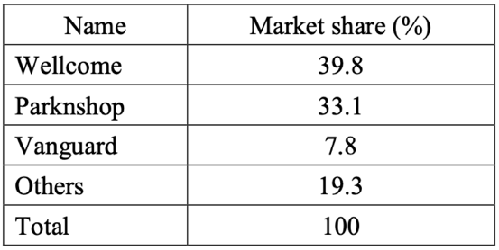
From the above table, we can conclude that the market of supermarkets in Hong Kong is an example of _____ because _______.
A. oligopoly ... sellers are interdependent in their marketing strategies
B. oligopoly ... a few major sellers are in control of the total sales of the market
C. monopolistic competition ... sellers can affect the market price as their products are heterogeneous from the consumers’ viewpoint
D. monopolistic competition ... there are many sellers adopting non-price competition in the market

下表顯示2012年香港超級市場的市場份額的分佈。
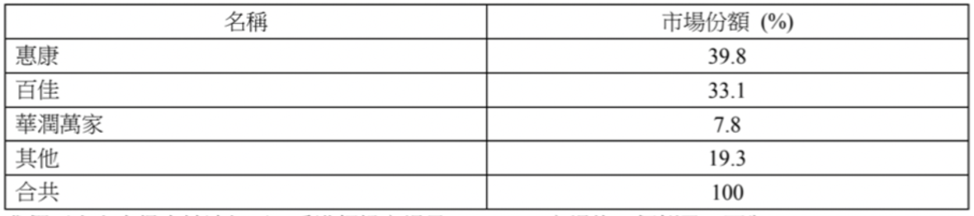
我們可由上表得出結論如下: 香港超級市場是 _______ 市場的一個例子，因為 _______。
A. 寡頭壟斷 ...... 賣家的營銷策略互相影響
B. 寡頭壟斷 ...... 幾位主要賣家操控了市場的總銷售量
C. 壟斷性競爭 ...... 賣家能影響市價, 因為從消費者角度來看,它們的貨品是異質的
D. 壟斷性競爭 ...... 市場上有許多賣家採用非價格競爭

Example Question 33 DSE2015MCQ20
Which of the following statements about the theme park industry in Hong Kong is correct?
A. Hong Kong Disneyland is a monopolist because its average cost of production drops when there are more tourists.
B. Hong Kong Disneyland guarantees a profit because it is protected by the government.
C. Hong Kong Disneyland and Ocean Park Hong Kong have no competition with each other as tourists may go to both theme parks.
D. Hong Kong Disneyland and Ocean Park Hong Kong are interdependent in their marketing strategies.

下列哪項有關香港主題公園行業的陳述是正確的?
A. 香港迪士尼樂園是一壟斷者，因為當遊客增加，它的平均生產成本下降。
B. 香港迪士尼樂園保證能獲得利潤，因為它受政府保護。
C. 香港迪士尼樂園和香港海洋公園之間沒有競爭，因為遊客可能會到訪兩個主題公園。
D. 香港迪士尼樂園和香港海洋公園的營銷策略是互相影響的。
，
Example Question 34 DSE2016MCQ20
Which of the following statements about monopoly are correct?
(1) A monopolist sets the market price.
(2) A natural monopoly arises when no firms are permitted to enter the market.
(3) There are substitutes for the products provided by a monopolist.
A. (1) and (2) only B. (1) and (3) only C. (2) and (3) only D. (1), (2) and (3)

下列哪些有關壟斷的陳述是正確的?
(1) 壟斷者定立市場價格。
(2) 當沒有廠商被獲准進入該市場，便會出現自然壟斷。
(3) 壟斷者所提供的產品是有替代品的。
A. 只有 (1)、(2) B. 只有 (1)、(3) C. 只有 (2)、(3) D. (1)、(2) 及 (3)

Example Question 35 DSE2017MCQ19
Which of the following statements about the monopolistic competition are correct?
(1) There can be a few or many buyers and sellers in the market
(2) The sellers are price searcher
(3) The goods and services provided by the seller are homogeneous
(4) There are free entry and exit in the market
A. (1) and (3) only B. (1) and (4) only C. (2) and (3) only D. (2) and (4) only

下列哪些有關壟斷性競爭的陳述是正確的？
(1) 市場上可以有少數或多個買家和賣家
(2) 賣家是尋價者
(3) 賣家提供的商品和服務是同質的
(4) 市場是自由進入與退出
A. 只有(1)及(3) B. 只有(1)及(4) C. 只有(2)及(3) D. 只有(2)及(4)

Example Question 36 DSE2018MCQ21
The market structure of the below global console hardware market is oligopoly. This statement is
Sony’s PS4 was responsible for $17.8 billion of sales value, or 51% share of the global console hardware market, compared with Microsoft’s Xbox One at $9.1 billion of sales value or a 26% market share. Nintendo’s 3DS platform (and its variants, such as the 2DS) was a distant third on the list with $2.6 billion of sales value or 8% share of the market.
A. Correct because the companies sell heterogeneous goods in the market
B. Correct because there are a few dominating companies in the market
C. Incorrect because the PS4 was only responsible for 51% of the market
D. Incorrect because there are a lot of sellers in the global market

索尼的PS4的銷售額為178億元，在全球遊戲機硬件市場的佔有率為51%，與其相比，微軟的Xbox One的銷售額為91億元，市場佔有率為26%。任天堂的3DS平台（及其他型號如2DS）則是遠遠落後第三名，銷售額26億元，市場佔有率為8%
上述環球遊戲機硬件市場結構屬寡頭壟斷，這陳述
A. 是正確的，因為各公司在市場售賣異質物品
B. 是正確的，因為市場有數家具支配力的公司
C. 是不正確的，因為PS4只佔市場的51%。
D. 是不正確的，因為環球市場有眾多賣家。

Example Question 37 DSE2019MCQ18
Which of the following statements about a perfectly competitive market are correct?
(1) Firms cannot survive if they ask a price higher than the market price
(2) There is no entry barrier to the market
(3) The profit-maximising condition of the firms is that price equals marginal cost
A. (1) and (2) only B. (1) and (3) only C. (2) and (3) only D. (1), (2) and (3)

下列哪些關於完全競爭市場的陳述是正確的？
(1) 如果企業要求的價格高於市場價格，則就無法生存
(2) 加入行業並不存在障礙
(3) 企業利潤最大化的條件是價格等於邊際成本
A. 只有 (1)、(2) B. 只有 (1)、(3) C. 只有 (2)、(3) D. (1)、(2) 及 (3)

Example Question 38 DSE2021MCQ9
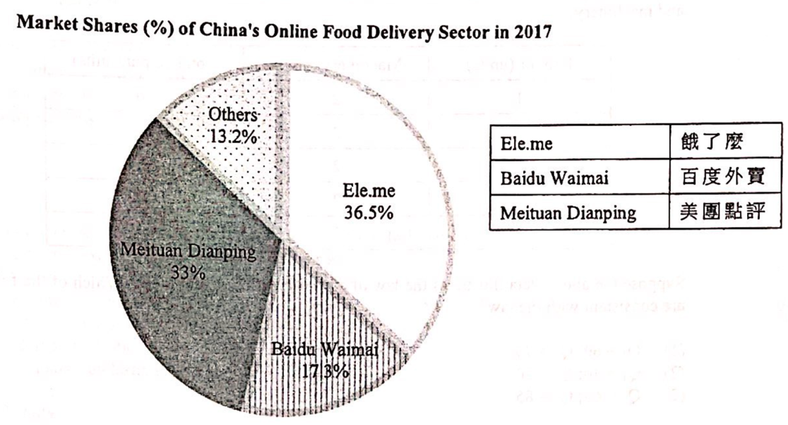
Based on the information in the above diagram, we can conclude that the market structure of online food delivery sector in China in 2017 could be regarded as _______ because ______.
A. monopolistic competition … market information about food delivery services was imperfect
B. monopolistic competition … there were price and non-price competitions among the service provider
C. oligopoly … service providers considered the reactions of other major providers ion making decisions
D. oligopoly … a few service providers had significantly large market shares than others

根據上圖的資料，我們可以得出結論：2017年中國網上食品外送行業的市場結構可被視為 ______，因為
(1) 壟斷性競爭，送餐服務的市場資訊不完全
(2) 壟斷性競爭，服務供應商之間存在價格和非價格競爭
(3) 寡頭壟斷，服務供應商在做決策時考慮了其他主要供應商的反應
(4) 寡頭壟斷，少數服務供應商的市場份額明顯高於其他供應商
A. 只有(1) B. 只有(1)、(2) C. 只有(1)、(3) D. 只有(2)、(3)
2012DSE LQ3a, b, 12a
A telecommunication service provider starts a credit company which offers loans to the public
(a) Explain what type of expansion this is. (2)
(b) List THREE possible motives for the above expansion. (3)
某電訊服務供應商成立一間信貸公司，向公眾提供貸款
(a) 解釋上述情況屬於何種類型的擴張
(b) 列出上述擴張的三個可能動機
_______________________________________________________________________________________
_______________________________________________________________________________________
_______________________________________________________________________________________
_______________________________________________________________________________________
_______________________________________________________________________________________
_______________________________________________________________________________________
_______________________________________________________________________________________
_______________________________________________________________________________________
_______________________________________________________________________________________
The local property market is considered to be overheated.
(c) Most private housing is constructed by serval major property developers in Hong Kong. State the market structure of the private housing market and list TWO features of such kind of market structure. (3)
(c) 香港大部分私人樓宇是由數間主要地產發展商興建。寫出私人樓宇市場的市場結構，並列出這種市場結構的兩項特徵。 (3)
_______________________________________________________________________________________
_______________________________________________________________________________________
_______________________________________________________________________________________
_______________________________________________________________________________________
_______________________________________________________________________________________
_______________________________________________________________________________________
_______________________________________________________________________________________
Marking Scheme:
(a) Conglomerate expansion, because (1)
the firm has expanded into unrelated industries (1)
集團擴張，因為 (1)
該廠商擴張至不相關的行業 (1)
(b) Possible motives:
- To have product or income diversification so as to spread risk / To make use of its brand name of one product in other products / To use resources more efficiently as the two companies can share some of their resources.
- To enjoy economies of scale (e.g. lower average cost of advertising as the total cost can be spread over a larger quantity of output.)
- Any other relevant point (1)
可能的動機：
- 令產品/收入多元化以分散風險 / 將其產品的品牌運用於其他的產品上 / 更有效地運用資源，因為兩件公司可分享部分的資源 / 享有規模經濟（例如廣告的平均成本會下降，因為這項總成本可攤分在更大數量的產出上
(c) Oligopoly (1)
- a few dominating firms / price searcher / interdependence of pricing policies / product can be heterogeneous / non-price competition / not easy to enter the industry / imperfect information
- any other relevant point (1)
寡頭壟斷
- 數間具支配力的廠商 / 尋價者 / 定價策略互相依賴 / 產品可為異質 / 非價格競爭 / 進入該行業並不容易
- 不完全資訊

Candidates’ Performance:
(ab) Good. While most candidates were able to identify the type of expansion, some of them misspelt the key terms. Some mistook conglomerate expansion for expansion to different stages of production. Most candidates showed a good understanding of the motives behind such expansion. Common mistakes included confusion between spreading risk and reducing risk, and wrong argument about enlargement of market share.
(c) Excellent. A minority of candidates misspelt the term ‘oligopoly’, while some imprecisely stated that there are only a few sellers in the market of oligopoly.
(ab) 良好。大多數考生能認出擴張的類型，但有部分串錯了重要字詞。部分考生誤將集團擴張當作向不同生產階段的擴張。大多數考生清楚了解這擴張背後的動機。考生常犯的錯誤包括：混淆分散風險和減低風險，及錯誤地論證市場佔有率上升
(c) 優秀。小部分考生未能正確串出寡頭壟斷的英文（oligopoly），亦有部分考生不準確地指出寡頭壟斷的市場只有數個賣家

2013DSE LQ1
In Hong Kong, there many travel agencies providing tour groups and booking services for air tickets. Give TWO reasons to explain why the market structure of travel agencies in Hong Kong NOT perfect competition is. (4)
香港很多旅行社提供旅行團和機票預訂的服務。舉出兩個原因，解釋為什麼香港旅行社的市場結構不是完全競爭。 (4)
_______________________________________________________________________________________
_______________________________________________________________________________________
_______________________________________________________________________________________
_______________________________________________________________________________________
_______________________________________________________________________________________
_______________________________________________________________________________________
_______________________________________________________________________________________
_______________________________________________________________________________________
Marking Scheme:
Reasons:
- Sellers provide heterogeneous services, e.g. different tour groups
- Market information is imperfect, e.g. information about routes and services
- Sellers engage in both price and non-price competition, e.g. advertisement
- Any other relevant point (2)
原因:
- 賣家提供異質服務，例如不同的旅行團
- 市場資訊並不完全，例如有關路線和服務的資訊
- 賣家進行價格及非價格競爭，例如廣告
- [只批閱首兩項。] (2)
Candidates’ Performance:
- Excellent. Most candidates gave good reasons, and some could even cite relevant real-life examples to support their answer. A few candidates failed to elaborate their answer or relate them to the case in the question when explaining imperfect information in the market.
- 優異。大部分考生提供合理的理由，而部分更引用相關的生活實例加以說明。在解釋市場資訊沒有完全流通時，一些考生未能闡述其答案，又或未能聯繫到題目。

2014DSE LQ4a, b, 2b
Tai Fai Lok Group operates a chain restaurant providing Chinese food.
(a) Tai Fai Lok Group has recently started Fai Lok Institute, which provides professional training for chefs and mangers for Chinese restaurants. To what type of expansion does this belong? Explain your answer. (2)
(b) Explain TWO advantages of such as expansion. (4)
大快樂集團經營連鎖餐廳，提供中式食物
(a) 大快樂集團近日設立了快樂學院，為中式餐廳的廚師和經理提供專業培訓。這屬於哪種擴張？試加以解釋。 (2)
(b) 解釋這擴張的兩個好處 (4)
_______________________________________________________________________________________
_______________________________________________________________________________________
_______________________________________________________________________________________
_______________________________________________________________________________________
_______________________________________________________________________________________
_______________________________________________________________________________________
_______________________________________________________________________________________
(c) Ah Wing runs a store selling mobile phone accessories in Mong Kok. Identify the market structure of mobile phone accessories retailers in Hong Kong. Give TWO reasons to support your answer. (3)
(c) 亞榮在旺角開設一家售賣手提電話配件的店鋪。指出香港的手提電話配件零售商屬於哪種市場結構，舉出兩個理由加以闡述。 (3)
_______________________________________________________________________________________
_______________________________________________________________________________________
_______________________________________________________________________________________
_______________________________________________________________________________________
_______________________________________________________________________________________
_______________________________________________________________________________________
_______________________________________________________________________________________
_______________________________________________________________________________________
_______________________________________________________________________________________
Marking Scheme:
(a) Vertical backward expansion because, by starting Fai Lok Institute, Tai Fai Lok Group has expanded its operation vertically backward to the previous stage of production to control directly the supply of factor inputs (chefs and managers) to its original (food) business. (2)
縱向後向擴張。因為大快樂集團藉成立快樂學院將業務擴展至上一階段的生產以直接控制原來業務（食品）的要素投入（廚師和經理）。 (2)
(b) Advantages:
- More steady supply of factor inputs such as chefs and managers / Better use of the brand name
- Program can be tailor-made for those graduates from the Institute who are hired to work in the Group’s restaurant, so as to shorten their training time (2)
好處：
- 要素投入的供應較穩定，例如廚師或經理 / 善用品牌效應
- 可設計配合自己業務的課程，故此聘用該學院畢業生時可減少訓練時間 (2)
(c) Monopolistic competition (1)
- Many sellers or no dominant sellers / Sellers selling heterogeneous products / Free entry into the market
- Any other relevant point (1)
壟斷性競爭
- 有很多賣家或沒有具支配力的賣家 / 賣家售賣異質的物品 / 自由進出市場
- 任何其他相關點
Candidates’ Performance:
(a) Good. A majority of candidates got the correct answer, though some failed to support the type of expansion with good reasons. Instead of expressing their answers explicitly in terms of the previous stage of production, they merely copied from the stem to argue that Tai Fok Institute is a backward expansion because it "provides professional training for chefs and managers for Chinese restaurants."
(b) Good. Many candidates related the case to the motives they suggested.
(c) Fair. Most candidates realized that they should not give examples of fixed cost in their answers. But many of them chose to provide examples of variable factors, such as electricity and part-time workers, instead of variable cost. Among those who were able to give a correct example, some did not explain how cost varies with output.
(a) 大部分考生知道正確答案，但是部分未能提供些好的理由支持這種擴張。考生沒有明確寫出「上一階段生產，卻只在題目中抄寫『快樂學院為中式餐廳提供專業的廚師和經理訓練」作為快樂學院是縱向後向擴張的理據。
(b) 良好。很多考生能寫出他們提供的動機和該個案的關係。
(c) 尚可。大部分考生知道他們不應舉出固定成本例子作答。但是很多考生選擇寫出可變要素的例子，例如電力和兼職員工而不是可變成本。在能夠寫出正確例子的考生中，部分沒有解釋成本如何隨著產量上升。

2015DSE LQ9b, c
McDonald’s is one of the major fast food chains in Hong Kong.
(a) McDonald’s has expanded its business by operating McCafé, which sells premium coffee like other coffeehouses such as Starbucks. To which type of expansion does this belong? Explain. (2)
(b) The price of a cup of Espresso in McCafé is lower than that in Starbucks. Suggest TWO possible reasons to explain why there is such a price difference. (4)
(a) 麥當勞把業務擴展至經營咖啡館McCafe，有如星巴克等咖啡館一樣出售優質咖啡。這屬於哪一類擴張？試加以解釋。 (2)
(b) 一杯意大利濃咖啡的價格在 McCafe 比在星巴克低。提出兩個可能原因，解釋為什麼有這樣的價格差異。 (4)
_______________________________________________________________________________________
_______________________________________________________________________________________
_______________________________________________________________________________________
_______________________________________________________________________________________
Marking Scheme:
(a) Lateral expansion, (1)
As fast food and coffee are related but not directly competitive products (1)
側向擴張， (1)
因為快餐和咖啡屬相關產品但並不直接競爭 (1)
(b) Possible reasons:
- lower-quality coffee / lower production cost / less pleasant environment / less attractive brand name
- Any other relevant point (2)
(b) 可能原因:
- 咖啡質素較低 / 生產成本較低 / 環境較差 / 品牌欠吸引 (2)
Candidates’ Performance:
(a) Good. Most candidates were able to identify the type of expansion and give a correct explanation
(b) Good. Many candidates gave well-reasoned explanations for the lower price charged by McCafe. A minority overlooked keywords in the question and only offered such reasons for the price difference as costs and/or qualities without actually comparing the cost quality difference between Starbucks and McCafe.
(a) 良好。大部分考生能辨別並正確解釋該擴張類型
(b) 良好。很多考生對McCafe所收取的低價有圓滿的解釋。有小部分考生忽略了題目的關鍵詞，沒有實際地比較星巴克和McCafe 的成本 / 素質分別，只是以成本 / 素質有差別作為價格有差別的原因

2016DSE LQ10a
Solar energy becomes an increasingly important energy source in the sunny western provinces, like Gansu and Xinjiang, in China. The diagram below shows the market shares of Top 10 solar photovoltaic (PV) module manufacturers in 2012.
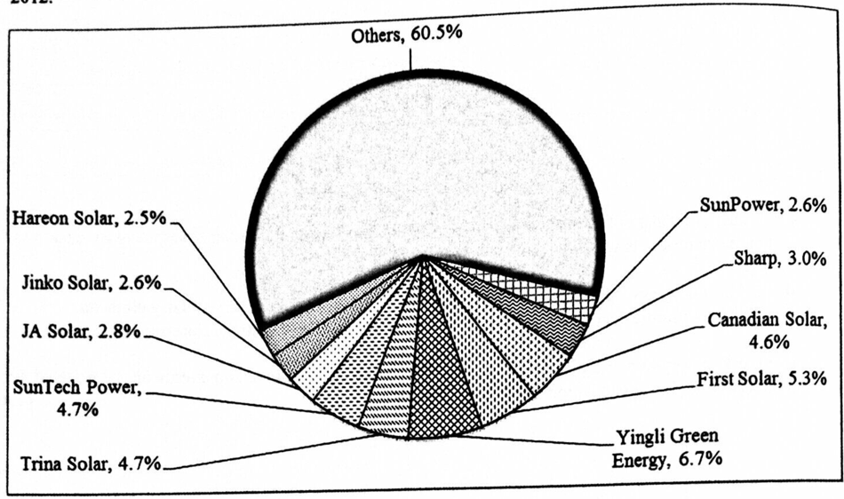
What was the market structure of the above solar PV module market? List TWO features of this market structure. (3)
在中國西部陽光充沛的省份，如甘肅和新疆，太陽能成為日益重要的能源。下圖顯示十大太陽能光電（PV）模板製造商於2012年的市場佔有率。
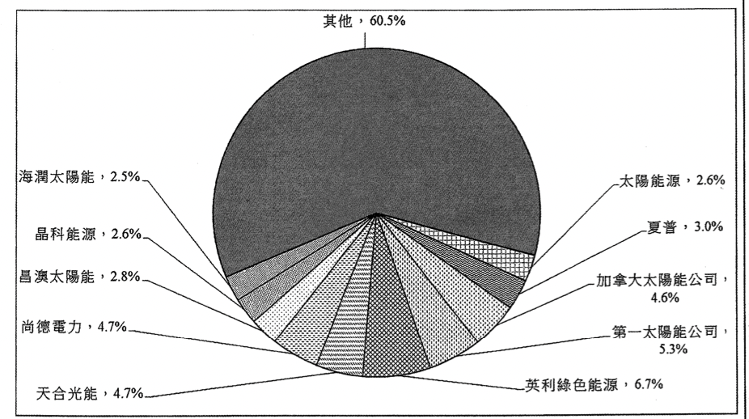
上述太陽能光電模板的市場屬哪種市場結構？列出該市場結構的兩項特點。 (3)
_______________________________________________________________________________________
_______________________________________________________________________________________
_______________________________________________________________________________________
_______________________________________________________________________________________
Marking Scheme:
Monopolistic competition. (1)
Features:
- Many sellers
- Price searchers
- (slightly) differentiated products
- Non-price competition
- Imperfect information
- Any other relevant point (1)
[Mark the FIRST TWO points only.]
壟斷性競爭 (1)
特點：
- 許多賣家
- 尋價者
- （少許）異質的商品
- 非價格競爭
- 市場資訊不完全
- 任何相關點
【只批閱首兩項】 (1)

Candidates’ Performance:
Good. Many candidates stated correctly the market structure of the industry. However, some candidates wrongly focused on
the top 10 manufacturers (whose market shares were actually rather small) and gave oligopoly as their answer. Confusing
terms such as “monopoly competition”, “monopolistic” and “competitive monopoly” were found in some of the answers.
良好。很多考生正確寫出該行業的市場結構。不過，一些考生錯誤地把焦點放在十大製造商（它們的市場佔有率其
實不大）而以寡頭壟斷作答。一些答案中出現混淆的術語，例如：「壟斷競爭」、「壟斷性」、「競爭性壟斷」

2017DSE LQ3
Refer to the following chart.
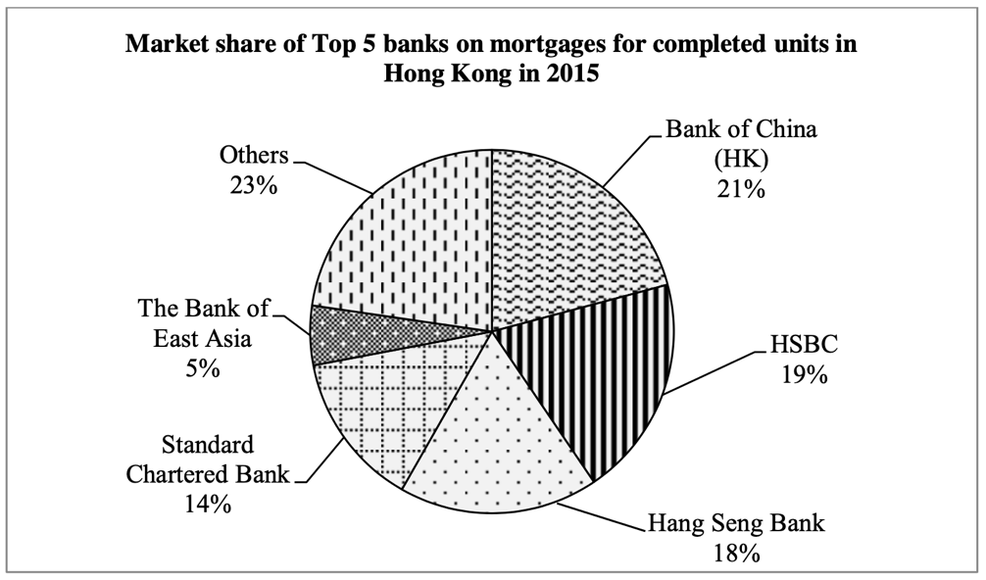
What was the market structure of the above market in 2015? List TWO features of this market structure. (3)
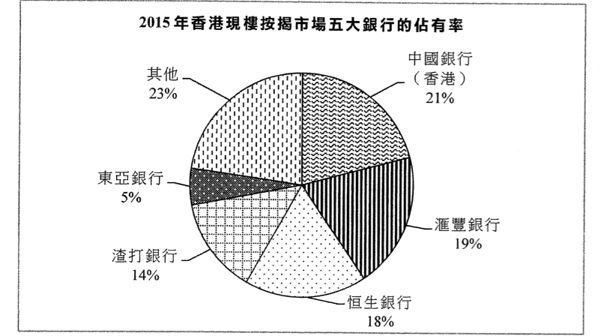
以上市場在2015年屬哪種市場結構？列出這市場結構的兩項特徵。 (3)
_______________________________________________________________________________________
_______________________________________________________________________________________
_______________________________________________________________________________________
_______________________________________________________________________________________
_______________________________________________________________________________________
_______________________________________________________________________________________
_______________________________________________________________________________________
Marking Scheme:
Oligopoly. (1)
Features:
- several dominant firms
- entry barrier
- interdependent pricing strategies
- imperfect market information
- Any other relevant point (1)
[Mark the FIRST TWO features only.]
寡頭壟斷 (1)
特徵：
- 有數間具支配性的廠商
- 進入市場有障礙
- 互相影響的價格策略
- 不完全的市場資訊
- 任何其他相關點 (1)
「只批閱首兩項特徵」

Candidates’ Performance:
Good. A small number of candidates failed to accurately write the term "oligopoly".
良好。有小部分考生未能準確寫出「寡頭壟斷」 這術語。

2018DSE LQ12a
Tourism is one of the ‘pillar industries’ in Hong Kong
Source 1 : search result from a hotel booking website
Hotel A  Tsim Sha Tsui East,  Kowloon | 30 square metres  2 Twin Beds | Free cancelling | Book now !  HK$2100  OR  RMB¥1750
Hotel B  Tsim Sha Tsui East,  Kowloon | 32 square metres  2 Twin Beds  Free WIFI | Non-refundable | Book now !  HK$2040  OR  RMB¥1700
With reference to Source 1, give TWO reasons to explain why the market structure of Hong Kong’s hotel industry is NOT perfectly competitive. (4)

旅遊業是本港其中一項「支柱產業」
資料1:從某預訂酒店網站上搜尋的結果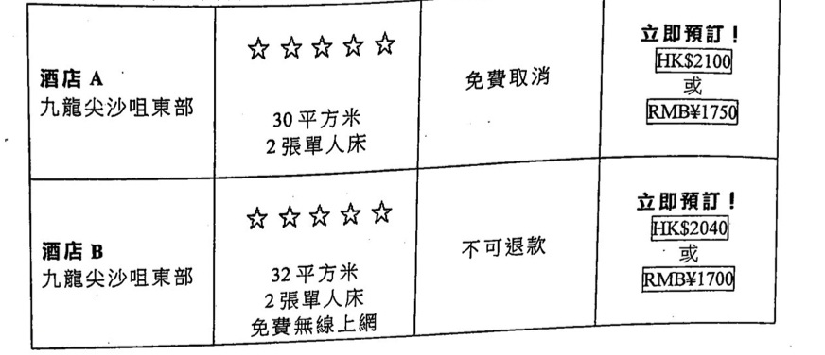
參考資料一，提出兩項理由解釋為什麼香港酒店業的市場結構不屬於完全競爭 (4)
_______________________________________________________________________________________
_______________________________________________________________________________________
_______________________________________________________________________________________
_______________________________________________________________________________________
_______________________________________________________________________________________
_______________________________________________________________________________________
Marking Scheme:
Reasons:
- Sellers provide heterogeneous services, e.g. room with different size/features
- Market information is imperfect, e.g. information about the quality services
- Price searcher / under competition there are different prices, e.g. different hotels charge different rooms rates for similar rooms.
- Any other relevant points (2)
原因：
- 賣家提供異質服務，例如提供不同大小和特色的房間
- 市場資訊並不完全，例如有關服務素質的資訊
- 尋價者 / 在競爭下出現不同的價格，例如不同酒店所提供的房間收取不同價錢。
- 任何其他相關點 (2)

Candidates’ Performance:
Good. Most candidates were able to make use of the information provided as evidence to illustrate why the market for hotel services is not perfectly competitive.
良好。大部分考生能利用所提供的資料作為論據，以解釋為何酒店服務市場並非完全競爭。

2019DSE LQ9b
A beauty queen in Hong Kong, Miss Amy Au, is famous for demonstrating the use of cosmetic products with short videos on social media websites. She also sells Japanese cosmetic products on her website. Apart from Japanese cosmetic products, she starts to sell Korean cosmetic products on her website. To what type of expansion does this belong? Give TWO possible reasons for this type of expansion. (3)
歐愛美小姐是香港選美冠軍，她以在社交媒體網站展示化妝品的使用示範短片而聞名。她也在自己的網站售賣日本化妝品。除了日本化妝品，她開始在其網站售賣韓國化妝品，這屬哪類擴張？舉出這種擴張的兩個可能原因。 (3)
_______________________________________________________________________________________
_______________________________________________________________________________________
_______________________________________________________________________________________
_______________________________________________________________________________________
_______________________________________________________________________________________
_______________________________________________________________________________________
Marking Scheme:
Horizontal expansion. (1)
Reasons:
- Enlarge the market share / Enjoy economies of scale / Make use of the brand name
- Any other relevant point (1)
橫向擴張 (1)
原因：
- 擴大市場佔有率 / 享有規模經濟 / 利用品牌效應
- 任何其他相關點

Candidates’ Performance:
Good. Lateral expansion is an acceptable answer as candidates may consider products from Japan and Korea not being substitutable. Some candidates got the key features of different kinds of expansions mixed up. They erroneously related increase in market share to lateral expansion, and market diversification to horizontal expansion.
良好，考生可能認為日本和韓國的產品不可互相替代，因此側向擴張亦是一個可接受的答案。部分考生混淆了不同種類的擴張的主要特徵，他們錯誤地指出側向擴張與增加市場佔有率有關，或橫向擴張與市場多元化有關。

2020DSE LQ9a
Ocean Park and Hong Kong Disneyland are the two large theme parks in Hong Kong. What is the market structure of the theme park industry in Hong Kong? List TWO features of this market structure. (3)
海洋公園和香港迪士尼是香港兩大主題公園。香港的主題樂園行業屬於哪種市場結構？列出這種市場結構的兩項特徵。 (3)
_______________________________________________________________________________________
_______________________________________________________________________________________
_______________________________________________________________________________________
_______________________________________________________________________________________
_______________________________________________________________________________________
_______________________________________________________________________________________
_______________________________________________________________________________________
Marking Scheme:
Oligopoly. (1)
Features:
- a few dominant sellers
- interdependency of pricing
- price and non-price competition
- Any other relevant point (1)
[Mark the FIRST TWO features only.]
寡頭壟斷 (1)
特徵：
- 幾個具支配力的賣家
- 訂價互相影響
- 價格及非價格競爭
- 任何其他相關點 (1)
Candidates’ Performance:
Good. The only problem was that a minority of candidates misspelled the term ‘oligopoly’ or created a term like ‘oligopoly competition’.
良好。唯一問題是少數考生書寫「寡頭壟斷」一詞時出錯，或者自創了「寡頭壟斷性競爭 」之類的新詞語

2021DSE LQ4
Give TWO reasons to explain why the smartphone market is NOT perfectly competitive. (4)
提出兩個理由，解釋為什麼智能電話市場不是完全競爭的。 (4)
_______________________________________________________________________________________
_______________________________________________________________________________________
_______________________________________________________________________________________
_______________________________________________________________________________________
_______________________________________________________________________________________
_______________________________________________________________________________________
_______________________________________________________________________________________
_______________________________________________________________________________________
_______________________________________________________________________________________
Marking Scheme:
Reasons:
- Sellers provide heterogeneous goods, e.g. smartphones with different specifications
- There exists non-price competition, e.g. advertisement
- Market information is imperfect, e.g. information about the performance of the smartphones
- Any other relevant point (2)
[Mark the FIRST TWO points only]
理由：
- 賣家提供異質物品，例如不同規格的智能電話
- 出現非價格競爭，例如廣告
- 市場資訊並不完全，例如智能電話的資訊
- 其他相關點 (2)
Candidates’ Performance:
Good. Some candidates simply described the characteristics of an oligopoly (e.g. imperfect information) without relating their answers to the smartphone market. A few candidates mis-asserted that price competition does not exist in perfectly competitive markets.
良好，部分考生知識描述寡頭競爭的特徵（例如資訊不完全）卻沒有將其答案連繫到智能電話市場。少數考生錯誤地認為在完全競爭市場中價格競爭並不存在

Marking Scheme:
Type 1 (The Objectives and Expansion of Firms)
1 | B | 2 | A | 3 | A | 4 | A | 5 | B | 6 | D | 7 | D | 8 | A | 9 | D | 10 | C
11 | A | 12 | A | 13 | A | 14 | A | 15 | B | 16 | D | 17 | D | 18 | C | 19 | D | 20 | D
21 | A | 22 | A | 23 | C | 24 | C | 25 | B | 26 | A | 27 | A | 28 | B | 29 | C | 30 | A
31 | B | 32 | C | 33 | C | 34 | C | 35 | B | 36 | D | 37 | A | 38 | D | 39 | C | 40 | B
41 | C | 42 | C
Type 2 (Market structure)
1 | D | 2 | A | 3 | D | 4 | D | 5 | C | 6 | A | 7 | B | 8 | C | 9 | C | 10 | A
11 | D | 12 | C | 13 | C | 14 | D | 15 | D | 16 | C | 17 | B | 18 | B | 19 | B | 20 | D
21 | A | 22 | C | 23 | B | 24 | D | 25 | C | 26 | D | 27 | B | 28 | B | 29 | D | 30 | A
31 | D | 32 | B | 33 | D | 34 | B | 35 | D | 36 | B | 37 | D | 38 | D | 39 | D | 40 | B
41 | C | 42 | A | 43 | C | 44 | C | 45 | D | 46 | C | 47 | C | 48 | A | 49 | A | 50 | D
51 | D

