Learning Focus:
Memo
(LQ Answering Flow, MC skills, your goals and resolutions…)
Specific Question Type
MC

咩話？DSE Sample Paper, Practice Paper, 2012, 2013, 2014, 2015, 2016, 2017, 2018, 2019, 2020, 2021, 2022
MC全部拍晒解題片？係呀，有唔明即scan即睇！就係咁firm！


Learning Focus:
Memo
(LQ Answering Flow, MC skills, your goals and resolutions…)
Specific Question Type
LQ

咩話？DSE Sample Paper, Practice Paper, 2012, 2013, 2014, 2015, 2016, 2017, 2018, 2019, 2020, 2021, 2022
LQ全部拍晒解題片？係呀，有唔明即scan即睇！就係咁firm！


Chapter 14 _ employment, Inflation, Business cycle
Type 1 (Whether included in employment, unemployment, labour force…)
Example Question 1 CE1994MCQ37
Which of the following people would be classified as ‘unemployed’ in Hong Kong?
A. Jack, aged 30, who has retired after winning the mark six.
B. Peter, aged 14, who cannot find a job after completing form three.
C. John, who has quit his job and has gone on a trip to Europe.
D. Mary, who lost her job five weeks ago and has been looking for a new job for one month.

在香港，下列何者被歸類為「失業」？
A. 積克，30歲，在贏取六合彩後便退了休。 B. 彼得，14歲，中三畢業後仍未找到工作。
C. 約翰辭去工作，現正去歐洲旅行。 D. 瑪麗於五周前失去工作，過去一個月內她不斷尋找新的工作。

Example Question 2 CE1996MCQ33
David has quit his job for two months because he has been ill and is resting in bed. According to the Hong Kong government, he is
A. unemployed B. underemployed. C. employed. D. not in the labor force.

小明辭去他的工作已有兩個月，因為他病了，一直卧床休息。香港政府現時將他視為下列哪一類？
A. 失業。 B. 就業不足。 C. 就業。 D. 不在勞動力行列之內。

Example Question 3 CE1998MCQ24
Which of the following are included in the calculation of the labour force of Hong Kong?
(1) an employee with a foreign nationality working in a law firm in Hong Kong.
(2) Mr. Chan, who is unemployed and searching for a job.
(3) Mr. Wong, who works as a volunteer in a community center after his retirement.
A. (1) and (2) only B. (1) and (3) only C. (2) and (3) only D. (1), (2) and (3)

下列何者計算在香港的勞動人口中？
(1) 在香港某律師樓工作的外籍僱員。
(2) 失業的陳先生正在尋找工作。
(3) 王先生退休後在社區中心當義工。
A. 只有(1)、(2) B. 只有(1)、(3) C. 只有(2)、(3) D. (1)、(2) 、(3)

Type 2 (Calculation of employment rate / unemployment rate)
Example Question 1 CE1997MCQ26
Study the following data about Hong Kong in a certain year: 細閱下列某年關於香港的資料：
 | Numbers of persons |  |  | 人數
Employed Population | 2 931 000 |  | 就業人數 | 2 931 000
Underemployed Population | 33 000 |  | 就業不足人數 | 33 000
Unemployed | 69 000 |  | 失業人數 | 69 000
The unemployment rate is
A. 2.27% B. 2.30% C. 3.36% D. 3.40%

失業率是
A. 2.27% B. 2.30% C. 3.36% D. 3.40%

Example Question 2 CE2002MCQ29
 | Numbers of persons |  |  | 人數
Population aged 15 or above | 10 000 000 |  | 15歲或以上人口 | 10 000 000
Employed Population | 6 800 000 |  | 就業人口 | 6 800 000
Unemployed population | 1 200 000 |  | 失業人口 | 1 200 000
Underemployed population | 800 000 |  | 就業不足人口 | 800 000

According to the above table, which of the following statements is/are correct?
(1) The labour force amounts to 8 000 000.
(2) The underemployment rate is 10%.
(3) The unemployment rate is 12%.
A. (3) only B. (1) and (2) only C. (1) and (3) only D. (2) and (3) only

根據上表，下列哪項描述是正確的？
(1) 勞動人口總數是8 000 000。
(2) 就業不足率是10%。
(3) 失業率是12%。
A. 只有(3) B. 只有(1)、(2) C. 只有(1)、(3) D. 只有(2)、(3)

Example Question 3 CE2003MCQ30
Study the following data about Hong Kong in the period of July 2002 to September 2002.
 | Numbers of persons |  |  | 人數
Employed Population | 3 243 000 |  | 就業人數 | 3 243 000
Underemployed population | 101 000 |  | 就業不足人數 | 101 000
Unemployed population | 267 000 |  | 失業人數 | 267 000
The unemployment rate is
A. 7.4% B. 7.6% C. 8.2% D. 10.2%
該期間內的失業率是
A. 7.4% B. 7.6% C. 8.2% D. 10.2%

Example Question 4 CE2004MCQ33
 | Numbers of persons |  |  | 人數
Employed Population | 18 400 |  | 就業人口 | 18 400
Underemployed population | 1 600 |  | 失業人口 | 1 600
Now there are 1 000 additional job seekers in the economy. If 90% of them succeed in finding a job, the unemployment rate
A. will increase. B. will decrease. C. will remain unchanged. D. may increase or decrease.

現有1000名新增加的尋找工作的人。若其中90%的人成功尋獲工作，該經濟的失業率
A. 會增加。 B. 會減少。 C. 會不變。 D. 可能增加亦可能減少。

Example Question 5 CE2005MCQ32
 | Numbers of persons |  |  | 人數
Aged 15 or above | 10 000 000 |  | 15歲或以上人口 | 10 000 000
Employed | 6 800 000 |  | 就業人口 | 6 800 000
Unemployed | 1 200 000 |  | 失業人口 | 1 200 000
Underemployed | 1 600 000 |  | 就業不足人口 | 1 600 000

According to the above data,
A. the total labour force is 9 600 000 B. the underemployment rate is 20%
C. the unemployment rate is 12.5% D. the unemployment rate is 16%

根據以上資料，
A. 勞動人口總數是9 600 000。 B. 就業不足率是20%。
C. 失業率是12.5%。 D. 失業率是16%。

Example Question 6 CE2006MCQ30
Suppose the unemployed population of an economy is 500 000 while the unemployment rate is 5%. The employed population is
A. 500 000 B. 1 000 000 C. 9 500 000 D. 10 000 000

假設某經濟的失業人口是500 000而失業率是5%。就業人口是
A. 500 000 B. 1 000 000 C. 9 500 000 D. 10 000 000

Example Question 7 CE2008MCQ30
Study the following figure of an economy
 | Numbers of persons |  |  | 人數
Unemployed | 20 000 |  | 失業人口 | 20 000
Underemployed | 60 000 |  | 就業不足人口 | 60 000
Employed | 480 000 |  | 就業人口 | 480 000
Person aged 15 or above | 1 000 000 |  | 15歲或以上人口 | 1 000 000
The unemployment rate of the economy is ___________ .
A. 2.0% B. 3.7% C. 4.0% D. 4.17%

該經濟的失業率是 __________。
A. 2.0% B. 3.7% C. 4.0% D. 4.17%

Example Question 8 DSE2012MCQ24
Many Hong Kong construction workers stay in Macau to work for serval years. If they are attached by the job opportunities offered by new infrastructure projects in Hong Kong and return to seek jobs, what will be the effect on the unemployment rate in Hong Kong?
A. The unemployment rate will increase. B. The unemployment rate will decrease.
C. The unemployment rate will remain unchanged. D. The effect on the unemployment rate cannot be determined.

許多香港建築工人留在澳門工作數年。若他們受香港新的基建工程所提供的就業機會所吸引，回港尋找工作，這對香港的失業率會有甚麼影響？
A. 失業率會上升。 B. 失業率會下降。
C. 失業率會維持不變。 D. 對失業率的影響未能確定。

Example Question 9 DSE2019MCQ24
The following table shows the data of an economy.
 | Numbers of persons |  |  | 人數
Population aged 15 or above | 6 500 000 |  | 15歲或以上的人口 | 6 500 000
Labour force participation rate* | 60% |  | 勞動人口參與率* | 60%
Employed population | 3 780 000 |  | 就業人口 | 3 780 000
Underemployed population | 100 000 |  | 就業不足人口 | 100 000
*Labour force participation rate = proportion of labour force *勞動人口參與率= 15歲或以上的人口中勞動人口所佔比例
in population aged 15 or above
Based on the above data, the unemployment rate of the economy is _____.
A. 1.85% B. 3.08% C. 3.38% D. 5.64%

根據以上資料，該經濟的失業率是_____。
A. 1.85% B. 3.08% C. 3.38% D. 5.64%

Example Question 10 DSE2020MCQ24
The following table shows the employment data of Hong Kong from April to June in 2019.
下表顯示2019年4至6月本港的就業數據。
 | Numbers of persons (‘000) |  |  | 人數 (‘000)
Population | 7524 |  | 人口 | 7524
Aged 15 or above | 6590 |  | 15歲或以上人士 | 6590
Employed persons | 3871 |  | 就業人口 | 3871
Unemployed persons | 114 |  | 失業人口 | 114
Underemployed persons | 41 |  | 就業不足人口 | 41
According to the above data, the underemployment rate is
A. 0.55% B. 0.62% C. 1.03% D. 1.06%

根據以上數據，就業不足率是_____。
A. 0.55% B. 0.62% C. 1.03% D. 1.06%

Example Question 11 DSE2021MCQ25
Suppose the unemployment rate of an economy is 8%. Which of the following would increase the
unemployment rate?
(1) 15% of the new graduates could not find jobs successfully.
(2) Some employers closed down their local businesses and migrated to other countries.
(3) Some of the part-time workers lost their job due to automation of production.
A. (1) and (2) only B. (1) and (3) only C. (2) and (3) only D. (1), (2) and (3)

假設某經濟的失業率是8%。下列哪些會令失業率上升？
(1) 15%的新畢業生未能成功找到工作。
(2) 一些僱主結束其本地業務並移居外國。
(3) 一些兼職的工人因為生產自動化而失去工作。
A. 只有(1)、(2) B. 只有(1)、(3) C. 只有(2)、(3) D. (1)、(2)及(3)

Type 3 (Cost of unemployment)
Example Question 1 CE1995MCQ37
Which of the following are the possible losses to society caused by unemployment?
(1) loss of output
(2) a higher crime rate
(3) a greater expenditure in public assistance
(4) a reduction in the government’s tax revenue
A. (1) and (2) only B. (1) and (3) only C. (2) and (4) only D. (3) and (4) only

下列各項中，哪些是因失業而可能導致的社會的損失？
(1) 產出的損失
(2) 犯罪率較高
(3) 公共援助支出較大
(4) 税收下降
A. 只有(1)及(2) B. 只有(1)及(3) C. 只有(2)及(4) D. 只有(3)及(4)

Example Question 2 CE2002MCQ31
Which of the following are possible losses to a society cause by unemployment?
(1) more government spending on public security due to a higher crime rate
(2) more unemployment assistance given by the government
(3) lower output level
(4) lower cost of living
A. (1) and (3) only B. (2) and (4) only C. (1), (2) and (3) only D. (2), (3) and (4) only

下列哪幾項有可能是失業對社會造成的損失？
(1) 由於犯罪率上升，政府為保障公眾部門安全而增加支出
(2) 政府提供更多失業援助
(3) 產出水平下降
(4) 生活費用下降
A. 只有(1)、(3) B. 只有(2)、(4) C. 只有(1)、(2)及(3) D. 只有(2)、(3)及(4)

Example Question 3 CE2007MCQ30
Unemployment is costly to society because
A. the employed will pay more tax. B. the potential GDP will fall.
C. the real output of the economy will fall. D. unemployment benefit is a burden to society.

社會要為失業付出代價，因為
A. 就業人士要繳付更多税款。 B. 潛在本地生產總值會下降。
C. 經濟的實質產出會下降。 D. 失業救濟會是社會的一種負擔。

Type 4 (Inflation and deflation)
Example Question 1 CE1990MCQ56
When both the price level and the money income level of a society rise,
A. the living standard will drop because the value of money decreases.
B. the living standard will rise because the citizens have more money to spend.
C. the living standard will not change because the rise in income is offset by the rise in price.
D. the effect on the living standard is not certain because the extent of both changes is unknown.

當物價水平和名義收入水平都上升時，
A. 生活水準會下降，因為貨幣價值下跌。
B. 生活水準會上升，因為市民有較多貨幣使用。
C. 生活水準維持不變，因為物價的上升和收入的增加互相抵銷。
D. 對生活水準的影響未確定，因為未知兩者改變的幅度。

Example Question 2 CE1991MCQ46
What will happen when there is inflation?
A. The cost of living will fall. B. The budget deficit will decrease.
C. The living standard will improve. D. The value of money will decrease.

通脹發生時會出現以下哪一項情況？
A. 生活成本會減少。 B. 財政赤字會減少。
C. 生活水準會有所改善。 D. 貨幣價值會下跌。

Example Question 3 CE1997MCQ31
An increase in the GDP deflector from 100 to 110 in a certain year means that
A. every household's cost of living has increased by 10%
B. the general price level has increased by 10%
C. the prices of all goods produced in the current year have increased by 10%
D. people's nominal incomes have increased by 10%

某年，本地生產總值平減指數由100上升至110，這意味
A. 每個家庭的生活成本增加了10%。 B. 一般物價水平上升了10%。
C. 當年生產的全部貨物的價格都上升了10%。 D. 市民的名義收入增加了10%。

Example Question 4 CE1999MCQ33
Study the figure below concerning the changes in the Consumer Price Index. Study the figure below concerning the changes in the Consumer Price Index. 參閲下表中消費物價指數的改變。
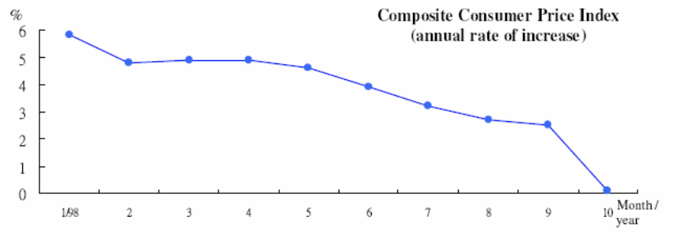
月/年
綜合消費物價指數（年增長率）
From the figure, we can conclude that
A. inflation has stopped as prices go down.
B. wages have decreased.
C. the cost of living has been rising at a slower rate.
D. some debts who purchased mortgages on flats recently have suffered a loss.

由上表，我們可得以下結論：
A. 物價持續下跌，通脹終止。 B. 工資下降。
C. 生活費用以較慢的速度增長。 D. 部分用按揭方法借錢供樓的負債者近期蒙受損失。

Example Question 5 CE2005MCQ34
Refer to the following diagram about the GDP deflator of Hong Kong from January 2000 to September 2004.
參閲下列關於香港於2000年1月至2004年9月期間的本地生產總值平減物價指數的圖。
本地生產總值平減物價指數
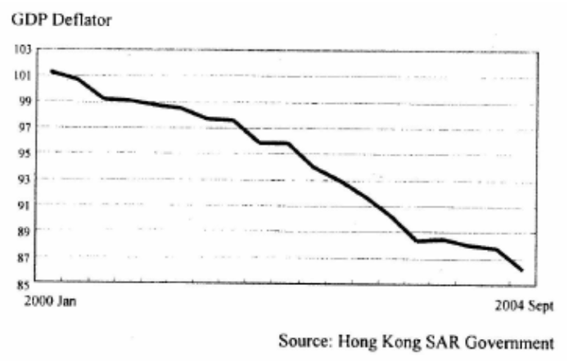
資料來源：香港特區政府
2004年9月
2000年一月
Based on the above diagram, we can conclude that during this period,
A. the nominal GDP was decreasing B. the real GDP was decreasing
C. the cost of living was increasing D. the purchasing power of money was increasing

根據上圖，我們可得出結論如下：在該期間，
A. 名義本地生產總值正在減少。 B. 實質本地生產總值正在減少。
C. 生活成本正在增加。 D. 貨幣購買力正在增加。
Example Question 6 CE2006MCQ31
The Consumer Price Index(A) of Hong Kong in the third quarter of 2005 has increased. This means that ________________ in Hong Kong has increased
A. the price of all goods B. the price of imported goods C. the nominal national income D. the cost of living

香港於2005年第三季的甲類消費物價指數上升了。這表示香港的_____上升了。
A. 全部貨品的價格 B. 進口貨品的價格 C. 名義國民收入 D. 生活成本

Example Question 7 CE2007MCQ33
Which of the following statements about inflation is correct?
A. A continuous increase in the price of a good is not inflation
B. During inflation, everyone suffers to the same extent
C. During inflation, incomes and prices increase at the same rate
D. Inflation may benefit some people, particularly those people whose incomes are fixed

下列哪一項對通脹的描述是正確的？
A. 一件物品的價格持續上升並非通脹。 B. 通脹發生時，每個人的損失都相同。
C. 通脹發生時，收入和物價都以相同的百分比增加。 D. 通脹可能使某些人得益，尤其是那些收入是固定的人。

Example Question 8 CE2007MCQ34
Refer to the following information about the composite consumer price index of Hong Kong. Based on the above information, we can conclude that during this period in 2006,
下表顯示香港綜合消費物價指數的資料。
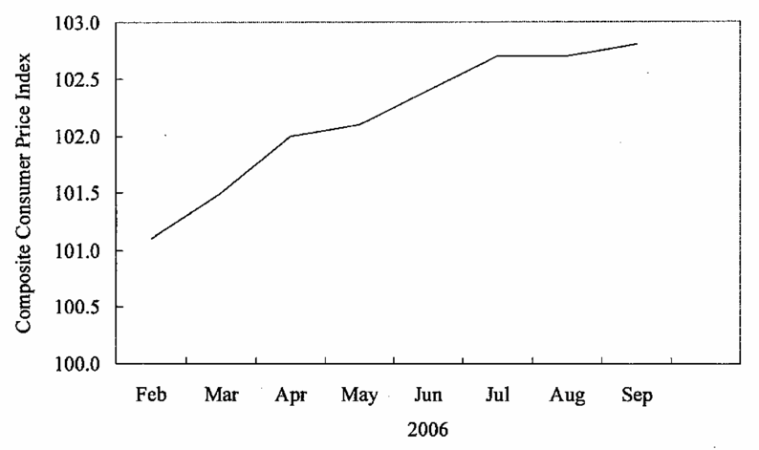
二月 三月 四月 五月 六月 七月 八月 九月
綜合消費物價指數
A. the nominal GDP was falling B. the nominal GDP was increasing
C. the purchasing power of money was falling D. the purchasing power of money was increasing

我們可從上述資料得出如下結論：在2006年該段時間內，
A. 名義本地生產總值正在下降。 B. 名義本地生產總值正在上升。
C. 貨幣的購買力正在下降。 D. 貨幣的購買力正在上升。
Example Question 9 CE2008MCQ33
The following table shows the Consumer Price Index (A) of Hong Kong from 2004 to 2006.
下表顯示香港從2004年至2006年的甲類消費物價指數。
Year年份 | Consumer Price Index (A) 甲類消費物價指數
2004 | 99.3
2005 | 100.3
2006 | 102.1
Based on the above table, we can conclude that during this period of time,
A. the per capital nominal GDP has increased B. the living standard has worsened
C. the cost of living has increased D. all of the above are correct
根據上表，我們可得結論如下，在該時期內，
A. 人均名義本地生產總值上升了。 B. 生活水準變差了。
C. 生活成本增加了。 D. 以上全部正確。

Example Question 10 CE2009MCQ33
When inflation is expected,
(1) Creditors will charge the debtors a higher nominal interest rate.
(2) Workers will request for a raise in their nominal wage rates.
(3) People will tend to hold more monetary assets instead of real assets.
A. (1) and (2) only B. (1) and (3) only C. (2) and (3) only D. (1), (2) and (3)

人們預期通脹時，
(1) 債主會向借款者收取更高的名義利率。
(2) 工人會要求提高他們的名義工資率。
(3) 人們會傾向持有更多貨幣性資產來取代實質資產。
A. 只有(1)、(2) B. 只有(1)、(3) C. 只有(2)、(3) D. (1)、(2)、(3)

Example Question 11 CE2009MCQ34
When the consumer price index of an economy increases from 100 to 110, it implies that
A. The prices of all consumer goods involved in the calculation of the index increased by 10%.
B. The cost of living has increased.
C. The standard of living has increased. D. People’s nominal income has increased.

某經濟的消費物價指數由100上升至110，這意味着：
A. 計算該指數中涉及的全部消費品的價格都上升了10%。 B. 生活費用增加了。
C. 生活水準提高了。 D. 人們的名義收入增加了。
Example Question 12 CE2011MCQ35
When inflation is expected,
(1) People will tend to hold more real assets instead of monetary assets.
(2) Employees will ask for an increase in their nominal wage rates to compensate for their loss of purchasing power.
(3) Creditors will gain and debtors will lose because the purchasing power of repayments will decrease.
A. (1) and (2) only B. (1) and (3) only C. (2) and (3) only D. (1), (2) and (3)

當人們預期有通脹出現，
(1) 人們會傾向增持實質資產以代替貨幣資產。
(2) 僱員會要求僱主提高他們的名義工資率，以補償他們損失了的購買力。
(3) 債主會得益，而欠債人會受損，因為所還款項的購買力會下降。
A. 只有(1)、(2) B. 只有(1)、(3) C. 只有(2)、(3) D. (1)、(2)、(3)

Example Question 13 DSESPMCQ34
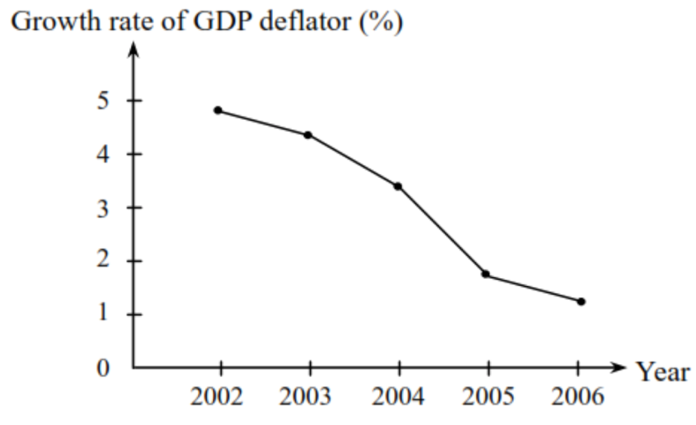
年份
本地生產總值平減指數增長率（%）
The above diagram shows that during the period
A. there is deflation in the economy. B. the growth rate of money stock is negative.
C. the general price level is rising. D. the standard of living is rising.

上圖顯示，在該段時期
A. 該經濟有通縮。 B. 貨幣供應量增長率為負數。
C. 一般物價水平正在上升。 D. 生活水準正在上升。

Example Question 14 DSE2014MCQ40
Which of the following statements about inflation is/are correct?
(1) Inflation occurs when the government handouts a large sum of cash to every citizen in a certain year.
(2) Inflation redistributes wealth from lenders to debtors if it is anticipated.
(3) People prefer holding real assets to cash under expected inflation.
A. (1) only B. (2) only C. (3) only D. (1), (2) and (3)

下列哪（幾）項有關通脹的陳述是正確的？
(1) 當政府在某一年向每位市民派發一大筆現金，通脹便會出現。
(2) 若通脹是預期的，通脹會令財富再分配，由貸款人轉至債務人。
(3) 在預期通脹的情況下，人們偏好持有實質資產而非現金。
A. 只有(1) B. 只有(2) C. 只有(3) D. (1)、(2)及(3)

Type 5 (Unexpected inflation and deflation → redistribution effect)
Example Question 1 CE1991MCQ48
Unexpected inflation will
(1) increase government revenue.
(2) Encourage exports.
(3) Redistribute income.
(4) Cause an inflow of short-term capital.
A. (1) and (2) only B. (1) and (3) only C. (2) and (4) only D. (3) and (4) only

意想不到的通脹發生時會
(1) 增加政府收益。
(2) 鼓勵出口。
(3) 改變國民收入的分配。
(4) 導致短期資金的流入。
A. 只有(1)及(2) B. 只有(1)及(4) C. 只有(2)及(4) D. 只有(3)及(4)

Example Question 2 CE1994MCQ38
Who will lose during an unanticipated inflation?
A. Mrs. Lee, who has hired a Filipino maid
B. Mr. Chan, who has bought ten coupons which can be exchanged for cakes at a bakery
C. Mr. Fu, who runs a restaurant
D. Mr. Wong, who has put all his money in his time deposit account

當非預期通貨膨脹出現時，下列何者會有損失？
A. 李太：她聘請了一位菲傭。 B. 陳先生：他購買了十張餅券，可以從麪包店換取糕餠。
C. 傅先生：他經營一間酒樓。 D. 王先生：他已經將全部金錢存入定期存款户口。

Example Question 3 CE1995MCQ36
Which of the following people will gain in times of unexpected inflation?
(1) holders of long-term government bonds
(2) holders of certificates of deposits
(3) those who have used credit cards to buy goods
(4) shareholders of companies which have issued long-term fixed-interest debentures.
A. (1) and (2) only B. (1) and (4) only C. (2) and (3) only D. (3) and (4) only

非預期通脹發生時，下列哪些人得益？
(1) 長期政府債券持有者
(2) 存款證持有者
(3) 用信用卡購買了物品的人
(4) 發行了長期定息債券的公司的股東
A. 只有(1)及(2) B. 只有(1)及(3) C. 只有(2)及(4) D. 只有(3)及(4)

Example Question 4 CE2005MCQ33
Which of the following would gain when unexpected inflation occurs?
A. holders of fixed deposits with banks
B. employees whose salaries are adjusted according to inflation
C. people who received a fixed amount of unemployment benefits
D. a government which has issued bonds at fixed interest rates

下列何者會因非預期通脹出現而得益？
A. 銀行定期存款的持有人 B. 按通脹調整薪酬的僱員
C. 領取定額失業援助的人 D. 發行了定息債券的政府

Example Question 5 CE2008MCQ31
Which of the following would lose during an unexpected inflation?
A. a tenant who has signed a fixed rental contract before the unexpected inflation occurs
B. an employer who has fixed the wage payment to his employees before the unexpected inflation occurs
C. a creditor who has loaned out a sum of money at a fixed interest rate before the unexpected inflation occurs
D. an insurer who is paying compensation, the amount of which was fixed before the unexpected inflation occurs

下列哪些人 / 機構會於非預期通貨膨脹出現時蒙受損失？
A. 在非預期通脹出現前已簽了固定租約的住客。
B. 在非預期通脹出現前已將發放予僱員的固定工資的僱主。
C. 在非預期通脹出現前以固定利率借出一筆款項的債主。
D. 在非預期通脹出現前提供固定賠償額賠償的保險公司。
Example Question 6 DSEPPMCQ31
Which of the following people will lose when unexpected inflation occurs?
A. an individual holding time deposits in a bank
B. a holder of government bonds with interest rates adjusted according to the inflation rate
C. a flat owner repaying a fixed-rate mortgage loan
D. a billionaire keeping all his wealth in the form of gold

當非預期通脹出現時，下列哪位人士會有損失？
A. 一位銀行定期存款持有人 B. 一名政府債券持有人，而該債券利率隨通脹率調整
C. 一名正在償還固定息率按揭貸款的樓宇業主 D. 一名以黃金保存全部財富的億萬富翁

Example Question 7 DSE2012MCQ32
The US government has accumulated a huge amount of debt, about US$14 trillion in 2011. If there is unexpected inflation in the US, which of the following parties will most likely gain?
A. Hong Kong residents holding cash in Hong Kong dollars under the linked exchange rate system
B. US citizens holding time deposits
C. Countries holding a large amount of US government bonds, like China and Japan
D. The US government

美國政府已累積的債務金額非常龐大，在2011年約為14萬億美元。若美國出現非預期通脹，下列哪類人士 / 機構最有可能從中得益？
A. 在聯繫匯率制度下，持有港元現金的香港市民 B. 持有定期存款的美國國民
C. 持有大量美國國庫債券的國家，如中國及日本 D. 美國政府

Example Question 8 DSE2013MCQ34
Which of the following people will benefit from unanticipated inflation?
A. A loan shark who lends out a sum of money at a floating interest rate
B. A manager who receives a fixed salary with the period of a two-year contract
C. A flat-owner who repays a fixed-rate mortgage loan
D. A retired teacher who receives dividends from various listed companies

下列哪位人士會受惠於非預期通脹？
A. 一位放高利貸者，以浮動利率借出一筆金錢 B. 一位經理，在兩年合約內收取固定薪金
C. 一位物業業主，償還固定息率按揭貸款 D. 一位退休教師，收取多間上市公司的股息

Example Question 9 DSE2015MCQ36
When unanticipated deflation occurs, which of the following people will lose?
A. People paying a fixed amount of rental payment. B. People receiving interest from their saving deposits.
C. People repaying a mortgage loan at a floating interest rate. D. People working under a fixed nominal wage contract.

當非預期的通縮出現，下列哪些人士會受損？
A. 支付定額租金的人 B. 收取儲蓄存款利息的人
C. 償還浮息按揭貸款的人 D. 在固定名義工資合約下工作的人

Example Question 10 DSE2016MCQ37
Which of the following people will gain in times of unexpected deflation?
(1) Holders of i-bonds issued by the Hong Kong Government
(2) Flat owners repaying floating rate mortgage loans
(3) Pensioners receiving fixed pensions
A. (1) and (2) only B. (1) and (3) only C. (2) and (3) only D. (1), (2) and (3)

在非預期通縮期間，下列哪些人士會得益？
(1) 香港政府發行的通脹掛鈎債券的持有人
(2) 正償還浮息按揭貸款的樓宇業主
(3) 正收取固定長俸的人士
A. 只有(1)、(2) B. 只有(1)、(3) C. 只有(2)、(3) D. (1)、(2)及(3)

Example Question 11 DSE2017MCQ34
When there is unexpected inflation, which of the following individual(s) will lose?
A. A firm paying his workers a fixed wage
B. A flat owner charging a rental with adjustment according to the change in price level
C. A retired civil servant receiving a fixed monthly pension
D. All of the above individuals will lose because the purchasing power of money will be lower.

當非預期通脹出現，下列哪（幾）位人士會受損？
A. 一位向工人支付固定工資的廠家。 B. 一位根據價格水平的轉變而調整租金的業主。
C. 一位領取每月定額長俸的退休公務員。 D. 以上三位人士均會受損，因為貨幣的購買力會下降。

Example Question 12 DSE2019MCQ37
Under unexpected deflation, which of the following persons will lose?
(1) Ms Mok holds a time deposit of one million dollars in a deposit taking company
(2) Mr Lo receives interest from Silver bond of which the rate of return is linked to the inflation, subject to a minimum return of 3%.
(3) Mr Chan signs a two-year contract with an online TV company to subscribe to its service by a fixed monthly payment.
A. (1) only B. (2) only C. (3) only D. (2) and (3) only

在非預期通縮下，下列哪（幾）位人士會有所損失？
(1) 莫女士在一家接受存款公司持有一百萬元定期存款。
(2) 盧先生持有銀色債券收取利息，債券的回報率和通脹掛勾，最低回報為3%。
(3) 陳先生與一家網絡電視公司簽約兩年，每月以固定費用訂購其服務。
A. 只有(1) B. 只有(2) C. 只有(3) D. 只有(2)、(3)

Example Question 13 DSE2020MCQ34
When there is unexpected inflation, which of the following persons will gain?
A. a landlord who adjusts his rental according to the price index
B. a creditor who has loaned out a sum of money at a floating interest rate
C. an employer who signs a fixed nominal wage contract with his employees
D. a retired civil servant who receives a fixed monthly pension

當非預期通脹出現，下列哪位人士會得益？
A. 一位根據物價指數調整其租金的業主。 B. 一位以浮動利率借出一筆款項的債主。
C. 一位與僱員簽訂固定名義薪酬合約的僱主。 D. 一位領取每月定額長俸的退休公務員。

Type 6 (Business Cycle)
Example Question 1 CE1994MCQ35
According to the data below, what do we call the phase of the business cycle that the economy was in 1991?
Year年份 | 1989 | 1990 | 1991 | 1992 | 1993
Real GDP growth rate (%) 本地生產總值實質增長率 (%) | 1.5 | 0.0 | 2.1 | 2.8 | 3.5
A. recovery B. peak C. recession D. trough

根據上表數據，某國在1991年處於經濟週期中哪個部分？
A. 復甦 B. 高峰 C. 衰退 D. 低谷

Example Question 2 CE1994MCQ36
During recession,
(1) The growth rate of national income is steady.
(2) The general price level begins rise.
(3) The unemployment rate increase.
(4) The production level declines.
A. (1) and (2) only B. (1) and (4) only C. (2) and (3) only D. (3) and (4) only
在經濟衰退期間，
(1) 國民收入有穩定的增長率。
(2) 一般物價水平開始上升。
(3) 失業率增加。
(4) 生產水平下降。
A. 只有(1)、(2) B. 只有(1)、(4) C. 只有(2)、(3) D. 只有(3)、(4)

Example Question 3 CE1995MCQ35
Which of the following will happen in times of recession?
(1) The total demand for goods and services will decrease.
(2) The budget deficit will decrease.
(3) The unemployment rate will increase.
(4) The balance of payments deficit will increase.
A. (1) and (3) only B. (1) and (4) only C. (2) and (3) only D. (2) and (4) only
經濟衰退時會出現下列哪些情況？
(1) 對於物品及服務的總需求下降。
(2) 財政赤字減少。
(3) 失業率上升。
(4) 國際收支赤字擴大。
A. 只有(1)及(2) B. 只有(1)及(4) C. 只有(2)及(3) D. 只有(2)及(4)

Example Question 4 CE1996MCQ59
Which of the following is NOT a characteristic of the phases of recession in a business cycle?
A. The consumption expenditure decreases.
B. The investment expenditure decreases.
C. The unemployment rate increases.
D. The government suffers from fiscal deficit as her tax revenue decreases and expenditure increase.

下列哪一項並非經濟循環中衰退時期的特徵？
A. 消費開支減少。
B. 投資開支減少。
C. 失業率增加。
D. 政府有財政赤字，因為它的税收減少而支出增加。

Example Question 5 CE1997MCQ30
An economy is experiencing the following : the unemployment rate is declining, prices have stopped falling and started rising, and investment expenditure is expanding. It is the ___________ phase of a business cycle.
A. recovery B. peak C. recession D. trough

某經濟系的失業率下降，物價止跌回升，投資支出不斷擴展。它處於經濟循環中哪一個時期？
A. 復甦 B. 高峰 C. 衰退 D. 谷底

Example Question 6 CE1998MCQ27
Which of the following indicates that the economy is beginning to recover from depression?
A. decreasing price level B. increasing government fiscal deficit
C. decreasing balance of payments deficit D. increasing employment rate

下列哪一項顯示某經濟體系正開始從蕭條中復甦？
A. 物價水平正在下跌。 B. 政府財政赤字正在增加中。
C. 國際收支赤字正在減少。 D. 就業率正在上升。

Example Question 7 CE1999MCQ27
In the diagram below, X is situated in a certain phase of the business cycle. Which of the following is a characteristic of this phase?
% change in real GNP

實質國民生產總值變動百分率

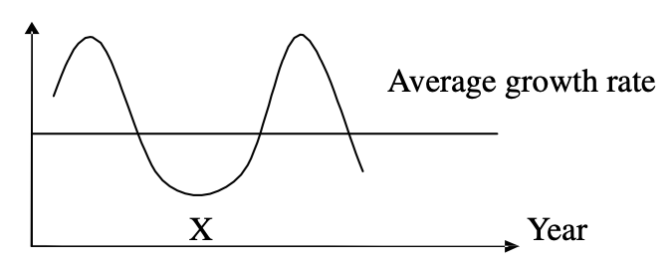
年份
平均增長率
A. The real GNP has a zero growth rate. B. The nominal GNP is higher than the real GNP.
C. The investment expenditure of the economy is zero. D. The unemployment rate is high.

上圖中，X標示經濟周期中某一時期。下列哪一項是該時期的特徵？
A. 實質國民生產總值的增長率是零。 B. 名義國民生產總值高於實質國民生產總值。
C. 該經濟的投資支出是零。 D. 高失業率。

***Example Question 8 CE1999MCQ28
According to the government, Hong Kong experienced a recession in 1998 because for three consecutive quarters, there was
A. an increase in the unemployment rate B. a fall in the average wage rate
C. a fall in the general price level D. a negative growth rate of real gross domestic product (GDP)

根據政府所言，香港在1998年經歷經濟衰退，因為連續三個季度的
A. 失業率上升。 B. 平均工資下降。
C. 一般物價水平下降。 D. 實質本地生產總值有負增長。

Example Question 9 CE2000MCQ37
The following phenomena are observed in an economy, Which phase of the business cycle is the economy in ?
(1) industrial output on an upward trend
(2) increasing imports and exports
(3) growth of retail receipts
(4) forecast of economic growth being revised upwards
A. peak B. recession C. trough D. recovery
下面的現象是在某經濟裏觀察到的，該經濟是處於經濟週期中的哪一個時期？
(1) 工業生產量在上升軌裏
(2) 進口及出口增加
(3) 零售收益出現增長
(4) 經濟增長預測向上修訂
A. 頂峰 B. 衰退 C. 谷底 D. 復甦
Example Question 10 CE2001MCQ38
If Hong Kong is in the stage of recovery in the business cycle,
A. government expenditure will increase. B. the proportion of tax revenue in total government revenue will decrease.
C. government revenue from direct taxes will increase. D. there will be a budgetary surplus for the government.

若香港正處於經濟週期中的復甦期，
A. 政府支出會增加。 B. 税收佔政府總收入的比例會減少。
C. 政府的直接税税收會增加。 D. 政府的財政預算會出現盈餘。

Example Question 11 CE2002MCQ28
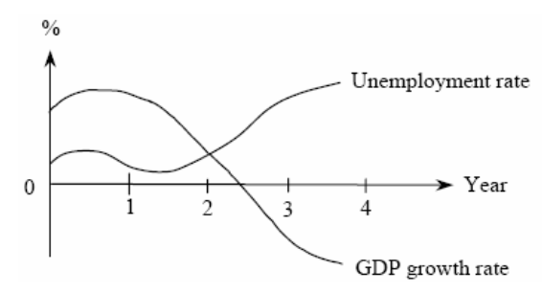
本地生產總值增長率
年份
失業率
The information above shows that the economy is in a stage of _______ in Year 3.
A. recession B. depression C. recovery D. prosperity

上列資料顯示該經濟第3年處於_____時期。
A. 衰退 B. 蕭條 C. 復甦 D. 繁榮

Example Question 12 CE2004MCQ32
When an economy is in the recovery stage,
(1) retail receipts will increase.
(2) the government will have a budget surplus.
(3) the unemployment rate will fall.
(4) the balance of payments deficit will decrease.
A. (1) and (3) only B. (1) and (4) only C. (2) and (3) only D. (2) and (4) only

當一經濟處於復甦時期，
(1) 零售收益會增加。
(2) 政府會有財政盈餘。
(3) 失業率會下跌。
(4) 國際收支赤字會減少
A. 只有(1)、(3) B. 只有(1)、(4) C. 只有(2)、(3) D. 只有(2)、(4)

Example Question 13 CE2005MCQ31
The following is observed in an economy: the unemployment rate is decreasing, the price level is no longer falling but rising instead, and the investment expenditure increasing. In which phase of the business cycle is the economy situated?
A. recovery B. peak C. recession D. trough

某經濟的失業率下降，物價止跌回升，投資支出增加。這經濟正處於經濟周期中哪一個時期？
A. 復蘇 B. 高峰 C. 衰退 D. 谷底

Example Question 14 CE2006MCQ27
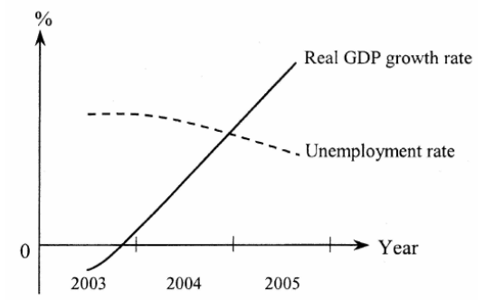
實質本地生產總值增長率
失業率
年份
According to the above information, the economy is in a stage of ____________ in 2004.
A. recovery B. prosperity C. recession D. depression

根據上圖資料，該經濟在2004年是處於_____時期。
A. 復蘇 B. 繁榮 C. 衰退 D. 蕭條

Example Question 15 CE2007MCQ31
In the diagram below, X is situated in a certain phase of the business cycle. Which of the following is a characteristic of this phase?
實質本地生產總值變動百分率
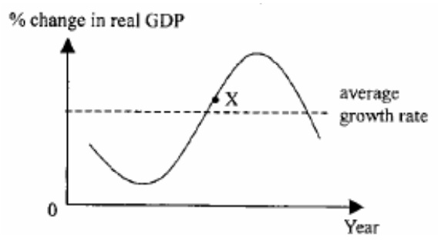
年份
平均增長率
A. The general price level is falling. B. The consumption expenditure is falling.
C. The balance of payments surplus is increasing. D. The level of investment is increasing.

上圖中，X標示經濟周期中某一個時期。下列哪一項是該時期的特徵？
A. 一般物價水平正在下降。 B. 消費支出正在下降。
C. 國際收支帳盈餘正在增加。 D. 投資水平正在增加。
Example Question 16 CE2008MCQ29
In the stage of economic ______________ , the percentage change in real GDP _________.
A. recession ... could be negative B. recovery ... is equal to the inflation rate
C. prosperity ... will be constant D. depression ... will be zero

在經濟 _______ 時期，實質本地生產總值的改變百分比 _______。
A. 衰退 ⋯⋯ 可能是負值 B. 復甦 ⋯⋯ 等於通帳率
C. 繁榮 ⋯⋯ 會是一個常數 D. 蕭條 ⋯⋯ 會是零

Example Question 17 DSE2013MCQ33
The following phenomena are observed in an economy:
(1) The unemployment rate is increasing
(2) The inflation rate is no longer rising but falling instead
(3) The inventories of producers are accumulating
(4) The forecast of economic growth is revised downward
The economy is in the _____ phase of a business cycle.
A. Recession B. Trough C. Recovery D. Peak

某經濟出現下列現象：
(1) 失業率正上升。
(2) 通脹率不再上升而是下降。
(3) 生產商的存貨正增加。
(4) 經濟增長的預測被調低了。
該經濟正處於經濟週期的_____階段。
A. 衰退 B. 低谷 C. 復甦 D. 高峰

Example Question 18 DSE2014MCQ39
In the diagram below, A is situated in a certain phase of the business cycle.
下圖中，A標示經濟周期中的某一時期。
實質本地生產總值轉變的百分率
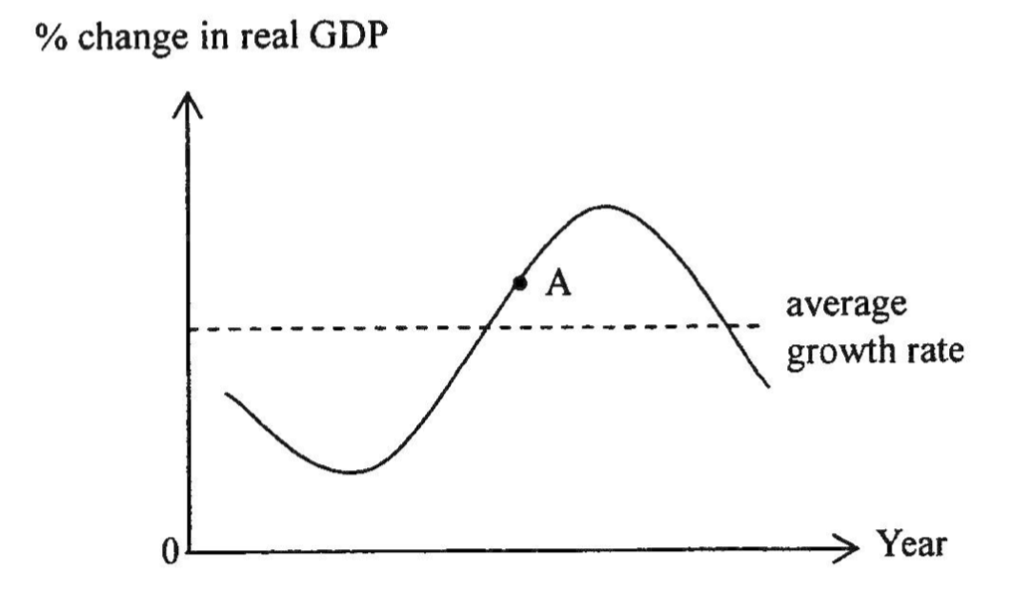
年份
平均增長率
At point A, there will be an increase in _____ in the economy.
- The labour employment level
- The general price level
- The sales of firms
- Transfer payment
A. (1) and (2) only B. (3) and (4) only C. (1), (2) and (3) only D. (1), (2), (3) and (4)

在A點，該經濟的_____會上升。
(1) 勞工就業水平
(2) 一般物價水平
(3) 廠商的銷售額
(4) 轉移支付
A. 只有(1)、(2) B. 只有(3)、(4) C. 只有(1)、(2)及(3) D. (1)、(2)、(3)及(4)

Example Question 19 DSE2021MCQ39
Study the following diagram. 細閲下圖。
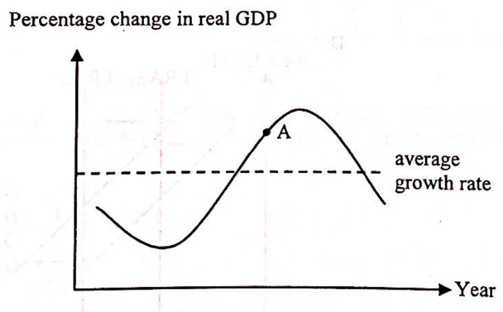
年份
實質GDP變動百分率
平均增長率
Which of the following are the features of an economy when it is operating at point A?
(1) Labour supply is increasing.
(2) Purchasing power of money is decreasing.
(3) Government expenditure is increasing.
(4) Business confidence of companies is increasing.
A. (1) and (3) only B. (1) and (4) only C. (2) and (3) only D. (2) and (4) only
當某經濟在A點運作，下列哪些是該經濟的特徵？
(1) 勞力供應正在增加。
(2) 貨幣的購買力正在減少。
(3) 政府支出正在增加。
(4) 廠商的商業信心正在增加。
A. 只有(1)、(3) B. 只有(1)、(4) C. 只有(2)、(3) D. 只有(2)、(4)

2012DSE LQ6ab, LQ11ab
(a) Rising unemployment is one of the phenomena which occurs during economic recession. State TWO losses to society caused by unemployment. (2)
(b) Other than rising unemployment, give TWO other economic phenomena which would occur during economic recession. (2)
Read the following news extract
Hong Kong’s inflation rate rose to 7.9% last month – the sharpest jump in 16 years – confirming what many families already feared as they struggle to keep up with the runaway cost of food and rent …..
(c) What is inflation? (2)
(d) Many workers have their salaries increased during inflation. Explain whether the real income of these workers would necessarily rise. (3)

(a) 經濟衰退其中一個現象是失業增加。寫出失業對社會造成的兩項損失。 (2)
(b) 除了失業增加外，舉出在經濟衰退時會出現的兩個經濟現象。 (2)
細閲下列的新聞節錄。
香港通脹率在上月份上升至7.9% —— 為16年來的最大升幅 —— 確認了許多家庭所懼怕的情況：他們為應付飛漲的食物成本和租金而感到吃力⋯⋯
(c) 什麼是通脹？ (2)
(d) 很多工人在通脹期間獲得加薪。解釋這些工人的實質收入會否必然上升。 (3)
_______________________________________________________________________________________
_______________________________________________________________________________________
_______________________________________________________________________________________
_______________________________________________________________________________________
_______________________________________________________________________________________
_______________________________________________________________________________________
_______________________________________________________________________________________
_______________________________________________________________________________________
_______________________________________________________________________________________
_______________________________________________________________________________________

Marking Scheme:
(a) Loss of output / Loss of human capital / Political unrest (@1)
產出的損失 / 人力資本的損失 / 政治動盪 (@1)

(b) Falling or even negative real GDP growth
Low / falling inflation or even deflation
Falling business confidence, levels of investment, consumption (@1)
實質本地生產增長下降，甚至負值
通脹下降或處於低水平，甚至出現通縮
商業信心、投資和消費水平下降 (@1)

(c) Persistent increase in the general price level (2)
一般物價水平持續上升。

(d) No, (1)
because the real income of workers would fall if the percentage increase in price level is greater than the percentage increase in nominal wage. (2)
否，因為 (1)
若物價水平的上升的百分比大於名義工資的上升百分比，工人的實質收入會下降。 (2)

Candidates’ Performance:
(a) Good. A small number of candidates mistook an increase in welfare payments (e.g., unemployment benefits) or an increase in government burden for a loss to society.
良好。小部分考生誤將增加褔利開支（如失業補貼）或政府負擔上升當作社會的損失。
(b) Excellent.
優異。
(c) Good. The only common mistake was stating their answer in terms of ‘price’ rather than the ‘general price level’
良好。考生常犯的錯誤只有以「價格」而不是「一般物價水平」為依據作答。
(d) Satisfactory. Some candidates missed the key work ‘necessarily’. Some others failed to recognize the different between a change in the general price level and a change in the inflation rate, thus giving a wrong comparison between the percentage increase in nominal income and the percentage increase in the inflation rate
令人滿意。部分考生忽視了重要字眼「必然」。另有考生未能認清一般物價水平改變和通脹率改變的分別，所以錯誤地比較名義收入上升的百分比和通脹率上升的百分比。

2013DSE LQ11b
The government has launched the “Work Incentive Transport Subsidy Scheme”, with the following objectives:
(1) | To relieve the burden of travelling expense commuting to and from work on the part of low-income households with employed members
(2) | To promote sustained employment
Applicants must meet the monthly income and asset limits of the household (e.g. for a single person, the monthly income cannot exceed $7300 and the assets cannot exceed $72000) and work no less than 72 hours per month in order to apply for a subsidy of $600 per month.
(b) Discuss the effects of the scheme on (9)
(i) labour mobility,
(ii) income inequality, and
(iii) the unemployment rate.

政府已推出「鼓勵就業交通津貼計劃」，目標如下：
(1) | 減輕低收入住戶在職人士往返工作地點的交通費負擔
(2) | 鼓勵持續就業
申請人必須符合住户每月入息和資產限額（以單身人士為例，每月入息不可超過$7 300，而資產不可超過$72 000）及每月工作不少於72小時以申請每月$600的津貼。 (9)
(b) 討論該計劃對下列各項的影響：
(i) 勞動流動性
(ii) 收入不均
(iii) 失業率
_______________________________________________________________________________________
_______________________________________________________________________________________
_______________________________________________________________________________________
_______________________________________________________________________________________
_______________________________________________________________________________________
_______________________________________________________________________________________
_______________________________________________________________________________________
_______________________________________________________________________________________
Marking Scheme:
The effect on the unemployment rate is uncertain.
The size of labor force would increase as more people originally outside the labour force are included to look for jobs. But the total number of unemployed may also increase as some of these new workers may fail to get a job. The resulting rate of unemployment depends on the percentage increase in the unemployed population relative to that in the labour force. (3)

對失業率的影響不能確定。
勞動人口會增加，因為有更多本來不包括在勞動人口之內的人會有誘因尋找工作。但是總失業人口可能增加，因為這些新的工人未必能獲得聘用。對失業率的影響受失業人口上升的百分比相對勞動人口上升的百分比所影響。 (3)

Candidates’ Performance:
Poor. Although most candidate were able to point out that more workers would go out to seek jobs, they failed to provide a comprehensive analysis of the possible effects of the policy on the unemployed and the labour force. Common mistakes include:
- failure to use the unemployment-rate formula;
- mixing up the concepts of "labour supply" and "labour force":
- mis-assuming that people who want to seek a job will necessarily get one;
- over-emphasizing the effect of the scheme on the number of unemployed while ignoring its possible effect on the size of the workforce.
欠佳。雖然大部分考生能指出更多工人會外出尋找工作，他們未能詳細分析政策可能對失業人數和勞動人口造成的影響。常見的錯誤包括：
- 沒有運用失業率的公式。
- 混淆了「勞力供應」和「勞動人口」這兩個概念。
- 錯誤假設尋找工作的人必然會找到工作。
- 過分強調計劃對失業人數的影響，而忽略了可能對勞動人口造成的影響。

2014DSE LQ5abci&ii
Study the following information about an economy. 細閲以下有關某經濟的資料。
Year年份 | Consumer price index消費物價指數 (CPI)
2012 | 120
2013 | 126
(a) Calculate the inflation rate in 2013 (1)
(b) Explain ONE difference between using CPI and Gross Domestic Product (GDP) deflator to measure the change in the price level. (2)
(c) Suppose people did not expect any change in the price level from 2012 to 2013. Explain whether each of the following persons would gain or lose when the change in the price level in the above table occurred.
(i) In 2012, Kitman borrowed a housing mortgage loan from a bank at a fixed nominal interest rate. (2)
(ii) In 2012, Marlene invested in a project with an expected nominal rate of return of 12% per year. In 2013, she discovered that the actual nominal interest rate of return was 15% per year. (3)
(a) 計算2013年的通脹率。 (1)
(b) 解釋以消費物價指數和以本地生產總值平減指數量度物價水平轉變的一個不同之處。 (2)
(c) 假設人們預期由2012年至2013年物價水平沒有任何轉變。當上表所示的物價改變出現，解釋以下各人會獲益還是受損。
(i) 在2012年，潔文以固定名義利率向某銀行借了一筆樓宇按揭貸款。 (2)
(ii) 在2012年，瑪蓮投資了一個項目，其預期名義回報率為每年12%。在2013年，她發現該計劃的實際名義 回報率為每年15%。 (3)
_______________________________________________________________________________________
_______________________________________________________________________________________
_______________________________________________________________________________________
______________________________________________________________________________________________________________________________________________________________________________
_______________________________________________________________________________________
_______________________________________________________________________________________
_______________________________________________________________________________________
_______________________________________________________________________________________
Marking Scheme:
(a) The inflation rate in 2013: (126-120)/120*100% = 5% (1)
2013年的通脹率：(126-120)/120*100% = 5% (1)

(b) CPI only includes consumer goods while GDP deflator includes both consumer goods and producer goods. / CPI calculated a fixed basket of goods and the weighting will be revised every 5 years while GDP deflator has variable baskets of goods for each year. (2)
不同之處：消費物價指數只包括消費者物品而本地生產總值平減指數包括消費者和生產者物品。/ 消費物價指數計算一籃子的物品，比重每5年修訂，而本地生產總值平減指數每年的比重均不相同。 (2)

(c) (i) Kitman would gain (1)
because the unexpected inflation would lower the real value (purchasing power) of the loan repayment. (1)
(ii) Marlene would lose (1)
because given the 15% rate of actual nominal return and the 5% rate of actual inflation, her actual real rate of
return equals 15% - 5% = 10%, which falls short of her expected real rate of return 12%. (2)
(i) 潔文會獲益， (1)
因為非預期通脹會減低所償還款項的實質價值(購買力)。 (1)
(ii) 瑪蓮會損失， (1)
因為已知實際名義回報率為15%而實際通脹率為5%，她的實際實質回報率為10%（=15%-5%）。
這遠低於預期實質回報率(12%)。 (1)

Candidates’ Performance:
(a) Excellent.
優異。
(b) Fair. Many candidates failed to define the two price indices clearly and to provide proper comparisons between them.
尚可。很多考生未能清楚寫出兩種價格指數的定義，亦未能正確地將兩者做比較。
(c) Good. Most candidates were able to demonstrate understanding of the purchasing power of money.
Fair. Half of the candidates did not make good use of the given data to illustrate their answers. They either ignored the given rates of return and of inflation or failed to difference between the “expected” and “actual” rates.
尚可。半數考生未能善用題目資料作答。他們忽略了所提供的回報率和通脹率或是未能分辨「預期」和「實際」的率。

2015DSE LQ5
Macau has developed rapidly in recent years and some workers in Hong Kong have been attracted to work there. Suppose the number of job positions in Hong Kong is constant. What would be the effect of the above phenomenon on the unemployment rate in Hong Kong? Explain your answer. (4)

澳門近年發展迅速，吸引了一些香港的工人到當地工作。假設香港的職位數量不變，上述的現象會對香港的失業率有甚麼影響？試加以解釋。 (4)
_______________________________________________________________________________________
_______________________________________________________________________________________
_______________________________________________________________________________________
_______________________________________________________________________________________
_______________________________________________________________________________________
Marking Scheme:
Unemployment rate = number of unemployed / total labour force) x 100% (1)
Since both total labour force and number of unemployed drop by an equal amount, the percentage decrease in the unemployed population is greater than the percentage decrease in the total labour force, implying a reduction in the unemployment rate. (3)
失業率 = (失業人數 / 總勞動人口) x 100% (1)
由於總勞動人口和失業人數下跌的人數相同，
失業人數下跌的百分比大於總勞動人口下跌的百分比，意味着失業率下跌。 (3)
Candidates’ Performance:
Fair. Contrary to what is stated in the question, some candidates assumed partial or no job replacement in the Hong Kong labour market as some workers moved to Macau. However, those who managed to provide logically consistent explanations were still given full credit. The following were common mistakes:
- Failure to realise that the unemployment rate is defined in percentage term;
- Mistaking the constant number of job positions for constant number of unemployed persons;
- Skipping the comparison between the percentage decrease in the unemployed population and that in the labour force.
一般。和題目所述的不同，部分考生假設當部分工人往澳門工作，本港勞力市場沒有完全替代甚至未有替代那些工人。不過，考生若能提供邏輯一致的解釋仍可獲滿分。
常見的錯誤如下：
- 不知道失業率的定義是以百分比計算的
- 誤將職位數目不變當作失業人數不變
- 沒有比較失業人數和勞動人口下跌的百分比

2016DSE LQ6abc
Below are the employment data of a country. 以下是某國的就業數據。
Employed population | 3 800 000 |  | 就業人口 | 3 800 000
Underemployed population | 800 000 |  | 就業不足人口 | 800 000
Unemployed population | 200 000 |  | 失業人口 | 200 000
(a) Calculate the unemployed rate of the country (2)
(b) Suggest THREE losses to the society caused by unemployment (3)
(c) Suppose the country is in the phase of recovery. Apart from the reduction in unemployment rate, give TWO general economic phenomena during recovery. (2)

(a) 計算該國的失業率。 (2) (b) 舉出三項失業對社會造成的損失。 (3)
(c) 假設該國正處於復甦期。除了失業率下降，舉出兩項在復甦期的一般經濟現象。 (2)
_______________________________________________________________________________________
_______________________________________________________________________________________
_______________________________________________________________________________________
_______________________________________________________________________________________
_______________________________________________________________________________________
_______________________________________________________________________________________
_______________________________________________________________________________________
_______________________________________________________________________________________
_______________________________________________________________________________________
_______________________________________________________________________________________
_______________________________________________________________________________________
_______________________________________________________________________________________
_______________________________________________________________________________________
_______________________________________________________________________________________
_______________________________________________________________________________________
Marking Scheme:
(a) The unemployment rate = 200 000/ (3 800 000 + 200 000) * 100% = 5% (1)
失業率 = 200 000/ (3 800 000 + 200 000) * 100% = 5% (1)

(b) Loss caused by unemployment:
Loss of output / Loss of human capital / Political and social unrest / (@1)
Any other relevant point
[Mark the FIRST THREE points only.]
失業所造成的損失：
產出下降 / 人力資本下降 / 政治和社會不穩 (@1)
任何其他相關點 [只批閲首三項]

(c) Economic phenomena:
Rising real GDP growth rate / Low/rising inflation / Rising levels of investment / consumption
Any other relevant point (@1)
[Mark the FIRST TWO points only.]
經濟現象：
實質GDP增長率上升 / 通脹上升 / 通縮下降 / 投資 / 消費水平上升 (@1)
任何其他相關點 [只批閲首兩項]

Candidates’ Performance:
(a) Good. A few candidates wrongly included the underemployed population in their calculation.
良好。部分考生錯誤把就業不足人口納入其計算內。
(b) Satisfactory. A common mistake was to regard the rise of unemployment benefits – a transfer payment – as a loss to
society.
令人滿意。一項常犯的錯誤是將增加失業援助金 —— 一種轉移支付 —— 當作社會的損失。
(c) Excellent. A small number of candidates did not read the question carefully, and included “the fall in unemployment
rate” as part of their answers.
優異。少數考生沒有小心審題，答案中包含了「失業率下降」。

2017DSE LQ9a
Figures 1 and 2 show some macroeconomic data of the US.
圖一和圖二顯示美國的一些宏觀經濟數據。
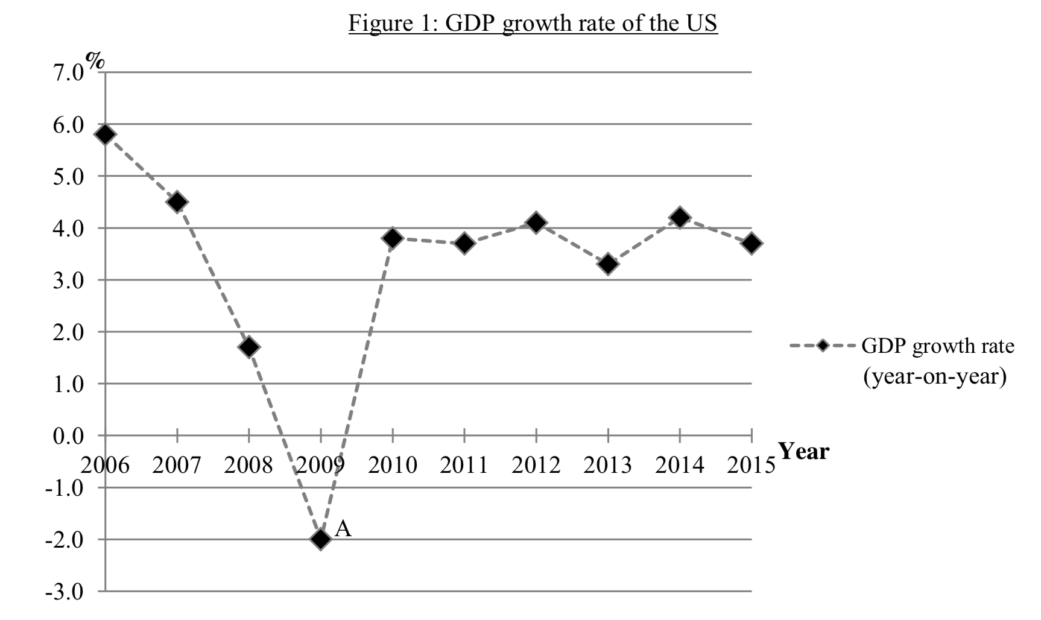
（按年計算）
本地生產總值增長率
圖一：美國本地生產總值的增長率
Refer to figure 1. Identify the phase of business cycle which point A is in. (1)
參考圖一。指出A點所在屬經濟周期的哪一階段。 (1)
_______________________________________________________________________________________
_______________________________________________________________________________________

Marking Scheme:
Depression / trough (1)
蕭條 / 低谷 (1)
Candidates’ Performance:
Excellent.

2018DSE LQ5b
During peak flu seasons, there is not enough medical staff in public hospitals in Hong Kong. In order to relieve the pressure of the medical staff, the government plans to recruit medical staff to re-join the public hospitals. Explain how the measure would affect the unemployment rate in Hong Kong. (4)

流感高峰期間，香港公立醫院的醫護人員人手不足。為了減輕醫護人員的壓力，政府計劃招聘退休醫護人員重投公立醫院工作。解釋該措施如何影響香港的失業率。 (4)
_______________________________________________________________________________________
_______________________________________________________________________________________
_______________________________________________________________________________________
_______________________________________________________________________________________
_______________________________________________________________________________________
_______________________________________________________________________________________
_______________________________________________________________________________________

Marking Scheme:
Unemployment rate = (number of unemployed people / the total labour force) x 100%
The number of unemployed people will not change while the labour force increases as the retired staff is not in the labour force originally. The unemployment rate will drop. (4)
失業率 = (失業人數 / 總勞動人口) x 100%
失業人數不變而勞動人口則上升，原因是退休醫護人員原初不在勞動人口中。失業率會下降。 (4)
Candidates’ Performance:
Good. Many candidates demonstrated a good understanding of the ‘unemployment rate’ formula and of how the change in government policy would affect each of the variables in the formula. Only a small number of candidates failed to state the formula or forgot that the unemployment rate should be in percentage terms.
良好。很多考生清楚了解計算失業率的公式，也知道政府政策如何影響公式內的每一個變量。只有少數考生未有寫出公式或是忘記了失業率須以百分比表示。

2019DSE LQ6abc
Study Tables 1 and 2 and answer the following questions. 細閲表1及表2，然後回答以下問題。
Table 1: Change in composite consumer price index (CCPI) 表1：綜合消費物價指數 (CCPI) 的變化
Year 2016 | Year 2017 |  | 2016年 | 2017年
+2.3% | +1.7% |  | +2.3% | +1.7%
Table 2: Minimum wage rate per hour 表2：每小時的最低工資率
Year 2016 | Year 2017 |  | 2016年 | 2017年
$32.5 | $34.5 |  | $32.5 | $34.5
(a) Based on Table 1, state the change in the general price level in 2017 (1)
(b) On 1 January 2017, Siu Keung expected + 2.3% change of the CCPI in that year, and he lent a sum of money to Kitman at 5 % interest rate per annum. On 31 December 2017, Kitman repaid the sum plus the interest to him. With reference to Table 1, explain whether Siu Keung would gain or lose. (3)
(c) Kitman has been receiving the minimum wage rate per hour. With reference to Table 1 and 2, explain how her real wage rate would change in 2017. (3)

(a) 根據表1，指出在2017年一般物價水平的變化。 (1)
(b) 2017年1月1日，小強預計該年CCPI的變化是 +2.3%，並以5%年利率將一筆款項借給潔文。2017年12月31日，潔文連本帶利把錢還給小強。參考表1，解釋小強會得益還是會損失。 (3)
(c) 潔文一直按每小時的最低工資率領取低工資。參考表1及表2，解釋在2017年她的實質工資率會如何轉變。 (3)
_______________________________________________________________________________________
_______________________________________________________________________________________
_______________________________________________________________________________________
_______________________________________________________________________________________
_______________________________________________________________________________________
_______________________________________________________________________________________
_______________________________________________________________________________________
_______________________________________________________________________________________
_______________________________________________________________________________________
_______________________________________________________________________________________

Marking Scheme:
(a) Increased (+1.7%) (1)
上升 (+1.7%)。 (1)

(b) He would gain because when the actual inflation (1.7%) was lower than the expected inflation rate (2.3%), the actual real
interest rate received (3.3%) was higher than the expected real interest ratev(2.7%).
OR the purchasing power of the interest received was higher than expected. (3)
他會得益，因為實際通脹率(1.7%)低於預期通脹率(2.3%)，所以他獲得的實際實質利率(3.3%)高於預期實質利率(2.7%)，或所收取利息的購買力高於預期。 (3)

(c) Real wage rates increased because the increase in the nominal wage rate 6.2% was higher than the inflation rate 1.7%. (3)
實質工資率上升，因為名義工資率上升6.2%高於通脹率1.7%。 (3)

Candidates’ Performance:
- Excellent. Only a minority of candidates mis-identified the situation as deflation.
優異。只有小部分考生將該情況誤作通縮。
(b) fair. Many candidates correctly answered that Siu Keung would gain, but not everyone could explain their answer clearly. Problems in their explanation include:
- mixing up real and actual interest;
- mixing up lenders and borrowers;
- simply comparing the actual and expected inflation rates to explain Siu Keung’s gain without discussing actual and expected real interest;
- stating the increase in the real value of interest / money without using such keywords as ‘received’ or ‘higher than expected’.
一般。很多考生正確答出小強會得益，但並非全部能清楚解釋答案。在解釋中出現問題包括：
- 混淆了實際利率和實質利率
- 混淆了貸款人和借款人
- 以實際和預期通脹率解釋小強的得益，而未能討論實際和預期實質利率
- 指出利息 / 貨幣的實際價值上升時，遺漏了重要術語，如「收取」或「高於預期」
(c) Satisfactory. Many candidates were able to compare correctly the percentage increase in nominal wage rate with the inflation rate in the corresponding year. However, some used the inflation rate in the wrong year for computing the percentage change in real wage.
令人滿意。很多考生能正確地將名義工資率上升的百分比與相對應年份的通脹率作比較。但部分考生運用通脹率計算實質工資率改變的百分比時，卻用了錯誤的年份。

DSE 2020 LQ3a & b & c, LQ4
Below are the gross domestic product (GDP) data of a country. 以下是某國的本地生產總值(GDP)資料。
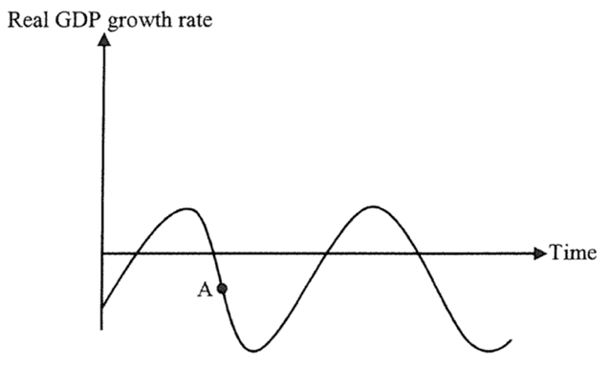
時間
實質本地生產總值增長率
(a) Identify the phase of business cycle which point A is in. (1)
(b) Apart from increasing unemployment rate, list TWO general economic phenomena which occur at point A. (2)
(c) State TWO losses to society caused by unemployment. (2)

(a) 指出A點所在位置屬於經濟周期的哪個時期。 (1) (b) 除了失業率上升外，列出在A點會出現的兩個一般經濟現象。 (2)
(c) 舉出失業對社會造成的兩種損失。 (2)
_______________________________________________________________________________________
_______________________________________________________________________________________
_______________________________________________________________________________________
_______________________________________________________________________________________
Study the following information of an economy. 細閲以下有關某經濟的資料。
Year | Consumer price index (CPI) |  | 年份 | 消費物價指數(CPI)
2018 | 110 |  | 2018 | 110
2019 | 117 |  | 2019 | 117
(d) Calculate the inflation rate in 2019. (1)
(e) Explain ONE difference between using CPI and GDP deflator to measure the change in the price level. (2)

(d) 計算2019年的通脹率。 (1)
(e) 解釋以消費物價指數和以本地生產總值平減指數去量度物價水平轉變的一項不同之處。 (2)
_______________________________________________________________________________________
_______________________________________________________________________________________
Marking Scheme:
(a) recession. (1)
衰退。 (1)

(b) Phenomena:
- falling/negative real GDP growth rate OR falling real GDP level
- falling inflation rate OR deflation occurs / falling consumption/investment /falling business confidence
[Mark the FIRST TWO points only.]
現象：
實質GDP增長率下降 / 變為負值 或 實質GDP水平下降
通脹下降 或 通縮 / 消費 / 投資水平下降 / 企業信心下降 [只批閲首兩項] (@1)

(c) Losses caused by unemployment:
- loss of output / loss of human capital / political and social unrest
[Mark the FIRST TWO points only.]
失業造成的損失：
產出損失 / 人力資本損失 / 政治和社會不穩 (@1)
任何其他相關點 [只批閲首兩項]

(d) Inflation rate = (117 – 110) / 110 x 100% = 6.36% (1)
通脹率 = (117 – 110) / 110 x 100% = 6.36% (1)

(e) Differences:
- CPI only includes consumer goods while GDP deflator includes both consumer goods and producer goods.
- CPI calculates a fixed basket of goods and the weighting will be revised after a period of time while GDP deflator has variable baskets of goods for each year.
- any other relevant point [Mark the FIRST point only.]
分別：
- CPI只包括消費者物品而GDP平減指數包括消費者物品及生產者物品。
- CPI的計算基於某固定籃子物品（其比重不會經常調整），而GDP平減指數的計算每年計算的物品籃子是可變的（其比重每年不同）。 (2)
- 任何其他相關點 [只批閲首項]

Candidates’ Performance:
- Excellent
優異。
- Good. A few candidates did not read the question carefully and included ‘increase in unemployment rate’ in their answers.
良好。有少數考生沒有審題，以「失業率上升」作答。
- Good. Some candidates regarded an increase in welfare payment as a loss to society.
良好。一些考生誤將社會福利開支上升當作社會的損失。
- Good, some candidates had problems in rounding off the inflation figures.
良好。一些考生在計算通脹率時四捨五入出錯。
(e) Satisfactory. Some candidates failed to explain the difference between CPI and GDP deflator from a single perspective. Instead, they merely stated one feature of CPI and another feature of GDP deflator without pointing out the difference.
令人滿意。部分考生未能從單一角度解釋CPI和GDP平減指數的分別。他們只寫出CPI的一項特徵和GDP平減指數的另一項特徵，卻沒有指出兩者的分別。

Marking Scheme:
Type 1 (Whether included in employment, unemployment, labour force…)
1 | D | 2 | D | 3 | A | 4 | C | 5 | D | 6 | D | 7 | C
Type 2 (Calculation of employment rate / unemployment rate)
1 | B | 2 | B | 3 | B | 4 | A | 5 | B | 6 | C | 7 | C | 8 | D | 9 | B | 10 | C
11 | D | 12 | D | 13 | D | 14 | D | 15 | C | 16 | C | 17 | D | 18 | C | 19 | C | 20 | C
Type 3 (Cost of unemployment)
1 | A | 2 | A | 3 | C | 4 | D | 5 | B
Type 4 (Inflation and deflation)
1 | D | 2 | D | 3 | B | 4 | C | 5 | D | 6 | D | 7 | A | 8 | C | 9 | C | 10 | A
11 | B | 12 | A | 13 | C | 14 | C | 15 | B | 16 | D | 17 | B | 18 | D | 19 | B | 20 | C
Type 5 (Unexpected inflation and deflation → redistribution effect)
1 | B | 2 | D | 3 | D | 4 | D | 5 | C | 6 | A | 7 | D | 8 | C | 9 | A | 10 | B
11 | C | 12 | C | 13 | C | 14 | A | 15 | D | 16 | D | 17 | A | 18 | A | 19 | A
Type 6 (Business Cycle)
1 | A | 2 | D | 3 | A | 4 | D | 5 | A | 6 | D | 7 | D | 8 | D | 9 | D | 10 | C
11 | A | 12 | A | 13 | A | 14 | A | 15 | D | 16 | A | 17 | A | 18 | C | 19 | D | 20 | D
21 | C | 22 | D | 23 | C | 24 | C | 25 | B

