Learning Focus:
Memo
(LQ Answering Flow, MC skills, your goals and resolutions…)
Specific Question Type
MC

咩話？DSE Sample Paper, Practice Paper, 2012, 2013, 2014, 2015, 2016, 2017, 2018, 2019, 2020, 2021, 2022 MC全部拍晒解題片？係呀，有唔明即scan即睇！就係咁firm！


Learning Focus:
Memo
(LQ Answering Flow, MC skills, your goals and resolutions…)
Specific Question Type
LQ

咩話？DSE Sample Paper, Practice Paper, 2012, 2013, 2014, 2015, 2016, 2017, 2018, 2019, 2020, 2021, 2022 LQ全部拍晒解題片？係呀，有唔明即scan即睇！就係咁firm！


Chapter 4 _ Market Intervention 市場干預
Type 1 (Effect of Market Intervention, P / Q / TR / Tax / Subsidies)
Example Question 1 CE1992MCQ27
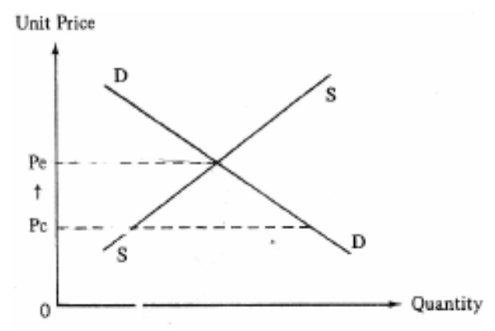
The above diagram shows the price and quantity of Good X. The price increases from Pc to Pe after the price ceiling is cancelled. As a result, the total expenditure on Good X will
A. increase B. decrease C. remain unchanged
D. either increase or decrease, depending on its price elasticity of demand

上圖顯示物品X的價格和數量。在價格上限取消後價格由PC上升至PE。物品X的消費總值會
A. 因此而增加 B. 因此而減少 C. 維持不變
D. 增加或減少，視乎他的價格需求彈性而定

Example Question 2 CE1996MCQ8
Shortage occurs when
A. a price floor below the equilibrium price is imposed. B. an effective price ceiling is imposed.
C. the supply is reduced. D. the demand increase sharply.

短缺在下列那一種情況下出現？
A. 實施低於均衡價格的價格下限。 B. 實施有效的價格上限。
C. 供應減少。 D. 需求大幅增加。

Example Question 3 CE1996MCQ9
Suppose initially the price of a certain good is fixed below the market equilibrium. Relaxing the price control will lead to
(1) an increase in revenue.
(2) a decrease in demand.
(3) an increase in revenue only if the demand for this good is inelastic.
(4) an increase in the quantity supplied.
A. (1) and (2) only B. (1) and (4) only C. (2) and (3) only D. (3) and (4) only

假設初時某物品的價格固定在市場均衡水平之下。放寬該價格管制會導致
(1) 銷售收益增加。
(2) 需求下降。
(3) 銷售收益增加，但必須配合一個條件，就是該物品的需求缺乏彈性。
(4) 供應量增加。
A. 只有(1)及(2) B. 只有(1)及(4) C. 只有(2)及(3) D. 只有(2)及(4)

Example Question 4 CE1992MCQ24
If the government imposes a price floor below the equilibrium price, there will be
A. a decrease in the sales revenue B. a decrease in the quantity transacted
C. an excess supply D. no excess demand

若政府實施一低於均衡價格的價格下限，
A. 銷售收益會有所減少 B. 交易量會有所減少
C. 會有超額供應 D. 不會有超額需求

Example Question 5 CE1998MCQ4
If a price floor is set below the equilibrium price of good X,
A. a shortage of good X will occur.
B. the quantity transacted will decrease.
C. the total revenue may increase or decrease, depending on the elasticity of demand for good X.
D. the total revenue will remain unchanged.

若將物品X的價格下限設在均衡價格之下，
A. 物品X會出現短缺。
B. 交易數量會下跌。
C. 總銷售收益可能上升或下跌，視乎物品X的需求彈性而定。
D. 總銷售收益會維持不變。

Example Question 6 CE1999MCQ6
Unit price ($) | Quantity Demanded (units) | Quantity Supplied (units) | 單位價格 ($) | 需求量 (單位) | 供應量 (單位)
7 | 8 | 20 | 7 | 8 | 20
6 | 12 | 18 | 6 | 12 | 18
5 | 16 | 16 | 5 | 16 | 16
4 | 20 | 14 | 4 | 20 | 14
3 | 24 | 12 | 3 | 24 | 12
Refer to the above supply and demand schedule for good X. The government sets its minimum price at $4 per unit. What would happen if the government raised the minimum price to $6 per unit?
A. The shortage of good X would disappear. B. The quantity transacted would increase.
C. Consumer expenditure on good X would decrease. D. The surplus of good X would decrease.

參照以上物品X的供求表。政府將他的最低價格定為每單位$4，若政府提高最低價格至每單位$6，
A. 物品的短缺會消失。 B. 交易量會增加。
C. 消費者在物品X的總支出會減少。 D. 物品的盈餘會減少。

Example Question 7 CE2004MCQ12
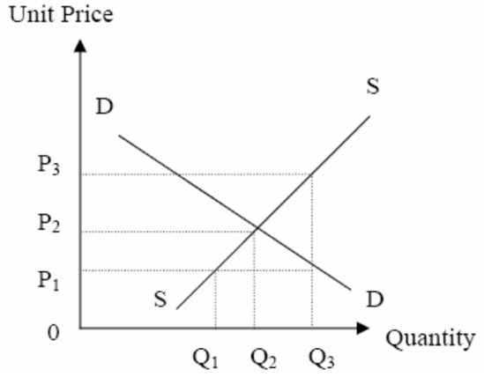
Refer to the above diagram. Which of the following statements is correct?
A. If a price ceiling is set at P1, the quantity transacted is Q3.
B. If a price floor is set at P1, the quantity transacted is Q2.
C. If a price floor is set at P3, the quantity transacted is Q2.
D. If a price ceiling is set at P3, non-price competition will occur.

參閱上圖。下列那一項是正確的？
A. 若價格上限設定在P1，交易量是Q3。 B. 若價格下限設定在P1，交易量是Q2。
C. 若價格下限設定在P3，交易量是Q2。 D. 若價格上限設定在P3，非價格競爭會出現。

Example Question 8 CE2007MCQ7
An imposition of a minimum wage legislation would increase
A. the employment opportunities of unskilled workers B. the total wage payment to unskilled workers
C. the unemployment of unskilled workers D. the inflow of foreign investment

實施最低工資法例會增加
A. 非技術工人的就業機會 B. 非技術工人的工資總額
C. 非技術工人的失業人口 D. 外國在當地的投資。

Example Question 9 CE2008MCQ12
The government raises the effective minimum wage of imported workers,
A. the employment of imported workers will increase
B. the problem of shortage of imported workers will become more serious
C. the unemployment rate of local workers will increase
D. the total wage earnings of local workers will increase

如果政府提高輸入勞工的有效最低工資，
A. 輸入勞工的雇用量會上升。 B. 輸入勞工的短缺問題會更為嚴重。
C. 本地勞工的失業率會上升。 D. 本地勞工的整體薪酬收入會上升。

Example Question 10 CE1994MCQ12
If the government imposes an effective quota on good Y, the market price of Y will _____ and its quantity transacted will ______.
A. increase … increase B. increase … decrease C. decrease … increase D. decrease … decrease

如果政府對物品Y實施一有效的配額限制，Y的市價會 _____ 和他的交易量會 _____ 。
A. 上升 … 上升 B. 上升 … 下降 C. 下降 … 上升 D. 下降 … 下降

Example Question 11 CE1994MCQ13
Refer to Question 10. The consumers’ total expenditure on good Y will
A. decrease. B. increase. C. remain unchanged.
D. increase or decrease, depending on the price elasticity of demand for good Y.

承接第10題，消費者購買物品Y的全部支出
A. 減少 B. 增加 C. 保持不變
D. 增加或減少，視乎Y的價格需求彈性而定。

Example Question 12 CE1999MCQ7
The abolition of an effective quota on an imported good will result in
(1) a fall in its price.
(2) an increase in its import volume.
(3) an increase in its total sales revenue.
(4) an improvement in its quality.
A. (1) and (2) only B. (1) and (3) only C. (1), (3) and (4) only D. (2), (3) and (4) only

取消對某進口物品的有效配額管制會使
(1) 它的價格下降。
(2) 它的進口數量增加。
(3) 它的總銷售收益增加。
(4) 它的品質提高。
A. 只有(1)及(2) B. 只有(1)及(3) C. 只有(1)、(3)及(4) D. 只有(2)、(3)及(4)

Example Question 13 CE2006MCQ10
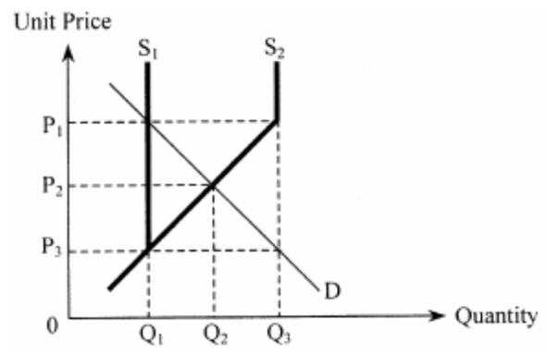
In country A, there is a quota restriction on an imported good. When the import quota quantity is Q1, the market price of the good is P1. Now suppose Country A increases the quota quantity from Q1 to Q3 as shown in the diagram below. As a result, the new total sales revenue would be
A. P1×Q1 B. P2×Q2 C. P1×Q3 D. P3×Q3

甲國對某入口貨品實施配額限制。配額數量為Q1時，該貨品的市價是P1。現假設甲國將配額數量由Q1增加至Q3，如下圖所示。結果，新的總銷售收益便會是
A. P1×Q1 B. P2×Q2 C. P1×Q3 D. P3×Q3

Example Question 14 CE2008MCQ9
Country A reduces the quantity of an effective quota on clothing imported from Country B. At the same time, imported clothing from other countries to Country A has become cheaper.
Which of the following graphs can illustrate the changes in Country A’s market of clothing imported from Country B? E1 is the original equilibrium point and E2 is the new equilibrium point.

甲國減少從越國進口成衣的有效配額數量。同時甲國從其他國家進口的成衣變得較以往便宜。下列那圖能說明甲國從乙國進口成衣的市場變動？E1是原來的均衡點，E2是新的均衡點。
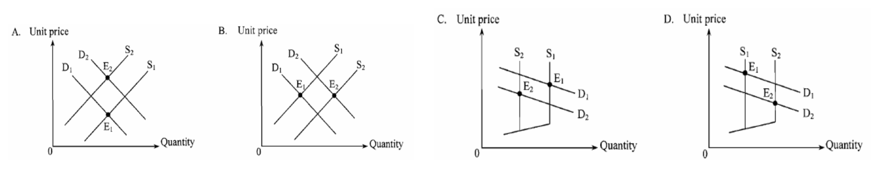
Example Question 15 CE1994MCQ8
Consider the following supply and demand schedule of wine in a certain country:
Unit price ($) | Quantity Demanded (units) | Quantity Supplied (units) | 單位價格 ($) | 需求量 (單位) | 供應量 (單位)
30 | 90 | 60 | 30 | 90 | 60
32 | 80 | 65 | 32 | 80 | 65
34 | 70 | 70 | 34 | 70 | 70
36 | 60 | 75 | 36 | 6 | 75
38 | 50 | 80 | 38 | 50 | 80
40 | 40 | 85 | 40 | 40 | 85
Suppose initially the wine market is in equilibrium. If the government imposes a tax of $6 for each unit of the wine sold, the new equilibrium price will be
A. $32 B. $36 C. $38 D. $40

假設原先葡萄酒市場是處於均衡狀況。若每售出一單位葡萄酒政府便徵稅$6 ，新的均衡價格是
A. $32 B. $36 C. $38 D. $40

Example Question 16 CE1994MCQ9
Government revenue from the above tax will be _______.
A. $240 B. $300 C. $360 D. $420

政府在上述稅項的收益是
A. $240 B. $300 C. $360 D. $420
Example Question 17 CE1996MCQ7
Unit price ($) | Quantity Demanded (units) | Quantity Supplied (units) | 單位價格 ($) | 需求量 (單位) | 供應量 (單位)
6 | 60 | 40 | 6 | 60 | 40
8 | 55 | 45 | 8 | 55 | 45
10 | 50 | 50 | 10 | 50 | 50
12 | 45 | 55 | 12 | 45 | 55
14 | 40 | 60 | 14 | 40 | 60
Refer to the above information about a good. What will be consumer tax burden if a per-unit tax of $4 is imposed?
A. $90 B. $100 C. $110 D. $180

根據上表所示某物品的資料，若政府徵收稅項為每單位$4 ，消費者賦稅負擔為
A. $90 B. $100 C. $110 D. $180

Example Question 18 CE1999MCQ8
Refer to the following supply and demand schedule for good Y
Unit Price ($) | 12 | 11 | 10 | 9 | 8 | 7
Quantity demanded (Units) | 40 | 60 | 80 | 100 | 120 | 140
Quantity supplied (Units) | 280 | 240 | 200 | 160 | 120 | 80
If the government imposed a $3 per unit tax on Y, what would the new total sales revenue be?
A. $360 B. $800 C. $960 D. $1320

參照以下物品Y的供求表
單位價格 ($) | 12 | 11 | 10 | 9 | 8 | 7
需求量(單位) | 40 | 60 | 80 | 100 | 120 | 140
供應量(單位) | 280 | 240 | 200 | 160 | 120 | 80
若政府對物品Y徵收$3從量稅，新的總銷售收益是
A. $360 B. $800 C. $960 D. $1320

Example Question 19 CE1999MCQ9
The ratio of the buyers’ tax burden to the sellers’ tax burden is
A. 1:1 B. 2:1 C. 1:2 D. 3:0

買家賦稅負擔與賣家賦稅負擔的比是
A. 1:1 B. 2:1 C. 1:2 D. 3:0

Example Question 20 CE2005MCQ10
Study the following table
Good X (unit price) | Quantity demanded in the market (units) | Quantity supplied in the market (units) | 物品X的  單位價格 ($) | 市場需求量 (單位) | 市場供應量  (單位)
$6 | 60 | 40 | $6 | 60 | 40
$9 | 55 | 45 | $9 | 55 | 45
$12 | 50 | 50 | $12 | 50 | 50
$15 | 45 | 55 | $15 | 45 | 55
$18 | 40 | 60 | $18 | 40 | 60
If the government fixes the production quota of Good X at 45 units, the market price of Good X will be
A. $9 B. $12 C. $15 D. $18\
若政府將物品X的配額固定在45單位，則物品X的市價是
A. $9 B. $12 C. $15 D. $18

Example Question 21 CE2005MCQ11
If the government uses a unit tax instead to fix the output of Good X at 45 units, the unit tax imposed on good X will be
A. $3 B. $6 C. $9 D. $12
若政府改以從量稅將物品X的產量限制在45單位，則每單位物品X的從量稅是
A. $3 B. $6 C. $9 D. $12

***Example Question 22 CE2006MCQ11
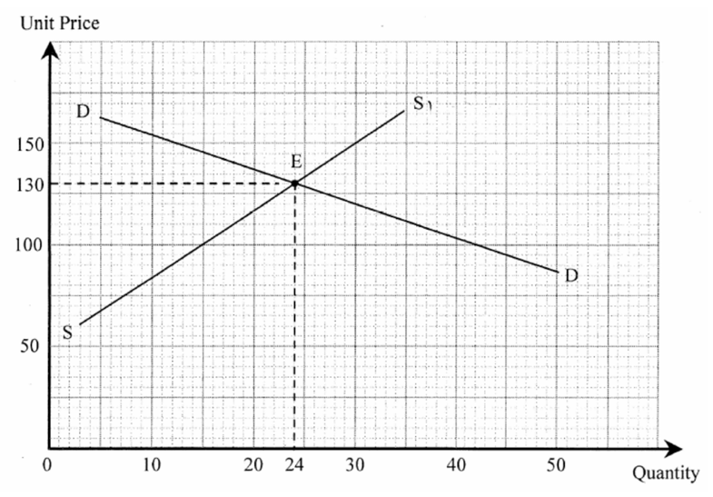
The graph below shows the market situation of Good A when a per-unit sales tax of $30 is charged on it. Suppose the above per-unit sales tax is abolished. The new market price would be
A. $100 B. $120 C. $140 D. $160
下圖顯示當政府徵收某物品每單位$30的從量銷售稅是該物品的市場情況。假設政府取消上述從量銷售稅。新市價會是多少？
A. $100 B. $120 C. $140 D. $160
Example Question 23 CE2006MCQ12 (Type 2 but need based on MCQ22)
With the range of the original and new market prices, the elasticity of demand of Good A is
A. smaller than its elasticity of supply B. equal to its elasticity of supply
C. greater than its elasticity of supply D. unity

在新、舊市價範圍內，該物品的需求彈性
A. 低於其供應彈性。 B. 等於其供應彈性。
C. 高於其供應彈性。 D. 是單一。

Example Question 24 CE2007MCQ6
Refer to the following demand and supply schedules of a good.
Price per unit | $20 | $25 | $30 | $35 | $40
Quantity demanded (Units) | 120 | 100 | 80 | 75 | 60
Quantity supplied (Units) | 80 | 80 | 80 | 80 | 80
If the government imposes a per-unit tax of $5 on the good, the new equilibrium price inclusive of tax will be _______.
A. $25 B. $30 C. $35 D. $40

下表是某物品的供需表：
單位價格 ($) | $20 | $25 | $30 | $35 | $40
需求量(單位) | 120 | 100 | 80 | 75 | 60
供應量(單位) | 80 | 80 | 80 | 80 | 80
若政府向物品徵收$5從量稅，連稅在內新的均衡價格會是 _____。
A. $25 B. $30 C. $35 D. $40

Example Question 25 CE2008MCQ7
The following table shows the supply of and demand for Good X.
Unit price ($) | Quantity Demanded (units) | Quantity Supplied (units) | 單位價格 ($) | 需求量 (單位) | 供應量 (單位)
5 | 10 | 50 | 5 | 10 | 50
4 | 20 | 40 | 4 | 20 | 40
3 | 30 | 30 | 3 | 30 | 30
2 | 40 | 20 | 2 | 40 | 20
1 | 50 | 10 | 1 | 50 | 10
If the government imposes a $2 per unit sales tax on Good X, the new equilibrium price will be ___.
A. $2 B. $3 C. $4 D. $5
下表顯示物品X的供需情況。若政府對物品徵收$2的從量銷售稅，新的均衡價格便會是。
A. $2 B. $3 C. $4 D. $5
Example Question 26 CE1990MCQ24
If a government abandons the policy of giving subsidy to farm products, then the price of farm products will __________ and the quantity of farm products transacted will __________ .
A. increase, increase B. decrease, decrease C. increase, decrease D. decrease, increase

如果政府取消對農產品的津貼，農產品的價格會，而交易數量會。
A. 上升，增加 B. 下降，減少 C. 上升，減少 D. 下降，增加

***Example Question 27 CE1995MCQ10
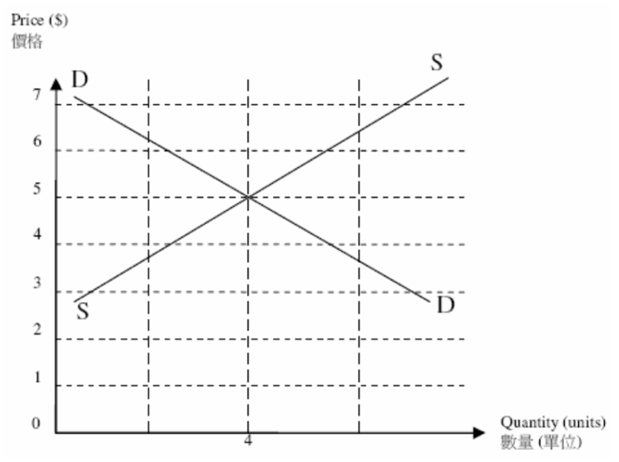
The above diagram shows the supply and demand for good X. If the government offers a subsidy of $2 for each unit of output, the market price will
A. decrease to $3. B. decrease to $4. C. increase to $6. D. increase to $7

以上是物品X的供需圖。若政府對每單位的產出津貼$2，市價會
A. 下跌至$3 B. 下跌至$4 C. 上升至$6 D. 上升至$7

Example Question 28 CE1996MCQ11
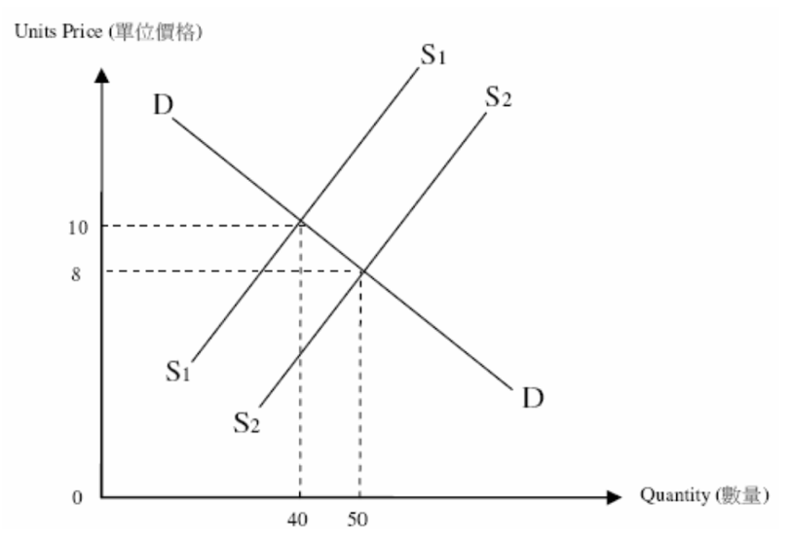
The diagram below shows that the unit price of a commodity falls from $10 to $8 when the government provides a per-unit subsidy of $5 to its suppliers. What is the total amount of suppliers’ benefit from the government subsidy?
A. $80 B. $120 C. $150 D. $250

下圖顯示，當某商品供應商獲得政府每單位$5的從量津貼時，該商品的單位價格從$10跌至$8。供應商從政府津貼中所獲得的利益共
A. $80 B. $120 C. $150 D. $250

Example Question 29 CE2000MCQ11
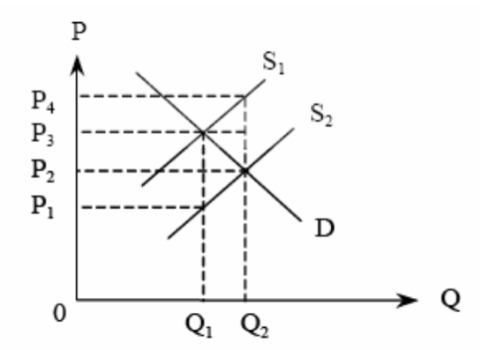
The amount of subsidy benefit enjoyed by the sellers of good Y is
A. (P2 –P1)×Q1 B. (P3–P1)×Q1 C. (P3–P2)×Q2 D. (P4–P3)×Q2

假設政府對物品Y給予從量津貼，使它的供應曲線從S1移至S2。物品Y的賣家可享有的津貼利益是
A. (P2 –P1)×Q1 B. (P3–P1)×Q1 C. (P3–P2)×Q2 D. (P4–P3)×Q2

Example Question 30 CE2001MCQ7
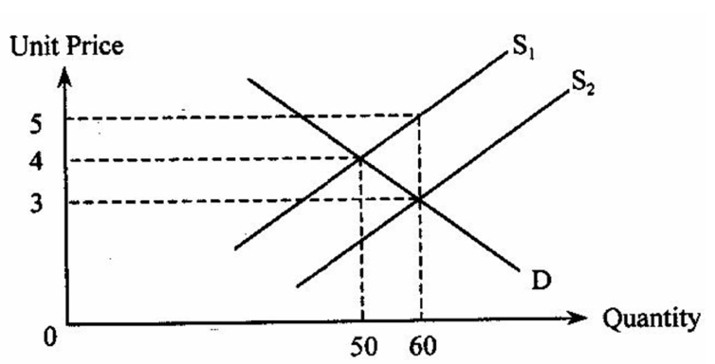
The above diagram shows the increase in supply of a good from S1 to S2 as a result of the provision of a per unit subsidy for the good by the government. Suppliers’ new total revenue excluding the subsidy ______ their old total revenue before the provision of the subsidy.
A. is smaller than B. is equal to C. is larger than D. may be larger or smaller than

上圖顯示政府對某物品提供從量津貼的結果：該物品的供應由S1增加至S2。供應商新的總收益再減去上述津貼後 _____ 之前政府沒有提供津貼時供應商的總收益
A. 少於 B. 等於 C. 多於 D. 可能多於或少於

Example Question 31 CE2004MCQ11
The following table shows the market demand and supply of a good.
Unit price ($) | Quantity Demanded (units) | Quantity Supplied (units) | 單位價格 ($) | 需求量 (單位) | 供應量 (單位)
10 | 70 | 130 | 10 | 70 | 130
9 | 90 | 120 | 9 | 90 | 120
8 | 110 | 110 | 8 | 110 | 110
7 | 130 | 100 | 7 | 130 | 100
6 | 150 | 90 | 6 | 150 | 90
5 | 170 | 80 | 5 | 170 | 80
If the government provides a per unit subsidy of $3 to the suppliers,
A. the new equilibrium price is $5 per unit.
B. the total amount of subsidy provided is $390.
C. the subsidy benefit enjoyed by the consumers is greater than that of the suppliers.
D. the total expenditure of consumers will decrease.

下表顯示某物品的市場需求及供應，若政府向供應商提供從量津貼$3，
A. 新均衡價格是每單位為$5。 B. 津貼總額是$390。
C. 消費者享有的津貼利益大於供應商。 D. 消費者總支出會減少。

Example Question 32 DSEPPMCQ8
An increase in tobacco duty will lead to
A. a rise in government tax revenue from cigarettes. B. a rise in smokers’ total expenditure on cigarettes.
C. a fall in the total market value of cigarettes. D. a fall in cigarette retailers’ total revenue net of tax.

增加煙草稅會導致
A. 政府從香港所徵收的稅款增加。 B. 吸煙人士對香煙的總支出增加。
C. 香煙總市值下降。 D. 香煙零售稅除稅後的總收益下降。

Example Question 33 DSEPPMCQ11
Refer to the following demand and supply schedules of good X.
Unit price ($) | 20 | 18 | 16 | 14 | 12 | 10
Quantity demanded (units) | 500 | 550 | 600 | 650 | 700 | 750
Quantity supplied (units) | 800 | 750 | 700 | 650 | 600 | 550
If the government lowers the quota from 700 units to 550 units,
A. the market price will drop by $2. B. the market price will rise by $2.
C. the market price will rise by $4. D. the market price will rise by $6.

參閱以下物品X的需求表及供應表。
單位價格 ($) | 20 | 18 | 16 | 14 | 12 | 10
需求量(單位) | 500 | 550 | 600 | 650 | 700 | 750
供應量(單位) | 800 | 750 | 700 | 650 | 600 | 550
若政府把配額由700單位減低至550單位，
A. 市價會下跌$2。 B. 市價會上升$2。
C. 市價會上升$4。 D. 市價會上升$6。

Example Question 34 DSE2012MCQ16
Refer to the following demand-supply schedule of good X.
Price ($) | Quantity demanded (units) | Quantity supplied (units) | 單位價格 ($) | 需求量 (單位) | 供應量 (單位)
10 | 700 | 300 | 10 | 700 | 300
11 | 600 | 400 | 11 | 600 | 400
12 | 500 | 500 | 12 | 500 | 500
13 | 400 | 600 | 13 | 400 | 600
14 | 300 | 700 | 14 | 300 | 700
15 | 200 | 800 | 15 | 200 | 800
If the government imposes a per unit tax of $4 on good X,
A. The total tax revenue will $2000 B. The total sales revenue will drop by $1800
C. The demand for good X is inelastic D. The total sales revenue of the substitutes of good X will drop

參閱以下物品X的供需表。若政府對物品X徵收$4從量稅，
A. 總稅收會是$2000。 B. 總銷售收益會減少$1800。
C. 物品X的需求屬低彈性。 D. 物品X替代品的總銷售收益會下降。

Example Question 35 DSE2012MCQ17
With reference to the above question, the ratio of the consumers’ tax burden to the producers’ tax burden is _________.
A. 1:1 B. 1:3 C. 3:1 D. None of the above

參閱上題，消費者稅項負擔和生產者稅項負擔的比率是
A. 1:1 B. 1:3 C. 3:1 D. 以上各項均不是

Example Question 36 DSE2012MCQ19
The increase of an effective quota on a good will result in
(1) An increase in the quantity transacted of the good
(2) A further improvement in the quality of the good
(3) A smaller deadweight loss
A. (1) and (2) only B. (1) and (3) only C. (2) and (3) only D. (1), (2) and (3)

增加對某物品的有效配額會導致
(1) 該物品的交易量上升。
(2) 該物品的質素進一步提升。
(3) 效率損失較小。
A. 只有(1)、(2) B. 只有(1)、(3) C. 只有(2)、(3) D. (1)、(2)及(3)
Example Question 37 DSE2013MCQ13
The following table shows the demand and supply schedule of good X
Price ($) | 2 | 3 | 4 | 5 | 6 | 7 | 8
Quantity demanded (units) | 90 | 80 | 70 | 60 | 50 | 40 | 30
Quantity supplied (units) | 30 | 40 | 50 | 60 | 70 | 80 | 90
Suppose the government imposes a $2 per-unit sales tax on each unit of good X sold. The total sales revenue net of tax is ______.
A. $180 B. $200 C. $280 D. $300

以下是物品X的供需表。
單位價格 ($) | 2 | 3 | 4 | 5 | 6 | 7 | 8
需求量(單位) | 90 | 80 | 70 | 60 | 50 | 40 | 30
供應量(單位) | 30 | 40 | 50 | 60 | 70 | 80 | 90
假設政府就每售賣一單位物品X收取$2從量銷售稅。除稅後的總銷售收益是 ______ 。
A. $180 B. $200 C. $280 D. $300

Example Question 38 DSE2013MCQ14
Refer to the following demand-supply diagram.
參閱以下供需圖。
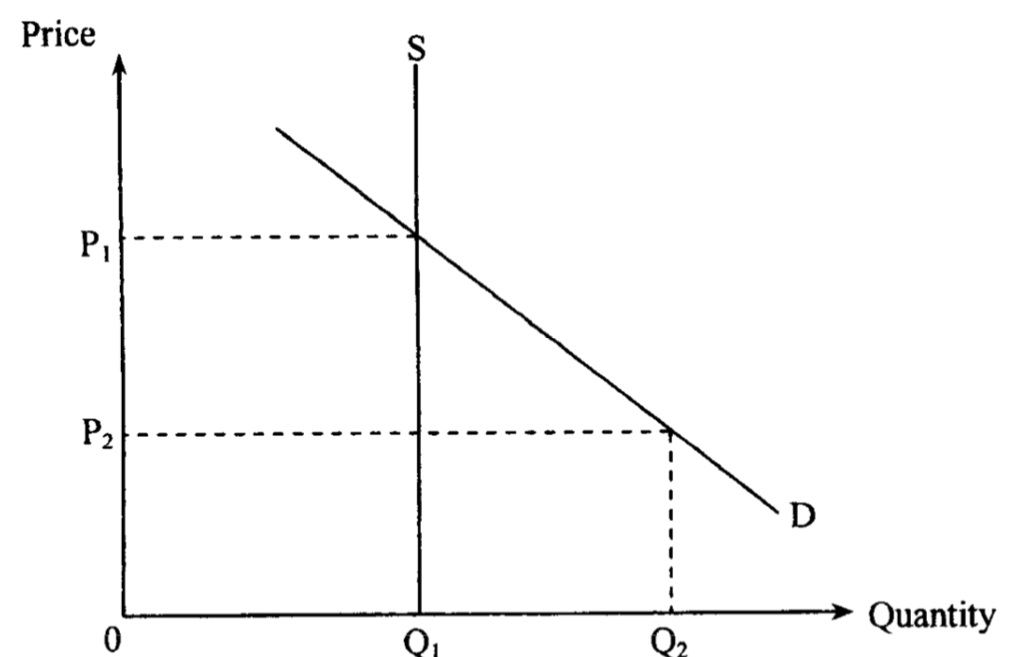
If the government raises the price floor from P2 to P1, the total revenue received by the sellers
A. will rise. B. will fall. C. will remain unchanged.
D. may rise or fall, depending on the price elasticity of demand.

若政府將價格下限由P2提高至P1 ，賣方收取的總收益
A. 會上升。 B. 會下降。 C. 會維持不變。
D. 可能上升或下降，視乎需求的價格彈性。

Example Question 39 DSE2013MCQ15
Suppose the government introduces an effective rent control which sets a maximum rental per square feet the landlords can charge to any tenants. Which of the following statement is correct?
- There will be a shortage of rental units
- The landlords will have less incentive to rent out their flats
- The landlords will spend less on maintenance of the rental flats
A. (1) and (2) only B. (1) and (3) only C. (2) and (3) only D. (1) , (2) and (3)

假設政府實施有效租金管制，即爲業主可向租客收取的每平方呎租金設定上限。下列哪項陳述是正確的？
(1) 出租單位會有短缺。
(2) 業主出租他們單位的意欲會較低。
(3) 業主會花費較少的金錢維修出租單位。
A. 只有(l)、(2) B. 只有(1)、(3) C. 只有(2)、(3) D. (l)、(2)及(3)

Example Question 40 DSE2014MCQ21
Which of the following are results of the government lowering an effective price ceiling on a good?
(1) A reduction in the producer surplus
(2) An increase in excess demand
(3) An increase in the total sales revenue if the demand is elastic
A. (1) and (2) only B. (1) and (3) only C. (2) and (3) only D. (1) , (2) and (3)

下列哪些是政府降低對某物品的有效價格上限的結果？
(1) 生產者盈餘下降。
(2) 超額需求上升。
(3) 若需求屬高彈性，總銷售收益會上升。
A. 只有(l)、(2) B. 只有(1)、(3) C. 只有(2)、(3) D. (l)、(2)及(3)

Example Question 41 DSE2014MCQ22
The imposition of a per-unit sales tax on cosmetics will
A. Reduce the total expenditure on cosmetics B. Reduce the total sales revenue (net-of-tax)
C. Increase the total social surplus in the cosmetics market. D. Increase the producer surplus in the cosmetics market.

政府對化妝品開徵從量銷售稅會
A. 引致對化妝品的總支出下降。 B. 引致除稅後總銷售收益下降。
C. 增加化妝品市場的總社會盈餘。 D. 增加化妝品市場的生產者盈餘。

Example Question 42 DSE2014MCQ16
Refer to the following demand and supply schedules of a good.
Price | $1 | $2 | $3 | $4 | $5
Quantity demanded (unit) | 120 | 100 | 80 | 75 | 60
Quantity supplied (unit) | 60 | 75 | 80 | 100 | 120
According to the information, we can conclude that
A. The total sales revenue would be $200 when the price is $2.
B. There would be a shortage of 25 units when the government imposes a price floor at $4.
C. When a per unit subsidy of $2 was granted to the seller, the total revenue (including the subsidy) would increase by $160.
D. When a per unit subsidy of $2 was granted to the seller, the equilibrium price would drop to $1.

參閱以下某物品的供需表。
單位價格 ($) | $1 | $2 | $3 | $4 | $5
需求量(單位) | 120 | 100 | 80 | 75 | 60
供應量(單位) | 60 | 75 | 80 | 100 | 120
根據以上資料，我們可得出結論如下：
A. 當價格是$2，總銷售收益是$200。
B. 當政府把價格下限定為$4，市場會出現25單位的短缺。
C. 當政府給予賣家每單位$2的補貼，總收益（包括補貼）會增加$160。
D. 當政府給予賣家每單位$2的補貼，均衡價格會下降至$1。

Example Question 43 DSE2015MCQ13
Many people queued up for days the tickets to watch the show of Tsz-Wah, a famous artist performing stand-up comedy. Some people complained that they were unable to buy tickets even though they were willing to pay the ticket price set by the organiser. The above situation implies that
A. Price was the only criterion for allocating the tickets. B. The producer was not maximising its profit
C. A black market for the tickets might emerge. D. There was an effective price ceiling in the ticket market.

很多人連日排隊買票觀看著名藝人子華的棟篤笑表演。有些人投訴他們雖然願意支付主辦機構所訂的門票價格，但他們仍買不到門票。上述情況意味着
A. 價格是分配門票的唯一準則。 B. 生產商沒有爭取最高利潤。
C. 有可能出現黑市門票。 D. 門票市場存在有效的價格上限。

Example Question 44 DSE2017MCQ16
Refer to the following supply and demand schedules for Good X
Unit price ($) | 6 | 7 | 8 | 9 | 10 | 11 | 12 | 13
Quantity demanded | 140 | 130 | 120 | 110 | 100 | 90 | 80 | 70
Quantity supplied | 60 | 70 | 80 | 90 | 100 | 110 | 120 | 130
If the government imposed a $2 per unit tax on Good X,
A. Sellers’ revenue net of tax would become $990 B. Tax burden borne by the sellers would be $90
C. The total tax revenue would be $200 D. Buyers’ total expenditure on Good X would decrease by $40

參看下列物品X的供需表。
單位價格 ($) | 6 | 7 | 8 | 9 | 10 | 11 | 12 | 13
需求量(單位) | 140 | 130 | 120 | 110 | 100 | 90 | 80 | 70
供應量(單位) | 60 | 70 | 80 | 90 | 100 | 110 | 120 | 130
若政府對物品X開徵$2從量稅，
A. 賣家的除稅後收入會是$990。 B. 賣家承擔的稅項負擔會是$90。
C. 總稅項收入會是$200。 D. 買家對物品X的總支出會下降$40。

Example Question 45 DSE2017MCQ18
Suppose the government imposed an effective rent control on living units. Which of the following would LEAST likely occur?
A. There would be a shortage of living units
B. Black market would emerge
C. Poor people would be able to rent a living unit more easily
D. Landlords would have a lower incentive to renovate their living units for rent

假設政府對住宅單位實施有效的租金管制。下列哪項出現的可能性最低？
A. 住宅單位會出現短缺。
B. 黑市會出現。
C. 窮人能夠較容易租得住宅單位。
D. 業主會有較低意欲翻新其住宅單位作出租之用。

Example Question 46 DSE2018MCQ18
Refer to the following supply and demand schedules for Good X.
Unit price ($) | 13 | 12 | 11 | 10 | 9 | 8 | 7
Quantity demanded (units) | 70 | 80 | 90 | 100 | 110 | 120 | 130
Quantity supplied (units) | 130 | 120 | 110 | 100 | 90 | 80 | 70
Suppose the government increases the price ceiling from $8 to $12. Which of the following statements is correct?
A. There would be a shortage of 40 units of Good X B. There would be a surplus of 40 units of Good X
C. The total expenditure on Good X would increase by $360 D. The quantity transacted of Good X would remain unchanged

參閱以下物品X的供需表。
單位價格 ($) | 13 | 12 | 11 | 10 | 9 | 8 | 7
需求量(單位) | 70 | 80 | 90 | 100 | 110 | 120 | 130
供應量(單位) | 130 | 120 | 110 | 100 | 90 | 80 | 70
假設政府將價格上限由$8提高至$12，下列哪項陳述是正確的？
A. 物品X會出現40單位的短缺。 B. 物品X會出現40單位的盈餘。
C. 對物品X的總支出會上升$360。 D. 物品X的交易量會維持不變。

Example Question 47 DSE2019MCQ16
Refer to the following supply and demand schedules of Good X.
Unit price ($) | 18 | 16 | 14 | 12 | 10 | 8 | 6
Quantity demanded (units) | 100 | 150 | 200 | 250 | 300 | 350 | 400
Quantity supplied (units) | 400 | 350 | 300 | 250 | 200 | 150 | 100
If the government increases the quota for Good X from 200 units to 350 units, the market price will
A. increase by $2 B. increase by $6 C. decrease by $2 D. decrease by $6

參閱以下物品X的供需表。
單位價格 ($) | 18 | 16 | 14 | 12 | 10 | 8 | 6
需求量(單位) | 100 | 150 | 200 | 250 | 300 | 350 | 400
供應量(單位) | 400 | 350 | 300 | 250 | 200 | 150 | 100
若政府把物品X的配額由200單位增加至350單位，市場價格會 _____ 。
A. 上升$2 B. 上升$6 C. 下降$2 D. 下降$6

Example Question 48 DSE2020MCQ15
The following table shows the demand and supply schedules of a good.
Price ($) | Quantity demanded (units) | Quantity supplied (units) | 單位價格 ($) | 需求量 (單位) | 供應量 (單位)
20 | 70 | 40 | 20 | 70 | 40
22 | 60 | 45 | 22 | 60 | 45
24 | 50 | 50 | 24 | 50 | 50
26 | 40 | 55 | 26 | 40 | 55
28 | 30 | 60 | 28 | 30 | 60
If the government provides a $6 per-unit subsidy for the producers of the good, the total subsidy provided by the government will be _______ and the ratio of consumers’ share to producers’ share of the subsidy will be _______.
A. $300 … … 1:1 B. $300 … … 1:2 C. $360 … … 1:1 D. $360 … … 1:2

下表顯示某物品的供需表。若政府及該物品的生產商每單位$6補貼，政府提供的補貼總額會是 ______，而消費者補貼份額和生產者補貼份額的比率會是 ______ 。
A. $300 … … 1:1 B. $300 … … 1:2 C. $360 … … 1:1 D. $360 … … 1:2

Example Question 49 DSE2020MCQ16
Refer to the following supply-demand diagram for the exported Chinese rare earth minerals.
參考以下中國稀土出口的供需圖。
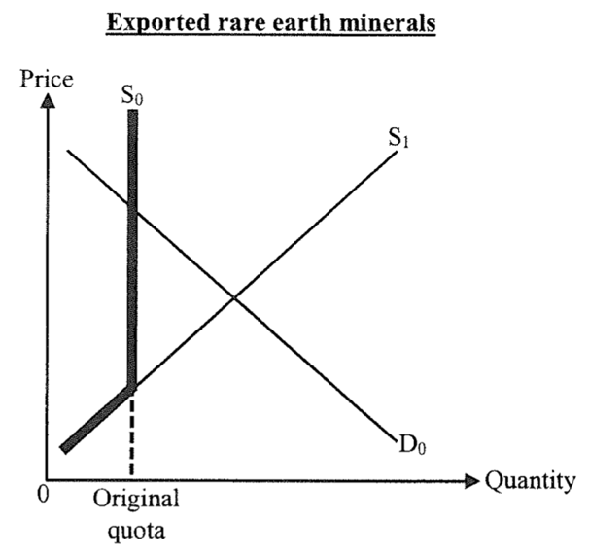
If China abolished the quota on the export of rare earth minerals,
(1) the export price of the rare earth minerals would drop.
(2) the export quantity if the rare earth minerals would raise.
(3) the total exchange value of the exported rare minerals would drop.
A. (1) and (2) only. B. (1) and (3) only. C. (2) and (3) only. D. (1), (2) and (3)

若中國取消對稀土的出口配額，
(1) 稀土的出口價格會下降。
(2) 稀土的出口數量會上升。
(3) 出口稀土的總交易價值會下降。
A. 只有(l)、(2) B. 只有(1)、(3) C. 只有(2)、(3) D. (l)、(2)及(3)

Type 1 (Effect of Market Intervention, P / Q / TR / Tax / Subsidies)

Type 2 (Market Intervention cross topic Elasticity)
Example Question 1 CE1990MCQ51
Suppose the government increases the tax on cigarettes by $2. Consequently, the price of each packet of cigarettes increases by $1.5. Which of the following statements is true?
A. The producers bear 1/4 of the tax. B. The demand for cigarettes is elastic.
C. The supply of cigarettes is elastic. D. The tax is progressive in nature.

假設政府增加$2香煙稅，每包香煙的價格因而上升了$1.5。下列哪一項描述為正確？
A. 生產者負擔了稅項的¼。 B. 香煙的需求有彈性。
C. 香煙的供應有彈性。 D. 香煙稅是一種累進稅。

Example Question 2 CE1995MCQ11
Suppose the government imposes a per unit sales tax of $5 on good X. Under what condition will the price increase by $5?
A. The supply of X is unitary elastic. B. supply of X is perfectly inelastic.
C. The demand for X is perfectly inelastic. D. The demand for X is unitary elastic.

假設政府對物品X徵收從量銷售稅$5。在下列那一種情況下，它的價格會增加$5？
A. X的供應屬單一彈性。 B. X的供應屬完全無彈性。
C. X的需求屬完全無彈性 D. X的需求屬單一彈性

Example Question 3 CE2001MCQ8
Suppose a per unit sales tax is imposed on good X. The sellers would bear a relatively smaller proportion of the tax burden if the demand for the good is _____ and the supply is _____.
A. elastic ... elastic B. elastic ... inelastic C. inelastic ... elastic D. inelastic ... inelastic

假設政府對物品X徵收從量銷售稅。若物品X的需求屬 _____ 而供應屬 _____ ，則賣方會相對地承擔較少比例的課稅負擔。
A. 高彈性 … 高彈性 B. 高彈性 … 低彈性 C. 低彈性 … 高彈性 D. 低彈性 … 低彈性

Example Question 4 CE2003MCQ11
Refer to the following market demand schedule of a good
Price ($) | 11 | 12 | 13 | 14
Quantity demanded (units) | 160 | 140 | 120 | 100
Suppose the government imposes a unit sales tax of $3 on the good. As a result, the equilibrium price of the good increase from $12 per unit to $13 per unit. Which of the following descriptions is correct?
A. The consumers bear a larger tax burden than the producers
B. The elasticity of demand of the good is greater than 1
C. The total tax burden is $120
D. The total sales revenue (including tax) has increased

單位價格 ($) | 11 | 12 | 13 | 14
需求量(單位) | 160 | 140 | 120 | 100
參閱以下某物品的市場需求表：假設政府對該物品徵收每單位$3的從量銷售稅，結果，該物品的均衡價格由每單位$12增加至每單位$13。下列那一項描述是正確的？
A. 消費者比生產者有較大的稅項負擔。 B. 該物品的需求彈性大於一。
C. 總稅項負擔是$120。 D. 總銷售收益（連稅在內）增加。

Example Question 5 CE2003MCQ12
If the equilibrium price of the good falls back to $12 per unit due to a decrease in production cost,
A. the producers will bear all the tax burden B. the total tax burden will be $360
C. there will be excess demand D. the total sales revenue net of tax will be $1260

若由於生產成本減少，該物品的均衡價格降回至每單位$12，則
A. 生產者會承擔全部稅項負擔。 B. 總稅項負擔會變成$360。
C. 會出現超額需求。 D. 除稅後的總銷售收益會變成$1260。

Example Question 6 CE2004MCQ10
Suppose the government imposes a per unit sales tax on good X of which the supply is perfectly inelastic. Only _____ will bear the tax burden, and the quantity transacted will _____ .
A. sellers ... remain unchanged B. sellers ... decrease
C. buyers ... remain unchanged D. buyers ... decrease

假設政府對物品X徵收從量銷售稅，X的供應是完全無彈性的。只有 _____ 要負擔該稅項而交易量 _____ 。
A. 賣家 … 不會改變 B. 賣家 … 會下降
C. 買家 … 不會改變 D. 買家 … 會下降

Example Question 7 CE2007MCQ11
The imposition of a per unit sales tax on a good will reduce its equilibrium quantity if
A. the demand is inelastic B. the demand is elastic
C. the demand is unitarily elastic D. All of the above is correct

在下列那一種情況下，政府向某物品徵收從量銷售稅會減少其均衡量？
A. 需求為低彈性 B. 需求為高彈性
C. 需求彈性屬單一彈性 D. 以上皆為正確答案

Example Question 8 CE2008MCQ8
Suppose the per unit sales tax on red wine is reduced. The sellers will enjoy a smaller proportion of a reduction in tax burden than the buyers if the demand for red wine is _____ and the supply is _____ .
A. elastic … elastic B. elastic … inelastic C. inelastic … elastic D. inelastic … inelastic

假設政府降低葡萄酒的從量銷售稅。若葡萄酒的需求屬 _____ 而供應屬 ____ ，則賣家稅項負擔的減少在比例上較買家為小。
A. 高彈性 … 高彈性 B. 高彈性 … 低彈性 C. 低彈性 … 高彈性 D. 低彈性 … 低彈性

Example Question 9 CE1999MCQ4
Case I : The market price of Good X decreases by $4 per unit after the provision of a $10 per unit subsidy. Case II : The market price of Good X decreases by $6 per unit after the provision of a $10 per unit subsidy. We can conclude that in comparing the two cases, Good X in Case I has a _____ demand or a _____ supply.
A. less elastic ... less elastic B. more elastic ... more elastic
C. less elastic ... more elastic D. more elastic ... less elastic

個案一：對物品X給予$10從量津貼後，它的市價下跌$4。
個案二：對物品X給予$10從量津貼後，它的市價下跌$6。
我們可得出結論如下：比較兩個個案，物品X在個案一的需求彈性 _____ 或供應彈性 _____。
A. 較高 … 較低 B. 較高 … 較高
C. 較低 … 較高 D. 較高 … 較低

Example Question 10 CE1994MCQ11
The demand for good X is perfectly inelastic. If the government offers subsidy of $4 for each unit of X produced, the equilibrium price of X will
A. remain unchanged B. decrease by $4 C. decrease by less than $4 D. decrease by more than $4

物品X的需求完全無彈性。假設每生產一單位，政府便津貼$4，獲得津貼後，X的均衡價格會
A. 保持不變 B. 下跌$4 C. 下跌少於$4 D. 下跌多於$4
Example Question 11 DSE2015MCQ12
The government provides a per-unit subsidy of $10 on producing green products. The market price drops by $6 as result. Which of the following statements about the green product market is/are correct?
(1) The supply of green products is more elastic than their demand.
(2) Consumers enjoy more subsidy benefits than producers.
(3) The demand for green products increases.
A. (2) only B. (1) and (2) only C. (1) and (3) only D. (1), (2) and (3)

政府對生產綠色產品提供$10的從量補貼，市場價格因而下降了$6。下列哪項 / 些有關綠色產品市場的陳述是正確的？
(1) 綠色產品的供應較其需求更具彈性。
(2) 消費者所獲得的補貼得益比生產者多。
(3) 綠色產品的需求上升。
A. 只有(2) B. 只有(1)、(2) C. 只有(1)、(3) D. (l)、(2)及(3)

Example Question 12 DSE2015MCQ16
Refer to the following table for the supply and demand schedule for a good.
Unit price ($) | 4 | 5 | 6 | 7 | 8
Quantity demanded (units) | 16 | 14 | 12 | 10 | 8
Quantity supplied (units) | 14 | 14 | 14 | 14 | 14
The government imposes a $2 per unit tax on the good. Which of the following statements about the good in correct?
A. Sellers’ revenue net of tax is $70. B. The new market price is $6.
C. The total tax revenue is $28. D. The above information is insufficient to determine the tax burden on sellers.

細閱下列有關某物品的供需表。
單位價格($) | 4 | 5 | 6 | 7 | 8
需求量(單位) | 16 | 14 | 12 | 10 | 8
供應量(單位) | 14 | 14 | 14 | 14 | 14
假設政府對該物品徵收$2的從量稅。下列那看有關該物品的陳述是正確的？
A. 賣方的除稅後收入會是$70。 B. 新的市場價格是$6。
C. 總稅項收入是$28。 D. 上述資料不足以判斷賣方的稅項負擔。

Example Question 13 DSE2016MCQ19
Refer to the following demand and supply schedules of a good.
Price ($) | 40 | 50 | 60 | 70 | 80 | 90
Quantity demanded (units) | 14 | 12 | 10 | 8 | 6 | 4
Quantity supplied (units) | 6 | 8 | 10 | 12 | 14 | 16
Which of the following statements is correct when the government provides a per unit subsidy of $20 on the good?
A. The total revenue including the subsidy is $840.
B. The total subsidy granted by the government is $200.
C. Within the range of the original and new market prices, the elasticity of demand is smaller than 1.
D. The change in total revenue of its complements is uncertain.

參閱以下某物品的供需表。
單位價格 ($) | 40 | 50 | 60 | 70 | 80 | 90
需求量(單位) | 14 | 12 | 10 | 8 | 6 | 4
供應量(單位) | 6 | 8 | 10 | 12 | 14 | 16
當政府對該物品提供每單位$20的補貼，下列哪項陳述是正確的？
A. 包括補貼在內的總收益是$840。
B. 政府所支付的補貼總額是$200。
C. 在原初市價和新市價的範圍內，需求彈性少於一。
D. 它的輔助品的總收入轉變是未能確定的。

Example Question 14 DSE2018MCQ14
The government imposes a per unit tax on a good. The price of the good will remain unchanged if
(1) The demand is perfectly elastic
(2) The demand is perfectly inelastic
(3) The supply is perfectly elastic
(4) The supply is perfectly inelastic
A. (1) and (3) only B. (1) and (4) only C. (2) and (3) only D. (2) and (4) only

政府對某物品徵收從量稅。若_____，該物品的價格會維持不變。
(1) 需求屬完全彈性
(2) 需求屬完全無彈性
(3) 供應屬完全彈性
(4) 供應屬完全無彈性。
A. 只有(1)、(3) B. 只有(1)、(4) C. 只有(2)、(3) D. 只有(2)、(4)

Example Question 15 DSE2019MCQ14
Refer to the following market demand for imported soybeans in Country A.
Price ($) | 10 | 11 | 12 | 13 | 14
Quantity demanded (units) | 700 | 600 | 500 | 400 | 300
When the government of Country A imposes a per-unit tariff of $3 on imported soybeans, the equilibrium price of the imported soybeans increases from $11 to $13. Which of the following statements are correct?
- The total sales revenue (net of tariff) of the imported soybeans is $4000
- The supply of the imported soybeans is more elastic than the demand for them
- Within the range of the original and the new equilibrium prices, the elasticity of demand of the imported soybeans is smaller than one.
A. (1) and (2) only B. (1) and (3) only C. (2) and (3) only D. (1), (2) and (3)

參閱以下有關甲國對進口大豆的市場需求。
單位價格 ($) | 10 | 11 | 12 | 13 | 14
需求量(單位) | 700 | 600 | 500 | 400 | 300
當甲國政府對進口大豆徵收$3從量關稅，進口大豆的均衡價格由$11上升至$13。下列哪些陳述是正確的？
(1) 進口大豆的總銷售收入（扣除關稅後）會是$4000。
(2) 進口大豆的供應，比起其需求更具彈性。
(3) 在原初和新的均衡價格範圍內，進口大豆的需求彈性少於一。
A. 只有(1)、(2) B. 只有(1)、(3) C. 只有(2)、(3) D. (l)、(2)及(3)

Example Question 16 DSE2021MCQ16
Refer to the following demand-supply schedules of Good X.
Price ($) | Quantity demanded (units) | Quantity supplied (units)
80 | 100 | 80
90 | 100 | 90
100 | 100 | 100
110 | 100 | 110
120 | 100 | 120
130 | 100 | 130
If a $10 per-unit subsidy is provided to the producers of Good X,
(1) the total revenue including the subsidy will remain unchanged.
(2) the subsidy benefit will be received entirely by the producers.
(3) the total expenditure of consumers on Good X will reduce by $1000.
A. (1) and (2) only B. (1) and (3) only C. (2) and (3) only D. (1), (2) and (3)

參閱以下物品X的供需表。
單位價格 ($) | 需求量 (單位) | 供應量 (單位)
80 | 100 | 80
90 | 100 | 90
100 | 100 | 100
110 | 100 | 110
120 | 100 | 120
130 | 100 | 130
若對物品X的生產商提供$10的從量補貼，
(1) 總收入（包括補貼）維持不變。
(2) 生產者會獲得全部的補貼得益。
(3) 消費者對物品X的總支出會減少$1000。
A. 只有(1)、(2) B. 只有(1)、(3) C. 只有(2)、(3) D. (l)、(2)及(3)

Example Question 17 DSESPMCQ12
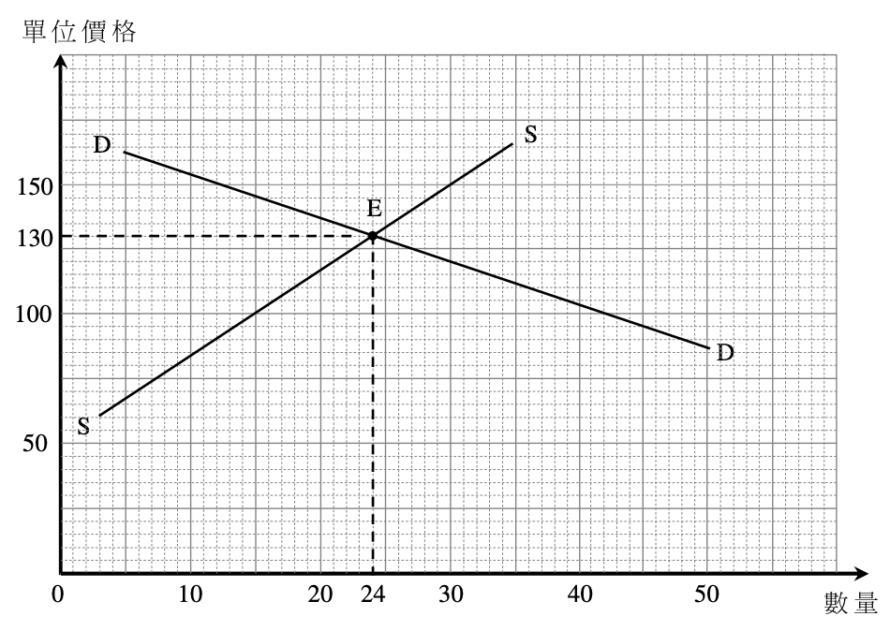
The graph below shows the market situation of Good X when the government provides a per-unit subsidy of $30 to the producers. Suppose the government abolishes the above per-unit subsidy. The new market price would be
A. $100 B. $120 C. $140 D. $160

根據以下資料，政府提供一項$30的從量補貼予X物品的生產商。下圖顯示X物品在得到補貼後的市場情況。假設政府取消上述重量補貼，新市價會是
A. $100 B. $120 C. $140 D. $160

Example Question 18 DSESPMCQ13
Within the range of the original and new market prices, the elasticity of supply of Good X is
A. smaller than its elasticity of demand. B. equal to its elasticity of demand.
C. greater than its elasticity of demand. D. unity.

在新，舊市價範圍內，X物品的供應彈性
A. 小於其需求彈性。 B. 等於其需求彈性。
C. 大於其需求彈性。 D. 是1。

Type 2 (Market Intervention cross topic Elasticity)

Type 3 (Market Intervention cross topic CSPS)
**Will be further discussed in Ch10 Consumer Surplus and Producer Surplus**
Example Question 1 DSE2015MCQ19
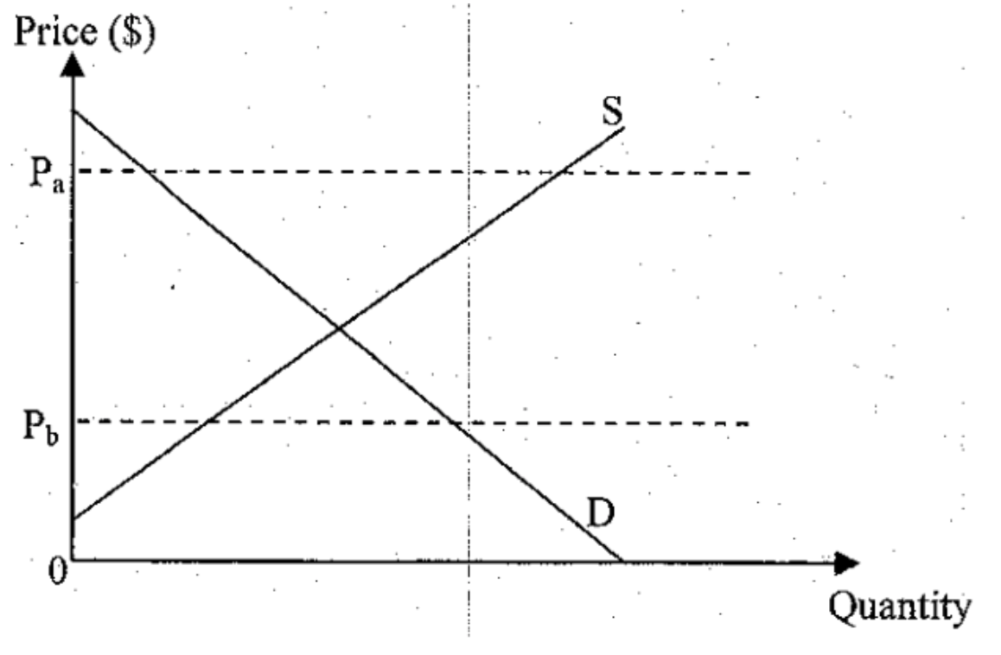
Refer to the following diagram, if the government lowers the price ceiling from Pa to Pb,
A. The quantity transacted will increase. B. The deadweight loss will decrease.
C. The producer surplus will decrease. D. The consumer surplus will increase.

細閱下圖。若政府將價格上限由PA調低至P B，
A. 交易量會上升。 B. 效率損失會下降。
C. 生產者盈餘會減少。 D. 消費者盈餘會增加。

2012DSE LQ5a
Country A has imposed an effective price ceiling on Good X. Suppose Country A eliminates all illegal transactions of Good X. Can this price control ensure all lower income buyers obtain the quantity of Good X they plan to purchase? Explain. (4)
甲國對物品X實施一有效的價格上限。假設甲國杜絕所有物品X的非法交易。這價格管制能確保所有較低收入的買家獲得他們計劃購買物品X的數量嗎？試加解釋。 (4)
_______________________________________________________________________________________
_______________________________________________________________________________________
_______________________________________________________________________________________
_______________________________________________________________________________________
_______________________________________________________________________________________
_______________________________________________________________________________________
_______________________________________________________________________________________
_______________________________________________________________________________________
Marking Scheme:
No, because (1)
There is excess demand / shortage OR (1)
Other competitive criteria / non-price competition, such as queuing, will emerge OR (2)
The new competitive criteria do not necessarily depend on income (2)
不會，因為 (1)
出現超額需求 / 短缺。 (1)
其他競爭準則 / 非價格競爭會出現，例如出現排隊。 (2)
新的競爭準則不一定和收入有關。 (2)
Candidates’ Performance:
Poor. Some candidates misinterpreted lowering the price ceiling as a relaxation of price control and the resulting increase in
Price, thus yielding an incorrect analysis. Among those who understood the gist of. The question, some failed to correctly
indicate the deadweight loss graphically.

尚可。雖然大部份考生正確指出價格控制不能確保低收入家庭會得到他們計劃購買的物品，但是他們未能好好解釋其原因。很多考生提及短缺，但沒有將該情況關連到非價格競爭上。部份考生就不清楚，「沒有非法交易」的意思是指「沒有黑市」。

***2013DSE LQ10c
There are cooks, waiters, managers and receptionists working in restaurants. The Hong Kong government has introduced an effective minimum wage. Subsequently, many restaurant owners claim that they are unable to employ enough workers for their restaurants at the minimum wage rate. With the aid of a demand-supply diagram, explain why the above phenomenon may arise. (9)
餐廳的工作人員包括廚師、侍應、經理和帶位員。香港政府引入了有效的最低工資。其後，很多餐廳東主聲稱未能以最低工資率為餐廳聘請足夠員工。以一供需圖輔助，解釋為什麼可能出現上述現象。 (9)
_______________________________________________________________________________________
_______________________________________________________________________________________
_______________________________________________________________________________________
_______________________________________________________________________________________
_______________________________________________________________________________________
_______________________________________________________________________________________
_______________________________________________________________________________________
_______________________________________________________________________________________
_______________________________________________________________________________________
_______________________________________________________________________________________
_______________________________________________________________________________________
_______________________________________________________________________________________
_______________________________________________________________________________________
_______________________________________________________________________________________
_______________________________________________________________________________________
_______________________________________________________________________________________
_______________________________________________________________________________________
_______________________________________________________________________________________
_______________________________________________________________________________________
_______________________________________________________________________________________
Marking Scheme:
Verbal Explanation:
An effective price floor will create a surplus of workers. If the restaurant workers change to work in other industries (for example, turn into security guards) the supply of workers in this industry drops, there may be a shortage for workers at the minimum wage rate. (4)
Indicate on the diagram:
- Wage rate set above the original equilibrium (1)
- Surplus (1)
- Magnitude of the leftward shift of the supply curve greater than surplus (2)
- Final shortage (1)

文字解說：
一有效的價格下限會造成工人的盈餘。若餐廳工人轉至其他的行業工作（例如轉當保安員），在這行業工人的供應下降。在最低工資率的水平，工人的短缺可能出現。 (4)
在圖中顯示：
- 工資率定在原初均衡之上 (1)
- 盈餘 (1)
- 供應曲線向左移幅度大於盈餘 (2)
- 最終短缺 (1)
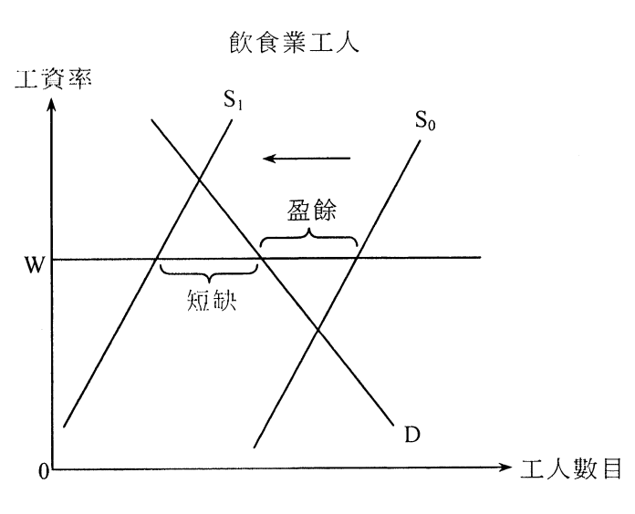

Candidates’ Performance:
Poor. Although the majority of candidates were able to use a demand-supply diagram to illustrate the concepts of price floor
and worker surplus, only a few of them could explain correctly how demand or supply changes accordingly to create “a
shortage under a price floor”. The following are some common mistakes:
- Misinterpretation of minimum wage as a price ceiling;
- Wrong configuration of an effective minimum wage as a wage set below the market-clearing wage in order to generate a shortage of labour;
- Mis-equating unemployment with labour shortage.

欠佳。雖然大部分考生能運用供需圖說明價格下限和工人的盈餘，但是只有小部分考生能正確解釋需求和供應相應的轉變令「價格下限中的短缺」出現。以下是常見的錯誤：
- 誤把最低工資當作價格上限。
- 錯誤配置有效最低工資：工資定在市場均衡工資之下令勞力短缺產生。
- 誤將失業當作勞力短缺。

2014DSE LQ9a
Many countries have a considered imposing ‘soft drink tax’ for health reasons. Suppose a country decides to impose a per unit tax on the sellers for every bottle of soft drink sold in the market. Under what condition will the soft drink buyers in the country bear a greater tax burden than the sellers? Illustrate your answer with a supply-demand diagram. (5)
許多國家以國民健康為理由考慮徵收「汽水稅」。假設某國決定對買家在市場中售出的每瓶汽水徵收一項從量稅。在什麼條件下該國的汽水買家會比賣家承受較高的稅項負擔？以一供需圖加以說明 (5)
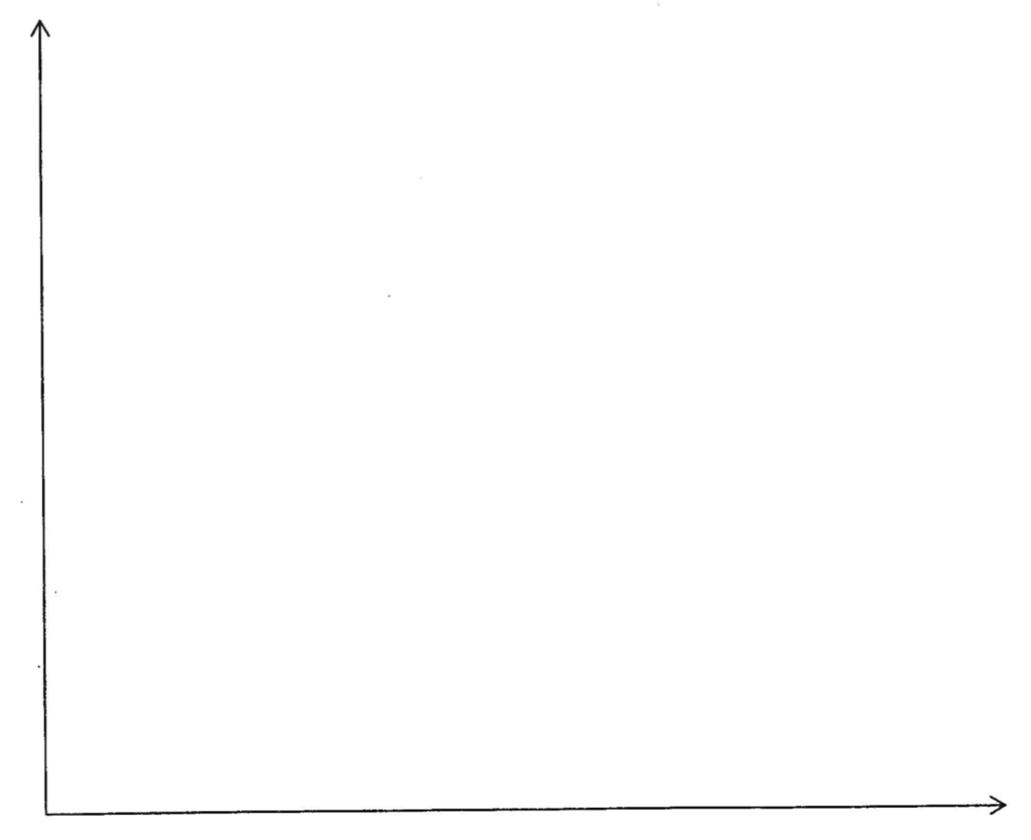
_______________________________________________________________________________________
_______________________________________________________________________________________
_______________________________________________________________________________________
_______________________________________________________________________________________

Marking Scheme:
Verbal explanation:
The condition is that the elasticity of demand for the good is smaller than the elasticity of supply. (1)
Indicate on the diagram:
- Parallel upward shift of supply curve due to the per unit tax (1)
- Price increases and quantity drops (1)
- Correct positions of buyer’s tax burden and sellers’ tax burden (1)
- Buyers’ tax burden > sellers’ burden (1)
文字解說：
- 該條件是該物品的需求彈性低於其供應彈性。 (1)
在圖中顯示：
- 供應曲線向上平衡移動。（由從量稅所引致） (1)
- P上升和Q下跌 (1)
- 買家和賣家稅項負擔的正確位置 (1)
- 買家負擔 > 賣家負擔。 (1)
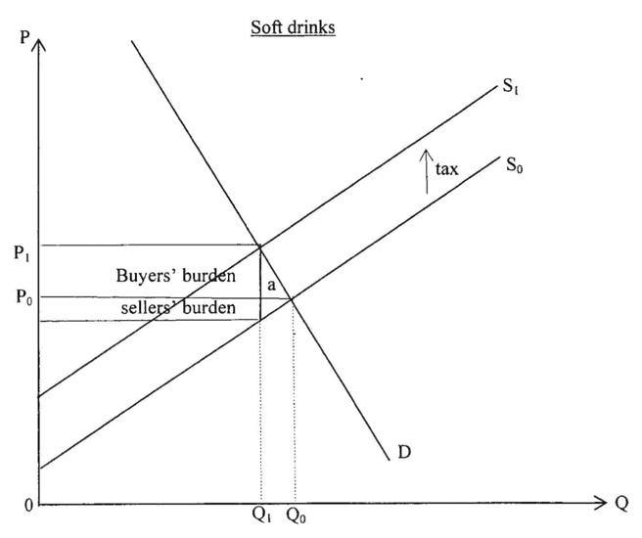
Candidates’ Performance:
Good. Many candidates indicated accurately the prices, quantities, and tax burdens before and after tax on a supply-demand diagram. There was a technical problem in graphical presentation, however, that candidates should be aware of- -the shading or using different colors to represent the tax burdens and the change in consumer surplus were sometimes hardly visible on the markers' computer screens. Candidates are thus advised to label the (3 or 4) corners of the relevant areas for these objects. A few candidates wrongly assumed inelastic demand and ignored the role of the demand and supply elasticities.

良好。很多考生能在供需圖中準確標示稅前和稅後的價格和數量，及稅項負擔。但是考生需要注意一個繪圖表達的技術問題：在標示稅項負擔時的陰影或用不同顏色在閱卷員的螢光幕上有時難以清楚看見。考生宜在有關的面積的三或四個角位作標示。一些考生錯誤地假設需求屬低彈性，忽略了需求和供應彈性的角色。

2015DSE LQ11c, d
Tobacco duty is an indirect tax in Hong Kong. The Financial Secretary has increased the tobacco duty rate with the aim of discouraging smoking.
(a) economist stated, “Other things being constant, the rise in the tobacco duty rate would not effectively reduce the quantity consumed of duty-paid cigarettes.” Justify his statement WITHOUT using a diagram. (4)
(b) In addition to the rise in tobacco duty, the Customs has made more effort to prevent the illegal sale of duty-not-paid cigarettes and has cracked down several illegal sellers. Is it possible that the quantity transacted of duty-not-paid cigarettes would increase? With the aid of a diagram, explain your answer. (7)
煙草稅是香港的一項間接稅。為了遏止吸煙，財政司司長增加了煙草稅率。
(a) 一位經濟學家指出：「其他因素不變，增加煙草稅都不會有效地減少已完稅香煙的消費量。」毋須運用圖表，論證他的陳述。 (4)
(b) 除了增加煙草稅，海關亦加強打擊非法售賣未完稅香煙，並搗破數個非法賣家。未完稅香煙的交易量有可能上升嗎？以圖輔助，加以解釋。 (7)
_______________________________________________________________________________________
_______________________________________________________________________________________
_______________________________________________________________________________________
_______________________________________________________________________________________
_______________________________________________________________________________________
_______________________________________________________________________________________
_______________________________________________________________________________________
_______________________________________________________________________________________
_______________________________________________________________________________________
_______________________________________________________________________________________

Marking Scheme:
(a) Tobacco duty would increase the market price of duty-paid cigarettes and thus reduce its quantity demanded (1)
If cigarette consumers are addicted, their demand for cigarettes would be inelastic, so the percentage decrease in quantity demanded would be smaller than the percentage increase in price. In this case, even a huge increase in tobacco duty may not be effective in reducing the consumption of cigarettes. (3)
(b) Verbal Explanation:
On the one hand, due to the HK Customs’ crack-down effort, the supply of duty-not-paid cigarettes would drop. On the other hand, as duty-paid cigarettes and duty-not-paid cigarettes are substitutes, tobacco duty would increase the demand for duty-not-paid cigarettes. It is thus possible that the total quantity of duty-not-paid cigarettes sold would increase if the increase in demand has a bigger effect on the quantity transacted than the decrease in supply. (4)
Indicate on the diagram:
- Rightward shift of the demand curve (1)
- Leftward shift of the supply curve (1)
- Final equilibrium with a higher quantity transacted (1)
(a) 煙草稅增加已完稅香煙的市場價格，故令其需求量下降。 (1)
若香煙消費者已吸煙成癮，他們對香煙的需求屬低彈性。因此需求量下降的百分率小於價格上升的百分率。在這情況下，即使煙草稅大幅上升，也未能有效減低香煙的消費。 (3)
(b) 文字解說：
一方面，未完稅香煙的供應因海關的打擊而下降。另一方面，因為未完稅和已完稅香煙屬代替品，煙草稅令未完 稅香煙的需求上升。未完稅香煙的銷售量有可能會上升，若需求上升對交易量的影響大於供應下降。 (4)
在圖中顯示：
- 需求曲線向右移 (1)
- 供應曲線向左移 (1)
- 最終均衡點的交易量較高 (1)
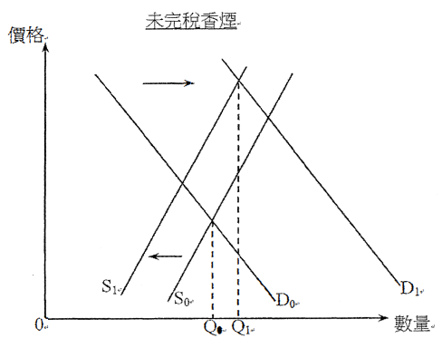
Candidates’ Performance:
(a) Fair. The following mistakes were common:
- neglecting the word "justify" and providing arguments against/ the statement;
- over-emphasizing the opportunity for the smokers to turn to the black market for cigarettes, while ignoring that the question only concerns duty-paid cigarettes,
- mistaking “effectiveness" for efficiency."

(b) Fair. Although most candidates were able to apply the supply- demand model to this somewhat complicated case. Some
filed to provide a comprehensive analysis. Common mistakes included:
- missing the keyword *duty-not-paid and wrongly focusing the discussion on duty-paid cigarettes;
- overlooking the effect of the rise in tobacco duty on the demand for duty-not-paid cigarettes;
- mis-locating the new equilibrium point despite correct specification of the shifts in demand and supply curves.

(a) 一般。常見的錯誤包括：
- 忽略了「論證」一詞，提出反對該陳述的論點。
- 過份強調吸煙人士可以向黑市購買香煙的機會，而忽略了這題目只跟已完稅香煙有關。
- 誤將「有效」當作「有效率」。

(b) 一般。雖然大部分考生均能應用供應需求模式於這較複雜的個案，但部分考生未能詳細分析這個案
常見的問題有：
- 忽略了關鍵詞「未完稅」，誤將討論重點放在「已完稅」香煙。
- 忽略了煙草稅上升對未完稅香煙的需求的影響。
- 錯誤地顯示新均衡點的位置，即使正確地指出需求和供應曲線的移動方向。

2016DSE LQ9
Thousands of farmers of the European Union held street protests to urge the government to support the price of their dairy products which were affected by the following events.
- The European Union abolished the effective quota on the production of dairy products.
- Russia imposed an embargo on the import of dairy products from the European Union.
Use ONE supply-demand diagram to illustrate the effect of the above two events on the price of the dairy products of the European Union. (4)
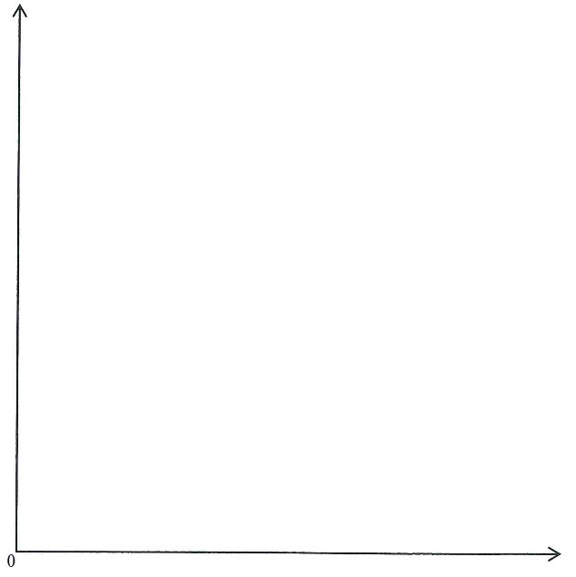
_______________________________________________________________________________________
_______________________________________________________________________________________
_______________________________________________________________________________________
_______________________________________________________________________________________
_______________________________________________________________________________________
_______________________________________________________________________________________
_______________________________________________________________________________________
_______________________________________________________________________________________

2016DSE LQ9
歐盟有近數千名農民舉行街頭抗議，促請政府支持受以下事件影響的乳製品價格。
- 歐盟取消了乳製品生產的有效配額。
- 俄羅斯對從歐盟進口乳製品實行禁運。
用一張供需圖來說明上述兩個事件對歐盟乳製品價格的影響。 (4)

_______________________________________________________________________________________
_______________________________________________________________________________________
_______________________________________________________________________________________
_______________________________________________________________________________________
_______________________________________________________________________________________
_______________________________________________________________________________________
_______________________________________________________________________________________
_______________________________________________________________________________________

Marking Scheme:
Illustrate in the diagram:
- Embargo effect: leftward shift of demand curve.
- An original kinked supply curve S0, with the vertical segment at the quota level Q0.
- Quota-abolition effect: A new upward-sloping supply curve, overlapping the kinked one below the original quota level Q0.
- Intersection of new demand curve (D1) and new supply curve (S1) results in a reduction in P.
在圖上顯示：
- 禁運的影響：需求曲線向左移。
- 原先折曲的供應曲線S0 (在配額量Q0是垂直的)。
- 取消配額的影響：新的供應曲線是向在上斜的，曲線在到達配額量Q0前和原先折曲的供應曲線重疊。
- 新的需求曲線(D1)與新的供應曲線(S1)相交，P因而下降。
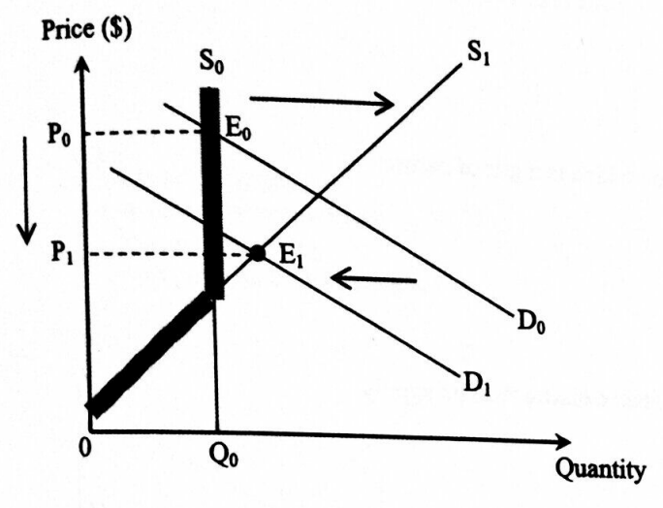

Candidates’ Performance:
Good. A majority of candidates correctly showed the effect of an embargo by shifting the demand curve leftward. Some also demonstrated a good knowledge of quota by drawing the kinked supply curve. However, a few of them misunderstood the key
word "abolish" as meaning introduction of a quota, and thus reached a wrong conclusion Some candidates also failed to represent the equilibrium price and quantity at the intersection of demand and supply curves. A minority of candidates mistakenly used the small open economy model to address this large country question.
良好。大部分考生正確地以需求曲線向左移顯示禁運的影響。部分考生亦劃出拐折的供應曲線，顯示其對配額的清楚認識。不過，少數考生誤把關健詞「廢除」當作「實施」故此得出了錯誤的結論。一些考生亦未有在需求和供應曲線的交點願示均衡價格和數量。少數考生誤用小型開放經濟模型去分析這屬大國的間題。

2016DSE LQ10c
The European Union has imposed an anti-dumping tariff on the Chinese produced solar panels. Under what condition will the producers bear a greater tariff burden than the buyers? Illustrate your answer with a supply-demand diagram.
歐盟對中國產的太陽能電池板徵收反傾銷關稅。在什麼條件下生產者比購買者承擔更大的關稅負擔?用供需圖來說明你的答案。 (7)

_______________________________________________________________________________________
_______________________________________________________________________________________
_______________________________________________________________________________________
_______________________________________________________________________________________
_______________________________________________________________________________________
_______________________________________________________________________________________
_______________________________________________________________________________________
_______________________________________________________________________________________
_______________________________________________________________________________________
_______________________________________________________________________________________
_______________________________________________________________________________________
_______________________________________________________________________________________
_______________________________________________________________________________________
_______________________________________________________________________________________
Marking Scheme:
Verbal explanation:
Condition: Demand for solar panels is more elastic than its supply (2)
Indicate on the diagram:
- Upward shift of supply curve (1)
- Price increases (1)
- Quantity decreases (1)
- Correct positions of buyer’s tax burden and sellers’ tax burden (1)
- Buyers’ tax burden < producers’ burden (1)
文字解說：
- 該條件是該物品的需求彈性低於其供應彈性。 (2)
在圖中顯示：
- 供應曲線上移 (1)
- P上升 (1)
- Q下跌 (1)
- 買家和賣家稅項負擔的正確位置 (1)
- 買家負擔 < 賣家負擔 (1)
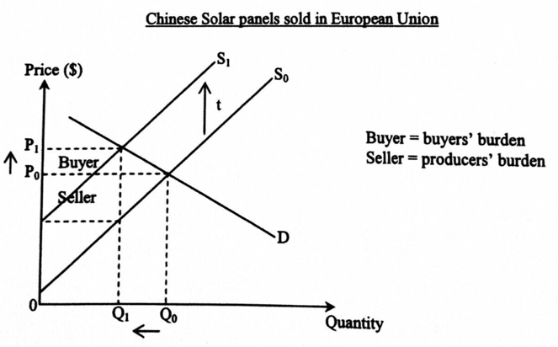
Candidates’ Performance:
Good. Most candidates were able to draw the diagram with labels showing the correct positions of the tariff burdens. However, unclear concepts were revealed in some candidates' verbal explanation. Some only stated elastic demand as the
condition, but failed to relate the tariff burden to the difference in the elasticities of demand and supply. A few candidates mis-used the model of small open economy (though partial credits were still given). A minority wrongly discussed the
distribution between consumer and producer surpluses.

良好。大部分考生能畫出有標示的圖，顯示關稅負擔的正確位置。不過，部分考生的文字解說顯示其對概念的理解模糊不清。一些考生只指出高彈性需求作為條件，並沒有將需求和供應彈性的差別與關稅負擔連繫起來。少數考生誤用了小型開放經濟的模式（雖然仍可獲部分分數）。少數考生錯誤地討論消費者和生產者盈餘的分布。

2017DSE LQ11a
The government of Country X introduces a per-unit subsidy to the education services of private universities. Under what condition would the students enjoy a larger share of subsidy benefit than the private universities? Illustrate your answer with the aid of Figure 3. (7)
X國政府向私立大學的教育服務提供一項從量補貼。在什麼條件下學生享受的補貼得益份額會大於私立大學的份額？以圖三輔助，說明你的答案。 (7)
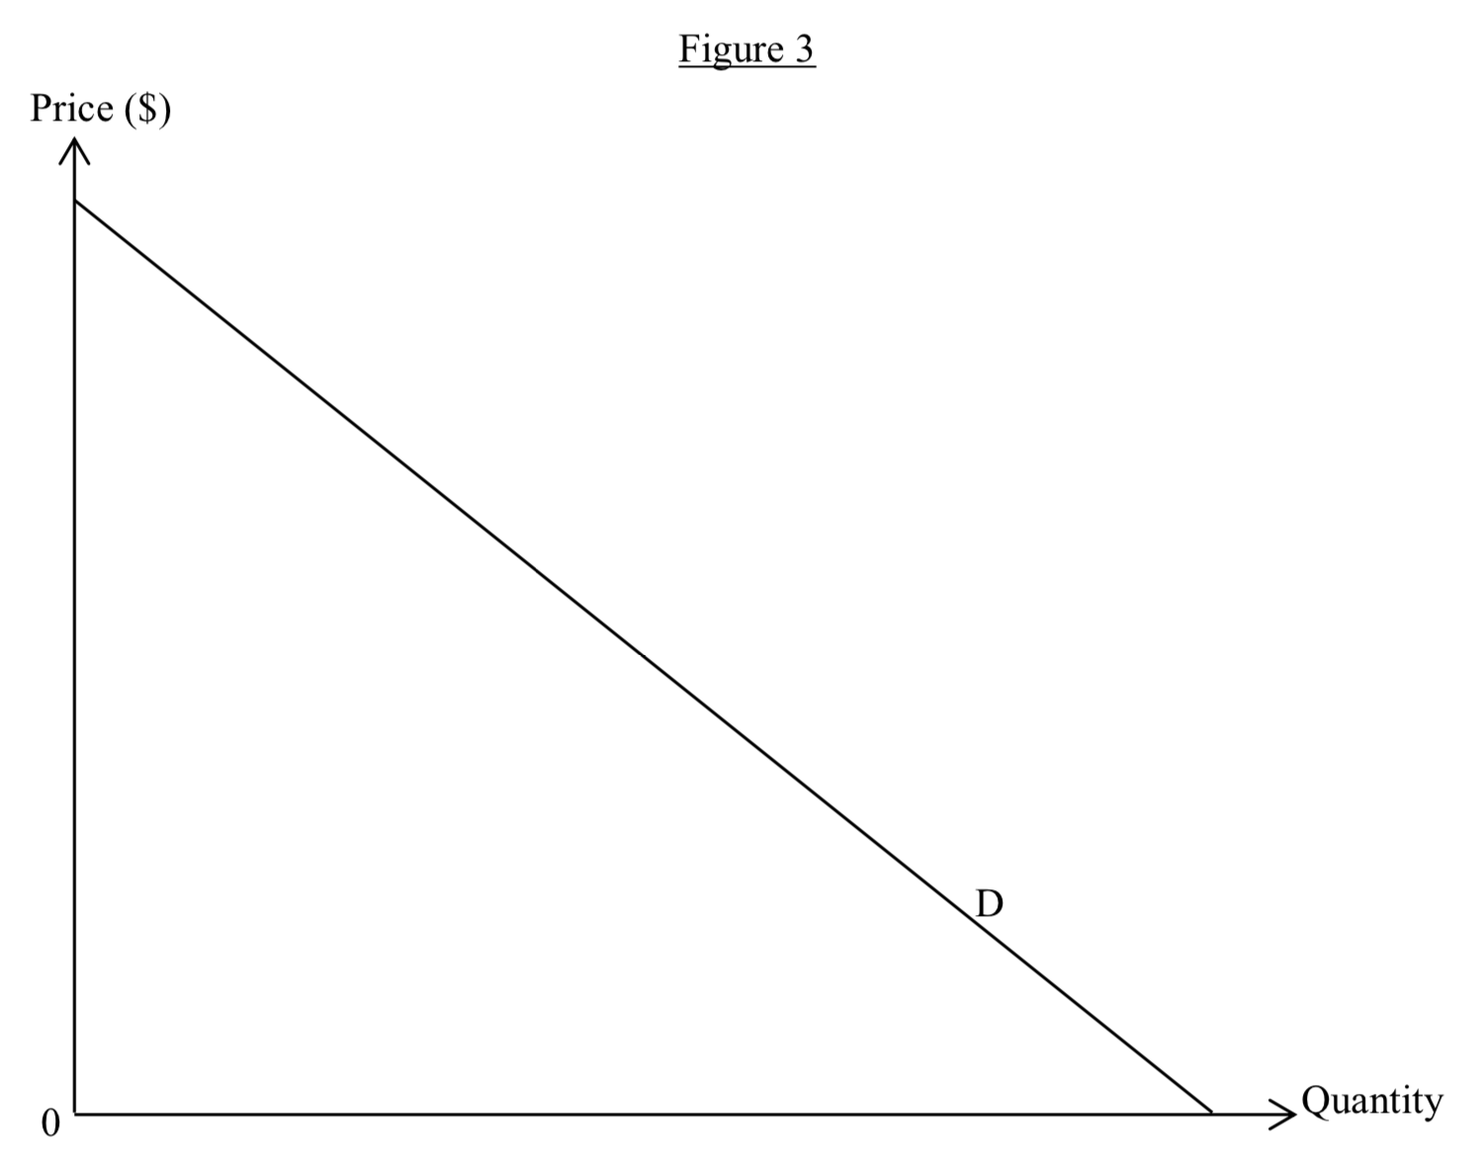
_______________________________________________________________________________________
_______________________________________________________________________________________
_______________________________________________________________________________________
_______________________________________________________________________________________
_______________________________________________________________________________________
_______________________________________________________________________________________

Marking Scheme:
Verbal explanation:
The condition is that the elasticity of demand for the service is lower than the elasticity of its supply. (2)
Illustrate in the diagram:
- Parallel downward shift of supply curve due to the per unit subsidy (1)
- Correct position of New Price (P1) (1)
- Correct position of New Quantity (Q1) (1)
- Correct position of producer’s benefit and consumer’s benefit (1)
- Consumers’ benefit > producers’ benefit (1)
文字解說：
該條件是對教育服務需求彈性低於其供應彈性。 (2)
在圖中顯示：
- 供應曲線因從量補貼向下平行移動 (1)
- 新價格的正確位置(P1) (1)
- 新交易量的正確位置(Q1) (1)
- 生產者得益(PB)和消費者得益(CB)的正確位置 (1)
- 消費者得益 ＞ 生產者得益 (1)
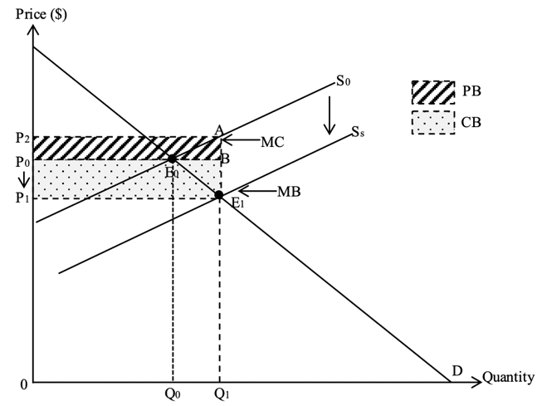
Candidates’ Performance:
Good. Most of the candidates can correctly show the shift of the supply curve caused by the per-unit subsidy, but only some candidates fully explain the difference in the benefit distribution of the subsidy by “providing the performance of the demand tool”. Some candidates mistakenly think that only "more elastic supply" or "less elastic demand" is enough for students to enjoy the larger subsidy benefits than private universities. There are also candidates who mistakenly compare consumer and producer surplus rather than consumer subsidy benefit and producer subsidy benefit.
良好。大部分考生能正確標示教育補貼引致供應曲線的移動，但只有部分考生以「供應較需求具彈性」完整地說明補貼得益分配的分別。部分考生誤以為只須「高彈性的供應」或「低彈性的需求」就足夠令學生享受較私立大學更高的補貼得益份額。另有考生錯誤地比較了消費者和生產者盈餘而非消費者補貼得益和生產者補貼得益。

2019DSE LQ12ai
Indicate the change in the total market value (net-of-tariff) of Chinese goods exporting to the US during the trade war in a demand-supply diagram. (Hint: The tariff can be assumed to be per-unit for simplicity.) (3)
在一幅供需圖上，表示在貿易戰期間出口到美國的中國物品總市場價值扣除關稅後的轉變。
(提示：為了簡化，關稅可假設為從量。) (3)

Marking Scheme:
Indicate in the diagram:
- S shifts up
- Lower total market value (net-of-tariff)
在圖中顯示：
- S向上移
- 較低的總市場價值(除稅後)
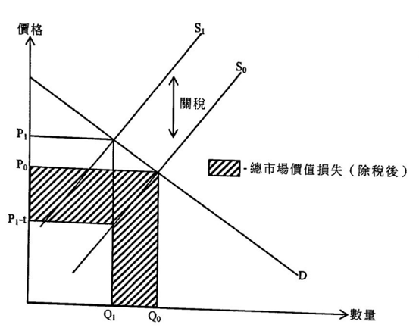
Candidates’ Performance:
Fair. Most candidates could illustrate how the imposition of tariff would affect the price and quantity of Chinese exports via an upward shift in the supply curve. Yet some of them overlooked the keyword “net-of-tariff" and mis-focused on how the elasticity of demand would affect the total market value. Others mistakenly used a supply-demand diagram for the case of a small open economy to analyse the trade war between the two largest economies in the world.
一般。大部份的考生能運用供應曲線的上移說明徵收關稅如何會影響中國出口的價格和數量。但部份考生忽略了重要字眼「除稅後」，將焦點放在需求彈性如何影響市場總值。另有部份考生錯誤地運用一小型開放經濟的供需圖去分析全球最大兩個經濟體的貿易戰。

2020DSE LQ10bi, bii
Donald Trump, the US president, once said that imposing tariffs would only increase the revenue of the US government and the US consumers did not have to pay more for the imported goods.
(a) With the aid of a supply-demand diagram, explain under ONE extreme condition that the consumers would bear NO tariff burden after the imposition of tariff. (4)
(For simplicity, the tariff is assumed to be per-unit.)
(b) Indicate the tariff revenue (i.e. sellers’ burden) in the same diagram. (1)
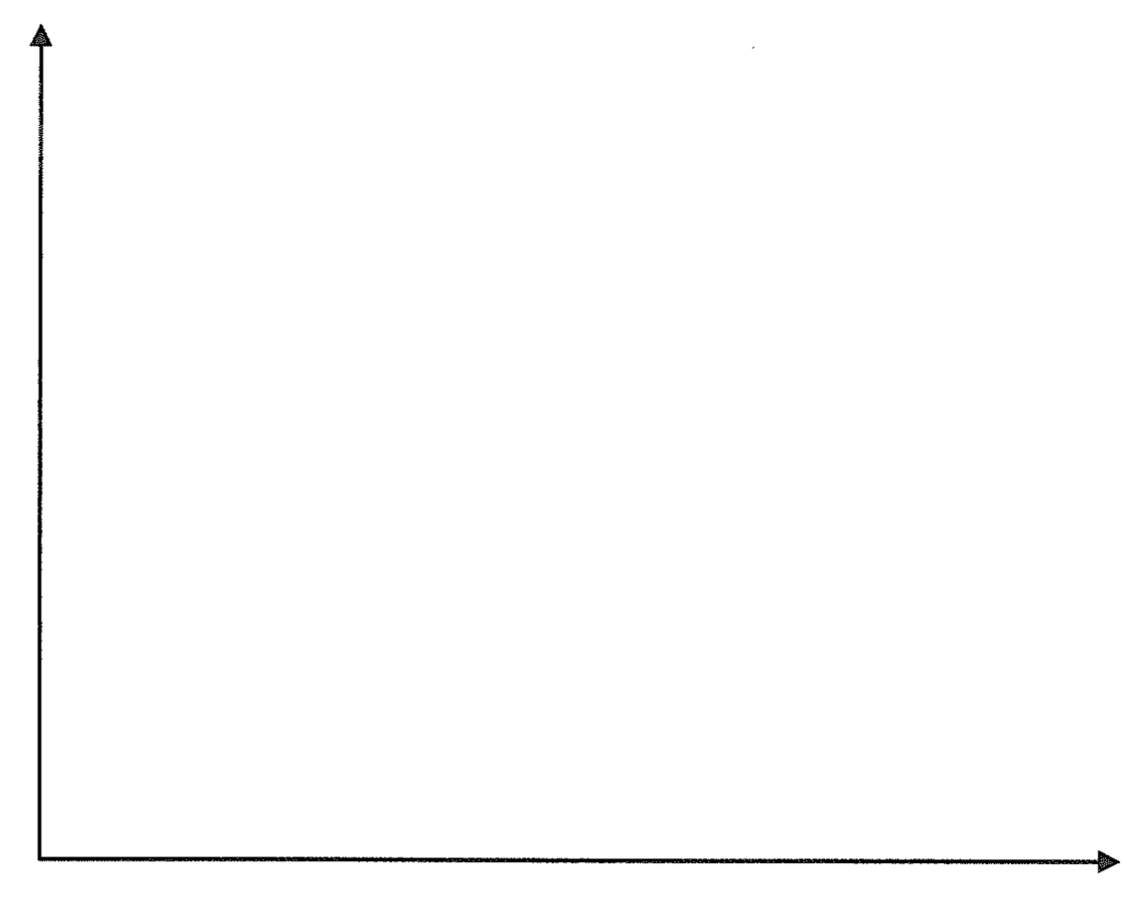
______________________________________________________________________________________________________________________________________________________________________________
______________________________________________________________________________________________________________________________________________________________________________

2020DSE LQ10bi, bii
美國總統唐納德·特朗普曾表示，徵收關稅只會增加美國政府的收入，美國消費者不必為進口商品支付更多的錢。
(a) 借助供需圖，解釋在一種極端情況下，加徵關稅後消費者不承擔稅項負擔的情況。 (4)
(方便起見，假設關稅為從量稅。)
(b) 在同一圖表中指出關稅收入（即生產者負擔） (1)

______________________________________________________________________________________________________________________________________________________________________________
______________________________________________________________________________________________________________________________________________________________________________
______________________________________________________________________________________________________________________________________________________________________________
______________________________________________________________________________________
Marking Scheme:
(a) Condition I: Ed infinite
Verbal elaboration:
The demand is perfectly elastic. Even after the imposition of tariff, the market price would not increase. It is because a tiny increase in price would drop the quantity demanded to zero, so the supplier cannot shift the tax burden to the consumers at all.
Indicate in the diagram:
- Horizontal demand curve
- Supply curve shifts up

(a) 條件一：需求彈性無限大
文字解說：
當需求屬於完全彈性，即使在徵收關稅後，市場價格不會上升。因為價格輕微上升會令需求量下降至零，供應商完全不能將關稅負擔轉嫁給消費者。 (2)
在圖中顯示：
- 水平的需求曲線 (1)
- 供應曲線上移 (1)

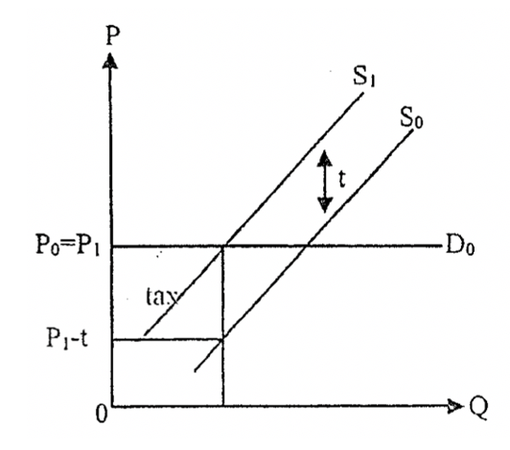

OR
Condition II: Es zero
Verbal elaboration:
The supply is perfectly inelastic. After the imposition of tariff, the market price would not increase. Given the quantity supplied is fixed, any increase in price would not only result in an excess supply.
Indicate in the diagram:
- Vertical supply curve
- Indication of tax amount

條件二：供應彈性為零
文字解說：
當供應完全無彈性，徵收關稅不會令市場價格上升。在固定供應量下，任何的價格上升只會引致超額供應。 (2)
在圖中顯示：
- 垂直的供應曲線(新和舊)
- 標示每單位稅項

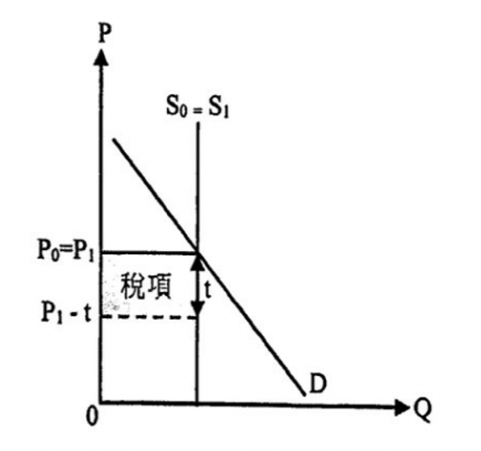

(b) correct tax amount indicated in the corresponding condition (1)
(b) 在相應的條件的圖中標示正確的關稅收入金額。 (1)

Candidates’ Performance:
Satisfactory. Most candidates correctly stated one such condition, but a few candidates missed some important steps in their verbal explanation or made some errors in their diagrams. Common mistakes are listed below:
- mis-matching perfectly elastic demand with a vertical demand curve OR perfectly inelastic
supply with a horizontal supply curve;
- failing to mention that the after-tax market price would stay unchanged, so that the consumers would bear no tariff burden;
- failing to identity correctly the after-tax market price and/or the per-unit price the sellers can receive net-of-tax, and thus to indicate correctly the tariff revenue.

今人滿意。大部分考生能正確指出一項條件，但有些考生的文字解說漏掉了一些重要步驟，或是他們的圖有錯處。常犯的錯誤如下：
- 以垂直的需求曲線錯配完全彈性需求，或者以水平的供應曲線錯配完全無彈性供應;
- 未能提到稅後市場價格會保持不變，消費者因而沒有關稅負擔;
- 未能正確辨識稅後市場價格及 / 或賣家能收取除稅後的單位價格，故此未能正確標示出總關稅收入。

2021DSE LQ10c
To stabilize the supply of surgical masks in Hong Kong, the Government has launched the ‘Local Mask Production Subsidy Scheme’, which provides subsidy to local mask producers. With the aid of a diagram, explain under what condition the total expenditure of consumers on surgical masks will decrease because of the subsidy. (For simplicity, the subsidy is assumed to be a per unit one.) (7)
為了穩定本港外科口罩的供應，政府推出本地口罩生產資助計劃，提供補貼予本地口罩生產商。以圖輔助，解釋在什麼情況下消費者對外科口罩的總支出會因為該補貼而下降。(為了簡化，假設該補貼屬從量。) (7)
______________________________________________________________________________________________________________________________________________________________________________
______________________________________________________________________________________________________________________________________________________________________________
______________________________________________________________________________________________________________________________________________________________________________
_____________________________________________________________________________________________________________________________________________________________________________________________________________________________________________________________________
______________________________________________________________________________________________________________________________________________________________________________
______________________________________________________________________________________________________________________________________________________________________________
_____________________________________________________________________________________________________________________________________________________________________________________________________________________________________________________________________
_____________________________________________________________________________________________________________________________________________________________________________________________________________________________________________________________________

Marking Scheme:
Verbal elaborations:
The provision of subsidy would result in an increase in the supply of masks. If demand is inelastic, the percentage decrease in price would be bigger than the percentage increase in quantity, so that total expenditure on masks would drop. (4)
Illustrate in the diagram:
- Downward shift of supply curve
- Correct positions of the increase in total expenditure (+) and the decrease in total expenditure (-)
- Area of (+) > Area of (-) (3)
文字解說：
提供補貼引致口罩的供應增加。若需求屬低彈性，價格下降的百分比會大於數量上升的百分比，因而口罩的總支出會下降。 (4)
在圖中顯示：
- 供應曲線向下移動
- 總支出增加和總支出減少的正確位置
- 面積 (+) > 面積 (-)。 (3)
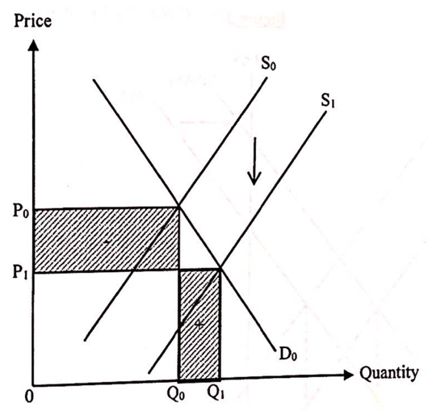

Candidates’ Performance:
Good. Many candidates were able to explain the case with a diagram. However, many of them made minor mistakes in their verbal explanations and/or diagrammatic illustrations. Common mistakes include:
- Wrongly stating that 'demand being more inelastic than supply' is the condition for the reduction in total expenditure as a result of the subsidy.
- Wrongly comparing the changes of price and quantity, instead of comparing their percentage changes.
- Failing to label the demand curve and/or the supply curve.
- Failing to indicate that the fall in total expenditure due to the price decrease [Area (-)] and the rise in total expenditure due to the quantity increase [Area (+)], or failing to show in the diagram that Area (-) > Area (+).
- Mis-reading the question and discussing the shares of subsidy benefits or changes in the consumer surplus vs. the producer surplus (which is not required by the question)

良好。很多考生能以一幅圖解釋該個案。不過很多考生在文字解說及 / 或繪圖時犯下了小毛病。常犯毛病包括：
- 錯誤寫出「需求彈性較供應彈性為低」作為補貼導致總支出下降的條件。
- 錯誤比較價格和數量的改變，而非它們百分比的改變。
- 未有標示需求及 / 或供應曲線。
- 未有標示因價格下降令總支出滅少[面積(-)和因數量上升令總支出增加[面積(+)]，或未有在圖中顯示面積(-)、面積(+)。
- 未有清楚審題，討論補貼得益的分配或消費者盈餘和生產者盈餘的改變(這並非題目所要求)。

Marking Scheme:
Type 1 (Effect of Market Intervention, P / Q / TR / Tax / Subsidies)
1 | A | 2 | B | 3 | B | 4 | D | 5 | D | 6 | C | 7 | B | 8 | C | 9 | D | 10 | B
11 | D | 12 | A | 13 | B | 14 | C | 15 | B | 16 | C | 17 | A | 18 | B | 19 | B | 20 | C
21 | B | 22 | B | 23 | C | 24 | B | 25 | C | 26 | C | 27 | B | 28 | C | 29 | D | 30 | A
31 | B | 32 | D | 33 | C | 34 | B | 35 | A | 36 | B | 37 | B | 38 | C | 39 | D | 40 | A
41 | B | 42 | C | 43 | C | 44 | B | 45 | C | 46 | C | 47 | C | 48 | D | 49 | A
Type 2 (Market Intervention cross topic Elasticity)
1 | A | 2 | C | 3 | C | 4 | B | 5 | D | 6 | A | 7 | D | 8 | C | 9 | D | 10 | B
11 | B | 12 | C | 13 | A | 14 | B | 15 | A | 16 | B | 17 | C | 18 | A
Type 3 (Market Intervention cross topic CSPS)
**Will be further discussed in Ch10 Consumer Surplus and Producer Surplus**
1 | C

NOTES

NOTES

