Learning Focus:
Memo
(LQ Answering Flow, MC skills, your goals and resolutions…)
Specific Question Type
MC

咩話？DSE Sample Paper, Practice Paper, 2012, 2013, 2014, 2015, 2016, 2017, 2018, 2019, 2020, 2021, 2022
MC全部拍晒解題片？係呀，有唔明即scan即睇！就係咁firm！


Learning Focus:
Memo
(LQ Answering Flow, MC skills, your goals and resolutions…)
Specific Question Type
LQ

咩話？DSE Sample Paper, Practice Paper, 2012, 2013, 2014, 2015, 2016, 2017, 2018, 2019, 2020, 2021, 2022
LQ全部拍晒解題片？係呀，有唔明即scan即睇！就係咁firm！


Chapter 19 _ Money Market
Type 1 (Interest rate and return of asset)
Example Question 1 DSEPPMCQ35
When the nominal interest rate is higher than the real interest rate, the expected inflation rate must be _____________.
A. positive B. negative C. rising D. falling

當名義利率高於實際利率，預期通脹率必定
A. 是正數。 B. 是負數。 C. 在上升。 D. 在下降。

Example Question 2 DSESPMCQ28
If the nominal interest rate on a one-year bond is 10% and the expected inflation rate is 2%, the nominal rate of return and the expected cost of holding cash are _______ and ________ respectively.
A. 0%...8% B. 0%...10% C. −2%...8% D. −10% ... 10%

若一年期債券的名義利率為10%，而預期通脹率為2%，持有現金的名義回報率和預期成本分別為________及_______。
A. 0%...8% B. 0%...10% C. −2%...8% D. −10% ... 10%

Example Question 3 DSE2014MCQ32
The nominal interest rate of a one-year bond and the expected inflation rate are 8% and 3% respectively. If the actual inflation rate is 6%, then the actual real interest rate is ________ and the actual rate of return of holding cash is _________.
A. 2% ... -6% B. 2% ... -8% C. 5% ... -6% D. 5% ... -8%

一年期債券的名義利率和預期通脹率分別是8%和3%。若實際通脹率是6%，則實際實質利率是________而持有現金的實際回報率是________。
A. 2% ... -6% B. 2% ... -8% C. 5% ... -6% D. 5% ... -8%

Example Question 4 DSE2015MCQ31
If the nominal interest rate is 5% and the expected inflation rate is 3%, the cost of holding money is ______, the nominal return of holding money is ______ and the expected real interest rate is ______.
A. 5% ...... -3% ...... 2% B. 5% ...... 0% ...... 2% C. 8% ...... -3% ...... 3% D. 8% ...... 0% ...... 3%

若名義利率是5%，而預期通脹率是3%，則持有貨幣的成本是______，持有貨幣的名義回報是______，而預期實質利率是______。
A. 5% ...... -3% ...... 2% B. 5% ...... 0% ...... 2% C. 8% ...... -3% ...... 3% D. 8% ...... 0% ...... 3%

Example Question 5 DSE2018MCQ34
Assume that the real interest rate is 6% and the expected inflation rate is 3%. If the actual inflation rate is 5%, the cost of holding money will be _____.
A. 4% B. 6% C. 9% D. 11%

假設實質利率是6%，預期通脹率是3%。若實際通脹率是5%，持有貨幣的成本會是_____。
A. 4% B. 6% C. 9% D. 11%

Example Question 6 DSE2019MCQ32
In times of inflation, suppose the nominal interest rate of a bond is higher than the expected inflation rate. If the actual inflation rate turns out to be higher than the expected inflation rate,
(1) The actual inflation rate will be higher than the nominal interest rate of the bond.
(2) The expected real rate of return of the bond will be greater than the actual real rate of return
(3) The actual real rate of return of the bond may be negative
(4) The real rate of return of holding cash will be higher than zero
A. (1) and (2) only B. (1) and (4) only C. (2) and (3) only D. (3) and (4) only

在通脹的時期，假設某債券的名義利率高於預期通脹率。若實際通脹率高於預期通脹率，
(1) 實際通脹率會高於該債券的名義利率
(2) 該債券的預期實質回報率會高於實際實質回報率
(3) 該債券的實際實質回報率可能是負數
(4) 持有現金的實質回報率會大於零
A. 只有(1)、(2) B. 只有(1)、(4) C. 只有(2)、(3) D. 只有(3)、(4)

Example Question 7 DSE2021MCQ34
Suppose the actual inflation rate and the nominal interest rate are -1% and 3% respectively. Which of the following statements are correct?
(1) The cost of holding cash is 3%
(2) The expected real interest rate is higher than the nominal interest rate
(3) The actual real rate of return on holding cash is 1%
A. (1) and (2) only B. (1) and (3) only C. (2) and (3) only D. (1), (2) and (3)

假設實際通脹率和名義利率分別是-1%和3%。下列哪些陳述是正確的？
(1) 持有現金的成本是3%。
(2) 預期實質利率高於名義利率。
(3) 持有現金的實際實質回報率是1%
A. 只有(1)、(2) B. 只有(1)、(3) C. 只有(2)、(3) D. (1)、(2)及(3)

Type 1 (Interest rate and return of asset)

Type 2 (Change in Money Demand and Money Supply)
Example Question 1 DSEPPMCQ25
Which of the following can explain a leftward shift of the money demand curve?
A. a rise in the interest rate B. an increase in income of households
C. a more widespread use of Octopus cards D. an increase in the required reserve ratio

下列哪項能解釋貨幣需求曲線向左移？
A. 利率上升 B. 住戶收入增加
C. 人們更廣泛使用八達通卡 D. 法定儲備比率增加

Example Question 2 DSEPPMCQ26
The diagram below shows the money demand and money supply curves of an economy. The original equilibrium point is at E.
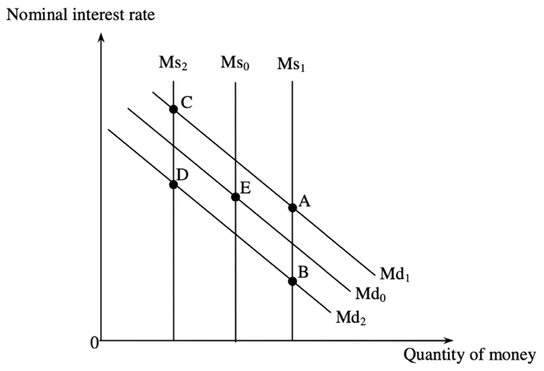
Suppose national income increases and the government carries out an open market purchase of bonds. The new equilibrium point will be at __________.
A. A B. B C. C D. D

下圖顯示某經濟的貨幣需求和貨幣供應曲線。起初的均衡點是E。
假設國民收入增加而政府在公開市場購入債券。新的均衡點是？
A. A B. B C. C D. D

Example Question 3 DSE2012MCQ30
On-line shopping has become more popular, and hence people hold less cash for transaction purposes. Which of the following measures can be adopted by a central bank to reduce the effect of the above situation on the interest rate?
- An increase in discount rate
- An increase in required reserve ratio
- An open market purchase of government bonds.
A. (1) and (2) only B. (1) and (3) only C. (2) and (3) only D. (1), (2) and (3)

網上購物日漸普及，人們因而持有較少現金作交易用途。中央銀行可採用下列哪些措施以減低上述情況對利率的影響？
(1) 提高貼現率
(2) 提高法定儲備比率
(3) 在公開市場購入政府債券
A. 只有(1)、(2) B. 只有(1)、(4) C. 只有(2)、(3) D. 只有(3)、(4)

Example Question 4 DSE2013MCQ27
Refer to the following diagram
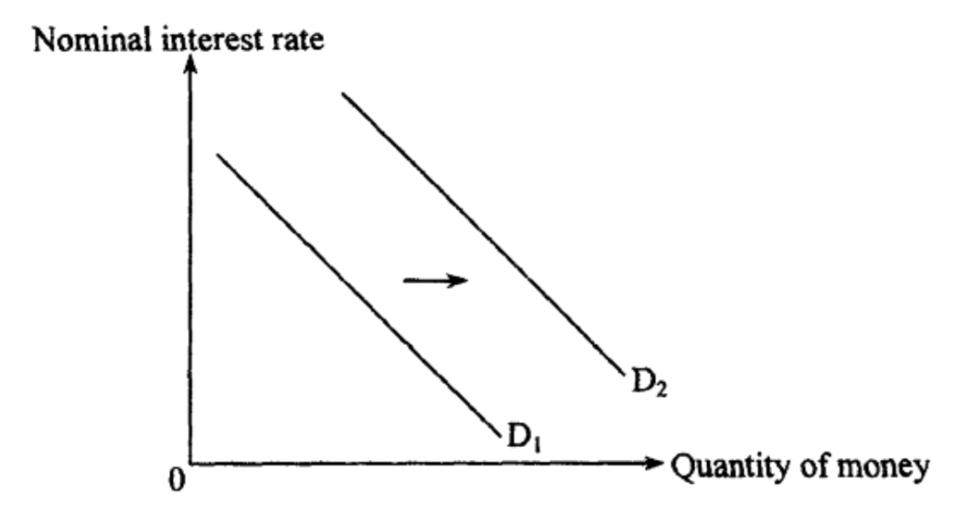
Which of the following will cause the money demand curve to shift from D1 to D2?
A. A fall in the nominal interest rate B. A rise in national income
C. More widespread use of electronic money D. An open market purchase of bonds by the central bank

參閱下圖。
下列哪項會令貨幣需求曲線由D1移至D2？
A. 名義利率下降 B. 國民收入上升
C. 人們更廣泛使用電子貨幣 D. 中央銀行在公開市場購買債券

Example Question 5 DSE2013MCQ30
If there is a decrease in the desire to consume, the net exports of an economy will ______ and the amount of money held for transaction purposes will ______.
A. Decrease ... decrease B. Decrease...remain constant C. Increase...increase D. Increase ... decrease

假設某經濟的消費意欲下降，其淨出口會，而持有作交易用途的貨幣金額會。
A. 下跌...下降 B. 下跌...維持不變 C. 上升...上升 D. 上升...下降

Example Question 6 DSE2015MCQ28
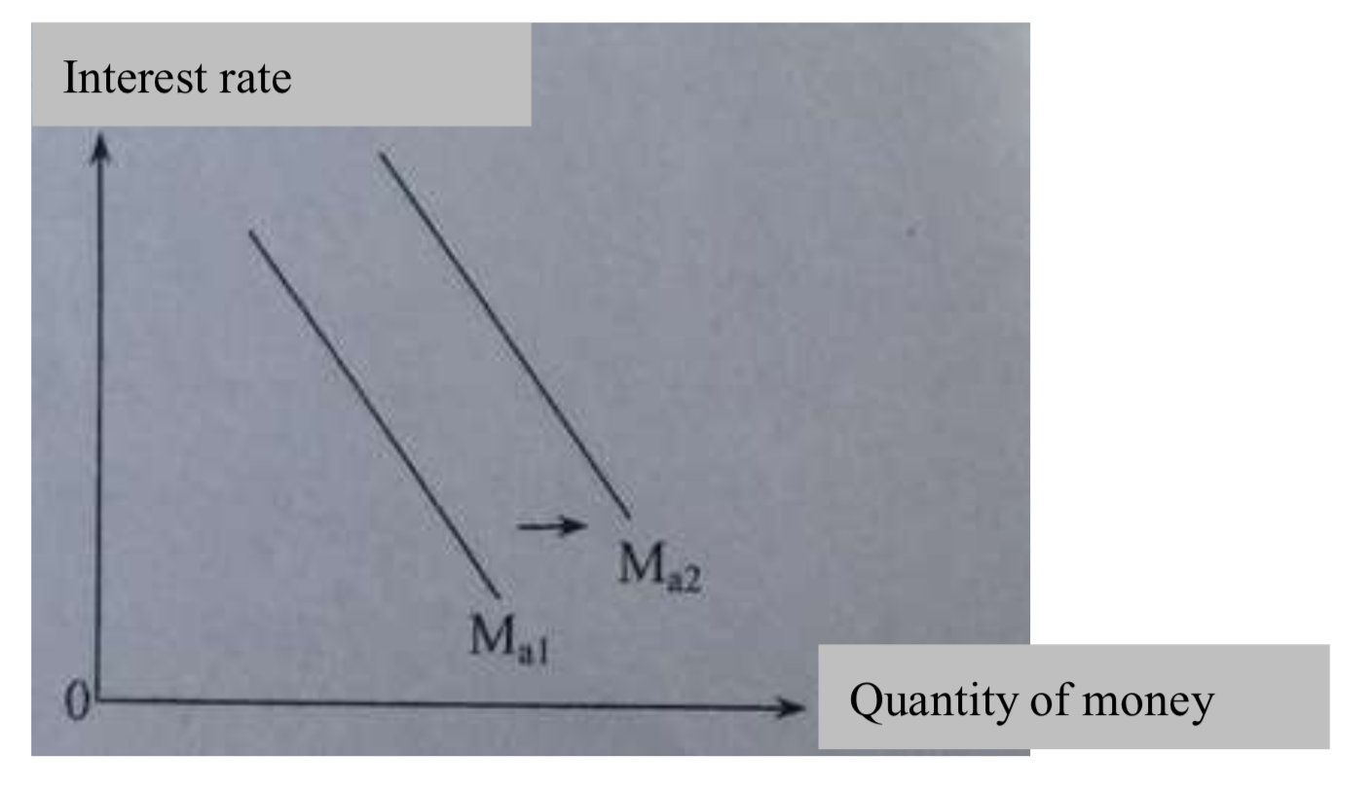
The curve of asset demand for money will shift from Ma1 to Ma2 when
A. The risk of investing in stock market increases. B. The interest rate decreases.
C. The general price level rises. D. The government reduces the income tax rate.

參閱下圖。
在下列哪種情況下，資產貨幣需求曲線會由Ma1移至Ma2？
A. 在股票市場投資的風險上升 B. 利率下降
C. 一般物價水平上升 D. 政府減低入息稅率

Example Question 7 DSE2016MCQ29
Refer to the diagram below
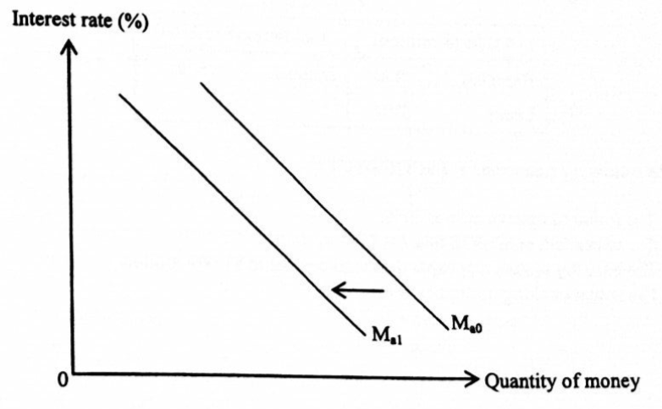
Which of the following will lead to the above change in the asset demand for money curve?
A. The stock market becomes less volatile. B. The general price level is expected to fall.
C. The central bank raises the discount rate. D. There is a fall in disposable income of households.

參閱下圖。
下列哪項會導致資產貨幣需求曲線有以上的改變？
A. 股票市場變得較少波動 B. 預期一般物價水平持續下跌。
C. 中央銀行提高貼現率。 D. 住戶的可用收入下跌。

Example Question 8 DSE2017MCQ30
Electronic payment systems allow customers to pay without cash. ApplePay, Visa payWave and MasterCard paypass are some of the examples.
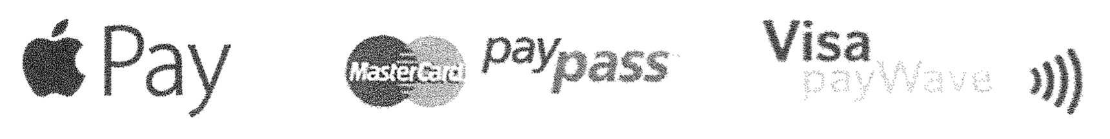
When more shops accept these electronic payment systems as a method of payment,
- Their cost of handling coins and notes will fall.
- The actual banking multiplier may increase
- Transactions demand for money will increase
A. (1) and (2) only B. (1) and (3) only C. (2) and (3) only D. (1), (2) and (3)

電子支付系統使顧客毋需以現金付費。例子有：ApplePay、Visa payWave及MasterCard pay pass。
當更多店鋪接受這些支付系統作付款方法，
(1) 它們處理輔幣和鈔票的成本會下降。
(2) 實際銀行乘數可能上升。
(3) 貨幣的交易需求會上升。
A. 只有(1)、(2) B. 只有(1)、(3) C. 只有(2)、(3) D. (1)、(2)及(3)
Example Question 9 DSE2017MCQ32
The diagram below shows the money demand and supply curves of an economy. The original equilibrium point is at E.
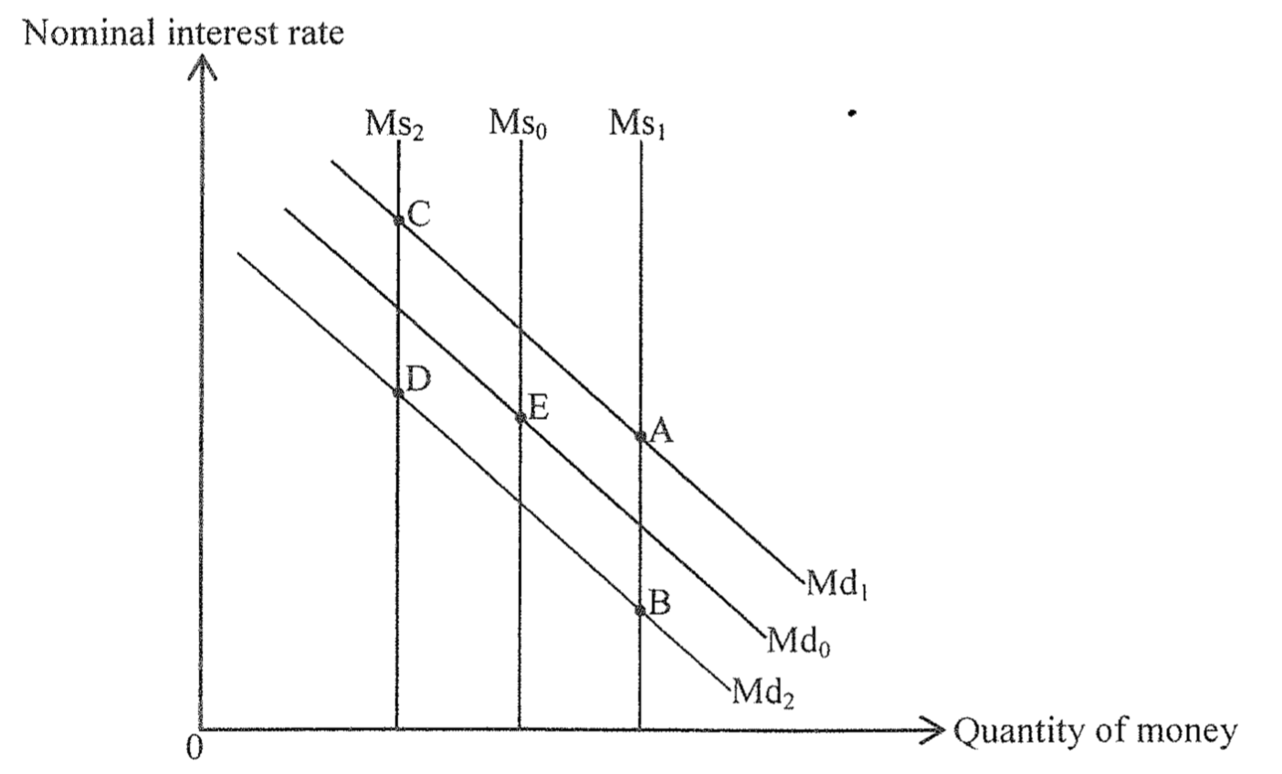
Suppose the risk of holding interest bearing assets (such as bonds) increase and the central bank reduces the discount rate. The new equilibrium point will be at _____.
A. A B. B C. C D. D

下圖顯示某經濟的貨幣需求和貨幣供應曲線。原初均衡點是E。
假設持有帶息資產（例如債券）的風險增加，而中央銀行下調其貼現率。新的均衡點會是_____。
A. A B. B C. C D. D

Example Question 10 DSE2018MCQ29
Which of the following would result in the below change in money demand?
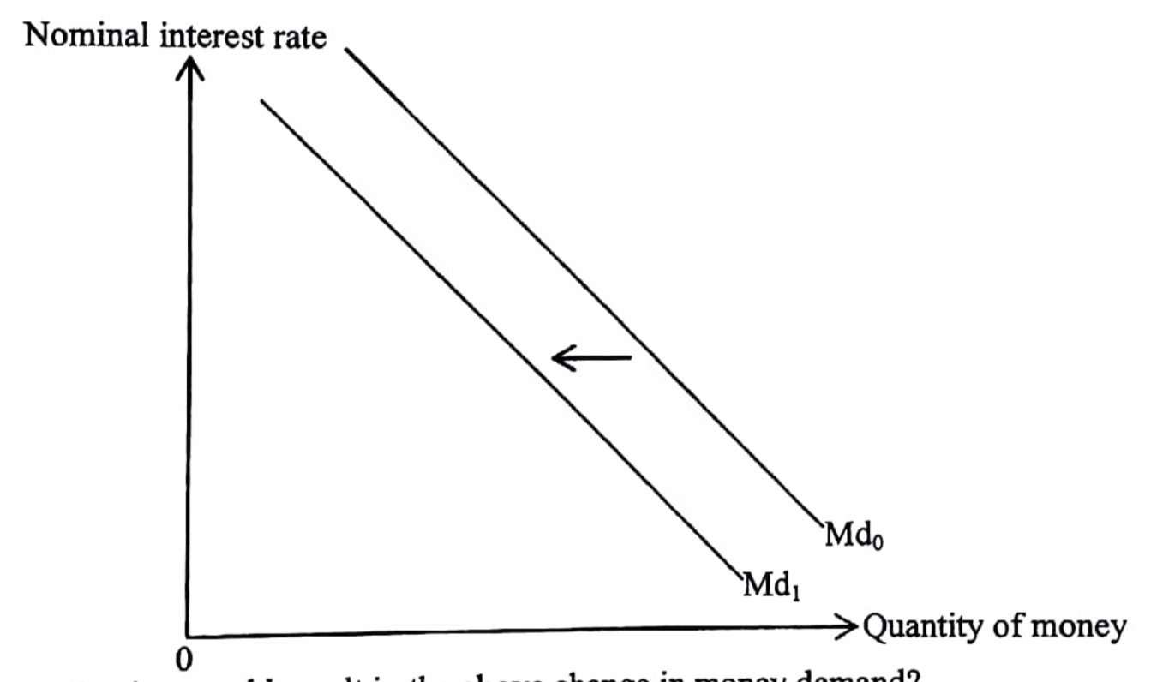
A. The central bank issues larger denomination banknotes for circulation
B. The expected inflation rate drops
C. The risk of investing in stock market decreases
D. Security problems have been found in the major electronic payment system

下列哪項會導致貨幣需求如上圖般改變？
A. 中央銀行發行更大面額的鈔票流通市面。
B. 預期通脹率下降。
C. 在股票市場投資的風險下降。
D. 主要電子支付系統出現保安問題。
Example Question 11 DSE2019MCQ33
The diagram below shows the money supply and money demand curves of an economy. The original equilibrium point is at point E.
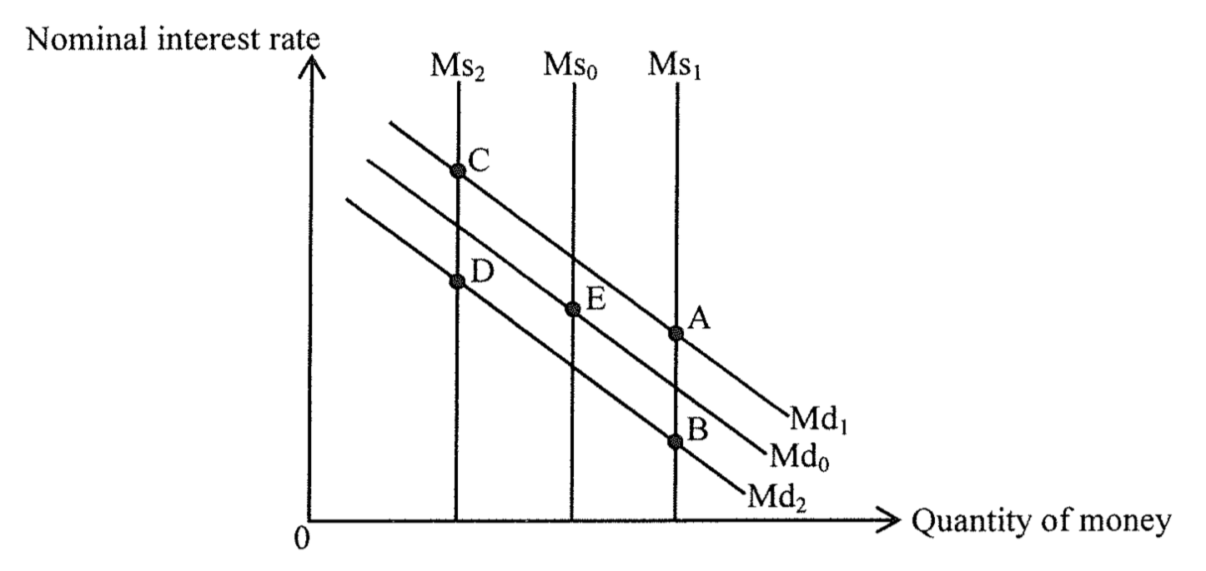
Suppose electronic payments become more common, and the central bank increases the legal reserve ratio of the commercial banks. The new equilibrium point will be at _____.
A. A B. B C. C D. D

下圖顯示某經濟的貨幣供應和貨幣需求曲線。原初的均衡點是E。
假設電子支付愈見普及，而中央銀行提高商業銀行的法定儲備比率。新的均衡點會是_____。
A. A B. B C. C D. D

Example Question 12 DSE2020MCQ28
The diagram below shows the asset demand curve for money of an economy.
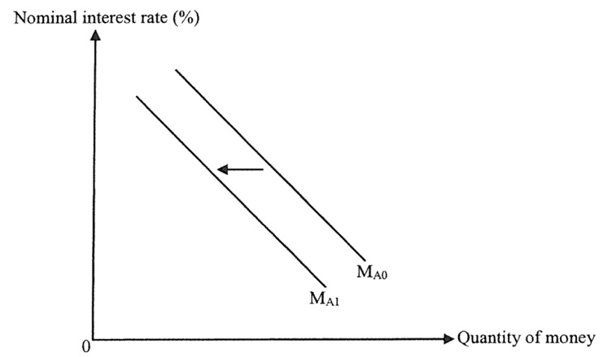
Which of the following will cause the above change in asset demand for money?
A. The nominal interest rate increases B. There is a contraction of monetary base
C. The use of electronic wallets such as Alipay becomes more popular D. The expected rate of return of holding bond increases

下圖顯示某經濟的資產貨幣需求。
下列哪項會導致以上的資產貨幣需求轉變。
A. 名義利率增加。 B. 貨幣基礎收縮。
C. 電子錢包（如支付寶Alipay）的使用日趨普及。 D. 持有債券的預期回報率上升。
Example Question 13 DSE2020MCQ31
The following diagram indicates the money supply curve (M_{s}) and money demand curve (M_{d}) of a certain economy. Suppose the initial equilibrium point is at point E.
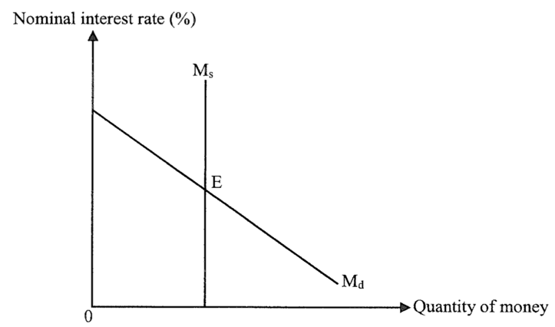
If the income of the public increases and the central bank sells government bonds to the public, the interest rate _________ and the quantity of money ________.
A. will increase …… will increase B. will increase …… may increase or decrease
C. may increase or decrease …… will decrease D. will increase …… will decrease

下圖顯示某經濟的貨幣供應曲線(Ms)和貨幣需求曲線(Md)。假設原初均衡點是E。
若公眾的收入增加，而中央銀行向公眾發售政府債券，則利率_________，貨幣數量_________。
A. 會減少……會增加 B. 會增加……可能增加或減少
C. 可能增加或減少……會減少 D. 會增加……會減少

Example Question 14 DSE2021MCQ33
The diagram below shows the money demand and money supply curves of an economy. The original equilibrium point is at E.
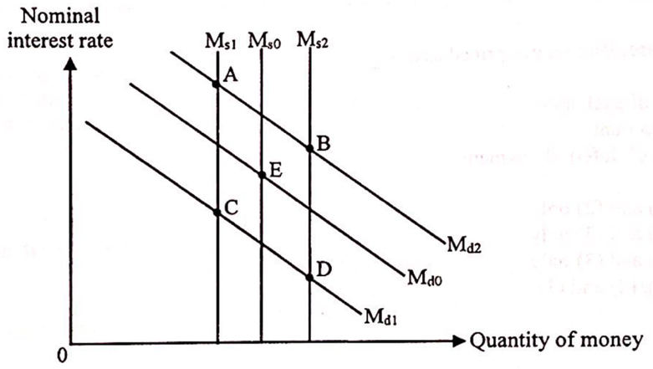
Suppose the stock market becomes more volatile. At the same time, the central bank decides to redeem government bonds from the public. The new equilibrium point will be at _______.
A. A B. B C. C D. D

下圖顯示某經濟的貨幣需求和貨幣供應曲線。原初均衡點是E。
假設股市日趨波動。同時，中央銀行決定向公眾贖回政府債券。新的均衡點會是_______。
A. A B. B C. C D. D
Type 2 (Change in Money Demand and Money Supply)

Type 2 (Change in Money Demand and Money Supply)

DSE2012 LQ11cd
Read the following news extract.
Hong Kong’s inflation rate rose to 7.9% last month – the sharpest jump in 16 years – confirming what many families already feared as they struggle to keep up with the runway cost of food and rent.
To relieve the effect of inflation on citizens, the government has issued inflation-linked bonds (ibonds) with interest paid to bondholders every six months. The interest rate is positively related to the actual inflation rate of the last half-year period.
(a) What is the opportunity cost of holding cash instead of ibonds? (2)
(b) Explain how ibonds would relieve the effect of inflation on their holders. (2)

細閱下列的新聞節錄。
香港通脹率在上月份上升至7.9%——為16年來最大的升幅——確定了許多家庭所懼怕的情況：他們為應付飛漲的食物成本和租金而感到吃力。
為紓緩通脹對市民的影響，政府發行了與通脹掛鈎的債券（ibonds），每六個月向債券持有人支付利息。其利率與過去半年期的實際通脹率有正向關係。
(a) 持有現金而不持有與通脹掛鈎的債券的機會成本是什麼？ (2)
(b) 解釋與通脹掛鈎的債券會如何紓緩通脹對其擁有人的影響。 (2)
_______________________________________________________________________________________
_______________________________________________________________________________________
_______________________________________________________________________________________
_______________________________________________________________________________________
_______________________________________________________________________________________
_______________________________________________________________________________________
_______________________________________________________________________________________
_______________________________________________________________________________________
_______________________________________________________________________________________
_______________________________________________________________________________________
_______________________________________________________________________________________
_______________________________________________________________________________________
_______________________________________________________________________________________
Marking Scheme:
(a) The opportunity cost is the nominal return of the ibonds. (2)
(b) The ibonds help preserve the purchasing power of the invested sum of money because the interest return of ibonds will increase at the same rate as actual inflation. (2)
(a) 該機會成本是與通脹掛鈎的債券的名義回報。 (2)
(b) 與通脹掛鈎的債券幫助保存所投資的款項的購買力。因為該債券的利息回報率的增加會和實際通脹率的增加
同。 (2)

Candidates’ Performance:
(a) Fair. Many candidates could relate the cost of holding cash to the return of ibonds, but they were unable to point out precisely that the cost is the ‘nominal’ interest return. Some used interest and interest rate interchangeably, creating confusion in their answers.
(b) Fair. Some candidates failed to use purchasing power and real values to explain the effect of ibonds. Other common mistakes included overlooking the positive relationship between inflation and the interest return of ibonds and failure to address the question from the perspective of ibond holders.
(a) 尚可。很多考生可以將與通脹掛鈎的債券的回報和持有現金的成本連繫，但是他們未能清楚指出該成本是其「名義」利息回報。部分考生把利息和利率交替使用，答案令人混淆不清。
(b) 尚可。部分考生未能運用購買力和實質價值解釋與通脹掛鈎的債券的影響。此外，一些常犯錯誤包括漠視通脹與通脹掛鈎的債券利息回報的正向關係，及未能由與通脹掛鈎的債券持有人的角度回答問題。

DSE2013 LQ3ab
(a) What is the relationship between nominal interest rate and real interest rate? (2)
(b) “When there is actual deflation, the nominal interest rate will be lower than the real interest rate.” Do you agree? Explain. (3)
- 名義利率與實質利率有什麼關係？ (2)
- 「當實際通貨收縮出現，名義利率會低於實質利率。」你同意嗎？試加解釋。 (3)
_______________________________________________________________________________________
_______________________________________________________________________________________
_______________________________________________________________________________________
_______________________________________________________________________________________
_______________________________________________________________________________________
_______________________________________________________________________________________
_______________________________________________________________________________________
_______________________________________________________________________________________
DSE2020LQ5a
What is the opportunity cost of holding money? (2)
持有貨幣的機會成本是什麼？試加解釋。 (2)
_______________________________________________________________________________________
_______________________________________________________________________________________
_______________________________________________________________________________________
_______________________________________________________________________________________
_______________________________________________________________________________________

Marking Scheme:
(a) Nominal interest rate (R) = expected inflation rate + real interest rate (r) (2)
(b) No, R will be lower than r only when the expected inflation rate is negative. But the existence of actual deflation does not imply that the deflation is expected. / (3)
Yes, because people may expect deflation beforehand and expected deflation will result in a nominal interest rate being lower than real interest rate. / (3)
Yes, because the realized (actual) real interest rate will be higher than the nominal interest rate when there is actual deflation. (3)
(a) 名義利率(R)=預期通脹率+實質利率 (r) (2)
(b) 不會，因為只有當預期通脹率是負數時，名義利率(R)低於實質利率(r)。實際通縮的出現並不意味著通縮是預期
的。/ (3)
會。因為人們可能預期了通縮出現，而預期通縮會導致名義利率低於實質利率。/ (3)
會。因為當實際通縮出現，實際的實質利率會高於名義利率。 (3)
Candidates’ Performance:
(a) Good. Some candidates omitted the important word “expected”.
(b) Poor. The gist of the question is whether or not deflation is expected. The majority of candidates presented vague argument, mixing up expected (ex ante) and actual (ex post) interest rates.
(a) 良好。部分考生忽略了重要的字詞「預期」。
(b) 欠佳。這道題目的重點在於通縮是否在預期之內。大部分考生提出模糊的論點，混淆了預期（事前的）和實際（事後的）利率。

Marking Scheme:
Nominal interest (rate) (1)
Because holding money gives up the opportunity to deposit the sum to banks and earn interest income. (1)
名義利息（或利率） (1)
因為某人持有貨幣時便放棄了將該筆金錢存入銀行並賺取利息收入的機會，或將該筆金錢購買可賺取利息的資產（如債券）的機會。 (1)
Candidates’ Performance:
Good. Many candidates were able to point out that holding cash implies forgoing the option to earn interest income from various means of financial investment, such as bank deposits or bonds. Weaker candidates could only state the definition of opportunity cost without elaborating on the kind of investment return people have to give up while holding cash. Some simply put down the term ‘interest’ without explanation.
良好。很多考生都能指出，持有現金意味著放棄透過各種投資工具如銀行存款或債券賺取利息收入這個選項。能力較弱的考生只寫出機會成本的定義，而沒有說明持有現金時須放棄的投資回報。部分考生只寫出「利息」一詞而沒有解釋。

Marking Scheme:
Type 1 (Interest rate and return of asset)
1 | A | 2 | B | 3 | A | 4 | B | 5 | C | 6 | C | 7 | B | 8 | A | 9 | B | 10 | C
11 | B | 12 | C | 13 | C | 14 | D | 15 | B
Type 2 (Change in Money Demand and Money Supply)
1 | C | 2 | A | 3 | A | 4 | B | 5 | D | 6 | A | 7 | A | 8 | A | 9 | A | 10 | C
11 | D | 12 | D | 13 | D | 14 | B | 15 | C | 16 | A | 17 | A | 18 | D | 19 | D | 20 | A
21 | A | 22 | A | 23 | A | 24 | C | 25 | D | 26 | D | 27 | D | 28 | B

