Learning Focus:
Memo
(LQ Answering Flow, MC skills, your goals and resolutions…)
Specific Question Type
MC

咩話？DSE Sample Paper, Practice Paper, 2012, 2013, 2014, 2015, 2016, 2017, 2018, 2019, 2020, 2021, 2022 MC全部拍晒解題片？係呀，有唔明即scan即睇！就係咁firm！


Learning Focus:
Memo
(LQ Answering Flow, MC skills, your goals and resolutions…)
Specific Question Type
LQ

咩話？DSE Sample Paper, Practice Paper, 2012, 2013, 2014, 2015, 2016, 2017, 2018, 2019, 2020, 2021, 2022 LQ全部拍晒解題片？係呀，有唔明即scan即睇！就係咁firm！


Chapter 12 _ Equity
Type 1 (Measuring Equity – Gini Coefficient and Lorenz Curve)
Example Question 1 DSEPPMCQ18
The following table shows the Gini coefficient of Economy A from Year 1 to Year 4.
Year | Gini coefficient
1 | 0.534
2 | 0.563
3 | 0.609
4 | 0.614
Based on the above information, which of the following statements is/are correct?
(1) The income of high-income households increases while the income of low-income households decreases.
(2) The income distribution becomes more uneven.
(3) The general living standard declines.
A. (1) only B. (2) only C. (3) only D. (1), (2) and (3)

下表顯示甲經濟由年份 1 至年份 4 的堅尼系數
年份 | 堅尼系數
1 | 0.534
2 | 0.563
3 | 0.609
4 | 0.614
根據以上資料，下列哪項 / 些陳述是正確的?
(1) 高收入住戶的收入增加，而低收入住戶的收入則減少。
(2) 收入分佈愈變不均。
(3) 一般生活水準下降。
A. 只有(1) B. 只有(2) C. 只有(3) D. (1)、 (2) 及 (3)

Example Question 2 DSEPPMCQ19
Which of the following is the most likely effect of an effective minimum wage law?
A. Income distribution will become more even. B. Total wage earnings of workers will rise.
C. The employed population will increase. D. Non-price competition will emerge.

下列哪項是有效的最低工資法最有可能帶來的影響?
A. 收入分佈會變得更平均。 B. 工人的總工資收入會上升。
C. 就業人口會增加。 D. 非價格競爭會出現。

Example Question 3 DSE2012MCQ20
The following diagrams show the Lorenz curves of Country A and Country B:
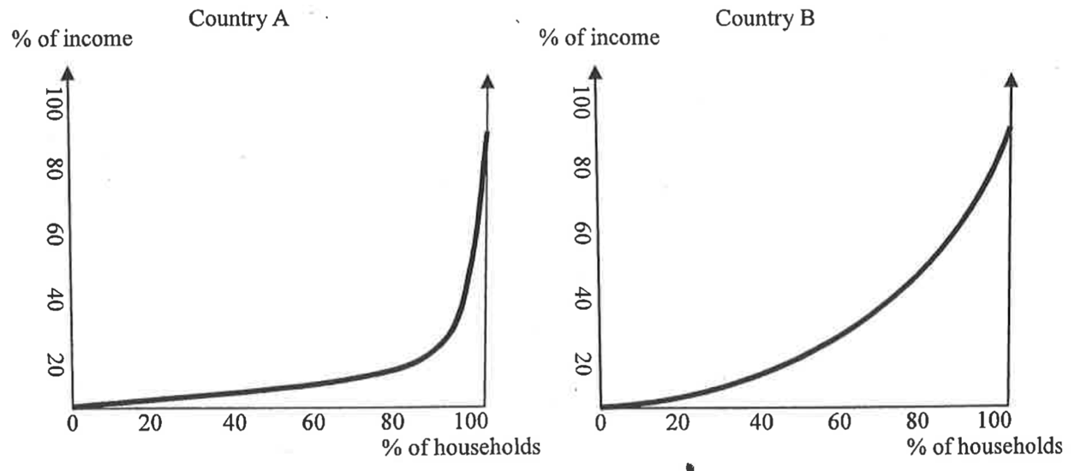
According to the above two diagrams,
A. Country B has a higher national income than Country A
B. The low income group of Country B has a higher income than that of Country A.
C. Country A has a more even distribution of income than Country B
D. Country A has a larger Gini coefficient than Country

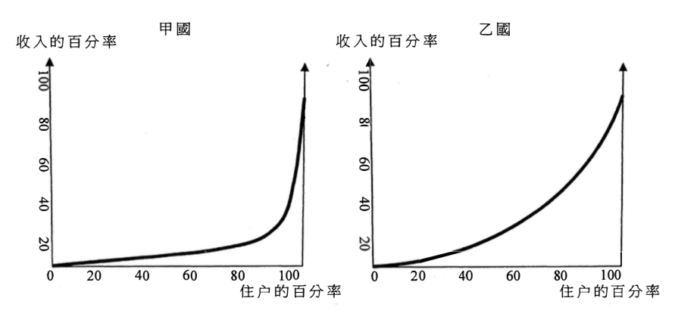
下圖顯示甲、乙兩國的洛倫茨曲線 。
根據以上兩圖 ，
A. 乙國的國民收入較甲國高。
B 乙國低收入組別人士的收入高於甲國低收入組別人士的收入。
C. 甲國的收入分配較乙國平均。
D. 甲國的堅尼系數較乙國高。

Example Question 4 DSE2012MCQ21
Which of the following are possible causes of income inequality among individuals?
(1) Difference in race
(2) Difference in capital ownership
(3) Difference in health
A. (1) and (2) only B. (1) and (3) only C. (2) and (3) only D. (1), (2) and (3)

下列哪些是導致不同人之間收入不均的可能原因?
(1) 種族的差異
(2) 資本擁有權的差異
(3) 健康的差異
A.只有 (1)、 (2) B.只有 (1)、 (3) C.只有 (2) 、 (3) D. (1)、(2)及(3)

Example Question 5 DSE2014MCQ20
Which of the following policies can reduce the Gini coefficient based on post-tax post-social transfer monthly household income in Hong Kong?
A. To raise the standard tax rate on salaries tax
B. To reduce the marginal tax rate on salaries tax
C. To reduce the amount of Comprehensive Social Security Assistance Schemes
D. To grant an equal sum of money to the Monetary Provident Fund accounts of every people

下列哪項政策能減低香港按除稅及福利轉移後住戶每月收入計算的堅尼系數？
A. 增加薪俸稅的標準稅率 B. 減低薪俸稅的邊際稅率
C. 減低綜合社會保障援助計劃的金額 D. 向每位僱員的強積金戶口注入一筆等額的金錢

Example Question 6 DSE2015MCQ21
Suppose the post-tax Gini coefficient of an economy is larger than its pre-tax Gini coefficient. This implies that
A. The government has increased the amount of transfer to the poor.
B. The tax system of the economy is likely to be regressive.
C. The problem of income inequality is worse than that in the previous year.
D. The government should reform the tax system.

假設某經濟除稅後的堅尼系數比稅前的堅尼系數高，這意味著
A. 政府增加了給窮人的轉移支付的金額 B. 該經濟的稅制很可能是累退性的。
C. 收人不均的問題比去年差。 D. 政府應該改革稅制。

Example Question 7 DSE2017MCQ20
Li Ka Shing Foundation gave HK$5000 to each 2017 HKDSE candidate living in those remote districts with lower average household income. Which of the following statements about this unconditional gift is correct?
A. To reduces the income inequality as a larger portion of the receivers of the gift are from lower income group.
B. It increases the income inequality as it is unfair to the candidates living in the non-remote districts
C. As the money is given to all candidates living those remote districts, income distribution remains unchanged
D. It helps equalizing opportunities as those candidates will study harder to improve their exam results.

李嘉誠基金向每位居住在那些平均住戶收人較低之偏遠地區的 2017年香港中學文憑考試考生派發港幣 5000元。下列哪項有關該無條件餽贈的陳述是正確的？
A. 這減低了收入不均，因為收到該餽贈的人較大部分來自低收入組別。
B. 這增加了收入不均，因為對居住在非偏遠地區的考生並不公平。
C. 因為該款項是給予那些居住在偏遠地區的所有考生，所以收入分配維持不變。
D. 這有助機會均等化，因為那些考生會更用功讀書以提高其考試成績。

Example Question 8 DSE2017MCQ21
The following diagram shows the Gini coefficient of Hong Kong on original household income.
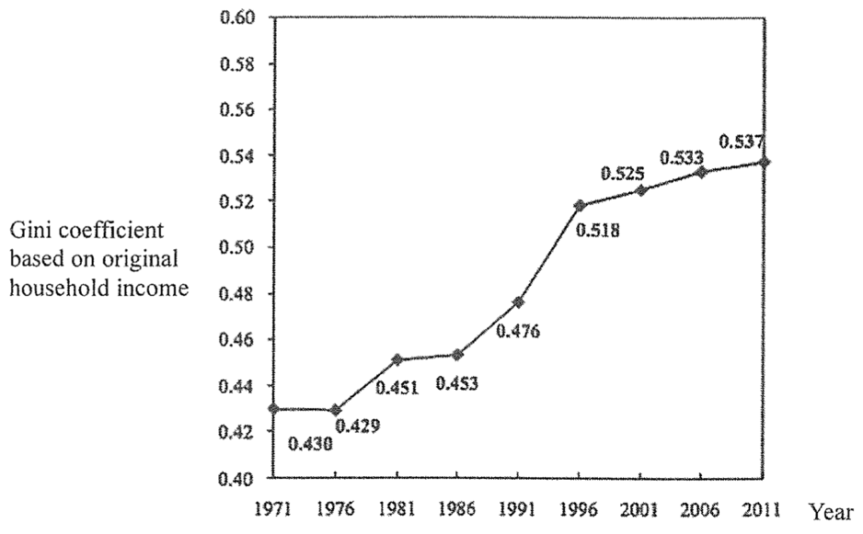
Based on the above diagram, we can conclude that
A. The income level of Hong Kong people increased
B. Income for high income household increased while income for low income household deceased
C. The welfare policy failed to reduce the income inequality
D. Income gap has been widening
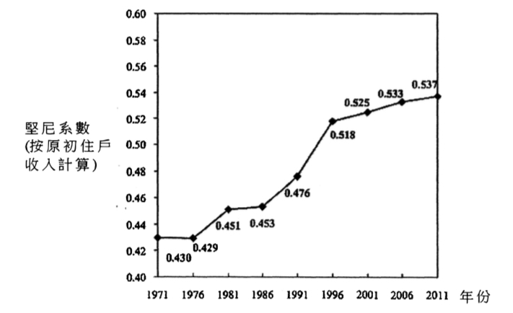
下圖顯示香港的堅尼系數(按原初住戶收人計算):
根據上圖 ，我們可以得出的結論是:
A. 香港人的收入水平上升 。 B. 高收人住戶的收人增加而低收入住戶的收入減少 。
C. 福利政策未能減低收人不均。 D. 收入差距日漸擴大。

Example Question 9 DSE2017MCQ22
The Work Incentive Transport Subsidy Scheme helps low-income earners reduce their cost of travelling to and from work and encourages them to get a job. Workers meeting certain criteria, such as monthly income and asset limits, are eligible to get the subsidy.
Which of the following would likely occur after the implementation of this scheme?
(1) Labour supply would increase
(2) Labour productivity would increase
(3) Geographical mobility of labour would increase
(4) Income inequality would decrease
A. (1) and (2) only B. (3) and (4) only C. (1), (3) and (4) only D. (2), (3) and (4) only

「鼓勵就業交通津貼計劃」協助低收入在職人士減低往返工作地點的交通費負擔，並鼓勵他們就業。工人只要符合指定條件，例如每月收人限額及資產限額，便有資格獲得津貼。
在上述計劃推行後，下列哪些會可能出現?
（1）勞力供應會增加。
（2）勞工生產力會增加。
（3）勞工的地域流動性會增加。
（4）收入不均會下降 。
A.只有(I)、(2) B.只有(3)、(4) C.只有 (1)、 (3) 及 (4) D.只有(2)、(3)及(4)

Example Question 10 DSE2019MCQ19
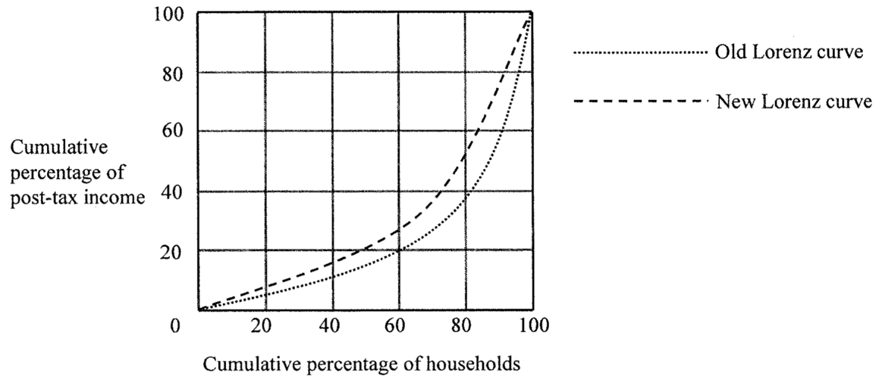
Which of the following policies would result the below change in the Lorenz curve in Hong Kong?
A. Lowering the profits tax rates B. Reducing the salaries tax allowance
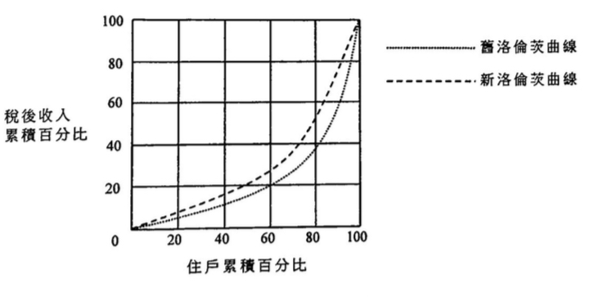
C. Increasing the progressivity of the salaries tax D. Raising the air passenger departure tax
下列哪項政策會使香港的洛倫茨曲線有以上的轉變？
A. 減低利得稅率 B. 減少薪俸稅免稅額
C. 提高薪俸稅的累進程度 D. 增加機場離境稅

Example Question 11 DSE2019MCQ20
Which of the following are the possible effects of this subsidy scheme?
Starting from the academic year 2017-18, the Hong Kong Government provides a subsidy of $30 000 annually for students pursuing full-time, self-financed undergraduate programmes (自資學士學位課程) offered by local private educational institutions.
- The unemployment rate will drop as labour force will increases
- The scheme helps equalize opportunities because students from low-income households will have a better chance to receive higher education
- The full employment output level will increase in the future because the average productivity increases after people receiving better education and training
A. (1) and (2) only B. (1) and (3) only C. (2) and (3) only D. (1), (2) and (3)

下列哪些是這資助計劃的可能影響？
由2017-18學年起，香港政府向修讀本地私立教育機構所開辦的全日制自資學士學位課程的學生提供每年$30 000的資助。
(1) 失業率會下降，因為勞動人口會增加。
(2) 該計劃有助於機會均等化，因為來自低收入住戶的學生有更大機會接受高等教育。
(3) 全民就業產出水平將來會上升，因為人們接受較佳的教育和培訓後平均生產力會上升。
A.只有(1),(2) B.只有(1),(3) C.只有(2),(3) D.(1),(2)及(3)

Example Question 12 DSE2020MCQ22
Study the following two Lorenz curves.
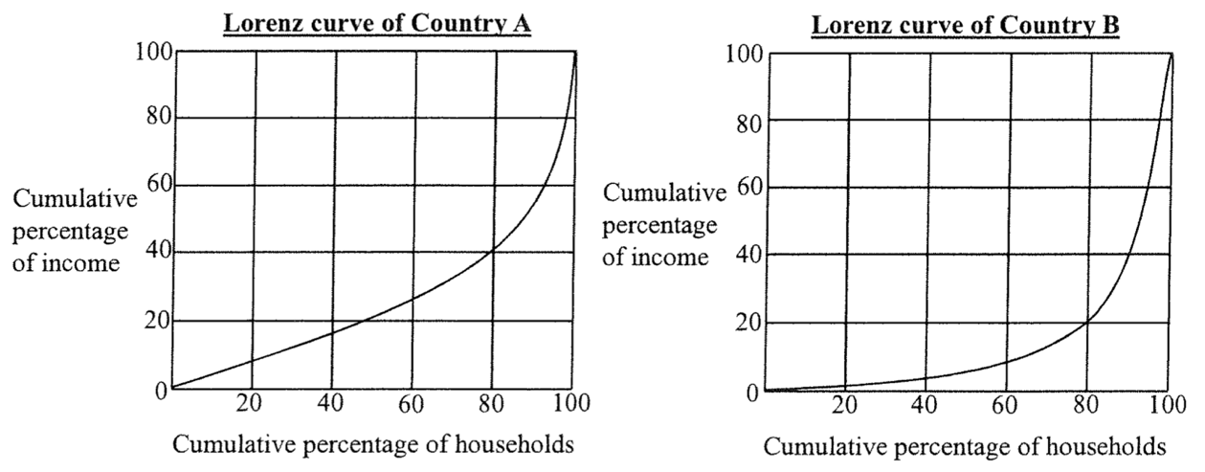
Compared with Country B,
A. the Gini coefficient of Country A is larger. B. Country A has a higher standard of living
C. the top 20% of households in Country A have less total income. D. Country A has a more even income distribution.
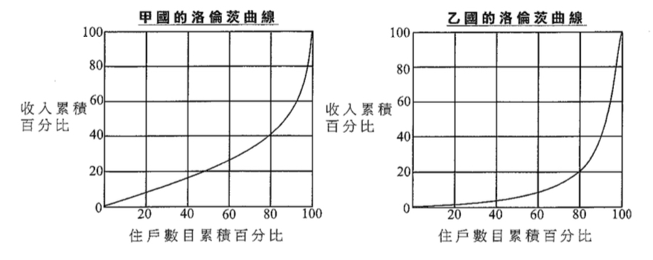
細閲以下兩條洛倫茨曲線。
與乙國相比，
A. 甲國的堅尼系數較高。 B. 甲國的生活水平較高。
C. 甲國最高端20%的住戶的總收入較低。 D. 甲國的收入分佈較均等。

Example Question 13 DSE2020MCQ23
The following table shows the data of average annual income earned by women and men according to their age in 2018.
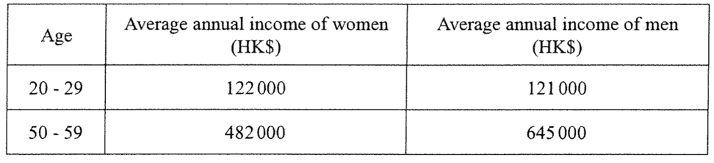
Which of the following may explain the phenomena shown by the above data?
(1) Women tend to leave the job market earlier than men for taking care of the family, leading fewer women to take up senior positions in companies.
(2) Sex discrimination in labour market exists in the older generations
(3) Accumulation of human capital contributes to the difference in income between different age groups.
A. (1) only B. (2) only C. (3) only D. (1), (2) and (3)

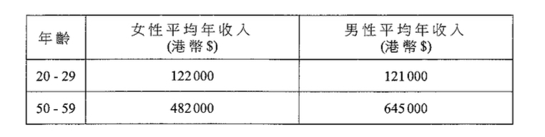
下表影示2018年女性與男性按年齡劃分的平均年收入資料。
下列哪些可能解釋以上資料所示的現象？
(1) 女性傾向於比男性更早離開職場以照顧家庭，以致擔任公司高職的女性較少。
(2) 勞動市場的性別歧視存在於年長一輩中。
(3) 人力資本的積累導致不同年齡組別的收入差異。
A. 只有(1) B. 只有(2) C. 只有(3) D. (1),(2)及(3)
Example Question 14 DSE2021MCQ21
Refer to the following policy proposals in Hong Kong.
Proposal (1): providing a cash subsidy for those who have been on the waiting list for public housing over five years
Proposal (2): raising the eligible age for the Elderly Comprehensive Social Security Assistance Scheme from 60 to 65
Proposal (3): raising the standard tax rate of the salaries tax
Which of the above proposals will reduce the Gini coefficient based on post-tax post-social transfer monthly household income in Hong Kong?
A. (1) and (2) only B. (1) and (3) only C. (2) and (3) only D. (1), (2) and (3)

參閱以下香港的政策建議。
建議 (1): 向在公屋輪候冊上超過五年的人士提供現金補貼
建議 (2): 將長者綜合社會保障援助計劃的合資格年齡由 60歲增加至 65歲
建議 (3): 將薪俸稅的標準稅率提高
以上哪些建議會降低香港按稅及福利轉移後住戶每月收入計算的堅尼系數？
A.只有(1), (2) B.只有(1), (3) C.只有(2), (3) D.(1), (2)及(3)

Example Question 15 DSE2021MCQ22
The following table shows the information about two top-tier football leagues.
 | Average annual income of the players
Football league | Defense players | Attacking players
England | $2 751 537 | $3 829 875
Italy | $1 536 945 | $2 625 975
Which of the following is/are possible reason(s) for the income differences among players?
(1) The television broadcast revenue generated by the top-tier football league in England is higher than that in Italy,
(2) The price level in England is higher than that in Italy.
(3) The commercial values of attacking players are higher than those of defensive players since attacking players are more popular.
A. (1) only B. (2) only C. (3) only D. (1), (2) and (3)

下表顯示有關兩個頂級足球聯賽的資料。
 | 球員的每年平均收入
足球聯賽 | 防守球員 | 進攻球員
英格蘭 | $2 751 537 | $3 829 875
意大利 | $1 536 945 | $2 625 975
下列哪項 / 些是球員之間收入差異的可能原因？
(1) 英格蘭頂級足球聯賽的電視轉播收入較意大利的為高。
(2) 英格蘭的物價水平較意大利的為高。
(3) 進攻球員的商業價值較防守球員的為高，因為進攻球員較受歡迎。
A.只有(1) B.只有(2) C.只有(3) D.(1),(2)及(3)
Type 1 (Measuring Equity – Gini Coefficient and Lorenz Curve)

2012DSE LQ4ab, 10b
According to a report of the United Nations in 2008, the Gini coefficients of Hong Kong and Beijing were 0.53 and 0.22 respectively.
(a) Was the income gap between the rich and the poor in Hong Kong wider or narrower than that in Beijing? (1)
(b) Explain how an increase in the standard tax rate of salaries tax will affect the post-tax Gini coefficient of Hong Kong. (3)
(c) In 2011, the Financial Secretary announced the “Scheme $6000” which provides $6000 to each Hong Kong permanent resident who is 18 years old or above. Do you think the government should introduce the “Scheme $6000” to improve equity in the Hong Kong society? Explain (4)
根據聯合國 2008 年的一份報告，香港及北京的堅尼系數分別是 0.53及 0.22。
(a) 與北京比較，香港貧富之間的收入差距屬較闊或較窄？ (1)
(b) 解釋增加薪俸稅的標準稅率會如何影響香港的除稅後堅尼系數。 (3)
(c) 財政司司長在 2011 年公布「$6000 計劃」：向每位十八歲或以上的香港永久居民派發$6000。你認爲政府應否 推行「$6000 計劃」以令香港社會更公平？試加解釋。 (4)
_______________________________________________________________________________________
_______________________________________________________________________________________
_______________________________________________________________________________________
_______________________________________________________________________________________
_______________________________________________________________________________________
_______________________________________________________________________________________
_______________________________________________________________________________________
_______________________________________________________________________________________
_______________________________________________________________________________________
_______________________________________________________________________________________
_______________________________________________________________________________________
_______________________________________________________________________________________
_______________________________________________________________________________________
_______________________________________________________________________________________
_______________________________________________________________________________________
Marking Scheme:
(a) Wider (1)
(b) Lower, because (1)
Higher income group has a lower post-tax income while the income of lower income groups remains unchanged. (2)
(c) - Equity is a subjective concept that involves value judgement. / Different people use different standards of equity. (1)
- Different people use different standards of equity. (1)
- Yes, because the $6000. Results in a higher percentage increase in income of the poor
- No, as it does not help equalize opportunities. Relative to the rich, the poor do not get more
resources to improve their productivity / increase future income.
- No, at it is not equalising outcomes as not everyone can benefit from the scheme, e.g. non-permanent residents and residents who are below 18 years old are not eligible for the $6000 (2)
(a) 更闊 (1)
(b) 較小，因為 (1)
較高收入的組別除稅後收入會下降，而較低收入組別的收入維持不變。 (2)
(c) - 公平等是一個主觀的概念，涉及價值判斷。/ 不同人對公平有不同的準則。 (1)
- 是，$6000 分窮人的收入有較大百分比的上升。 (1)
- 否，因爲計劃沒有幫助機會平等化。相對富人來說，窮人沒有取得較多的資源以改善他們的生產力 / 增加將來的收入。
- 否，因爲計劃沒有幫助結果平等化，因為不是每個人能在計劃中得益，例如非永久居民和未夠18歲的居民沒有資格領取$6 000 。 (2)
Candidates’ Performance:
(a) Excellent.
(b) Poor. Many candidates did not realise an increase in the standard tax rate has no effect on the poor as the tax only applies to the high-income group. Some provided a comparison between the rich and the poor of their tax payments as percentage of their incomes, which was irrelevant to this question.
(c) Poor. Some candidates showed an inadequate understanding of the two concepts of equity. Some others missed the key words ‘to improve equity’, thus providing irrelevant discussion or wrongly focusing their discussion on the disincentive effects of transfer payments in general.
(a) 優異。
(b) 欠佳。多數考生不知道標準稅稅率上升不會影響窮人，因為該稅項只適用於高收入人士。部分考生比較富人和
窮人所付稅款佔其收入的百分率，和題旨無關。
(c) 欠佳。部分考生對平等的兩個概念理解不足。另有考生未有注意重要字眼「令(社會)更公平」，提供與題旨無關的討論，或是誤把討論的焦點放在轉移支付減低工作意慾的一般影響。

2013DSE LQ7ab
Table 1 shows the Gini coefficients by occupation of Hong Kong in the years 2006 and 2011.
Table 1 | Gini Coefficient
 | 2006 | 2011
Construction | 0.362 | 0.385
Financing, insurance, real estate and business services | 0.544 | 0.548
(a) According to Tale 1, which occupation has a smaller income inequality among its workers? Give TWO possible reasons that account for such a difference in income inequality. (4)
表一展示香港在2006年及2011年按職業分類的堅尼系数。
表一 | 堅尼系數
 | 2006 | 2011
建造業 | 0.362 | 0.385
金融、保險、地產和商用服務業 | 0.544 | 0.548
(a) 根據表一，哪項職業的從業員之間收入不均情況較輕微？舉出兩個可能原因解釋這收費不均出現差異的情況。(4)
_______________________________________________________________________________________
_______________________________________________________________________________________
_______________________________________________________________________________________
_______________________________________________________________________________________
_______________________________________________________________________________________
_______________________________________________________________________________________
_______________________________________________________________________________________
_______________________________________________________________________________________
_______________________________________________________________________________________
_______________________________________________________________________________________
_______________________________________________________________________________________
_______________________________________________________________________________________
_______________________________________________________________________________________
Table 2 shows the employment distribution by industry section of Hong Kong in the years 2006 and 2011.
Table 2 | Employment Distribution by Industry Section
 | 2006 | 2011
Construction | 8.0% | 7.7%
Financing, insurance, real estate and business services | 17.0% | 19.2%
Table 3 shows the Gini coefficient of Hong Kong in the years 2006 and 2011.
Table 3 | 2006 | 2011
Gini Coefficient | 0.533 | 0.537
(b) How may the data given in Tables 1 and 2 help explain the change in the income inequality of Hong Kong as reflected in Table 3?

表二顯示香港在2006年及2011年按行業分類的就業分佈。
表二 | 按行業分類的就業分布
 | 2006 | 2011
建造業 | 8.0% | 7.7%
金融、保險、地產和商用服務業 | 17.0% | 19.2%
表三顯示香港在2006年及2011年的堅尼系數。
表三 | 2006 | 2011
堅尼系數 | 0.533 | 0.537
(b) 表一及表二提供的資料如何可以幫助解釋表三所反映香港收入不均情況的轉變？
_______________________________________________________________________________________
_______________________________________________________________________________________
_______________________________________________________________________________________
_______________________________________________________________________________________
_______________________________________________________________________________________
_______________________________________________________________________________________
_______________________________________________________________________________________
_______________________________________________________________________________________
_______________________________________________________________________________________
Marking Scheme:
(a) Construction. (1)
This is because the entry to a particular occupation is closely associated with a person’s human capital, which tends to be more homogeneous among the construction workers than among finance professionals. (2)
The construction industry often pays their workers by time rates, which are more or less uniform across workers. In addition to basic salaries, compensation to the employees of financing, insurance, real estate and business services often include performance-based commissions, bonuses and profit-sharing, which may result in a greater diversity of income within this industry. (2)
(b) The Gini coefficient, which reflects the degree of income inequality, has increased in the HK economy as a whole. (1)
Possible reasons:
- As shown in Table 1, income inequality in both the construction and financing, insurance, real estate and business services industries has increased. Other things being equal, this would contribute to the increase in the income inequality in the entire economy. (2)
- As shown in Table 2, there is an increase in the proportion of working population in the industry with a larger disparity of income (i.e. financing, insurance, real estate and business services) and a decrease in the industry with a smaller disparity of income (i.e. construction). Other things being equal, this changing pattern of employment distribution across the two industries would contribute to the increase in the income inequality in the entire economy. (2)
(a） 建造業。 (1)
這是因為一個人能否加入某特定職業，是與他的人力資本有密切關係。相到於金融專業人士，建造業工人的人力資本傾向較同質。 (2)
建造業向工人支付薪金通常以工時計算，工人的薪金大致相同。金融及商用服務業的僱員的報酬除了底薪，通常亦包括根據表現發放的佣金、花紅及利潤分享。這可引致該行業内薪金有較大的差異。 (2)
(b) 對香港整體經濟來說，反映收入不均程度的堅尼系數是上升了。 (1)
可能原因：
- 表一所示，在建造業和金融及商用服務業的收入不均情況皆變得較嚴重。其他因素不變，這會令整體經濟的收入不均變得較嚴重。 (2)
- 表二所示，收入不均較嚴重的行業（金融、保險、地產及商用服務業）所佔勞動人口的比例上升，而收入不均較輕微的行業（建造業）所佔勞動人口的比例下降。其他因素不變，兩個行業之問就業形態的改變會令整體經濟的收入不均情況變得較嚴重。 (2)

Candidates’ Performance:
(a) Fair. The majority of candidates made use of the information provided by Table 1 to explain the difference in income inequality between occupations. Common mistakes include:
- overlooking the key word “occupation” and comparing instead the income inequality across years;
- discussing merely the meaning of Gini-coefficient without actually addressing the question;
- mixing the concept of income inequality with that of income instability.
(b) Poor. This question is demanding as it requires interpretation of data from several tables. The data in Table 1 and 3 extracted from the results of the population census and by-census while those in Table 2 are extracted from Hong Kong in Figures 2012 Edition. Although there are differences in the data coverage and industry classification for the statistics extracted from these two sources, the question aims to examine candidates’ in-depth understanding of the concept of “income inequality” as well as the ability to infer possible reasons for the increasing income equality of Hong Kong from simplified data. The majority of candidates were able to point out that income inequality has increased but failed to make good use of the given data in their explanations. Some candidates misinterpreted the percentage distribution of employment across industries as their employment populations, and thus wrongly regarded a rise in the figures for a certain industry as an increase in the number of (employed) workers in that industry.

- 尚可。大部分的考生利用表一所提化的資料解釋職業間收入不均的分别。一些常犯的錯誤包括：
- 忽略了重要字詞「職業」，而比較不同年份的收入不均的情況；
- 只討論堅尼系數的意思而沒有真正回應題旨
- 混淆了收入不均和收入不穩定這兩個概念。
(b) 欠佳。這道較難的題目要求考生詮釋數個表格的資料。表一及表三的資料摘錄自人口普查及中期人口普查的結果，而表二的資料摘錄自香港統計數字一覧(2012)。儘管上述兩個來源所摘錄的統計數字的資料範圍和行業分類有分別，這題目旨在考核考生對「收入不均」這概念的深入認識，並從簡化的資料推斷出香港收入不均愈趨嚴重的可能原因。雖然大部分考生能指出收入不均的情況變得嚴重，他們未能好好運用已有的資料加以解釋。一些考生誤將不同行業的就業分佈百分比當成行業的就業人口，故此誤將某行業數值的上升當作該行業(就業)人口上升。

2013DSE Lq11a, bii
The government has launched the “Work Incentive Transport Subsidy Scheme”, with the following objectives:
(1) To relieve the burden of travelling expenses commuting to and from work on the part of low-income households with employed members
(2) To promote sustained employment
Applicants must meet the monthly income and asset limits of the household (e.g. for a single person, the monthly income cannot exceed $7300 and the asset cannot exceed $72000) and work no less than 72 hours per month in order to apply for a subsidy of $600 per month.
(a) Do you think that the scheme can achieve the above two objectives? Explain (4)
(b) Discuss the effects of the scheme on income inequality. (3)

政府已推出「鼓勵就業交通津貼計劃」，目標如下：
(1) 減輕低收入住戶在職人士往返工作地點的交通費負擔
(2) 鼓勵持續就業
申請人必須符合住戶每月入息和資產限額（以單身人士為列，每月入息不可超過$7 300，而資產不可超過$72 000）及每月工作不少於72小時以申請每月$600的津貼。
(a) 你認為該計劃可以達到上述兩項目標嗎？試加解釋。 (4)
(b) 討論該計劃對收入不均的影響。 (3)
_______________________________________________________________________________________
_______________________________________________________________________________________
_______________________________________________________________________________________
_______________________________________________________________________________________
_______________________________________________________________________________________
_______________________________________________________________________________________
_______________________________________________________________________________________
_______________________________________________________________________________________
_______________________________________________________________________________________
_______________________________________________________________________________________
_______________________________________________________________________________________
Marking Scheme:
(a) Objective (1): Yes, as it provides cash subsidies relieving the burden on travelling expenses.
Objective (2): Yes, if the WITSS continues to subsidize the workers on travelling expenses. /
Objective (2): No, as employment (as well as unemployment) largely depends on the aggregate demand and supply of the economy (which may fluctuate over time) rather than the WITSS. (4)
(b) It helps to reduce the income inequality. It helps equalize outcome as it provides extra money for the lower-income only / it increases their opportunity of finding a job with higher income because they can travel farther away from their residential area. (3)

(a) 目標（1）：是，因為這計劃提供了現金津貼，舒緩交通費用的負擔。
目標（2）：是，若該計劃繼續補貼工人的交通費。
目標（2）：否，因為就業（和失業）主要受經濟的總需求和總供應（可能隨時間變動）所影響，而非受這計劃影
響。 (4)
(b) 它有助減低收入不均、因為它只提供額外金錢予低收入人士、有助成果均等化 / 它增加低收人人士找到一份收入較高的工作機會，因為他们可以前往距離居住區更遠的地方作 。 (3)

Candidates’ Performance:
(a) Fair. The majority of candidates were able to point out that the scheme is a subsidy to workers to relieve their burden of transportation expenses and that the subsidy results in a greater incentive for job-seekers to seek jobs. Some candidates failed to state clearly which objective they were referring to, resulting in confusing answers. Some others overlooked the word “sustained” or mis-thought that the scheme would increase work incentives.
(b) Satisfactory. The majority of candidates were able to point out that some households in the lower-income group could benefit from the scheme. In their elaborations, some brighter candidates could even distinguish the concept of “equalizing income” from that of “equalizing opportunities”. A common problem, however, is that there was an over-emphasis on the poor in candidates’ discussions, without mentioning how the policy would affect the rich.
- 尚可。大部分考生能指出，該計劃是對工人的一項補貼，以減輕其交通費用的負擔，而且該津貼令求職者求職的意慾較大。部分考生未能清楚指出他們的答案與哪個目標有關，答案令人混淆。又有其他考生忽略了「持續」一詞或是誤以為計劃會增加工作意慾。
- 滿意。大多數考生能指出部分低收入的住戶能因該計劃獲益。在闡述其答案時，部分能力較佳的考生能分辦「收入均等」和「機會均等」這兩個概念。但是一個常見的問題是考生過分著重貧窮人士的討論，未能指出該政策會如何影響富有人士。

2015DSE LQ8
The government is considering spending a certain sum of its budget surplus on the following two proposals:
Proposal 1: To extend the free education to 15 years
Proposal 2: To provide unemployment benefits
Evaluate the two proposals in terms of equality. (4)

政府正考慮從其財政盈餘撥出一筆款項，用於下列兩項提案：
提案1：將免費教育延長至15年
提案2：提供失業援助金
試以公平為依據，評價該兩項提案。 (4)
_______________________________________________________________________________________
_______________________________________________________________________________________
_______________________________________________________________________________________
_______________________________________________________________________________________
_______________________________________________________________________________________
_______________________________________________________________________________________
_______________________________________________________________________________________
_______________________________________________________________________________________
_______________________________________________________________________________________
_______________________________________________________________________________________
_______________________________________________________________________________________
_______________________________________________________________________________________
_______________________________________________________________________________________
_______________________________________________________________________________________
_______________________________________________________________________________________
_______________________________________________________________________________________
_______________________________________________________________________________________
Marking Scheme:
Proposal 1:
- Equalizing opportunities:
Free education for longer years means that the poor are able to receive more education and improve their productivity and hence income-earning power in the future. (2)
Proposal 2:
- Equalizing income / outcome:
More welfare payments to the unemployed could help reduce the income inequality between the employed (rich) and the unemployed (poor). (2)

提案1:
- 機會均等：免費教育的年期增加令窮人能接受更多的教育，從而提高他們未來的生產力及賺錢能力。 (2)
提案2:
- 收入 / 結果均等:
- 給予失業人士較多福利縮減就業人士（富人）和失業人士（窮人）的收入差距。 (2)

Candidates’ Performance:
Satisfactory. The majority of candidates manned to provide an evaluation of the policy proposals in terms of equality and aggregate output. Some common mistakes were as follows:
- failure to analyse “equality” effects of the policies on “equality” in the sense of equalizing opportunities and equalising incomes
- providing a discussion of the pros and cons of the two proposals without using the given criteria (i.e., equality and output);
- stating the policy effects on such macroeconomic variables as consumption, investment, and government expenditure without relating them to the change in AD / SRAS / LRAS inaccurate use of terms like “real” output. “aggregate” output, and “potential” output.
令人滿意。大部分考生能依據公平和總產出評價道這些政策建議。常見的錯誤如下：
- 未能分析政策對「公平」的效果，「公平」，在這裡是指機會均等及收入均等。
- 没有運用題目的準則（即公平和產出）去討論兩個提案的優點和缺點。
- 指出政策對宏觀經濟變量（如消費、投資•政府支出）的影響，卻沒有指出與AD / SRAS / LRAS的關係
- 未能準確運用「實質」產出、「總」產出和「潛在」產出等術語。

2016DSE LQ11c, d
Here is an extract from the Hospital Authority webpage
The Hospital Authority is committed to providing community-based primary care services. Our target patients included the elderly, low-income individuals, and patients with chronic diseases.
(a) With reference to Source B, explain how the services provided by the Hospital Authority can enhance equity. (2)
(b) Many people argue that public clinics should raise the fee to reduce the waiting time. Evaluate this argument in terms of equity and economic efficiency. (4)
摘錄醫院管理局的網頁
醫院管理局致力提供以社區為本的基礎醫療服務，服務對象包括長者、低收入人士和長期病患者。
(a) 參考資料乙，解釋醫院管理局提供的服務可以如何促進公平。 (2)
(b) 很多人認為公立診所應該提高收費以減少輪候時間。以公平和經濟效率為依據，評價這種看法。 (4)

_______________________________________________________________________________________
_______________________________________________________________________________________
_______________________________________________________________________________________
_______________________________________________________________________________________
_______________________________________________________________________________________
_______________________________________________________________________________________
_______________________________________________________________________________________
_______________________________________________________________________________________
_______________________________________________________________________________________
_______________________________________________________________________________________
_______________________________________________________________________________________
_______________________________________________________________________________________
_______________________________________________________________________________________
_______________________________________________________________________________________
_______________________________________________________________________________________
Marking Scheme:
(a) Equalize income/outcome: basic medical service acts like a transfer or subsidy-in-kind, enjoyed mainly by the low-income group; The high-income group may choose not to “queue up” for such medical benefits and turn to private medical service instead. (2)
OR
Equalize opportunities: basic medical service provided for the patients with chronic diseases would improve their health, allowing them to continue to work and earn income. Therefore, their income would not affected by their ability to afford medical service (their background), but rather by their work effort. (2)

(b) Equity: After the fee raise, the poor may no longer be able to afford the fee and thus be deprived of the opportunity to enjoy the medical services. Equity may be worsened as the poor cannot enjoy the transfer / subsidy while the rich can still use the service. (2)
OR
After the fee raise, the poor may no longer be able to afford the fee and thus be deprived of the opportunity to enjoy the medical services. The poor may then be deprived of the chance to wo0rk and earn income due to their poor health. (2)
Efficiency: The fee increase would improve efficiency as it results in a price closer to the equilibrium level, thus narrowing the gap between MB and MC and reducing the size of deadweight loss. (2)

(a) 收入 / 結果均等：基礎醫療服務的作用像一種轉移 / 非金錢的補貼，主要受益者是低收入人士。高收入人士可能選擇不排隊享用這種利益，而轉用私人醫療服務。 (2)
或
機會均等：對長期病患者提供的基礎醫療服務可改善他們的健康，令他們可以工作，從而賺取收入。因此，他們的收入不是取決於他們的負擔醫療服務的能力（他們的背景）而是他們工作上的努力。 (2)

(b) 平等：在加費後，窮人未必能負擔該費用，因而被剝奪享用醫療服務的機會。這會令社會變得更不平等，因為窮人不能享受該轉移 / 補貼但富人仍可使用該服務。 (2)
或
在加費後，窮人未必能負擔該費用，因而被剝奪享用醫療服務的機會。這會令社會變得更不平等，窮人或會因健康欠佳而被剝奪工作和賺取收入的機會。 (2)
效率：加價會改善效率，因為價格會更接近均衡價格，縮減邊際利益和邊際成本之間的差距，令效率損失下降。 (2)

Candidates’ Performance:
(a) Good. Most candidates were able to give an explanation in their own words, but only some made use of the concepts of "equalising income / opportunity" in their answers.
(b) Good. Many candidates were able to demonstrate their understanding of the effects of the fee increase on efficiency and equity, and some could explain the efficiency-equity trade off in this case as well. The following shows a list of mistakes;
- thinking that they were only required to provide reasons to support the argument;
- mis-labelling their statement about efficiency under the heading of equity, or vice versa;
- failure to provide an explanation for their stand using economic terms.
(a) 良好。大部分考生能以自己的文字解釋，但只有一些考生運用「收入均等化 / 機會均等化」的概念作答。
(b) 良好。很多考生能顯示他們了解費用增加對效率和公平的影響，部分考生能解釋個案中效率與公平之間是此消彼長的。以下列出一些考生的錯誤：
- 以為只須提供理由支持該論點。
- 誤將有關效率的陳述寫在公平的標題下，反之亦然。
- 未能以經濟術語解釋立場。

2017DSE LQ11c, 13bii
(a) The government of Country X introduces a per-unit subsidy to the education services of private universities. Explain whether subsidizing education can help improve equality. (3)
(a) X國政府向私立大學的教育服務提供一項從量補貼。解釋補貼教育能否促進公平。 (3)
_______________________________________________________________________________________
_______________________________________________________________________________________
_______________________________________________________________________________________
_______________________________________________________________________________________
_______________________________________________________________________________________
(b) To cope with the problem of a rapidly aging population in Hong Kong, the government has proposed a retirement protection scheme under which eligible elderly would receive $38 760 per year. To finance the scheme, there are different proposals which include:
Proposal A: increase the standard tax rate and the progressivity of salaries tax
Proposal B: use the fiscal reserves in the government
Discuss the effects of these two proposals on income distribution. (4)
為了應付香港人口急速老化的問題，政府建議一項退休保障計劃，計劃下合資格長者每年可領取$38 760。有人提出不同提案為該計劃融資，包括：
提案A：增加薪俸稅的標準稅率和累進程度
提案B：運用政府的財政儲備
討論上述兩項提案對收入分布的影響。 (4)
_______________________________________________________________________________________
_______________________________________________________________________________________
_______________________________________________________________________________________
_______________________________________________________________________________________
_______________________________________________________________________________________
_______________________________________________________________________________________
_______________________________________________________________________________________
_______________________________________________________________________________________
Marking Scheme:
(a) Yes. Subsidizing education is a measure to equalize opportunities, so the poor will not be deprived from university education because of their background. Education also improves their future income, thus reducing income inequality over generations. (3)

(b) Proposal A’s effect on income distribution:
- In general salaries tax payers (higher income group) pay more tax while non-tax payers (lower income group) are not affected. (2)
- High income tax payers pay more, low income tax payers pay less. (2)
- The after-tax income inequality is reduced. (1)
Proposal B’s effect on income distribution:
- No change in existing tax structure result in no extra effect on current tax payers, so the income inequality is unaffected. (2)
- Reduction of fiscal reserves may result in a rise in tax in the future, so future tax payers may pay more. (2)

(a) 是。補貼教育是令機會均等化的一種方法，故此窮人不會因為財務上的限制而不能獲得大學教育。教育亦改善他們將來的收入，故此能減輕隔代收入不均。 (3)
(b) 提案A對收入分配的影響：
- 整體上薪俸稅納稅人（較高收入人士）支付更多稅款，而非納稅人（較低收入人士）不受影響。 (2)
- 高收入的納稅人付稅較多，低收人的納稅人付稅較少。 (2)
- 除稅後收人不均情況減輕了。 (1)
提案B對收入分配的影響：
- 不會對現在的納稅人有額外的影響，所以收入不均的情況不變。 (2)
- 財政儲備下降可能促使將來加稅，故此將來的納稅人（主要是人口中的年輕人）可能要付更多稅款令世代之間的收入不均加劇。 (2)

Candidates’ Performance:
(a) Good. Most candidates were able to explain the impact of subsidized education on equalising of opportunity and / or
equalising of future income. Some candidates did not emphasize that the effect of this policy mainly affects low-income group.
(b) On Proposal A, the candidate performed well. Many candidates have a good understanding of income inequality. Some candidates were able to draw conclusions by analyzing how changes in the tax structure affected high-income group and low-income group respectively.
On Proposition B, candidates performed poorly. Most candidates only mentioned transfer payments, and the conclusion has nothing to do with the topic. A small number of candidates used knowledge outside of books to explain how future generations may be harmed.
(a) 良好。大部分考生能說明補貼教育對機會均等化及 / 或將來收入的均等化的影響。部分考生没有強調該政策的效果主要是影響低收入人士。
(b) 在提案A方面，考生的表現良好。很多考生對收入不均的認識不俗。部分考生能分析稅項結構的轉變如何分別影響高收入人士和低收入人士，從而得出結論。
在提案B方面，考生的表現欠佳。大部分考生只提到轉移支付，結論無關題旨。小部分考生運用在書本以外的知識，解釋未來世代可能會受損。

2018DSE LQ4
Apart from the difference in education level, explain TWO factors that may lead to income inequality (4)
除了教育程度差異以外，解釋可能導致收入不均的兩個因素。 (4)
_______________________________________________________________________________________
_______________________________________________________________________________________
_______________________________________________________________________________________
_______________________________________________________________________________________
_______________________________________________________________________________________
_______________________________________________________________________________________
Marking Scheme:
Factors:
- Race, as there may be racial discrimination in the job market and some ethnic minority groups may suffer a lower wage rate for the same job.
- Gender, as sex discrimination may exist in the workplace. On average, female suffers a lower wage rate for the same rank.
- Physical attributes, as average income may be higher for people who are fitter, or taller, or better-looking since these people are more productive for certain jobs (e.g. sportsmen, fashion models)
因素：
- 種族，因為職場可能有種族歧視，部分少數族裔在相同工作的工資率可能較低。
- 性別，因為職場可能出現性別歧視。女性平均工資率在相同職級會較低。
- 身體條件，因為較健康、高大或外表較佳的人平均收入可能較高，原因是這些人在部分職位發揮較高的生產力。（例如運動員、模特兒）。
Candidates’ Performance:
Good. Most candidates were able to list two factors leading to income inequality, but only some managed to provide proper explanations. Instead of simply quoting terms like racial or sex discrimination, candidates were required to elaborate on the different kinds of discrimination that may prevail in the economy. Furthermore, instead of making vague statements like ‘physical attributes affect income’, they were required to explain specifically which type of people - with which kind of physical attribute (e.g. height / fitness / appearance) would earn higher income on average.
良好。大部分考生能舉出引致收入不均的兩個因素，但只有部分考生提供恰當的解釋。考生須闡述在經濟中可能出現的不同類別的歧視，而非只寫出術語(如性別 / 種族歧視)。考生亦須準確解釋哪一種人具備哪種身體條件（如高度 / 體能 / 外貌）會賺取較高平均收人，而非籠統地指出影響收人的因素 （例如：身體條件影響收人）。

2019DSE LQ2b
Li Ka Shing Foundation offered an unconditional cash gift of $5000 to each 2018 HKDSE candidate living in Yuen Long, Tuen Mun and Islands districts under the project ‘Decide Well, Spend Wisely’.
Statement A: The project can improve the public examination results of candidates in those districts.
Statement B: The project can improve equity in Hong Kong
Justify Statement B (4)

李嘉誠基金以「善用錢」計劃的名義，向在元朗、屯門及離區居住並應考 2018 年香港中學文憑考試的每名考生無條件發放 $5000元現金。
陳述 A： 該計劃可以改善這些地區考生的公開考試成績。
陳述B： 該計劃可以令香港更公平。
論證陳述B。 (4)
_______________________________________________________________________________________
_______________________________________________________________________________________
_______________________________________________________________________________________
_______________________________________________________________________________________
_______________________________________________________________________________________
Marking Scheme:
Equalising income: The districts are with lower average household income so this cash will help narrow the income gap
Equalising opportunity: The subsidy on education will enhance the chance of the poor to get higher education without being hindered by their backgrounds.
收入均等化： 這些區域的住戶平均收入較低，故此該筆現金會幫助縮窄收入差距。
機會均等化： 補貼教育合提高低收入人士獲得高等教育的機會，避免他們受其背景所累。
Candidates’ Performance:
Fair. Mis-reading the question, some candidates chose to discuss whether Statement B was positive or normative (rather than justifying it). There were also candidates who mistook the keyword “justify” for “evaluate” and went on to analyse whether the statement was correct. Some missed out the key terms such as “equalising incomes / outputs” and “equalizing opportunities” in their discussion.
一般。部分考生誤解題目，選擇討論陳述 B是實證性還是規範性（而沒有論證該陳述）。亦有考生誤將重要字詞「論證」當成「評價」進而分析該陳述句是否正確。部分考生在討論中遺漏了重要概念，例如「收人 / 產出均等化」和「機會均等化」。

Marking Scheme:
Type 1 (Measuring Equity – Gini Coefficient and Lorenz Curve) P.2
1 | B | 2 | D | 3 | D | 4 | D | 5 | A | 6 | B | 7 | A | 8 | D | 9 | C | 10 | C
11 | C | 12 | D | 13 | D | 14 | B | 15 | D | 16 | D | 17 | B | 18 | B | 19 | A | 20 | C

