**Project4Task1**

**Team Member:**

Yash Jahagirdar      Andrew id – ybj

Leo Lin Andrew id – hungfanl

**Name of the API:**

Frankfurter App

**The URL of the API documentation**

https://www.frankfurter.app/

**what our mobile application will do with the information from the API**

The mobile application is a currency converter application for certain currencies that converts the amount entered by the user to the desired currency selected by the user. The application will ask the user for a number as an input and asks the user for the currency to be converted from and the currency to be converted to from the dropdown provided in the application, and call the Frankfurter API and get the converted currency from the API. Finally, the application will then display the converted currency in the application.

**1b Screenshot**

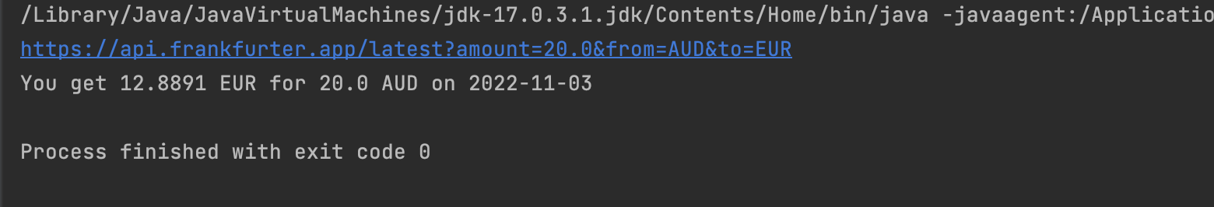

**2c Screenshot**

