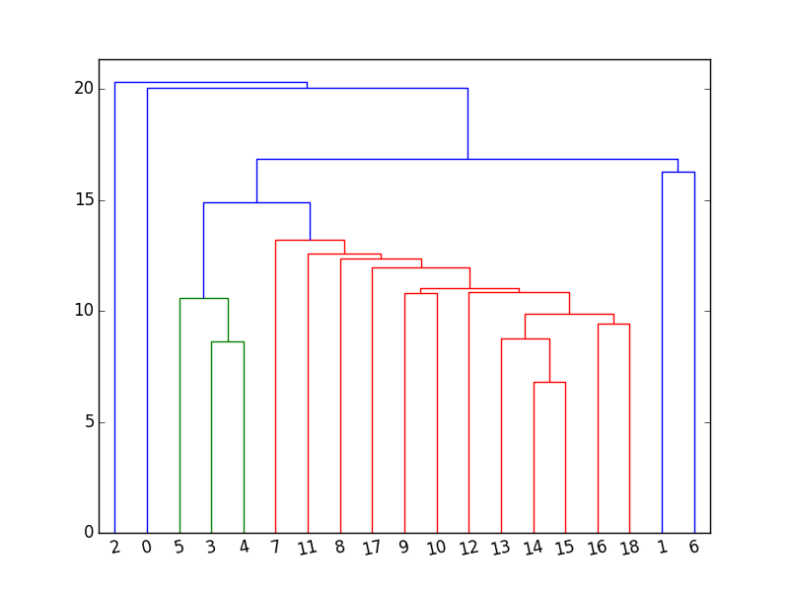

There are 20 channels in this graph. This is the hierarchical clustering dendrogram generated using the Euclidean distance between each channels. This graph shows the approximate clusters for different channels. This is the rough sketch of what our final clusters should be. We use it to compare with our results later.

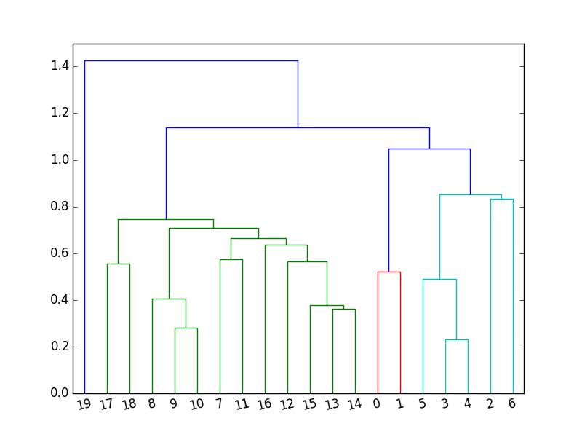

This is the dendrogram after we compared the clustering across different athletes. As we can see on this graph, there are 3 different groups. Channel 19 is a separate group, then channels 7-18 is in another group, while channel 0-6 is in the third group. This results was generated by using Jaccard index method after comparing pairs of channels. The sscluster step used on each different athletes. Each athletes have their own clustering, and by comparing the clustering using the Jaccard index, we were able to get the distance map from each channel across all athletes. After we generate the distance for each athelets, we were able to use the distance map and then generate this dendrogram to show the channel cluster across all athletes.

50_10 50_15 50_5 60_10 60_15 60_5 70_10 70_15 70_5

50_10 0.00 0.05 0.25 0.05 0.05 0.05 0.05 0.05 0.15

50_15 0.21 0.00 0.38 0.00 0.00 0.00 0.00 0.00 0.19

50_5 0.06 0.06 0.00 0.06 0.06 0.06 0.06 0.06 0.16

60_10 0.21 0.00 0.38 0.00 0.00 0.00 0.00 0.00 0.19

60_15 0.21 0.00 0.38 0.00 0.00 0.00 0.00 0.00 0.17

60_5 0.21 0.00 0.38 0.00 0.00 0.00 0.00 0.00 0.17

70_10 4.75 0.00 0.38 0.00 0.00 0.00 0.00 0.00 0.17

70_15 0.21 0.00 0.38 0.00 0.00 0.00 0.00 0.00 0.17

70_5 0.15 0.03 0.33 0.03 0.05 0.05 0.05 0.05 0.00

This is to confirm that our rolling window analysis makes sense even when we move the windows. The table was generated by Jaccard distance, and 0.00 means no difference at all.

ADD the heatmap and put the triplet table in them. Put the result of alpha waves filtering in the document, compare with the original dendrogram. 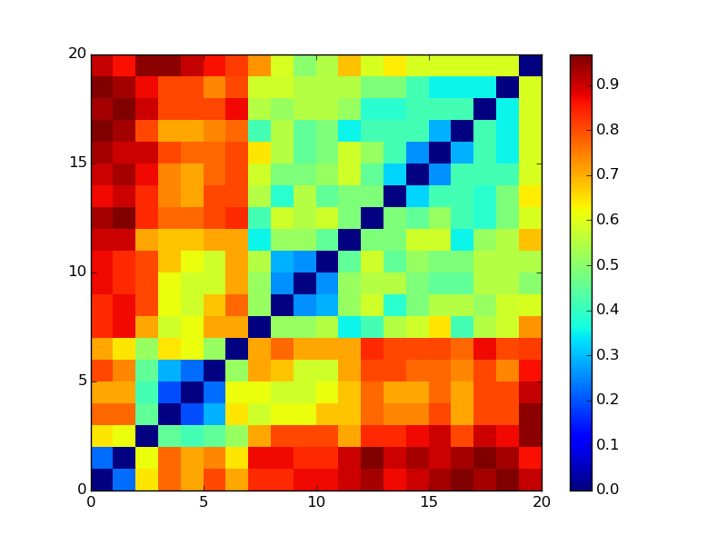

This is the heatmap between channels across all different athelets. Note that the lighter the color means the closer those channels are. The hotter(redder) the color the more distant they are. So it seems that 0-2 are similar to each other, 3-5 are similar to each other, 9-12 are similar to each other. According to the cooring of this graph, we can see that channels 0-20 are more similar to the closer channels.

|  |  |  |  |
| --- | --- | --- | --- |
| 9 | 17 | 18 | 0.709677419 |
| 10 | 12 | 18 | 0.709677419 |
| 10 | 13 | 17 | 0.709677419 |
| 10 | 13 | 18 | 0.709677419 |
| 10 | 14 | 18 | 0.709677419 |
| 10 | 15 | 17 | 0.709677419 |
| 10 | 15 | 18 | 0.709677419 |
| 10 | 17 | 18 | 0.709677419 |
| 11 | 15 | 18 | 0.709677419 |
| 13 | 14 | 19 | 0.681818182 |
| 13 | 15 | 19 | 0.681818182 |
| 2 | 3 | 6 | 0.677419355 |
| 2 | 3 | 7 | 0.677419355 |
| 2 | 4 | 6 | 0.677419355 |
| 2 | 4 | 7 | 0.677419355 |
| 2 | 5 | 6 | 0.677419355 |

Triplet distance table. The values are calculated by Jaccard distance, and this is across all distances. This is to show that we have calculated the distances between triplets of channels. 1 of such values means the most distant, while 0 means identical. This just shows the relationship among the three channels.