**Bus Ticket System Manual**

GUANGZHOU DINGHAN ELECTRONIC

TECHNOLOGY CO., LTD

Feb 7 2025

# CONTENT

CONTENT 1

Handheld Pos 2

Register 2

Set up 2

ISSUE CARDS 4

RECHARGE 4

Platform 5

Card Manage 5

Vehicle Management 6

Route Management 6

Route inquiry 7

Vehicle management 8

Other Setting 8

equipment management 8

Quota 9

System Setting 10

Role Permissions Settings 10

Validator 11

## Handheld Pos

### Register

The register interface will show up when open the **MFDEVICE.apk** at the first time. There is a serial number on the interface. Send it to us and we will send register code back. Enter the register code and click register button. The homepage will show up after registering successfully.

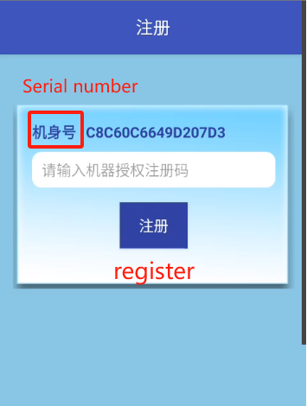

### Set up

Click on the top right corner of the screen to enter the set up interface

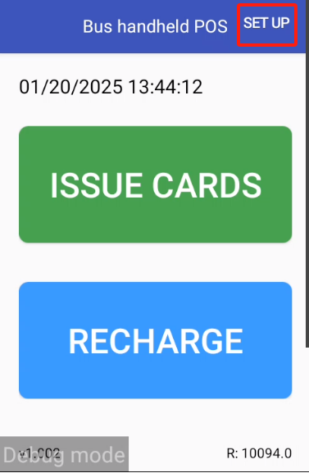

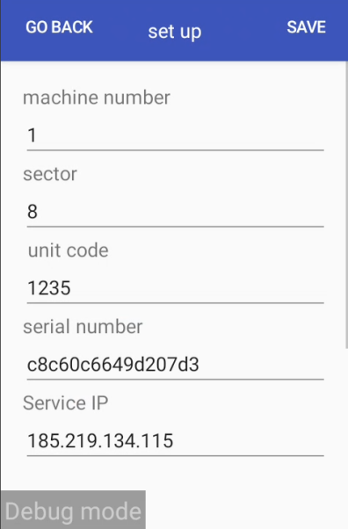

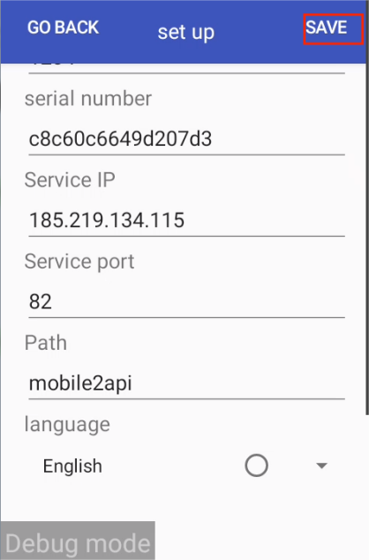

**Machine number:** According to the device id on the platform

**Sector:** 8

**Unit code:** 1235

**Serial number**: need to be input when adding device on the platform. (More details in the **equipment management** part)

**Service ip**: 189.219.134.115

**Service port**: 82

**Path**: mobile2api

After setting up,click **Save.**

### ISSUE CARDS

Click **ISSUE CARDS** button. Then enter the **Name** ,**Phone Number** and choose **Gende**r and **CARD TYPE** on the ISSUE CARDS interface.

After doing all these, click **ISSUE CARDS** and place the card on the NFC tap area.

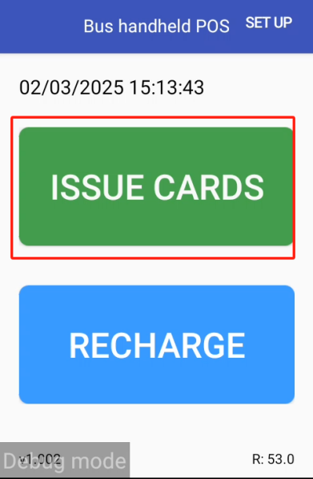

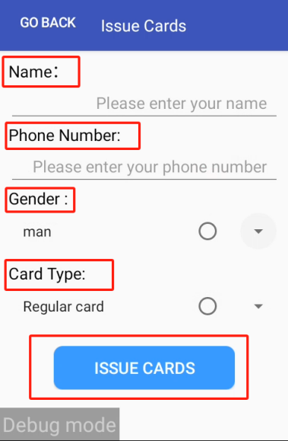

### RECHARGE

Click **RECHARGE** button to enter the Recharge interface. Place the card on the NFC tap area to check out card information. Enter the **Recharge amount** you need and click **ISSUE CARDS** and place the card on the NFC tap area again.

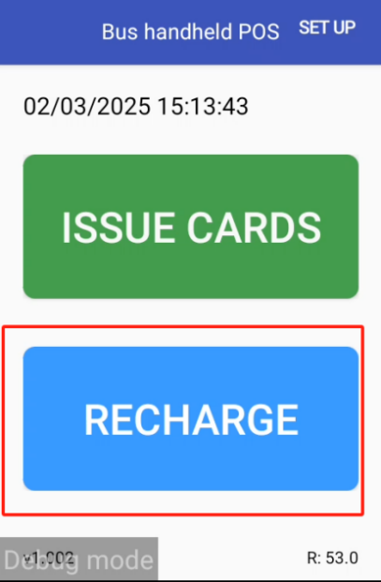

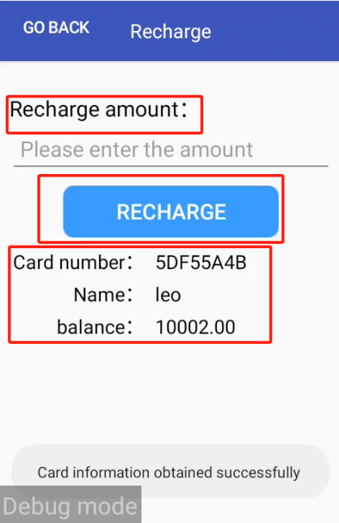

## Platform

### Card Manage

**Member Profile** interface has all the information of the issued cards. Including **registration date,phone number,full name,card type,card status and balance.**

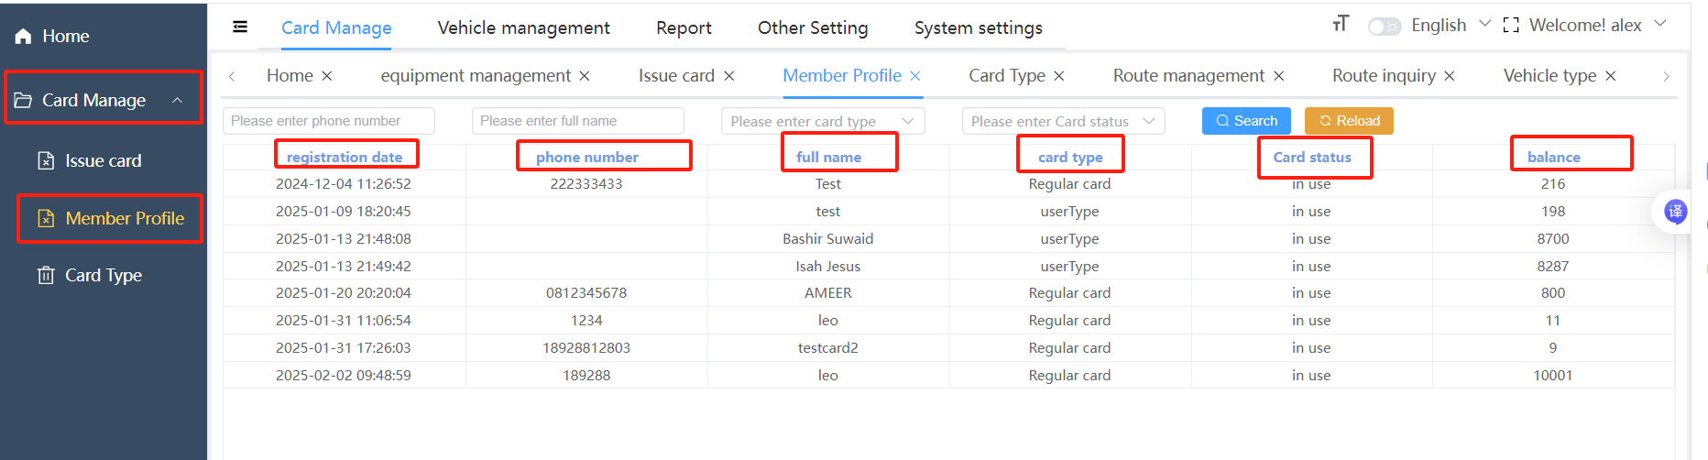

Add new customer type on the **Card Type and** set the **Recharge ratio** and **Discount ratio** for it.

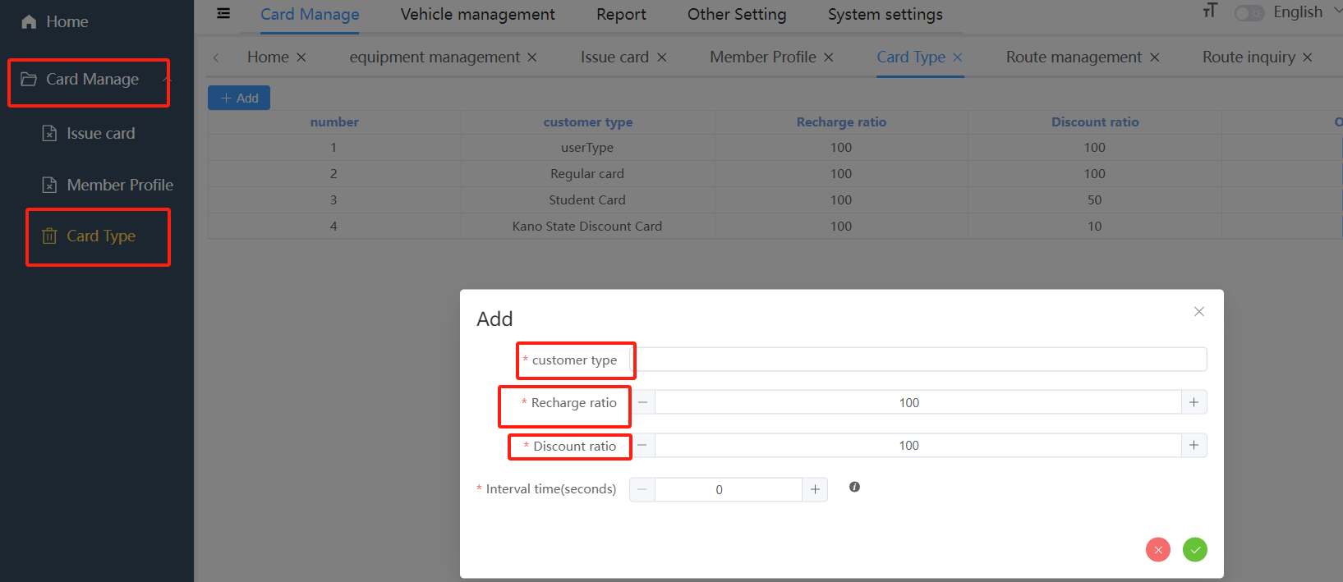

## Vehicle Management

### Route Management

Click **Add Route Level** and add a parent level at first.

Select city as the type and enter the city name.

Add the routes for the city and set first bus time ,last bus time and fare.

Add the station for the every route and arrange the **Station sequence.**

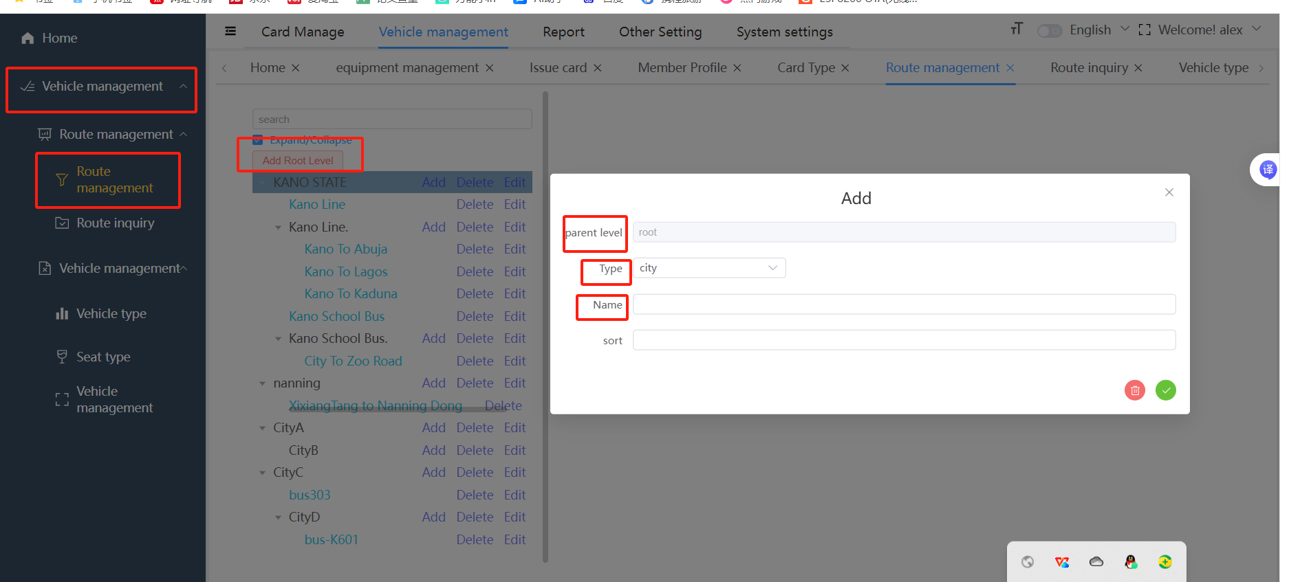

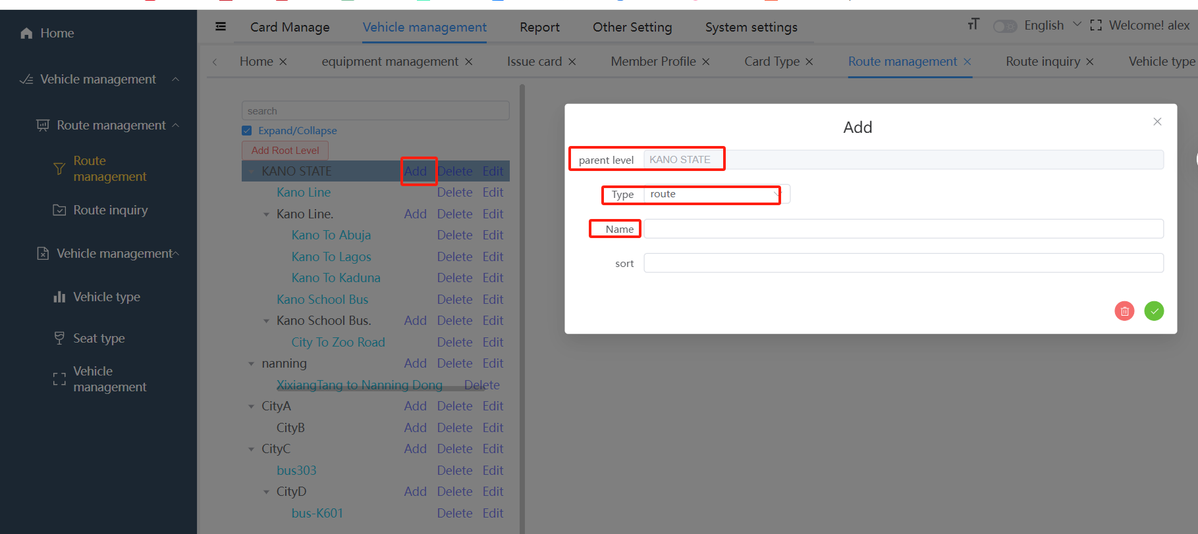

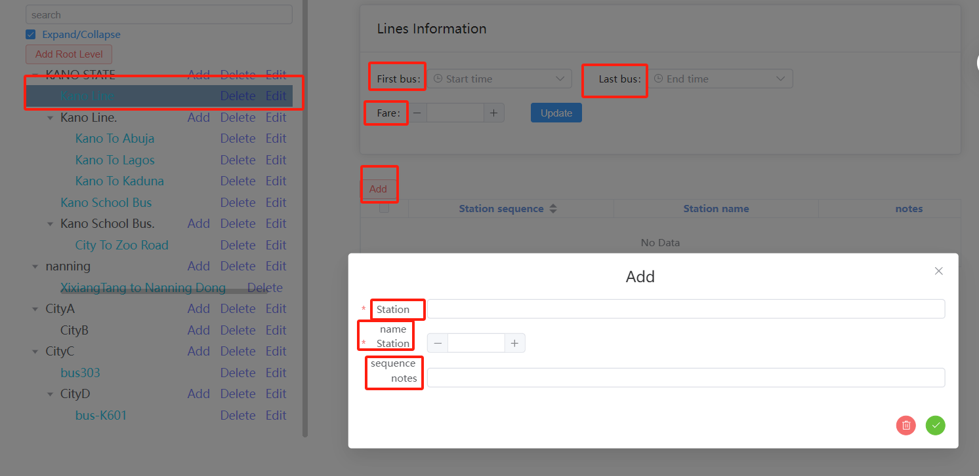

### Route inquiry

Check out the route information on the **Route inquiry** interface. Including **Bus number**,**Start station and Destination**,**Time and Route and Station**.

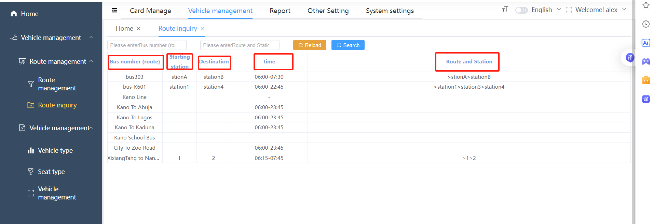

### Vehicle management

Add the vehicle on the **Vehicle management** interface. Input the bus licence. Choose the Maximum number of passengers. Select seat type and bus type. Enter the driver’s name. Choose the route for the bus.

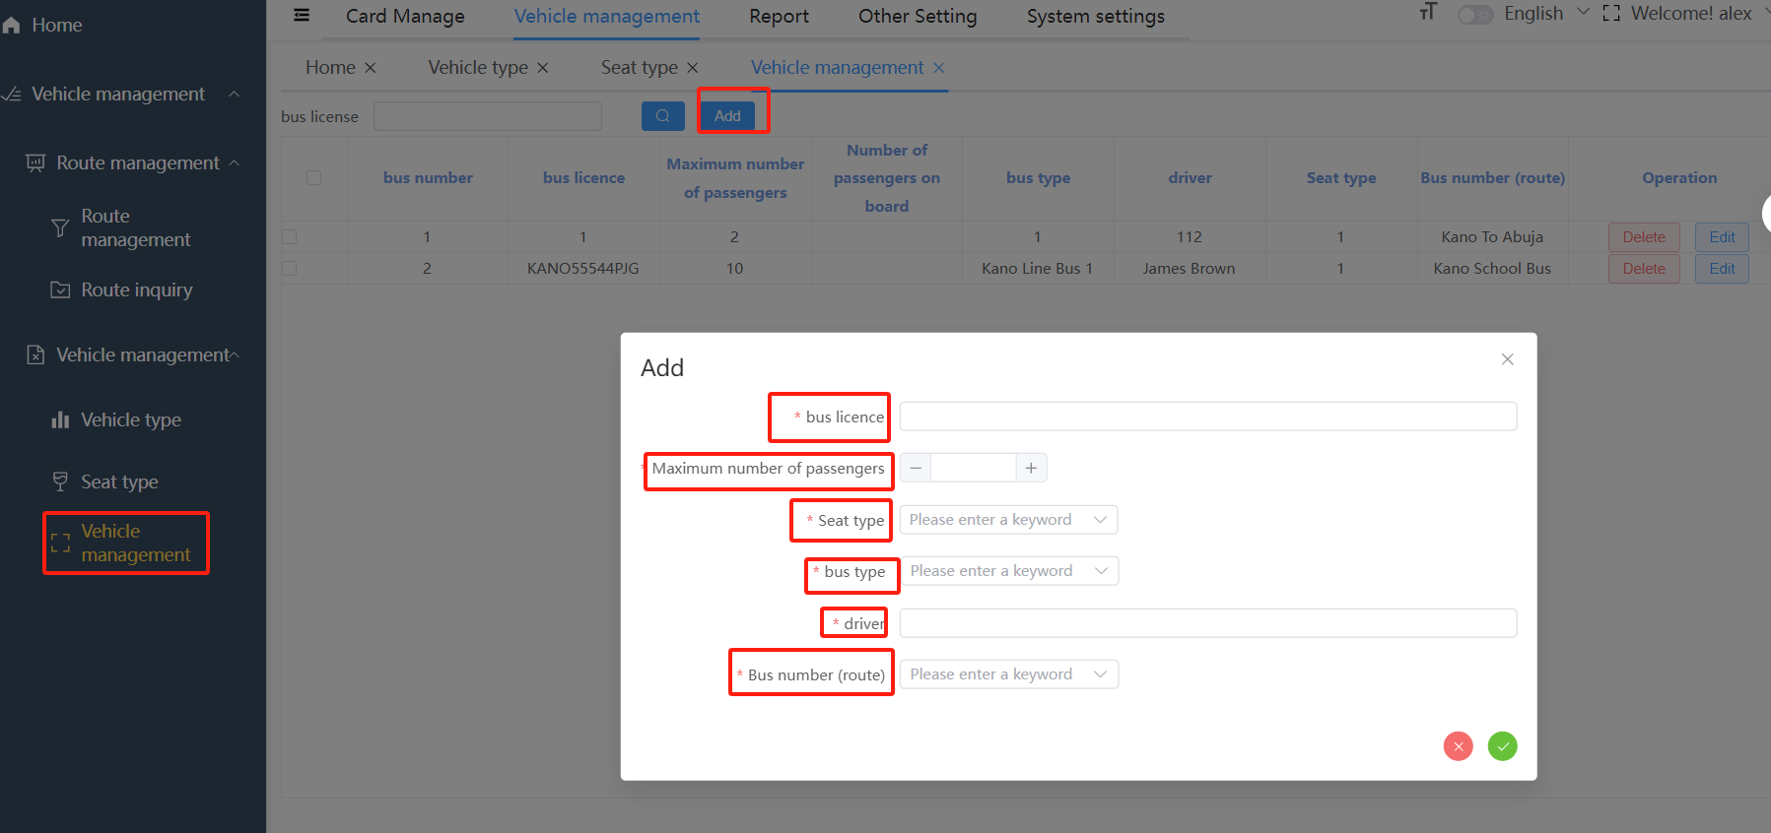

## Other Setting

### equipment management

**Other Setting**→**equipment** **management**→**Add**

**device id**: Updates automatically when add new equipment.The device id is unique for each device.

**pos Type**: Select Recharger or Consumer as the pos type. The pos type decide whether the device has quota function.

**Device name**: To distinguish each device.No limit for the device name

**Serial Number**: The serial number which needs to be filled in is on the setting interface of the device.

**Agent name**: Input it when the pos type is recharge machine.The device belongs to agent.

**License plate number**: Input it when the pos type is validator. License plate number correspond to the route and vehicle type.

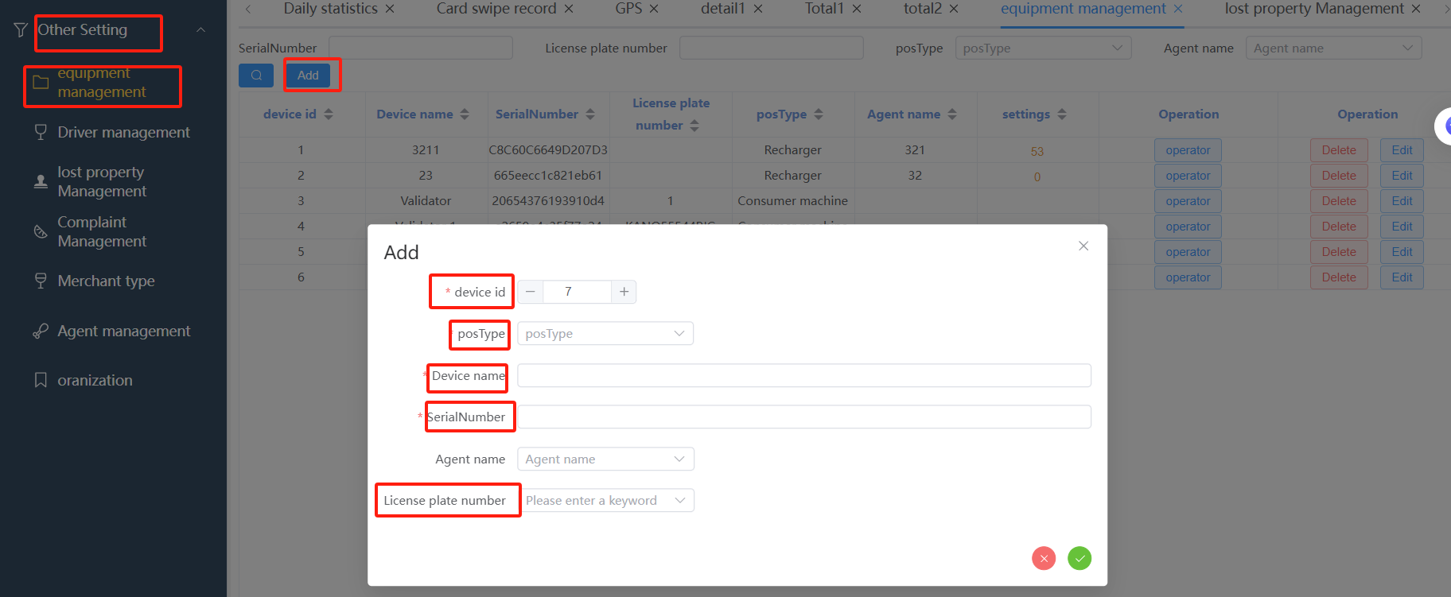

### Quota

**Other Setting**→**equipment** **management**→**quota setting**(The pos type must be recharge machine)

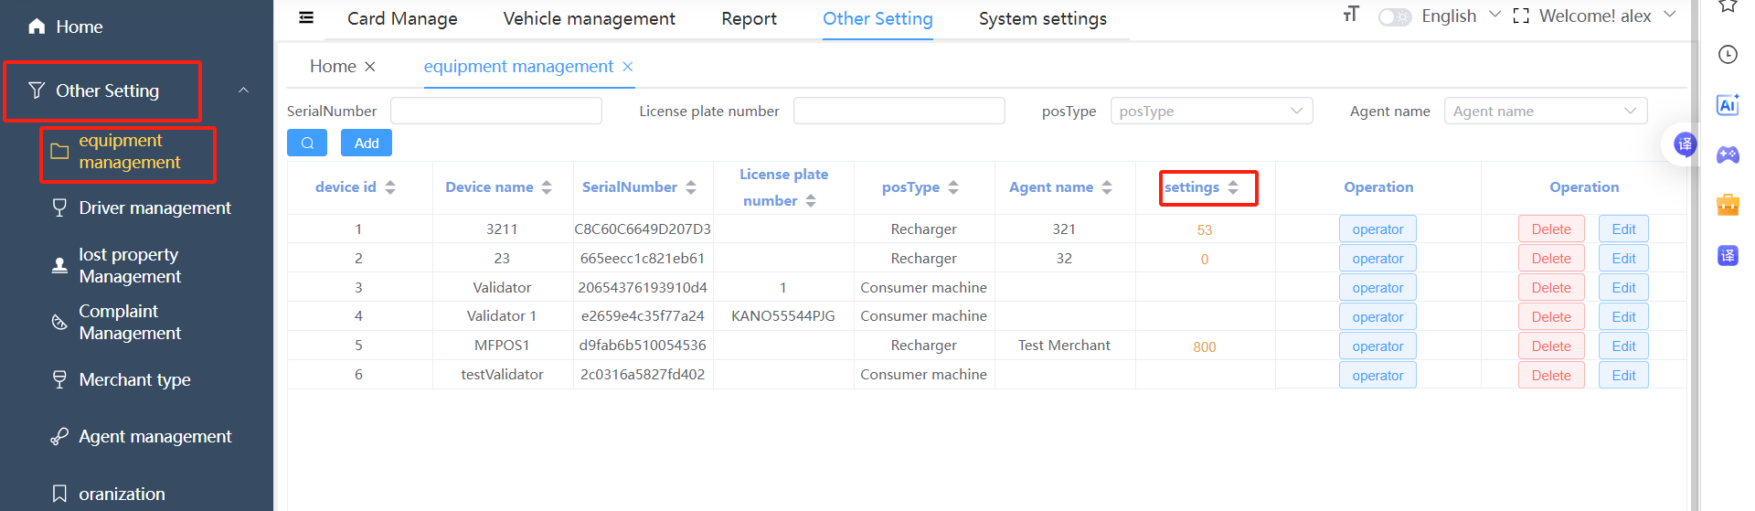

The number showed up on the interface is current quota. Click it to enter the recharge quota interface. Fill in the quota and click **add.** This will be added to the current quota.

## System Setting

### Role Permissions Settings

System settings→Role settings→add

Type the Role Name and the Permission Characters. Choose the menu permissions you want.

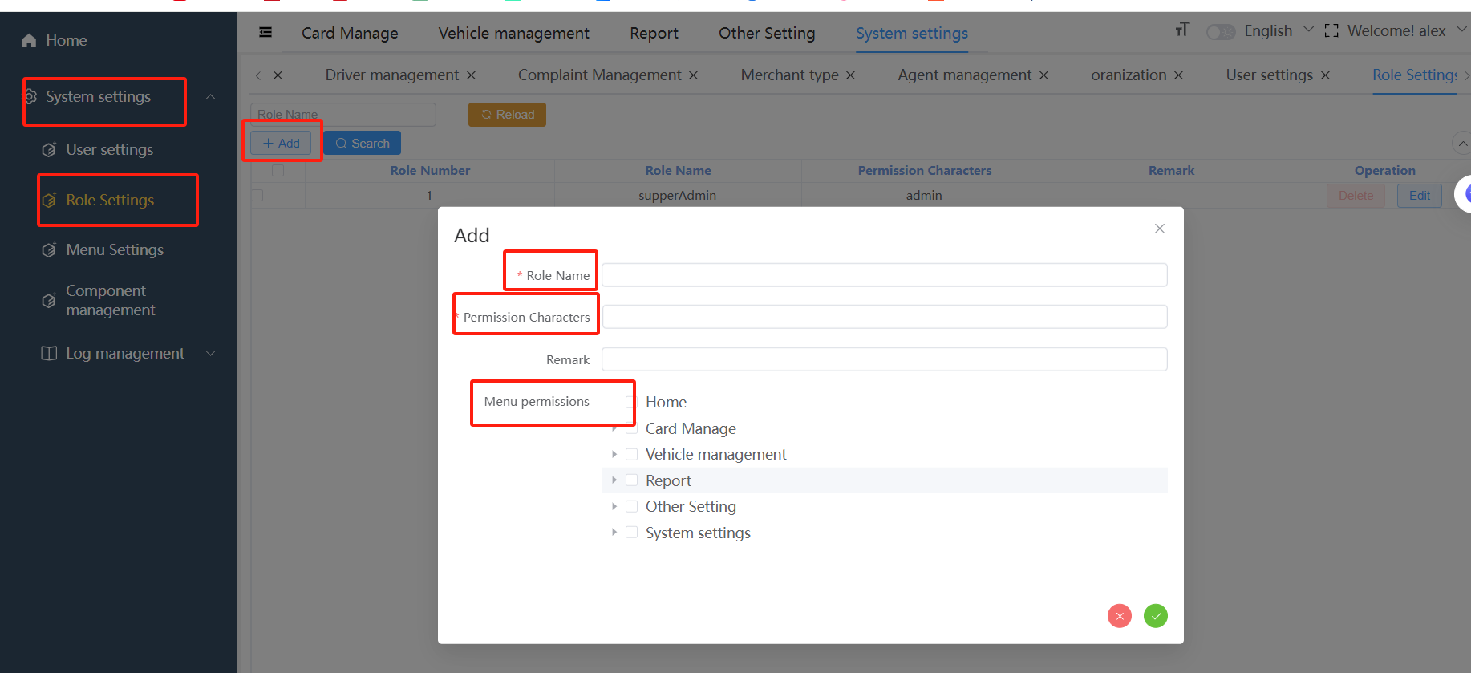

For example, I added a role called gg which is only given the permission for **Issue card**.

Noted that Card Manage must be selected if you want to select **Issue card**, because the parent level of menu must be enabled.

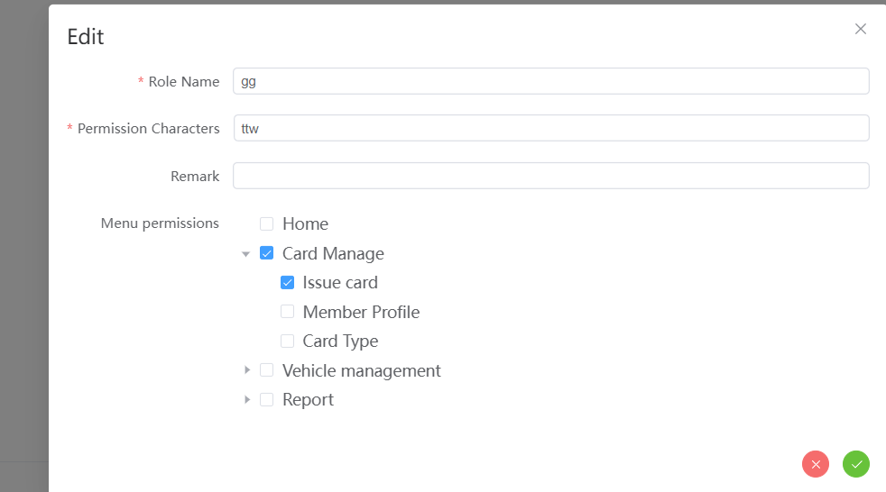

Then I add a new user on the User Settings interface, I select the role with the restricted permission.

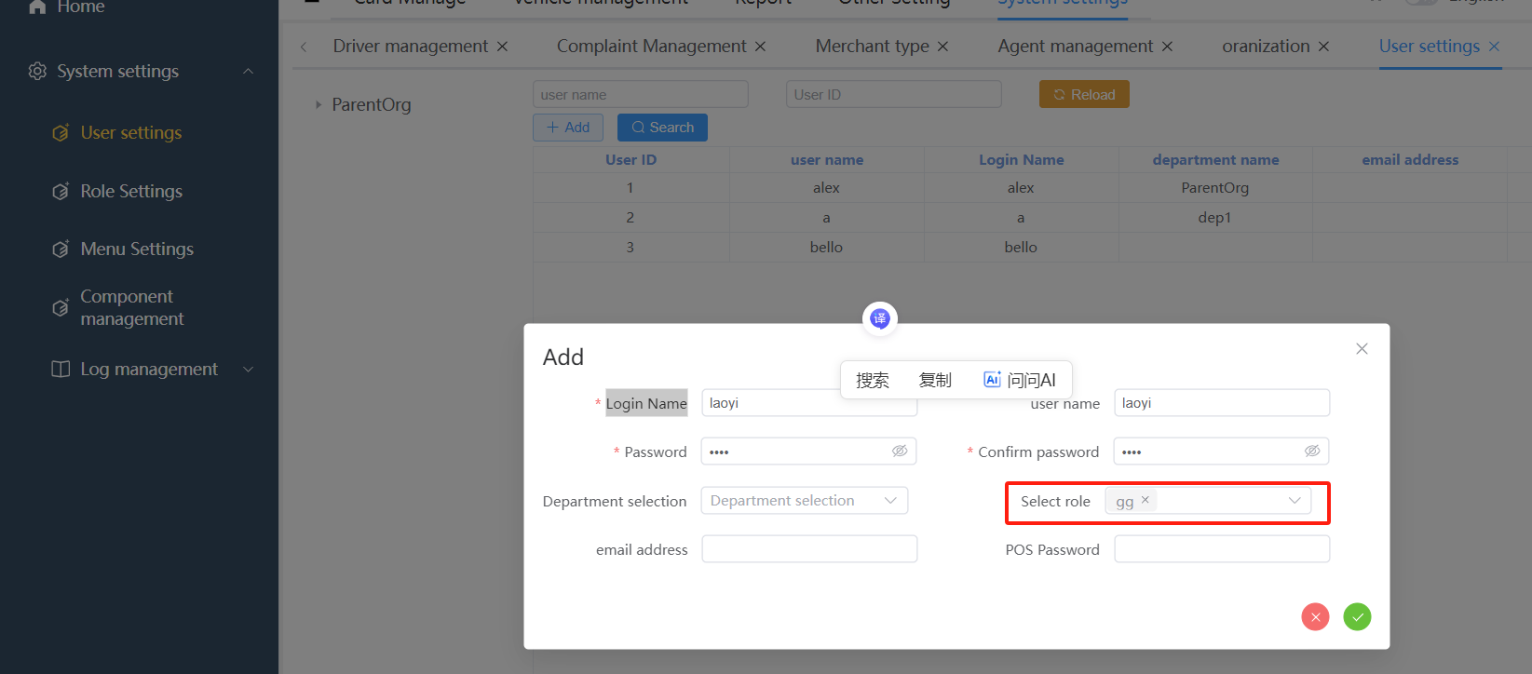

After log in with the new user, we can see that the only function can be found is **Issue card**.

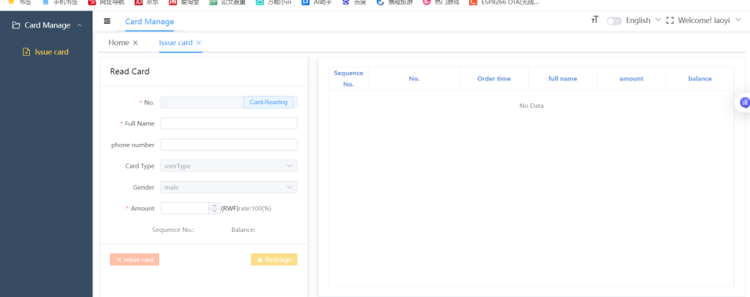

## Validator

Please update the program to the latest version V1.78

Can be downloaded through the link:

http://185.219.134.115:82/mobile2api/dh/app/downGet?fileName=buschezai.apk

If the program version is V1.76, online updates can be used, but due to the permission issues with Android 11, permissions need to be set for the first installation. The operation is as follows:

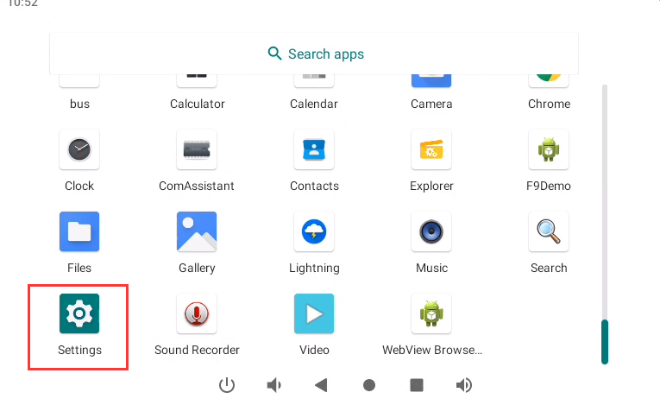

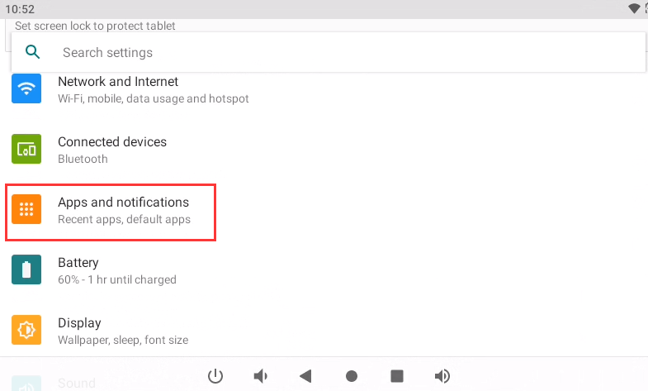

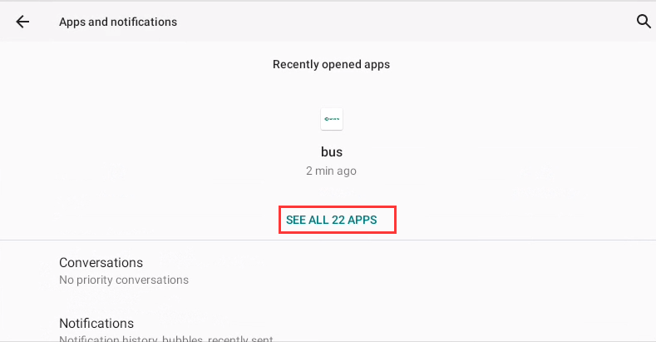

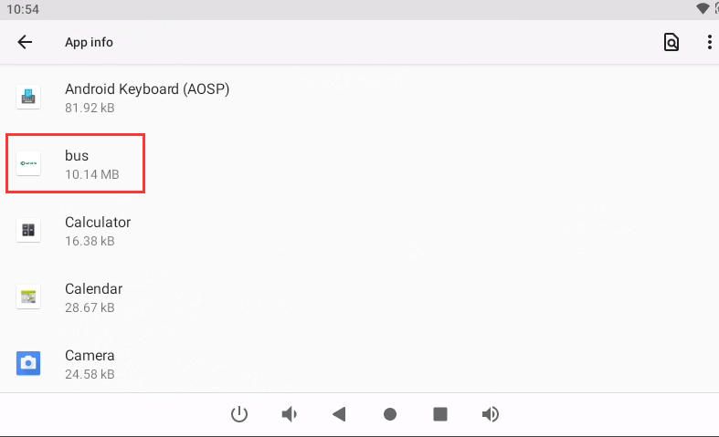

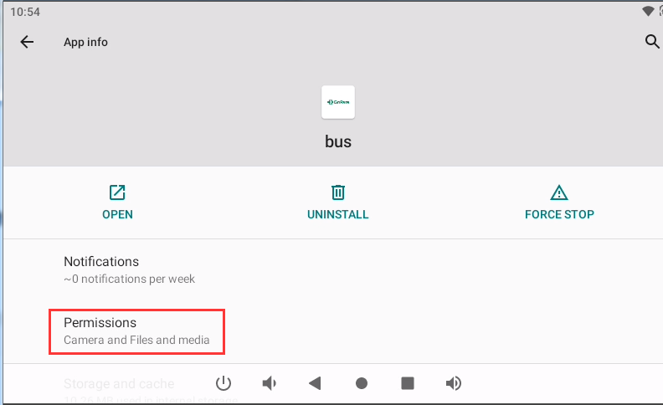

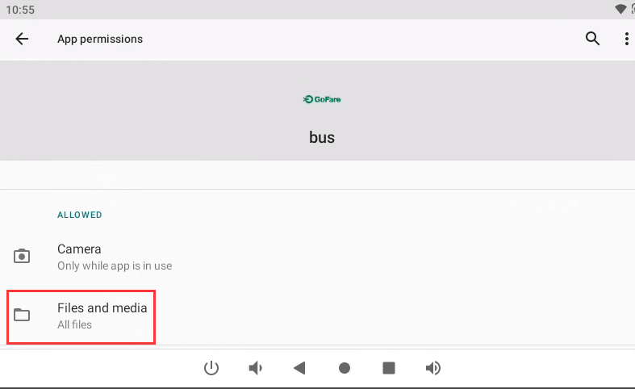

After setting the permissions, automatic update can be used if there is a new version.

Access to the Setting interface needs to input the password when the latest version is 1.78. (The default password is 9999. The password can be changed after Access to the setting interface). The setting interface is as follows:

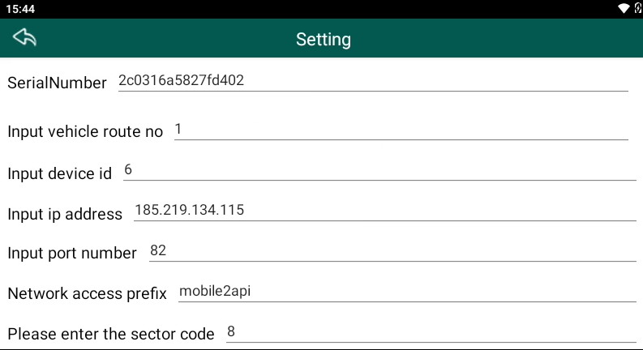

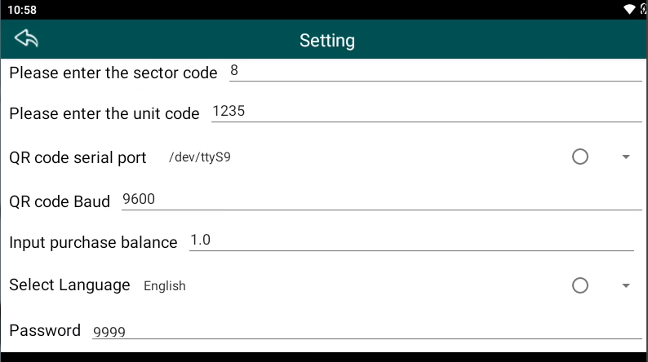

**Serial Number:** The unique ID code for the validator. It should be filled in the equipment management of the platform.One serial number corresponds to one device id.

**Route**: The name of the valdator’s route. Displayed on the homepage.

**Device ID**:Corresponds to the serial number.

**IP Address**: 185.219.134.115

**Port Number:** 82

**Access prefix**: mobile2api

**Sector code:** 8

**Unit code**: 1235

**QR code serial port**: /dev/ttyS9

**QR code Baud**: 9600

**Password**: The default one is 9999. It can be changed by yourself.

After finishing setting, click save.

