# Server IP Setting

First,click start→setting→Network&Internet→Ethernet

Click the edit button of IP assignment.Choose Manual instead of Automatic.Then turn on IPv4 and edit as follow：

IP address:192.168.0.25

Subnet mask:255.255.255.0

Gateway:192.168.0.1

Preferred DNS:0.0.0.0

After setting all these options,click save.

## Platform

To visit platform,open the browser and visit <http://192.168.0.25:8989/ticket/>

The default username is alex and the default password is dhcard

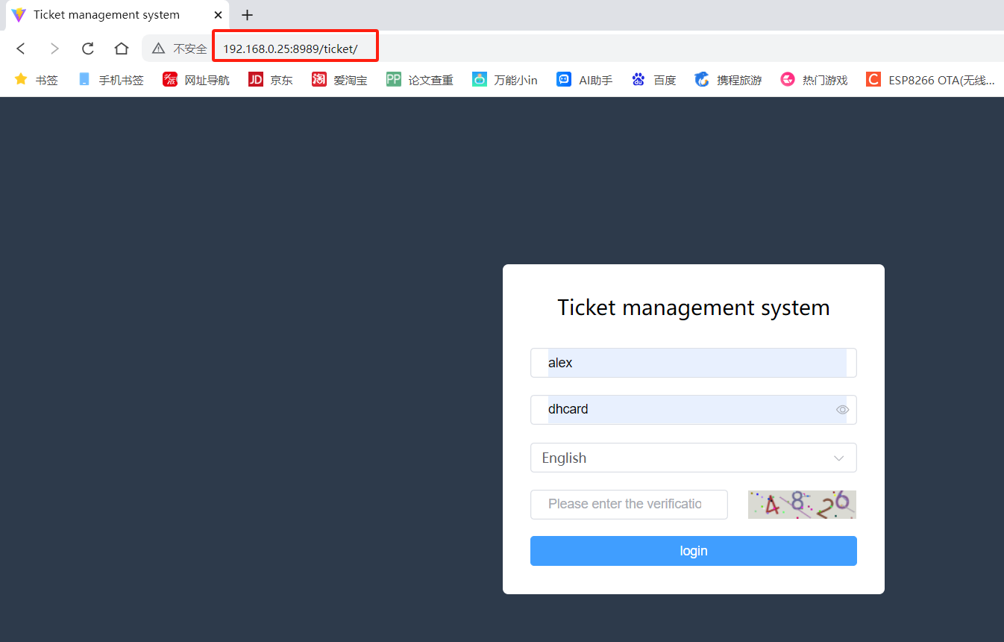

You will see the following interface after login successfully.

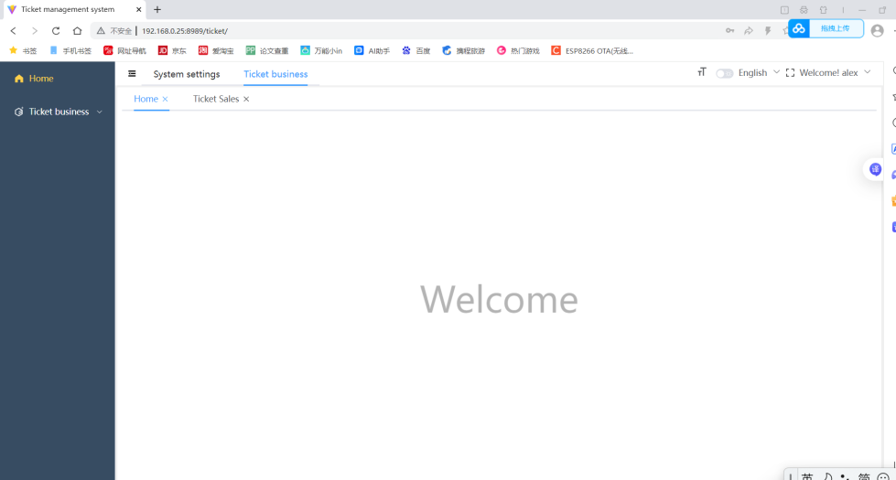

Ticket business→Pos machine

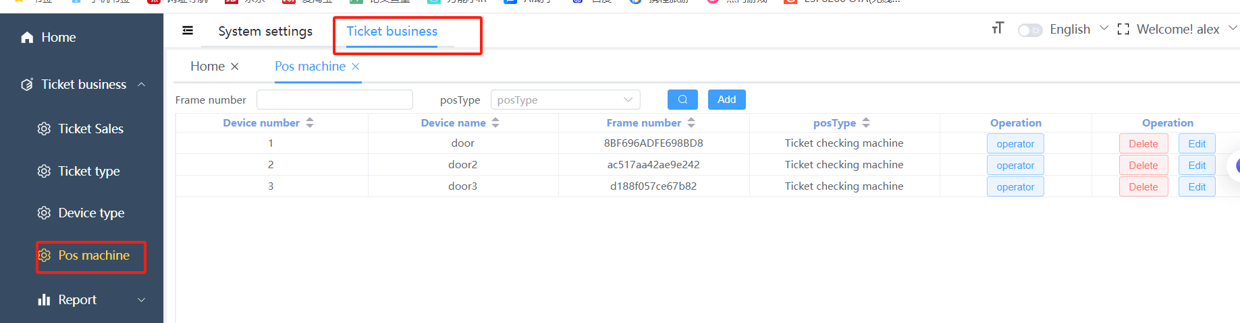

Click add button to add ticket checking machine.Choose the right posType and fill the rest options.The serial number must be as same as handheld pos.

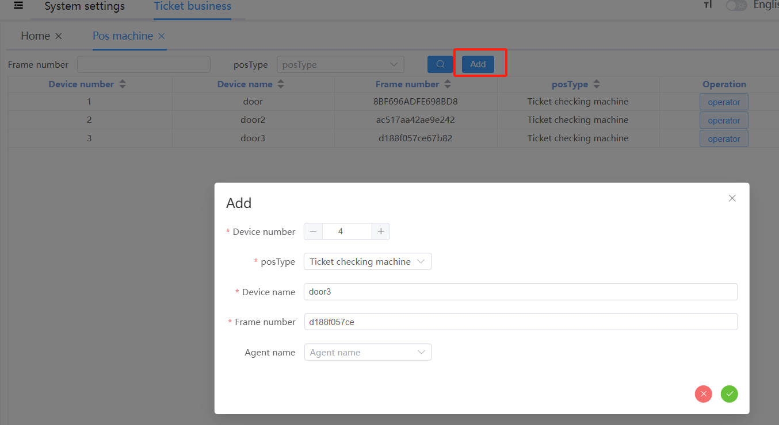

To check out serial number, you have to long press the VERSION button of the handheld pos.

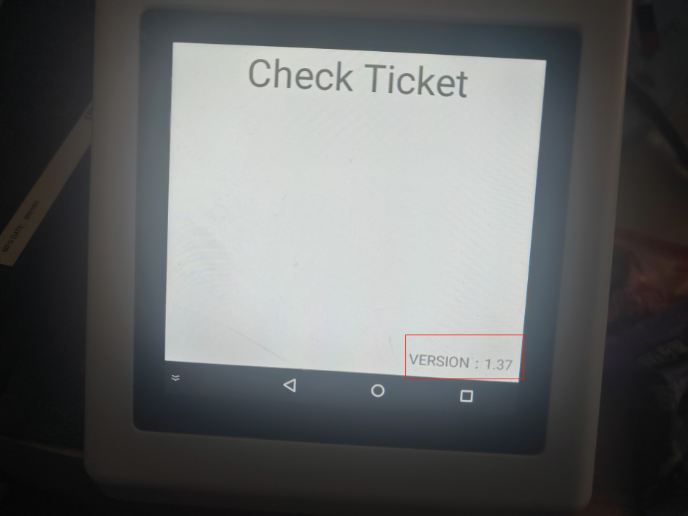

Then the following interface will be showed and you can find out the serial number of the handled pos.

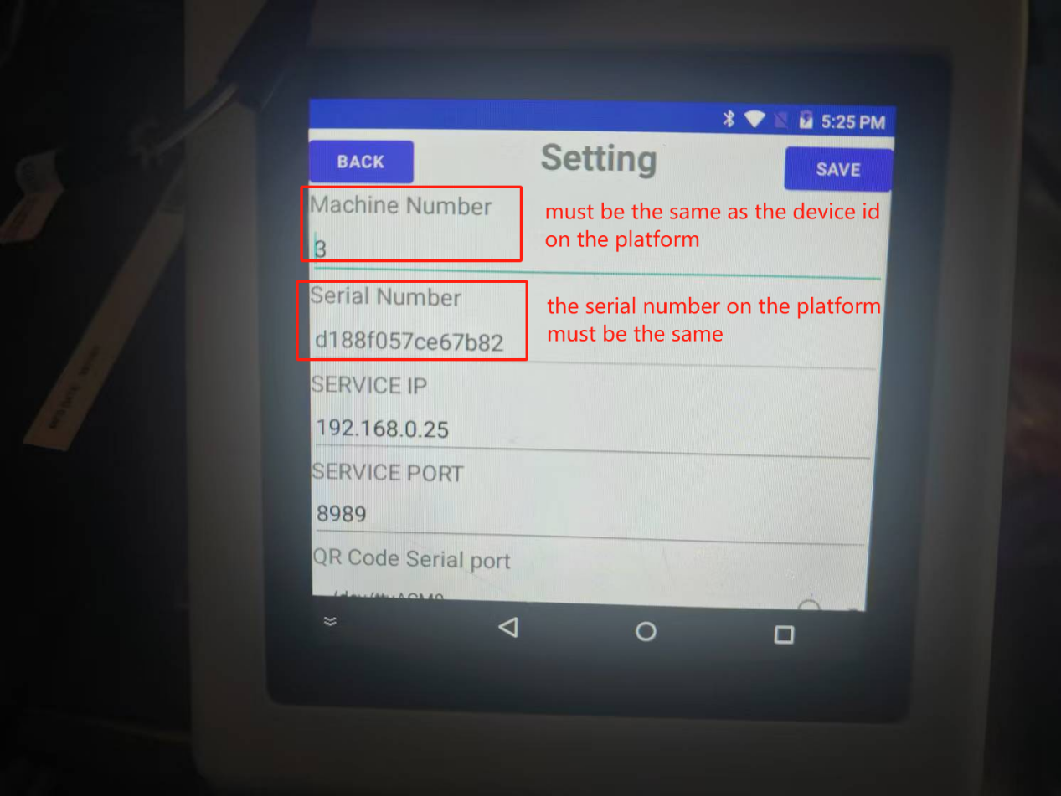

Tickets Sales→sale

Fill the phone number and full name of the customer.Increase the ticket’s counts of the customer type you need and click complete.The tickets will be printed automatically.

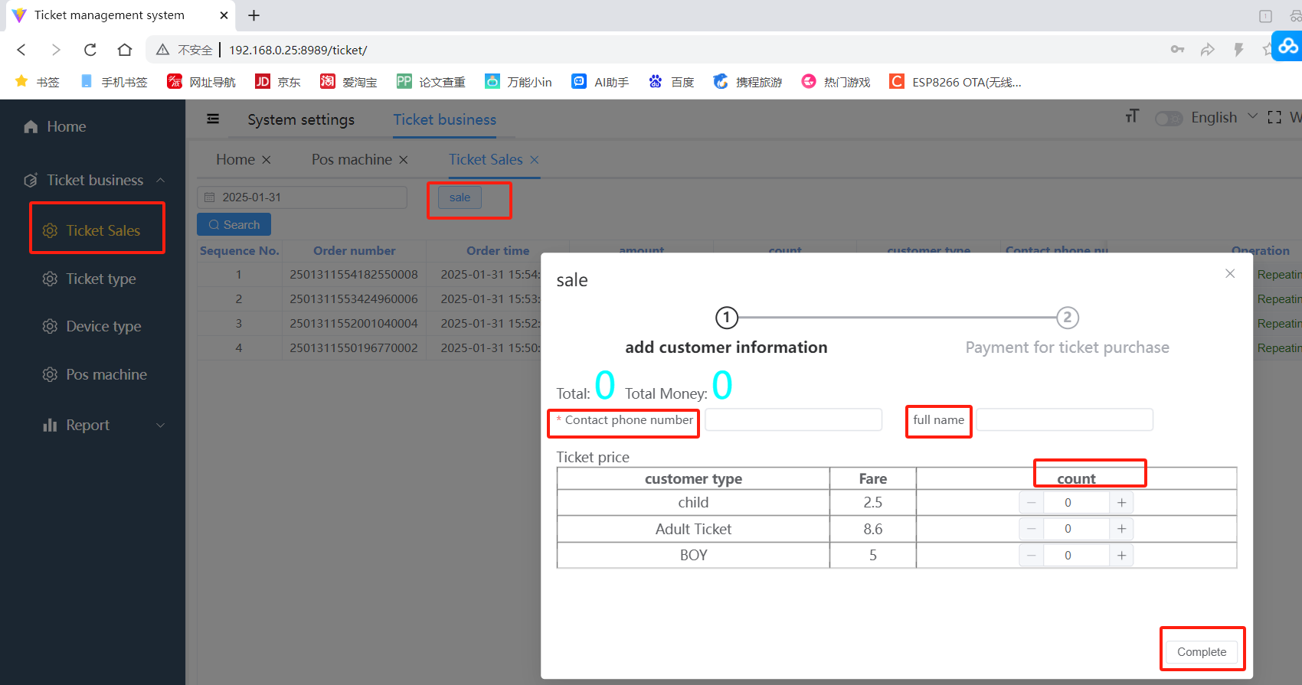

## Role Permissions Settings

System settings→Role settings→add

Type the Role Name and the Permission Characters.Choose the menu permissions you want.

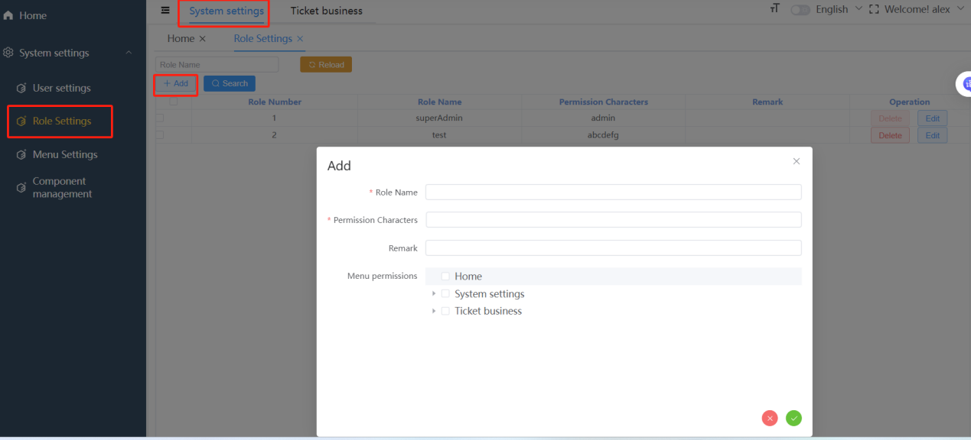

For example, I added a role called test which is only given the permission for tickets sales.

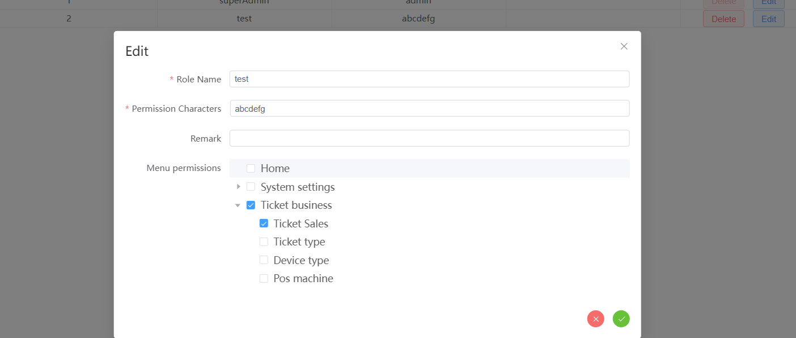

Then I add a new user on the User Settings interface,I select the role with the restricted permission.

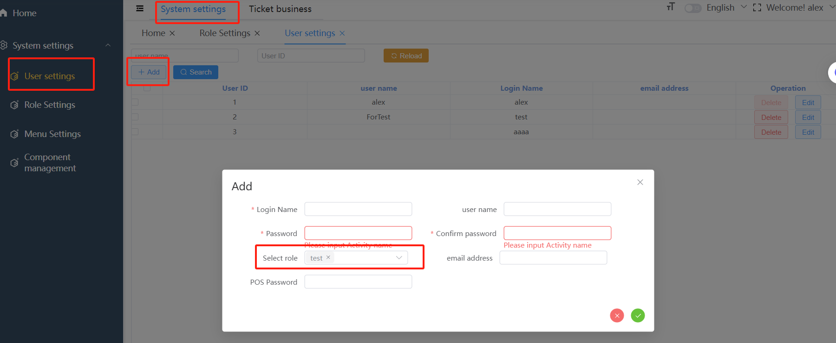

After logging with the new user,the unique function can be found is Tickets Sales.

