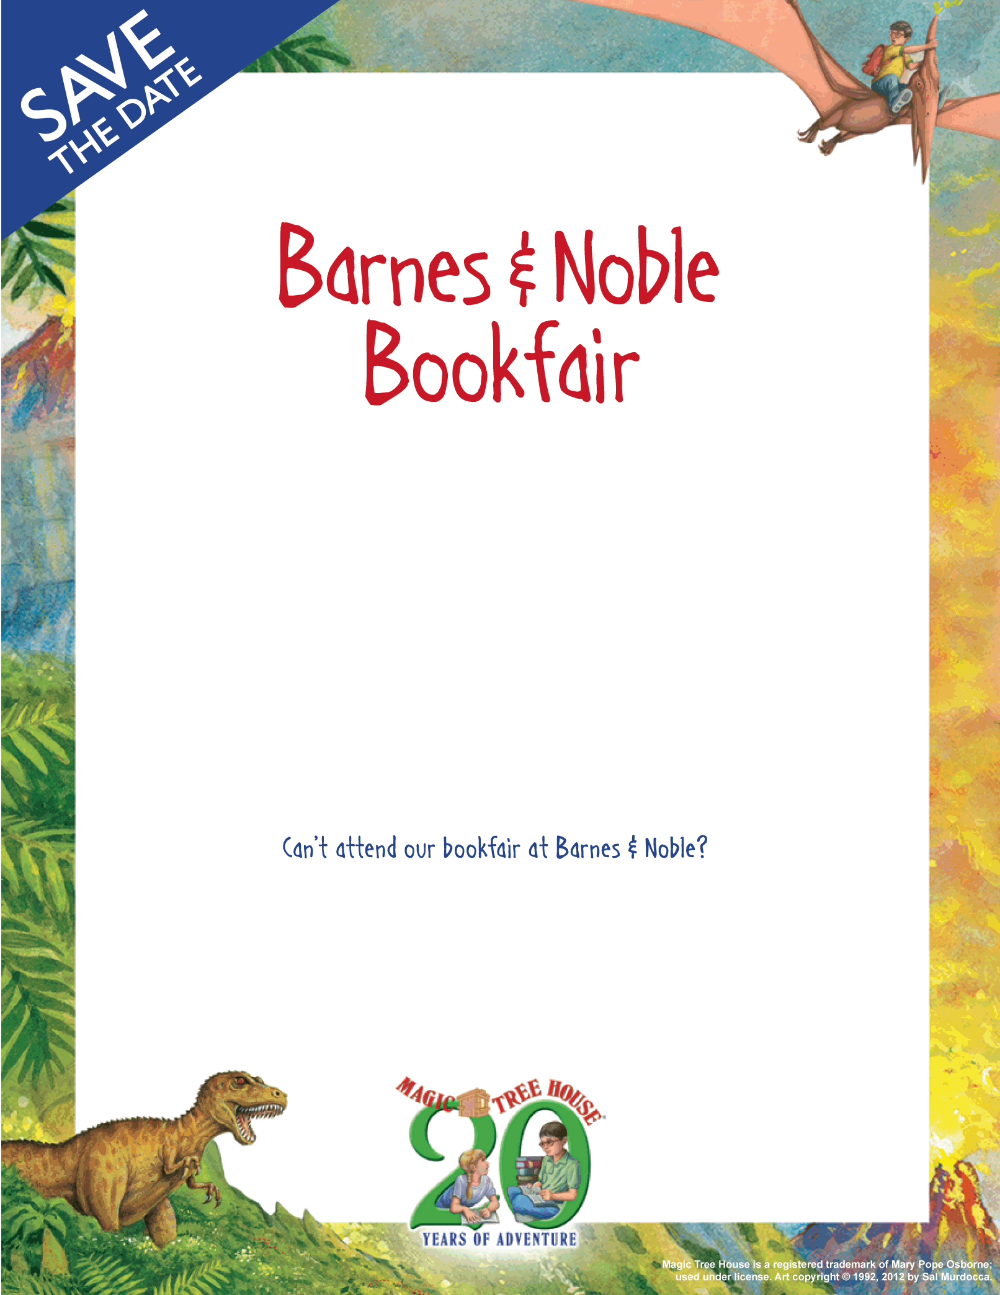
June 1st – June 8th, 2013
Barnes & Noble – Union Square

- John Carter Cash, son of Johnny Cash, will be reading from his new children’s book, Lupus Rex, at Barnes & Noble – Union Square on Saturday, June 1st at 12:30 p.m.
- Class visits June 3rd-June 5th to Barnes & Noble, Union Square.
- All store and online purchases from June 1st-June 8th benefit the school library.
- Help stock up your children’s classroom for next year with the teacher wishlists available at B&N during class visits and in the office.
- Get promotional cards in office to handout to friends, colleagues, and family.
- Post details on Facebook, Twitter, LinkedIn, etc.
Visit BN.COM/bookfairs to support us online or shop at any B&N store from 6/01/13 to 6/08/13 and enter Bookfair ID #11114907 at checkout.

A percentage of your Barnes & Noble purchases will benefit our school library.
The Children’s Workshop School’s

