How we built the software

1. Design (or Inspiration)

2. Coding of Pages

- Encoding of lessons

- Creating the calculator

3. Coding the formulas

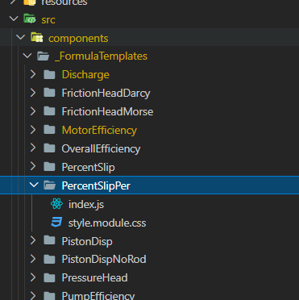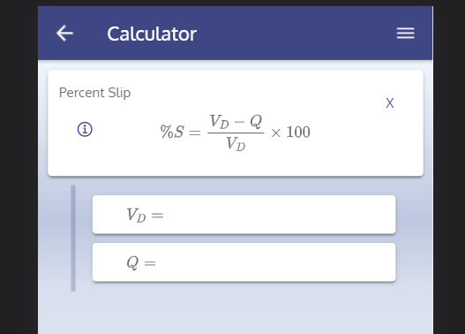

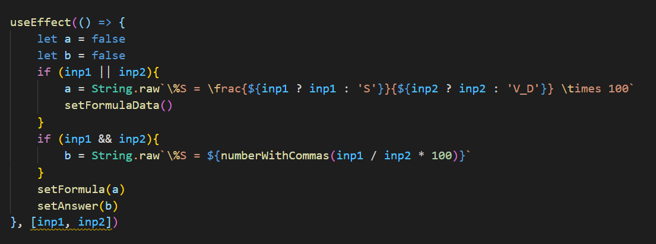

Blue – Logic for computing the actual answer

Orange – Controls how the formula is shown on the screen. If one of input is given, then show an incomplete formula. If all input is given, show the output

Green – a and be represent final output (those that will be shown on screen. False means they are hidden on screen)

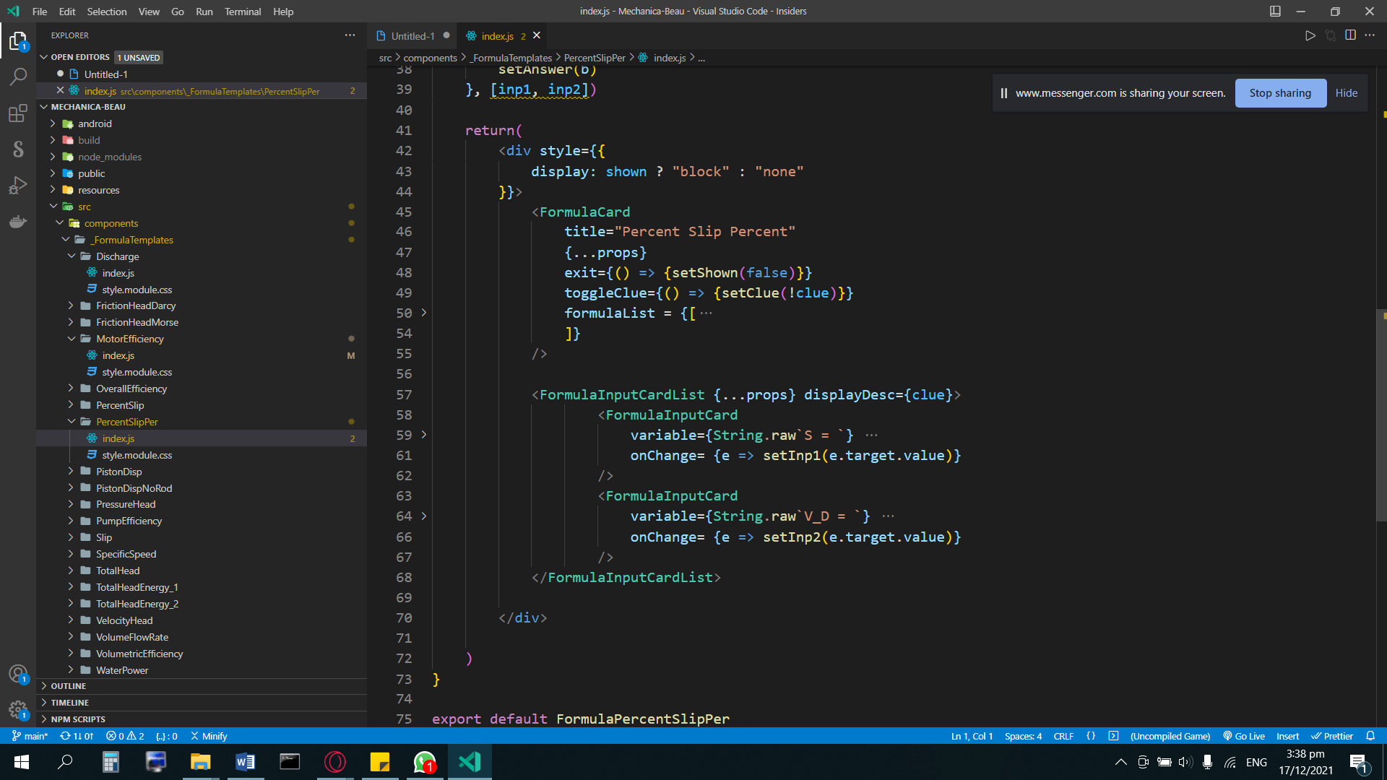

Orange – layout blueprint

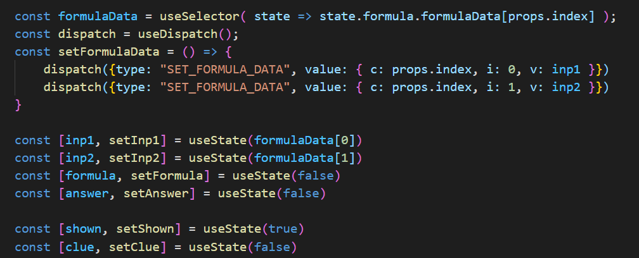

Orange – Program variables that links between the logic and the display

Green – Controls the input from the screen and gives it to the logic part

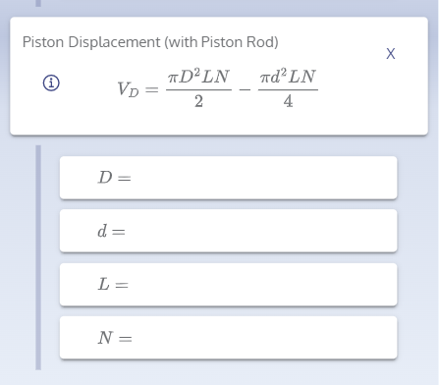

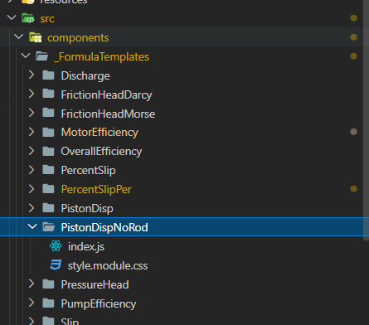

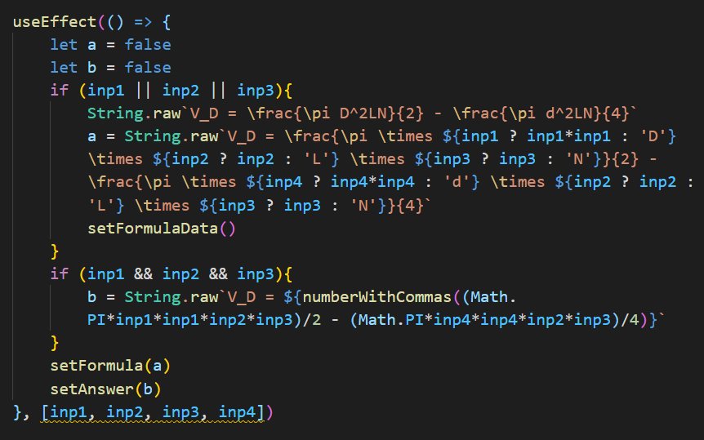

Green – Logic that computes the formula

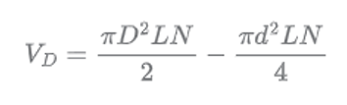

Inp1 = D; inp2 = L; inp3 = N ; inp4 = d

(Math.PI * inp1 * inp1 * inp2 * inp3) / 2 -

(Math.PI * inp4 * inp4 * inp2 * inp3) / 4

Orange – Controls how the formula is shown on the screen. If one of input is given, then show an incomplete formula. If all input is given, show the output

Green – a and be represent final output (those that will be shown on screen. False means they are hidden on screen)

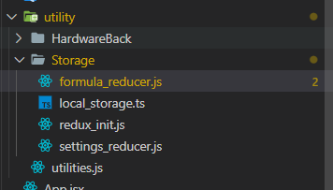

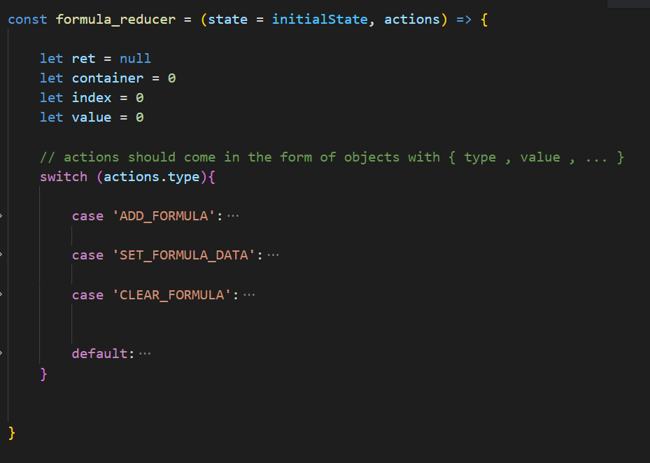

Formula_reducer – this code handles the history of the formula when the calculator is exitted

