Attud - Brief Report - Updated

Henrique Pinto Gomide

09-01-2015

# Introduction

This is final report on the survey "International Needs for Treating Tobacco Use". The survey aimed to understand the needs of tobacco treatment provider.

# Methods

All tools used to collect, evaluate quality, analyze data were freeware or/and Open-source. For data collection we have used Ona (<https://ona.io/>), for data analysis R (R Core Team, 2015) using ggplot2 and sjPlot packages. This report was created using RMarkdown.

# Results

## Participants

The data reported here were collected from 159 valid cases. One case was considered invalid (test submission), thus removed. Most of participants were women 60.4% with mean age of 47.5 (SD = 11).

## Profession

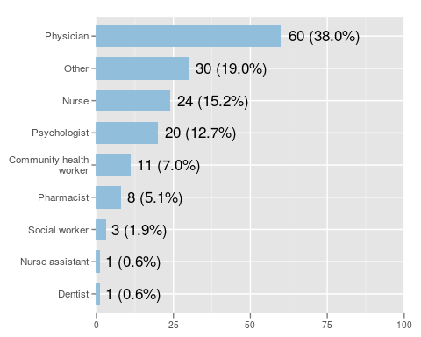

## Region of the World

## Are you a member of Attud?

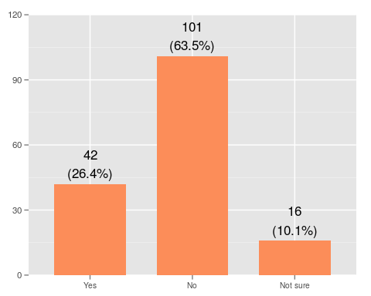

# Practioner Role and Trainning

## How did you learn how to treat tobacco dependence?

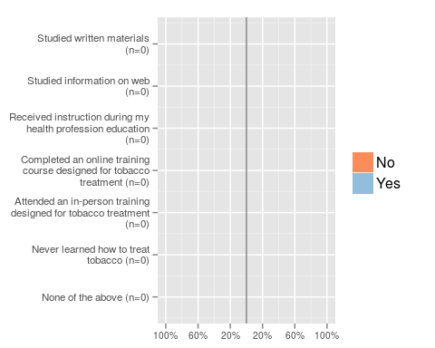

## What tobacco treatment activities do you currently perform?

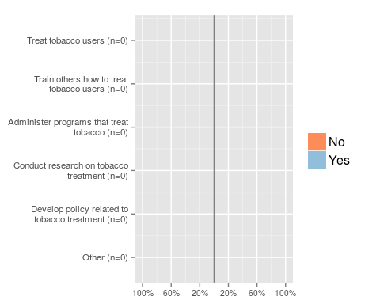

# Tobacco Treatment Training in Your Country

## Think back to your professional training curriculum. About how many hours of instruction in how to treat tobacco dependence were provided?

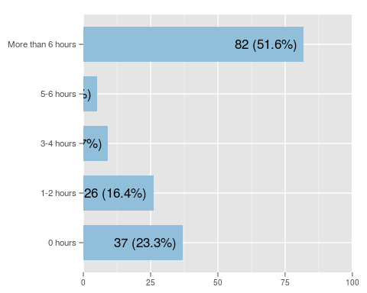

## Outside of health care provider education, is any form of training for treating tobacco dependence available in your country?

## Overall, how would you rate access to tobacco treatment training in your country?

## Overall, how would you rate the quality of the tobacco treatment training that is available in your country?

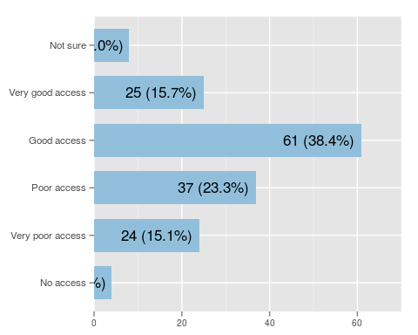

## Does your country have any form of professional certification for tobacco treatment?

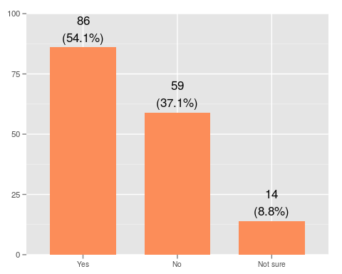

# Guidelines for Tobacco Treatment

## Does your country have national guidelines for the treatment of tobacco dependence?

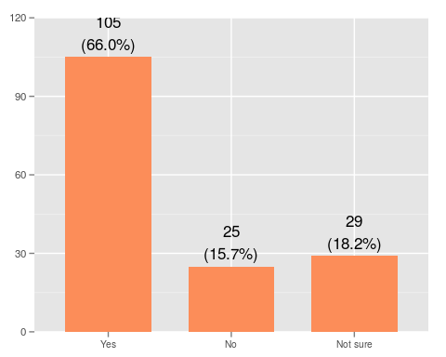

# Survey Collection

## Access over time

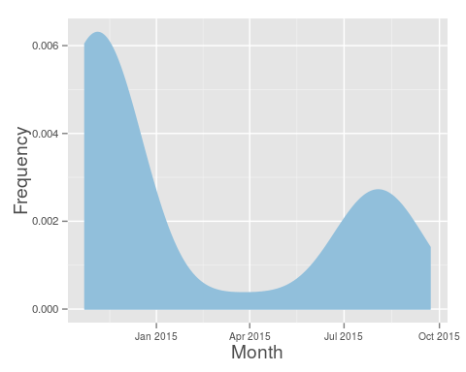

# Countries

## Import list with uncoded countries  
uncoded <- read.csv("R/uncodedCountries.csv")  
## Import list with coded countries  
coded <- read.csv("R/codedCountries.csv", col.names = c("code", "local_name"))  
## Merge the two lists  
listCountries <- merge(coded, uncoded, by = "local_name")  
## Table results from attud questionnaire  
teste <- as.data.frame(table(attud$group5.group8.q18))  
## Pick good names for dataframe  
colnames(teste) <- c("code", "Freq")  
### Convert vars into character  
teste$code <- as.character(teste$code)  
listCountries$code <- as.character(listCountries$code)  
listCountries$local_name <- as.character(listCountries$local_name)  
# Merge table and list of codes  
table1 <- merge(teste, listCountries, by = "code")  
  
# Subset the data for coutries that answered the survey at least once   
table2 <- subset(table1, table1$Freq > 0)  
# Create data from two variables - frequency and English name  
finalCountryTable <- table2[, c("Freq", "en_name", "region")]  
# Sort the data  
sorted <- finalCountryTable[order(-finalCountryTable$Freq), ]  
print(sorted)

## Freq en_name region  
## 20 19 Taiwan (Republic of China) Eastern Asia  
## 23 19 Australia Australia  
## 26 19 United States North America  
## 43 11 Spain Southern Europe  
## 35 8 Canada North North America  
## 41 7 Ireland Northern Europe  
## 13 6 Argentina Southern South America  
## 29 6 Israel Middle East, Western Asia  
## 4 5 Egypt Africa, Middle East  
## 7 5 Nigeria West Africa  
## 32 4 India South-Central Asia  
## 33 4 Brazil Central Eastern South America  
## 3 3 Malaysia Southeast Asia  
## 36 3 Czech Republic Eastern Europe  
## 37 3 Chile Western South America  
## 45 3 Jordan Middle East, Western Asia  
## 1 2 Jamaica Greater Antilles, Caribbean  
## 12 2 Uruguay Central East South America  
## 27 2 Venezuela Northern South America  
## 39 2 Germany Western Europe  
## 44 2 France Western Europe  
## 2 1 Kenya Eastern Africa  
## 5 1 Antarctica Antarctica  
## 6 1 Nepal South-Central Asia  
## 8 1 Pakistan South-Central Asia  
## 9 1 Peru Western South America  
## 10 1 Portugal Southern Europe  
## 11 1 New Zealand Oceania; Australia  
## 14 1 Georgia Western Asia  
## 15 1 Oman Middle East  
## 16 1 Switzerland Western Europe  
## 17 1 Singapore Southeast Asia  
## 18 1 Saudi Arabia Arabian Peninsula, Middle East  
## 19 1 Sweden Northern Europe  
## 21 1 Sudan Northern Africa  
## 22 1 Turkey Southeastern Europe, Western Asia  
## 24 1 Uganda Eastern Africa  
## 25 1 United Kingdom Northern Europe  
## 28 1 Vietnam South-East Asia  
## 30 1 Bangladesh South-Central Asia  
## 31 1 Belgium Western Europe  
## 34 1 Burkina Faso West Africa  
## 38 1 Denmark Northern Europe  
## 40 1 Ecuador North West South America  
## 42 1 Greece Southern Europe

# Row 13 is from Antarctica! What to do in this case?  
write.csv(sorted, "freqTablebyCountry.csv")