# Hearing of the Committee on Economic and Monetary Affairs of the European Parliament

Introductory Statement by Mario Draghi, President of the ECB, at the ECON committee of the European Parliament, Brussels, 24 September 2018

Mr Chairman,

Honourable members of the Economic and Monetary Affairs Committee,

Ladies and gentlemen,

It is a pleasure to be back at the [European Parliament](http://www.europarl.europa.eu/portal/en) before your Committee.

Ten years ago, the euro area entered a severe recession. That crisis exposed structural weaknesses and forced us to address them. The work is not yet over, but we are reaping the benefits of our efforts: growth has been positive for more than five years, and the unemployment rate is at its lowest level since November 2008.

* Total fraud involving Single Euro Payments Area cards fell to €1.8 billion in 2016, 0.4% less than in 2015
* Card fraud at ATMs dropped by 12.4% from 2015 to 2016
* Online fraud rose slightly from 2015 and accounted for 73% of total value of card fraud in 2016

In my remarks today, I will discuss the current economic environment and the role that the ECB’s monetary policy plays in it. At the request of your Committee, I will also discuss central bank communication, which nowadays forms an integral part of monetary policy.

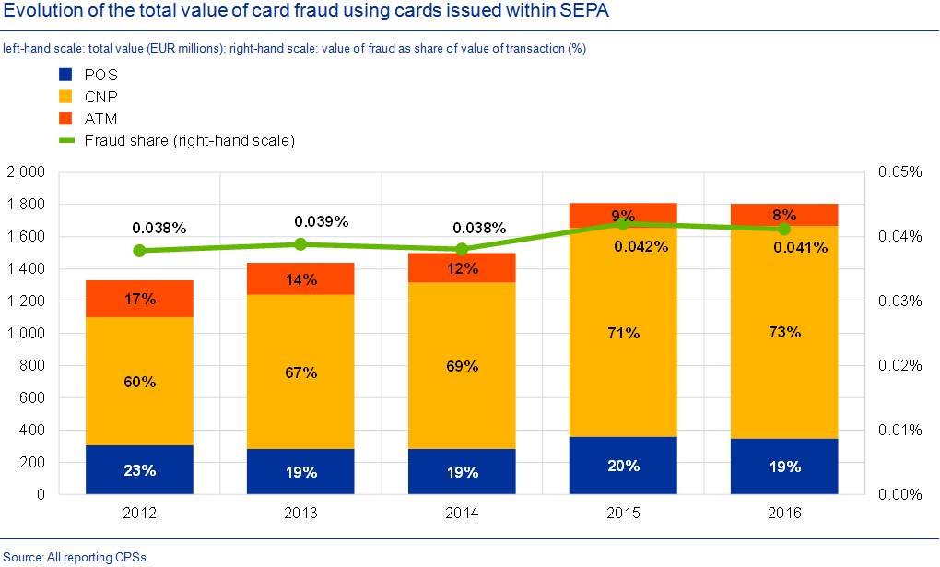

## The euro area outlook

The information that has become available since my last visit in July broadly confirms an ongoing broad-based expansion of the euro area economy, which grew by 0.4% in the second quarter of 2018. Despite some moderation following the strong growth performance in 2017, the economy continues to exhibit high levels of capacity utilisation, and labour markets are tightening with signs of labour shortages in some countries and sectors. This is reflected in the unemployment rate in the euro area, which stood at 8.2% in July. Since reaching a trough five years ago, euro area employment has increased by about 9.2 million. On account of the improving labour market and overall conditions, households’ disposable income in the euro area is currently growing at the highest rates observed in the last ten years. Higher income supports private consumption, which is expected to increase by 1.5% in 2018. These factors, together with business investment being fostered by the favourable financing conditions, rising corporate profitability and solid demand, continue to support spending.

Looking ahead, the latest ECB staff macroeconomic projections confirm the outlook for continued broad-based growth of the euro area economy. Average annual growth is foreseen to be 2.0% in 2018, 1.8% in 2019 and 1.7% in 2020, with a slight downward revision for 2018 and 2019, mainly reflecting weaker global trade. Risks surrounding the euro area outlook can still be viewed as broadly balanced, although the threat of protectionism, vulnerabilities in emerging markets and financial market volatility have become more prominent recently. Fiscal policies in several euro area countries might be less neutral than we expected some time ago.

Regarding inflation developments, [HICP inflation](/mopo/html/index.en.html) stood at 2.0% in August, down from 2.1% in July. Headline inflation remains somewhat higher than in the first months of the year, reflecting the strong increase in oil prices. Measures of underlying inflation remain generally muted but have been increasing from earlier lows as domestic price pressures are strengthening and broadening. Underlying inflation is expected to increase further over the coming months as the tightening labour market is pushing up wage growth. For example, annual growth in negotiated wages in the euro area increased from 1.5% in 2017 to 1.7% in the first quarter to 2018 and to 2.2% in the second quarter. This supports our confidence that the pick-up in wage growth will continue, as wage agreements often last two years or more.

|  |  |  |  |
| --- | --- | --- | --- |
| Assets | Balance | Transactions | Adjustment |
| Gold and gold receivables | 355,452 | 0 | −17,751 |
| Claims on non-euro area residents denominated in foreign currency | 319,387 | 1,053 | 198 |
| Receivables from the IMF | 73,806 | 12 | −150 |
| Balances with banks and security investments, external loans and other external assets | 245,580 | 1,041 | 348 |
| Claims on euro area residents denominated in foreign currency | 18,407 | −2,016 | 119 |
| Claims on non-euro area residents denominated in euro | 20,048 | 1,643 | −43 |
| Balances with banks, security investments and loans | 20,048 | 1,643 | −43 |
| Claims arising from the credit facility under ERM II | 0 | 0 | 0 |
| Lending to euro area credit institutions related to monetary policy operations denominated in euro | 732,054 | −11,978 | 0 |
| Main refinancing operations | 6,434 | 1,471 | 0 |
| Longer-term refinancing operations | 725,490 | −13,557 | 0 |
| Fine-tuning reverse operations | 0 | 0 | 0 |
| Structural reverse operations | 0 | 0 | 0 |
| Marginal lending facility | 130 | 109 | 0 |
| Credits related to margin calls | 0 | 0 | 0 |
| Other claims on euro area credit institutions denominated in euro | 29,793 | −3,905 | 0 |
| Securities of euro area residents denominated in euro | 2,869,201 | 9,331 | −8,849 |
| Securities held for monetary policy purposes | 2,615,124 | 9,122 | −7,629 |
| Other securities | 254,077 | 209 | −1,220 |
| General government debt denominated in euro | 24,438 | 0 | −23 |
| Other assets | 251,013 | 546 | 5,646 |
| Total | 4,619,792 | −5,326 | −20,703 |

Looking forward, annual rates of [HICP inflation](/mopo/html/index.en.html) are likely to hover around current levels in the coming months and are projected to reach 1.7% in each year between now and 2020. This stable profile conceals a slowing contribution from the non-core components of the general index, and a relatively vigorous pick-up in underlying inflation. Reflecting these dynamics, the ECB projections foresee inflation excluding food and energy reaching 1.8% in 2020.

## The ECB’s monetary policy and its effectiveness

Overall, recent developments vindicate the Governing Council’s earlier assessments of the medium-term inflation outlook. Accordingly, at our last meeting the Governing Council decided to maintain the significant monetary policy stimulus in its present configuration and, in line with the conditional plan announced at our press conference in June in Riga, to reduce the monthly pace of net asset purchases to €15 billion from October until the end of the year. We anticipate that, subject to incoming data confirming our medium-term inflation outlook, we will then end net purchases.[1]

This doesn't mean that our monetary policy will cease to be accommodative. For our baseline expectations of a rising inflation path to materialise, we need to remain patient, prudent and persistent in calibrating the monetary policy stance. In line with this approach, we will continue to provide substantial monetary stimulus by combining three policy measures: first, our enhanced forward guidance on the key ECB interest rates, which we expect to remain at present levels at least through the summer next year, and in any case for as long as necessary to ensure the continued convergence of inflation towards our aim; second, the residual net asset purchases that we will be conducting until the end of this year; and third, the reinvestment of the sizeable stock of acquired securities.

Our monetary policy measures have made a very substantial contribution to the positive economic developments in the euro area. If we consider all the policy measures taken since mid-2014, our staff estimates show that the overall impact on euro area real GDP growth and euro area inflation is – in both cases – around 1.9 percentage points cumulatively between 2016 and 2020.

## Importance of central bank communication

Let me now turn to the topic of central bank communication that you suggested for today’s meeting.

Regarding this topic, forward guidance has indeed become an important instrument for all major central banks as conventional monetary tools have reached their effective lower bound, and the ECB is no exception.

Forward guidance on our policy interest rates has evolved considerably over time, since we first introduced it in July 2013.

Roughly speaking, it has gone through three phases. When we first gave forward guidance in 2013, our goal was to insulate euro area financing conditions, and especially the near-term segment of the term structure of money market interest rates, from the heightened volatility emanating from the US money market as a result of the “taper tantrum” episode of May-June 2013.

During the second phase, our forward guidance served to reinforce the effectiveness of the net asset purchases. By expressing the Governing Council’s expectations about the likely future path of interest rates, we ensured that the downward impact that the asset purchases were exerting on longer-term yields was not counteracted by unanchored market expectations of short-term interest rate increases.

Since June 2018 we have expressed our expectation that, subject to incoming data confirming our medium-term inflation outlook, net purchases will likely end after December 2018. As we had for some time tied the horizon for our rate path to the end of our net purchases – giving indications that interest rates will remain at their present levels “well past the end of our net purchases” – announcing a conditional plan for terminating net purchases by a certain date made it necessary for us to re-anchor the rate guidance. Steering expectations of the policy rate path was critical because the path of inflation that the Governing Council viewed as moving closer to the objective of a sustained adjustment was – and still is – conditional on a term structure of interest rates that embodies expectations of constant policy rates over an extended period of time after December 2018.

It was important for us to retain firm control over the signalling implicit in our monetary policy announcements. At that critical juncture, we had to reassure investors and the public that the likely change in the course of our asset purchases will not stymie the recovery and frustrate progress toward inflation normalisation.

With this in mind, in June 2018 we said that we expected interest rates to remain at their present levels “at least through the summer of 2019, and in any case for as long as necessary to ensure that the evolution of inflation remains aligned with our current expectations of a sustained adjustment path”. This rate guidance, which we reasserted back in July and also this month, actually contains two parts: first, the “through the summer of 2019” formulation is a calendar-based element, which refers to when we anticipate conditions that might warrant a first rate increase; and second, a state-dependent component, indicating our expectation that rates will remain unchanged in any case for as long as necessary to ensure the continued sustained convergence of inflation to levels that are below, but close to, 2% over the medium term.

As it turned out, the realignment of market expectations with those of the Governing Council was immediate and smooth. The new formulation has helped market participants to better understand our reaction function and adjust the outlook on which they base their plans accordingly.

Of course, steering financing conditions – by guiding the expectations of market professionals – is only part of our task. We are responsible for ensuring price stability for the 340 million people of the euro area who use the euro and make economic decisions every day.

Reaching out to citizens is the key to maintaining public confidence in their central bank, and in the appropriateness and efficacy of its policies. In this respect, hearings before the European Parliament are a fundamental – absolutely fundamental – channel through which we can explain to the people of Europe the reasons for our decisions and how those decisions impact their lives. The ECB and the European Parliament, building on the framework enshrined in primary law, have responded to the demand for stronger scrutiny that arose during the crisis and have ensured a high degree of accountability throughout it. Nevertheless, this should be no reason for complacency. We are well aware that maintaining people’s trust in the ECB calls for tireless efforts on our side.

Facing challenging times, we have sought to enhance understanding of our decisions. For instance, since January 2015 the ECB has been publishing regular accounts of the Governing Council’s monetary policy discussions. As the exchanges and conversations we have in this room testify, this additional set of information enables you – and anyone who is interested in the conduct of monetary policy – to enhance scrutiny of the ECB’s policies. At the same time, this has provided us with greater opportunities to explain our decisions and demonstrate that we are acting in accordance with our democratic mandate.

Over the past few years, we have also stepped up our efforts to overcome the key communication challenges posed by the euro area structure, namely reaching out to citizens in 19 countries, who naturally have different expectations regarding the ECB. We have thus enhanced our communication strategy, directly addressing a wider range of audiences. In addition to our institutional activities, my fellow Executive Board members and I have participated in about 180 events over the last two years, a quarter of them in centres of education.

If I include think tanks, foundations, non-profit organisations and governmental bodies, we delivered more speeches to these fora than at the ECB and the NCBs. ECB staff members have complemented these efforts with a dedicated outreach programme aimed specifically at secondary schools and universities which goes into the functions and purpose of a central bank in an advanced economy, and also explains the financial crisis and the ECB’s role in alleviating its effects on the people of Europe. We have covered similar ground in our expanded website, which now features videos, explainers and charts that describe complex issues in an accessible way. We have started using new tools, such as YouTube and LinkedIn, as well as Twitter, where we have almost 440,000 followers.

## Conclusions

The European Parliament, which represents EU citizens, is the key to fostering people’s understanding of and trust in ECB decisions. In this sense, it contributes to the effectiveness of our monetary policy.

But your contribution, as parliamentarians, does not end here. You, as co-legislators, have a role to play in making sure that Europe is well prepared if the risks I mentioned in my introduction were to materialise. We have seen that, far from damaging growth, a strong regulatory framework is essential in ensuring strong long-term economic performance.

Today, ten years since the start of the financial crisis, there is still important unfinished business when it comes to improving the EU financial legislative framework. As we are approaching the end of this legislative term, we need to seize the opportunity now. I thus count on the Parliament’s support to make sure that the framework provides the necessary stability to the markets, thus protecting EU citizens, as customers, workers and taxpayers.

Thank you for your attention. I am at your disposal for questions.

1. The ECB and the European Parliament have increased the frequency of their interactions, made innovations regarding the format and sharpened the focus of their exchanges. For more details, see “The evolution of the ECB’s accountability practices during the crisis”, Economic Bulletin, Issue 5, ECB, 2018.