Sarah Johnson

2019:
Min- 116
Median- 1692
Max- 2731

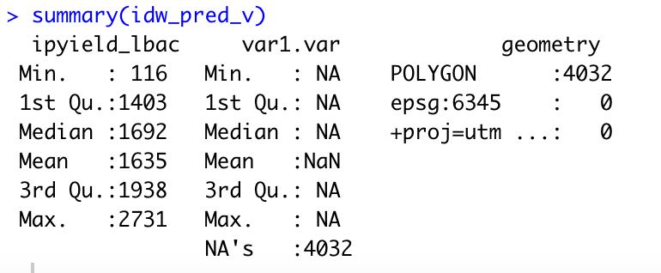

2020:
Min- 414.3
Median- 1128.5
Max- 1771.8

