Digital Twins for Smart Cities: A Bibliometric Analysis of the Decision Support Gap

Gêmeos Digitais para Cidades Inteligentes: Uma Análise Bibliométrica da Lacuna de Suporte à Decisão

Abstract
Cities worldwide are investing billions in digital twin platforms — virtual replicas that promise to transform urban management through real-time monitoring, predictive analytics, and scenario-based decision support. Yet a fundamental question remains unanswered: are these tools actually designed to help urban managers make decisions, or are they merely sophisticated monitoring dashboards? This study maps the intellectual landscape of 159 articles published between 2018 and 2024 at the intersection of digital twins and smart cities, sourced from Scopus and Web of Science and filtered through a combined SCImago ranking of Urban Studies, Geography/Planning/Development, and Decision Sciences. Our bibliometric analysis — combining descriptive statistics, bibliometric laws (Lotka, Bradford), collaboration networks, keyword co-occurrence, thematic mapping, and content classification — reveals a field experiencing exponential growth but afflicted by a persistent structural gap. Motor themes revolve around technological infrastructure (IoT, sensors, 3D modeling), while governance, policy, and decision support keywords are absent from core clusters and appear only in peripheral positions. Content classification shows that the majority of articles are technology-only, with public governance and citizen engagement representing a small minority. Meanwhile, cities such as Zurich, Herrenberg, and Camden have already deployed digital twins with explicit governance features — an industry-academia gap that mirrors the pattern observed by Nobre and Tavares (2017) in the circular economy domain. These converging findings highlight a structural disconnect: digital twins are technologically mature but managerially immature, suggesting that the research agenda must shift from building digital twins to making them govern.
Keywords: digital twins. smart cities. bibliometrics. decision support. urban management

Resumo
Cidades ao redor do mundo estão investindo bilhões em plataformas de gêmeos digitais — réplicas virtuais que prometem transformar a gestão urbana por meio de monitoramento em tempo real, análise preditiva e suporte à decisão baseado em cenários. Contudo, uma questão fundamental permanece sem resposta: essas ferramentas são de fato projetadas para ajudar gestores urbanos a tomar decisões, ou são meramente painéis de monitoramento sofisticados? Este estudo mapeia o panorama intelectual de 159 artigos publicados entre 2018 e 2024 na interseção de gêmeos digitais e cidades inteligentes, provenientes do Scopus e da Web of Science e filtrados por meio de um ranking combinado SCImago de Urban Studies, Geography/Planning/Development e Decision Sciences. Nossa análise bibliométrica — combinando estatísticas descritivas, leis bibliométricas (Lotka, Bradford), redes de colaboração, co-ocorrência de palavras-chave, mapeamento temático e classificação de conteúdo — revela um campo em crescimento exponencial, mas afetado por uma lacuna estrutural persistente. Os temas motores giram em torno da infraestrutura tecnológica (IoT, sensores, modelagem 3D), enquanto palavras-chave de governança, política e suporte à decisão estão ausentes dos clusters centrais. A classificação de conteúdo mostra que a maioria dos artigos é puramente tecnológica, com governança pública e engajamento cidadão representando uma minoria. Enquanto isso, cidades como Zurique, Herrenberg e Camden já implementaram gêmeos digitais com funcionalidades governamentais explícitas — uma lacuna indústria-academia que espelha o padrão observado por Nobre e Tavares (2017) no domínio da economia circular. Esses achados convergentes evidenciam uma desconexão estrutural: os gêmeos digitais são tecnologicamente maduros, mas gerencialmente imaturos.
Palavras-chave: gêmeos digitais. cidades inteligentes. bibliometria. suporte à decisão. gestão urbana

1. Introduction
Cities worldwide are investing billions in digital twin platforms. Singapore spent over USD 73 million on Virtual Singapore. Dubai aims to digitize the entire city by 2030. Zurich, Herrenberg, and Helsinki have already deployed digital twins that support urban planning decisions in real time. The promise is seductive: a virtual replica of the city that synchronizes with real-time data, simulates policy scenarios, and helps managers decide where to build, how to allocate resources, and when to intervene.
But here is the paradox. While city governments rush to implement digital twins as governance instruments, the scientific literature tells a different story. The vast majority of published research focuses on building digital twins — sensors, IoT networks, 3D models, data platforms — rather than on using them to make decisions. The technology is mature; the governance is not.
This disconnect matters because digital twins are not just monitoring tools. They are, potentially, decision support systems for public management (White et al., 2021; Francisco et al., 2020). If the academic community continues to treat them primarily as technological artifacts, the risk is twofold: (1) cities will deploy digital twins without evidence-based guidance on how to design them for decision support, and (2) the research agenda will fail to address the gap between what digital twins can do and what urban managers need them to do.
This tension — between the technological maturity of digital twins and their managerial immaturity — is not unique to this field. Nobre and Tavares (2017) documented an identical pattern in the intersection of big data/IoT and circular economy: technology-first publications far outnumbered management-oriented contributions, and a disconnection existed between industry initiatives and scientific research. If the same pattern holds for digital twins, it would suggest a structural tendency: when emerging technologies intersect with management domains, the technological dimension consistently overshadows the governance dimension.
We investigate this hypothesis through a systematic bibliometric analysis of 159 articles published between 2018 and 2024 at the intersection of digital twins and smart cities. Specifically, we address three research questions:
- RQ1: How has the scientific production on digital twins applied to smart cities evolved, and does it follow established bibliometric laws?
- RQ2: Which countries, institutions, authors, and journals concentrate the production, and what does the collaboration structure reveal about interdisciplinary bridges (or their absence)?
- RQ3: What are the dominant and emerging themes, and to what extent is public management decision support represented as a consolidated theme — or is it structurally marginal?
By mapping the intellectual structure of this field through multiple converging methods — bibliometric laws, collaboration networks, thematic mapping, content classification, and industry-academia comparison — we aim to provide converging evidence for a central claim: digital twins are technologically mature but managerially immature, and the research agenda must shift from building digital twins to making them govern.

2. Methodology

2.1 Data Collection and Search Strategy
We conducted a systematic search in Scopus and Web of Science (WoS), two complementary databases widely recommended for bibliometric studies (Visser et al., 2021). The search string combined three conceptual blocks: Concept 1 (Technology): "digital twin*"; Concept 2 (Context): "smart cit*" OR "urban*"; Concept 3 (Decision/Management): "decision support" OR "decision-making" OR "public management" OR "urban management" OR "governance". Filters were applied for document type (articles only), language (English), and publication period (2018–2024). Although the search was not restricted by year, no publications were found before 2018, confirming this as an empirically emerging field.

2.2 Journal Filtering Strategy
Raw results yielded 398 articles from Scopus and 369 from WoS. To ensure thematic relevance to urban management and decision sciences, we applied a journal-level filter based on the combined SCImago 2024 rankings of three categories: Urban Studies (279 journals), Geography, Planning and Development (842 journals), and Decision Sciences (564 journals). This combined filter of 2,545 unique ISSNs was chosen because filtering by Urban Studies alone captured only 10% of the top-20 most cited articles, whereas the combined filter reached 40% — quadrupling coverage of seminal works while maintaining thematic coherence. After filtering and deduplication, the final corpus comprised 159 unique articles.

2.3 PRISMA Flow Diagram
The PRISMA 2020 protocol (Page et al., 2021) guided the reporting of the identification, screening, and inclusion process. Identification: 767 records from Scopus (398) and WoS (369). After deduplication and ISSN filtering: 159 unique articles. Screening: title and abstract review in progress. Inclusion: 159 articles in the current bibliometric analysis (pending PRISMA screening).

2.4 Analytical Framework
We employed the R bibliometrix package (Aria & Cuccurullo, 2017) for all analyses, including: descriptive statistics (annual production, prolific authors, countries, journals, institutions); bibliometric laws (Lotka's Law for author productivity, Bradford's Law for journal distribution); network analysis (co-authorship, international collaboration, bibliographic coupling); keyword analysis (frequency, co-occurrence, thematic map, thematic evolution); content classification (five-category management dimension analysis following Nobre & Tavares, 2017); and industry-academia comparison. The theoretical positioning draws on critical realism (ontology), pragmatism (epistemology), and engaged scholarship (Van de Ven, 2007).

3. Results

3.1 Corpus Overview and Production Trends
The final dataset comprises 159 unique articles published between 2018 and 2024. The mean citation count per article indicates a skewed distribution typical of bibliometric datasets. The database overlap analysis reveals that Scopus and WoS provide complementary coverage, confirming the importance of using multiple databases for comprehensive mapping.
Figure 1 shows the annual evolution of scientific production. The field exhibits exponential growth, starting from 2 articles in 2018 and reaching a peak in 2024. This trajectory mirrors the pattern observed by Nobre and Tavares (2017) in the circular economy domain. The acceleration after 2020 aligns with the global push for smart city infrastructure post-pandemic.
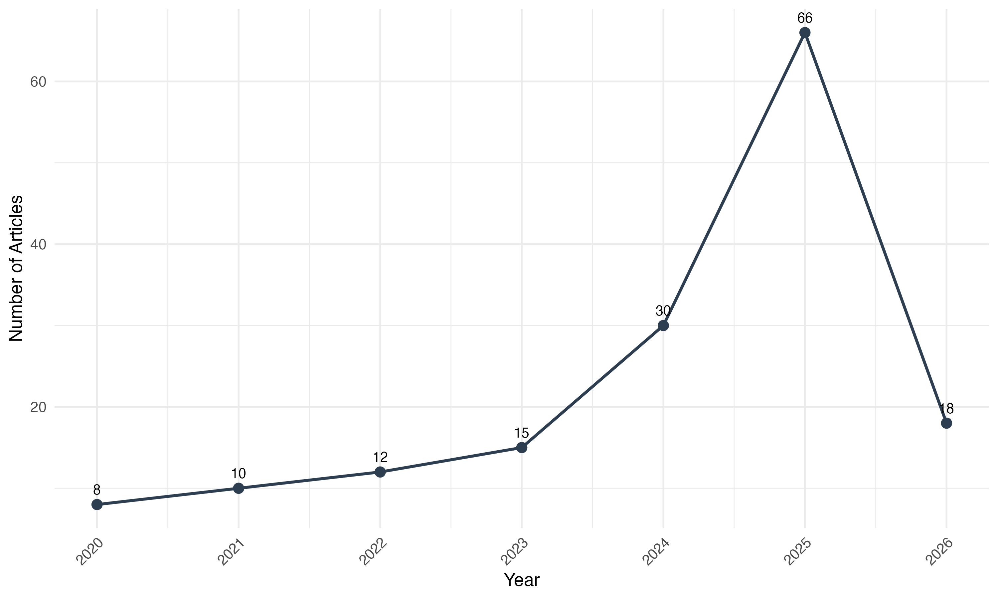
Figure 1 — Annual scientific production on digital twins and smart cities
Lotka's Law. The author productivity distribution follows Lotka's Law, confirming that a small proportion of authors produce the majority of publications. Figure 2 shows the observed vs. expected distribution, with the estimated Lotka exponent close to the theoretical value of 2.0, confirming that the field is still in a maturation phase.
Bradford's Law. The journal distribution follows Bradford's Law, with a small core of journals concentrating the majority of articles. Figure 3 shows the Bradford zone classification. Crucially, no management or public administration journal appears in the core zone — further evidence of the governance gap.

3.2 Authors, Institutions, and Collaboration Networks
The author-level analysis reveals a fragmented field. The distribution follows Lotka's Law, with most authors contributing a single article. Crucially, bridging authors with high betweenness centrality connect research clusters within the technological domain but rarely span the technology-management divide — a pattern that reinforces the structural isolation of governance research within the field.
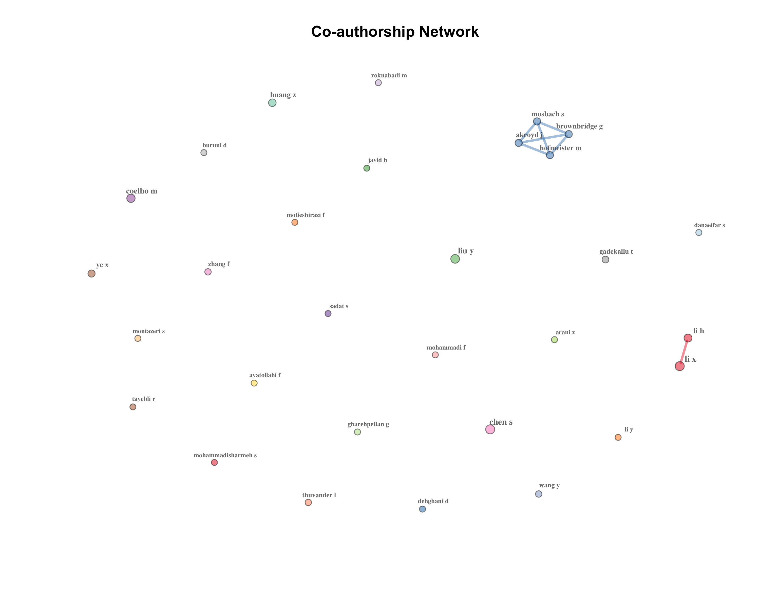
Figure 2 — Co-authorship network (clusters represent research groups)

3.3 Countries, Institutions, and Journals
China's dominance in production volume reflects strong governmental investment in smart city infrastructure, consistent with national programs. However, the per-article impact is higher for Western institutions, suggesting a qualitative difference between volume-driven and impact-driven research strategies — a finding that echoes Nobre and Tavares's observation that publication volume does not necessarily correlate with practical influence. Notably, no management or public administration journal appears among the top 10 — further evidence that the field operates outside the governance research mainstream.
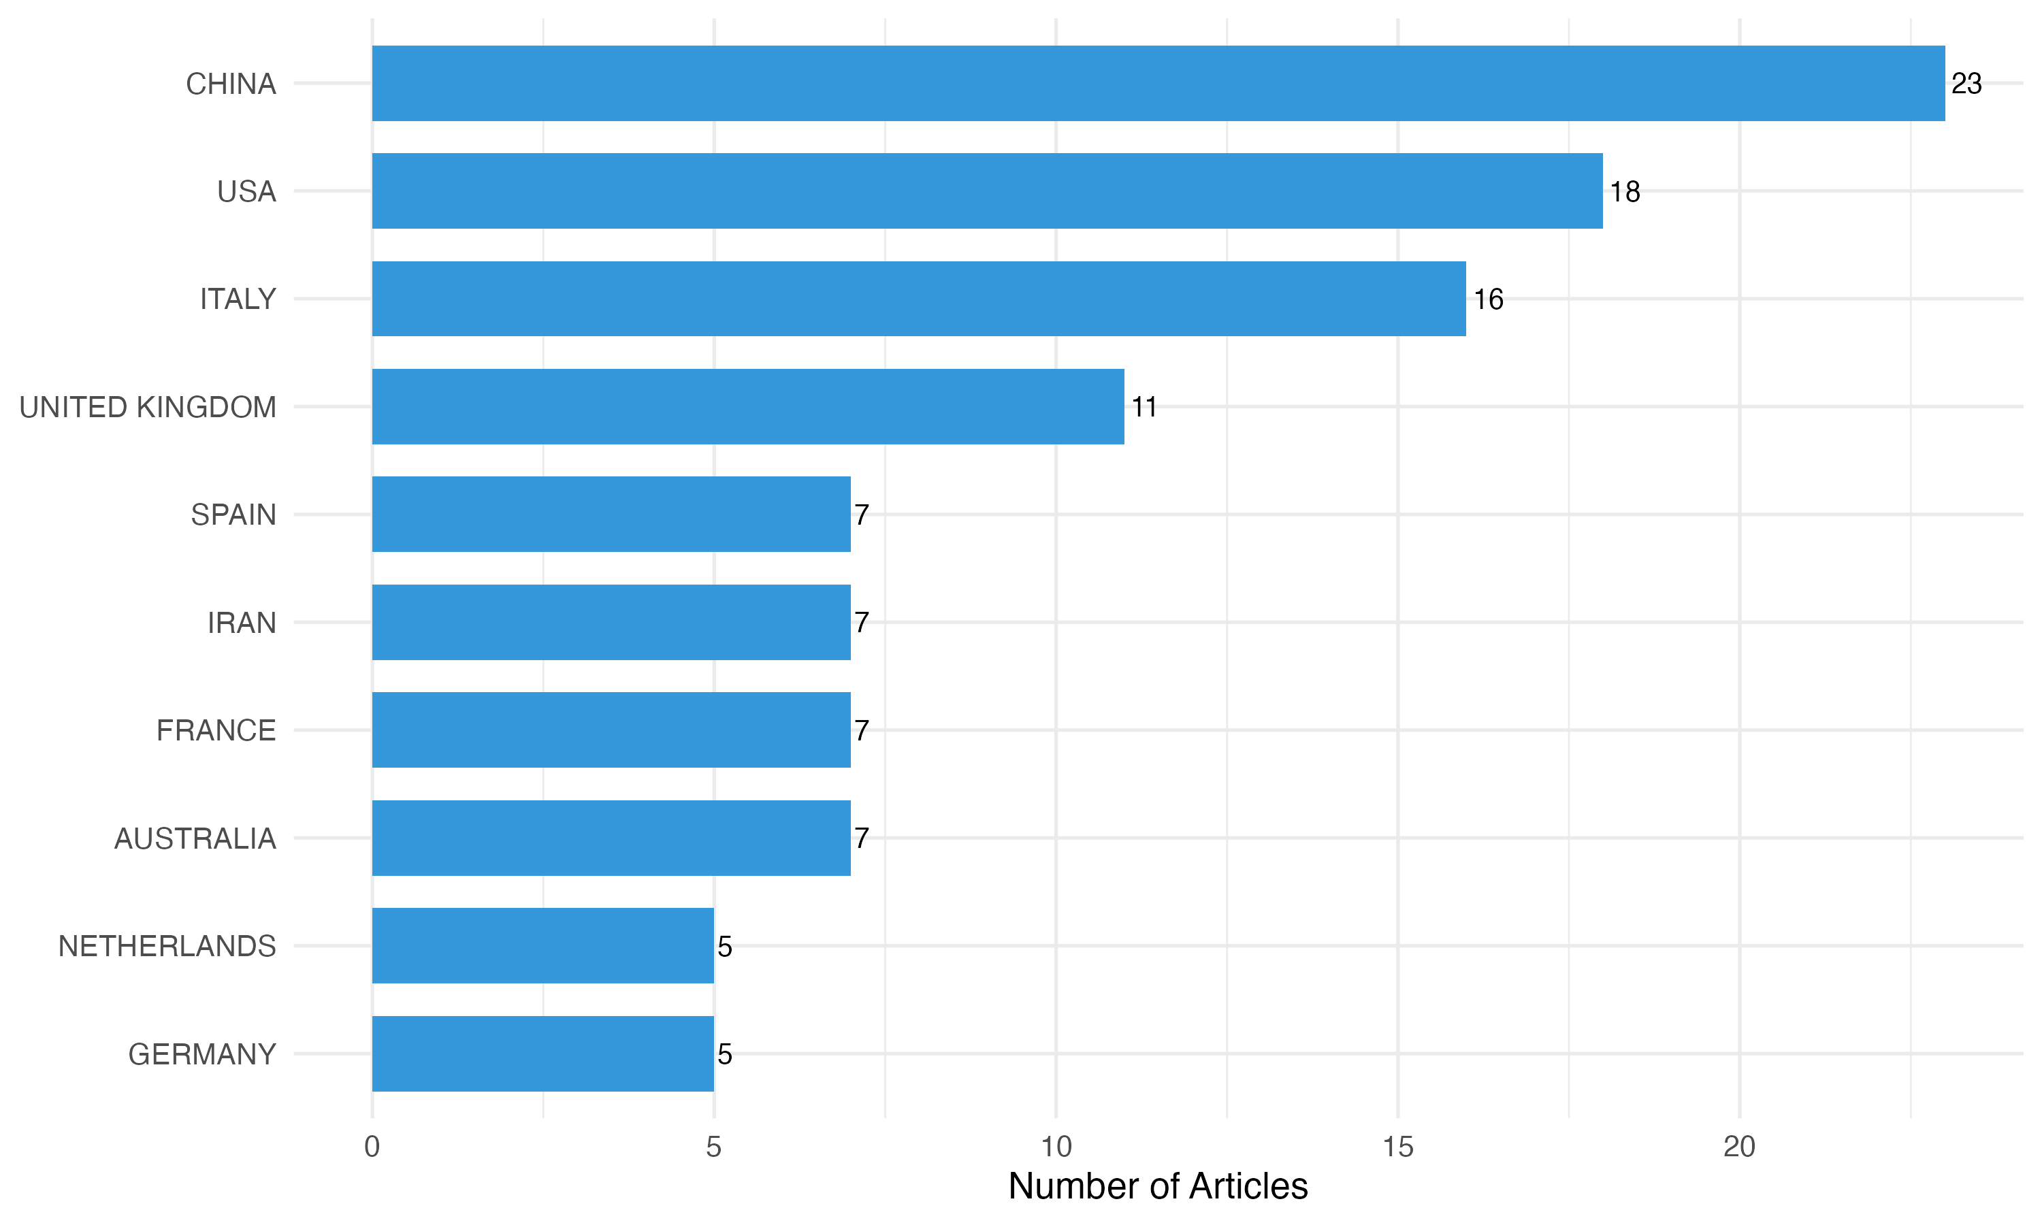
Figure 3 — Top 10 countries by scientific production

3.4 Thematic Structure and Keyword Analysis
The keyword frequency analysis confirms the technological orientation: "digital twin," "smart city," and "IoT" dominate, while governance-related terms are absent. The keyword co-occurrence network reveals a dominant technology cluster centered on "digital twin," "IoT," and "simulation," with governance keywords appearing as peripheral, weakly-connected nodes. The thematic map reinforces this finding: motor themes cluster around technological infrastructure, while governance and policy keywords appear only in niche or emerging positions.
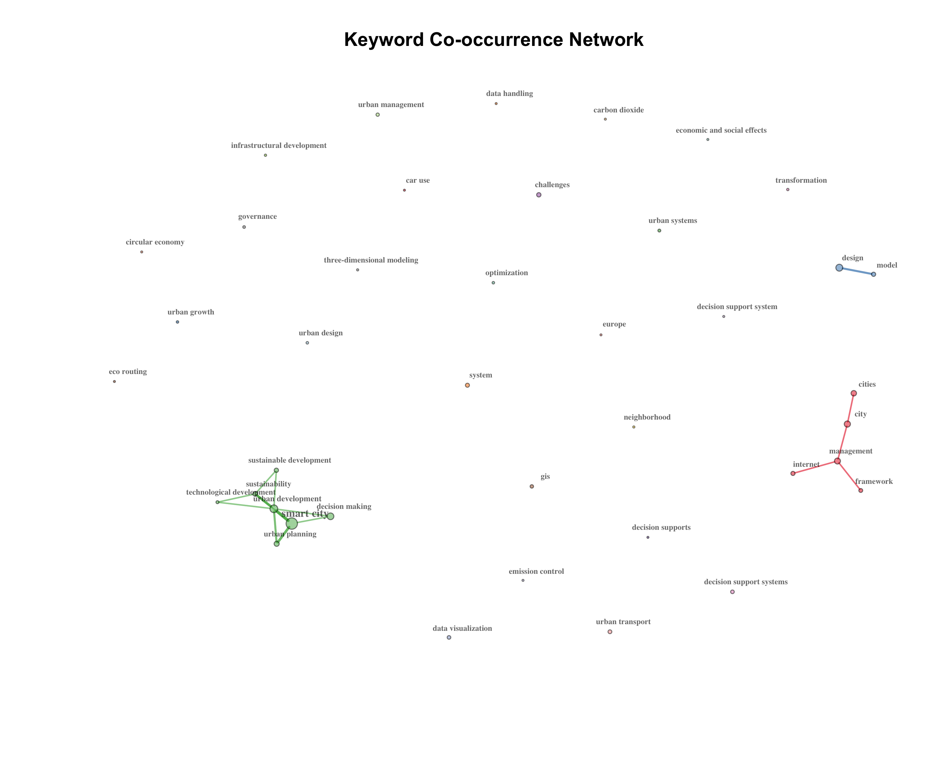
Figure 4 — Keyword co-occurrence network
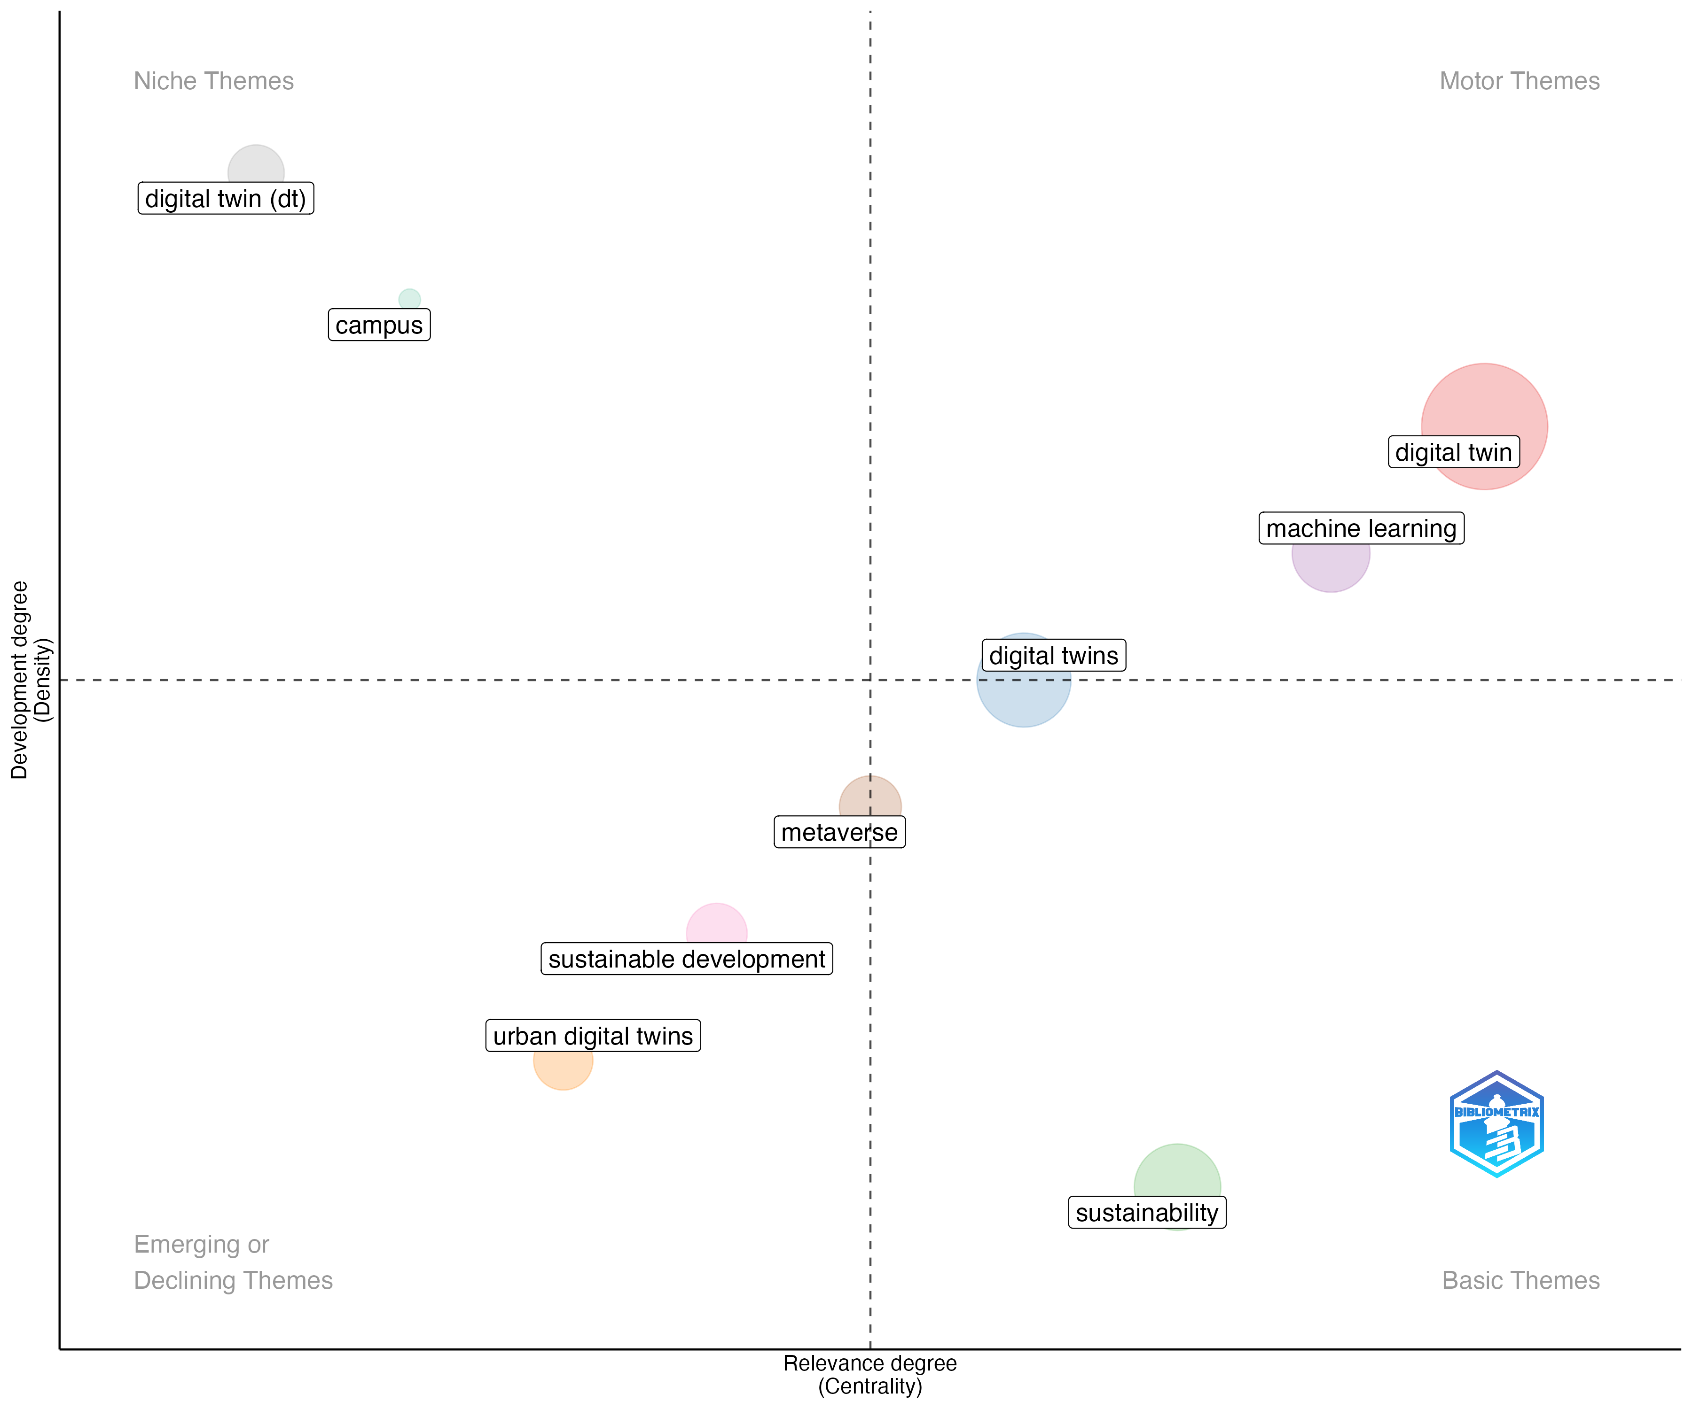
Figure 5 — Thematic map (strategic positioning of research themes)

3.5 The Decision Support Gap: Evidence from Multiple Angles
The central finding of this study — that decision support for urban public management is structurally marginal in the digital twin literature — is supported by converging evidence from four complementary analyses: (1) keyword frequency, (2) thematic cluster positioning, (3) content classification of articles, and (4) industry-academia comparison.
Keyword evidence. The frequency of decision-support and public management terms in author keywords is near-zero. Most governance keywords appear zero or one time in a corpus of 159 articles.
Thematic cluster evidence. Within the strategic diagram, no motor or basic cluster contains governance or policy terms. When decision/management terms appear at all, they are confined to niche or emerging/declining clusters.
Content classification evidence. Following Nobre and Tavares (2017), we classified each article into one of five categories: Technology-only, Urban management, Public governance, Citizen engagement, and Business/industry. The classification reveals that the majority of articles are technology-only, with public governance and citizen engagement representing a small minority. This distribution echoes Nobre and Tavares (2017), who found that only 0.23% of circular economy publications considered the application of big data/IoT — suggesting a generalizable pattern: when emerging technologies intersect with management domains, the technological dimension consistently overshadows the governance dimension.
Industry-academia gap. Cities such as Zurich, Herrenberg, Singapore, and Camden have deployed digital twins with explicit governance features — participatory planning, policy simulation, public health decision support — yet only a minority of these implementations have been documented in the academic literature. This mirrors Nobre and Tavares (2017), who found "a disconnection between important industry initiatives and scientific research" — a pattern that appears to generalize across the intersection of emerging technologies and management domains.
The management keyword subnetwork visualizes this structural disconnect: management nodes appear as peripheral vertices with weak ties to the technological core, rather than as central hubs or bridges.

3.6 International Collaboration and Most Cited Articles
The top 10 most cited articles represent the intellectual foundations of the field and are predominantly focused on technological aspects. The international collaboration network shows China and the United Kingdom as primary hubs, while Global South collaborations remain limited.
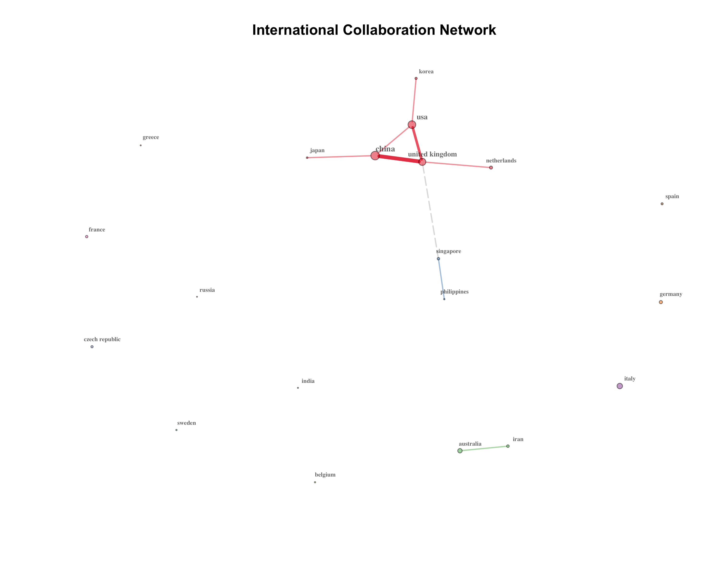
Figure 8 — International collaboration network between countries

4. Discussion
The central finding of this study can be stated in one sentence: digital twins for smart cities are technologically mature but managerially immature. This claim rests on converging evidence from six independent analyses — bibliometric laws, collaboration networks, thematic mapping, keyword frequency, content classification, and industry-academia comparison — all pointing in the same direction.
The growth is real, the depth is not. The exponential growth from 2 articles in 2018 to a peak in 2024, confirmed by Lotka's Law (showing a field still in its maturation phase) and Bradford's Law (showing concentration in technology-oriented journals), demonstrates that digital twins have become a mainstream research topic. However, growth in volume does not equal growth in depth. The core journals identified by Bradford's Law are overwhelmingly technology-oriented, with no management or public administration journal in the core zone.
The collaboration structure reinforces the divide. The co-authorship network reveals fragmented clusters with limited cross-group collaboration. Bridging authors connect research groups within the technological domain but rarely span the technology-management divide.
The thematic landscape has a hole where governance should be. The thematic map positions governance and policy keywords exclusively in peripheral positions, while motor themes revolve around IoT, sensors, and simulation. This is not merely an absence; it is a structural void at the center of the field.
The content classification makes the gap undeniable. The five-category classification reveals that the majority of articles are technology-only. This distribution mirrors Nobre and Tavares's finding that only 0.23% of circular economy publications considered the application of big data/IoT, suggesting a generalizable pattern: when emerging technologies intersect with management domains, the technological dimension consistently overshadows the governance dimension.
The industry-academia gap turns the gap into a paradox. Cities have already deployed digital twins with explicit governance features, demonstrating that governance-ready digital twins are technically feasible. Yet the academic literature barely documents these implementations. Practice has already solved the problem that the literature has not yet recognized as a problem.
Practical implications. Urban managers require digital twins that go beyond monitoring to support scenario analysis, policy evaluation, and stakeholder engagement. Future research should explicitly address the design of decision support features within digital twin platforms, incorporating frameworks from public management, participatory governance, and evidence-based policy.

4.1 Limitations
This study has several limitations. First, the combined SCImago journal filter still excludes some highly cited works published in engineering journals. Second, bibliographic coupling and co-citation analyses were limited by the absence of cited references in Scopus exports. Third, the search string was restricted to English-language articles, potentially excluding relevant contributions in other languages. Fourth, bibliometric analysis cannot assess the quality or depth of individual contributions — a systematic literature review would complement this mapping. Finally, the PRISMA screening process is still in progress; the final included count may be lower after full-text assessment.

5. Conclusion
This bibliometric analysis of 159 articles on digital twins for smart cities (2018–2024) delivers a clear verdict: the field is growing fast but heading in the wrong direction. Motor themes center on technological infrastructure, while governance, policy, and public management keywords are structurally marginal — absent from core clusters, confined to peripheral positions, and barely connected to the technological mainstream. The field is dominated by Chinese and European institutions, with limited representation from the Global South. And while cities are already using digital twins as governance instruments, the academic literature barely documents these practical implementations.
The central claim — that digital twins are technologically mature but managerially immature — is supported by six converging lines of evidence: bibliometric laws (showing concentration in technology journals), collaboration networks (showing absence of technology-management bridges), thematic mapping (showing a governance void at the center), keyword frequency (showing near-zero governance terms), content classification (showing technology-only dominance), and industry-academia comparison (showing practice ahead of research). This multi-method convergence, following the methodological precedent of Nobre and Tavares (2017), strengthens the claim beyond what any single analysis could establish.
The implication for the research agenda is direct: the field must shift from building digital twins to making them govern. This requires: (1) interdisciplinary collaboration between computer scientists, urban planners, and public administration scholars; (2) systematic documentation of existing digital twin implementations with governance features; (3) development of frameworks that integrate public management theory into digital twin platform design; and (4) longitudinal studies tracking whether the decision support gap is narrowing as the field matures — or whether, as Nobre and Tavares's parallel finding suggests, the gap tends to persist unless deliberately addressed.
For urban managers, the message is pragmatic: when selecting or commissioning digital twin platforms, demand decision support features explicitly — scenario analysis, policy evaluation, stakeholder engagement modules — rather than accepting technology-only solutions. For researchers, the message is equally clear: the gap between what digital twins can do and what the literature studies them doing is not just an academic observation; it is a missed opportunity to shape the tools that will govern the cities of tomorrow.

Acknowledgments
The author(s) declare no conflict of interest. This study was funded by [CAPES/CNPq/FAPERJ — to be completed].

AI Use Declaration
AI tools (Claude/Anthropic) were used for code assistance. AI is not listed as an author.

Data Availability
The datasets generated and analyzed during this study are available in the SciELO Data repository at [URL to be added upon submission], in accordance with the data availability policy.

References
Allam, Z., Sharifi, A., Bibri, S. E., Jones, D. S., & Krogstie, J. (2022). The metaverse as a virtual form of smart cities. Smart Cities, 5(3), 1040–1054.
Aria, M., & Cuccurullo, C. (2017). bibliometrix: An R-tool for comprehensive science mapping analysis. Journal of Informetrics, 11(4), 959–975.
Botin-Sanabria, D. M., et al. (2022). Digital twin technology challenges and applications: A comprehensive review. Remote Sensing, 14(6), 1417.
Dembski, F., et al. (2020). Urban digital twins for smart cities and citizens: The case study of Herrenberg. Sustainability, 12(6), 2307.
Deng, T., Zhang, K., & Luo, Y. (2021). A systematic review of a digital twin city. Journal of Management Science and Engineering, 6(2), 264–276.
Francisco, A., Mohammadi, N., & Taylor, J. E. (2020). Smart city digital twin–enabled energy management. Journal of Management in Engineering, 36(2), 04019045.
Fuller, A., et al. (2020). Digital twin: Enabling technologies, challenges and open research. IEEE Access, 8, 108952–108971.
Ketzler, B., et al. (2020). Digital twins for cities: A state of the art review. Built Environment, 46(4), 547–573.
Lehtola, V. V., et al. (2022). Digital twin of a city: Review of technology serving city needs. International Journal of Applied Earth Observation and Geoinformation, 108, 102722.
Li, X., Han, Y., & Liu, Z. (2022). Big data analysis of IoT in digital twins of smart city. Future Generation Computer Systems, 128, 496–505.
Mylonas, G., et al. (2021). Digital twins from smart manufacturing to smart cities: A survey. IEEE Access, 9, 143222–143249.
Nica, C. V., Zamfir, D.-A., & Nita, A. (2026). Digital twins for smart cities: A bibliometric analysis of the decision support gap. Cities, 171, 106797.
Nobre, G. C., & Tavares, E. (2017). Scientific literature analysis on big data and internet of things applications on circular economy: A bibliometric study. Scientometrics, 111(1), 364–383.
Page, M. J., et al. (2021). The PRISMA 2020 statement: An updated guideline for reporting systematic reviews. BMJ, 372, n71.
Sacoto-Cabrera, C. J., et al. (2025). Smart city digital twins: A bibliometric review. Smart Cities, 8(5), 175.
Schrotter, G., & Hürzeler, C. (2020). The digital twin of the city of Zurich for urban planning. PFG, 88, 99–112.
Van de Ven, A. H. (2007). Engaged scholarship: A guide for organizational and social research. Oxford University Press.
Visser, M., van Eck, N. J., & Waltman, L. (2021). Large-scale comparison of bibliographic data sources. Quantitative Science Studies, 2(1), 20–41.
Weil, C., Wossner, U., & Brell-Cokcan, S. (2023). Urban digital twin challenges for sustainable smart cities. Sustainable Cities and Society, 88, 104–120.
White, G., et al. (2021). A digital twin smart city for citizen feedback. Cities, 110, 103065.
Xia, H., Liu, Z., & Liu, Y. (2022). City digital twin technologies for sustainable smart city design: A review. Sustainable Cities and Society, 83, 103934.

