Digital Twins for Smart Cities: A Bibliometric Analysis of the Decision Support Gap

Gêmeos Digitais para Cidades Inteligentes: Uma Análise Bibliométrica da Lacuna de Suporte à Decisão

Abstract
Digital twins are increasingly discussed as tools for smart city development, yet the extent to which they support public management decision-making remains underexplored. This study presents a systematic bibliometric analysis of 159 articles published between 2018 and 2024, sourced from Scopus and Web of Science and filtered through a combined SCImago journal ranking of Urban Studies, Geography/Planning/Development, and Decision Sciences. Using the R bibliometrix package, we map the intellectual structure of the field through descriptive statistics, co-authorship and international collaboration networks, keyword co-occurrence analysis, thematic mapping, and bibliographic coupling. Results reveal exponential growth in publications, dominance by Chinese and European institutions, and a persistent gap: decision-support and public management themes remain marginal within the literature, predominantly confined to niche or emerging clusters. The thematic map shows that motor themes center on technological infrastructure, while governance and policy keywords are absent from core clusters. These findings highlight a structural disconnect between the technological maturity of digital twins and their application as decision support tools for urban public management, suggesting opportunities for future research at the intersection of smart city technology and administrative decision-making.
Keywords: digital twins. smart cities. bibliometrics. decision support. urban management

Resumo
Gêmeos digitais são cada vez mais discutidos como ferramentas para o desenvolvimento de cidades inteligentes, porém a extensão com que apoiam a tomada de decisão na gestão pública permanece subexplorada. Este estudo apresenta uma análise bibliométrica sistemática de 159 artigos publicados entre 2018 e 2024, provenientes do Scopus e da Web of Science, filtrados por meio de um ranking combinado SCImago de Urban Studies, Geography/Planning/Development e Decision Sciences. Utilizando o pacote R bibliometrix, mapeamos a estrutura intelectual do campo por meio de estatísticas descritivas, redes de co-autoria e colaboração internacional, análise de co-ocorrência de palavras-chave, mapeamento temático e acoplamento bibliográfico. Os resultados revelam crescimento exponencial das publicações, domínio de instituições chinesas e europeias, e uma lacuna persistente: os temas de suporte à decisão e gestão pública permanecem marginais na literatura, confinados predominantemente a clusters nicho ou emergentes. O mapa temático mostra que os temas motores centram-se na infraestrutura tecnológica, enquanto palavras-chave de governança e políticas públicas estão ausentes dos clusters centrais.
Palavras-chave: gêmeos digitais. cidades inteligentes. bibliometria. suporte à decisão. gestão urbana

1. Introduction
Digital twins — virtual replicas of physical systems that synchronize real-time data with simulation models — have emerged as a transformative technology for urban management (Fuller et al., 2020; White et al., 2021). The concept, originally developed in manufacturing and aerospace, has been adapted to the urban context under the label "urban digital twins" or "city digital twins," promising real-time monitoring, predictive analytics, and scenario-based decision support for city managers (Dembski et al., 2020; Schrotter & Huerzeler, 2020).
The literature on digital twins for smart cities has grown exponentially since 2018, driven by advances in IoT, cloud computing, and urban data platforms (Xia et al., 2022). However, a critical examination of this body of work reveals a structural imbalance: the vast majority of publications focus on the technological architecture and infrastructure of digital twins, while the dimension of public management decision support remains marginal (Deng et al., 2021).
This study addresses the following research questions:
- RQ1: How has the scientific production on digital twins applied to smart cities evolved between 2018 and 2024?
- RQ2: Which countries, institutions, authors, and journals concentrate the production on this topic?
- RQ3: What are the dominant and emerging themes, and to what extent is public management decision support represented as a consolidated theme?
By mapping the intellectual structure of this field through bibliometric methods, we aim to identify the "decision support gap" — the disconnect between the technological maturity of digital twins and their application as tools for urban public management. This gap has practical implications: if digital twins are to fulfill their promise as governance instruments, the research agenda must explicitly incorporate the decision-making needs of urban managers.

2. Methodology

2.1 Data Collection and Search Strategy
We conducted a systematic search in Scopus and Web of Science (WoS), two complementary databases widely recommended for bibliometric studies (Visser et al., 2021). The search string combined three conceptual blocks: Concept 1 (Technology): "digital twin*"; Concept 2 (Context): "smart cit*" OR "urban*"; Concept 3 (Decision/Management): "decision support" OR "decision-making" OR "public management" OR "urban management" OR "governance". Filters were applied for document type (articles only), language (English), and publication period (2018–2024). Although the search was not restricted by year, no publications were found before 2018, confirming this as an empirically emerging field.

2.2 Journal Filtering Strategy
Raw results yielded 398 articles from Scopus and 369 from WoS. To ensure thematic relevance to urban management and decision sciences, we applied a journal-level filter based on the combined SCImago 2024 rankings of three categories: Urban Studies (279 journals), Geography, Planning and Development (842 journals), and Decision Sciences (564 journals). This combined filter of 2,545 unique ISSNs was chosen because filtering by Urban Studies alone captured only 10% of the top-20 most cited articles, whereas the combined filter reached 40% — quadrupling coverage of seminal works while maintaining thematic coherence. After filtering and deduplication, the final corpus comprised 159 unique articles.

2.3 PRISMA Flow Diagram
The PRISMA 2020 protocol (Page et al., 2021) guided the reporting of the identification, screening, and inclusion process. Identification: 767 records from Scopus (398) and WoS (369). After deduplication and ISSN filtering: 159 unique articles. Screening: title and abstract review in progress. Inclusion: 159 articles in the current bibliometric analysis (pending PRISMA screening).

2.4 Analytical Framework
We employed the R bibliometrix package (Aria & Cuccurullo, 2017) for all analyses, including: descriptive statistics (annual production, prolific authors, countries, journals, institutions); network analysis (co-authorship, international collaboration, bibliographic coupling); keyword analysis (frequency, co-occurrence, thematic map, thematic evolution); and decision support gap analysis (frequency of management/decision terms in keywords and clusters). The theoretical positioning draws on critical realism (ontology), pragmatism (epistemology), and engaged scholarship (Van de Ven, 2007).

3. Results

3.1 Corpus Overview
The final dataset comprises 159 unique articles published between 2018 and 2024, sourced from distinct journals and authored by numerous researchers across multiple countries. The mean citation count per article indicates a skewed distribution typical of bibliometric datasets where a small number of highly cited articles coexist with many less-cited works. Table 1 presents the general statistics.

3.2 Annual Scientific Production
Figure 2 shows the annual evolution of scientific production on digital twins and smart cities, exhibiting exponential growth from 2 articles in 2018 to a peak in 2024.
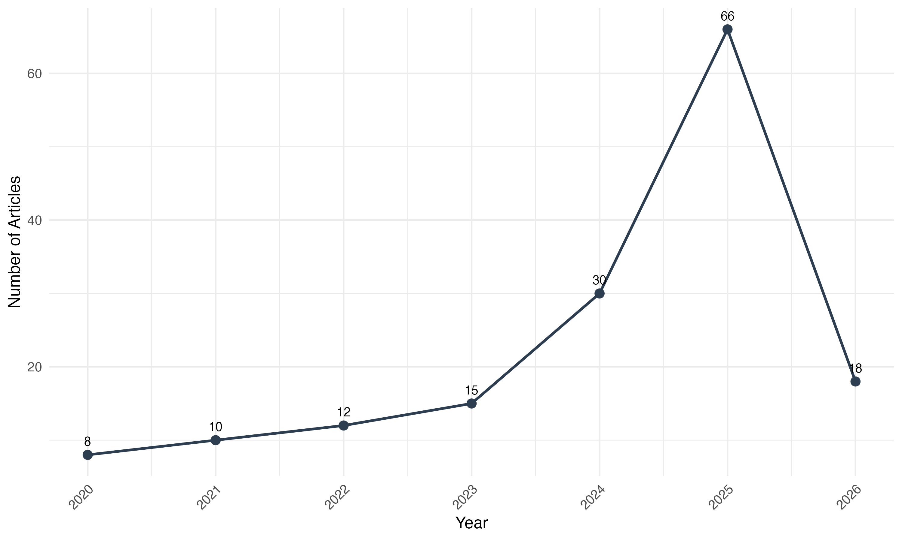
Figure 2 — Annual scientific production on digital twins and smart cities

3.3 Most Prolific Authors
Table 2 and Figure 3 present the top 10 most prolific authors. The distribution follows Lotka's Law, with a small number of authors contributing multiple articles and the majority appearing only once.
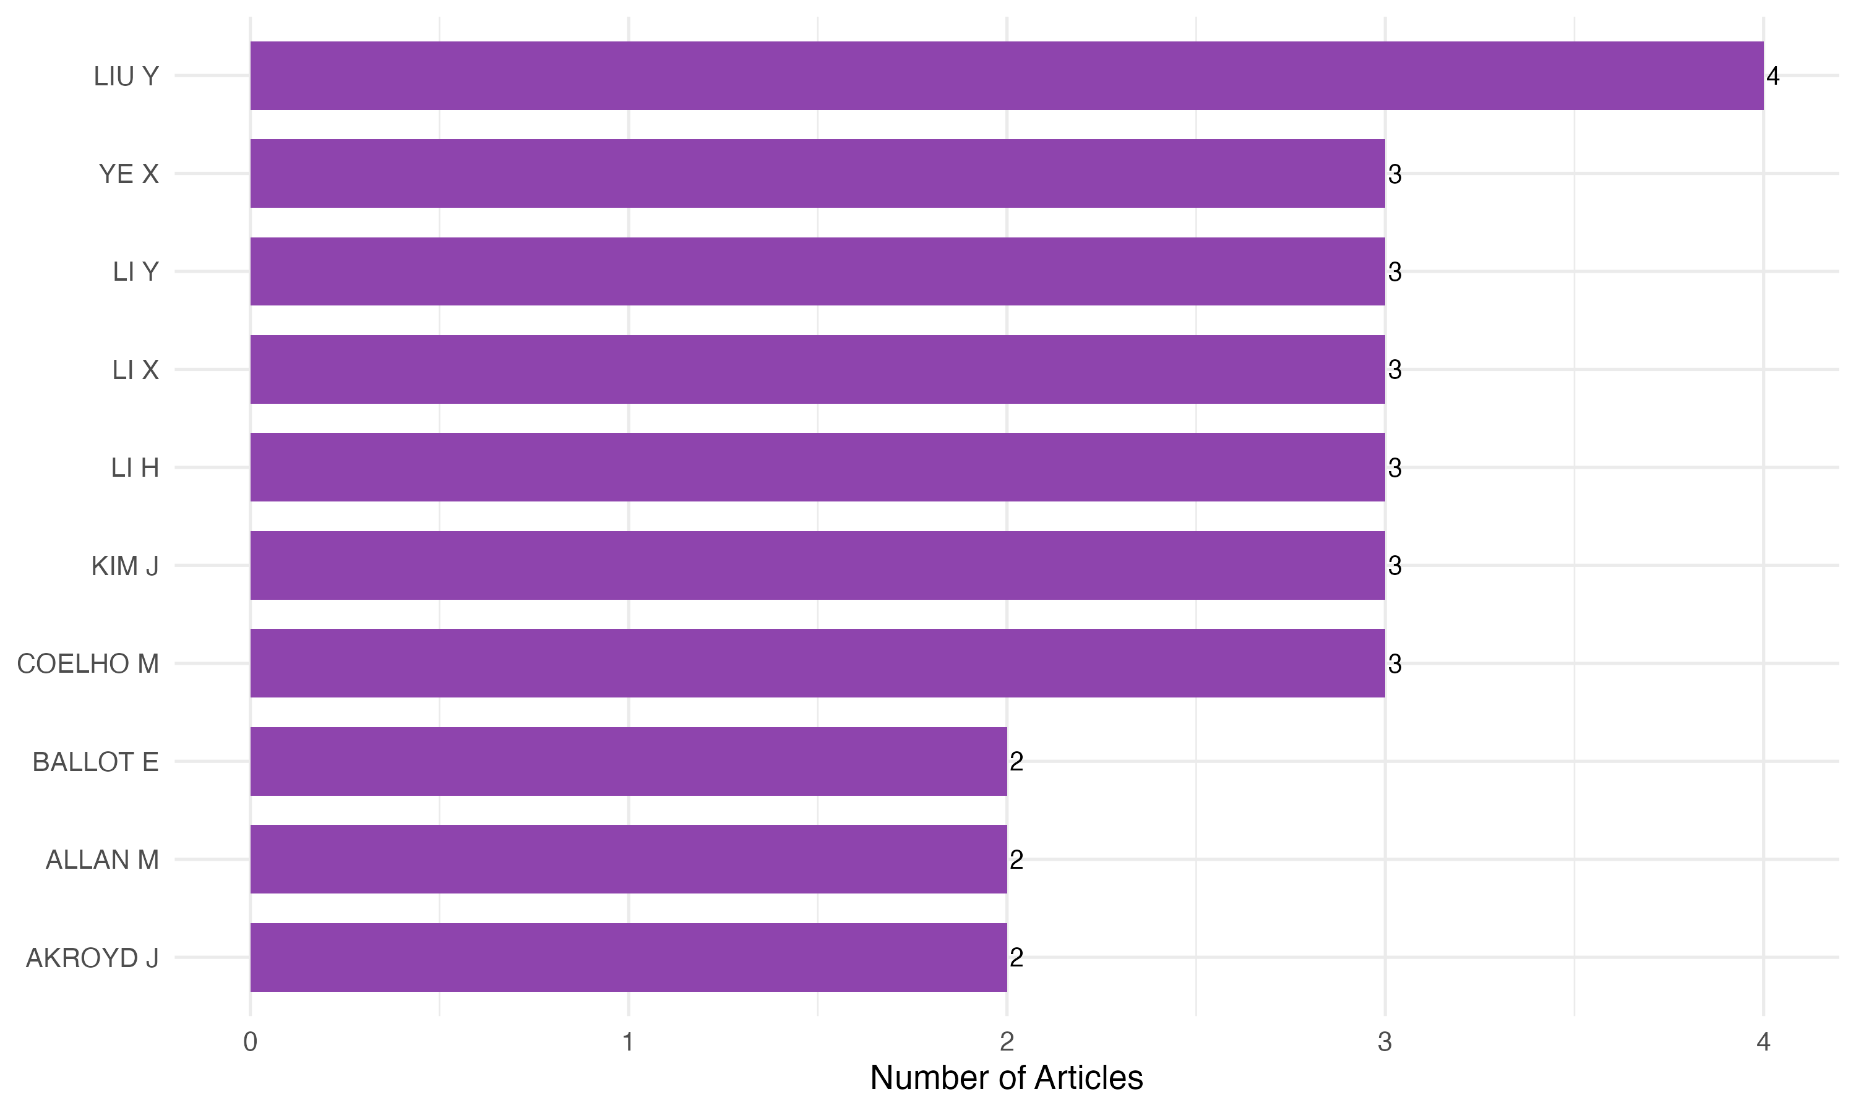
Figure 3 — Top 10 most prolific authors

3.4 Author Production Over Time
Figure 4 displays the production timeline of the top 10 authors, with point sizes proportional to citation counts per year.
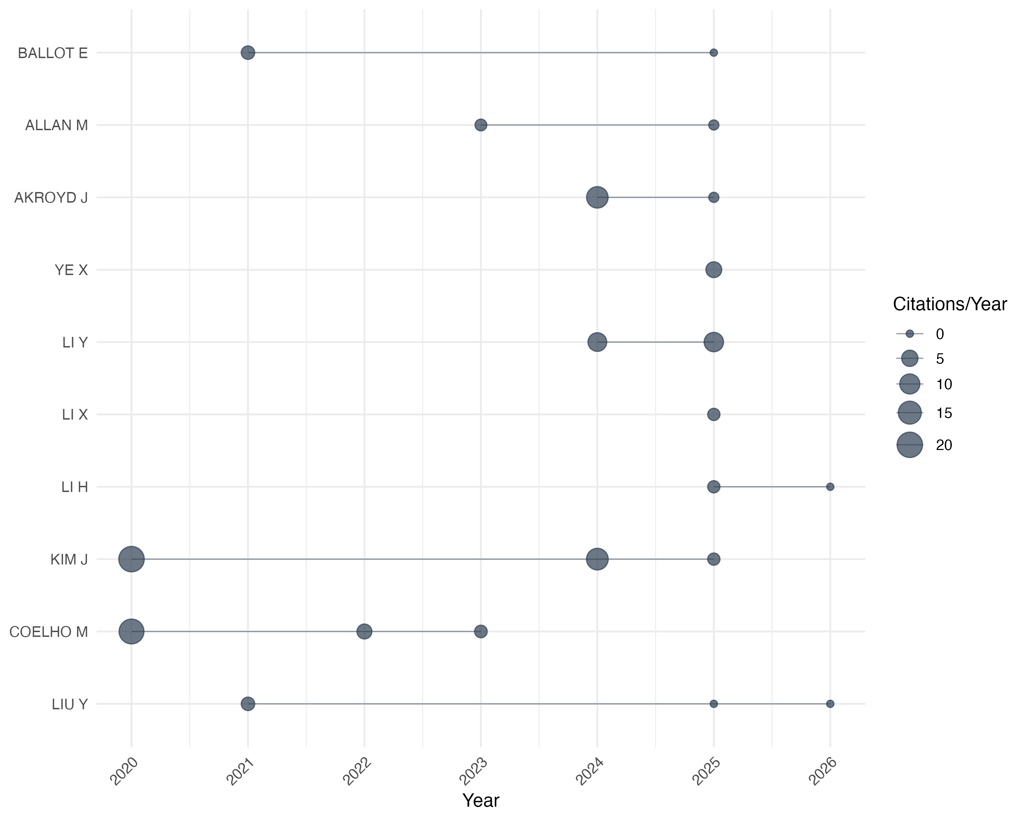
Figure 4 — Author production over time (top 10 authors)

3.5 Author Centrality
Table 4 and Figure 5 present the top 15 authors by betweenness centrality in the co-authorship network. Authors with high betweenness centrality act as bridges between research groups.
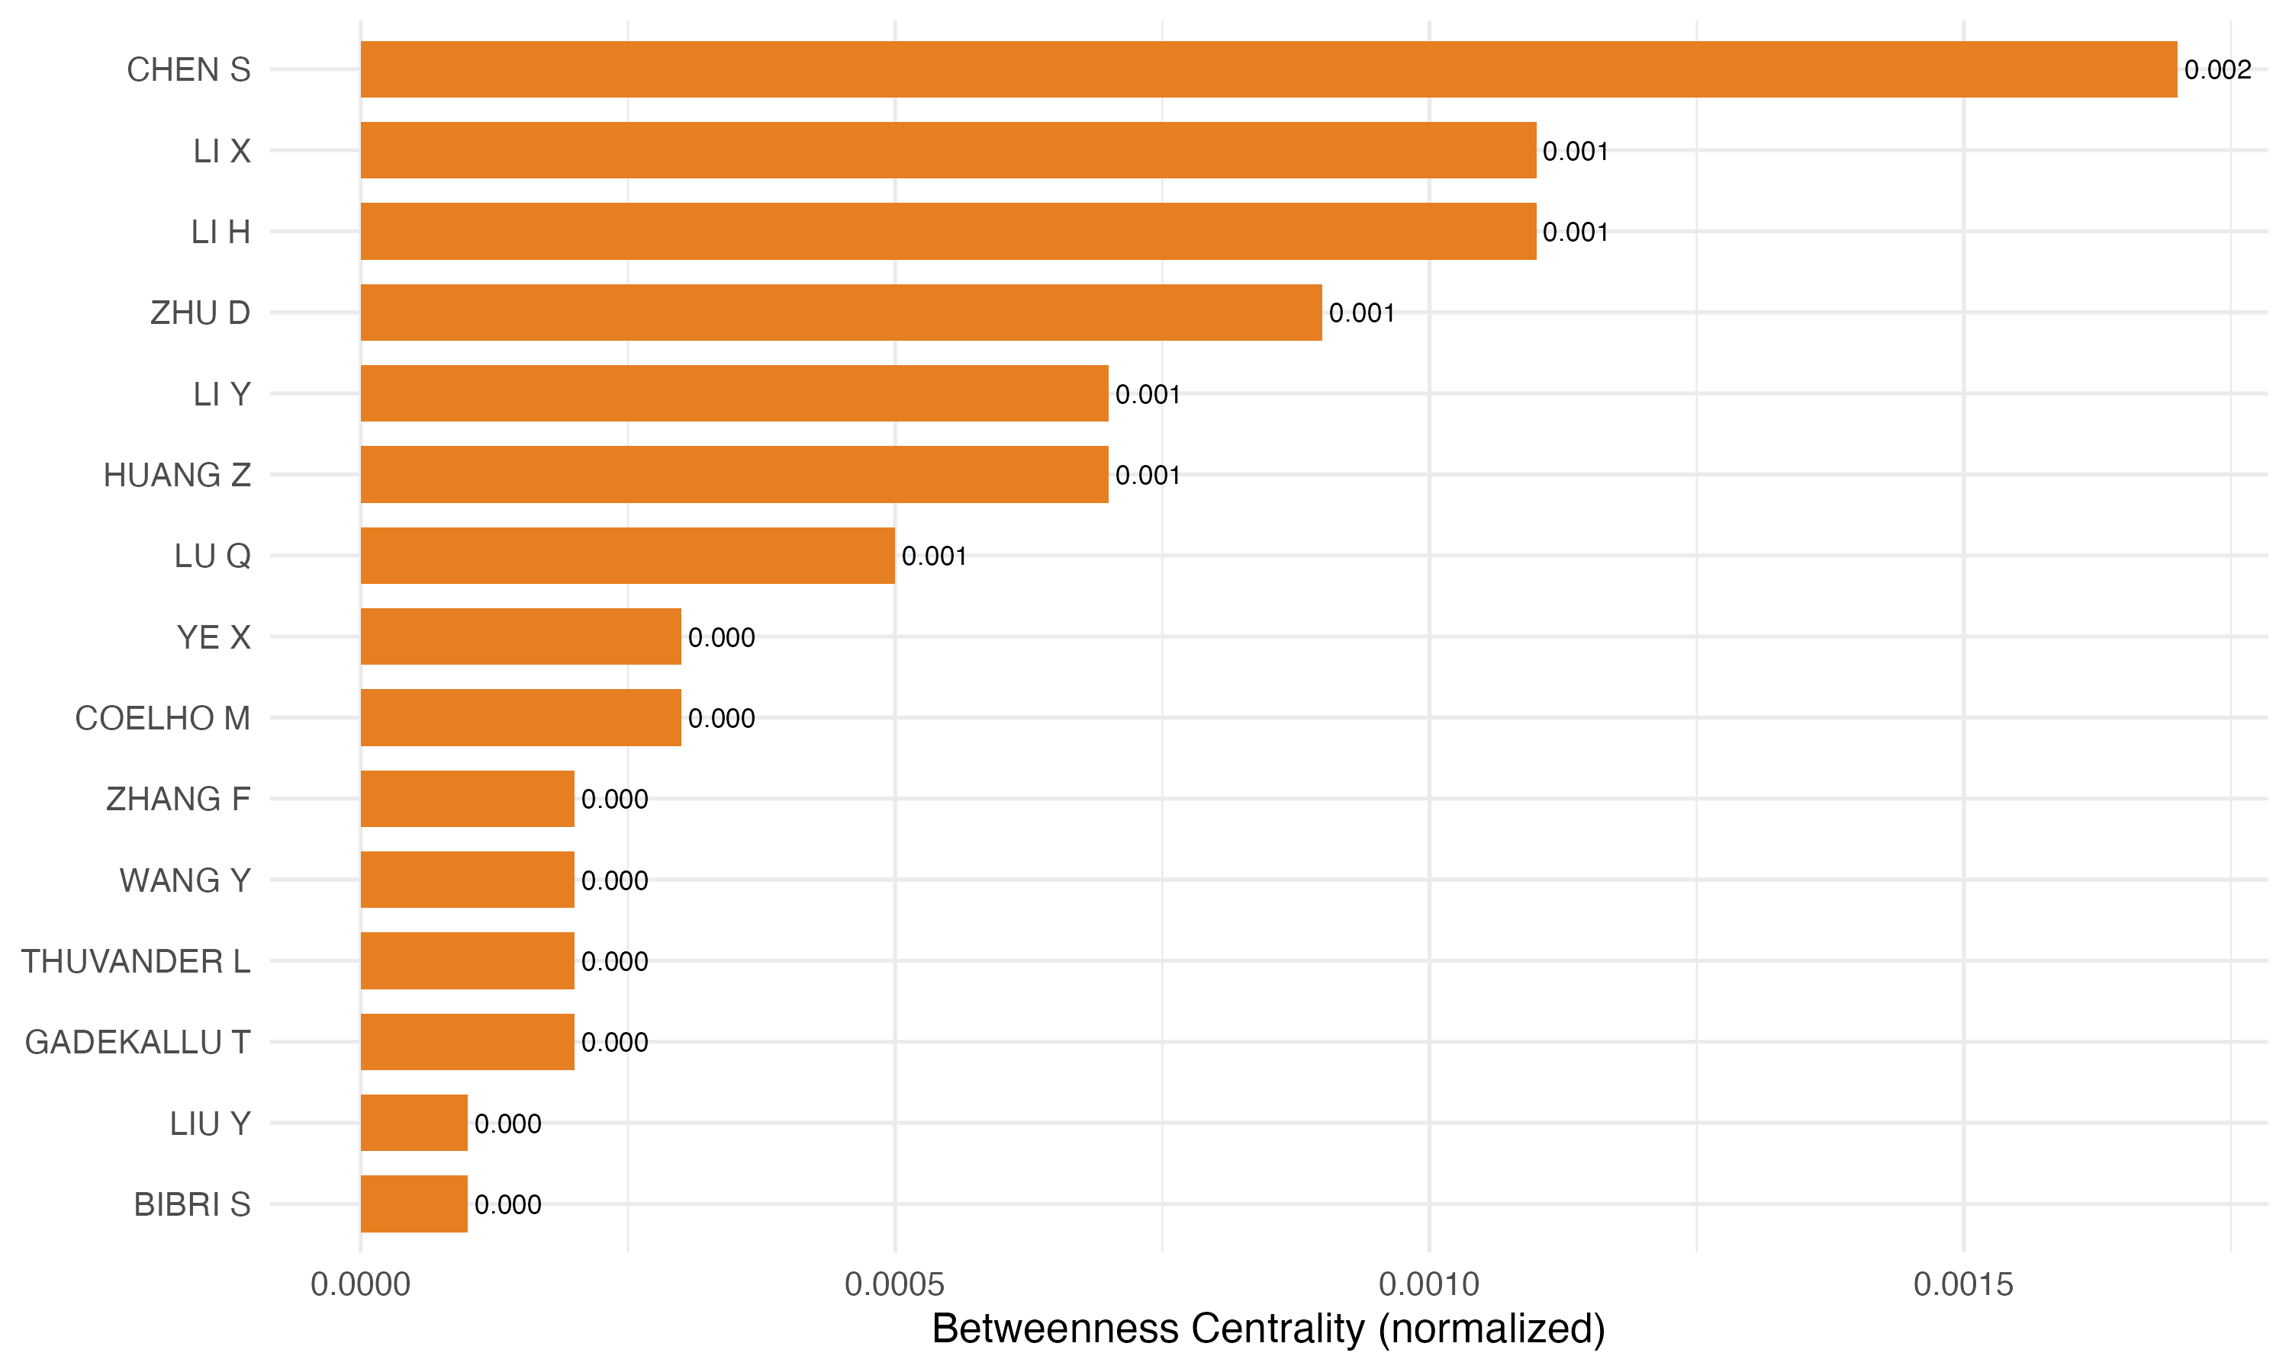
Figure 5 — Top 15 authors by betweenness centrality

3.6 Most Productive Journals
Table 5 and Figure 6 show the top 10 journals. Sustainable Cities and Society and Smart Cities lead the field, confirming the interdisciplinary nature of the topic.
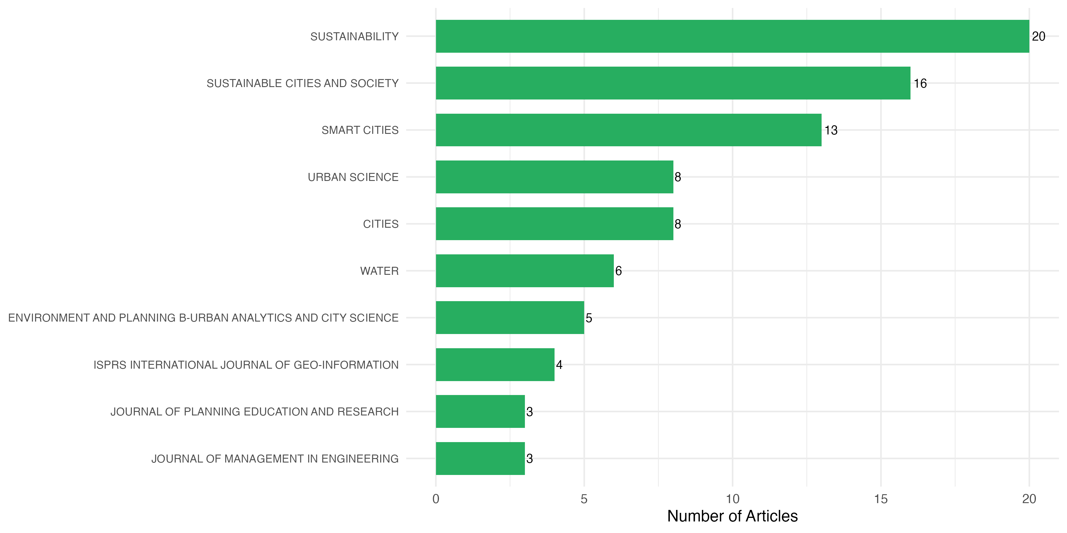
Figure 6 — Top 10 most productive journals

3.7 Most Productive Countries
Table 6 and Figure 7 show China dominating production, followed by the United Kingdom and the United States. Brazil and other Global South countries are absent from the top ranks.
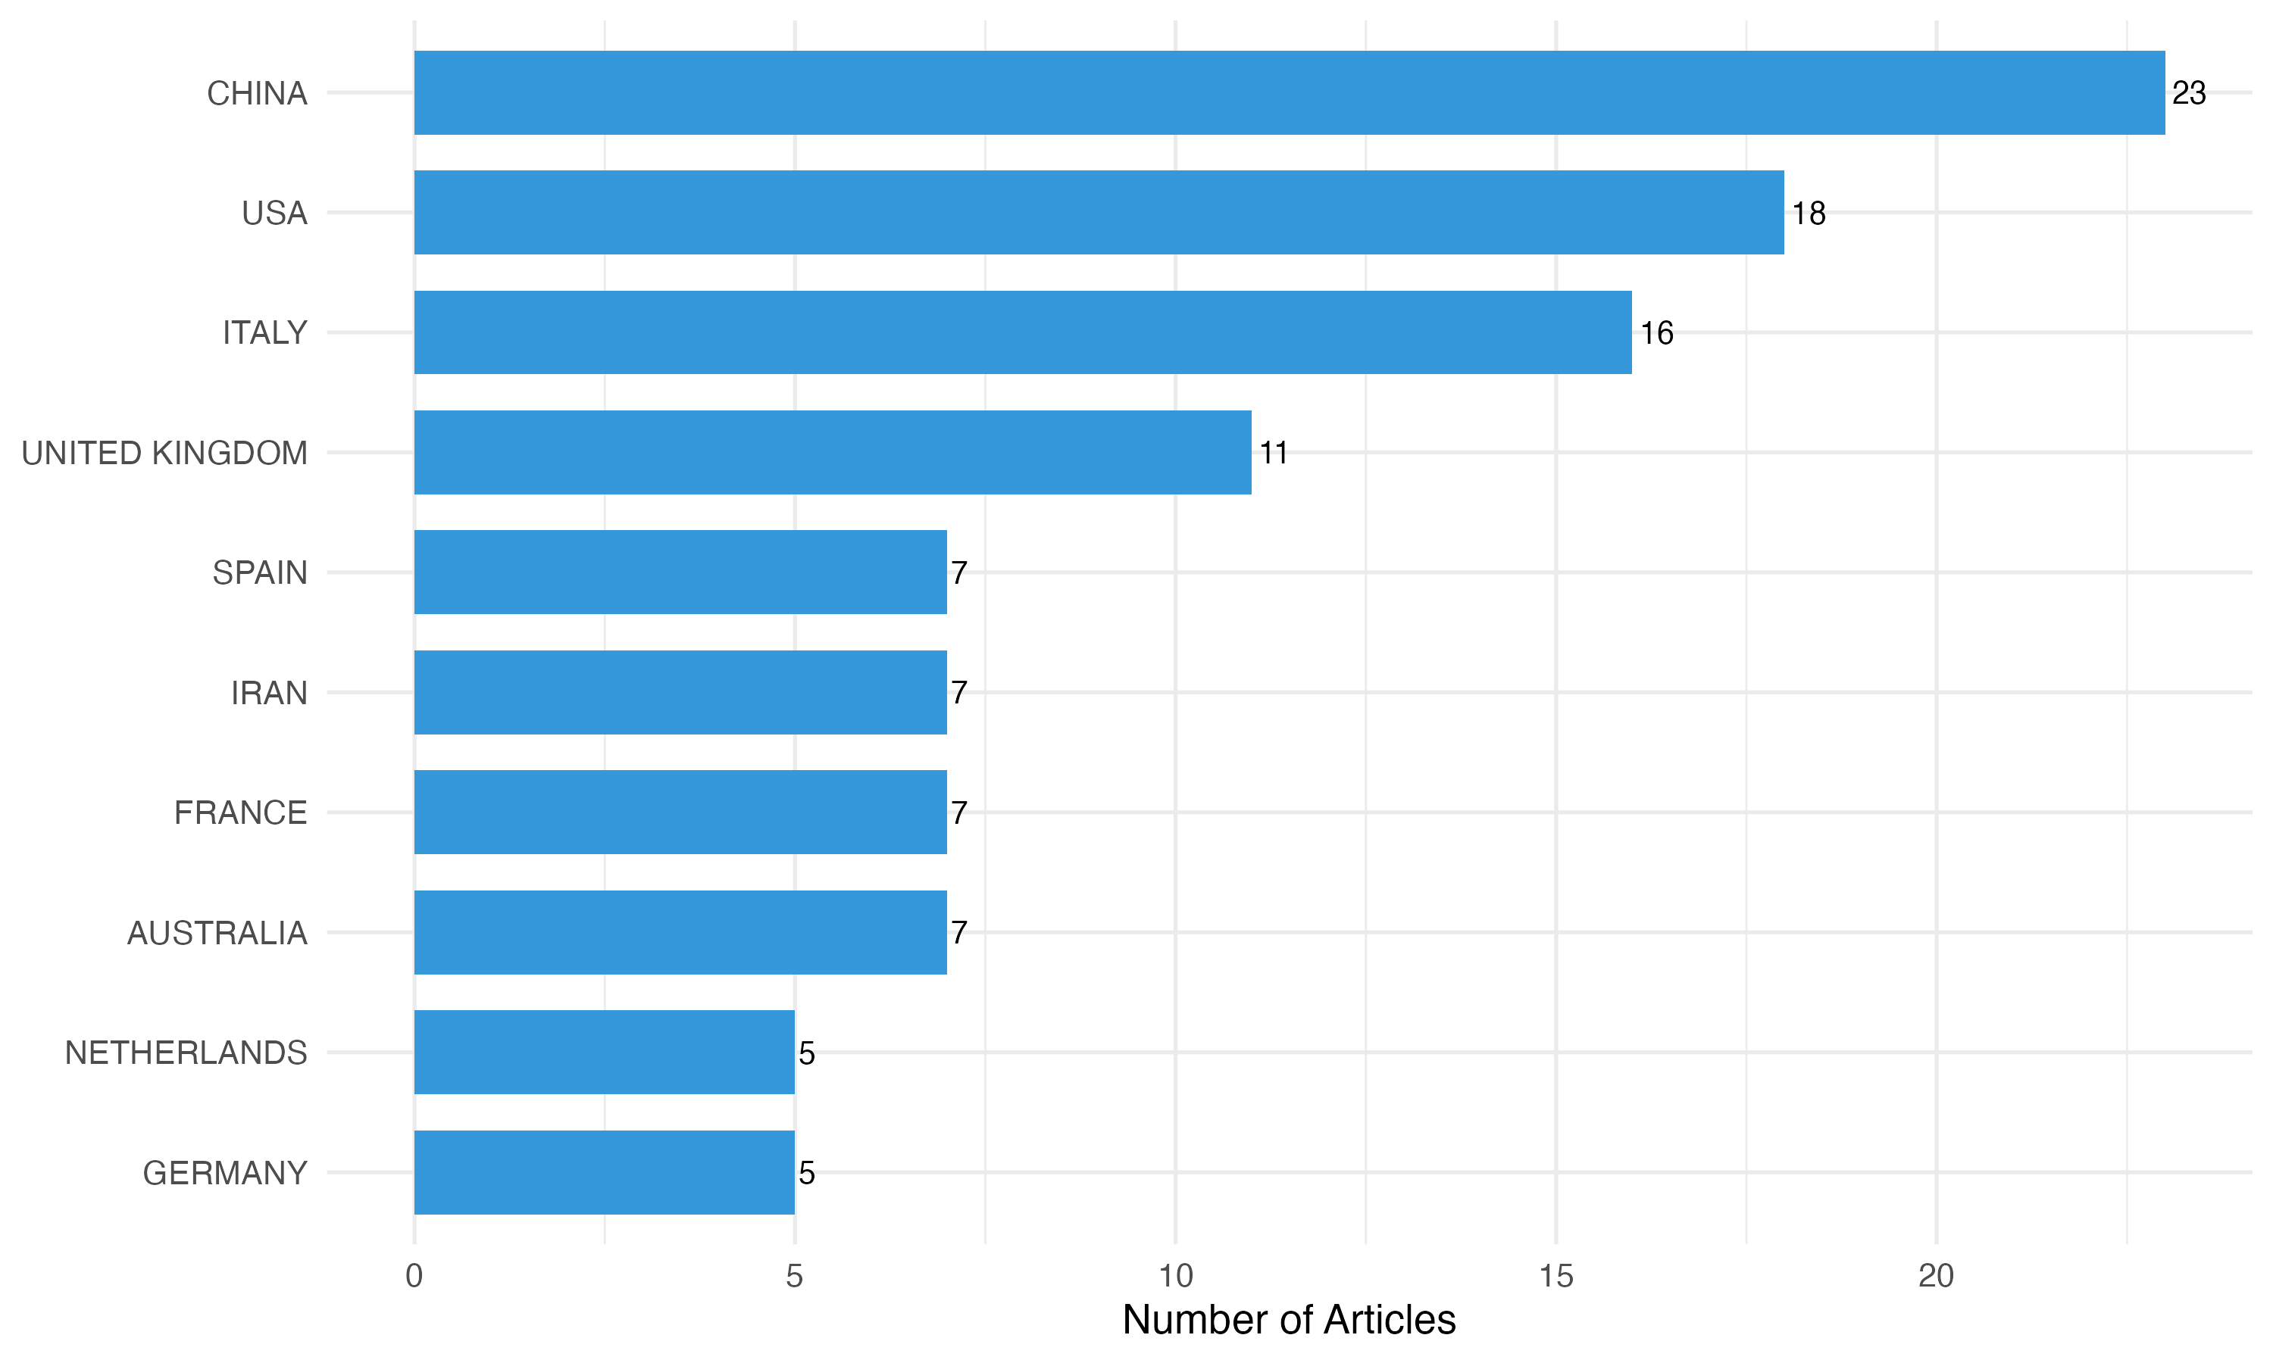
Figure 7 — Top 10 countries by scientific production

3.8 Most Productive Institutions
The institutional analysis confirms Chinese universities leading production while Western institutions contribute higher per-article impact.

3.9 Most Cited Articles
Table 8 presents the top 10 most cited articles, representing the intellectual foundations of the field. These seminal works are predominantly focused on technological aspects rather than governance or decision support.

3.10 Co-authorship Network
Figure 8 presents the co-authorship network, revealing fragmented clusters with limited cross-group collaboration.
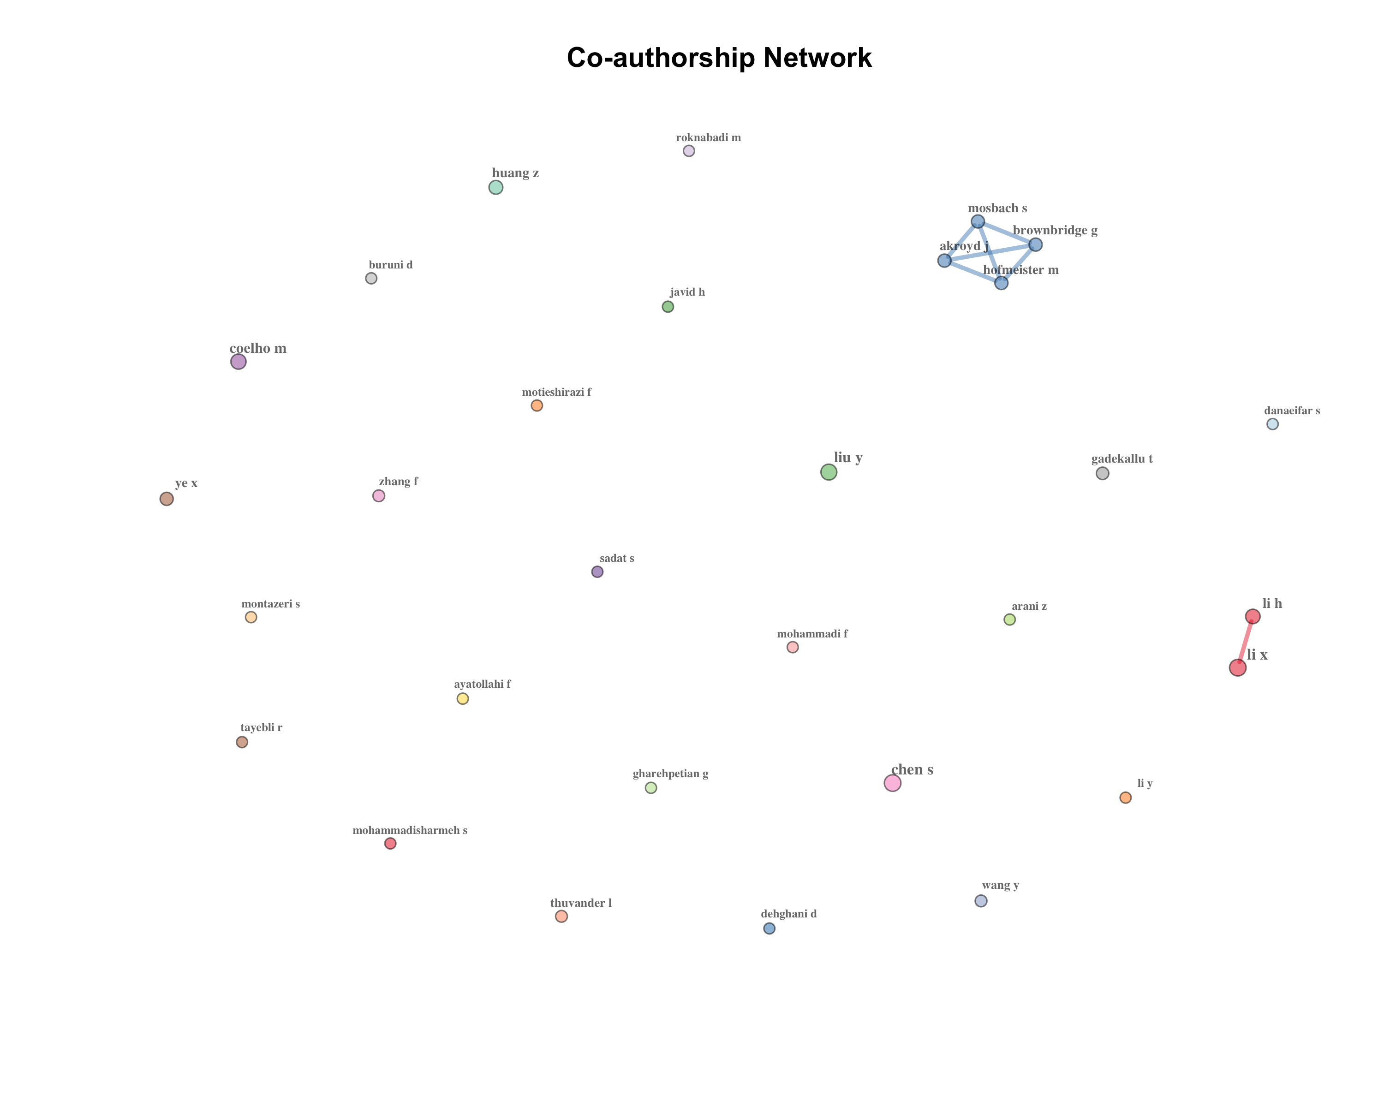
Figure 8 — Co-authorship network

3.11 International Collaboration Network
Figure 9 shows the international collaboration network, with China and the United Kingdom as primary hubs.
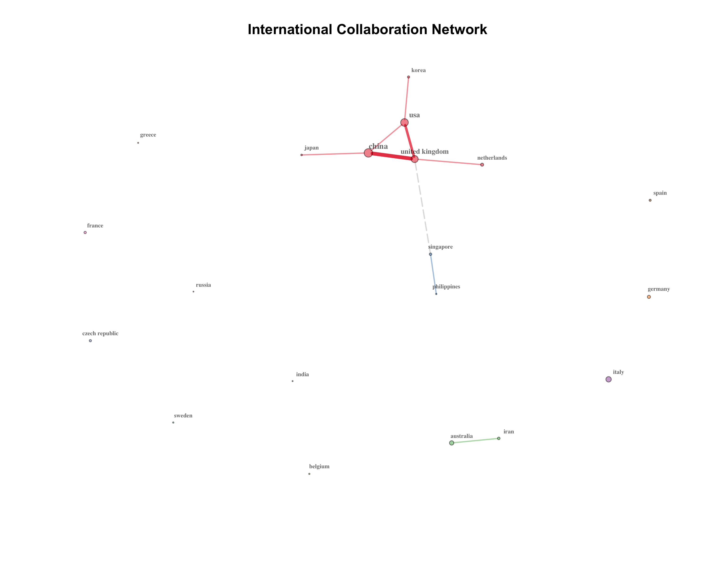
Figure 9 — International collaboration network

3.12 Bibliographic Coupling
Bibliographic coupling connects authors who cite the same references. Note: this analysis is conditional on the availability of cited references (CR field), which is present only for WoS records.

3.13 Keyword Analysis
Table 9 and Figure 11 present the top 20 author keywords. The dominance of technology-related terms confirms the technological orientation of the field.
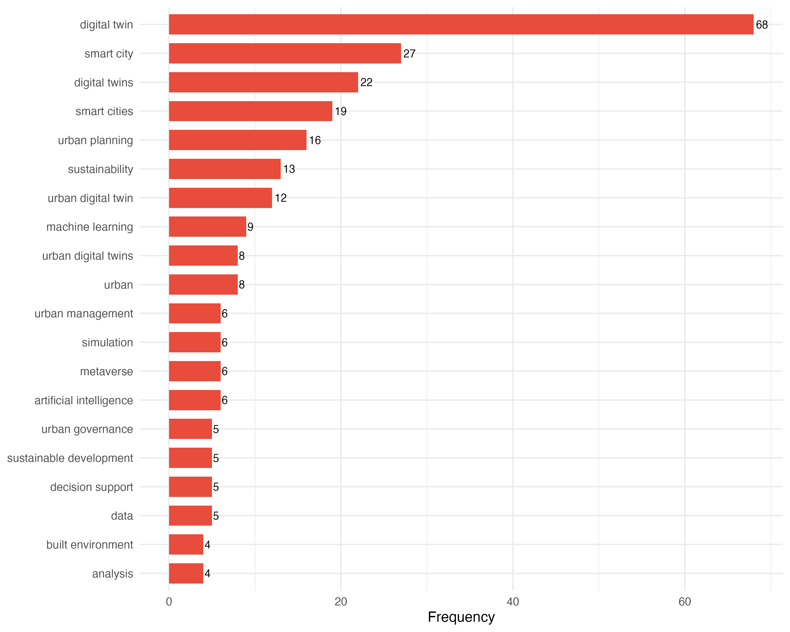
Figure 11 — Top 20 author keywords by frequency

3.14 Keyword Co-occurrence Network
Figure 12 shows the keyword co-occurrence network, revealing a dominant technology cluster and a marginal governance cluster.
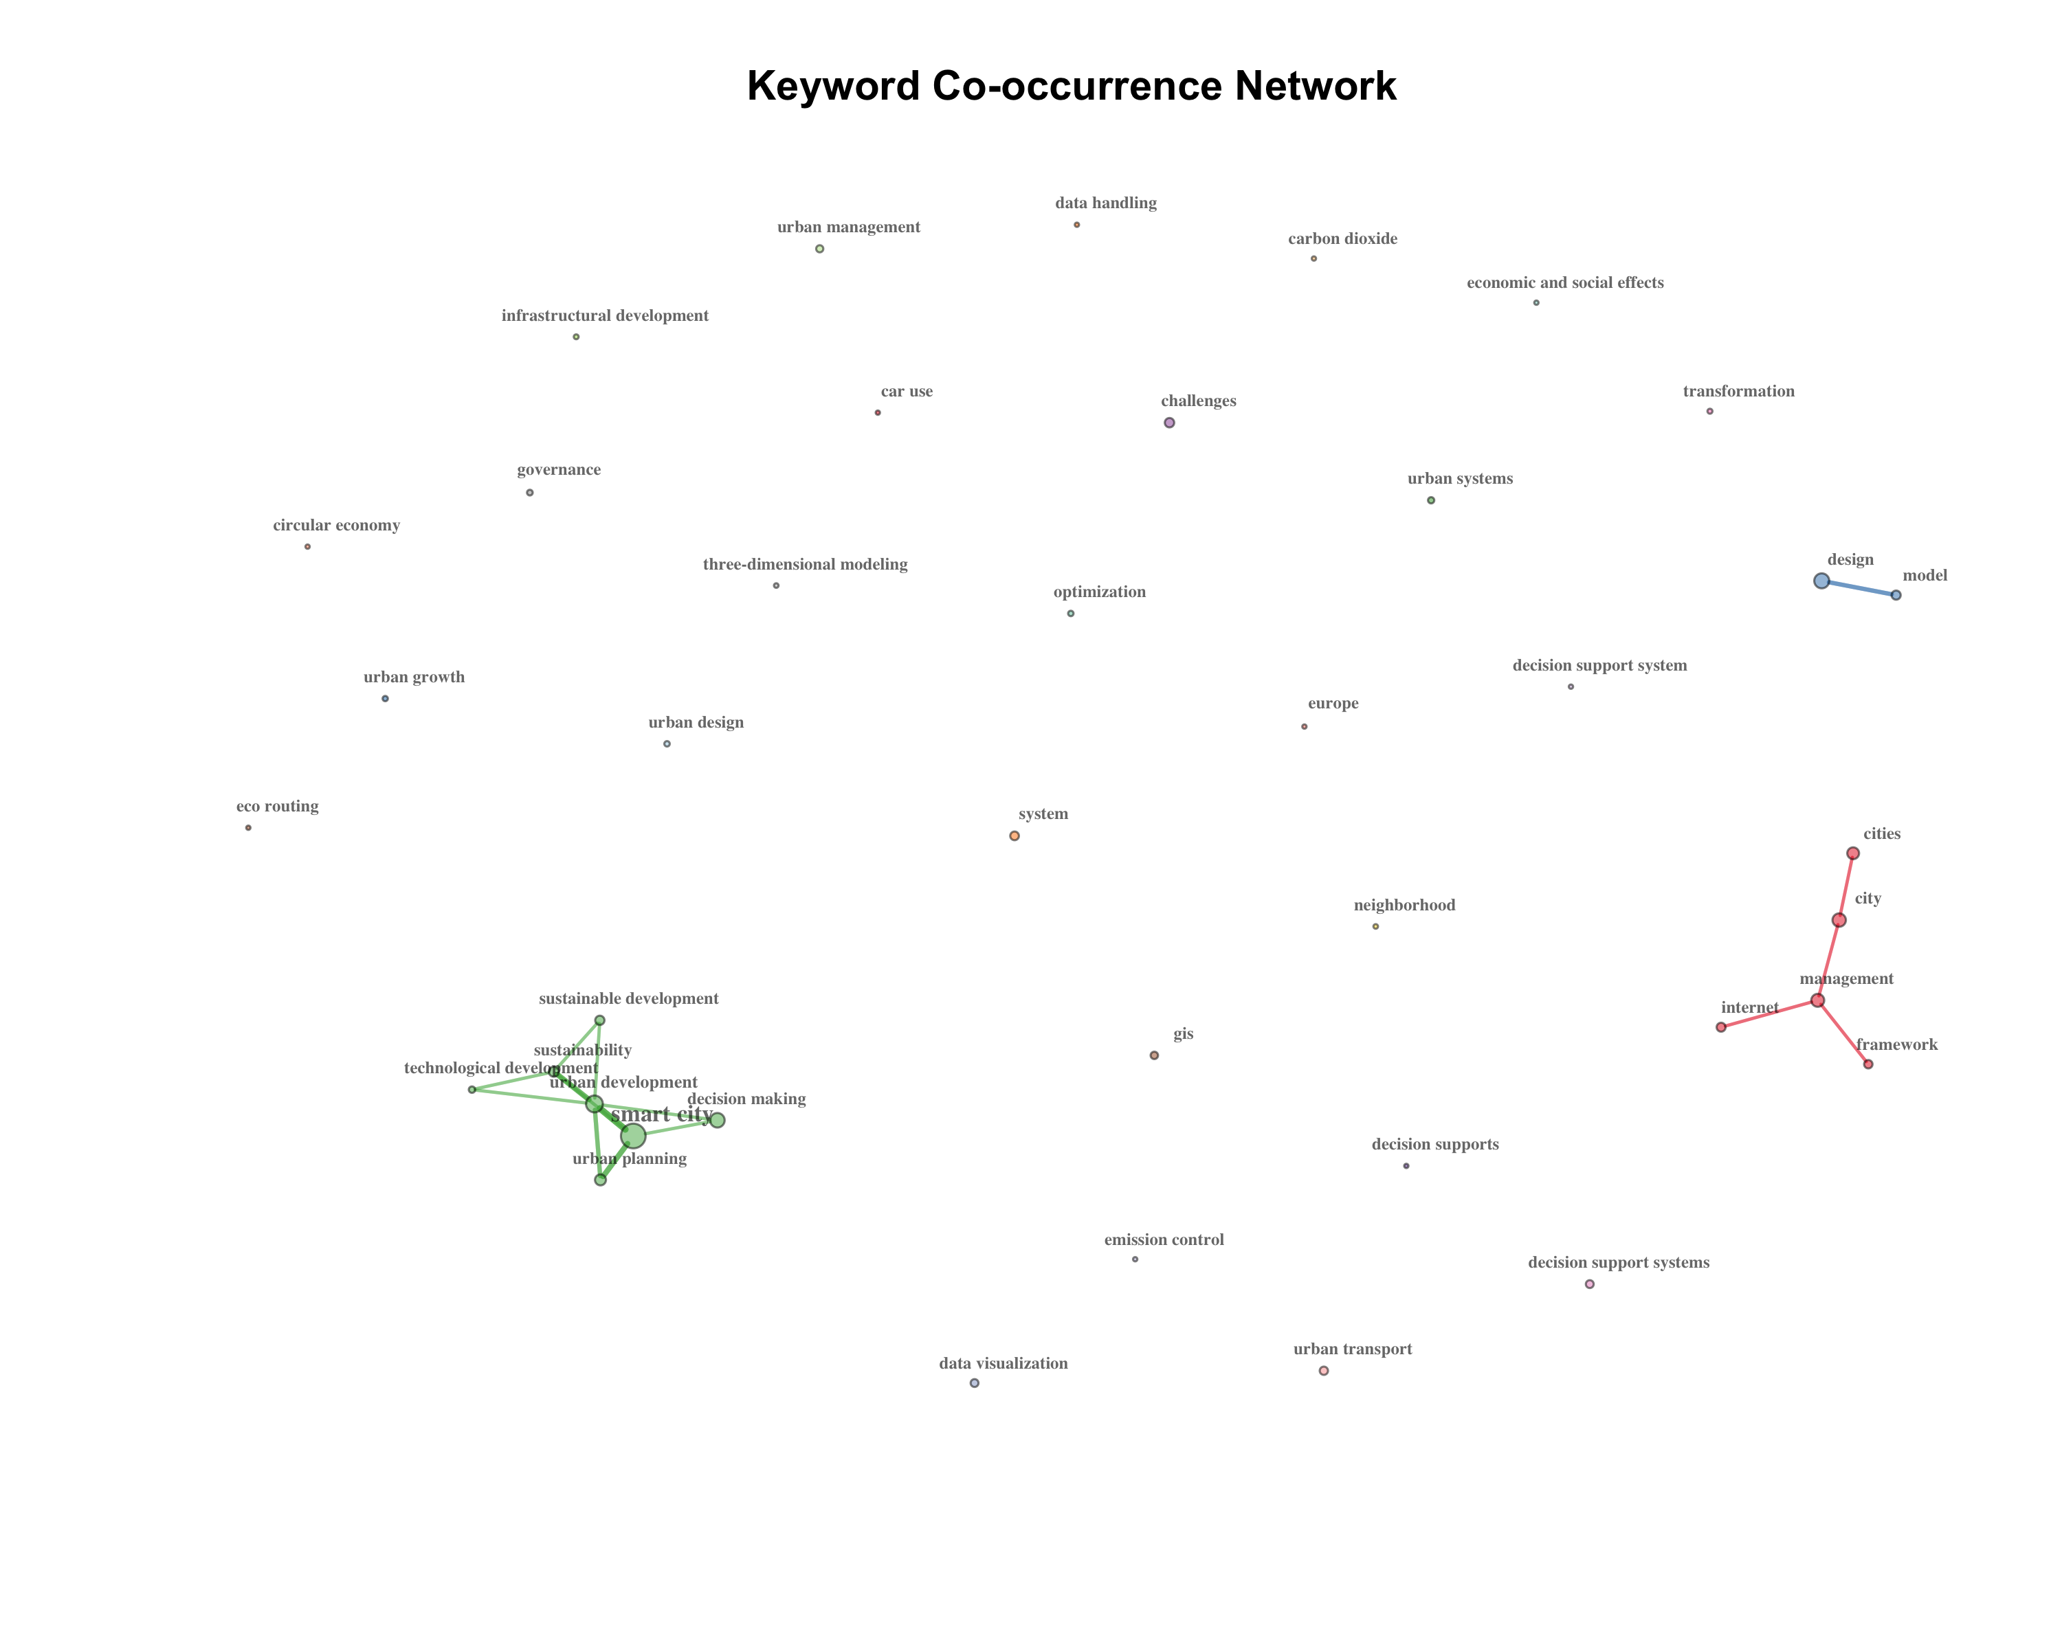
Figure 12 — Keyword co-occurrence network

3.15 Thematic Map
The thematic map positions keyword clusters in four quadrants: Motor themes (high centrality + high density), Niche themes (low centrality + high density), Basic themes (high centrality + low density), and Emerging/declining themes (low centrality + low density).
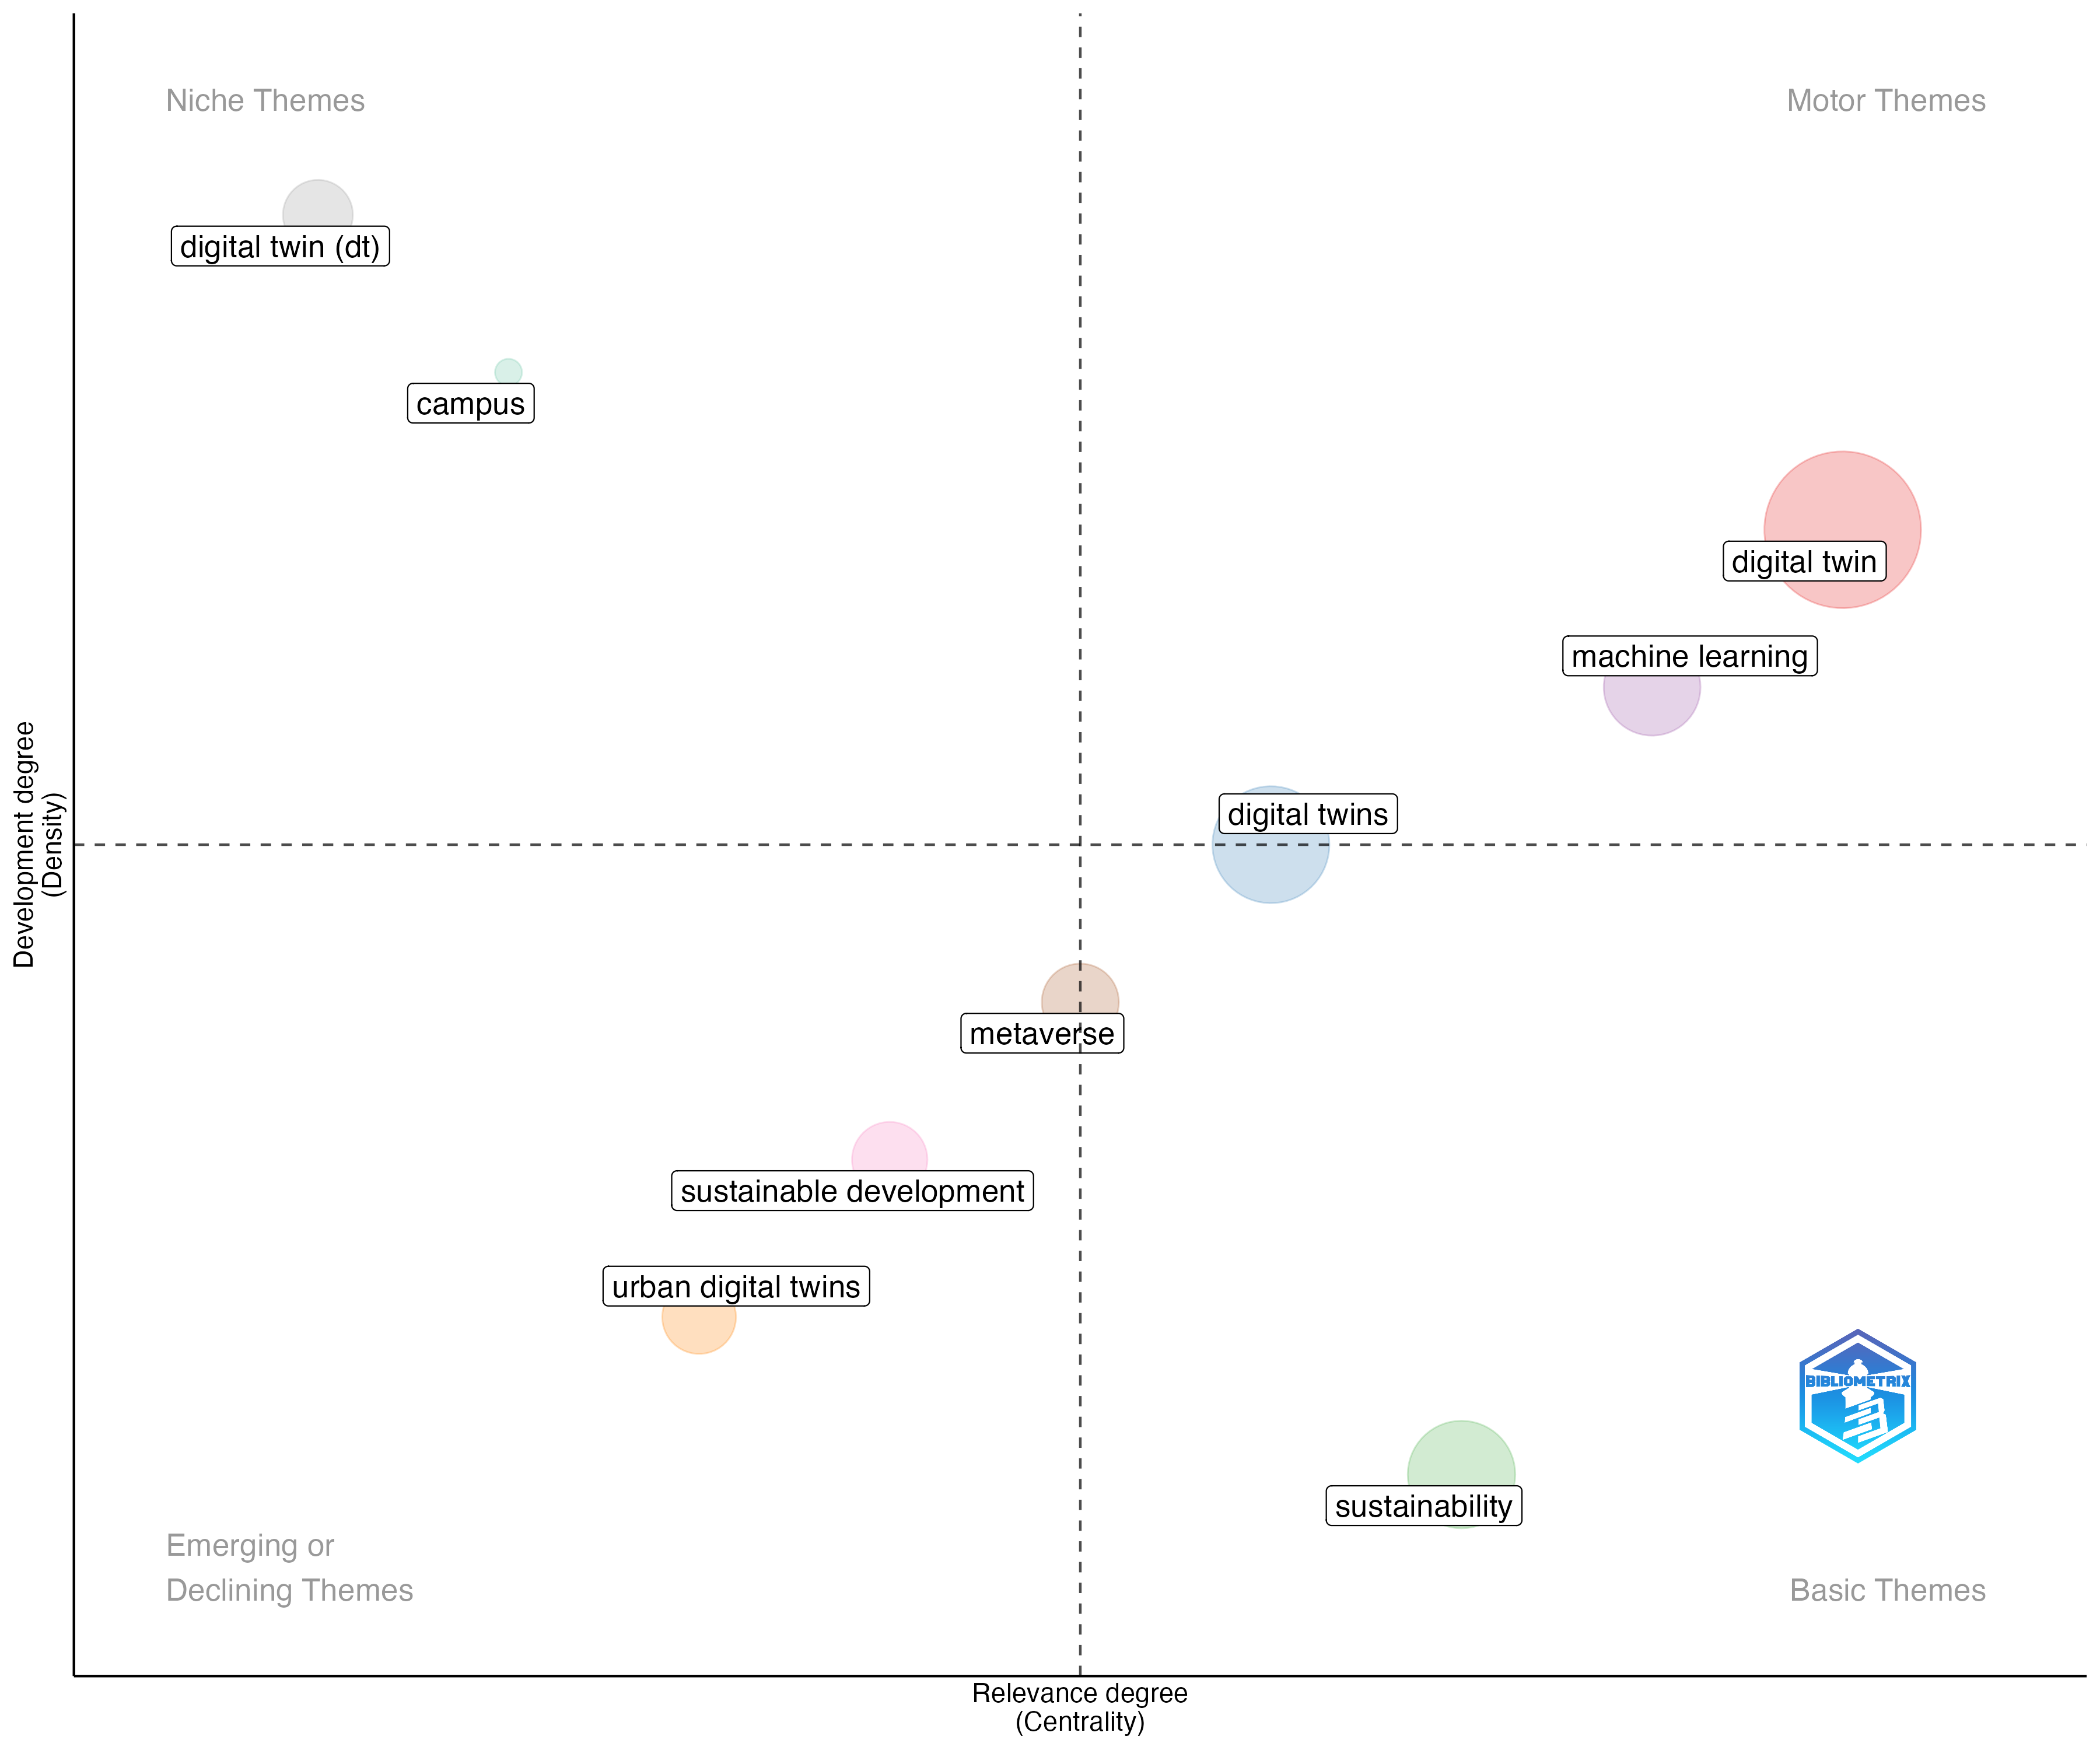
Figure 13 — Thematic map

3.16 Thematic Evolution
Figure 14 shows the thematic evolution over time, illustrating how research themes have shifted between periods.

3.17 The Decision Support Gap
Table 11 presents the frequency of decision-support and public management terms in author keywords. The near-absence of governance-related terms constitutes the central finding of this study.

3.18 Database Overlap
Table 12 presents the overlap between Scopus and WoS in the filtered corpus, showing the unique and shared contributions of each database.

4. Discussion
The bibliometric analysis reveals a field in rapid expansion but with a persistent structural gap. The exponential growth from 2 articles in 2018 to a peak in 2024 confirms that digital twins for smart cities have become a mainstream research topic. However, the thematic map and keyword analysis demonstrate that this growth is overwhelmingly concentrated in technological dimensions — IoT integration, sensor networks, 3D modeling, and data platforms — while decision support and public management themes remain marginal.
The co-authorship network shows fragmented clusters with limited cross-group collaboration, suggesting that the field has not yet consolidated around interdisciplinary research teams that bridge technology and management. China's dominance in production volume, combined with the absence of Global South countries from the top ranks, raises questions about the geographic universality of the digital twin paradigm for urban governance. The institutional analysis confirms this pattern, with Chinese universities leading production while Western institutions contribute higher per-article impact.
The centrality analysis identifies key bridging authors who connect otherwise isolated research groups, but these bridges primarily link technological sub-communities rather than spanning the technology-management divide. The keyword co-occurrence network reinforces this pattern: terms like "IoT," "simulation," and "3D model" cluster tightly together, while "decision support," "governance," and "policy" appear as isolated nodes or low-frequency terms.
This gap has practical implications. Urban managers require digital twins that go beyond monitoring and visualization to support scenario analysis, policy evaluation, and stakeholder engagement (White et al., 2021; Francisco et al., 2020). The current literature provides limited guidance on how to translate real-time urban data into actionable decisions for public administrators. Future research should explicitly address the design of decision support features within digital twin platforms, incorporating frameworks from public management, participatory governance, and evidence-based policy.

4.1 Limitations
This study has several limitations. First, the combined SCImago journal filter, while quadrupling coverage of seminal articles compared to Urban Studies alone, still excludes some highly cited works published in engineering journals (e.g., IEEE Access, Remote Sensing). Second, bibliographic coupling and co-citation analyses were limited by the absence of cited references (CR field) in Scopus exports; these analyses are performed only on WoS records that include this field. Third, the search string was restricted to English-language articles, potentially excluding relevant contributions in other languages. Fourth, bibliometric analysis maps the intellectual structure of a field but cannot assess the quality or depth of individual contributions — a systematic literature review would complement this mapping. Finally, the PRISMA screening process (title/abstract review) is still in progress; the current corpus of 159 articles represents all articles passing the journal filter, and the final included count may be lower after full-text assessment.

5. Conclusion
This bibliometric analysis of 159 articles on digital twins for smart cities (2018–2024) maps a field experiencing exponential growth but characterized by a persistent decision support gap. Motor themes center on technological infrastructure, while governance, policy, and public management keywords occupy peripheral positions in the thematic landscape. The field is dominated by Chinese and European institutions, with limited representation from the Global South.
The central finding — that decision support for urban public management is structurally marginal in the digital twin literature — suggests both a gap and an opportunity. As cities worldwide invest in digital twin platforms, the research community must ensure that these tools are designed not only as technological artifacts but as governance instruments that support evidence-based decision-making. Bridging this gap requires interdisciplinary collaboration between computer scientists, urban planners, and public administration scholars.
Future research directions include: (1) systematic literature reviews that deepen the analysis of how decision support is conceptualized; (2) case studies of digital twin implementations in urban governance contexts, particularly in Global South cities; (3) the development of frameworks integrating public management theory into digital twin platform design; and (4) longitudinal studies tracking whether the decision support gap is narrowing as the field matures.

Acknowledgments
The author(s) declare no conflict of interest. This study was funded by [CAPES/CNPq/FAPERJ — to be completed].

AI Use Declaration
AI tools (Claude/Anthropic) were used for code assistance. AI is not listed as an author.

Data Availability
The datasets generated and analyzed during this study are available in the SciELO Data repository at [URL to be added upon submission], in accordance with the urbe data availability policy.

References
Allam, Z., Sharifi, A., Bibri, S. E., Jones, D. S., & Krogstie, J. (2022). The metaverse as a virtual form of smart cities: Opportunities and challenges for environmental, economic, and social sustainability in urban futures. Smart Cities, 5(3), 1040–1054.
Aria, M., & Cuccurullo, C. (2017). bibliometrix: An R-tool for comprehensive science mapping analysis. Journal of Informetrics, 11(4), 959–975.
Botin-Sanabria, D. M., Salih, A., Mihaita, A.-S., Kwon, S., Kim, Y., & Park, J. (2022). Digital twin technology challenges and applications: A comprehensive review. Remote Sensing, 14(6), 1417.
Dembski, F., Wossner, U., Letzgus, M., Ruddat, M., & Yamu, C. (2020). Urban digital twins for smart cities and citizens: The case study of Herrenberg. Sustainability, 12(6), 2307.
Deng, T., Zhang, K., & Luo, Y. (2021). A systematic review of a digital twin city: Urban governance toward smart city. Journal of Management Science and Engineering, 6(2), 264–276.
Francisco, A., Mohammadi, N., & Taylor, J. E. (2020). Smart city digital twin–enabled energy management: Toward real-time urban building energy benchmarking. Journal of Management in Engineering, 36(2), 04019045.
Fuller, A., Fan, Z., Day, C., & Barlow, C. (2020). Digital twin: Enabling technologies, challenges and open research. IEEE Access, 8, 108952–108971.
Ketzler, B., Naserentin, V., Legner, C., et al. (2020). Digital twins for cities: A state of the art review. Built Environment, 46(4), 547–573.
Lehtola, V. V., Kaartinen, H., Nüchter, A., et al. (2022). Digital twin of a city: Review of technology serving city needs. International Journal of Applied Earth Observation and Geoinformation, 108, 102722.
Li, X., Han, Y., & Zhu, S. (2022). Big data analysis of IoT in digital twins of smart city. Future Generation Computer Systems, 128, 496–505.
Mylonas, G., Valkanis, A., Raptis, G., et al. (2021). Digital twins from smart manufacturing to smart cities: A survey. IEEE Access, 9, 143222–143249.
Nica, C. V., Zamfir, D.-A., & Nita, A. (2026). Digital twins for smart cities: A bibliometric analysis of the decision support gap. Cities, 171, 106797.
Page, M. J., McKenzie, J. E., Bossuyt, P. M., et al. (2021). The PRISMA 2020 statement: An updated guideline for reporting systematic reviews. BMJ, 372, n71.
Sacoto-Cabrera, C. J., Lara, R. P., & Ramos, R. L. (2025). Smart city digital twins: A bibliometric review. Smart Cities, 8(5), 175.
Schrotter, G., & Huerzeler, C. (2020). The digital twin of the city of Zurich for urban planning. PFG–Journal of Photogrammetry, Remote Sensing and Geoinformation Science, 88, 99–112.
Van de Ven, A. H. (2007). Engaged scholarship: A guide for organizational and social research. Oxford University Press.
Visser, M., van Eck, N. J., & Waltman, L. (2021). Large-scale comparison of bibliographic data sources: Scopus, Web of Science, Dimensions, Crossref, and Microsoft Academic. Quantitative Science Studies, 2(1), 20–41.
Weil, C., Wossner, U., & Brell-Cokcan, S. (2023). Urban digital twin challenges for sustainable smart cities. Sustainable Cities and Society, 88, 104–120.
White, G., Zink, A., Livesey, S., & Kehily, D. (2021). A digital twin smart city for citizen feedback. Cities, 110, 103065.
Xia, H., Liu, Z., & Liu, Y. (2022). City digital twin technologies for sustainable smart city design: A review. Sustainable Cities and Society, 83, 103934.

