Assignment 1:

Data Base for Q#1:

|  |
| --- |
| -- Create the Locations table  CREATE TABLE Locations (  Location_id NUMBER PRIMARY KEY,  City VARCHAR2(50)  );  -- Insert sample data into Locations  INSERT INTO Locations (Location_id, City) VALUES (1100, 'New York');  INSERT INTO Locations (Location_id, City) VALUES (1200, 'Los Angeles');  -- Create the Employees table  CREATE TABLE Employees (  Employee_id NUMBER PRIMARY KEY,  First_name VARCHAR2(50),  Last_name VARCHAR2(50),  Manager_id NUMBER,  Hire_date DATE  );  -- Insert sample data into Employees  INSERT INTO Employees (Employee_id, First_name, Last_name, Manager_id, Hire_date) VALUES (100, 'Manager', 'Smith', NULL, TO_DATE('2023-01-15', 'YYYY-MM-DD'));  INSERT INTO Employees (Employee_id, First_name, Last_name, Manager_id, Hire_date) VALUES (101, 'John', 'Doe', 100, TO_DATE('2023-02-10', 'YYYY-MM-DD'));  INSERT INTO Employees (Employee_id, First_name, Last_name, Manager_id, Hire_date) VALUES (102, 'Jane', 'Smith', 100, TO_DATE('2023-03-05', 'YYYY-MM-DD'));  -- Create the Departments table  CREATE TABLE Departments (  Department_id NUMBER PRIMARY KEY,  Department_name VARCHAR2(50),  Manager_id NUMBER,  Location_id NUMBER,  FOREIGN KEY (Manager_id) REFERENCES Employees(Employee_id),  FOREIGN KEY (Location_id) REFERENCES Locations(Location_id)  );  -- Insert sample data into Departments  INSERT INTO Departments (Department_id, Department_name, Manager_id, Location_id) VALUES (320, 'Testing', 100, 1100);  INSERT INTO Departments (Department_id, Department_name, Manager_id, Location_id) VALUES (321, 'Designing', 100, 1200);  INSERT INTO Departments (Department_id, Department_name, Manager_id, Location_id) VALUES (322, 'Manufacturing', 100, 1200);  INSERT INTO Departments (Department_id, Department_name, Manager_id, Location_id) VALUES (320, 'Marketing', 100, 1200); |

Query 1:

|  |
| --- |
| SET SERVEROUTPUT ON  DECLARE  v_new_department_id NUMBER;  v_department_name VARCHAR2(50) := 'Testing';  v_manager_id NUMBER;  v_location_id NUMBER;  v_city_name VARCHAR2(50);  BEGIN  -- Prompt for a valid city name without any department  DBMS_OUTPUT.PUT('Please provide the valid city without department: ');  DBMS_OUTPUT.NEW_LINE;  v_city_name := UPPER('&v_city_name');  -- Check if the city is not listed in the Locations table  BEGIN  SELECT Location_id INTO v_location_id  FROM Locations  WHERE UPPER(City) = v_city_name;  EXCEPTION  WHEN NO_DATA_FOUND THEN  DBMS_OUTPUT.PUT_LINE('This city is NOT listed: ' || v_city_name);  RETURN;  END;  -- Check if the city already contains one department  SELECT COUNT(*) INTO v_manager_id  FROM Departments  WHERE Location_id = v_location_id;  IF v_manager_id = 1 THEN  DBMS_OUTPUT.PUT_LINE('This city already contains a department: ' || v_city_name);  -- Check if the city contains more than one department  ELSIF v_manager_id > 1 THEN  DBMS_OUTPUT.PUT_LINE('This city has MORE THAN ONE department: ' || v_city_name);  ELSE  -- Find the manager with the most direct reports  SELECT e.Manager_id INTO v_manager_id  FROM Employees e  JOIN Departments d ON e.Employee_id = d.Manager_id  WHERE d.Location_id = v_location_id  GROUP BY e.Manager_id  HAVING COUNT(*) = (  SELECT MAX(report_count)  FROM (  SELECT COUNT(*) AS report_count  FROM Employees e2  JOIN Departments d2 ON e2.Employee_id = d2.Manager_id  WHERE d2.Location_id = v_location_id  GROUP BY e2.Manager_id  )  );  -- Get the highest existing Department_id and increase it by 50  SELECT NVL(MAX(Department_id), 0) + 50 INTO v_new_department_id  FROM Departments;  -- Insert the new department  INSERT INTO Departments (Department_id, Department_name, Manager_id, Location_id)  VALUES (v_new_department_id, v_department_name, v_manager_id, v_location_id);  -- Display the new row  DBMS_OUTPUT.PUT_LINE('DEPARTMENT_ID ' || v_new_department_id || ' ' || v_department_name || ' ' || v_manager_id || ' ' || v_location_id);  END IF;  EXCEPTION  WHEN OTHERS THEN  DBMS_OUTPUT.PUT_LINE('An error occurred: ' || SQLERRM);  END;  /  SET SERVEROUTPUT OFF |

Output:

User input: New York

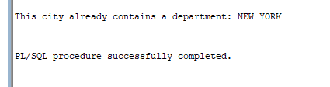

User input: los Angeles

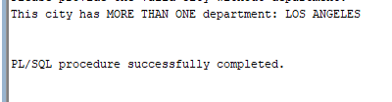

User input: Belgrade

Query 2:

|  |
| --- |
| SET SERVEROUTPUT ON  ACCEPT v_input_description CHAR PROMPT 'Enter the beginning of the Course Description in UPPER case: ';  DECLARE  v_search_description VARCHAR2(50);  v_has_exceptions NUMBER := 0;  v_course_found NUMBER := 0; -- Variable to track if a course with the given description is found  v_no_prereq NUMBER := 1; -- Variable to track if there's no prerequisite  BEGIN  v_search_description := UPPER('&v_input_description');  -- Initialize a cursor for selecting sections  FOR rec IN (SELECT s.SECTION_ID, s.COURSE_NO, s.CAPACITY  FROM SECTION s  WHERE s.COURSE_NO IN (  SELECT c.PREREQUISITE  FROM COURSE c  WHERE UPPER(c.DESCRIPTION) LIKE v_search_description || '%'  ))  LOOP  v_no_prereq := 0; -- Reset the variable when a matching course is found  -- Initialize a variable to count the number of students  DECLARE  v_student_count NUMBER := 0;  v_section_id NUMBER := rec.SECTION_ID;  BEGIN  -- Use a cursor for loop to iterate through enrollments  FOR enr_rec IN (SELECT e.STUDENT_ID  FROM ENROLLMENT e  WHERE e.SECTION_ID = rec.SECTION_ID)  LOOP  -- Count the students  v_student_count := v_student_count + 1;  END LOOP;  -- Check if the student count is greater than or equal to 7  IF v_student_count >= 7 THEN  -- Raise the custom exception  DBMS_OUTPUT.PUT_LINE('There are more than 7 students for section ' || rec.COURSE_NO);  DBMS_OUTPUT.PUT_LINE('^^^^^^^^^^^^^^^^^^^^^^^^^^');  v_has_exceptions := 1;  ELSE  -- Display the student count  DBMS_OUTPUT.PUT_LINE('There are ' || v_student_count || ' students for section ID ' || v_section_id);  END IF;  EXCEPTION  WHEN OTHERS THEN  -- Handle other exceptions  DBMS_OUTPUT.PUT_LINE('An error occurred for section ' || v_section_id);  END;  END LOOP;  -- Check if there were any exceptions  IF v_has_exceptions = 0 THEN  -- No exceptions occurred  DBMS_OUTPUT.PUT_LINE('No exceptions occurred.');  END IF;  -- Check if any course with the given description was found  SELECT COUNT(*) INTO v_course_found  FROM COURSE c  WHERE UPPER(c.DESCRIPTION) LIKE v_search_description || '%';  -- Check if no prerequisite course is found  IF v_no_prereq = 1 AND v_course_found <> 0 THEN  DBMS_OUTPUT.PUT_LINE('No pre-req of this course.');  END IF;    IF v_course_found = 0 THEN  -- No course with the given description found  DBMS_OUTPUT.PUT_LINE('No valid course.');  END IF;  END;  /  SET SERVEROUTPUT OFF |

Output:

User input : STRUCTURED

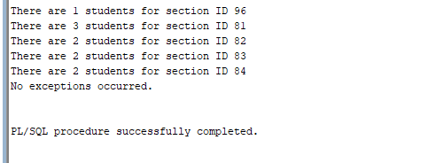

|  |
| --- |
| There are 1 students for section ID 96  There are 3 students for section ID 81  There are 2 students for section ID 82  There are 2 students for section ID 83  There are 2 students for section ID 84  No exceptions occurred.  PL/SQL procedure successfully completed. |

User input: UNIX

User input: DP

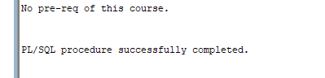

User input: SPORT

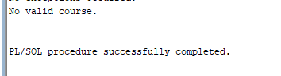

Query 3:

|  |
| --- |
| SET SERVEROUTPUT ON  ACCEPT v_input_description CHAR PROMPT 'Enter the beginning of the Course description in UPPER case: ';  DECLARE  v_search_description VARCHAR2(100);  BEGIN  -- Assign the user input to the search variable  v_search_description := UPPER('&v_input_description');  -- Initialize a cursor for selecting course information  FOR rec IN (SELECT c.COURSE_NO, c.DESCRIPTION, c.COST, c.PREREQUISITE  FROM COURSE c  WHERE UPPER(c.DESCRIPTION) LIKE v_search_description || '%')  LOOP  -- Check if any courses were found  IF rec.COURSE_NO IS NOT NULL THEN  -- Display course information    -- Check if there is a prerequisite, and if so, print its information  IF rec.PREREQUISITE IS NOT NULL THEN  DBMS_OUTPUT.PUT_LINE('---------Input Course--------------');  DBMS_OUTPUT.PUT_LINE('Course: ' || rec.COURSE_NO || ' - ' || rec.DESCRIPTION);  DBMS_OUTPUT.PUT_LINE('Cost: ' || rec.COST);  DECLARE  v_prerequisite_course_no NUMBER;  v_prerequisite_description VARCHAR2(100);  v_prerequisite_cost NUMBER;  v_prerequisite_prereq NUMBER;  v2_prerequisite_course_no NUMBER;  v2_prerequisite_description VARCHAR2(100);  v2_prerequisite_cost NUMBER;  v2_prerequisite_prereq NUMBER;  BEGIN  SELECT c.COURSE_NO, c.DESCRIPTION, c.COST, c.prerequisite  INTO v_prerequisite_course_no, v_prerequisite_description, v_prerequisite_cost, v_prerequisite_prereq  FROM COURSE c  WHERE c.COURSE_NO = rec.PREREQUISITE;  SELECT c.COURSE_NO, c.DESCRIPTION, c.COST, c.prerequisite  INTO v2_prerequisite_course_no, v2_prerequisite_description, v2_prerequisite_cost, v2_prerequisite_prereq  FROM COURSE c  WHERE c.COURSE_NO = v_prerequisite_prereq;  DBMS_OUTPUT.PUT_LINE('Prerequisite: ' || v_prerequisite_course_no || ' - ' || v_prerequisite_description);  DBMS_OUTPUT.PUT_LINE('Prerequisite Cost: ' || v_prerequisite_cost);  DBMS_OUTPUT.PUT_LINE('========================================');  DBMS_OUTPUT.PUT_LINE('Course: ' || v_prerequisite_course_no || ' - ' || v_prerequisite_description );  DBMS_OUTPUT.PUT_LINE('Cost: ' || v_prerequisite_cost);  DBMS_OUTPUT.PUT_LINE('Prerequisite: ' || v2_prerequisite_course_no || ' - ' || v2_prerequisite_description);  DBMS_OUTPUT.PUT_LINE('Prerequisite Cost: ' || v2_prerequisite_cost);  EXCEPTION  WHEN NO_DATA_FOUND THEN  DBMS_OUTPUT.PUT_LINE('Prerequisite information not found.');  END;  ELSE  DBMS_OUTPUT.PUT_LINE('NO prereq for this course found');  END IF;  DBMS_OUTPUT.PUT_LINE('========================================');  ELSE  DBMS_OUTPUT.PUT_LINE('There is NO VALID course that starts with: ' || v_search_description || '. Try again.');  END IF;  END LOOP;    END;  /  SET SERVEROUTPUT OFF |

Output:

User input: DATABASE

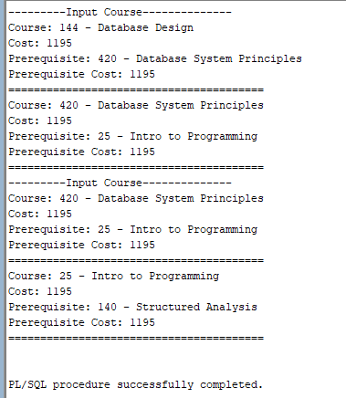

|  |
| --- |
| ---------Input Course--------------  Course: 144 - Database Design  Cost: 1195  Prerequisite: 420 - Database System Principles  Prerequisite Cost: 1195  ========================================  Course: 420 - Database System Principles  Cost: 1195  Prerequisite: 25 - Intro to Programming  Prerequisite Cost: 1195  ========================================  ---------Input Course--------------  Course: 420 - Database System Principles  Cost: 1195  Prerequisite: 25 - Intro to Programming  Prerequisite Cost: 1195  ========================================  Course: 25 - Intro to Programming  Cost: 1195  Prerequisite: 140 - Structured Analysis  Prerequisite Cost: 1195  ========================================  PL/SQL procedure successfully completed. |

User input: DP

User input: SPORT

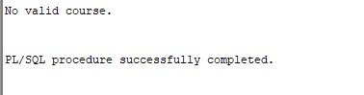

Query 4:

|  |
| --- |
| SET SERVEROUTPUT ON  -- Accept two keywords for course description  ACCEPT keyword1 CHAR PROMPT 'Enter the first keyword within the course description: ';  ACCEPT keyword2 CHAR PROMPT 'Enter the second keyword within the course description: ';  -- Declare variables for course information  DECLARE  v_keyword1 VARCHAR2(100) := UPPER('&keyword1');  v_keyword2 VARCHAR2(100) := UPPER('&keyword2');  v_course_found BOOLEAN := FALSE;  BEGIN  -- Initialize a cursor for selecting course information  FOR rec_course IN (SELECT c.COURSE_NO, c.DESCRIPTION FROM COURSE c  WHERE UPPER(c.DESCRIPTION) LIKE '%' || v_keyword1 || '%' AND UPPER(c.DESCRIPTION) LIKE '%' || v_keyword2 || '%')  LOOP  v_course_found := TRUE;  -- Display course number and name  DBMS_OUTPUT.PUT_LINE(rec_course.COURSE_NO || ' ' || rec_course.DESCRIPTION);  DBMS_OUTPUT.PUT_LINE('**************************************');  -- Initialize a child cursor to count enrollments for each section  FOR rec_section IN (SELECT s.SECTION_ID, COUNT(*) AS ENROLLMENTS  FROM SECTION s  LEFT JOIN ENROLLMENT e ON s.SECTION_ID = e.SECTION_ID  WHERE s.COURSE_NO = rec_course.COURSE_NO  GROUP BY s.SECTION_ID  ORDER BY s.SECTION_ID)  LOOP  -- Display section number and enrollment count  DBMS_OUTPUT.PUT_LINE('Section: ' || rec_section.SECTION_ID || ' has an enrollment of: ' || rec_section.ENROLLMENTS);  END LOOP;  DBMS_OUTPUT.PUT_LINE('========================================');  END LOOP;  IF v_course_found = FALSE THEN  DBMS_OUTPUT.PUT_LINE('There is NO course containing these 2 words. Try again.');  END IF;  END;  /  SET SERVEROUTPUT OFF |

Output:

User input 1: JAVA

User input 2: PROGRAM

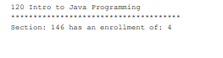

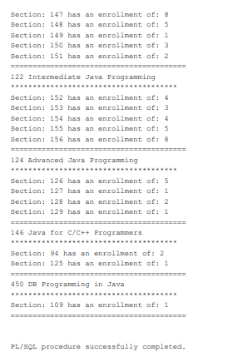

|  |
| --- |
| 120 Intro to Java Programming  **************************************  Section: 146 has an enrollment of: 4  Section: 147 has an enrollment of: 8  Section: 148 has an enrollment of: 5  Section: 149 has an enrollment of: 1  Section: 150 has an enrollment of: 3  Section: 151 has an enrollment of: 2  ========================================  122 Intermediate Java Programming  **************************************  Section: 152 has an enrollment of: 4  Section: 153 has an enrollment of: 3  Section: 154 has an enrollment of: 4  Section: 155 has an enrollment of: 5  Section: 156 has an enrollment of: 8  ========================================  124 Advanced Java Programming  **************************************  Section: 126 has an enrollment of: 5  Section: 127 has an enrollment of: 1  Section: 128 has an enrollment of: 2  Section: 129 has an enrollment of: 1  ========================================  146 Java for C/C++ Programmers  **************************************  Section: 94 has an enrollment of: 2  Section: 125 has an enrollment of: 1  ========================================  450 DB Programming in Java  **************************************  Section: 109 has an enrollment of: 1  ========================================  PL/SQL procedure successfully completed. |

User input 1 = INTRO

User input 2 = C

User input 1 = INTRO

User input 2 = SOCCER

