2018-09-07

Leonardo Molina

**Flex Sensor**

Detect changes on a flex sensor using an Arduino. This setup provides a non-invasive method of detecting movements of a resting subject.

The sensor is attached to an analog input of the Arduino which reports to the serial port any changes detected. The same information is encoded in 8-bits in pins 54 to 61 (A0 to A7) of the Arduino Mega or Arduino Due so that it can be fed to a data acquisition system such as the Digital Lynx and have it synchronized to electrophysiological measurements.

**Principle of operation**

Bending the sensor causes changes in resistance that are read at an analog input of the Arduino. If the sensor is placed in a cushioned surface, any forces applied to this surface will be picked up by the sensor. This can be caused every time that the subject adjusts their body weight, for example.

**Prerequisites**

* [Arduino](https://www.arduino.cc/en/Main/Software) (last compiled and tested with Arduino 1.8.5)
* [Arduino Mega2560](https://store.arduino.cc/usa/arduino-mega-2560-rev3) or [Arduino Due](https://store.arduino.cc/usa/arduino-due)
* Flex sensor
* 10KOhm resistor

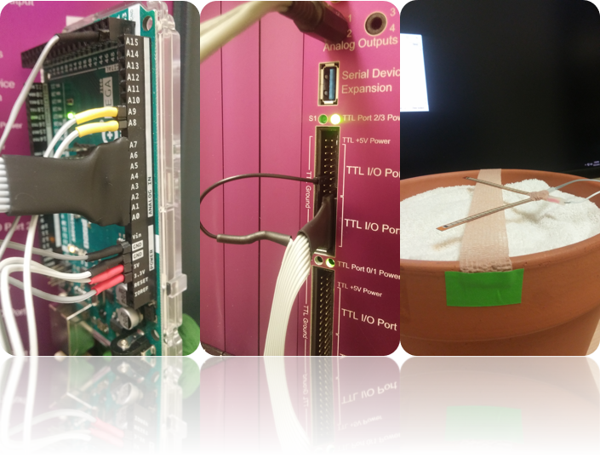**Installation**

* Install Arduino.
* Download and extract the project folder.
* Setup the flex sensor: Connect one end to +5V and the other end to the resistor to ground. The point between the resistor and the sensor connects to A8 (pin 62) of the Arduino. You may add a second flex sensor and connect it to A9 (pin 63).
* Plug-in the Arduino to the computer, upload code:
  + Open FlexSensor.ino
  + Select Tools/Board/Arduino Mega 2560 (or Arduino Due if using this board and having downloaded support from the Board Manager).
  + Select Tools/Port corresponding to board.
  + Click on Sketch/Upload

## Usage example

[https://drive.google.com/file/d/1NOsbR6badt6qm2y43nk8ZikhCGXgu5zO](https://drive.google.com/file/d/1NOsbR6badt6qm2y43nk8ZikhCGXgu5zO)