Kubernetes Authentication via Akeyless Gateway
Design Document

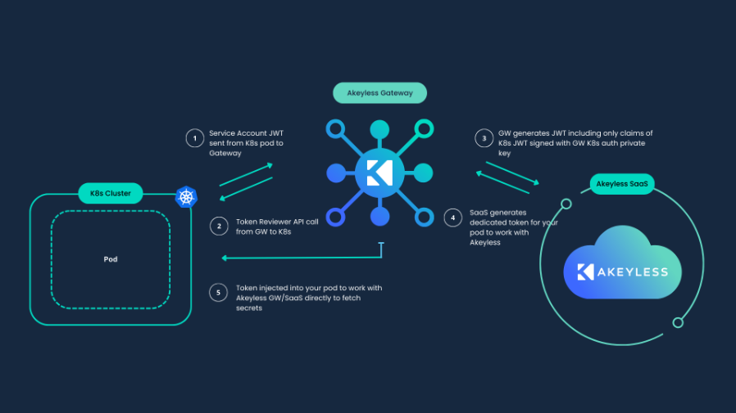

1. Architectural Interaction Overview
The architecture consists of three trust boundaries:
Zone 1 — Kubernetes Cluster
• Pod
• ServiceAccount
• Kubernetes API Server
Zone 2 — Akeyless Gateway
• K8s Auth Config
• Auth Method
Zone 3 — Akeyless SaaS / Control Plane
• Roles
• Access Policies
The Gateway acts as a trust bridge between Kubernetes and Akeyless.
It does not store static secrets for Pods and never trusts JWTs directly — trust is established strictly through verification against the Kubernetes API.

2. Logical Authentication Flow
Complete secret access flow:
1. A Pod starts inside Kubernetes.
Kubernetes automatically mounts the ServiceAccount JWT into the Pod.
2. The Pod sends a request to Akeyless Gateway and includes its JWT.
3. The Gateway initiates a TokenReview request to the Kubernetes API.
A dedicated ServiceAccount (token reviewer) is used for this validation.
4. The Kubernetes API:
• Verifies token signature
• Validates expiration
• Confirms ServiceAccount identity
5. The Gateway maps the ServiceAccount identity to the configured Auth Method rules.
6. If validation succeeds, the Gateway requests temporary credentials from Akeyless.
7. The Pod receives access to the secret.
Trust model:
Pod → trusts Kubernetes
Gateway → trusts Kubernetes API
Akeyless → trusts Gateway via Access ID and Signing Key

3. Why a Dedicated ServiceAccount Is Used
A Dedicated ServiceAccount is used exclusively to perform TokenReview operations.
Reasons:
• Principle of least privilege
• Isolation of Gateway from other ServiceAccount permissions
• Prevention of privilege escalation
• Auditable access boundary
ClusterRoleBinding with the role system:auth-delegator grants permission to perform token reviews.

4. Script Breakdown by Architectural Blocks

Block A — Configuration Variables
Block Purpose:
This block implements the corresponding architectural element described in sections 1–3. The exact script commands are shown below:
# --- CONFIGURATION ---
TEST_NS="leon-k8-auth-test"
SA_NAME="gateway-token-reviewer"
SA_FILE="create_sa_gw_token_reviewer.yaml"
TOKEN_FILE="generate_token_for_sa.yaml"
SECRET_NAME="sa-reviewer-token"
AUTH_METHOD_NAME="/K8s/k8s-auth-leon-test"
GW_CONFIG_NAME="k8s-config-created-by-script"
GW_URL="https://gw-gke.lm.cs.akeyless.fans/api/v1"
ROLE_NAME="/FullAccess"
LOG_FILE="create_k8s_auth.log"

Block B — Logging and Context
Block Purpose:
This block implements the corresponding architectural element described in sections 1–3. The exact script commands are shown below:
exec > >(tee -a "$LOG_FILE") 2>&1
CURRENT_CTX=$(kubectl config current-context)
echo "Active context: $CURRENT_CTX"

Block C — Namespace Creation
Block Purpose:
This block implements the corresponding architectural element described in sections 1–3. The exact script commands are shown below:
kubectl create namespace $TEST_NS --dry-run=client -o yaml | kubectl apply -f -

Block D — ServiceAccount and RBAC Creation
Block Purpose:
This block implements the corresponding architectural element described in sections 1–3. The exact script commands are shown below:
cat <<EOF > $SA_FILE
apiVersion: v1
kind: ServiceAccount
...
kind: ClusterRoleBinding
name: role-tokenreview-binding-$TEST_NS
roleRef:
kind: ClusterRole
name: system:auth-delegator
EOF
kubectl apply -f $SA_FILE

Block E — Reviewer ServiceAccount Secret Creation
Block Purpose:
This block implements the corresponding architectural element described in sections 1–3. The exact script commands are shown below:
cat <<EOF > $TOKEN_FILE
apiVersion: v1
kind: Secret
type: kubernetes.io/service-account-token
EOF
kubectl apply -f $TOKEN_FILE
sleep 5

Block F — Cluster Parameter Extraction
Block Purpose:
This block implements the corresponding architectural element described in sections 1–3. The exact script commands are shown below:
SA_JWT_TOKEN=$(kubectl get secret $SECRET_NAME -n $TEST_NS --output='go-template={{.data.token | base64decode}}')
CA_CERT=$(kubectl config view --raw --minify --flatten --output='jsonpath={.clusters[].cluster.certificate-authority-data}')
K8S_HOST=$(kubectl config view --minify --output jsonpath='{.clusters[0].cluster.server}')
K8S_ISSUER=$(kubectl get --raw /.well-known/openid-configuration | jq -r '.issuer')

Block G — Kubernetes Auth Method Creation
Block Purpose:
This block implements the corresponding architectural element described in sections 1–3. The exact script commands are shown below:
AUTH_RESULT=$(akeyless create-auth-method-k8s --name "$AUTH_METHOD_NAME" --json)
ACCESS_ID=$(echo $AUTH_RESULT | jq -r '.access_id')
PRV_KEY=$(echo $AUTH_RESULT | jq -r '.prv_key')

Block H — Role Association with Auth Method
Block Purpose:
This block implements the corresponding architectural element described in sections 1–3. The exact script commands are shown below:
akeyless assoc-role-am --role-name "$ROLE_NAME" --am-name "$AUTH_METHOD_NAME"

Block I — Gateway K8s Auth Config Creation
Block Purpose:
This block implements the corresponding architectural element described in sections 1–3. The exact script commands are shown below:
akeyless gateway-create-k8s-auth-config --name "$GW_CONFIG_NAME" --gateway-url "$GW_URL" --access-id "$ACCESS_ID" --signing-key "$PRV_KEY" --k8s-host "$K8S_HOST" --k8s-issuer "$K8S_ISSUER" --k8s-ca-cert "$CA_CERT" --token-reviewer-jwt "$SA_JWT_TOKEN"

