selected_point = -0.0002 - 0.0012i(A1)

k = 0.0012 (if k > 0 than stable)

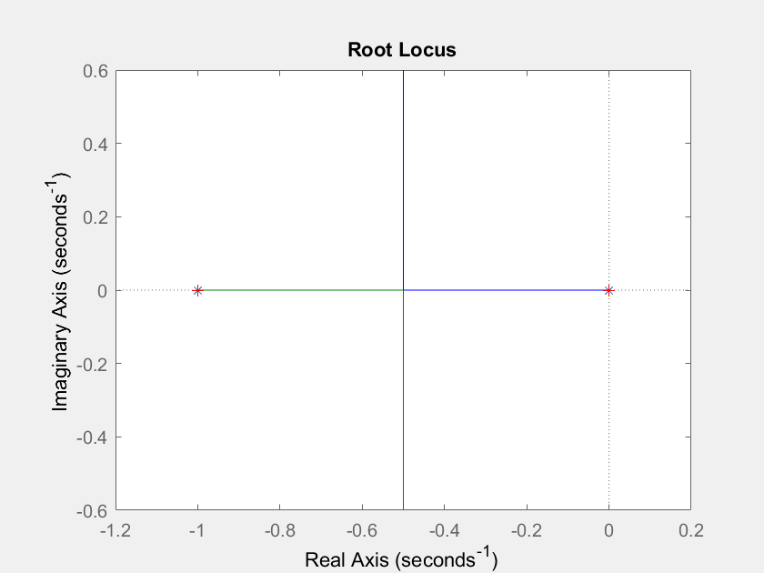

selected_point = 0.0284 + 1.4256i(A2)

k2 = 6.2145 (if k > 0 than stable)

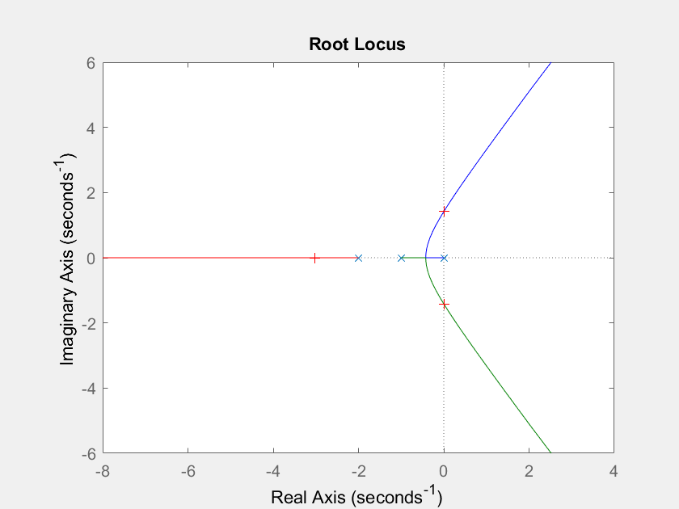

selected_point = -0.0269 + 0.9752i(A3)

k3 = 9.2563

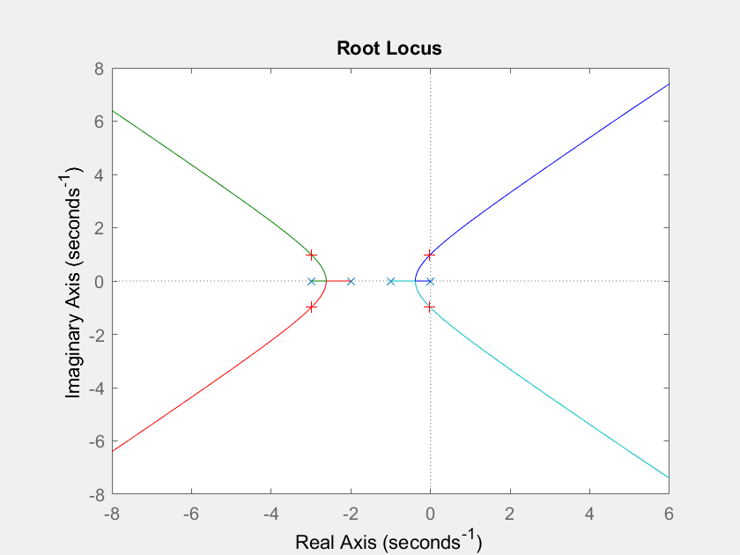

selected_point = -0.0174 - 0.0093i(A4)

k4 = 0.0098

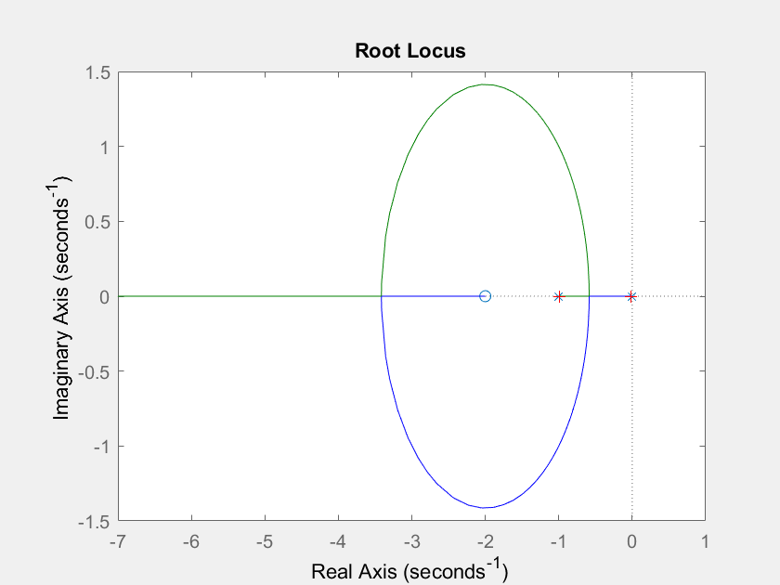

selected_point = -0.0000 - 0.0031i(B5)

k5 = 9.6049e-06

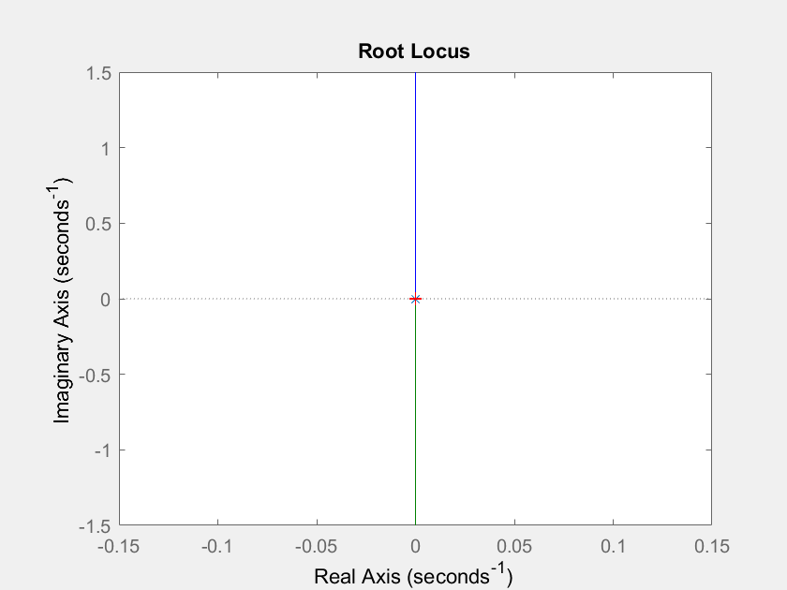

selected_point = 0.0130 - 0.0031i(B6)

k6 = 1.7716e-04

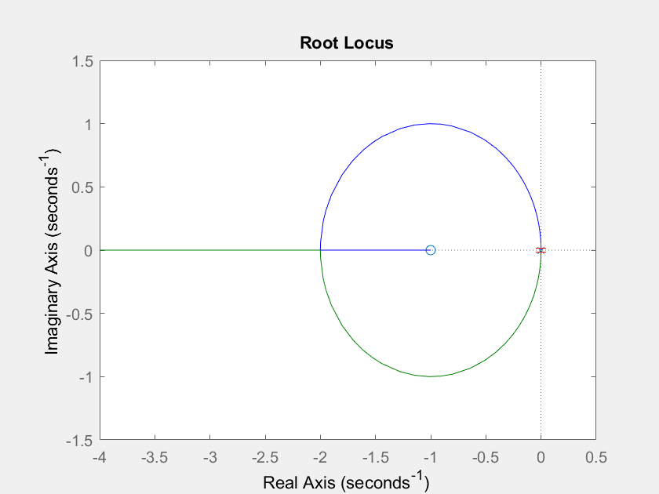

selected_point = -0.0095 - 0.0207i(B7)

k7 = 0.0063

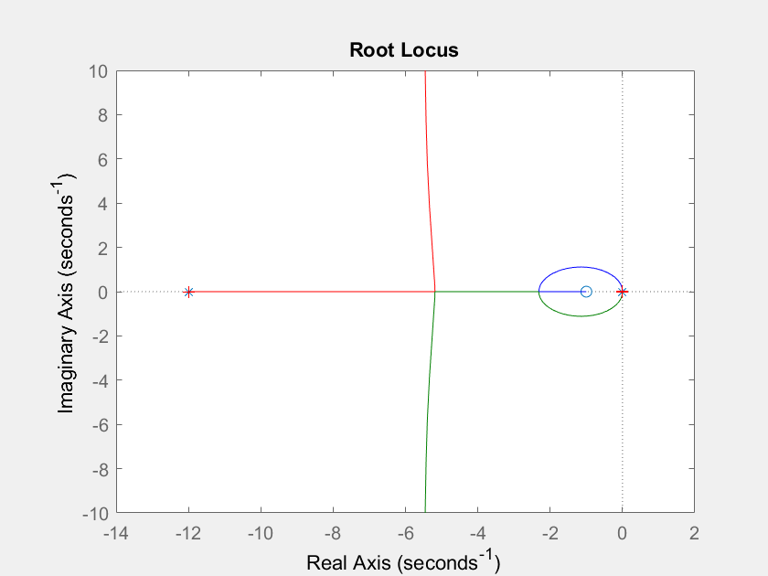

selected_point = 0.0190 - 0.0207i(B8)

k8 = 0.0070

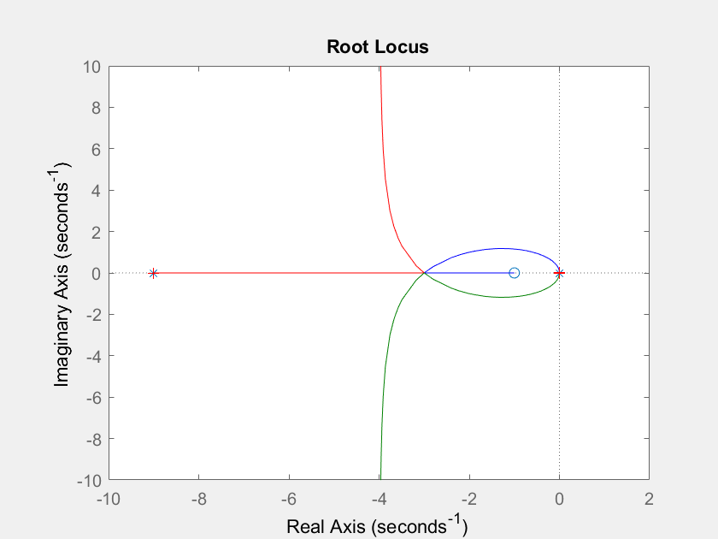

selected_point = 0.0095 - 0.0207i(B9)

k9 = 0.0021

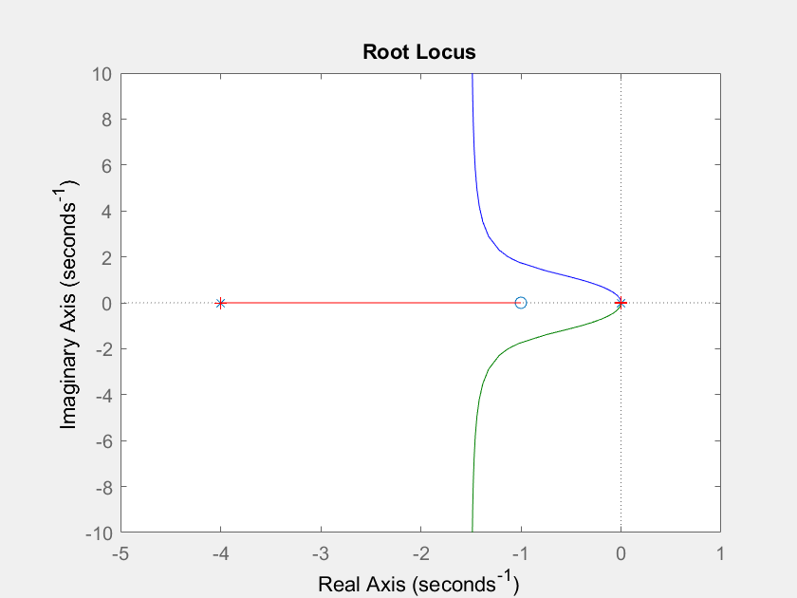

selected_point = -0.0012 + 1.9886i(C10)

k10 = 0.0229

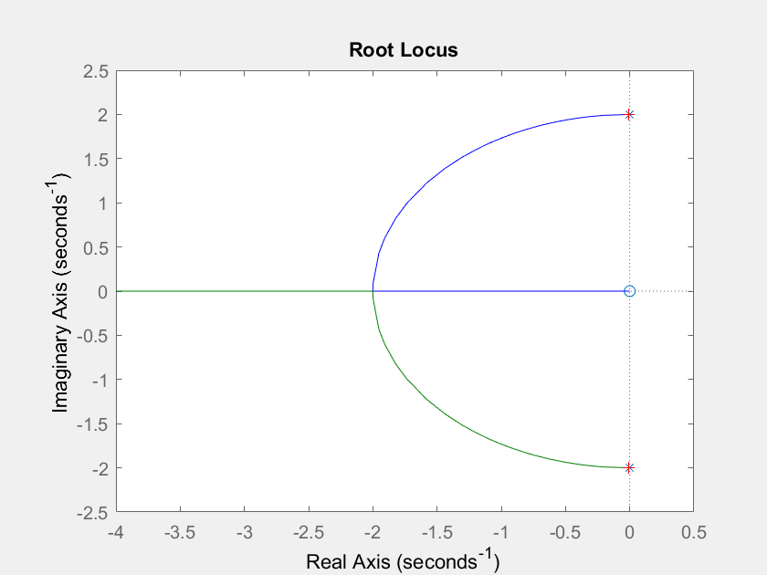

selected_point = -0.0029 + 1.9886i(C11)

k11 = 0.0315

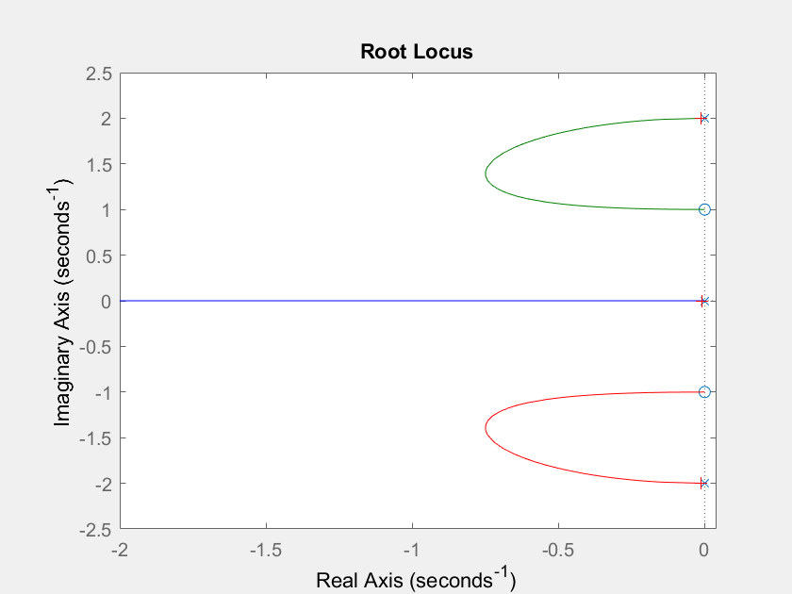

selected_point = -0.0014 + 1.0072i(C12)

k12 = 0.0050

